Name: 范振軒; B13303159
Position: backend
Designed the first few versions of backend logic:
(the final version was designed and implemented by others)
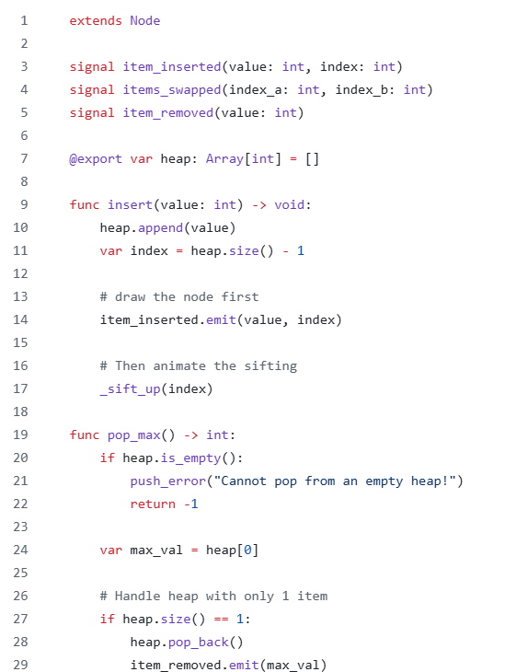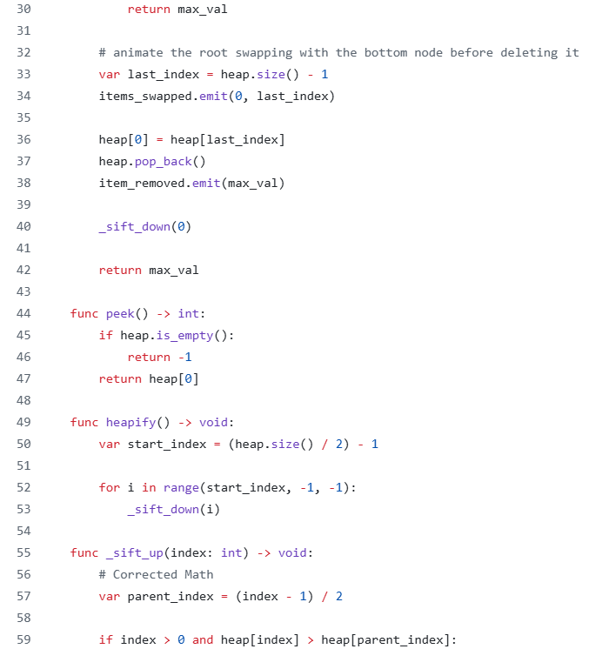
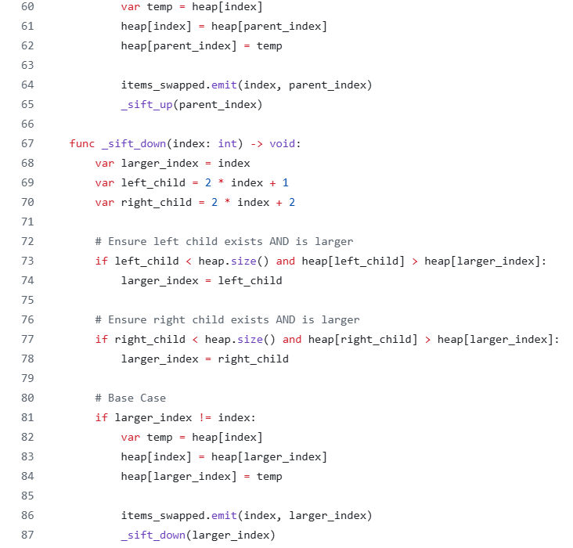
Implemented the first version of array visualization:
(the more detailed versions were modified by others)
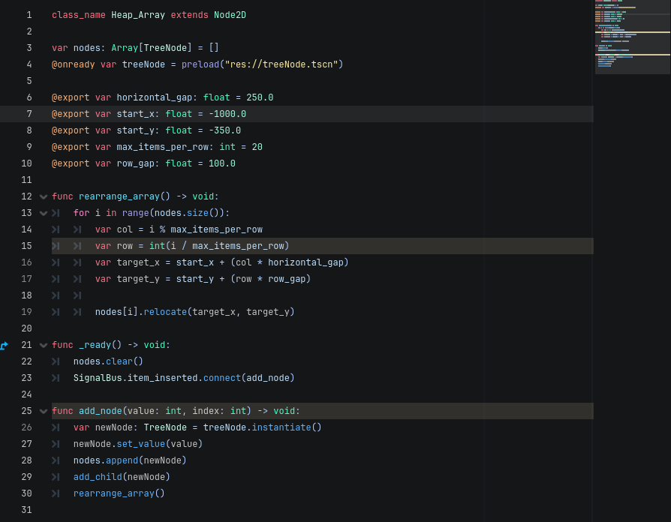
Discussion participation:
