Delivery App

1. Idea

This app makes it main idea of app that customers can call drivers to conveniently carry their stuff.

1. Components

Project has three parts mainly.

1. Android/Ios
2. Admin panel

This app has two parts mainly. One is customer side and another is driver side.

1. Appflow.

Customer search drivers for his stuff, if he want to move stuff quickly, he can find drivers in 5 mile from him. So customer will have his stuff location and weight ,size etc about stuff information. Also he will insert price and time for this too.

Next he will post to all drivers.

In driver side, driver has posted customer’s stuff information. He can decide according to his car type.

Each user (driver and customer) will be tracked by GPS.

So driver can send notification to Customer.

After customer see his Rate, he will decide your stuff to him.

He will call driver and they will match their contract.

-customer side

1. sign up (facebook, google sign)

2. login

3. verifyNumber

4. MainHome

5. customer profile

6. order

7. Search(google map)

8. driver profile

9 . Rate

10.payment

-driver side

1 .signup

2.login

3.personal information

4. verify Number

5.Add vehicle Details.

6.vehicle Ownership Form

7.upload Driving License

8.MainHome

9.customer profile

10 dirver profile

11. Earning

-Admin&backend

Amdin can manage all drivers and customers.

Admin can has drivers and customer lists.

Because app has payment, if user has expire date, admin can give permission to Users.

Also admin can see tracking order location through google map.

-App design

This design was made by me in last year.

App only has completed design.

This design only is example. After you see this, you can decide.

Customer side

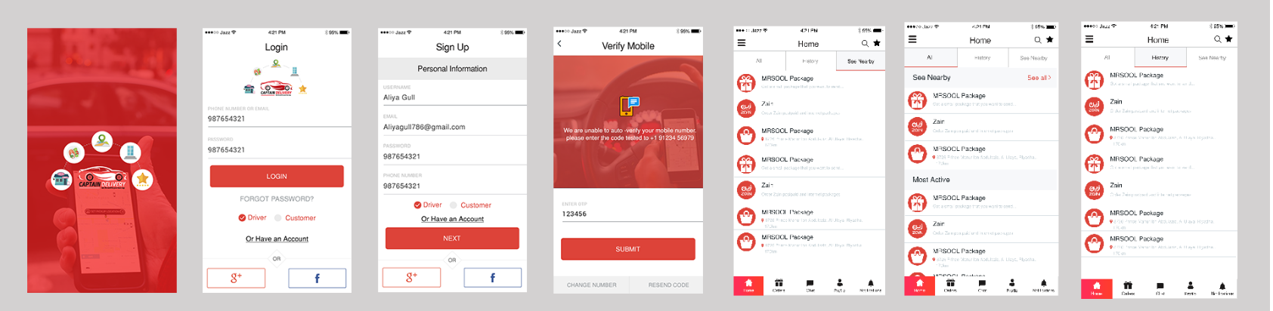

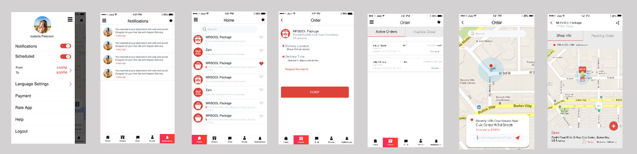

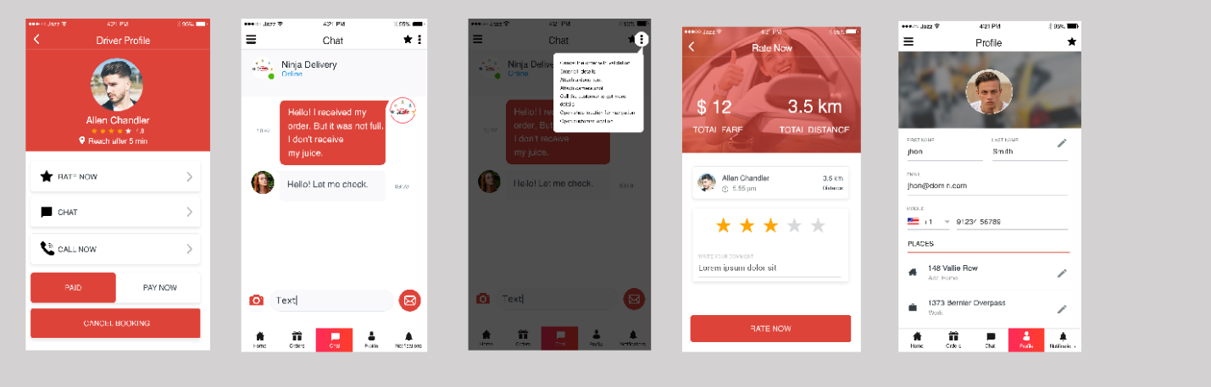

Driver design

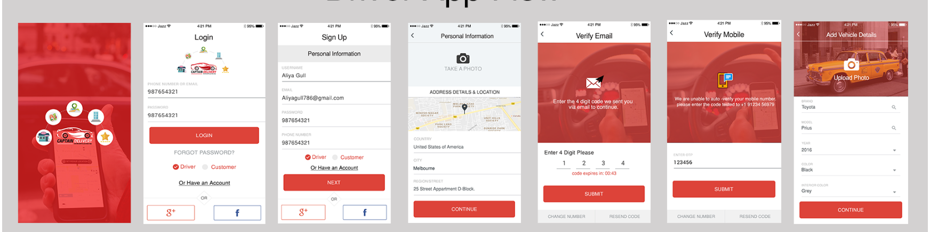

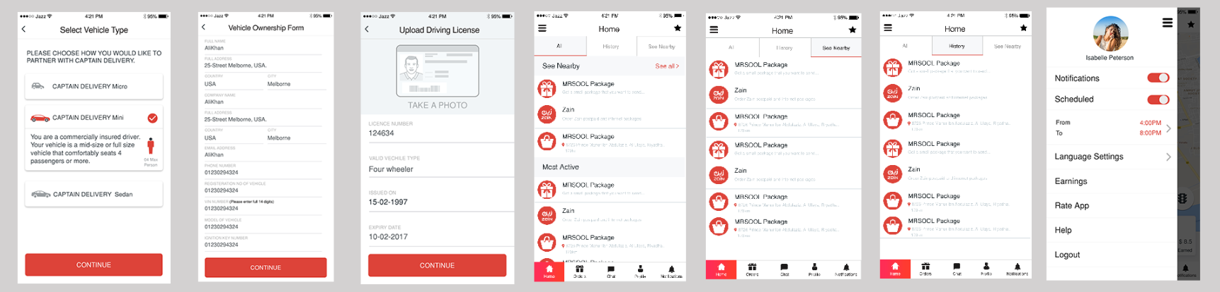

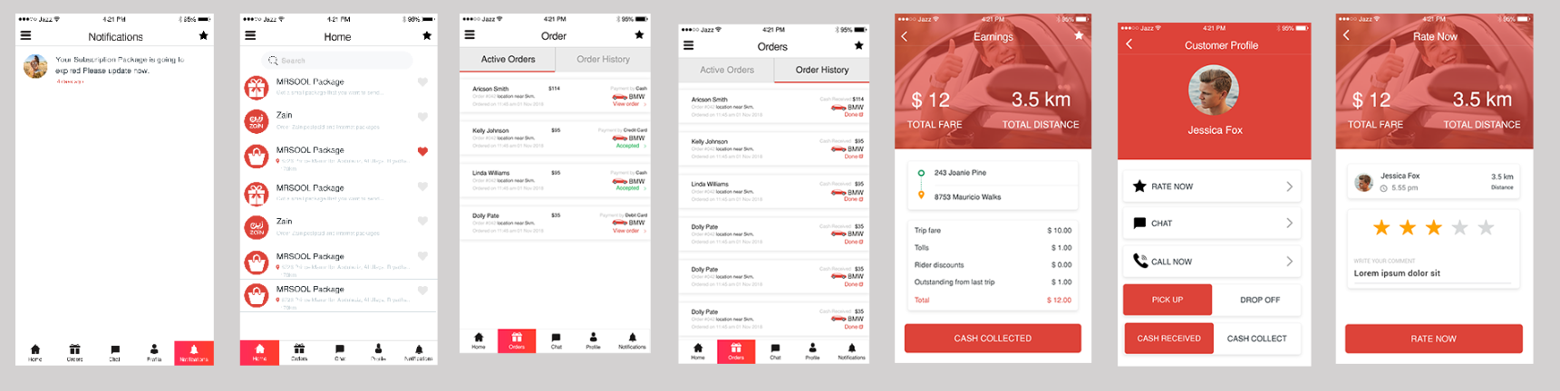

- Admin design 