Banyan Switch A more realistic approach than the crossbar switch is the banyan
switch (named after the banyan tree). A banyan switch is a multistage switch with
microswitches at each stage that route the packets based on the output port represented as
a binary string. For n inputs and n outputs, we have log2 n stages with nl2 microswitches
at each stage. The first stage routes the packet based on the high-order bit of the binary
string. The second stage routes the packet based on the second high-order bit, and so on.
Figure 8.24 shows a banyan switch with eight inputs and eight outputs. The number of
stages is Log₂(8) = 3.

Figure 8.24 A banyan switch
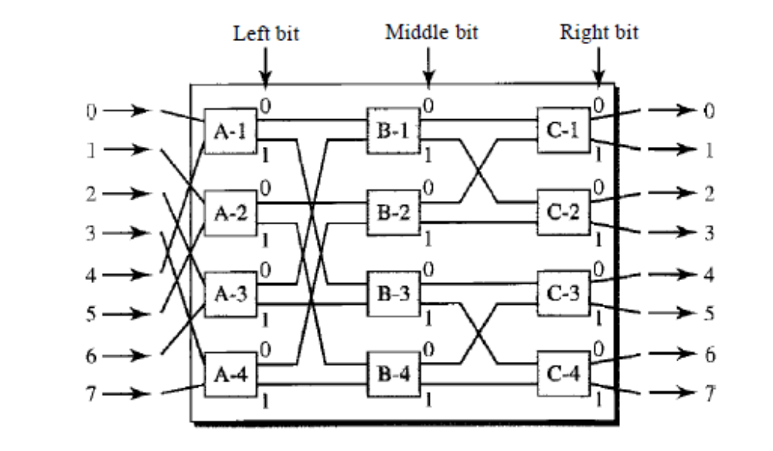
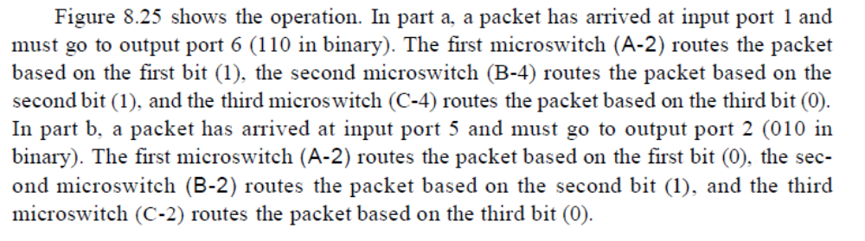
From:


