Data Technician Week 5
Workbook
Azure Data Fundamentals

Name:
Course Date:
Table of contents
Day 1: Task 1 3
Day 1: Task 2 4
Day 1: Task 3 5
Day 2: Task 1 6
Day 3: Task 1 10
Day 3: Task 2 11
Day 3: Task 3 12
Day 4: Task 1 13
Day 4: Task 2 14
1. Scenario Background 14
2. Data Laws and Regulations 14
3. Azure Service Recommendations 14
4. Data Types and Data Modelling 14
5. Data Storage Formats and Structures in Azure 15
6. Additional Considerations 15
Submission Guidelines: 15
Course Notes 18
Additional Information 19

Day 1: Task 1

Please research and complete the questions below relating to key concepts of cloud.

Be prepared to discuss the below in the group following this task.

What can cloud computing do for us in the real-world? | Cloud computing helps businesses through team collaboration. Software such as Microsoft Teams allow teams to communicate across the world. Google Workspace allows users to collaborate on the same document allowing for scaled increase of productivity.  Cloud computing can also be scaled allowing for the purchase or sale of storage dependent on what’s required busier periods may require more storage but during quieter periods this cost can be managed by reducing cloud space.
How can it benefit a business? | Cloud computing reduces the costs on a business. Not having a physical data server reduces costs such as electrical costs of 24/7 use. As well as this, physical servers require an experienced handler to ensure it remains updated which is a highly experienced role that would require a large salary to cover the cost.  Additionally, cloud computing allows for near instant backup of data files. Helping the business retain their data even if there is computer crashes in the business.
What’s the alternative to cloud computing? | The alternatives to cloud computing are: On-Premises Servers, Edge and Fog Commputing and Private Clouds.  On-Premises: managing your own physical hardware.  Edge and Fog: processing data onto smart devices rather than sending over the internet.  Private: running a cloud like system inside a single organisation.
What cloud providers can we use, what are their features and functions? | The three largest cloud providers are: Amazon Web Services, Microsoft Azure and Google Cloud Platform.  (https://www.bmc.com/blogs/aws-vs-azure-vs-google-cloud-platforms/)  Azure and Google have a substantial market share particularly in their domains of Microsoft and the Google services respectively such as: Android and Google Workspace.  AWS has the greatest number of services compared to MA and GCP (250 compared to ~200 and ~200 respectively) such as, AWS providing services in robotics that aren’t provided by the other services. In addition, AWS is considered the gold standard of cloud computing. Whereas, Azure is considered for its much cheaper cost and Microsoft integration.

Day 1: Task 2

Please research the below cloud offerings, explain what they are and provide Introduction to Microsoft Azure Data Core data concepts - Training | Microsoft Learn v
Do core concepts - 22min. Provide 40 mins to do this
examples of use cases.

Cloud Offerings | Explain what it is | When / how might you use this service in the real-world?
IaaS (Infrastructure as a service) | IaaS works by giving the customer the hardware required to run your applications. This still requires the customer to maintain the use of the data themselves. | Iaas allows for the reduction of cost on a business as it allows the storage of your resources without needing to own any of the infrastructure to store it. You would use this as part of your business if you have experienced employees that are fully able to complete the set up and maintenance of these systems.
PaaS (Platform as a service) | PaaS works by allowing the customer to provide their own code onto a platform/application. | A business would use a PaaS system as this streamlines the systems in the business with the cloud computing controlling the servers. This allows the employees the time to and energy into ensuring the code for the systems is correct. This also makes collaboration much easier as teams can work remotely with office workers.
SaaS (Software as a service) | SaaS works by the customer paying for the service of a complete application which is entirely maintained by the cloud. The customer is only responsible for dealing with the data. | A business would use SaaS as this mitigates the need to perform all of the local installations required to set up your systems. This can also be cost effective to the business as subscribing to the software can mitigate the cost instead of purchasing the licenses for the software.

Day 1: Task 3

Please research the below terms and explain what they are, when they would be appropriate and a real-world example of where it could be implemented (i.e. what type of organisation).

Public Cloud | A public cloud is a style of computing model that allows third parties to allow access to shared infrastructure over the internet (https://azure.microsoft.com/en-us/resources/cloud-computing-dictionary/what-is-a-public-cloud). Public clouds are typically across the board able to be used by organisations. For example, smaller businesses can use this to help them scale quickly.
Private Cloud | A private cloud is an exclusive cloud that can be accessed by just one single organisation. The advantage being that this data cannot be accessed by anyone outside of the organisation. Organisations that might use private clouds are ones such as governmental agencies that are dealing with sensitive data that potentially relates to the country. Healthcare such as the NHS would also use this as medical data is highly private and they would have to ensure that this is incredibly secure.
Hybrid Cloud | A hybrid cloud involves the combined use of either private clouds, or on-premises data centres with a public cloud such as AWS. Bank and financial institutions would be the most likely to use a hybrid system as they would potentially use on premises data storage in house to ensure that customer data is secure and that they are compliant with data privacy and GDPR. But also as a financial institution they would also use a public cloud to live analytical data usage especially the stock market.
Community Cloud | A community cloud is similar to a private cloud in which organisations will have their own data centres. However, there is an overarching community cloud in which organisations that have similar goals and achievements will be able to share data with each other. Again, the most likely to use a community cloud would be the NHS as they would have to be able to share their data with potentially other practices across the country or for services such as 111 or 999 so that when necessary a user can get the correct information not from just a single data centre.

Day 2: Task 1

Describe, with examples, the three major areas that the Computer Misuse Act deals with. Cite your sources.

Area | Description | Example
Unauthorised Access | A user gaining access to an others computer system through use of a virus or malware to obtain data. | An example of this is phishing scams. This can be used to obtain login details to access data.
Unauthorised Access with Intent to Commit Further Crimes | A user gaining access to an others computer system through use of a virus or malware to obtain data.  With the purpose of further committing a crime such as fraud, identify theft. | An example of this is obtaining someone’s banking details using malware with the express purpose of stealing finances from the user.
Unauthorised Acts Impairing Operation | This involves flooding a network with multiple requests for an action which can temporarily slow down or even shut down operations. | An example of this is a business being sent a Denial of Service attack which would overwhelm the network with multiple requests which can lock out users.

The Computer Misuse Act 1990 is an act under which an individual can be criminalised for a computer-related offence. Describe three extra powers that the Police and Justice Act 2006 (Computer Misuse) has added. (Cite sources)

Description
One extra power added in this act was to increase the lengths of sentencing on acts in the Computer Misuse Act making the penalties more severe.

Additionally, there was legislation added to explicitly mentions Denial of Service to make this act illegal.

Finally, the legislation on hacking tools was widened making more activities illegal such as obtaining hacking tools, supplying tools for hacking.
(https://www.legislation.gov.uk/ukpga/2006/48/part/5/crossheading/computer-misuse).

Look at the website below to answer the questions:
https://www.gov.uk/personal-data-my-employer-can-keep-about-me

Write down three items of data which a company can store about an employee.
Name
Address
Date of Birth

Give three more examples of data that an employer can only store if they first get the employee’s permission.
Sexual Orientation
Religion
Health and Medical Conditions

Conduct further research to answer the questions below. (Please do your fact-checking and cite sources.)

Question | Answer
Provide one example of: Copyright infringement | Using another creator’s music as the backing sound for content created by yourself without the original creator’s permission.
Provide one example of: Plagiarism | Copy and pasting a quotation from one piece to yours without any citation of where the information was found
What are two consequences of copyright infringement and software piracy? | There are civil penalties. This can include paying the creator financial compensation for lost earnings.  There are also criminal penalties. Such as a maximum penalty of £50,000 or 6 months in prison.
Give three possible consequences for individuals when using pirated software | One is the potential of malware being hidden inside the software files. You are also susceptible to copyright laws which have criminal consequences. Finally, unlicensed software does not get software updates leaving the software susceptible to new malware threats.

Listed below are some laws which we have covered today:

1. Computer Misuse Act 1990
2. Police and Justice Act 2006 (Computer Misuse)
3. Copyright, Designs and Patents Act 1988
4. Copyright (Computer Programs) Regulations 1992
5. The Health and Safety (Display Screen Equipment) Regulations 1992
6. Data Protection Act 2018
7. Consumer Rights Act 2015
- Insert a number in the first column of each row to match each of the statements with one of the above Acts.

- One of the statements is incorrect and not illegal. For this statement, write ‘Not illegal’.

Act number | Clause
1 | With some exceptions, it is illegal to use unlicensed software
7 | Any product, digital or otherwise, must be fit for the purpose it is supplied for
2 | Unauthorised modification of computer material is illegal
Not Illegal | It is illegal to create or use a hacking tool for penetration testing
6 | Personal data may only be used for specified, explicit purposes
5 | Employers must provide their computer users with adequate health and safety training for any workstation they work at
1 | It is illegal to distribute hacking tools for criminal purposes
3 | It is illegal to distribute an illicit recording
6 | Personal data may not be kept longer than necessary
1 | Gaining unauthorised access to a computer system is illegal
5 | Employers must ensure that employees take regular and adequate breaks from looking at their screens
2 | It is illegal to prevent or hinder access (e.g. by a denial-of-service attack) to any program or data held in any computer
7 | Personal data must be accurate and where necessary kept up to date

Day 3: Task 1 – Lab 1

Please complete the lab - Your tutor will guide you

Completed lab | 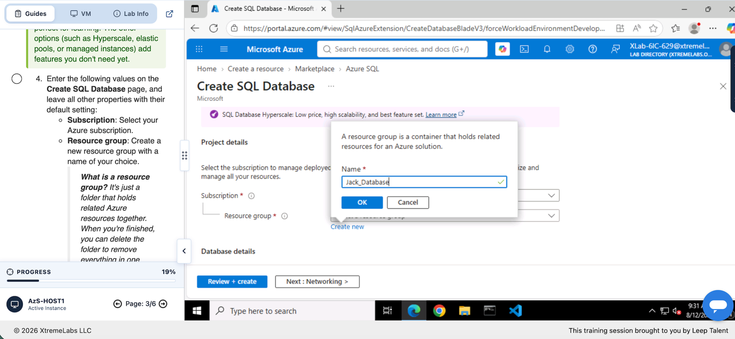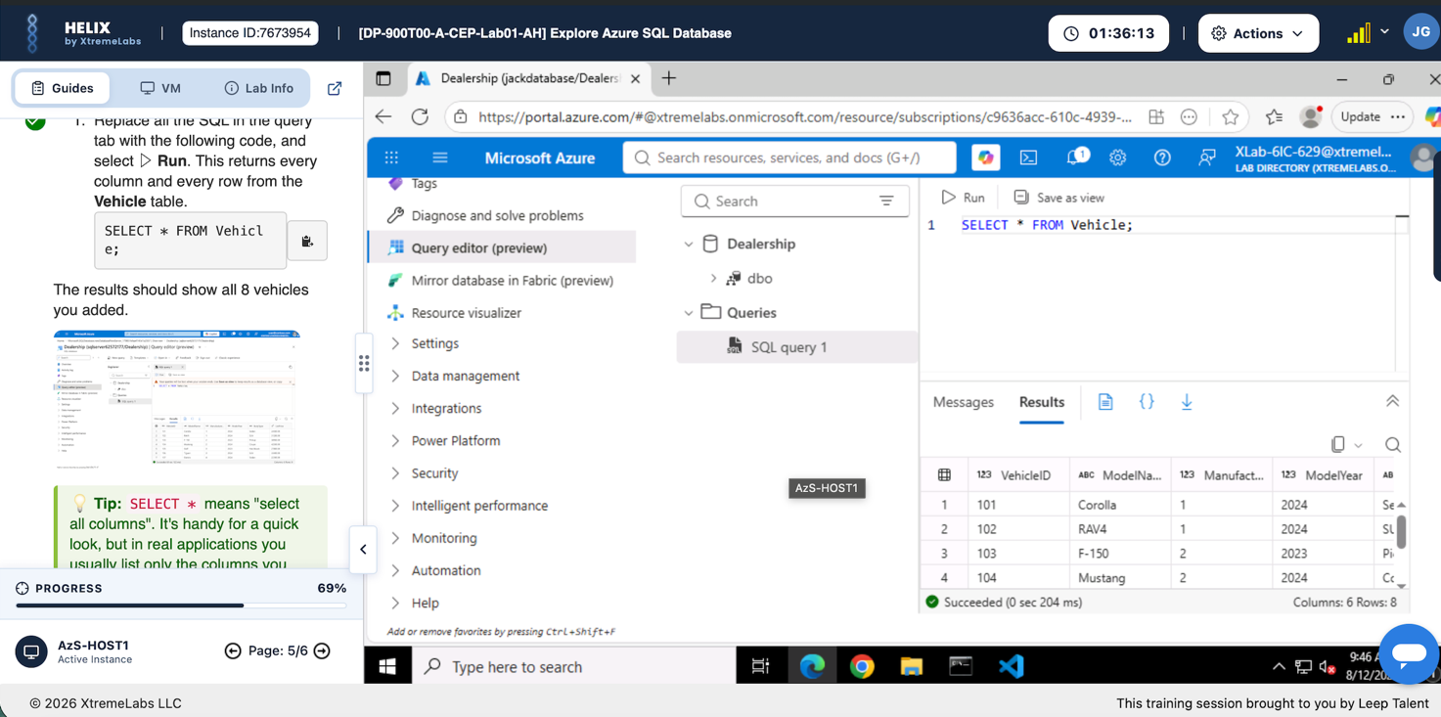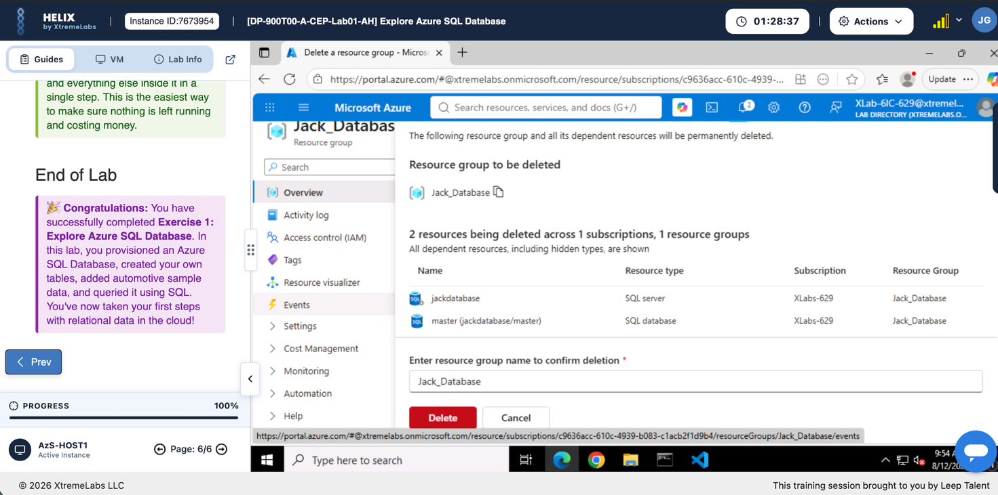

Day 3: Task 2 – Lab 2

Please complete the lab - Your tutor will guide you

Completed lab | 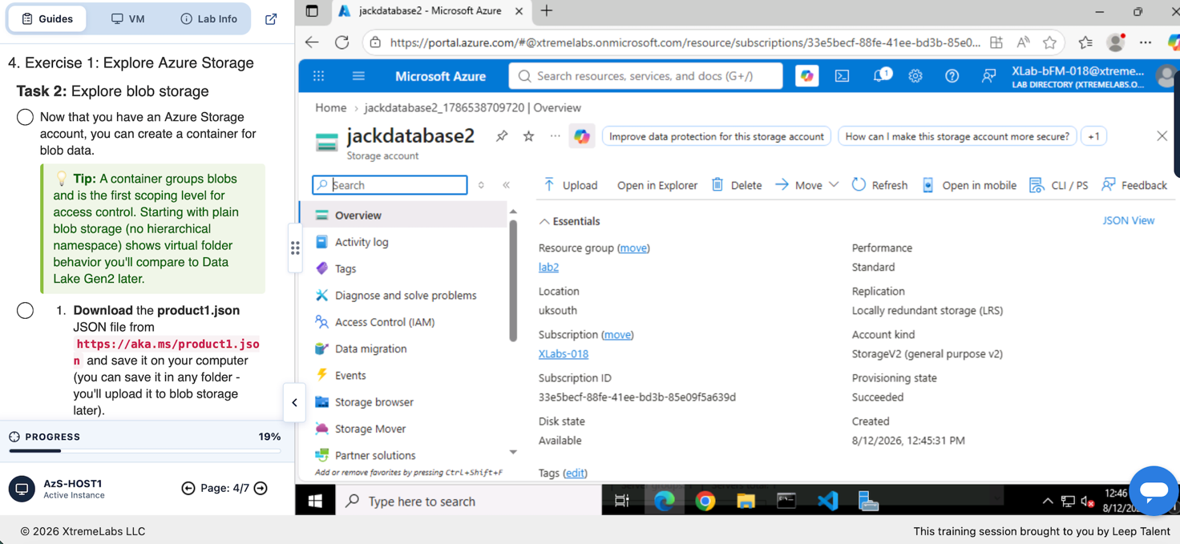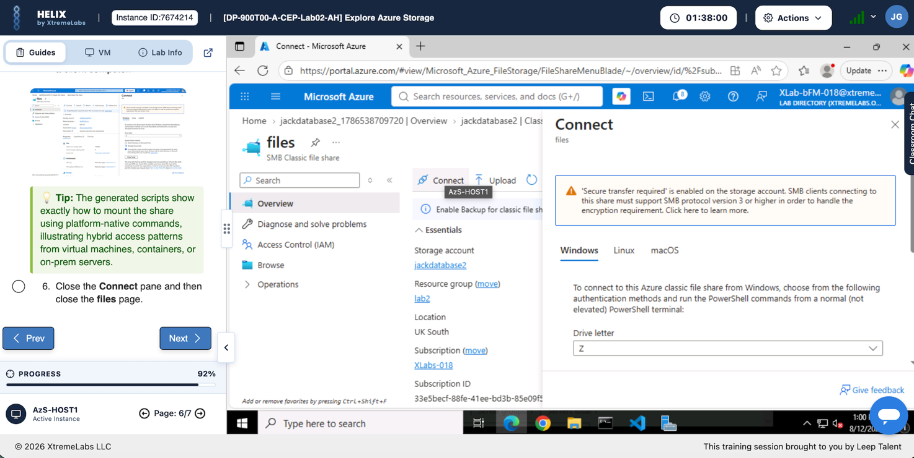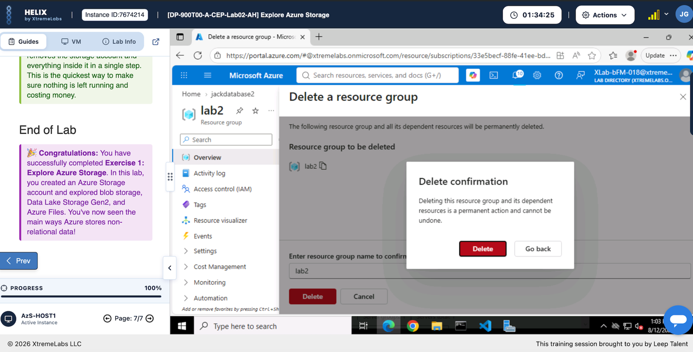

Day 3: Task 3 – Lab 3

Please complete the lab - Your tutor will guide you

Completed lab | 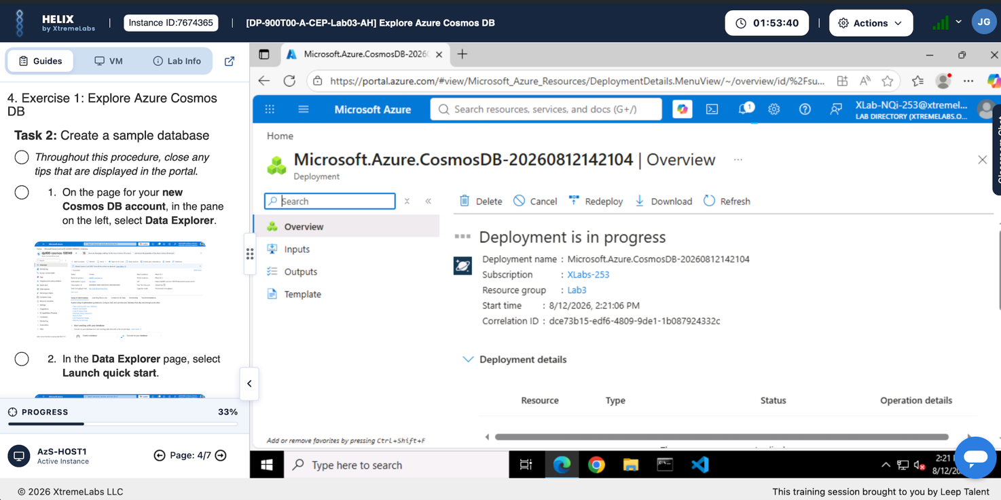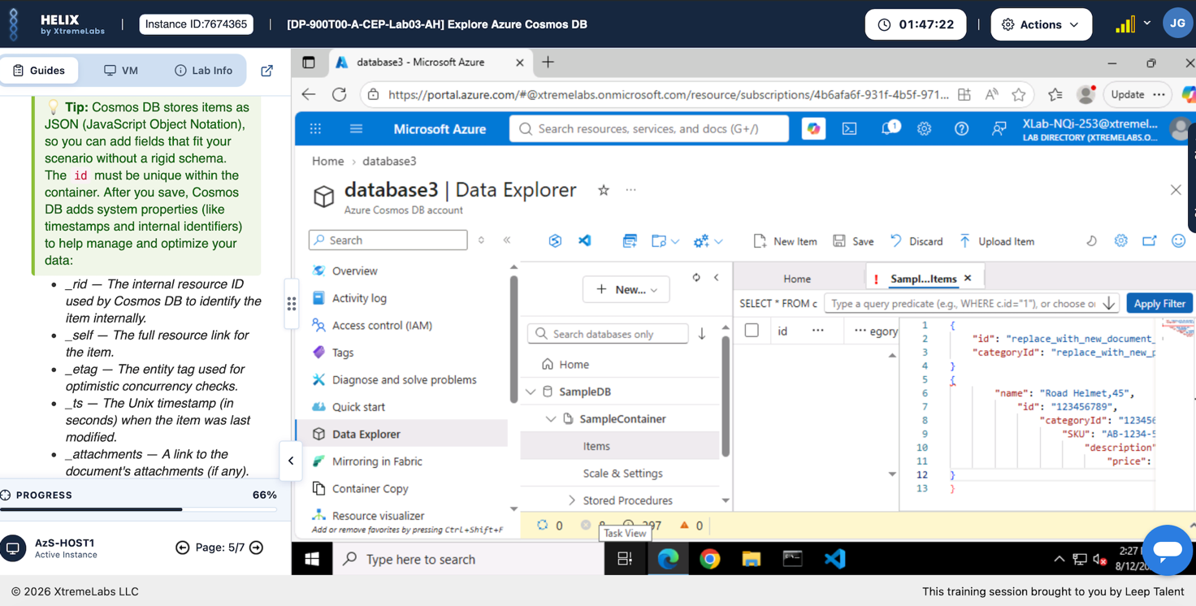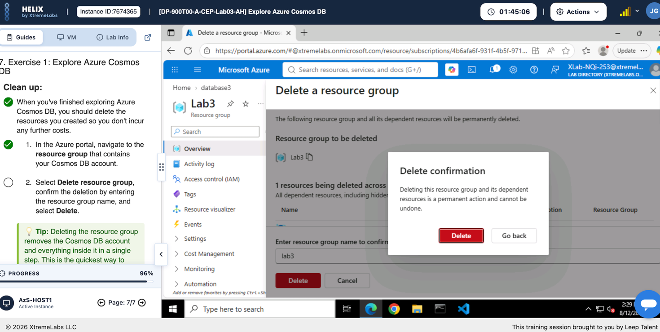

Day 3: Task 4 – Lab 4

Please complete the lab – Your Tutor will guide you.

Completed lab | 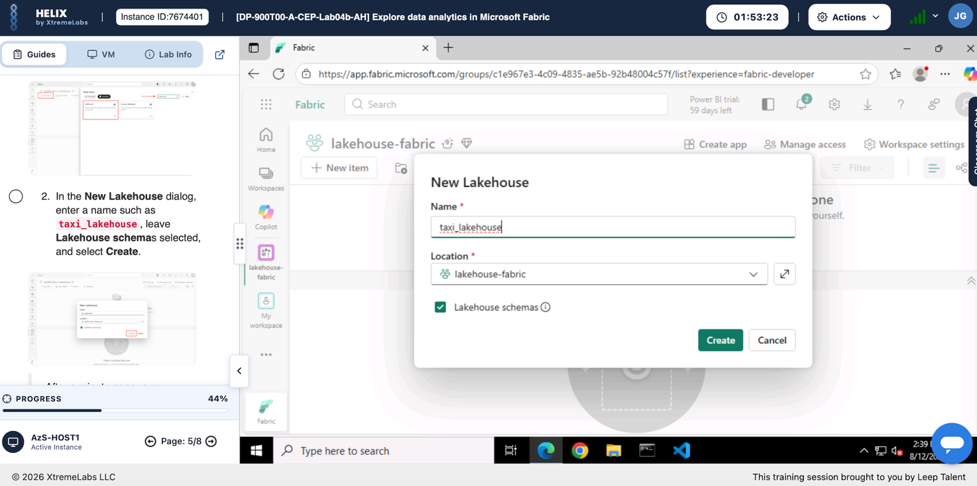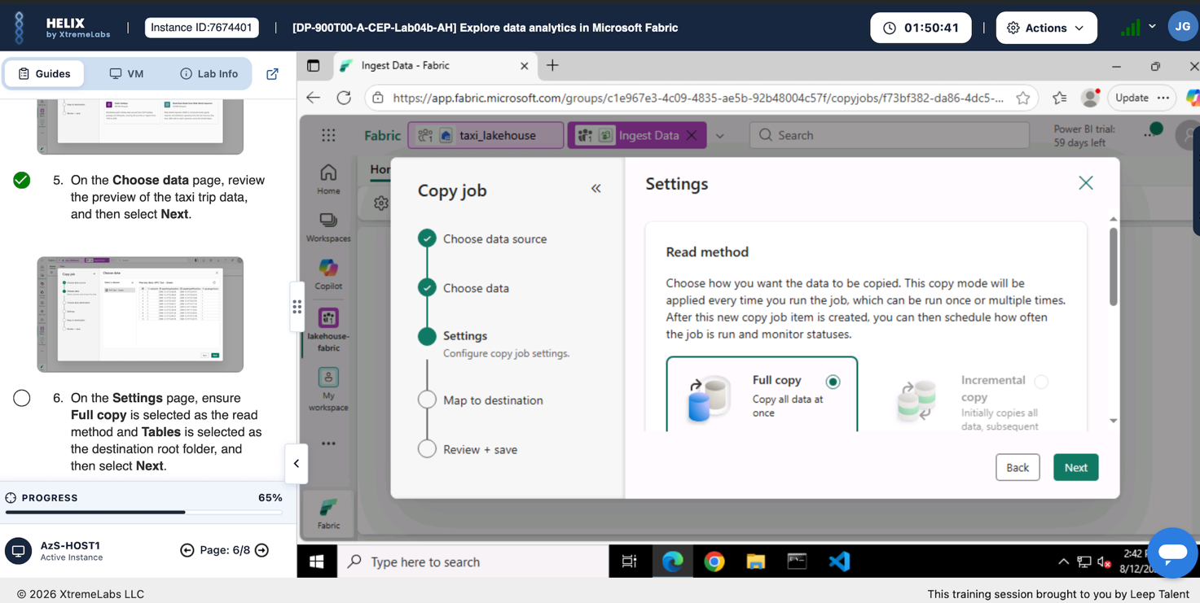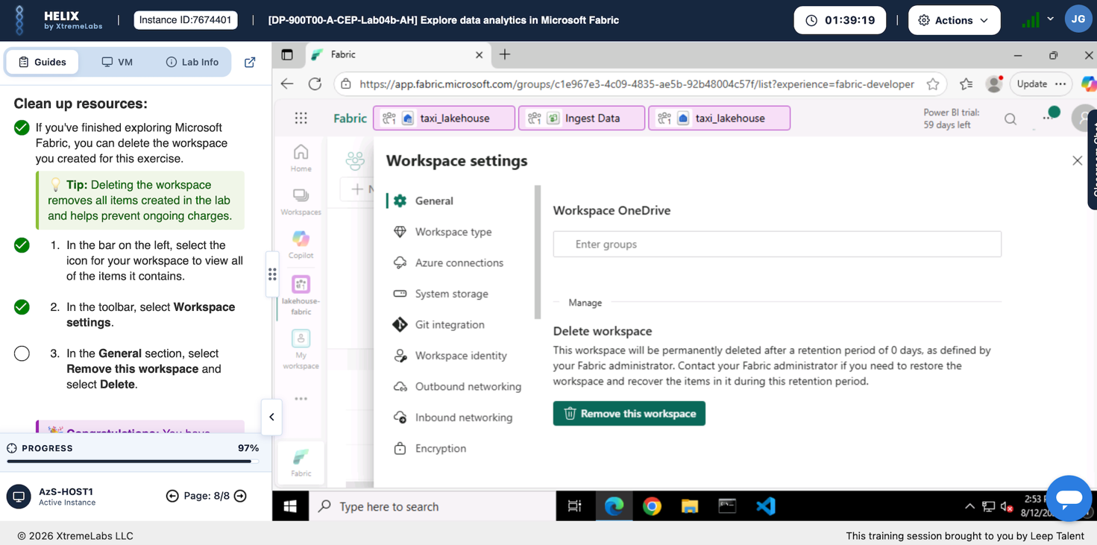

Day 4: Task 1 – Lab 6

Complete Lab – Your tutor will guide you.

Result | 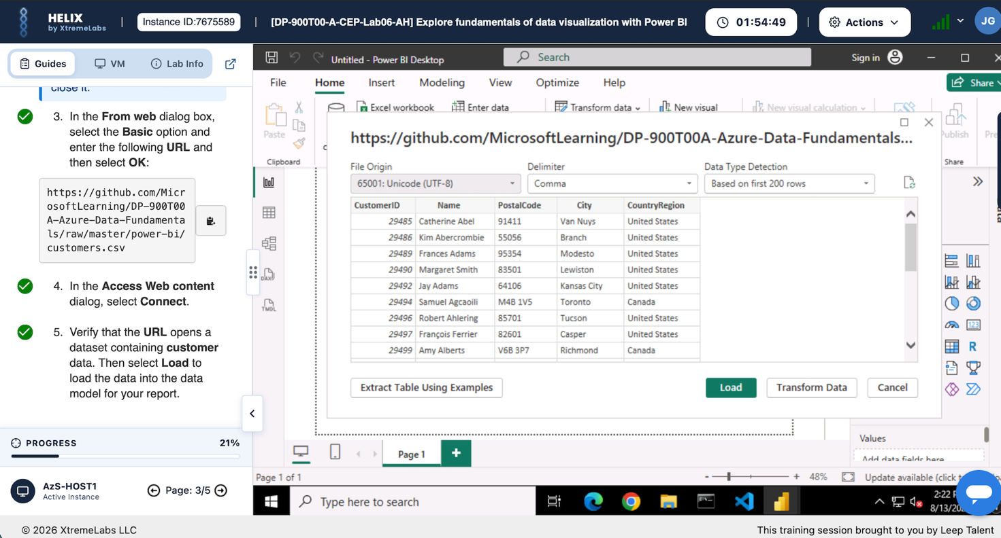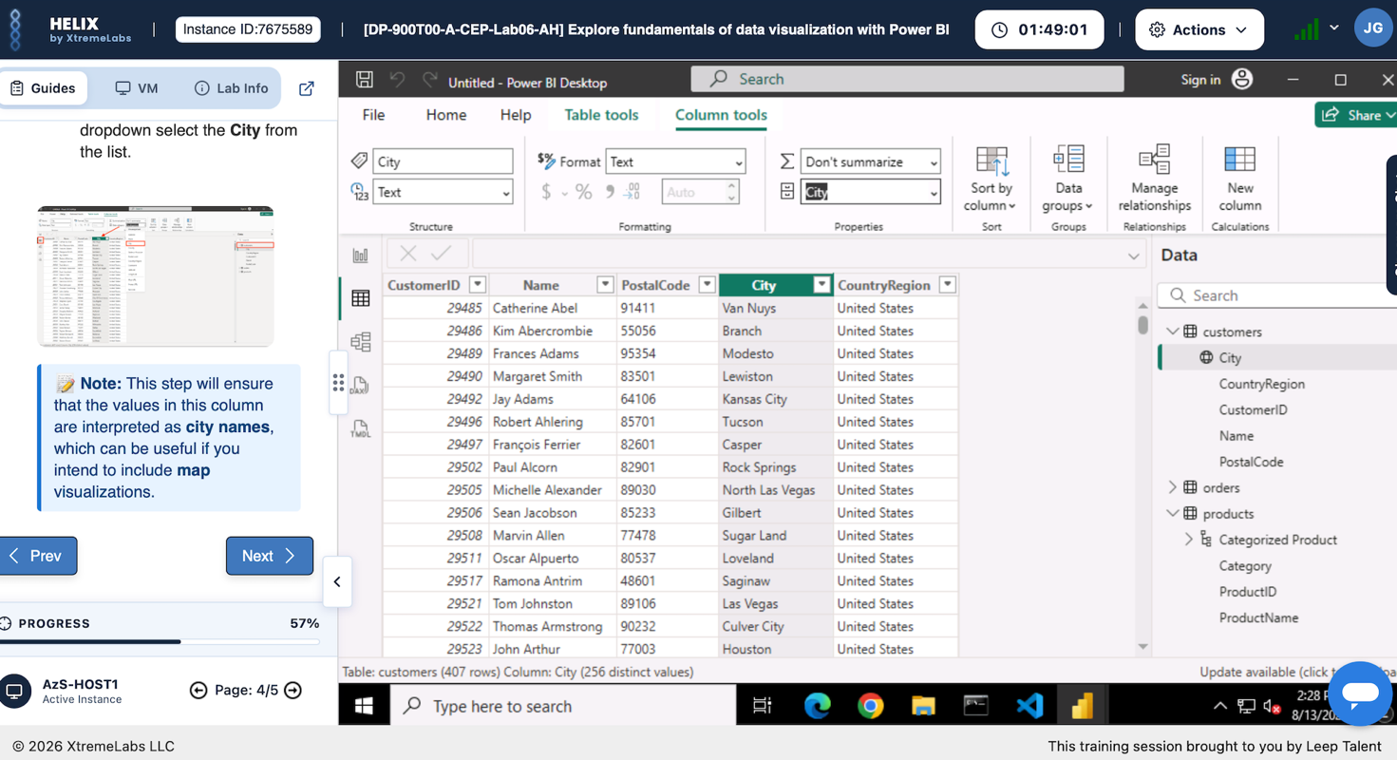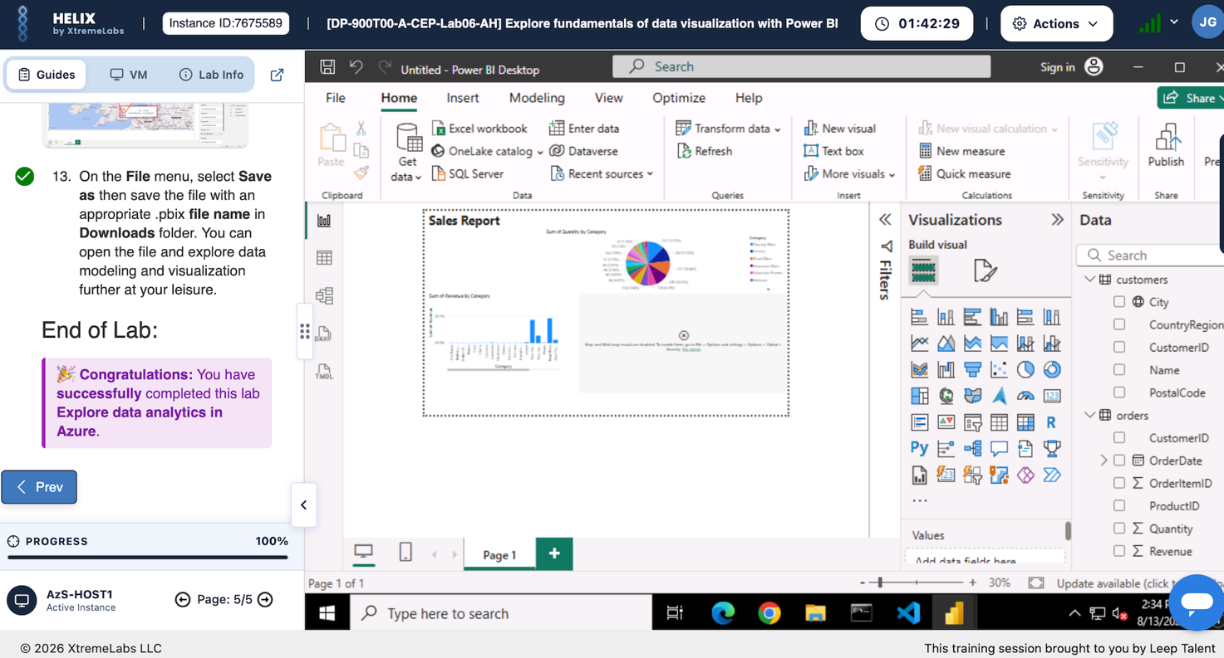

Day 4: Task 2

1. Scenario Background
"Paws & Whiskers" is a growing pet shop that aims to improve its business by analysing sales, customer information, and inventory data. Currently, the data is collected manually or stored in spreadsheets. Management is interested in transitioning to Microsoft Azure to streamline data storage, analysis, and reporting, enabling them to make data-driven decisions.

2. Data Laws and Regulations
Identify and explain the data laws and regulations relevant to handling customer data within the proposal. Ensure you cover the following points:
- GDPR Compliance: Highlight the importance of adhering to the General Data Protection Regulation (GDPR), particularly as it relates to storing and processing customer information.
- Data Protection Act (DPA) 2018: Outline how the DPA 2018 may affect the way "Paws & Whiskers" collects and stores data, ensuring compliance with UK laws on data privacy.
- Other Industry Standards: Research any additional data protection standards or regulations that may apply to pet shop data, particularly if they involve sensitive or payment information.

3. Azure Service Recommendations
Recommend Microsoft Azure services that would suit the company’s data analysis needs and explain why these services are suitable. Your recommendations should include:
- Data Storage: Identify suitable storage options, such as Azure Blob Storage or Azure SQL Database, and discuss the benefits of each for storing large datasets, including inventory, sales transactions, and customer details.
- Data Analysis Tools: Recommend tools such as Azure Machine Learning for customer behaviour analysis or Azure Synapse Analytics for analysing sales trends.
- Data Integration and Automation: Explain how services like Azure Data Factory could automate data collection and integration processes, improving efficiency.

4. Data Types and Data Modelling
Define the types of data "Paws & Whiskers" will need to work with and describe your approach to data modelling:
- Data Categories: Identify key data types, such as customer demographics, transaction history, pet inventory, and product categories.
- Data Modelling Approach: Outline how you would structure this data using a relational model or a data warehouse approach, considering factors like tables, entities, relationships, and primary keys.

5. Data Storage Formats and Structures in Azure
Discuss how you would store data within Azure and the formats you would recommend:
- Data Formats: Specify recommended formats (e.g., CSV for raw data imports, JSON for structured data, Parquet for analytics) and explain why these formats are suitable for specific data types.
- Data Security and Encryption: Include recommendations for securing data using Azure’s built-in encryption features and access controls to ensure compliance with data privacy regulations.

6. Additional Considerations
Provide any other considerations that might enhance data handling and efficiency in Azure, such as:
- Backup and Disaster Recovery: Outline a backup plan using Azure Backup or Azure Site Recovery to safeguard against data loss.
- Data Visualisation: Discuss the potential use of Power BI within Azure for creating dashboards that provide management with real-time insights into sales and customer trends.
- Future Scalability: Comment on how Azure services can scale as the business grows, accommodating larger datasets and more complex analyses.

Submission Guidelines:
- Structure: Ensure your report is well-organised, with sections for each task (e.g., Data Laws, Azure Services, Data Types, etc.).
- Formatting: Include headings, bullet points where appropriate, and any visuals or diagrams that support your explanations.
- References: Cite any resources or regulations referenced in the report.
- Length: Aim for 1500-2000 words.
- Undertake your fact-checking and cite your sources

Paws & Whiskers Moving to Microsoft Azure

Paws & Whiskers is an ever-expanding pet shop that is looking to transition to using Microsoft Azure to perform data insights. This will be an impactful transition as the business is currently managing its data using spreadsheets. Due to the limitations of spreadsheets to continue expanding moving on from using spreadsheets is a top priority.

With this move to Microsoft Azure the business will be transitioning to a cloud-based system which will enable them to perform analysis and reporting of their data and composite large scale data storage. Allowing for the highlighting and viewing of data visually that can easily be used to make business decisions using this data.

Data Laws and Regulations

General Data Protection Regulations

GDPR is described as any type of data that can be used either directly or indirectly to personally identify an individual (Goddard, 2017). It is important as it ensures that obtainees of such pieces of data highlight strong transparency and openness as well as explicit and clear consent of the individual (Goddard, 2017). For severe violations of GDPR up to 20 million Euros fine can be applied to a business, or 4% of their total global turnover (gdpr-info.eu).
- Transparency from the business is paramount. Customers must be informed of how their data would be used by the business. As well as this, customers will have to right view and delete any inaccurate data that the business may be storing.
- Data Minimisations of customer is also paramount. The business will only be able to store the most necessary data concerning its customers such as: names, e-mail addresses etc.

Data Protection Act (2018)

The data protection act is an act for the regulation of the processing of data of an individual (legislation.gov.uk). This act ensures individuals have the right to privacy of their personal data from any other individual without their consent. For breaches of the Data Protection Act up to £8.7 million or 2% of total turnover of the business can be given as fines for any breaches (ico.org.uk).
- Unauthorised access is of strong importance to remain compliant with the Data Protection Act. Therefore, the transition to Microsoft Azure will ensure that through use of its built-in security that customer data remains safely stored.

Azure Service Recommendations

Data Storage

Data storage on Microsoft Azure can be provided in two separate ways: Azure Blob Storage and Azure SQL Databases.

Advantages of using Azure Blob Storage are:

- Blob storage is massively scalable allowing for mass storage of data types such as text, binary files, customer documents and digital receipts.
- Blob storage is incredibly cost efficient as tiering options can be accessed (hot, cool, archive)
As Azure Blob Storage is more effective at storing unstructured data it will be more accommodating to large data files such as images, and reports as well as other visualisations. (https://azure.microsoft.com/en-gb/products/storage/blobs).

Advantages of using Azure SQL Database are:

- The use of automatic backups ensures that all databases are backed and therefore your data cannot be lost.
- Azure is cloud-based software therefore work can be performed from anywhere with an internet connection.
- Additionally, Azure is automatically updated therefore you can be sure that your data is always being processed on the latest software.
SQL Databases work well with relational databases which makes them a great choice when dealing with customer information, transaction data, pet products and inventory. (https://www.softensity.com/blog/benefits-and-features-of-azure-sql/#:~:text=Azure%20SQL%20Database%20leverages%20all,about%20maintenance%20or%20potential%20outages).

Data Analysis

Azure Synapse Analytics:

Synapse Analytics allows for the cleaning and shaping of large datasets into SQL or python. Also allowing for the querying of data inside of data lakes without having to move the data.

Advantages of Synapse Analytics:
- Powerful data analysis – can support complex queries and analytics allowing for the identification of patterns and trends in the data.
- Business Intelligence – can be linked and used in conjunction with Power BI enabling the user to create visualisations and reports.
- Decision Making – allows businesses to turn very large datasets into information that can be detailed to staff concisely.
(https://www.existbi.com/blog/azure-synapse-analytics-worthwhile/)

Azure Machine Learning:

Azure Machine Learning allows for the building and test of learning models as well as aiding in the fine tuning and deployment of these models.

Advantages of Machine Learning:
- Monitoring of Models – has access to the tools to monitor deployed models.
- Automated Machine Learning - has the capacity to automatically test multiple different algorithms and being able to find the most suitable.
(https://www.geeksforgeeks.org/machine-learning/what-is-machine-learning/)

Data Integration and Automation

Azure Data Factory

Advantages of Data Factory:
- Utilises a drag and drop system so code writing skills aren’t as necessary.
- Automatically processes incoming data from more than one source.

Data Types and Data Modelling

Data Categories

The data that Paws & Whiskers will have to collect for the business will be split into four areas.
- Customer Information – Customer names and contact information such as: phone, email addresses.
- Transactions – Date of purchase, which items were purchased.
- Pet Products – Pet food, pet toys, pet accessories.
- Inventory – Breeds/types of pets, stock levels, availability.

Data Modelling Approach

A relational database would be best to use to effectively store data for Paws & Whiskers. This relational database will be split into four tables:
- Customers Table
Fields: CustomerID (Primary Key), Name, Email, Phone_Number
- Transactions Table
Fields: TransactionID (Primary Key) CustomerID (Foreign Key) Date, TotalAmount
- Products Table
- Fields: ProductID (Primary Key) CategoryID (Foreign Key), Name, Price, StockAmount
- Categories Table
Fields: CategoryID (Primary Key), Name;

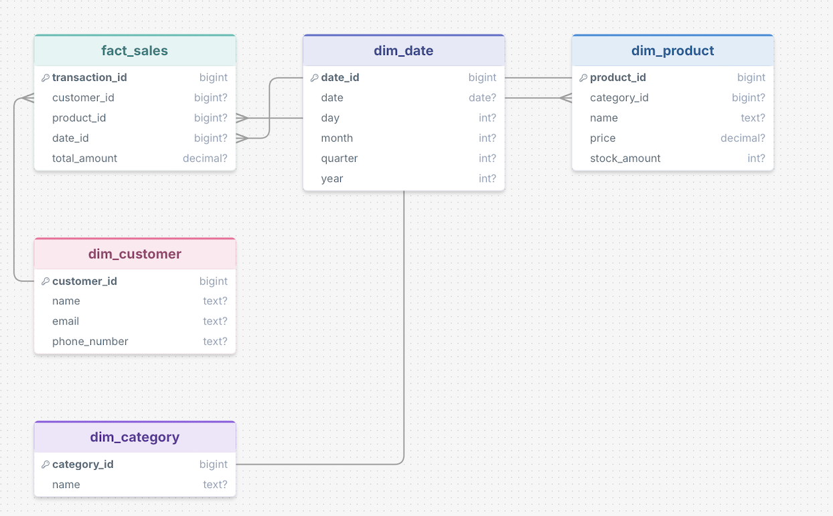

Data Storage Formats and Structures in Azure

Data Formats

- JSON – The best data type to be used structured data. In addition, JSON in much faster to process its syntax and is flexible in its integration with schema especially in SQL Databases.
- CSV – CSV is universally compatible with all systems allowing for ease of access. In Addition, CSV allows for raw data to be wholly viewable and readable further showing its ease of use.

Data Security and Encryption

Paws & Whiskers will have to ensure that compliance with GDPR and the Data Protection Act is followed. The best way to achieve this is encryption of its data so that only people with the correct access will be able to access and manipulate this data.

Microsoft Azure ensures protection of its data through use of 256-bit AES encryption for its data. Data that is being moved across networks is safely distributed owing to TLS protocols ensuring the protection of data.
- Azure also gives access to Platform-Managed Keys. These allow Microsoft to oversee the creation of keys as well as managing these keys.

Additional Considerations

Backup and Disaster Recovery

Azure Backup:

Azure Backup is software that intuitively secures your data and workbooks through the creation of backups protecting your data from deletion, crashes or even cyber-attacks.

Advantages of Azure Backup:
- Easy to Automate – Microsoft Backup allows users to create policies that ensure regular backups are routinely made further enhancing confidence in data safety.
- Multiple Recovery Options – Backup allows for the retrieval of individual files or even large datasets. Allowing for any amount of data to be retrievable.
(https://azure.microsoft.com/en-gb/products/backup)

Azure Site Recovery:

Azure Site Recovery is an automatic process that performs the continuous replication and recovery of physical servers and virtual machines. (https://learn.microsoft.com/en-us/azure/site-recovery/site-recovery-overview).

Advantages of Azure Site Recovery:
- Disaster Recovery – Allows business to be able to recover servers after dealing with failures.
- Minimises Downtime – Due to the routine backups that are confirmed throughout the software servers can be quickly returned so that staff can continue to work.

Data Visualisation

Power BI allows for visualisations to be created that are interactive and visually pleasing. Displaying information like customer purchase trends, stock inventory levels and sales performance in real time. It also allows for KPI’s (Key Performance Indicators) to be tracked and displayed visually which can aid in really displaying the data in concise ways in which the business can make its decision on moving forward.

Future Scalability

Microsoft Azure is an incredibly flexible software and therefore Paws & Whiskers will be able to further increase its scalability and grow more as a business.

- Expandable Storage – The use of Blob Storage and SQL Databases can easily scaled to ensure the databases can accommodate the levels of data through peaks and troughs of the business enabling the business to manage costs effectively.

With Microsoft Azure this potential scalability will allow the business to grow outside of its region and has the potential to scale the business nationwide or even internationally. However, with this the business should note the viability of the systems scalability only ensure it aligns with the customer base it currently has.

Conclusion

Due to the ever-growing data market, the competitiveness between businesses has risen over the last few years. Therefore, there is a growing need move to more technical systems to streamline data collection and evaluation. As stated above, a move to Microsoft Azure will allow the business to effortlessly scale their data needs for any influxes of data collected. Services like Synapse Analytics can enable the business to visualise and gain insights on the trends shown throughout the business which can be used to evaluate future directions for the business. Finally, the robust security features that are available for use with Microsoft Azure will allow for the confidence that as a company you are remaining GDPR compliant and all of Azure’s collaboration tools will allow for the continuation strong data management across systems.

Course Notes

It is recommended to take notes from the course, use the space below to do so, or use the revision guide shared with the class:

Additional Information

We have included a range of additional links to further resources and information that you may find useful, these can be found within your revision guide.

END OF WORKBOOK

Please check through your work thoroughly before submitting and update the table of contents if required.

Please send your completed work booklet to your trainer.

