Problem 1

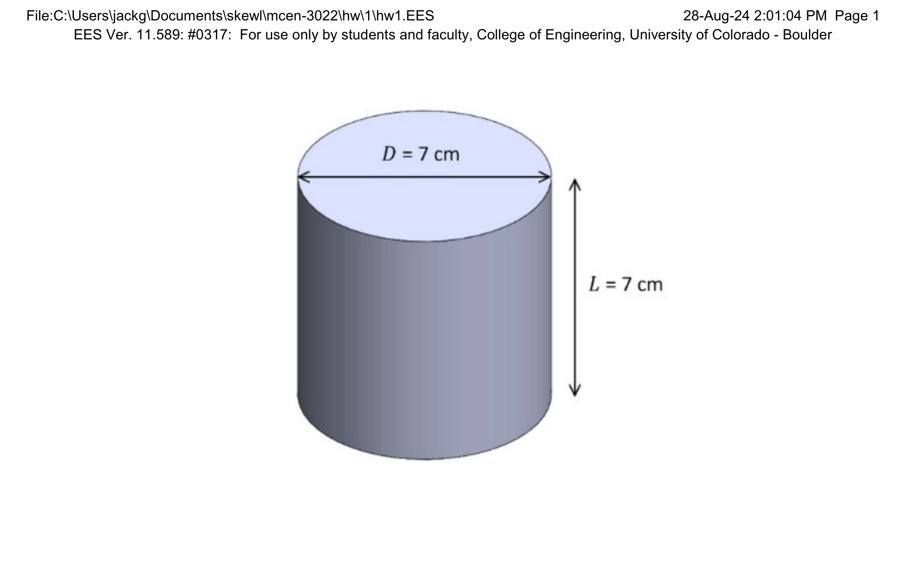
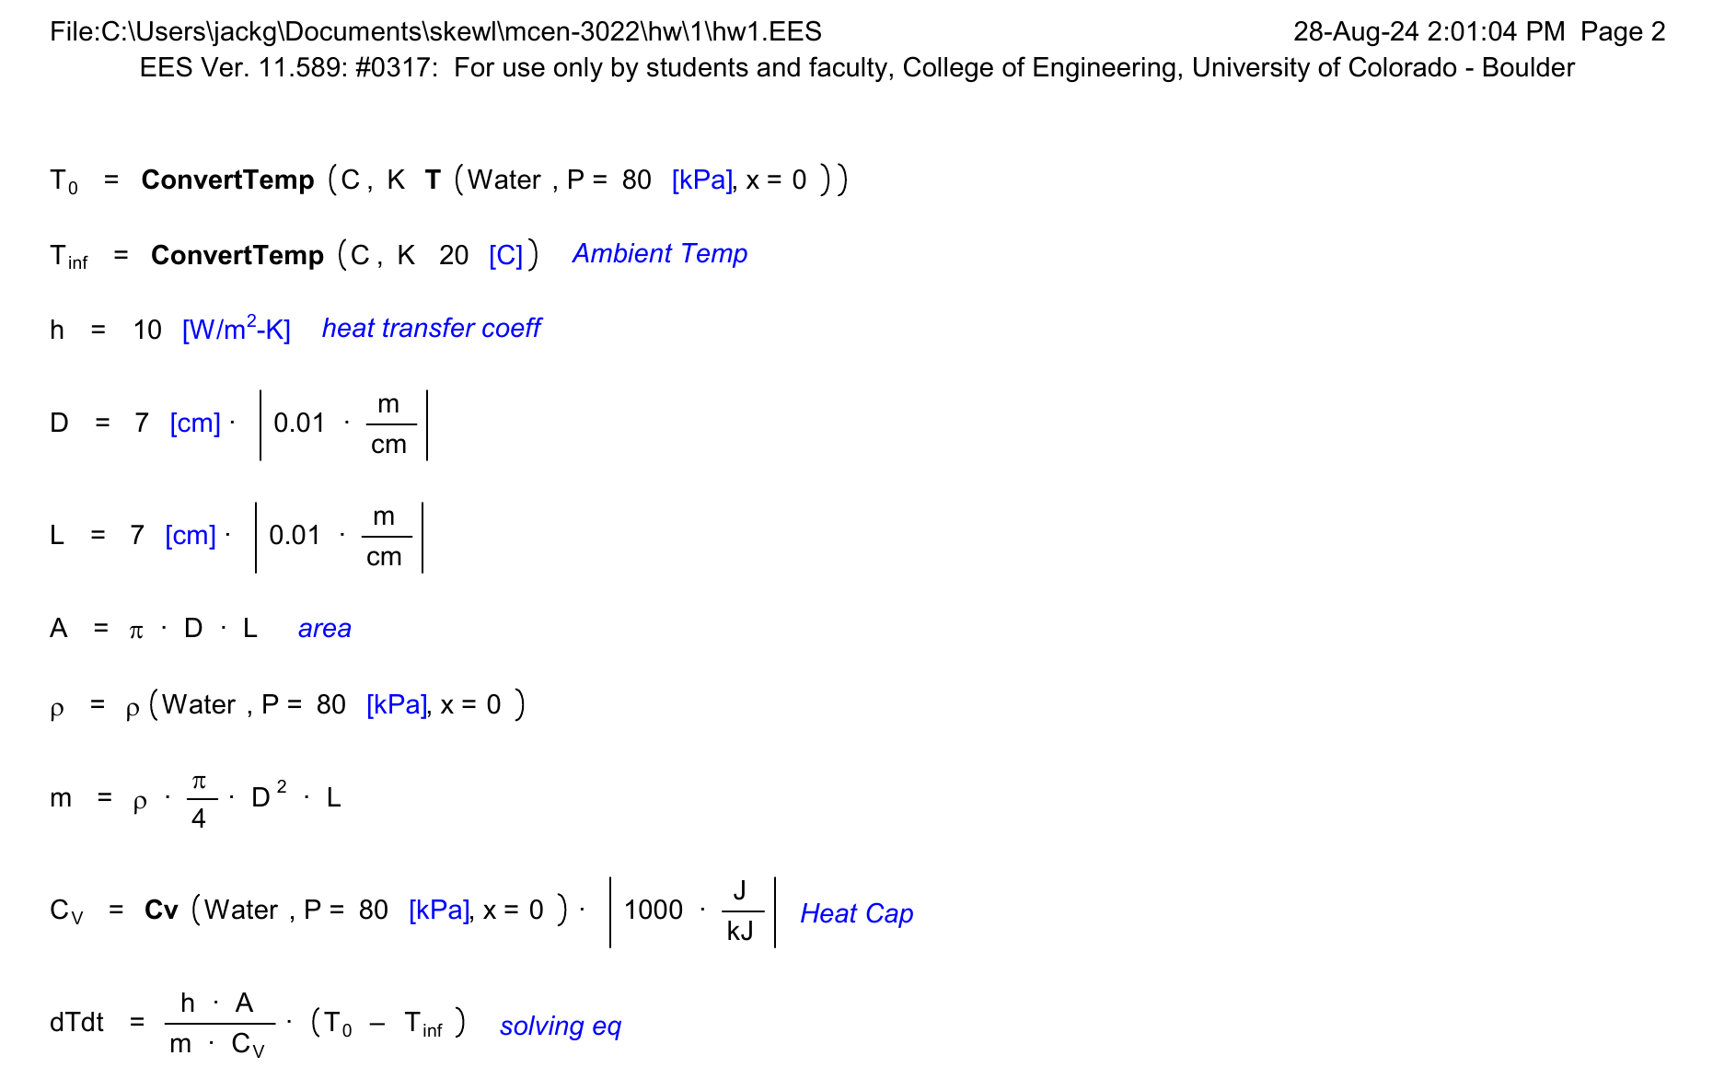
EES Results:
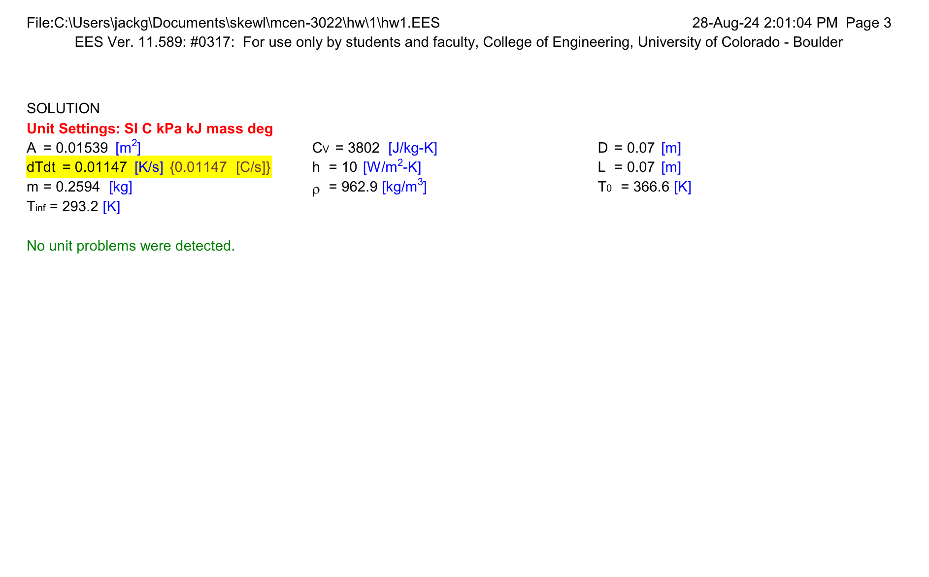
PROBLEM 2

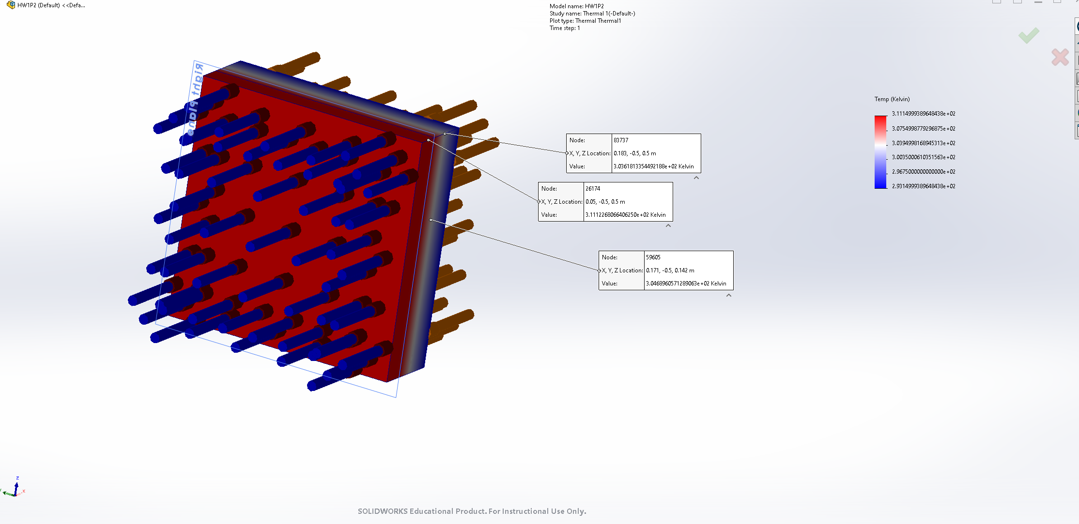
simulation:

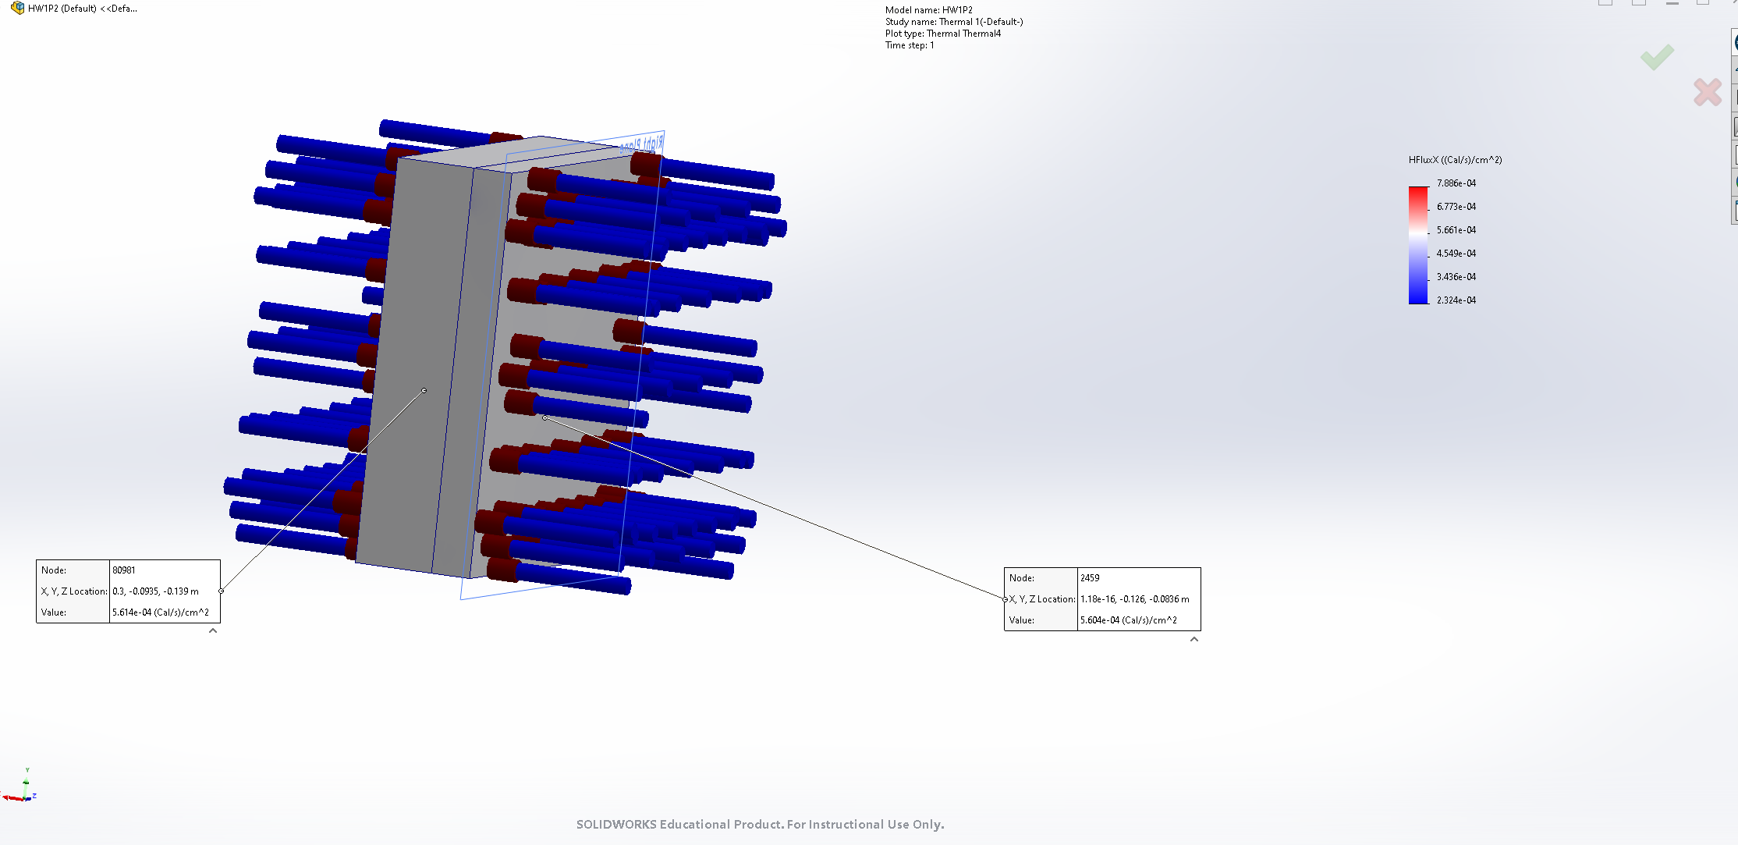
Flux:
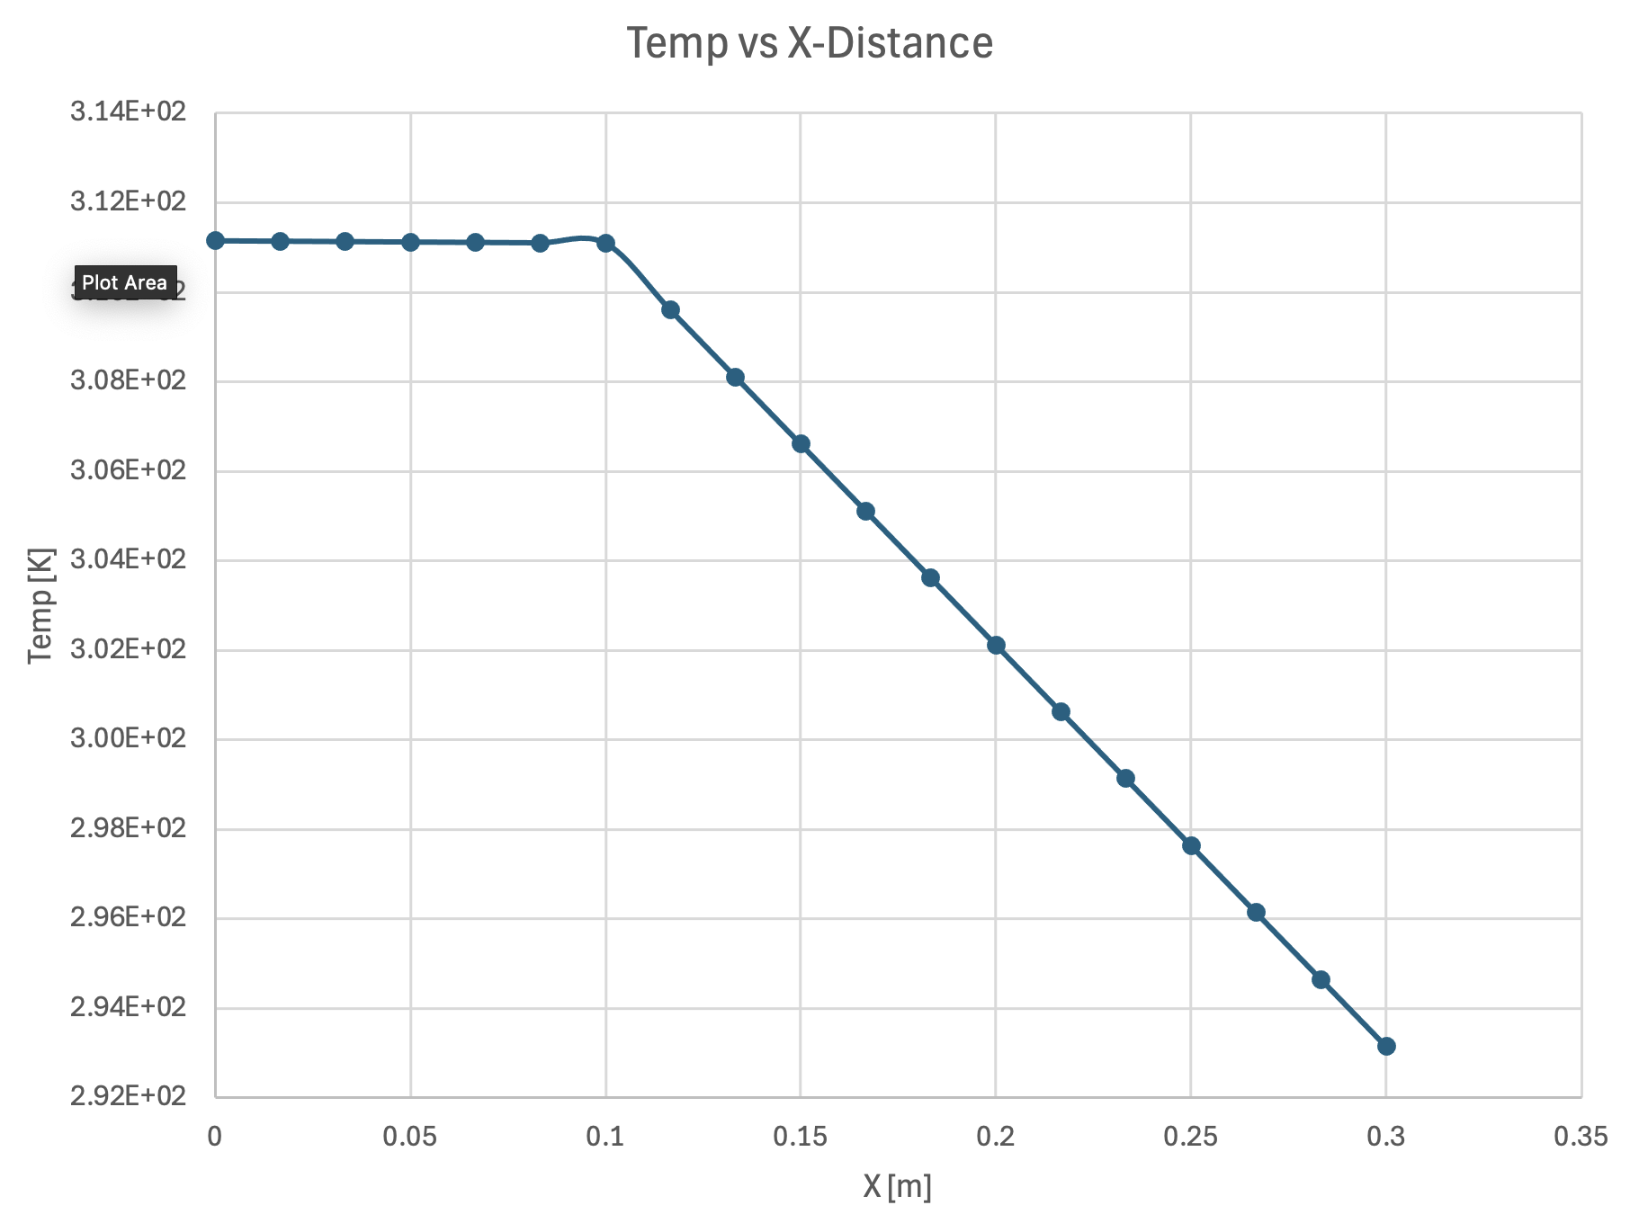
Graph:

Explanation:

Different materials have different heat-capacities/specific-heat values that affect the rate at which temperature changes. The slope is near flat for the steel because of its high Cv value.

