CIS 9 - Sample questions for midterm 1

Numpy

1. What is the output?

arr = np.zeros((4,2))

print(arr[-1])

2. Write code to print the first, middle, and last element of a numpy array

3. Explain what this prints: print(arr[arr%2==0])

4. You have an array of one year or 365 average daily temperatures,in degree Celsius.

Convert them to Fahrenheit. The formula is: F = (C x 9/5) + 32

5. In the array above, find the index of the highest temperature.

6. What is the output?

arr = np.array([[1,4], [7,-1],[2,5]])

print(np.median(arr, axis=0))

Pandas

Given the following DataFrame named gb, with the first few rows shown but there are many other rows:

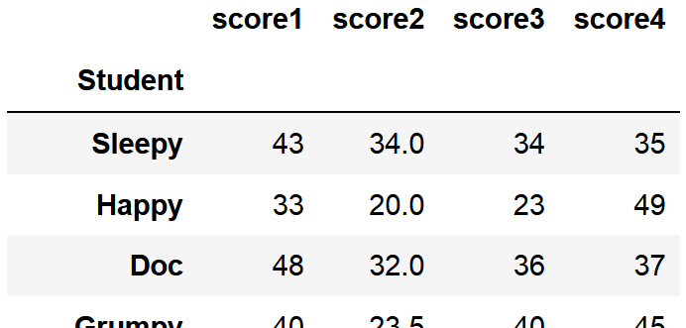

1. Print Happy's scores

2. Find the mean of score4

3. Explain what this prints: print(gb.max())

4. Change Doc's score4 to 50

5. Explain what this prints: print(gb[gb.score1 > 45].score1)

Matplotlib

1. Given the gb DataFrame above, you want to know whether score1 is generally better or worse than score 2.

Write code to create a plot that compares the 2 scores.