# Wigner-Smith ACA Testing

## Unit Testing of ACA routines

* Scattering Matrix
  + Tested against analytical matrix for sphere with spherical wave incident
  + Properties of S matrix
    - Unitary, symmetric
* Scattering Matrix derivative
  + Unit tests mimicking routine
  + Unit tests comparing to finite difference derivative
* WS Matrix
  + Tested against alternate formulations
  + Testing properties of Q and decomposed Q
* Solving at WS Mode
  + Agrees with when not using ACA

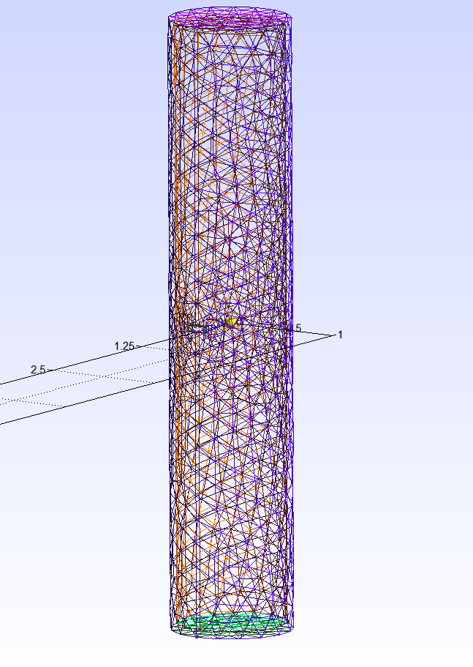

Unit tests all pass, but when I run a slotted cylinder, GMRES is not converging for most computations of columns of Js in the calculateScatteringMatrix routine using the radius 0.5 and height 5 cylinder. I need to step back now. I am going to run the big slotted cylinder with a much larger slot, lowering the Q and hopefully making GMRES converge more easily.

Could also go wring using iterative solver on dense matrix

## Test 1: Lower Q sphere single solve

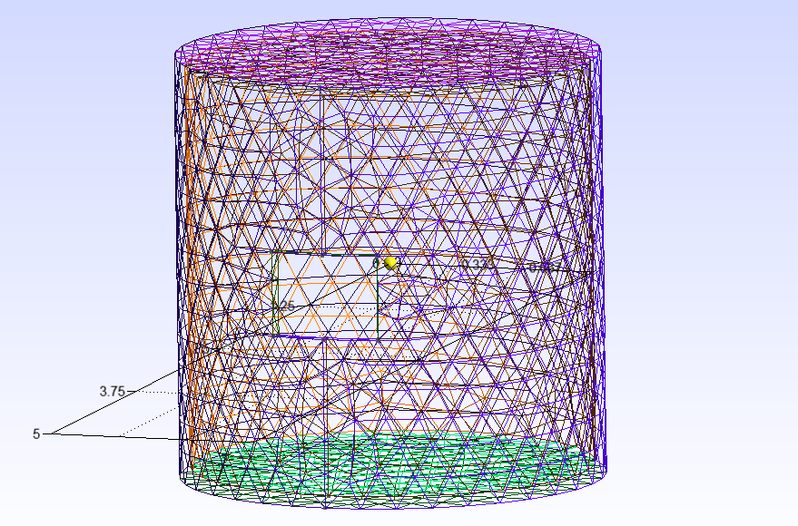

Run the radius 1 height 2 cylinder with the large slot with a spherical excitation of lowest allowable lambda. This mesh has 3436 elements making it capable of running with and without ACA so I can compare results. For this test I am forgoing WS modes and just going to run with a predefined spherical wave input with lambda = 1.62. Full run details are in Test1/slotted_cylinder_ACA_test1.txt. All tests involve Sound-Soft IE.

Results show visual agreement between using ACA and not using ACA. Also the ACA algorithm converged so this is expected.

## Test 2: Varying excitation

Following the success of test 1, I now want to change l and m of the spherical wave to see if that causes problems as well as change the wave’s amplitude to be 2*k like done in computing the scattering matrix.

At this point, if the ACA run shows convergence in running GMRES, I will refrain from running the problem without ACA.

See run files 1-3 for the exact tests ran here, but they all were able to converge to solutions that visually look valid.

## Test 3: Solve at WS Mode

Now it is time to test running at a WS mode using the big slotted cylinder of the previous two tests.

This runs fine, but there time delay, at largest, is still negative which tells me no energy is coupling into the cylinder. I need to make the slot bigger or decrease wavelength

## Test 4: Enlarge the Slot

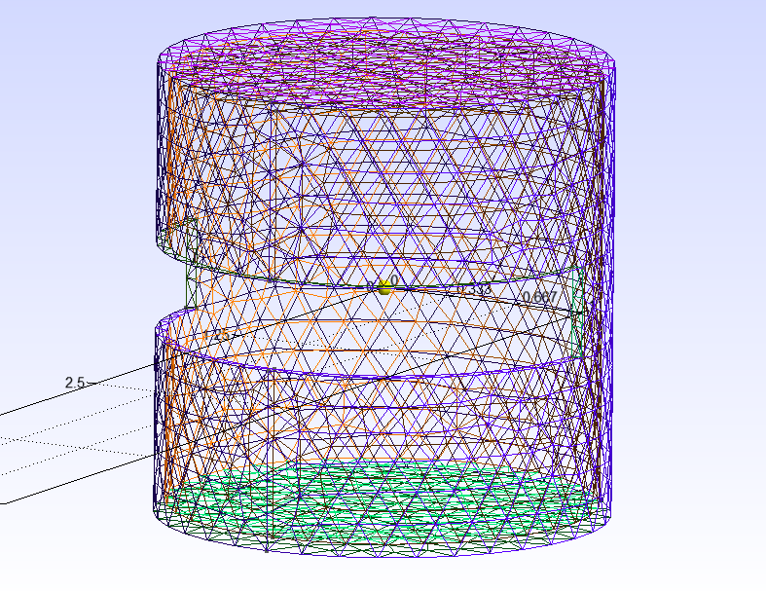

I am going to modify the big_slotted_cylinder_r1_h2 geometry to have a slot that is larger than a wavelength in the direction around the cylinder and rerun the same test for run1

MISTAKE: I was not computing max degree properly, I was doing lambda * max_dimension instead of k*max_dimension. I am now rerunning the bigger slot geometry to with max_l=8 for run2. Now the largest time delay is ~0 seconds. This is kind of strange, but the wavelength still might be considered large and needs to be smaller to see a positive time delay.

For run3 I will up the number of elements so I can decrease the wavelength. I remeshed to around 10000 elements and decreased lambda to 0.95. This will take a while to run. It has been 18 hours since I started the run and it still hasn’t completed. It doesn’t look like GMRES is converging when computing the scattering matrix. I am going to cancel the run and try doing a single solve of this mesh.

## Test 5: Enlarged slot single solve

I am doing a single solve of the really wide slot geometry with ~10000 elements with lambda=0.95 and l, m = 0 to copy the first solve done in computing the scattering matrix since I know this one did not converge.

GMRES did not converge for this test.

## Test 6: Go back to smaller slot

Since the previous test didn’t converge let’s try the same excitation with the previous mesh only with 10000 elements. GMRES did not converge for this.

Current thoughts: Maybe Q is too high at this lower frequency and Z is too ill-conditioned to be solved with GMRES with its current settings. This is hard to check using ACA since Z is not explicitly constructed. If I could solve the sound-soft CFIE instead and it was successful, this would also tell me that the sound-soft IE Z is ill-conditioned.

Second run in this test will not use ACA. I can compare the results with the ACA results, but also have the option of computing the condition number of Z without ACA.

The results are visually very similar when using ACA and not using ACA

## Test 7: Go back to Simple Geometries (plate)

Test a circular plate

**Run 1**: no ACA, single solve, LU decomposition

**Run 2**: no ACA, single solve, GMRES

Left: LU decomposition; Right: GMRES; **results agree**

**Run 3**: ACA, single solve

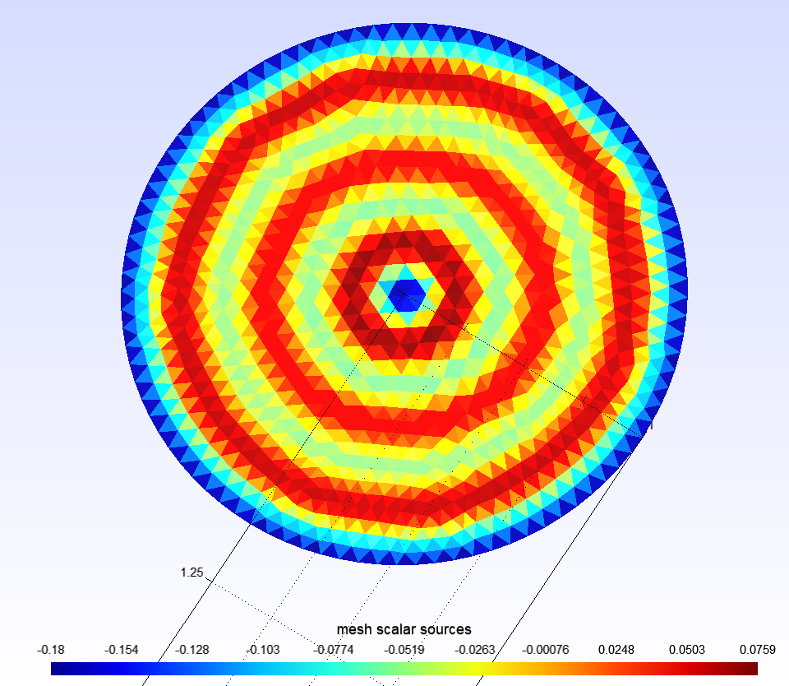

Results look to match runs 1 and 2

Summary: ACA works fine here and the geometry doesn’t suffer from spurious resonances

## Test 8: Run the r1 h2 cylinder without ACA at WS mode

I ran the ~3000 element cylinder at a WS mode with and without ACA and compared the WS time delays in the plot below

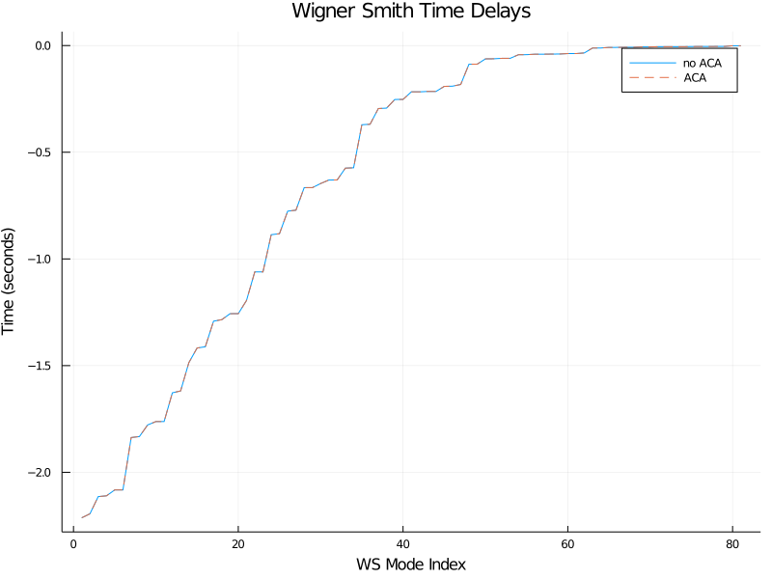

Showing agreement between the two. Furthermore, GMRES converged for all solves involved in the run using ACA.

## Test 9: Run a cylinder with no hole

**Run 1** will use the same cylinder with radius 1 and height 2 but the hole will be removed and number of elements will be set to ~3000. Since there will no longer be an interior, the minimum wavelength will decrease to ~1.2m. No ACA will be used. The image below is the cylinder simulated in these tests

**Run 2** will run the exact same problem but with ACA.

Comparing the time delays of using ACA and not using ACA shows great agreement again in the plot below

**Run 3** will use ~10000 elements. This will be first ran with ACA to see if GMRES will converge. This should be compared to the ~10000 element cylinder with a slot that was not able to converge GMRES.

Look at convergence profile, residual as GMRES iterates

**Run 4** does not solve at a WS mode. Run 3 was taking a seriously long time so I am timing a single run to see how feasible run 3 should be. I can also try going to 4 octree levels and hopefully see a speedup.

Results: It took nearly 12 hours to run a single solve in run 4. I am going to add timers to each major step of the code to see what is taking so long.

With the timers added, I want to run a few cylinders with only a single solve with and without ACA to compare their runtimes.

**Run 5** will be a cylinder with 6206 elements for a single solve not using ACA. This ran in 556 seconds.

**Run 6** was the same as 5 but with ACA. GMRES converged in 712 iterations and ran total in 208 seconds.

**Run6.5** is the same as 6, but uses 4 octree levels. This is simply to help me judge how many levels to use in run 7 with more elements.

**Run 7** I will go back to the 10000 element cylinder and run it with ACA observing the runtime and convergence of GMRES. GMRES converge with 4657 iterations (too large number of iterations) and a total runtime of 918 seconds with 3 octree levels. A single solve took 382 seconds.

This raises the question: How would it be remotely possible to run something, say, ten wavelengths in size?

Since my routine does num harmonics + 1 solves, this would take > 434 hours = 18.1 days IF it ran at the same speed as the 10000 element slotted cylinder which it was would take much longer due to requiring finer discretization to run on my laptop. Can I truncate the scattering matrix more? How do I figure out when I can truncate the scattering matrix?

Looking at Utkarsh and Eric’s first EM WS paper, they imply on page 10 in the scattering example that

With this in mind, for a scatterer, I should be able to get away with num harmonics = 63, but for good measure if I set num harmonics = 100, max l = 9. If this is true, then I need to update the documentation to reflect this.

**Run 7.5** was the same as 7, but with 4 octree levels. It was a bit slower.

Left off going to rerun test 8 geo to see speed up with changes to Js

**Run 8** will run the 6206 element cylinder at a WS mode. This was successful (GMRES converged on every solve) and took 8272 seconds = 137 minutes. The image below on the left shows the sources’ magnitudes on the cylinder and on the right are the WS time delays.

**Run 9** I should try going back to a cylinder with a hole and running a single solve again (look back at was done to make sure this is not a duplicate test).

## Test 10: Back to the cylinder with a hole

**Run 1** I will rerun a single solve of the first cylinder with a hole with 3436 elements. Lambda = 1.65. Ran with no problems in 89 seconds.

**Run 2** Same as run 1, but with 6692 elements and holding lambda constant = 1.65. Not decreasing lambda makes this different than previous tests. Ran with no problems in 342 seconds.

**Run 3** Same as run 1 and 2, but with 10212 elements and holding lambda constant = 1.65. When lambda was held to be 10 element edge lengths, this test failed (i.e. GMRES was not converging). GMRES converged in 1793 iterations and total runtime was 625 seconds. This was successful.

**Run 4** is back to running the same problem as run 1, but at WS mode 81 and computing the WS time delays. This ran with GMRES converging for all solves and a total runtime of 1457 seconds = 24.2 minutes. The plots below are the magnitude of sources for WS mode 81 on the cylinder and time delays.

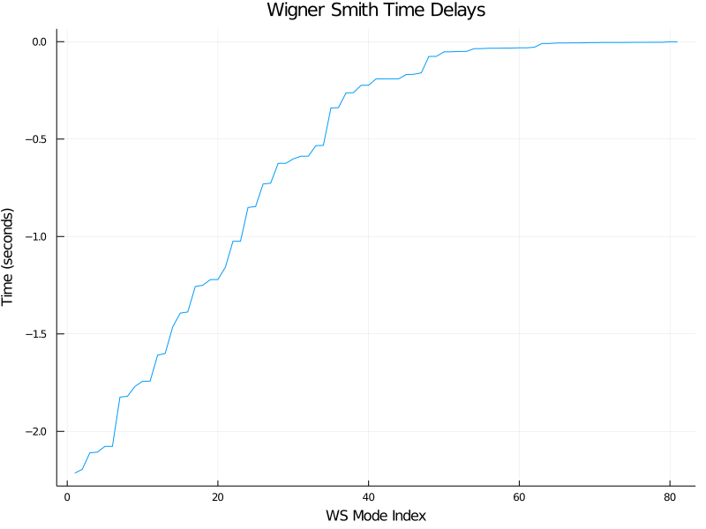

Based on both images/plots, it is clear that little to no energy is coupling to the interior of the cylinder.

**Run 5** will run the 6692 element cylinder at WS mode 81 with the same lambda value. All GMRES solves converged and the total runtime was 8742 seconds = 145 minutes.

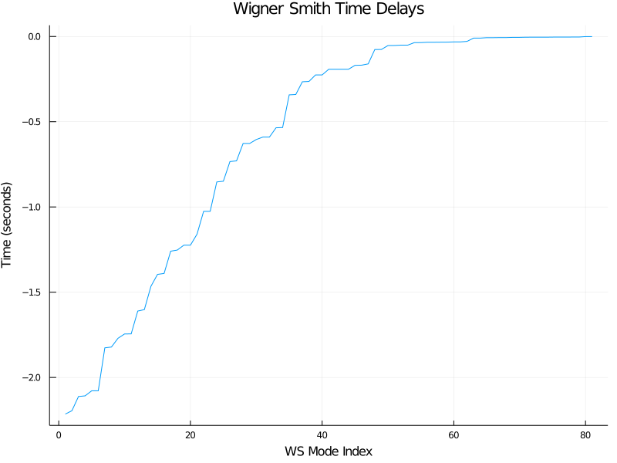

**Run 6** will run the 10212 element cylinder at WS mode 81 with the same lambda value. All GMRES solves converged and the total runtime was 11589 seconds = 193 minutes.

Next:

* Dense MoM matrix, N^2 elements,
  + LU takes N^3 operations
    - Just the factorization takes N^3
    - Back substitution only takes N^2 per RHS
    - With N RHSs N^3 per full solve
  + Compress with some routine (ACA)
    - Can get storage to NlogN (not ACA)
    - Can’t do LU since we can only multiply matrix
    - In theory gmres conveges in N iterations
    - Cost N^2logN for one RHS
    - For all RHS N^3logN (full solve)
  + Good codes, can do this in lower than N iterations with GMRES
    - For all RHS would be become ~N^2logN
      * Better speed and storage
* Number of iterations above is too large, could be something wrong
  + **Since cylinder is closed, this should be ran with CFIE**
    - Only has mathematical resonances that if I am close to, could be causing large iterations
  + If structure has hole, then I will have physical resonances that cannot do away with
    - Then iteration counts similar to this would be expected