Because I do not have permission to write in the root directory, instead of creating the “PE-1.txt” in the root directory, my program creates a text file in another directory.

**Step 1.1:** Before we compile and execute the “PE-Import.c”, there is no “PE-1.txt” in this directory.

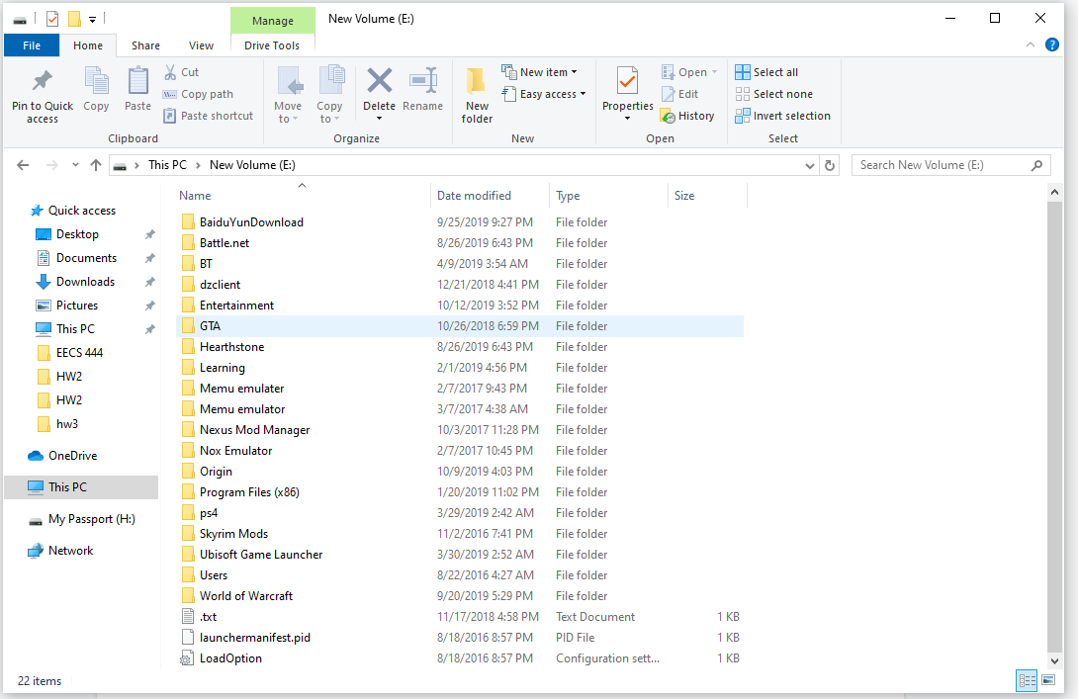

**Step 1.2:** The program prints out “file PE-1.txt does not exist” to Stdout and creates a “PE-1.txt” in this directory.

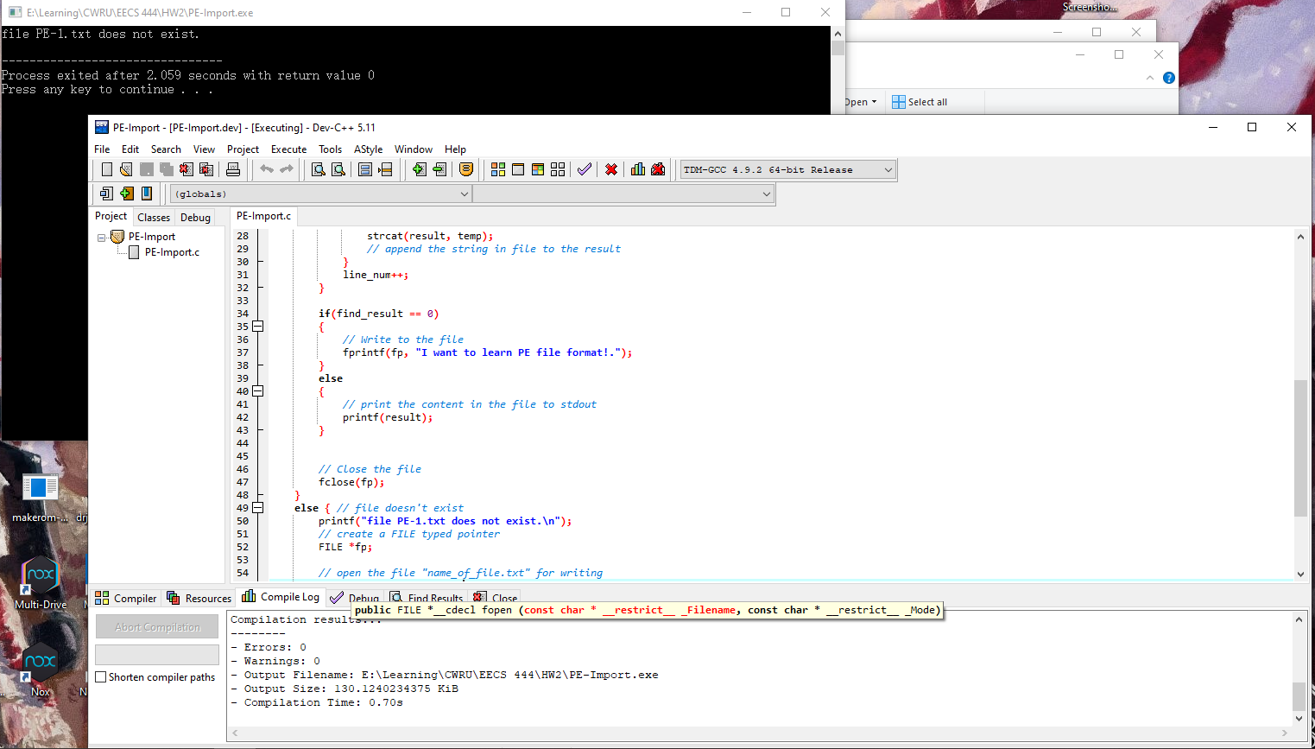

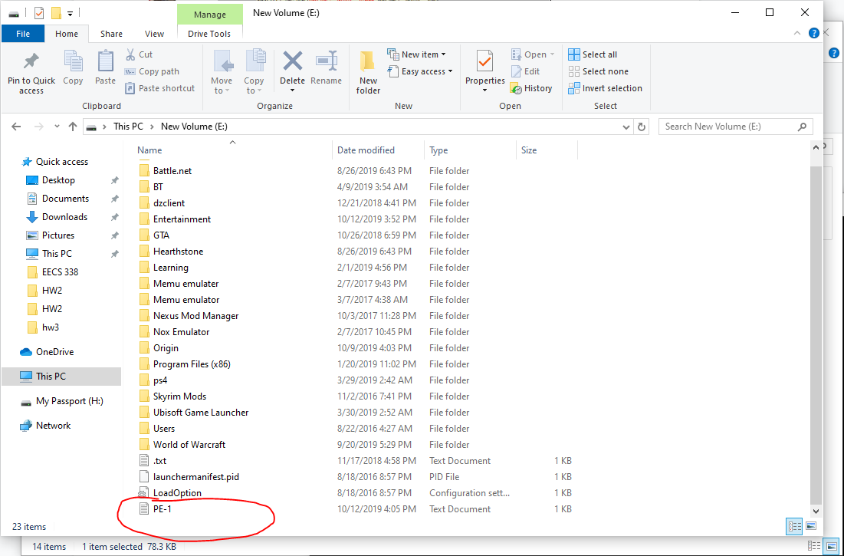

**Step 1.3:** The program will print out the content “I want to learn PE file format” to Stdout if the “PE-1.txt” is already exist in this directory.

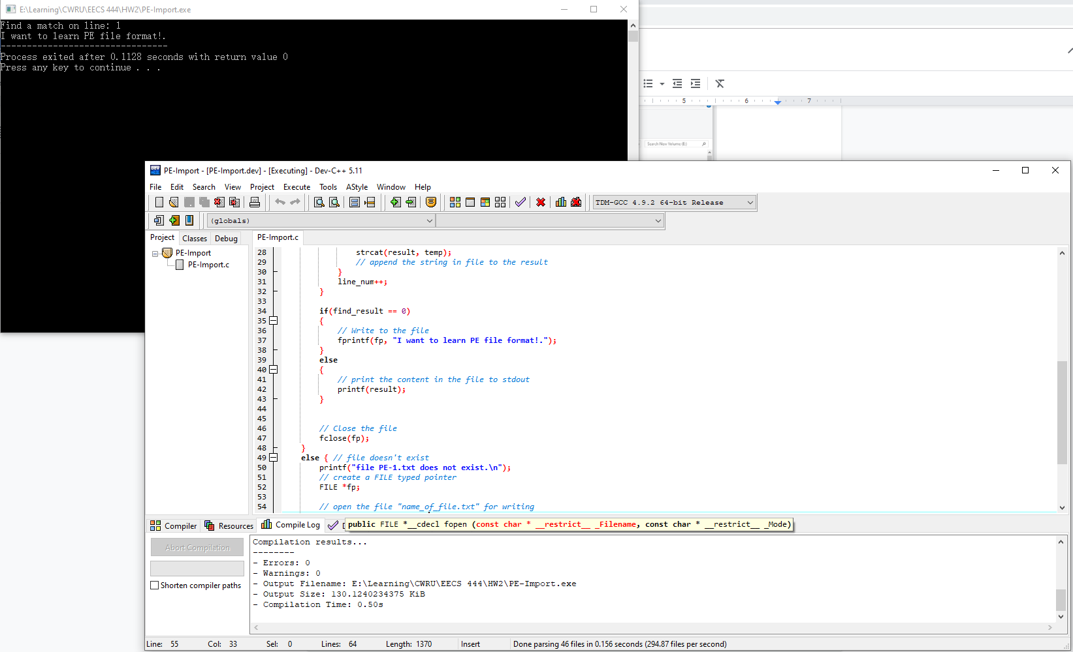

**Step 2.1:** Use Exeinfo PE to check the content in the Import Table for program “PE-Import.exe”.

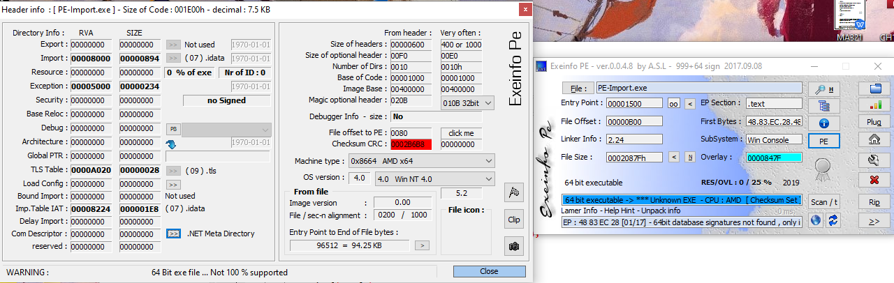

**Step 3.1:** Use UPX to pack the PE-Import.exe.

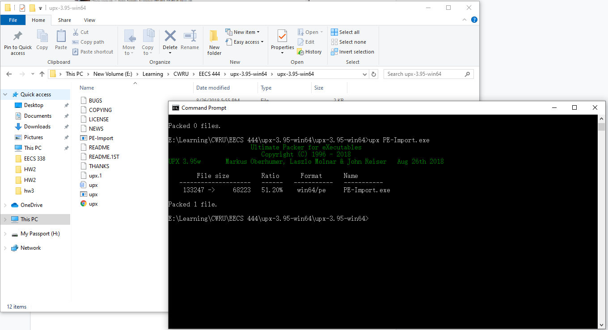

**Step 3.2:** Use Exeinfo PE to check the content in the Import Table for packed “PE-Import.exe”.

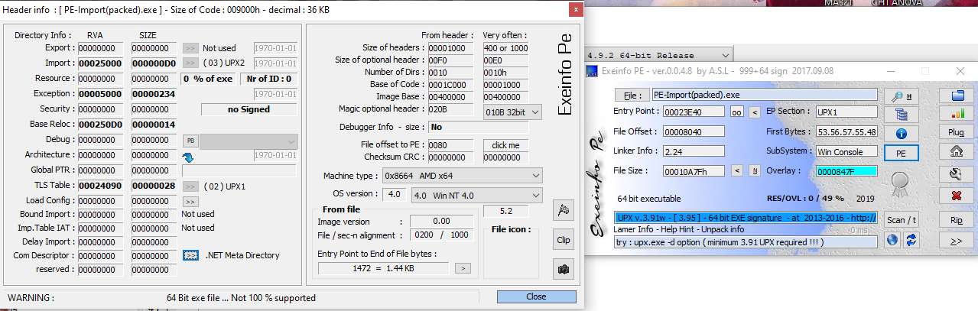

**Step 3.3:** Use UPX to unpack the PE-Import.exe.

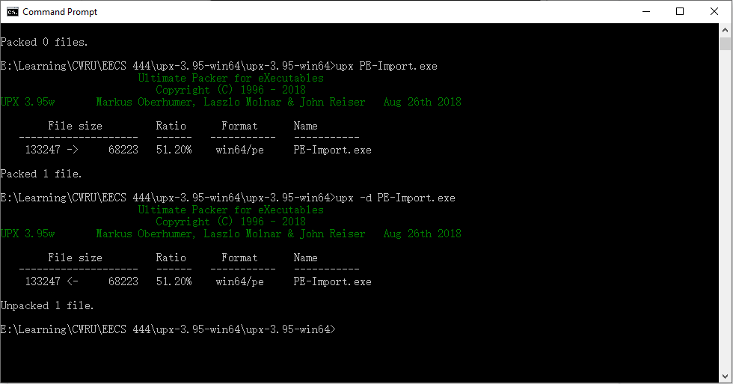

**Step 3.4:** Use Exeinfo PE to check the content in the Import Table for unpacked “PE-Import.exe”.

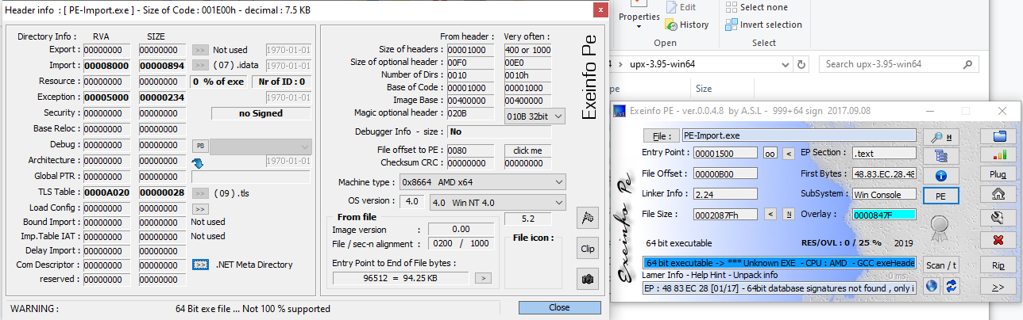

**Step 4.1:** The result of anti-malware scanner for “PE-Import” before using any technique.

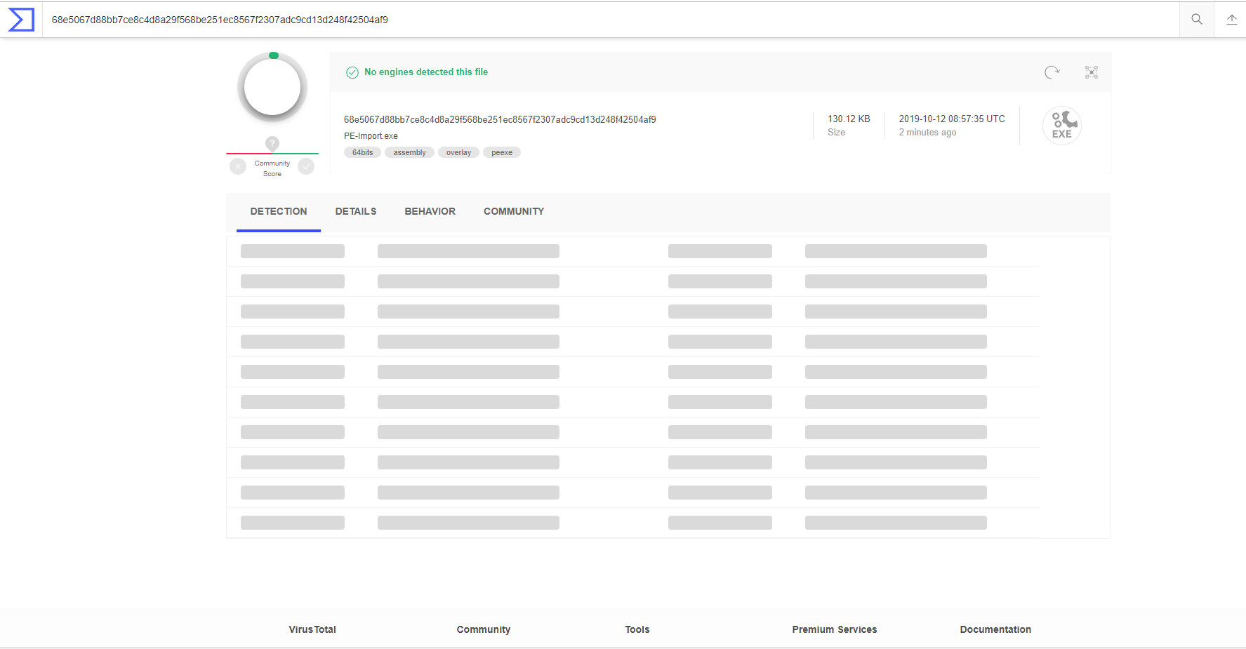

**Step 4.2:** The result of anti-malware scanner for “PE-Import” by using packing.

