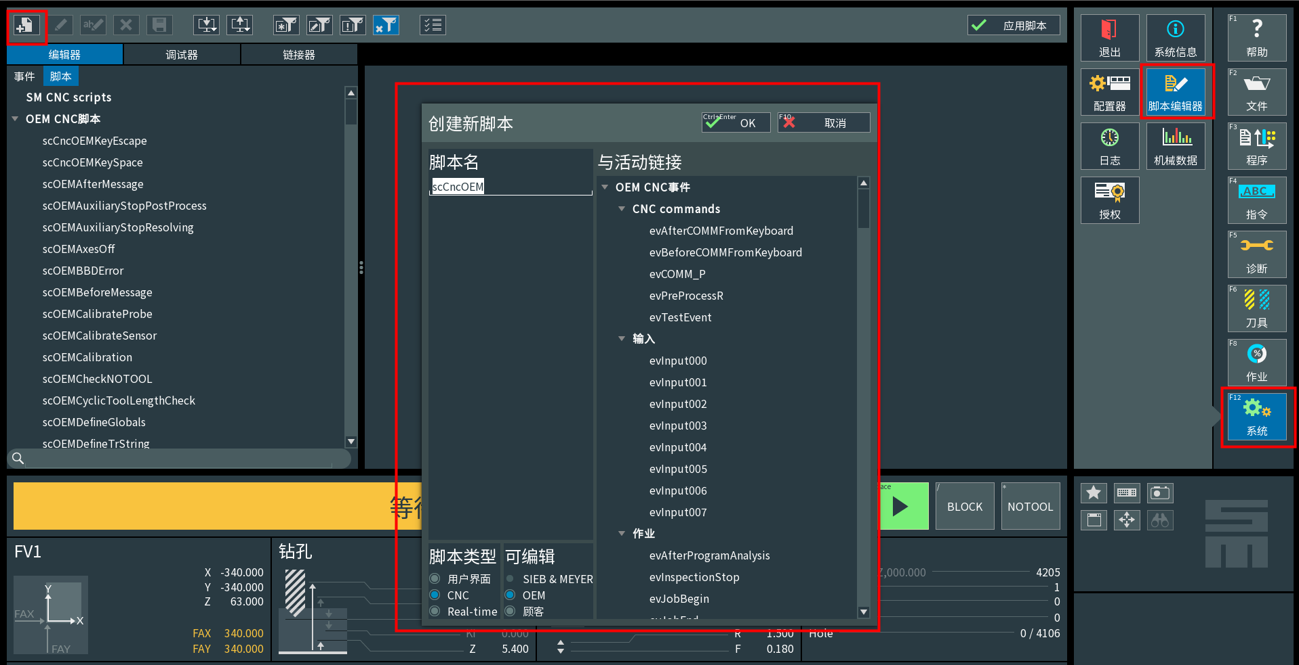
scCncOEMBoardDirectionCheck
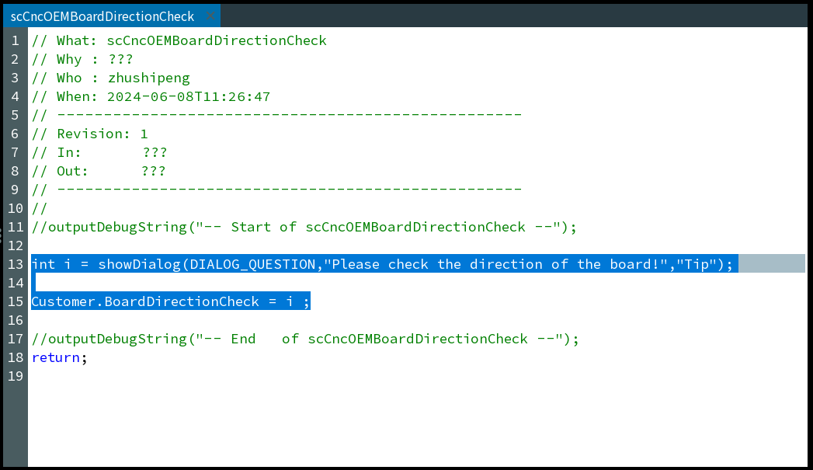
int i = showDialog(DIALOG_QUESTION,"Please check the direction of the board!","Tip");

Customer.BoardDirectionCheck = i ;

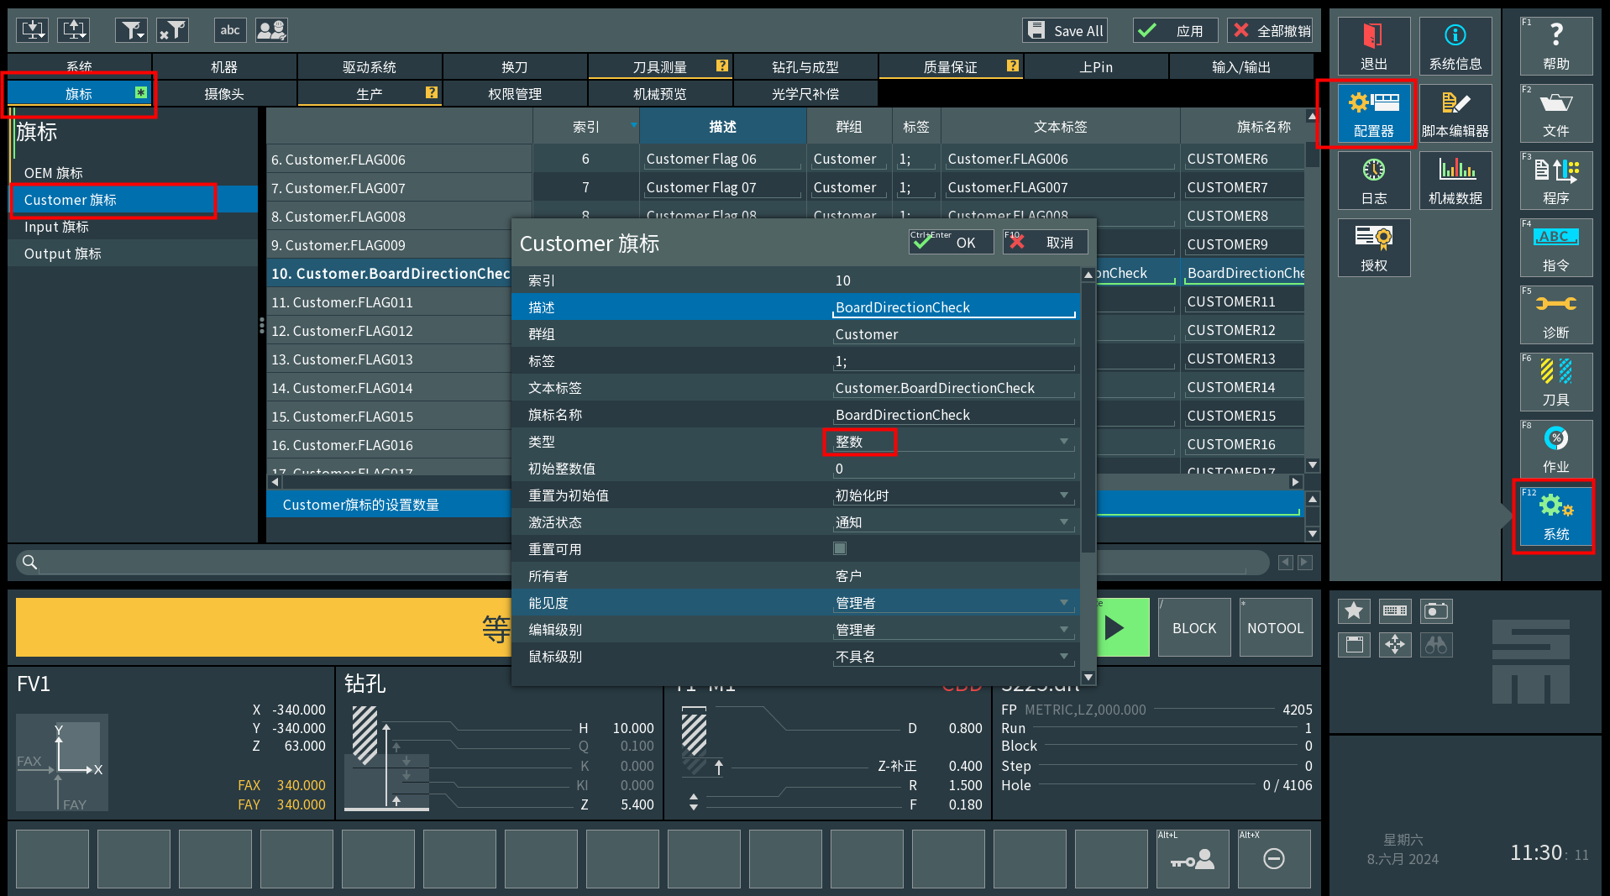
BoardDirectionCheck
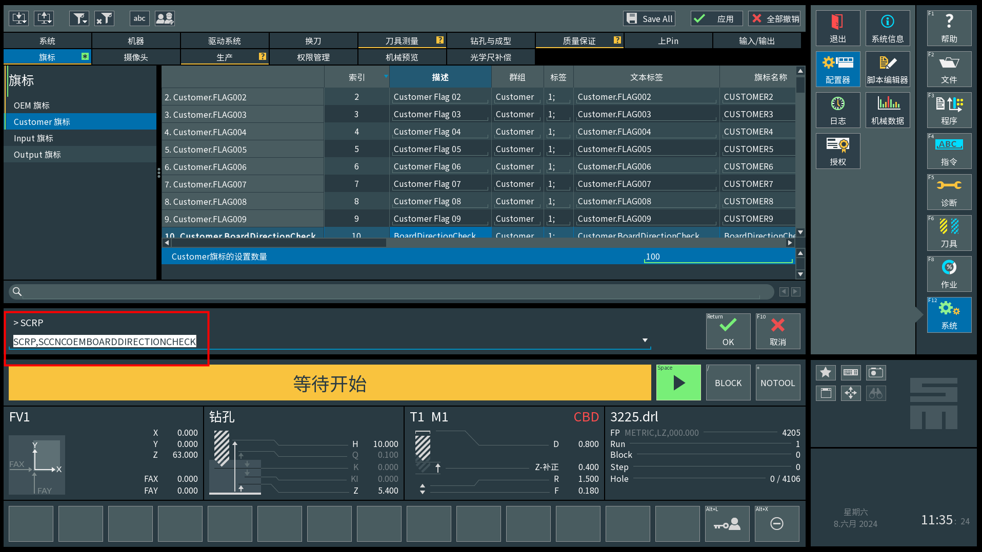
SCRP,SCCNCOEMBOARDDIRECTIONCHECK
