3/17/2025

Assumptions of LP

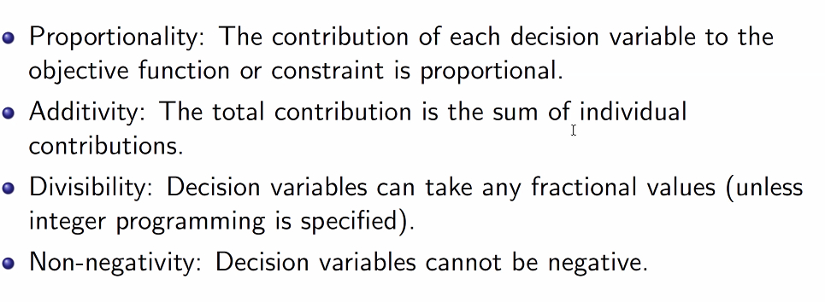

Areas of Application

