Following is original signals

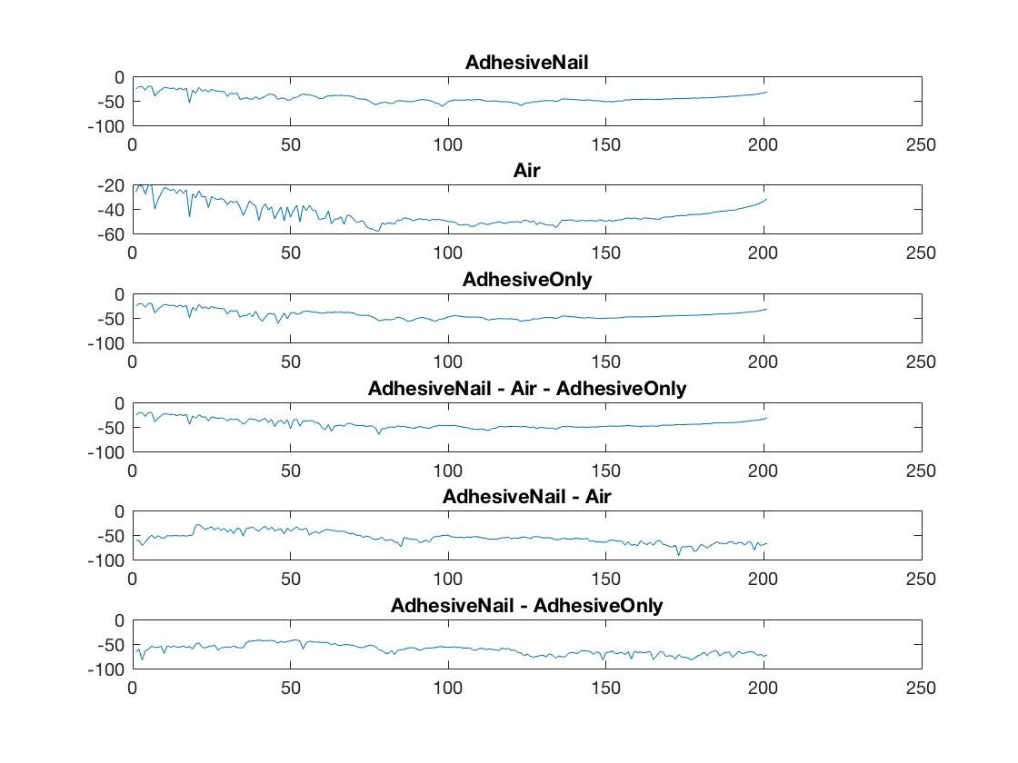

Using ICA Method, we could get the individual signals with input signal of AdhesiveNail

And the following is the result.

The third one is similar to the air signal of the original signals

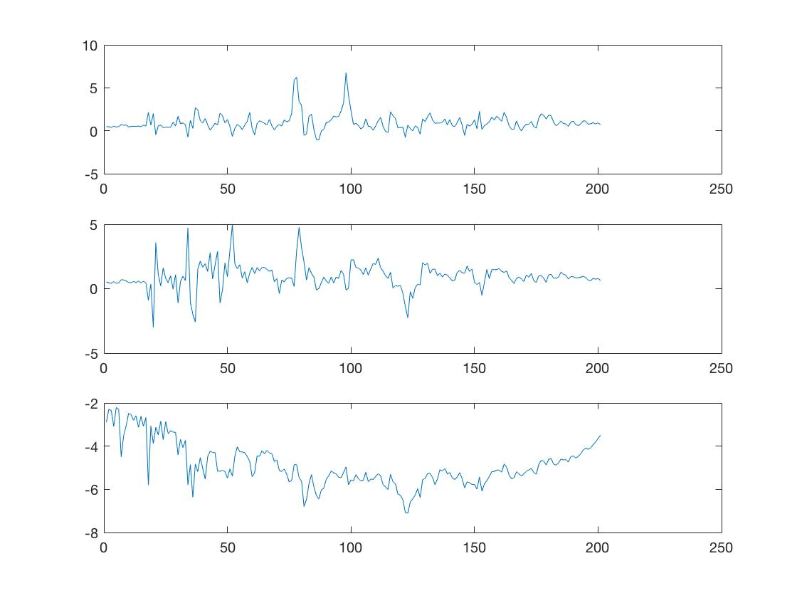

Comparison with signal 3 with air signal.

