Lookup for grating angle and texture tiling in Virmen
Orientation: | VirmenTexture | Vertical tiling (wallHeight / ) | Horizontal tiling (floorLength /)
vertical
90 | 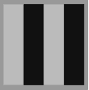 | 10 | 10
84 | 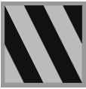 | 40 | 10
78 | “ | 20 | 10
67 | “ | 10 | 10
horizontal
0 |  | 10 | 10
6 | 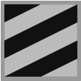 | 10 | 40
12 | “ | 10 | 20
22 | “ | 10 | 10

