**BurnInTest**

**Version 1.0**

**Version History**

|  |  |  |  |
| --- | --- | --- | --- |
| **Version** | **Date** | **Handled by** | **Comments** |
| V1.0 | 18-Dec-2019 | ZL Chen | First version release. |

Precondition Setting:

Prepare the DUT machine, and make sure the USB port can be work, then insert it.

* Setting the User Account Control Setting.
  + Please refer to the “User Account Control Setting.pdf” attachment

(\automation\sop\other\User Account Control Setting)

* Install BurnInTest to a USB drive.

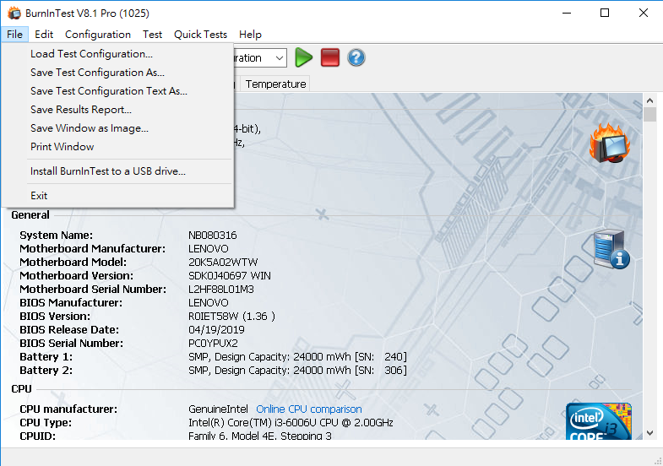

* Set the logging. (Log file name: C:\BIT_log.htm)

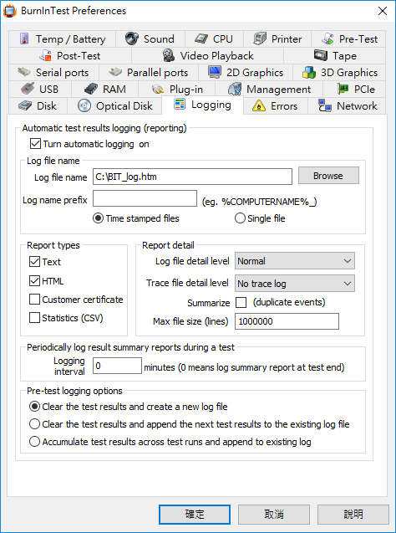

* Copy the dqa.bitcfg to the BurnInTest folder. That is parameter setting data.

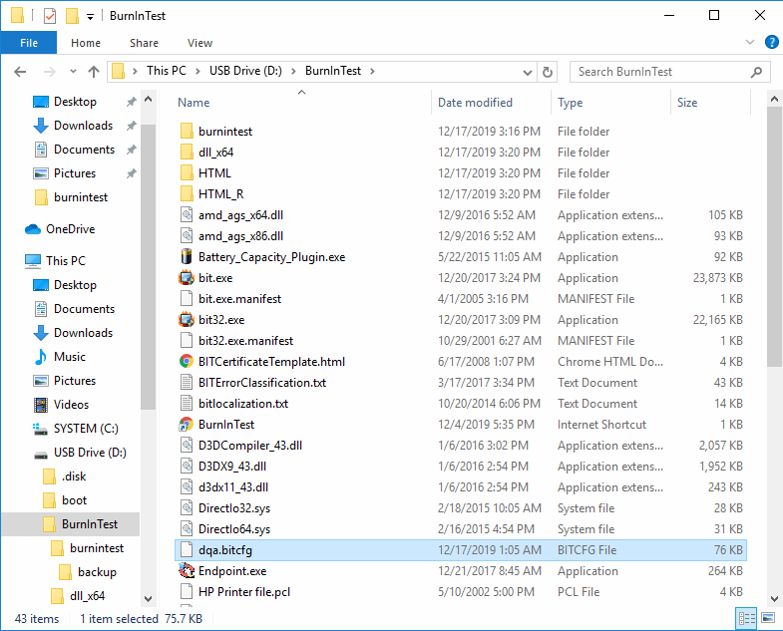

Step 1:

Insert the USB driver to the DUT machine, then copy the burnintest folder to the BurnInTest folder with USB drive.

Step 2:

Open the burnintest folder, and tap the delete.exe. The older report is deleted.

Step 3:

Open the burnintest folder, and tap the execute_720_min.exe. The program is running.

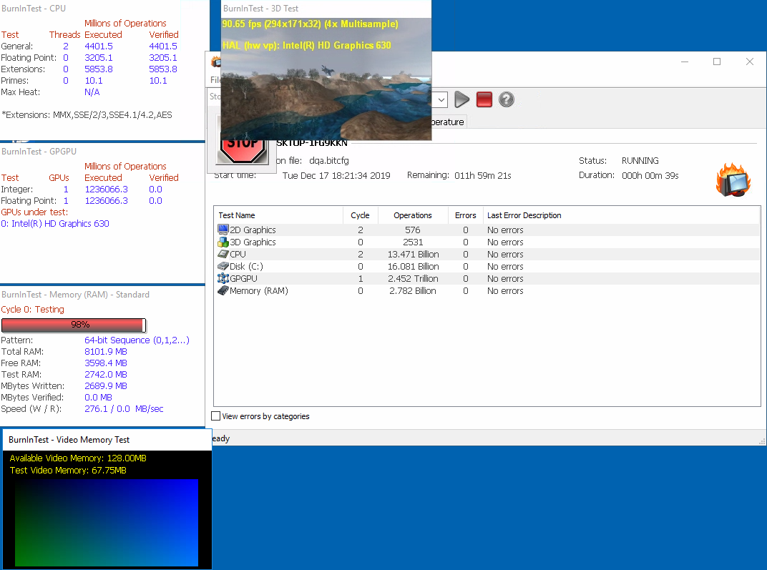

Step 4:

Wait for 12 hours, the program is stop, please tap the “OK” and close the windows. The log will be archive under the backup folder.

