**Resolution**

**Version 1.0**

**Version History**

|  |  |  |  |
| --- | --- | --- | --- |
| **Version** | **Date** | **Handled by** | **Comments** |
| V1.0 | 16-Aug-2019 | ZL Chen | First version release. |

Precondition Setting:

N/A

Please follow the implement as below:

Step 1:

Copy the resolution folder to your windows desktop.

Step 2:

You can found the format_reboot.bat or format.bat under the resolution folder.

If you need reboot, please run the “format_reboot.bat”. Otherwise, please run the “format.bat”

Step 3:

If you run the “format_reboot.bat”, please copy the counter.txt and resolution_reboot.txt to the startup folder.

If you run the “format.bat”, please copy the counter.txt and resolution.txt to the startup folder.

Step 4:

Modify the wait time you want as below:

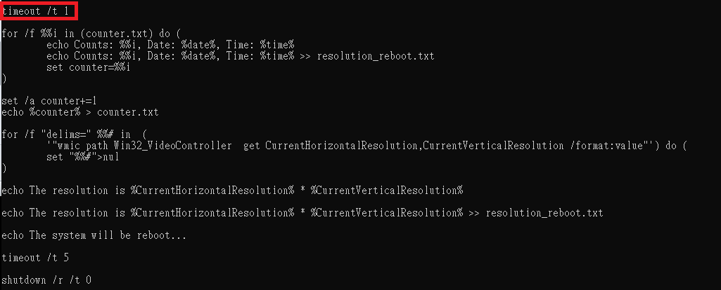

The log as the resolution.txt or resolution_reboot.txt