**Jacqueline Joiner**

4455 SW 34th Street LL202

Gainesville, FL 32608

(352)219-5521

jackiejoiner93@yahoo.com

**Objective**

I am looking for a job or internship that will allow me to use my skills in various Adobe Products such as Photoshop, Illustrator, and InDesign that I have gained throughout high school and college.

**Education**

University of Florida, Gainesville, FL (Spring 2012-Present)

Major: Journalism

Full time student, 13 credit hours

Santa Fe College, Gainesville, FL (Fall 2011)

Major: Journalism

Full time student, 12 credit hours

Mainland High School, Daytona Beach, FL (2007-2011)

High School Diploma

**Work Experience**

The Swamp Restaurant

Position: Hostess

Responsibilities: greeting and sitting customers, bussing tables, keeping hostess stand clean and organized, and maintaining the inside and outside of the restaurant.

Wage: $7.67 per hour plus tip outs

Hours worked per week: 15-20 hours

The Independent Florida Alligator (July 2012 to January 2013)

Position: Production Staff

Responsibilities: Drawing pages for the paper using Adobe InDesign, creating graphic designs that are displayed in the paper

Wage: $7.67 per hour

Hours worked per week: 6-9

Gumby’s Court of Heroes (2008 to present)

Position: Cashier

Responsibilities: Answering phones, taking orders from customers using VLink POS, serving food, bussing tables, handling $200-$500 at a time.

Wages: 8.50 per hour plus tips

Hours worked per week: 10-15

**Additional Skills**

Familiar with working with customer service, have worked with computers and programs such as Microsoft Office 2003 and later as well as Adobe Photoshop, Illustrator and InDesign CS3 and later, certified in Adobe Photoshop CS3 and CS4.

**Achievements in High School**

Graduated Summa Cum Laude with 4.13GPA at top 5% of class, Junior Varsity Cheerleader (10), Competition/Basketball Cheerleader (10,11), Varsity Cheerleader (11), Yearbook staff member (10,11,12), National Honors Society Member (12), National Technical Honors Society member (12), Certified in Adobe Photoshop CS3 (11) and CS4 (12), Superintendent Diploma of Distinction Candidate (12)

**References**

Jeff O’Brien Natalie Teer

Relationship: Current Employer Relationship: Work Supervisor

Profession: Business Owner Profession: Assistant Production Manager

(352)256-8263 (850)642-0063

**Availability**

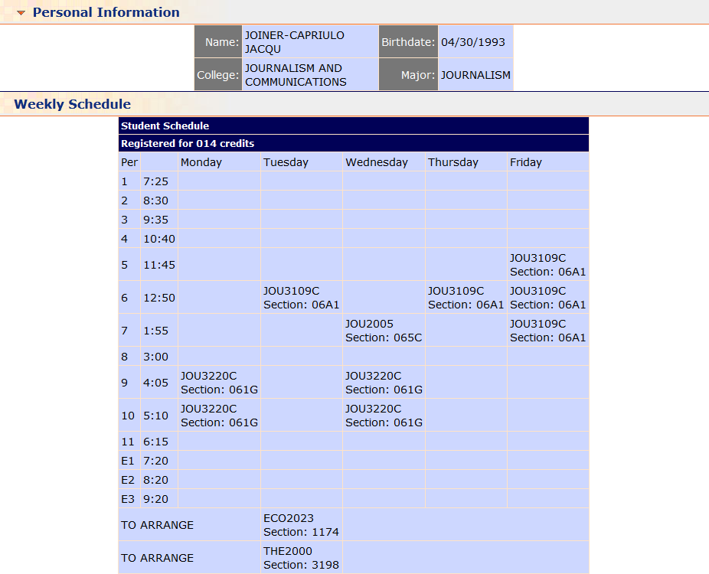

I am also available on the weekends