Question List:

The Architecture of product
Component Chart of Authentica:
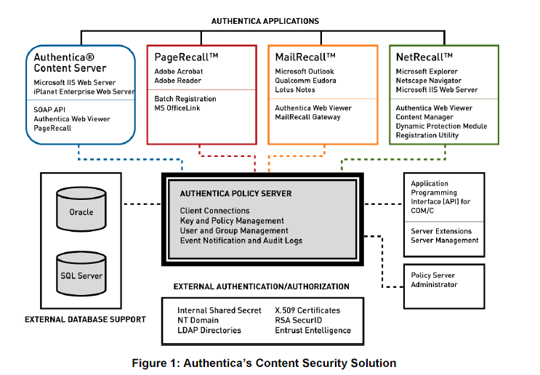

The Main Logic and Process for mail protection
Mail 的发送流程:
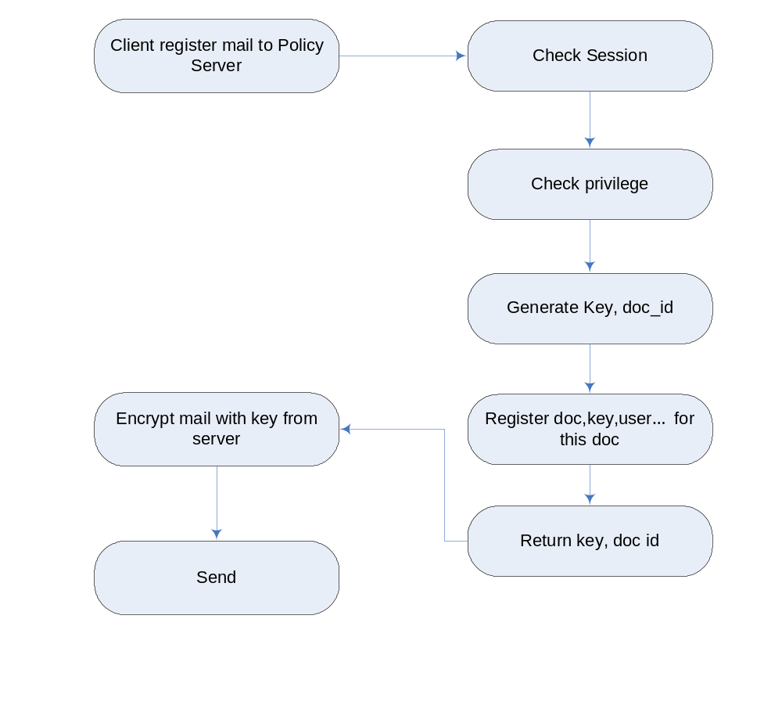

Read Mail:
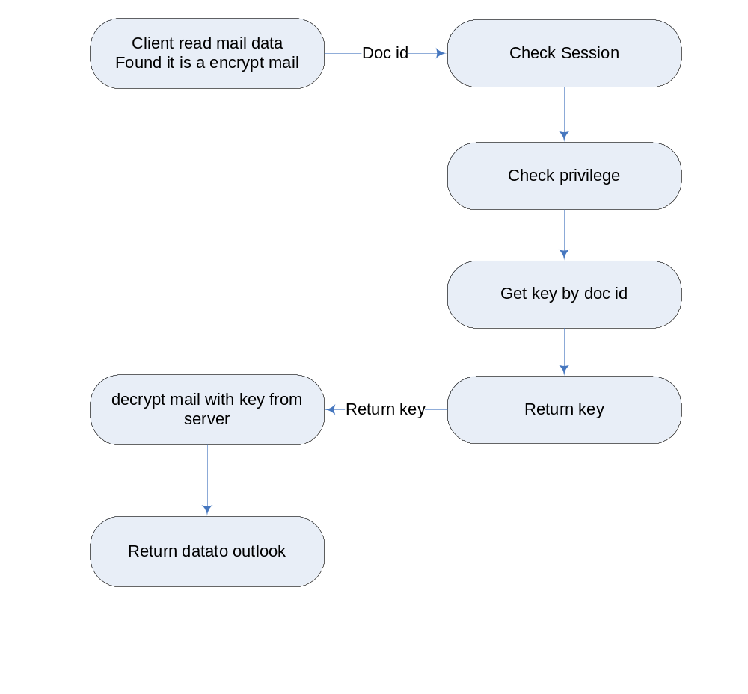

问题1:
outlook client如何识别这是一封加过密的邮件
server 是否保存加密后的文档(从表结构看， 似乎没有保存)
加密过和未加密的mail文件内容是不一样的。

Server Interface
  - Authentication
    - Login
    - Logout
    - Session check
  - Authorization
    - Get Privilege for User./Group
    - Assign privilege to User/Group
  - User Management
    - Create user
    - Delete user
    - Create group
    - Delete group
    - Add/Remove user to/from group
  - Document encryption
    - Register Document
    - Get key for document
    - Get user privilege for document(read, print…)
    - Change access right for this document.
    - Recall document

