Problem 2
b)
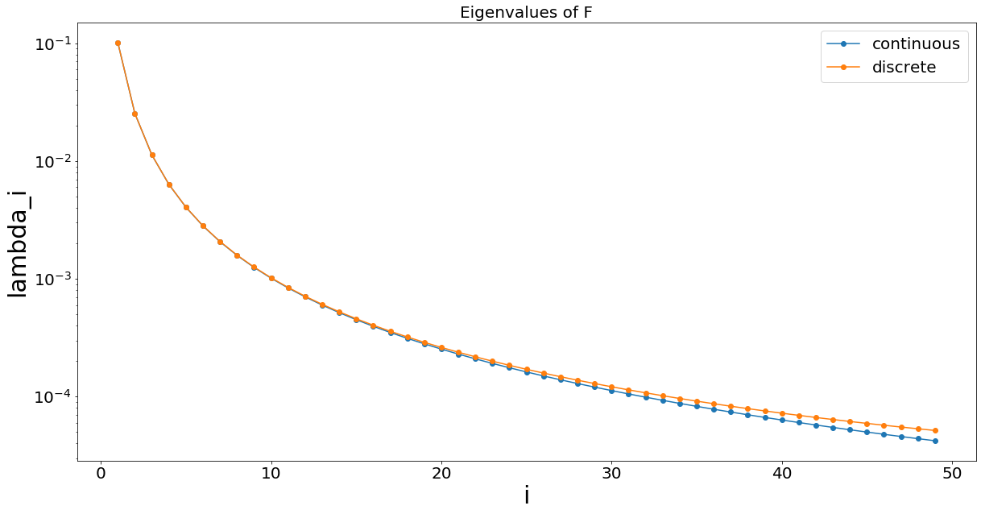
The eigenvalues of continuous operator decay slightly faster than those of discrete operator.

c) Set L = 1.
When k = 1, nx = 20, noise_std_dev = 0 (no noise), the inversion is perfect.
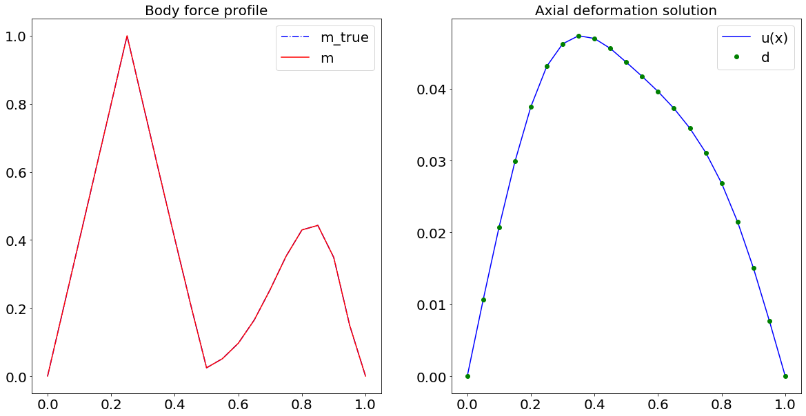Illustration 1: k = 1, nx = 20, noise_std_dev = 0

When k = 1, nx = 20, noise_std_dev = 0.0004, the naive inversion is very unstable.
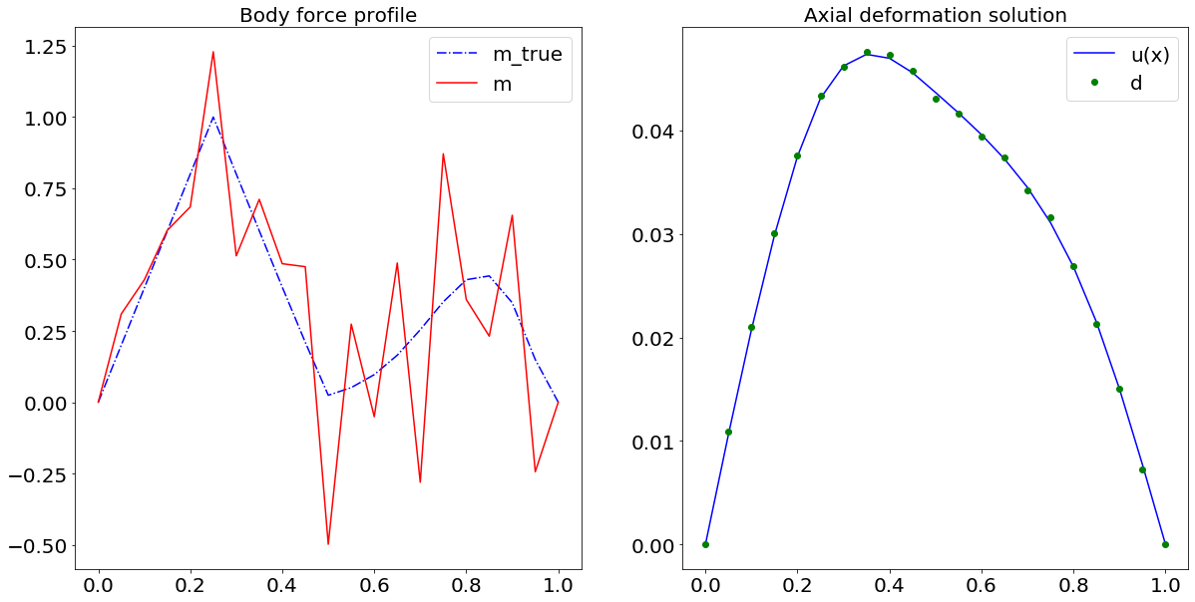Illustration 2: k = 1, nx = 20, noise_std_dev = 0.0004
We maintain the same noise level, and decrease k. The inversion becomes more stable.
k = 0.1, nx = 20, noise_std_dev = 0.0004.
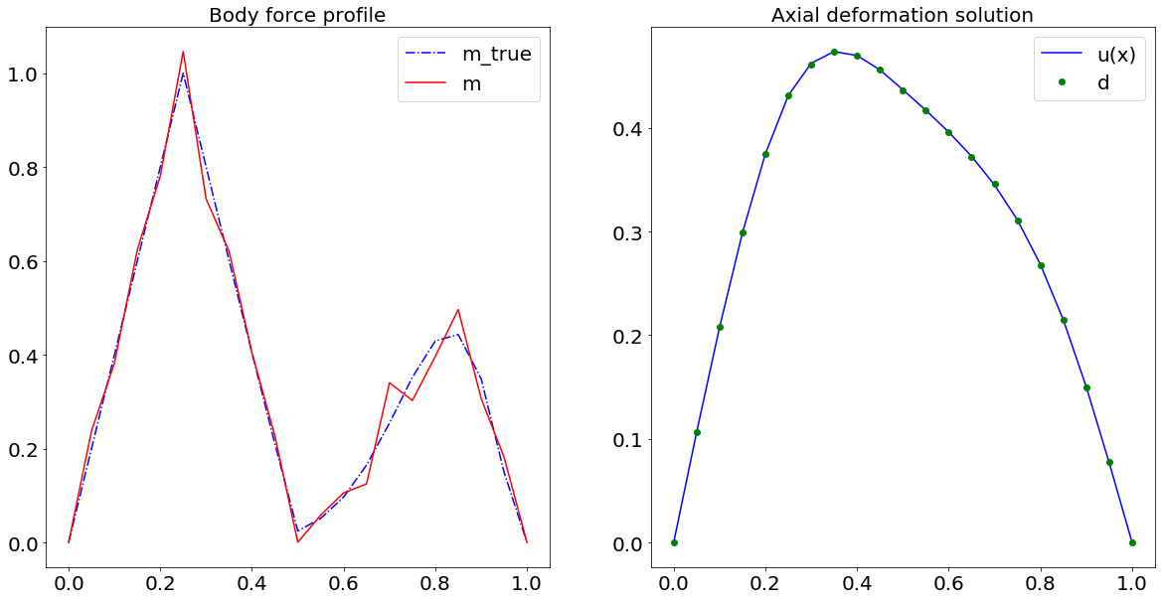Illustration 3: k = 0.1, nx = 20, noise_std_dev = 0.0004
If we increase number of grid points, then the inversion becomes more unstable.
When k = 0.1, nx = 50, noise_std_dev = 0.0004, we have
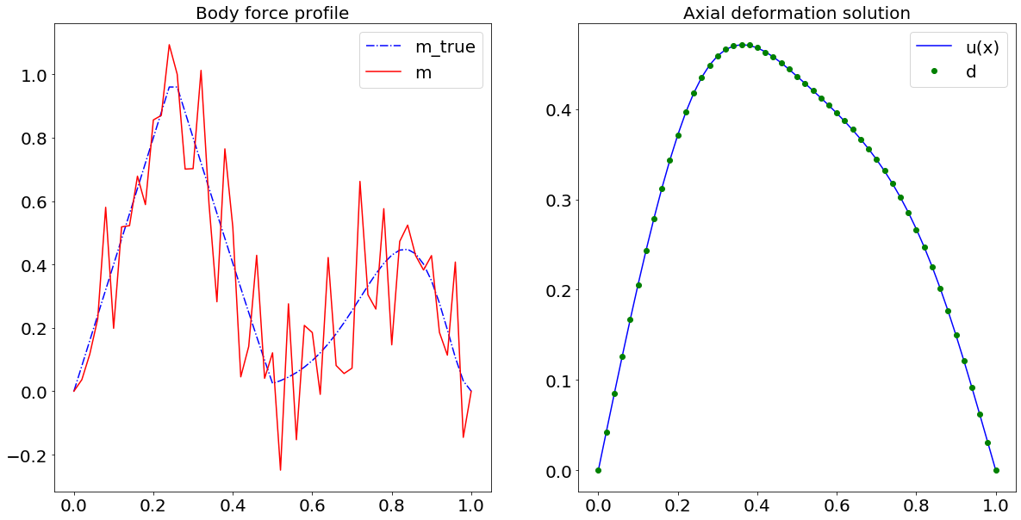Illustration 4: k = 0.1, nx = 50, noise_std_dev = 0.0004
To sum up, smaller nx and smaller diffusivity k contribute to better stability, and vice versa.

d)
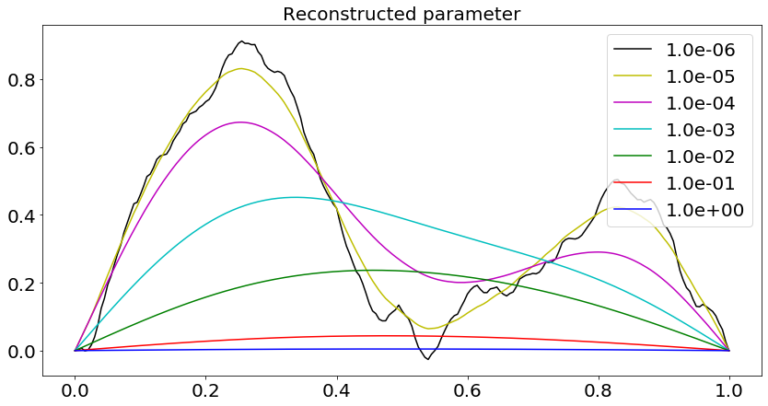

e) Take alpha = 1e-8, 1e-7, …, 1. From the L-curve, we select the best alpha as the “elbow” – alpha = 1e-6.
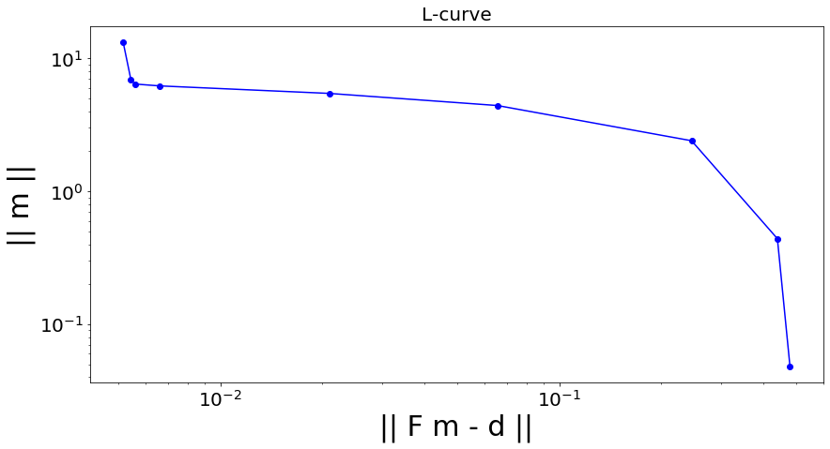
f) By Morozov’s discrepancy principle, we select alpha to be 1e-6.
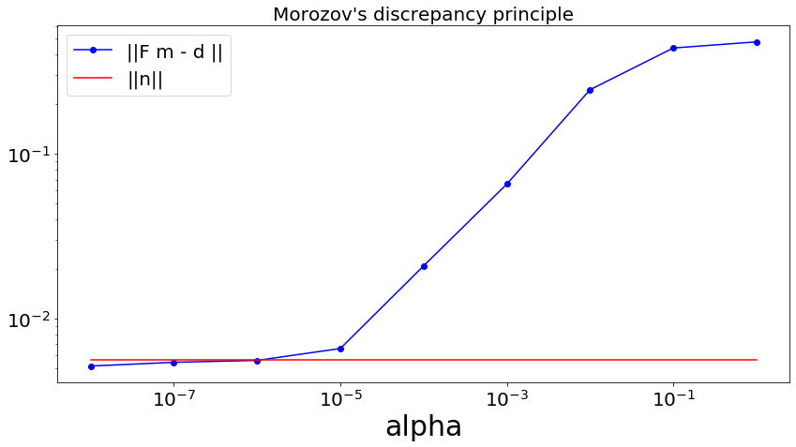

g)
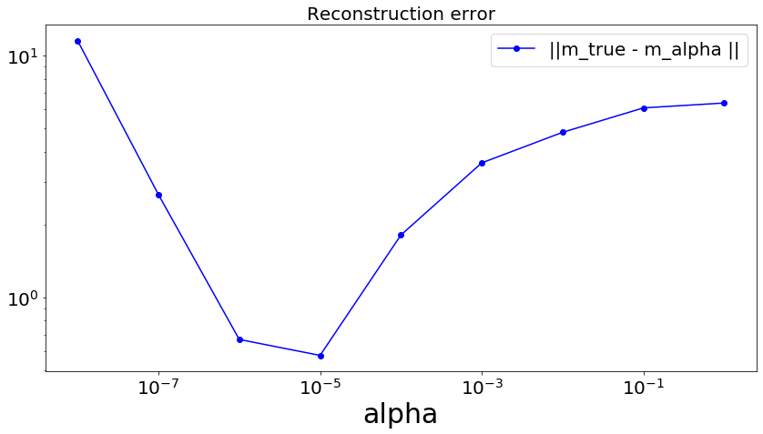
alpha = 1e-5 minimizes the L2 error. The “optimal” value of alpha from L-curve and discrepancy principle is 1e-6, which is very close to the theoretically best alpha.

