MONDAY WORKOUT PLAN
3 Sets × 4 Laps | Session 1 | April 28, 2026

25  STUDENTS | 3 × 4  SETS × LAPS | 90 sec  REST (WALK LAP) | ~40 min  TOTAL SESSION

SESSION FLOW

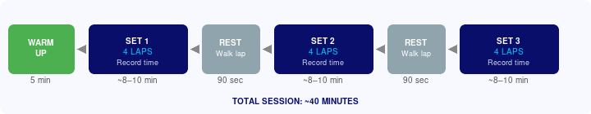

FIELD SETUP & GUIDE POSITIONS

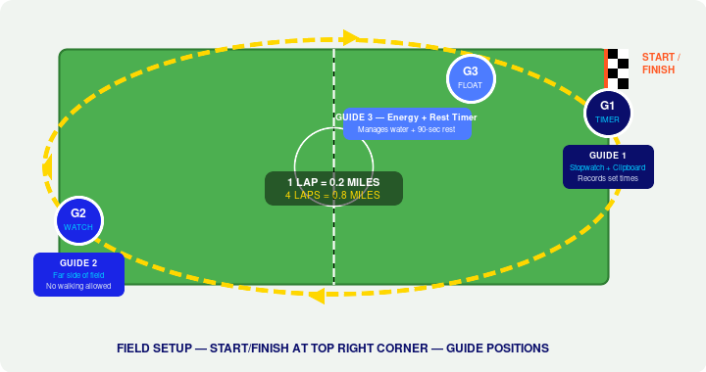

GUIDE | POSITION | RESPONSIBILITY
G1 | Start / Finish Line | Holds stopwatch. Calls out time as each student crosses finish. Records every student's set time on clipboard. Calls 'GO' to start each set.
G2 | Far Side of Field | Watches the back half of the lap where students slow down or walk. Calls out encouragement. Corrects any walkers immediately.
G3 | Floating + Rest Zone | Manages water during rest period. Times the 90-second rest. Keeps energy high. Signals G1 when rest is over and next set should begin.

THE WORKOUT — 3 SETS OF 4 LAPS

SET | DISTANCE | EFFORT INSTRUCTION | GUIDE ACTION
SET 1 | 4 laps  0.8 miles | "Run at a pace you can hold all the way through. No sprinting, no walking." | G1 starts stopwatch on GO. Records each student's time as they finish lap 4. G3 begins 90-sec rest timer immediately after last student finishes.
REST | Walk recovery lap | Walk only. Sip water. Breathe. | G3 times 90 seconds. G1 reviews recorded times. G2 resets to far side. G3 calls 'LINE UP' at 90 sec.
SET 2 | 4 laps  0.8 miles | "Same pace as Set 1. You should feel the same at lap 4 as you did at lap 1." | G1 records times again. Compare Set 2 vs Set 1 for each student. Note anyone who slowed significantly — check in with them during rest.
REST | Walk recovery lap | Walk only. Final water break. | G3 times 90 seconds. G1 preps final set callout. G2 checks in with any students who looked fatigued.
SET 3 | 4 laps  0.8 miles | "Last set. Finish strong. This is the one that counts." | G1 records final set times. This is their Session 1 baseline — file the clipboard. All three Guide times will be used to set weekly targets.

RECORDING SET TIMES — SESSION 1 BASELINE

Why we record set times, not lap times
Set time = 4 laps completed. Guide calls out elapsed time the moment each student crosses the line after lap 4. Students only need to hear one number — no math, no per-lap tracking. Session 1 times become the personal baseline every student tries to beat going forward.

STUDENT NAME | SET 1 TIME | SET 2 TIME | SET 3 TIME
_______________________________ | _______ : _______ | _______ : _______ | _______ : _______
_______________________________ | _______ : _______ | _______ : _______ | _______ : _______
_______________________________ | _______ : _______ | _______ : _______ | _______ : _______
_______________________________ | _______ : _______ | _______ : _______ | _______ : _______
_______________________________ | _______ : _______ | _______ : _______ | _______ : _______
(Continue on separate roster sheet)

TARGET SET TIMES BY GRADE GROUP

Session 1: Do not share these targets with students yet. Use them internally to understand where each student stands relative to their race cut-off. Begin communicating targets in Session 3.

GRADE GROUP | RACE CUT-OFF | PACE TARGET | 4-LAP SET TARGET
Gold | L2 (4th & 5th) | 34 min for 3.0 mi | 11:20 / mile | Under 9:04
Blue | L1 (2nd & 3rd) | 35 min for 3.0 mi | 11:40 / mile | Under 9:20
Green | LL (K & 1st) | 38 min for 3.0 mi | 12:40 / mile | Under 10:08

KEY COACHING CUES FOR GUIDES

SAY THIS  - "Run at a pace you can hold for all 4 laps."  - "If you can sprint right now, you started too fast."  - "Arms relaxed, eyes forward."  - "Keep going — your body is stronger than your brain thinks."  - "Walk lap only. Save it for the next set." | WATCH FOR  - Students sprinting lap 1 and dying lap 3  - Walking on the far side of the field (G2 responsibility)  - Students skipping a lap or cutting corners  - Anyone who looks distressed or stops completely  - Groups bunching — faster kids lapping slower kids

SESSION 1 GOAL
Every student completes all 3 sets without stopping. Pace does not matter today. Completion is the win. The times recorded are their baseline — every future session is measured against it.

