**Users Manual**

**Getting it up and running.**

1. Unzip and move to desktop
2. Open command prompt. Type CD place the folders URL link, click enter.
3. Enter the following commands
   1. Composer install
   2. Npm install
   3. Npm run build
   4. Open xampp and start mySQL
   5. Php artisan migrate ( yes )
   6. Php artisan db:seed
   7. Php artisan serve
4. Login with administrative account or create your own
   1. Admin Credentials: [admin@money.com](mailto:admin@money.com) password: money
5. The admin account will have data already inside.
6. To make the “see budget” work you will need to click on the 2 budgets so the category prices are generated

**Make Budgets, Categories and Items the same way.**

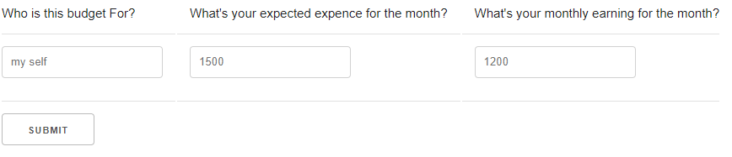

1. Make budgets for all household members fill the categories with items they are responsible for (budget: child , Category: Education, Item: Tuition, Books )
2. Fill out this form and click submit to generate that instance.
3. In all cases if the fields are left blank or with the same name you will be returned back.

**Seeing the category totals.**

1. Click “see budget” after populating categories with items to see the break down based on theme (Needs,Wants,...).
2. This will show the top 3 most expensive items and how much you'll need to pay out pocket (hours needed to work)

**Admin panel**

1. Will allow you to make an administrative, handle their privileges and take that users Create, Update, Delete Permissions away for 3 days, at which point they will be reinstated.
2. Do not delete the account you’re on, that will crash the ‘people in budget’ tab which categories and items is reliant on.
3. If you remove your own admin privilege the app will refresh allowing you to undo the mistake, otherwise navigate off the tab and you'll not see the tab again.
   1. If you want admin account back in command line run
   2. Cd URL enter
   3. Php artisan migrate:fresh - -seed (no space - -)

**API tab**

1. Will Allow you to see the weather in Vancouver as you make your way to the bank.