Software Engineering Document

For: iMason
Project: iMason Job Board



iMason
By:
- Ben King
- Adrian Alfonso
- Eli Chesnut
- Jack Johnson

CS 5351 - Senior Design
Spring 2026

Sponsor: Hiba Agha

Document History
February 9, 2026: Initial Draft Created
September 10, 2025: Updated document, added in xxxx, modified yyy
September 30, 2025: Final document

Table of Contents

Table of Contents 2
Company Overview 3
Introduction of Project 3
Requirements & Key Features 3
Wireframes / GUI / UI 3
Architecture & Technical Design 4
Introduction 4
Context Diagram 4
Architecture Design 4
Technology Stack 4
Optional 4
Implementation 4
Coding 4
Testing 4
Handover 5
Future Phases 5

Company Overview

Infrastructure Masons (iMasons) is a global, nonprofit, professional association of individuals connected and empowered to build a greater digital future for all. Their mission is to “unite the builders of the digital age to aggregate, amplify, and apply their ideas, insights, and initiatives to develop a greater digital future.” Our sponsor, Hiba Agha, who has been recently appointed Executive Director, “will lead the Foundation’s strategy, operations, fundraising, and program development. She brings deep experience in education systems, workforce development, and nonprofit leadership, and has played a central role in shaping iMasons’ education and workforce initiatives.”

Introduction of Project
The project is a Web Application that will be used by students and employers in order to connect about internships, mentorships, and employment. The Web Application is a valuable project for iMasons because this will become an addition to their current services, broadening the number of existing services provided and outreach that they currently have. iMason’s has a vast amount of partners and now it will be possible to connect their partners with students through their network, creating outreach that these companies and students did not have access to before. iMason’s current state of business operations consist of numerous initiatives and partnering with companies to help achieve those initiatives. Creating this Web Application will now let iMason’s become this intermediary piece where their partners can use their Web Application when looking for new hires, and vice versa, where students part of the iMason’s network can be looked at through a different lens when searching for an internship, mentorship, or employment, all additional to their current state of operations.

Requirements & Key Features
Start this section with scope and requirements of the project at a feature or component level. This should breakdown the key deliverables or business value from the Introduction.
- Features (with User Stories) – this will primarily be functional requirements
  - Login Page with iMason’s Credential & Authentication
    - User will be able to login with a username and password
    - User will then be verified by the system by matching iMason’s credential stored in database
  - Student Profile Creation
    - User/student will be able to add a bio about themselves
    - User/Student will be able to add links to important information like linkedIn profile or github
  - Employer Posting Page
    - User/Employer will be able to post internship/employment roles
    - User/Employer can add specific questions related to the posting they want the applier to answer as well as standard provided questions
  - Employer Search Filters
    - User will be able to search postings by location, type, availability, and industry
  - Analytics Dashboard
    - Employers will be able to see who viewed or applied to their posting
    - Students will be able to apply or ‘save for later’ on employer postings
- Non-functional requirements – Non-functional requirements (NFRs) describe how a system should behave, not what features it provides.
  - Performance: How fast and responsive the system must be.
    - The Web Application will load every page within 5 seconds for all users
  - Scalability: How the system handles growth.
    - The Web App will scale horizontally to support 10x current traffic without code changes.
  - Availability & Reliability: How often the system is operational.
    - The Web App will maintain 99.9% uptime excluding scheduled maintenance.
  - Security: How the system protects data and access.
    - All data in transit shall be encrypted using TLS 1.2+.
  - Usability & Accessibility: How easy the system is to use.
    - New users shall complete onboarding within 15 minutes without training needed.
  - Maintainability: How easy the system is to modify and support
    - The Web App will be a modular design in order to make modification efficient.
  - Data Integrity & Accuracy: Trustworthiness of data.
    - The Web App will be 99.9% trustworthy due to the use of iMason credential and authentication process during sign up.

Wireframes / GUI / UI
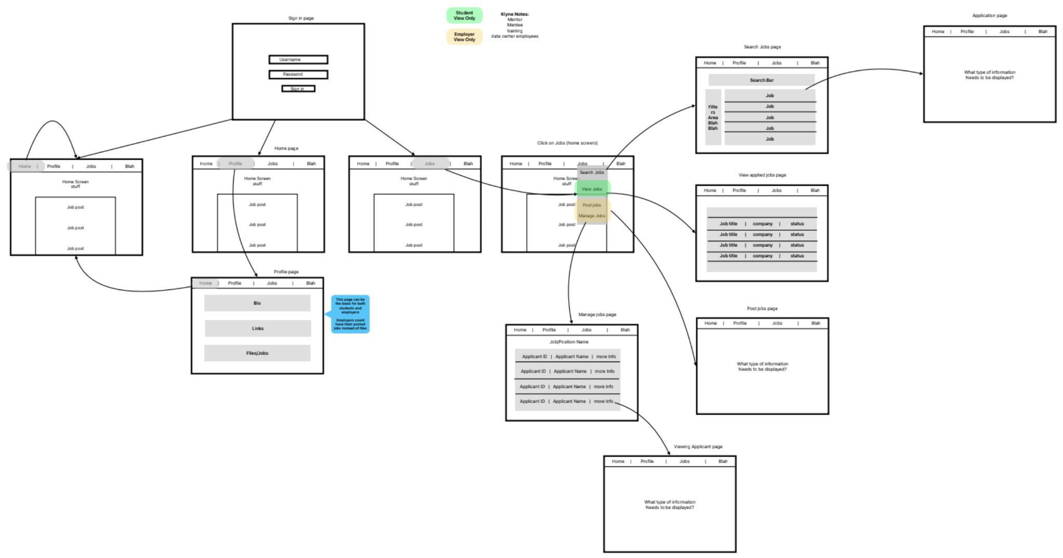

Architecture & Technical Design

Introduction
The proposed solution is a web-based career matching platform that connects students and employers through a secure, scalable, and analytics-driven system. The architecture was designed to support user authentication using iMason credentials, dynamic profile management, employer job postings, advanced search filtering, and real-time analytics. Given the requirement for high availability, scalability, and maintainability, a modern three-tier web architecture was selected. The technical approach emphasizes modular design, horizontal scalability, and strong security controls (TLS encryption and credential validation). Early design challenges included balancing fast page load requirements (≤5 seconds) with analytics tracking and ensuring secure authentication without introducing excessive complexity. These were addressed through the use of efficient API design, indexed database queries, and a stateless backend architecture that supports horizontal scaling.

Context Diagram
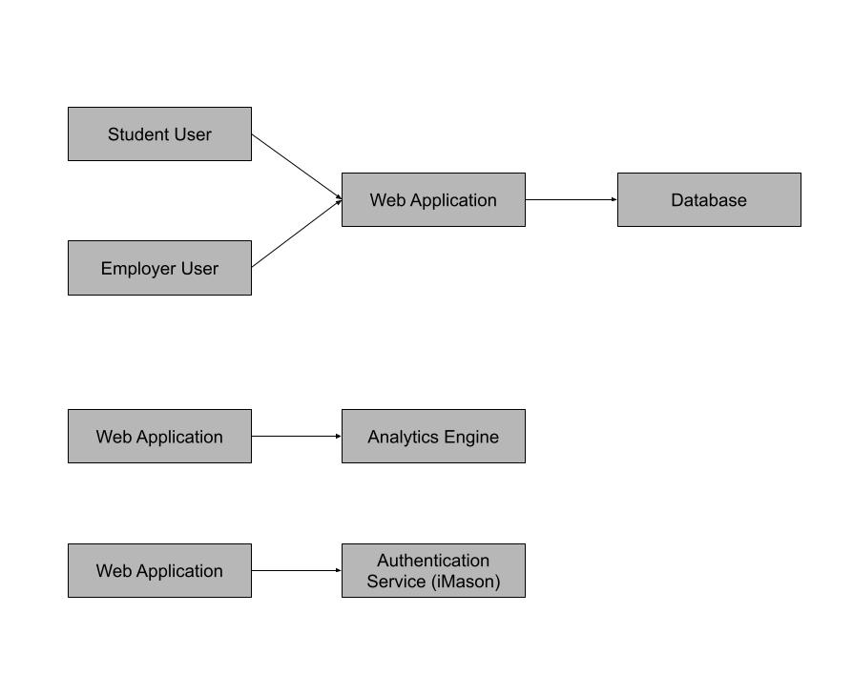

Architecture Design
High-level Components
- Front end - presentation layer
- Backend/API - application layer
- Database - data layer
- External Authentication - iMason
- Analytics module

Technology Stack
- Frontend
  - React.js
    - Improves maintainability and usability
    - Supports responsive design
  - HTML5
    - Modern browser support
- Backend
  - Undecided API
    - High performance
    - Good scalability support
- Database
  - SQL
    - Reliable relational database
    - Strong data integrity
- Security Components
  - iMasons credential verification
  - Password hashing

Implementation

Coding
How will the system be implemented correctly and consistently?
- Coding Standards & Conventions - In order to ensure consistency and maintainability, the project will follow established coding standards:
  - Use consistent naming conventions (camelCase)
  - Modular file structure
  - Clear function documentation
  - Error handling for all API endpoints
  - Proper comments
- Technology Stack & Development Environment - Languages & Frameworks (tentative):
    - Frontend: React.js, Javascript, HTML
    - Backend: python
    - Database: SQL
    - Authentication: iMasion integration
    - Encryption: TLS 1.2+
  - Development Tools:
    - IDE: VS code
    - Version Control: Git or Github
    - API testing: Postman
  - Git Branching Strategy:
    - Main -> production ready code
    - Develop -> integration branch
    - Feature -> Individual features
    - Pull requests required before merge
- Module / Component Implementation Strategy
  - Authentication Module
    - Responsibilities
      - Handle login requests
      - Validate iMason credentials
      - Issue secure session tokens
    - Interactions
      - Frontend login page
      - iMason authentication service
      - User database
  - Student Profile Module
    - Responsibilities
      - create/update student bio
      - Store linkedIn,Github or other links
      - Retrieve profile data
  - Employer Posting Module
    - Responsibilities
      - Create job postings
      - Store custom questions
      - Manage applicant submissions
  - Search & FIlter Module
    - Responsibilities
      - Filter by location, type, availability, industry, etc.
      - Use indexed queries for performance
  - Analytics Module
    - Responsibilities
      - Track views
      - Track applications
      - Generate dashboard metrics

Testing
How will we prove it works and continues to work?
- Test Concept (The “Why” and “What”) - Define the overall testing approach, objectives, and scope of testing for the system. Sections could include:
  - Testing objectives
  - Scope of testing (what is and isn’t tested)
  - Testing levels: (Unit, Integration, System, Acceptance

Testing Objective: The objective of testing the iMason Job Board is to verify that all features function correctly, meet the requirements, and deliver a reliable experience for both students and employers. Testing will confirm that authentication, job posting, search filtering, and profile creation behave as expected under normal and edge-case conditions.

Testing Scope:
- In scope: user authentication and login, student profile creation, employer job posting, employer search and filter functionality, and page load performance.
- Out of scope for this phase: third-party integrations beyond iMason credentials, mobile native applications.

Testing Levels: Unit testing will validate individual components like form validation logic and API endpoints. Integration testing will verify that the frontend, backend, and database interact correctly. System testing will validate end-to-end user workflows, like when a student logs in and applies to a posting. Acceptance testing will confirm the system meets sponsor requirements before handover.

- Test Cases (functional and non-functional) - Create detailed test cases that validate the system’s functional and non-functional requirements.
  - Each test case must include (create a table / can be combined with TTM):
    - Test Case ID
    - Related requirement ID / user story / feature
    - Description
    - Preconditions
    - Test steps
    - Expected results
    - Actual results (if executed)
    - Pass/Fail status

ID | Description | Preconditions | Test Steps | Expected Results | Actual Results | Status
TC-01 | Valid user login with iMason credentials | User account exists in the iMason database | 1. Navigate to login page.  2. Enter valid username and password.  3. Click Login. | User is authenticated and redirected to the dashboard
TC-02 | Login attempt with invalid credentials | The login page is accessible | 1. Navigate to the login page.  2. Enter incorrect password.  3. Click Login. | Error message is displayed, user is not logged in
TC-03 | Student creates a profile with bio and external links | User is logged in as a student | 1. Navigate to profile page.  2. Enter bio text and LinkedIn URL. 3. Save profile. | Profile is saved and displayed correctly with all entered information
TC-04 | Employer creates a job posting with custom questions | User is logged in as an employer | 1. Navigate to the posting page.  2. Fill in role details and add a custom question. 3. Submit posting. | Posting is created and visible to students; a custom question appears on the application form
TC-05 | Search postings filtered by location and job type | At least 2 job postings exist with different locations and types | 1. Navigate to the search page.  2. Apply location filter.  3. Apply job type filter.  4. Review results. | Only postings matching selected filters are returned
TC-06 | All pages load within the 5-second performance requirement | Application is deployed to a test environment with sample data | 1. Open browser dev tools.  2. Navigate to each major page. 3. Record load time for each. | Every page loads in under 5 seconds

- Defect Management & Reporting - Explain how defects will be documented, tracked, and resolved during the testing process.

The founder will log all Defects found, and the team will be alerted and begin to fix them. If it is a critical bug, it will be fixed before any more feature implementation is continued. We will log the tester's name, the bug they found, and the severity to ensure we have a record of every issue that arises. Once an issue is fixed, the tester will re-run all tests to ensure it works 100% of the time.

- Optional: Test Traceability Matrix (TTM) (Highly Recommended) - Provide a test traceability matrix demonstrating coverage of all system requirements.

Handover
- Handover Plan
  - The goal is to ensure the company can fully own, operate, and maintain the system with minimal external support.
  - Source code will be delivered through the organization’s Git repo.
  - Administrative access will be granted to Hiba, which she can grant to the designated company engineering team.
  - All active branches will be merged into the main production branch.
- Transition Plan
  - The transition will occur in phased steps to minimize operational risk
  - Repo access granted to whomever the company designates
  - Environment replication in company infrastructure
  - Shadow support period (can negotiate timeline)
  - Formal ownership sign-off

Future Phases
Recommended Enhancements:
- Real-time features
  - Realtime notification for applications
- Security Hardening:
  - Audit logging
  - Penetration testing
- Analytics expansion
  - Student engagement metrics
  - Exportable reporting

