Jack Zhan

Homework 2

1.

#Homework 2

#Author: Jack Zhan

#This is the code for Homework 2

#Loading the library marray

library(marray)

#Setting the working directory

setwd("C:\\Users\\Jack\\Desktop\\R_Lab\\HW2")

file_location <- "C:\\Users\\Jack\\Desktop\\R_Lab\\HW2"

#loading the genepix_files

genepix_files <- read.GenePix(path=file_location)

2.

#Normalize each array using median global, loess, and print-tip-group loess methods

genepix_normal <- maNorm(genepix_files,norm="median")

genepix_loess <- maNorm(genepix_files,norm="loess")

genepix_tip <- maNorm(genepix_files,norm="printTipLoess")

genepix_none <- maNorm(genepix_files,norm="none")

# 4 figures arranged in 2 rows and 2 columns

par(mfrow=c(2,2))

#Plot each of the 4 No Normalization

maPlot(genepix_none[,1],main='No Normalization\nArray 1',legend.func=NULL)

maPlot(genepix_none[,2],main='No Normalization\nArray 2',legend.func=NULL)

maPlot(genepix_none[,3],main='No Normalization\nArray 3',legend.func=NULL)

maPlot(genepix_none[,4],main='No Normalization\nArray 4',legend.func=NULL)

dev.copy(png,'genepix_none.png')

dev.off()

# 4 figures arranged in 2 rows and 2 columns

par(mfrow=c(2,2))

#Plot each of the 4 Normalization

maPlot(genepix_normal[,1],main='Normalization\nArray 1',legend.func=NULL)

maPlot(genepix_normal[,2],main='Normalization\nArray 2',legend.func=NULL)

maPlot(genepix_normal[,3],main='Normalization\nArray 3',legend.func=NULL)

maPlot(genepix_normal[,4],main='Normalization\nArray 4',legend.func=NULL)

dev.copy(png,'genepix_normal.png')

dev.off()

# 4 figures arranged in 2 rows and 2 columns

par(mfrow=c(2,2))

#Plot each of the 4 Loess

maPlot(genepix_loess[,1],main='Loess\nArray 1',legend.func=NULL)

maPlot(genepix_loess[,2],main='Loess\nArray 2',legend.func=NULL)

maPlot(genepix_loess[,3],main='Loess\nArray 3',legend.func=NULL)

maPlot(genepix_loess[,4],main='Loess\nArray 4',legend.func=NULL)

dev.copy(png,'genepix_loess.png')

dev.off()

# 4 figures arranged in 2 rows and 2 columns

par(mfrow=c(2,2))

#Plot each of the 4 Print Tip Loess

maPlot(genepix_tip[,1],main='Print Tip Loess\nArray 1',legend.func=NULL)

maPlot(genepix_tip[,2],main='Print Tip Loess\nArray 2',legend.func=NULL)

maPlot(genepix_tip[,3],main='Print Tip Loess\nArray 3',legend.func=NULL)

maPlot(genepix_tip[,4],main='Print Tip Loess\nArray 4',legend.func=NULL)

dev.copy(png,'genepix_tip.png')

dev.off()

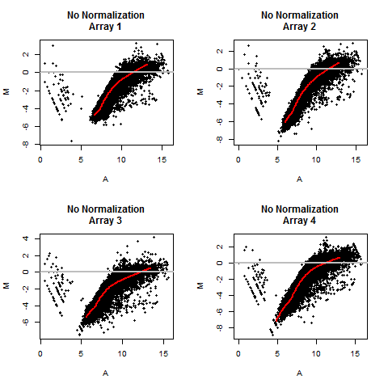

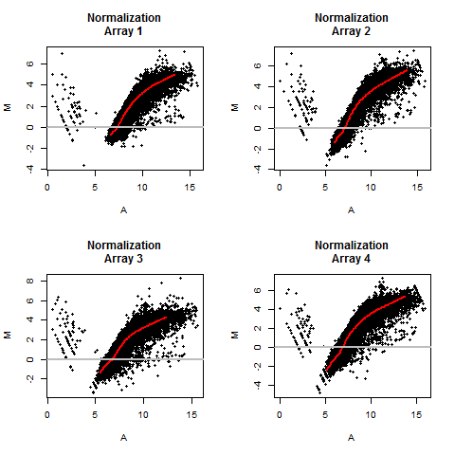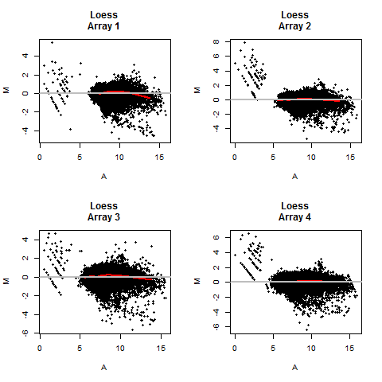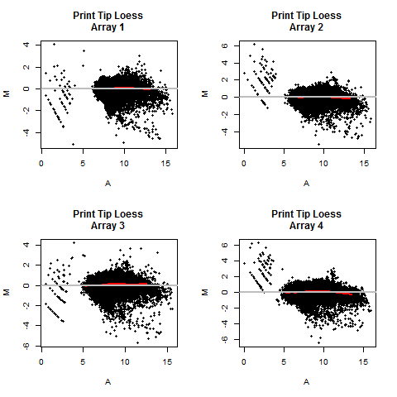

3.

#Density plot with log ratio values

#Remove all missing values for calculation

density_none <-density(maM(genepix_none)[,4],na.rm=T)

density_normal <-density(maM(genepix_normal)[,4],na.rm=T)

density_loess <-density(maM(genepix_loess)[,4],na.rm=T)

density_tip <-density(maM(genepix_tip)[,4],na.rm=T)

plot(c(-10,10),c(0,1),main="Array 4 Density plots",xlab="Log Ratio",ylab="Density")

lines(density_none, lwd=1,col="black")

lines(density_normal, lwd=1, col="red")

lines(density_loess, lwd=1,col="blue")

lines(density_tip, lwd=1,col="green")

legend("topright",c("None","Normalized","Loess","Print Tip Loess"),pch=15,col=c("black","red","blue","green"))

dev.copy(png,'density_plot.png')

dev.off()

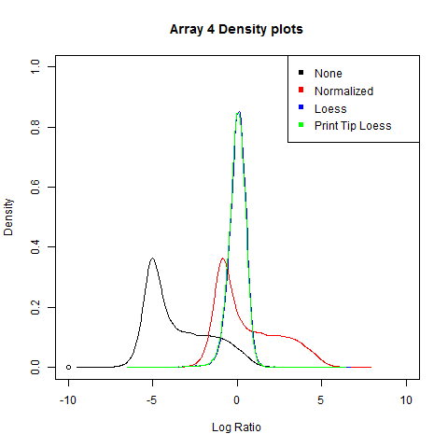

4. I think Loess is the best. Print Tip Loess is basically the same as Loess based on the graphs produced. They both have a log ratio close to 0 and a cluster that most resembles a circle around 0.

5.

#Extracting the Cy5 foreground and background values

foreground <- maRf(genepix_files)

background <-maRb(genepix_files)

#subtract the background from the foreground values, then log2 transform

cy5 <- log2(foreground-background)

print (cy5)

#Calculating global median normalization

cy5_normalized <-cy5

for (i in 1:ncol(cy5)) {

cy5_normalized[,i] = cy5_normalized[,i]/median(cy5_normalized[,i],na.rm = T)

}

6.

# Spearman Correlation calculation on cy5_normalized

cy5.cor <- cor(cy5_normalized,method="spear",use="pairwise.complete.obs")

rownames(cy5.cor) <- c()

colnames(cy5.cor) <- c()

print(cy5.cor)

[,1] [,2] [,3] [,4]

[1,] 1.0000000 0.8962752 0.8790831 0.8990696

[2,] 0.8962752 1.0000000 0.8766078 0.9080043

[3,] 0.8790831 0.8766078 1.0000000 0.8854758

[4,] 0.8990696 0.9080043 0.8854758 1.0000000

# Spearman Correlation calculation on loess data

loess_normalized <- maM(genepix_loess)

loess.cor <- cor(loess_normalized,method="spear",use="pairwise.complete.obs")

rownames(loess.cor) <- c()

colnames(loess.cor) <- c()

print(loess.cor)

[,1] [,2] [,3] [,4]

[1,] 1.0000000 0.6882265 0.7587292 0.6916965

[2,] 0.6882265 1.0000000 0.7217613 0.7061138

[3,] 0.7587292 0.7217613 1.0000000 0.7467916

[4,] 0.6916965 0.7061138 0.7467916 1.0000000

#Create matrix plot using pairs function

pairs(cy5_normalized,labels=c("Array 1","Array2","Array3","Array4"),main="Cy5 background Subtract\nNormalized Intensities",pch="*",col="red")

dev.copy(png,'matrix_cy5.png')

dev.off()

pairs(loess_normalized,labels=c("Array 1","Array2","Array3","Array4"),main="LnNormalized Intensities",pch="*",col="red")

dev.copy(png,'matrix_loess.png')

dev.off()

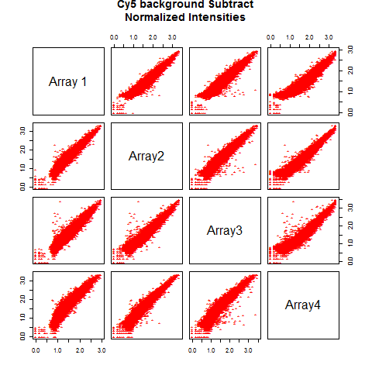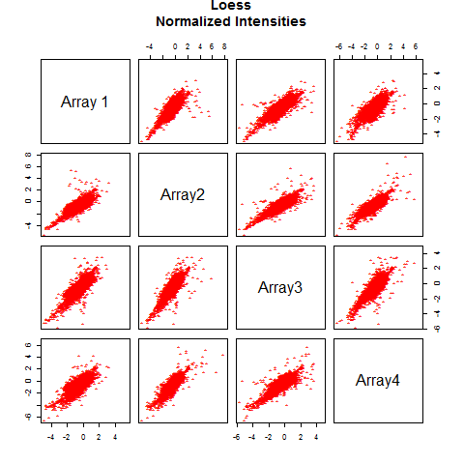

7.

#Get unlogged version of background subtract

cy5_unlog <- foreground-background

#put values in matrix

cy5_matrix <- matrix(cy5_unlog,nrow=nrow(cy5_unlog),ncol=ncol(cy5_unlog))

print(cy5_matrix)

#sort the columns

cy5_sort <- apply(cy5_matrix,2,sort)

#Get mean on sorted data

print(cy5_sort)

cy5_mean <- apply(cy5_sort,1,mean)

print(cy5_mean)

#Apply row mean to a new matrix

cy5_mean_matrix <- matrix(cy5_mean,nrow=nrow(cy5_unlog),ncol=ncol(cy5_unlog))

print(cy5_mean_matrix)

#Rank the inital matrix with the argument ties=”first"

cy5_rank <- apply(cy5_matrix,2,rank,ties="first")

#Create empty matrix

cy5_final<-matrix(, nrow=nrow(cy5_unlog),ncol=ncol(cy5_unlog))

#Rank the columns independently on the original background subtracted matrix

for(i in 1:ncol(cy5_rank)) {

cy5_final[,i] = cy5_sort[cy5_rank[,i],i]

}

#verifying the rankings with histograms of each column

par(mfrow=c(2,2))

hist(cy5_final[,1])

hist(cy5_final[,2])

hist(cy5_final[,3])

hist(cy5_final[,4])

dev.off()

8.

#Spearman Correlation calculation on cy5_final

log_cy5 <- log2(cy5_final)

log_cy5.cor <- cor(log_cy5,method="spear",use="pairwise.complete.obs")

print(log_cy5.cor)

[,1] [,2] [,3] [,4]

[1,] 1.0000000 0.8962752 0.8790831 0.8990696

[2,] 0.8962752 1.0000000 0.8766078 0.9080043

[3,] 0.8790831 0.8766078 1.0000000 0.8854758

[4,] 0.8990696 0.9080043 0.8854758 1.0000000

airs(log_cy5,labels=c("Array 1","Array2","Array3","Array4"),main="Background subtracted Cy5\nRank Normalized",pch="*",col="red")

dev.copy(png,'matrix_rank_cy5.png')

dev.off()

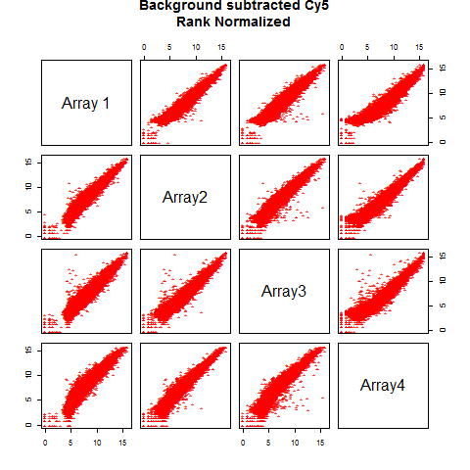

9. I would go with background select rank normalized because the image in the matrix plots are most consistent throughout the arrays. We also did a lot of work to create the plot as well.

10.

f.parse <- function(path=pa,file=fi,out=out.fi) {

d <- read.table(paste(path,file,sep=""),skip=11,sep=",",header=T)

u <- as.character(unique(d$Name))

u <- u[u!=""]; u <- u[!is.na(u)];

ref <- unique(as.character(d$Name[d$Type=="Reference"]))

u <- unique(c(ref,u))

hg <- c("B-actin","GAPH","18S")

hg <- toupper(hg)

p <- unique(toupper(as.character(d$Name.1)))

p <- sort(setdiff(p,c("",hg)))

mat <- matrix(0,nrow=length(u),ncol=length(p))

dimnames(mat) <- list(u,p)

for (i in 1:length(u)) {

print(paste(i,": ",u[i],sep=""))

tmp <- d[d$Name %in% u[i],c(1:3,6,9)]

g <- toupper(unique(as.character(tmp$Name.1)))

g <- sort(setdiff(g,c("",hg)))

for (j in 1:length(g)) {

v <- tmp[toupper(as.character(tmp$Name.1)) %in% g[j],5]

v <- v[v!=999]

v <- v[((v/mean(v))<1.5) & ((v/mean(v))>0.67)] #gene j vector

hv3 <- NULL

for (k in 1:length(hg)) { #housekeeping gene vector (each filtered by reps)

hv <- tmp[toupper(as.character(tmp$Name.1)) %in% hg[k],5]

hv <- hv[hv!=999]

hv3 <- c(hv3,hv[((hv/mean(hv))<1.5) & ((hv/mean(hv))>0.67)])

}

sv <- mean(as.numeric(v)) - mean(as.numeric(hv3)) #scaled value for gene j

if(i==1) { #reference sample only

mat[u[i],g[j]] <- sv

next

}

mat[u[i],g[j]] <- sv - mat[u[1],g[j]]

}

}

mat[1,][!is.na(mat[1,])] <- 0

fc <- 2^(-1 * mat)

write.table(t(c("Subject",dimnames(mat)[[2]])),paste(path,out,sep=""),quote=F,sep="\t",col.names=F,row.names=F)

write.table(round(fc,3),paste(path,out,sep=""),quote=F,sep="\t",append=T,col.names=F)

}

f.parse(file_location,"\\Inflammation_qRT-PCR.csv","\\output.txt")

11.

#Convert to matrix

pcr_matrix <- t(as.matrix(qrt_pcr))

pcr_matrix = pcr_matrix[,-14]

print(pcr_matrix)

qrt_pcr.cor <- cor(pcr_matrix,method="spear",use="pairwise.complete.obs")

print(qrt_pcr.cor)

matrix_cor_qrt <- as.matrix(qrt_pcr.cor)

print(matrix_cor_qrt)

matrix_cor_qrt = matrix_cor_qrt

#Remove unwanted data

matrix_cor_qrt[is.na(matrix_cor_qrt)] <- 0

matrix_cor_qrt[matrix_cor_qrt > .9999999] <- 0

#Get max value

print(max(matrix_cor_qrt))

#Max value of 0.9724138 for 434_3 and 434_8

#grab the 434_3 and 434_8

p_434_3 <-as.numeric(qrt_pcr["434_3",])

print(p_434_3)

p_434_8 <-as.numeric(qrt_pcr["434_8",])

print(p_434_8)

#Plot graph

plot(p_434_3,p_434_8,xlab="434_3",ylab="434_8",main="Top two Patients\nP Cor=0.972",pch="*",col="red")

dev.copy(png,'qrt_plot.png')

dev.off()

