**Level 3 Team Project**

Work as a team to complete the following.

Your task is to build a simple GUI with six buttons. (see image) There should be an up, down, left, right button and a start and stop button.

When the record button is pressed, the program should then remember all the unique directional buttons that are pressed. However, if a certain direction is pressed twice (or more) in a row, the program should ignore all presses after the first. When the stop button is pressed, use a JOptionPane to display the list of unique directions in forward and reverse order.

SAMPLE OUTPUT

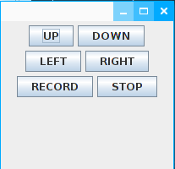

button presses:

record

up

down

down

left

up

up

right

right

right

right

down

down

up

left

stop

output:

forward: up, down, left, up, right, down, up, left

backward: left, up, down, right, up, left, down, up

The program is broken down into three packages. GUI, logic, and tests. Use the test classes in the test package to write unit tests for all needed methods first.

The WindowBuilder class in the gui package should only construct the window and use the InstructionManager object to handle all the logic.

The InstructionManager class has two array lists and a stack. Use one array list to store the directions in order. Then use the stack to fill the second array list with the direction in reverse order. Add appropriate field variables along with getters and setters when necessary.

*Bonus: Add some sort of indicator to let the user know if the program is recording or not.