WEEK 4 SEMESTER 2: SQL

1.

2.

3.

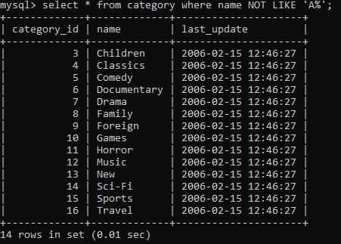4.

5.

6.

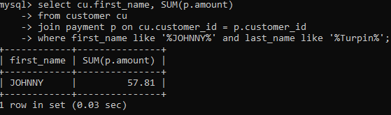 7.

8.

9.

10.

* Return all movies that are made after 2017 from the sci-fi category.
* Return the title of all actors who were in documentaries in 2014.
* Return the number of categories which have a name that does not start with the letter D.
* Return the number of actors which took part in the drama category in 2020.
* Return the name of the customer the bought the most movies in 2006 , show how much was spent