KolbKart

No-Lift Portable Shopping Cart

Jack Kolb

ME9, Engineering Graphics and Design

May 27th, 2017 to June 5th, 2017

Design Introduction 1

Given Problem Statement:

“Design a portable shopping cart that can be easily loaded into the rear of an SUV or minivan without removing the contents of the cart. The cart shall satisfy the following requirements:
- The cart shall have a cargo container (“basket”) with a base of 16 x 24 inches and 12 inches deep for holding groceries or other goods up to 30 lb.
- The cart shall easily slide into the back of the vehicle with a deck height of 30 inches without requiring the user to do any lifting.
- The stowed volume of the cart, including the cargo container, shall not exceed 30 x 30 x 18 inches (18 inches in height).
- The unloaded cart shall weigh less than 30 lb.
- The time required to load or unload the loaded cart from the vehicle shall not exceed 45 seconds.
- The portion of the cart that contacts the vehicle shall be designed not to damage the vehicle.
- The cart shall be simple, safe, reliable and aesthetically pleasing”

Restated Problem Statement:

- Design a personal shopping cart
- Basket ≥ 16 x 24 x 12 inches, expected load ≤ 30 lb
- Slides into expected deck height of 30 inches, no lifting
- Stowed volume ≤ 30 x 30x 18 inches
- Unloaded cart ≤ 30 lb
- Load/Unload time ≤ 45 seconds
- No vehicle damage
- “simple, safe, reliable, looks pretty”

Physical Design Essentials:

- Rounded edges (safety)
- Simple, sturdy mechanisms (reliability, performance)
- Factor of Safety ≥ 1.5 (reliability, safety, performance)
- Quality parts (reliability, safety, performance)

Likely Materials:

- Basket: Steel, Aluminum, Plastic, Fabric
- Frame: Steel, Aluminum, Plastic, Brass
- Wheels: Steel, Plastic
- Widgets: Steel, Aluminum Plastic

Design Concept Generation 2

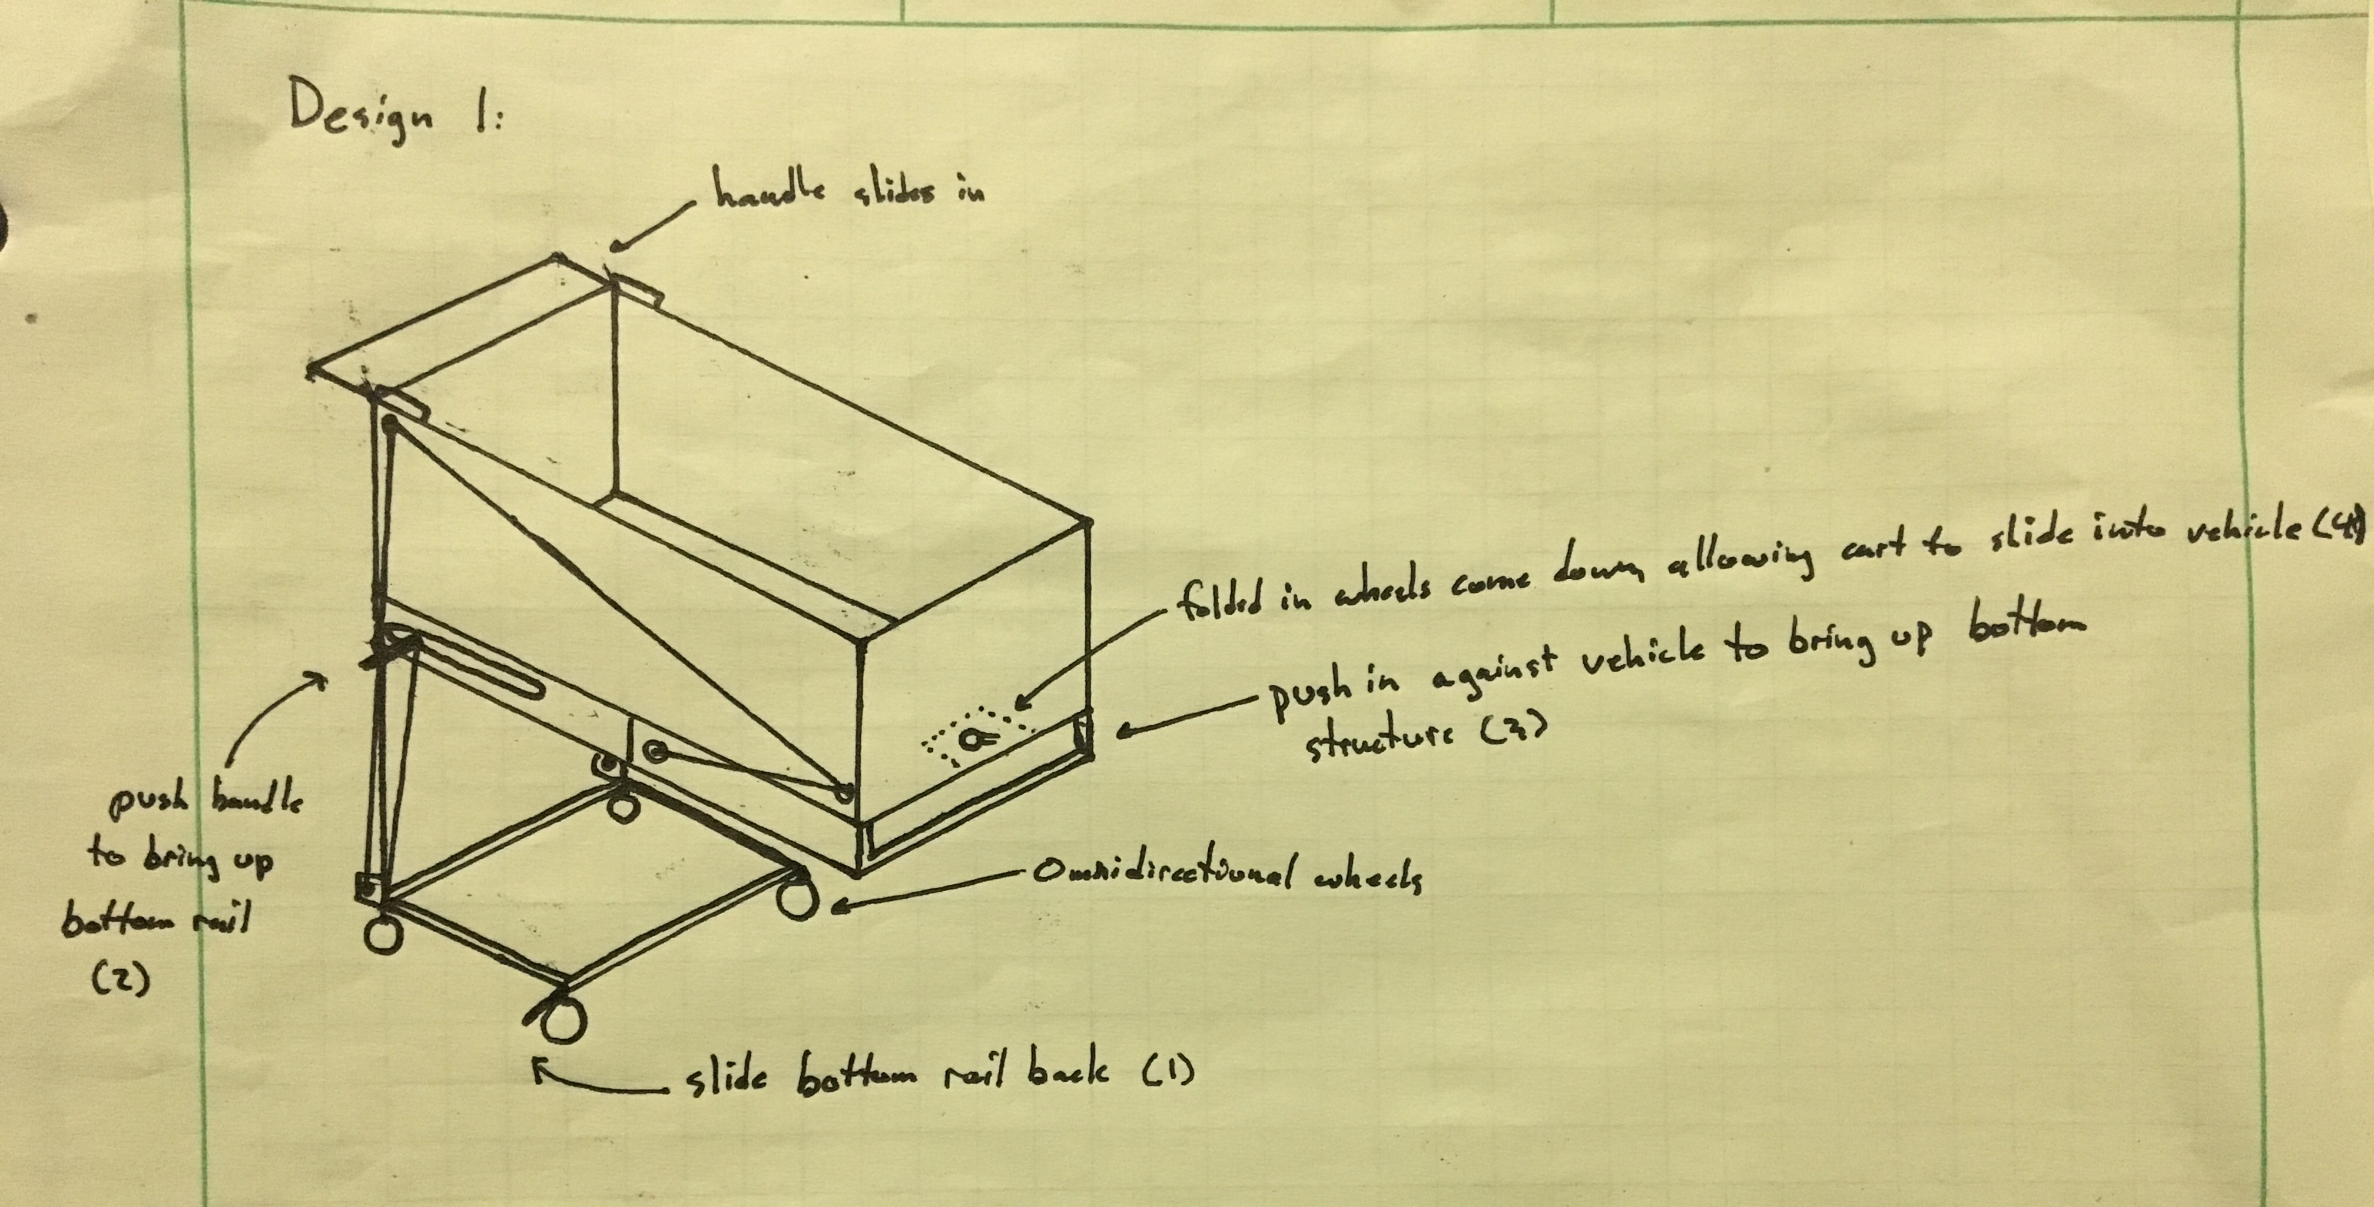

Design 1 features a pulley system to retract the legs: the user first uses the friction of the basket’s bottom and the vehicle deck to fold the legs, and then pushes a handle to raise the legs.

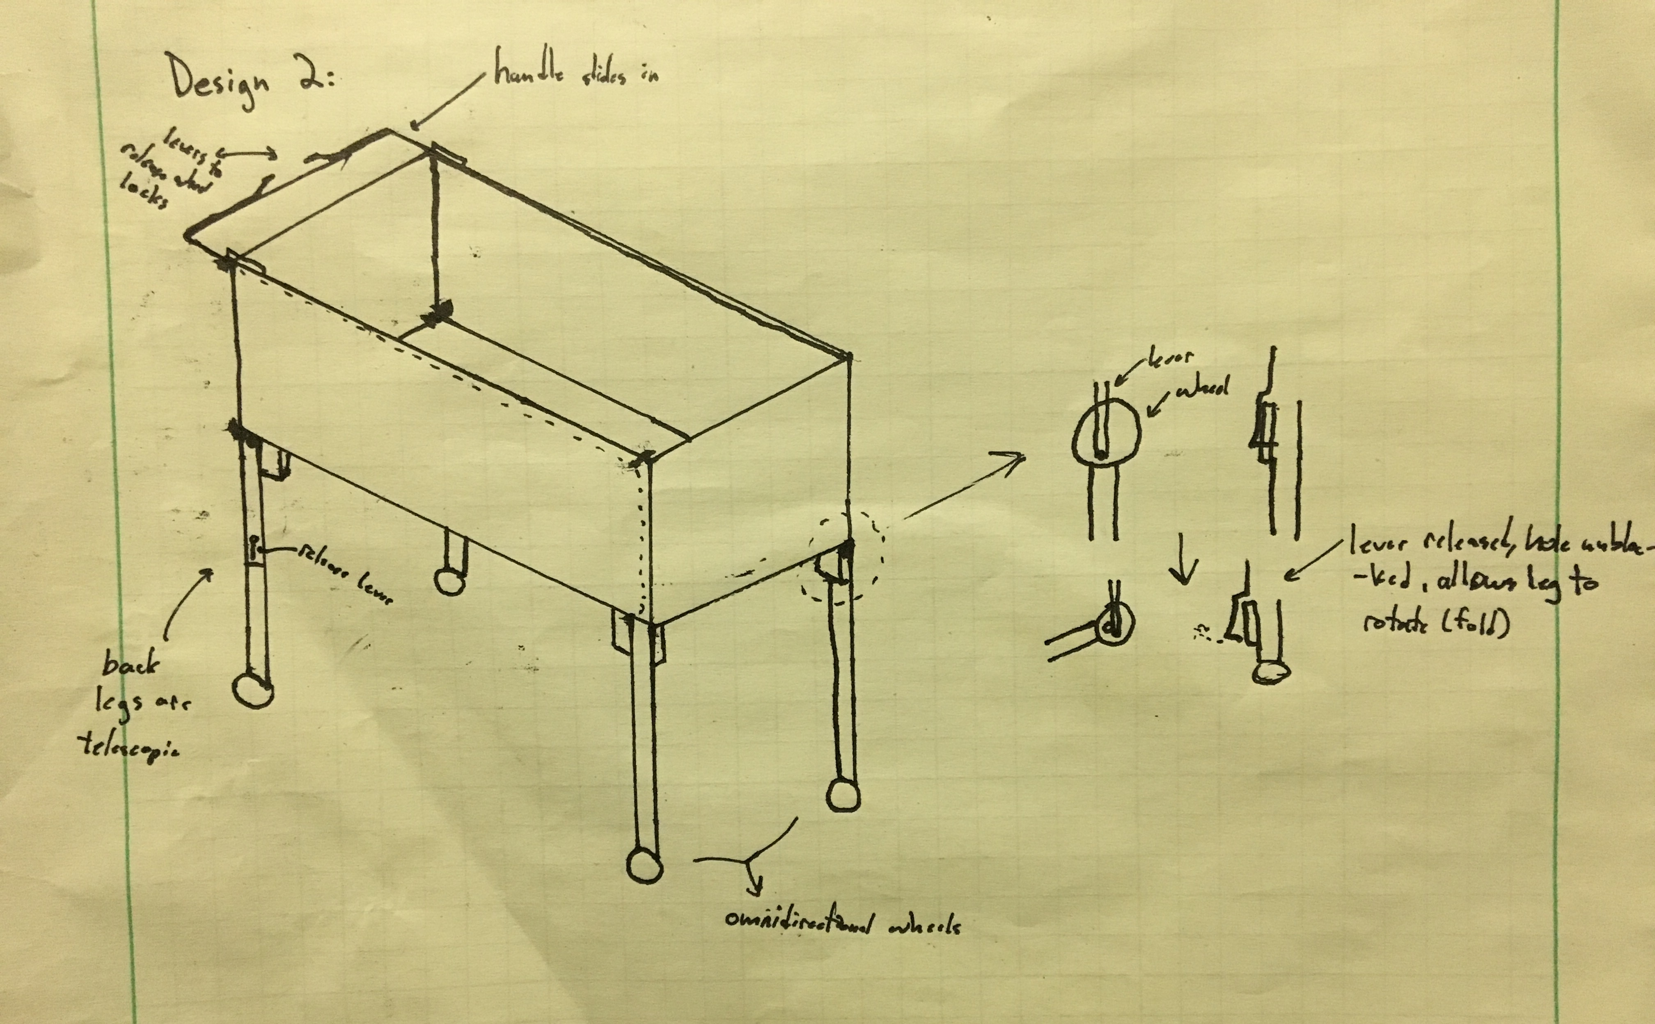

Design 2 features legs that fold back and in underneath/next to the cart.

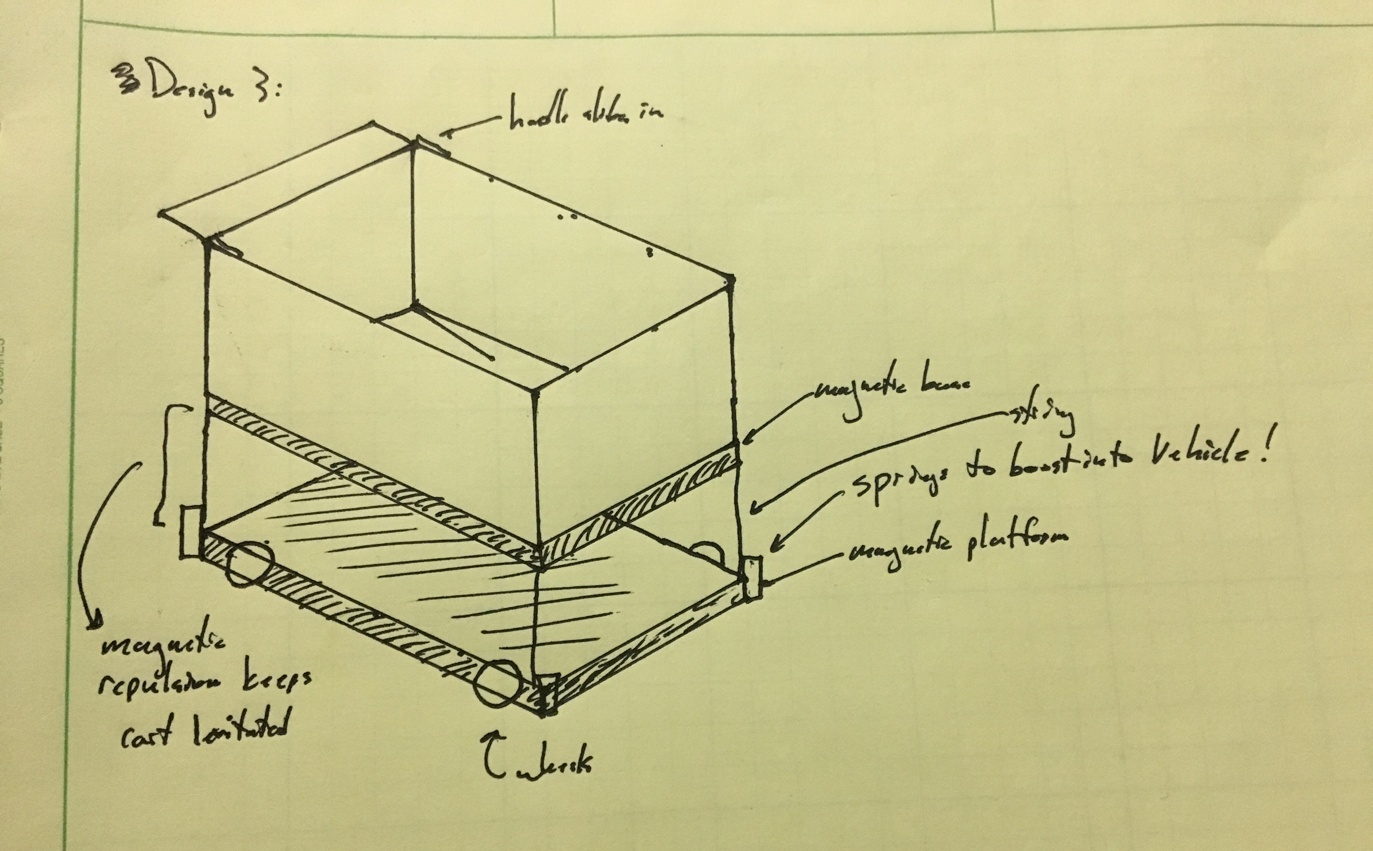

Design 3 features an electromagnetic surface underneath the cart, repelling the cart, allowing the basket to hover midair. To stow, the electromagnet reverses polarity, attracting the two surfaces.

Design Decision Matrix 3
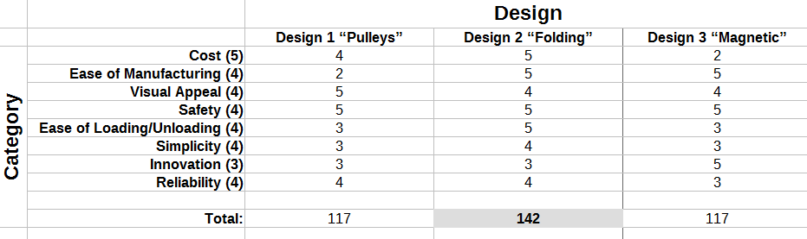

Cost: the expected monetary cost of the design’s manufacturing
Ease of Manufacturing: the expected simplicity of the design’s manufacturing ability
Visual Appeal: the design’s expected aesthetics
Safety: the design’s expected safety, to the user, the vehicle, and bystanders
Ease of Loading/Unloading: the design’s expected simplicity and efficiency of stowing/unstowing from a vehicle
Simplicity: the overall simplicity of the design
Innovation: the overall innovative metric of the design
Reliability: the overall reliability of the design, after time and wear

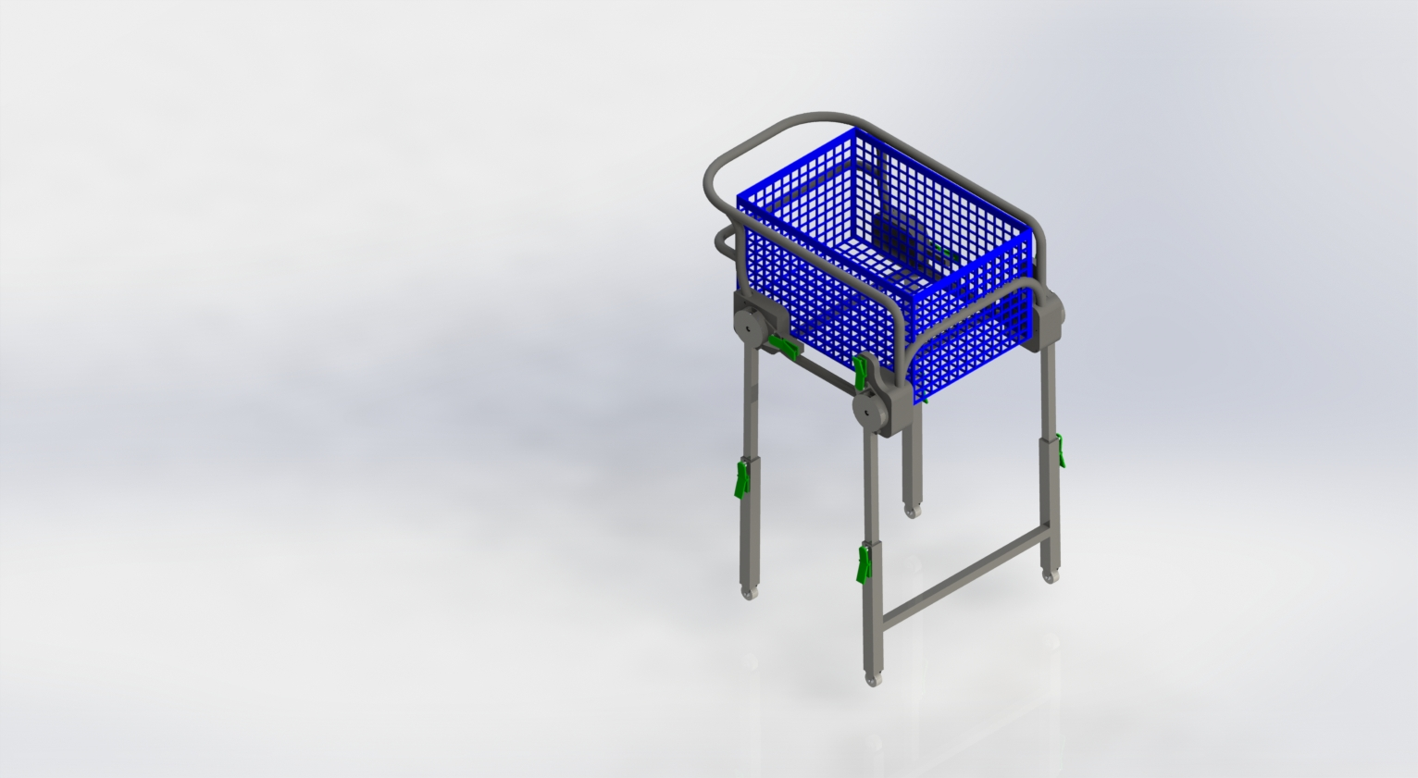
As per the decision matrix, the focused design will be Design 2. This cart will feature telescopic, locking legs that fold back, allowing for simple, reliable operation at a low cost.

Design Properties 4

Total Mass = 29.74 pounds

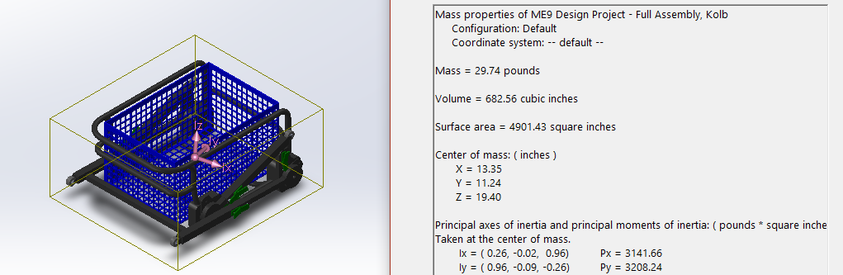
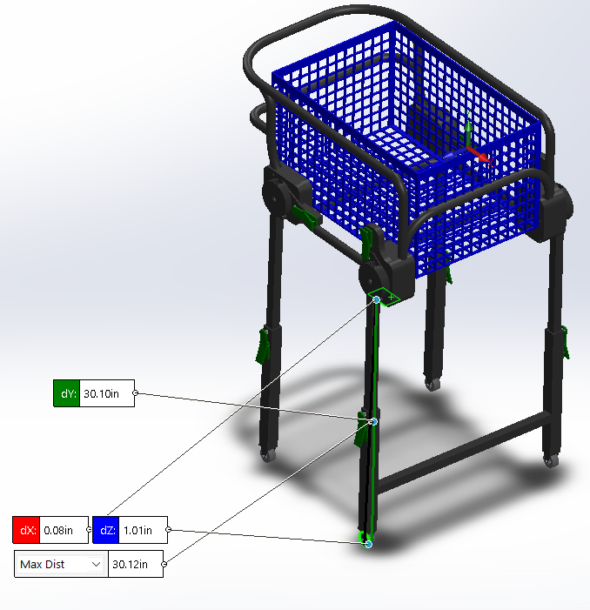

Unloaded Deck Clearance = 30.10 inches (right)
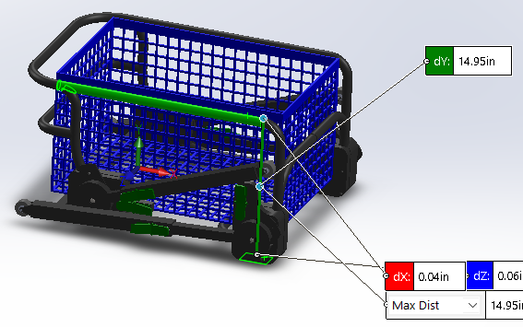

Stowed Height = 14.95 inches (above)

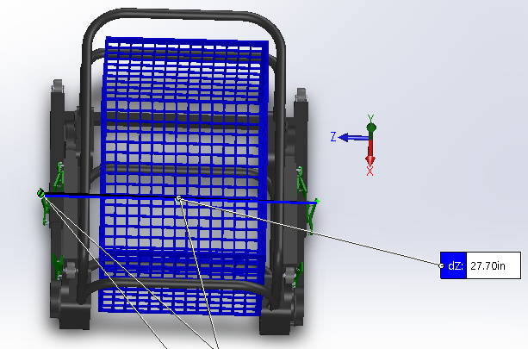
Stowed Width = 27.70 inches (right)

Stowed Length = 29.32 inches (below)

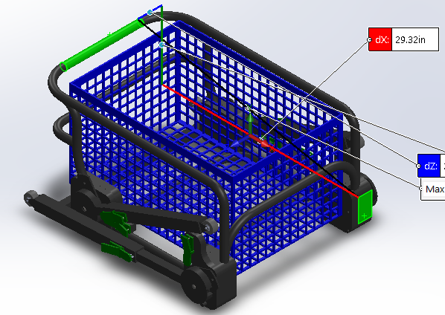

Basket Dimensions: 16 x 24 x 12.8 inches

Mechanism Overviews and Summaries 5

Levers:

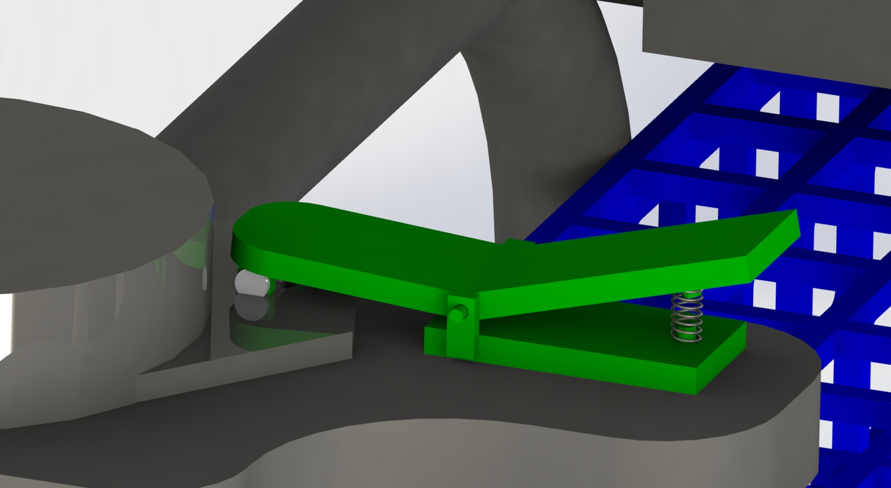
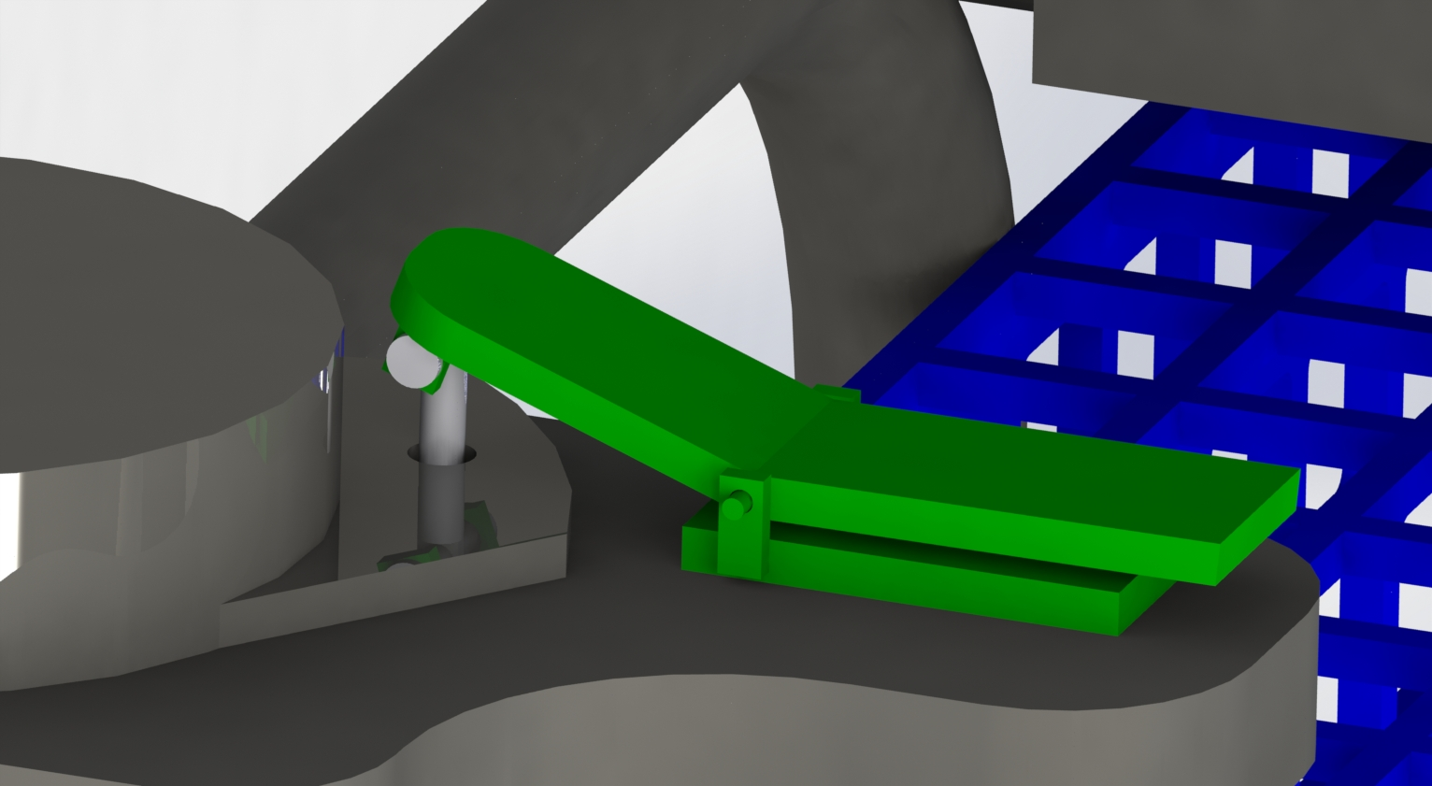

There are eight (8) total lever mechanisms on the cart, two per leg. By depressing the lever (see above), a pin is lifted and removed from an aligned hole, allowing rotation or movement of the part (see below). When the lever is not depressed, a spring prevents the pin from dislodging.

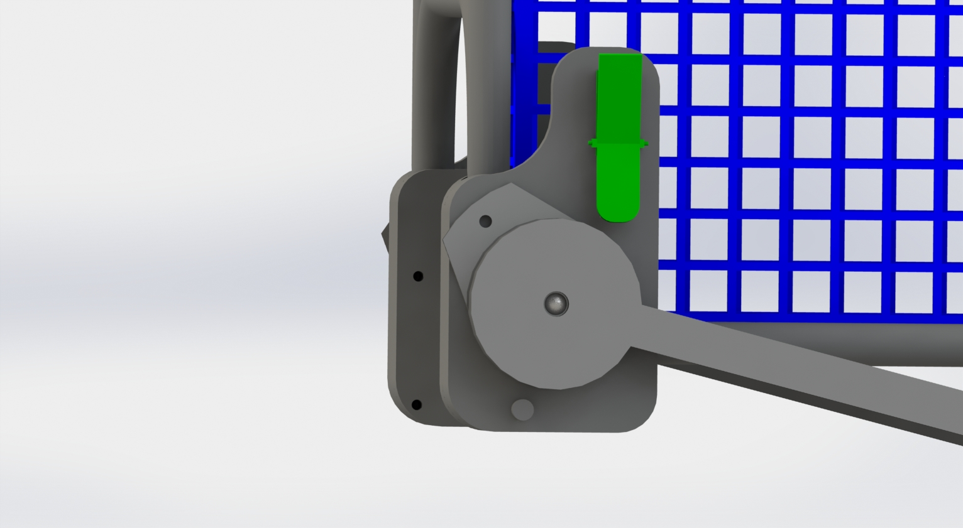
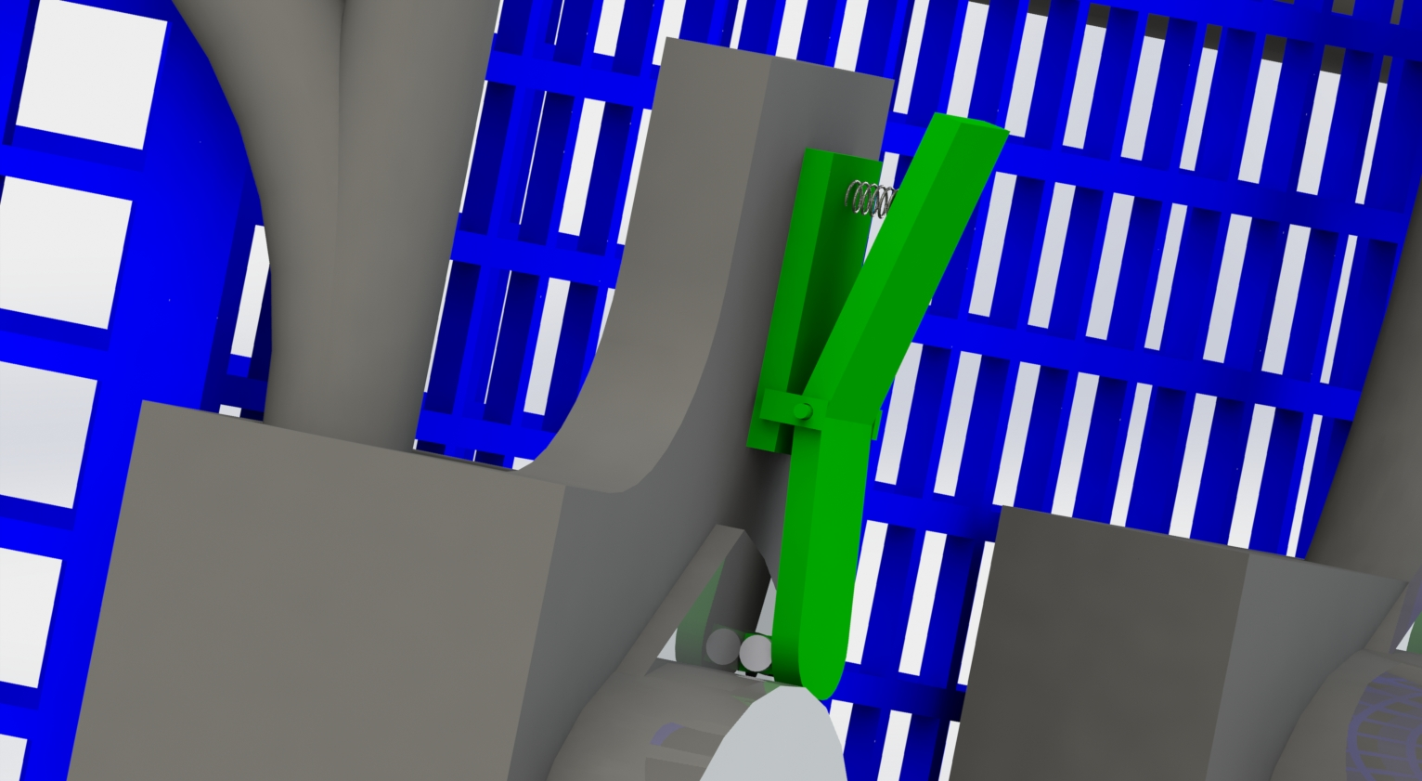

The lever toggle and base are made of ABS plastic, for it’s low-weight; the pin is made of Delrin 2700 NC010 plastic, for it’s high structural integrity and low-weight. The spring is a standard, stainless steel spring of diameter 0.2 inches.

Mechanism Overviews and Summaries 6
Frame:

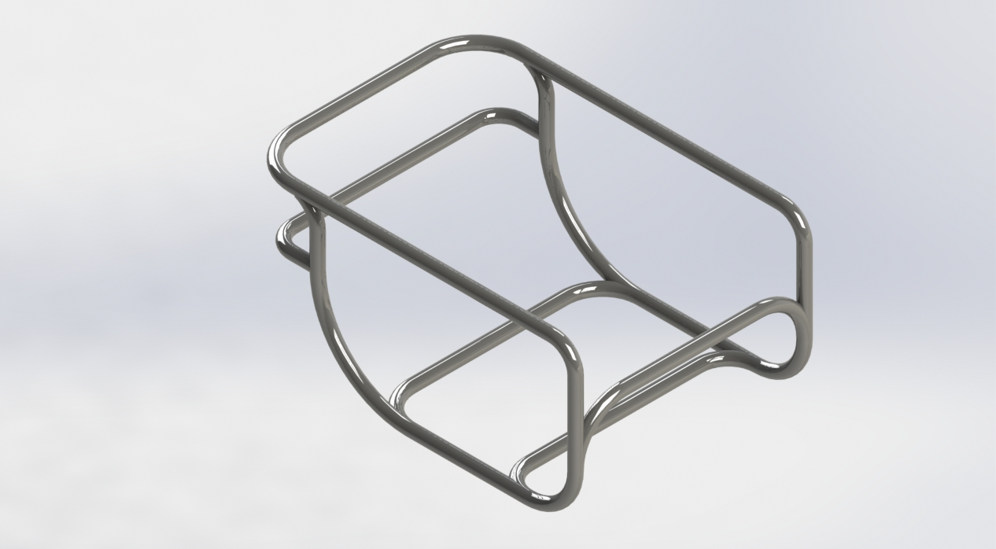

The frame’s curved design (see above) is intended for enhanced visual appeal and safety, compared to right-angle designs. The frame does not attach to the basket, but instead holds it, allowing the user to remove the basket if desired. The frame’s interior dimensions allow the basket 2.1 inches of “wiggle room” widthwise, and .64 inches lengthwise, for easier placement and removal. The top rear bar extends 2 inches out, to act as a handle for the cart.

The frame is made of Delrin 2700 NC010 plastic, for its high structural integrity, low cost, and low weight. Compared to aluminum or steel, plastic feels more pleasant to touch, and is resistant to temperature change, providing a more pleasurable, temperate experience.

Bolt:
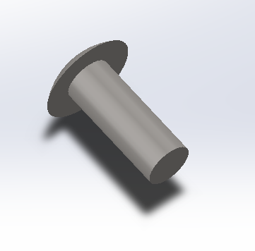

A single bolt model is used for the fastening and
axle of the legs to the leg braces (other fastenings
use plastic fusion). The provided bolt model part has
a shaft length of 0.65 inches, a shaft diameter of
.25 inches, and a head diameter of .5 inches.

The leg and brace holes can tolerate a bolt head diameter of
up to .6 inches.

The bolt is made of cast stainless steel, for its high structural strength.

Mechanism Overviews and Summaries 7

Leg Braces:
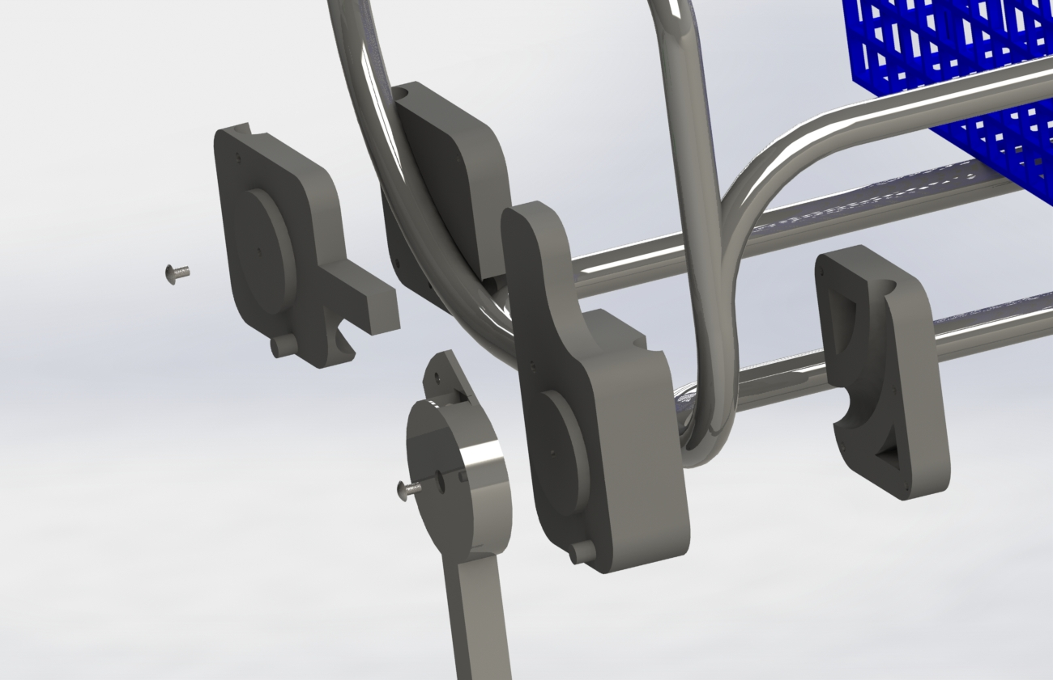

Each leg has a brace, split into two parts: an inside and an outside. The split is for manufacturing purposes. As shown, a swept cut matches the curved frame, fully restricting the brace’s movement. The brace consists of the frame attachment, an extrusion tab for lever placement, and a circular extrusion on which the leg caps over. An axle bolt connects the leg to the brace, allowing one degree of rotational freedom. All leg braces are made of ABS plastic, for its low weight and adequate structural integrity.

Legs:

Legs consist of two parts: an upper and lower structure.

The upper structure (see right) contains a long, vertical, square-prism, hollow axis. At the top is a circular form, perfectly fitting the corresponding leg brace. The leg is attached to the brace through both a bolt (which extends through the head’s center hole into the brace) and a lever pin (which extends through the tab’s hole into the brace).

When the lever is depressed, the leg is able to rotate along the bolted axis, however when the lever is not depressed, the leg is fixed.

The lower structure (not shown) is simple: merely a long hollow square prism, dimensioned to slide along the upper structure. A lever attached to the lower structure allows it to be fixed (or not) to the upper structure. At one end the structure is capped off, to support a wheel.

Both the upper and lower leg structures are made of Delrin 2700 NC010 plastic, for its high structural integrity, low cost, and low weight. While aluminum or steel would be more structurally sound, they are significantly heavier, and push the shopping cart’s overall weight beyond 30 pounds.

Mechanism Overviews and Summaries 8

Wheels:

The wheels are omnidirectional stock wheels (found here: “https://grabcad.com/library/shopping-cart-4”).

The original wheels were scaled down to a factor of 0.35, and the material changed to Delrin 2700 NC010 plastic (for its high structural integrity and low weight).

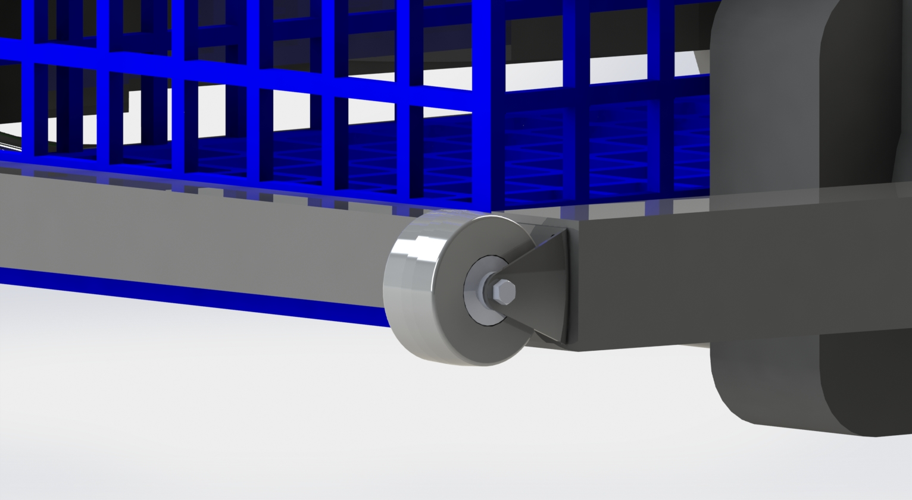

Basket:

The basket is not attached to the frame, allowing the user to use solely the basket instead of the cart if desired. Basket handles are not displayed on this design, however excess vertical space on the upper mouth has been provided to allow the installation of a handle. The basket is formed primarily in a grid pattern, with spacings large enough to greatly reduce weight and material costs, but small enough to contain all usual purchased items.

The basket is made from ABS plastic, in a tradeoff of high structural integrity for reduced weight, with the consideration of the frame’s support on the basket’s bottom face.

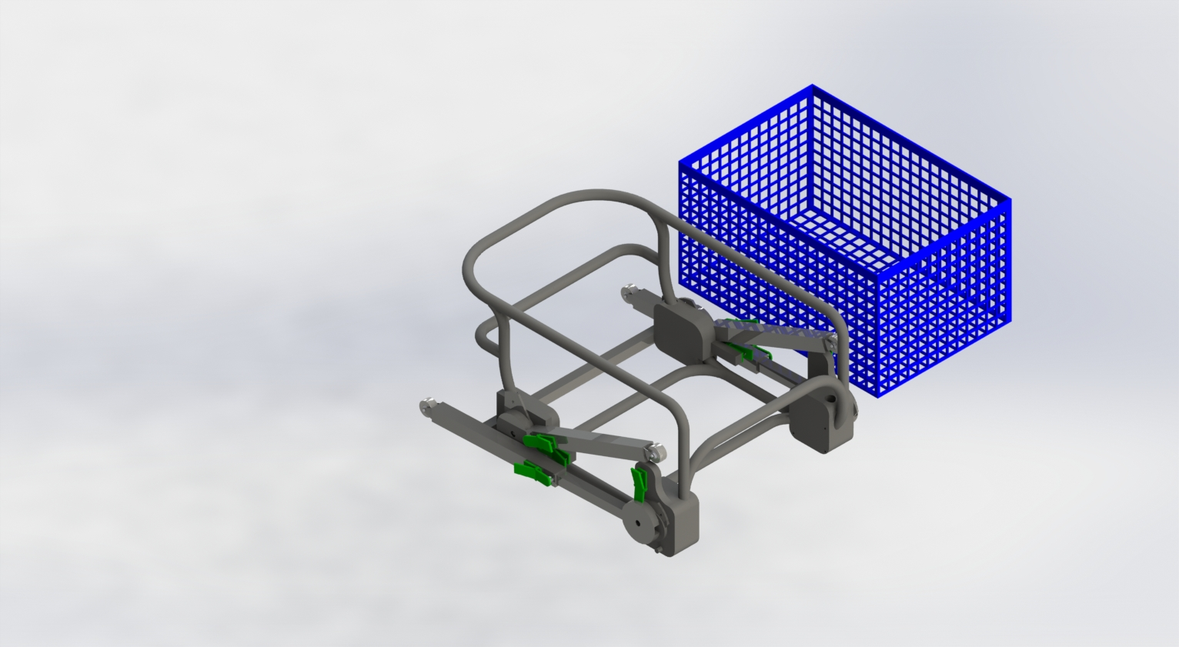

Operation Overview 9

Loading and unloading the shopping cart are simple reversed processes.

Unloading:
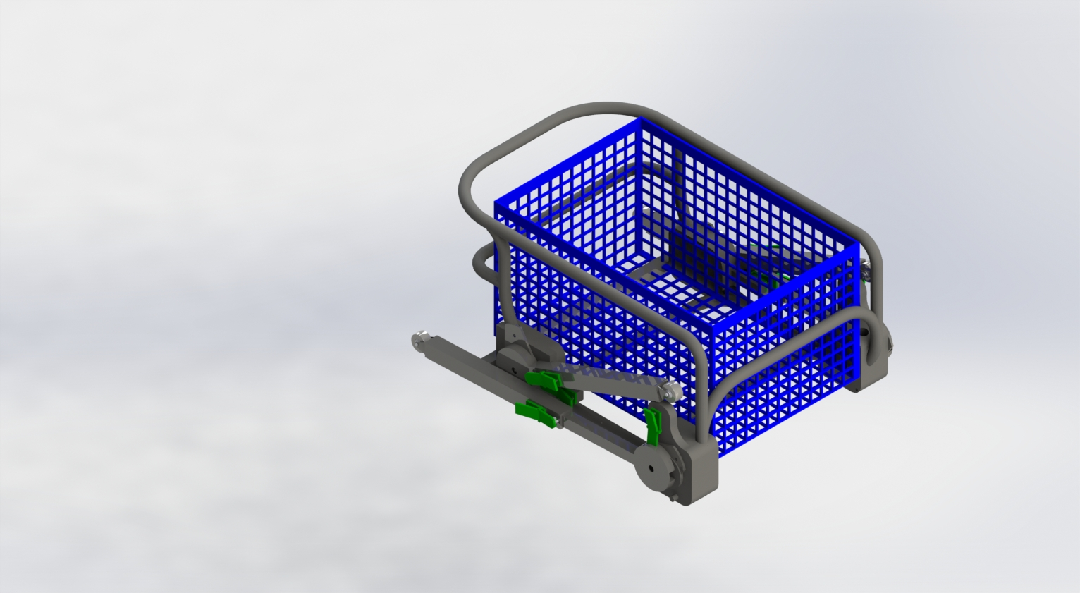
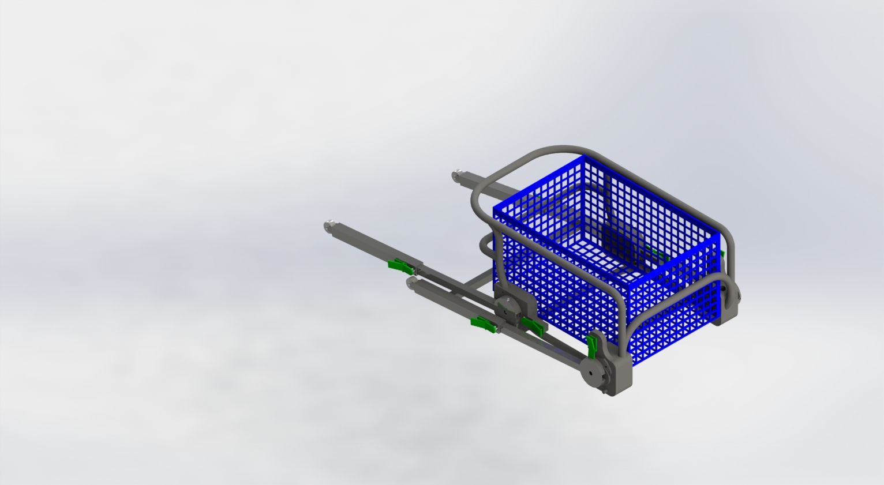
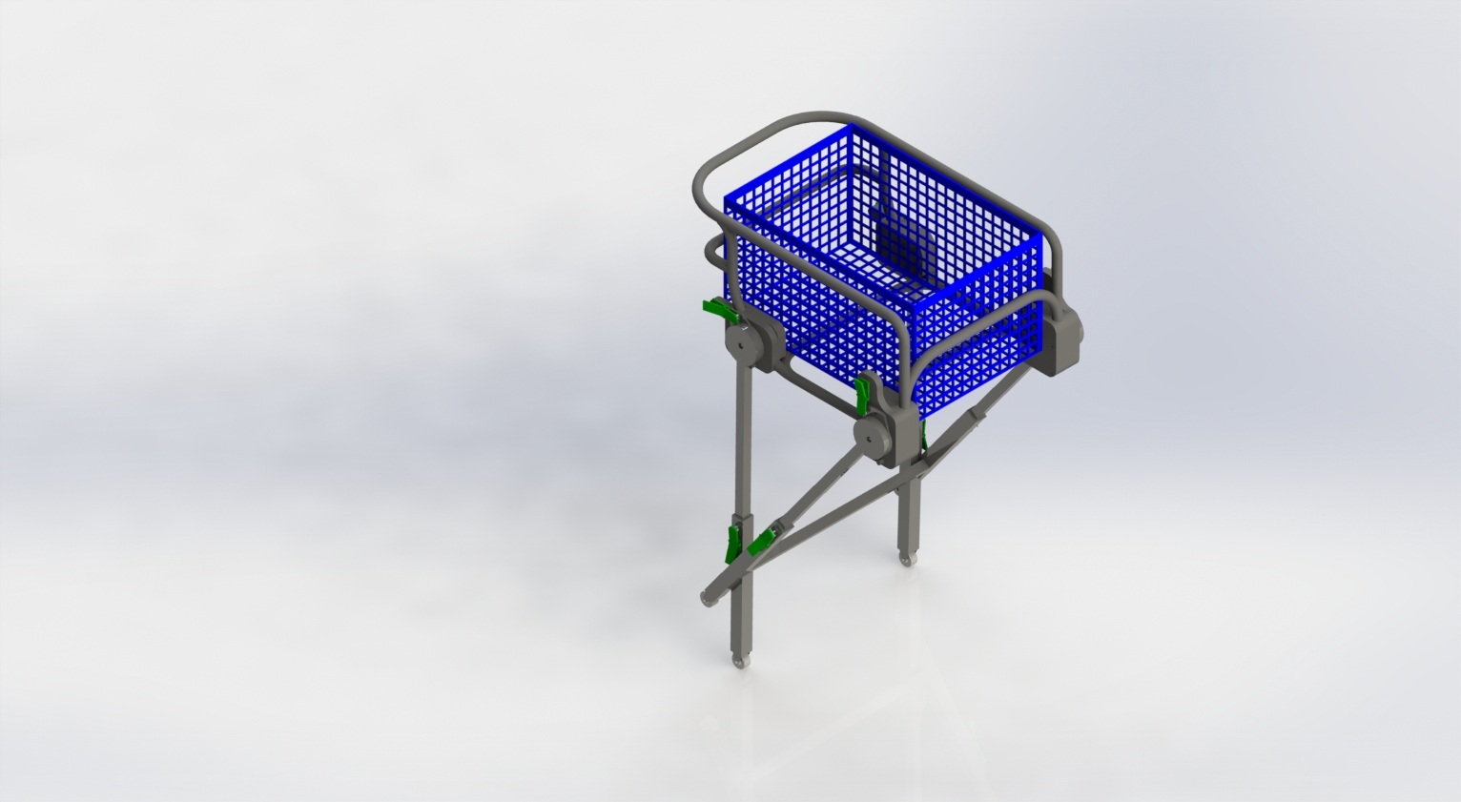

To unload: the user first flips the back legs back, allowing them to fall to a vertical position as the cart is pulled off the vehicle deck; the back legs are then extended and locked into place with the levers; once the cart is pulled further off the vehicle deck, the front legs are extended and locked with the levers. With all four legs locked, the cart is ready for use (estimated time: 30 seconds).

Loading:

To load: the user depresses the leg levers, unlocking the front legs; the user pushes the cart onto the vehicle deck, rotating the front legs. When the front legs are unable to be further pushed, the back legs are unlocked, and the cart is pushed into the vehicle; the legs’ levers are then used to unlock the upper and lower leg sections, the user then slides the lower sections in; lastly, the rear legs are rotated “up-and-over”. The cart is now stowed (estimated time: 30 seconds).

Conclusion 10

While this shopping cart design is highly effective and efficient for its required tasks, it does not seem to provide enough benefit beyond what is currently offered by standard shopping carts to make a meaningful difference or incentivise a market among elderly (and not) customers.

Regardless, this design effectively meets or exceeds all stated requirements, and appears ready to produce.

