Harvest

1. We have done superadmin and company admin pages and users for trucker’s and operator’s harvest rig pages so far.

- Problem  
 I need exact data type and user options for all the db fields.

For example in Harvest per field Table;

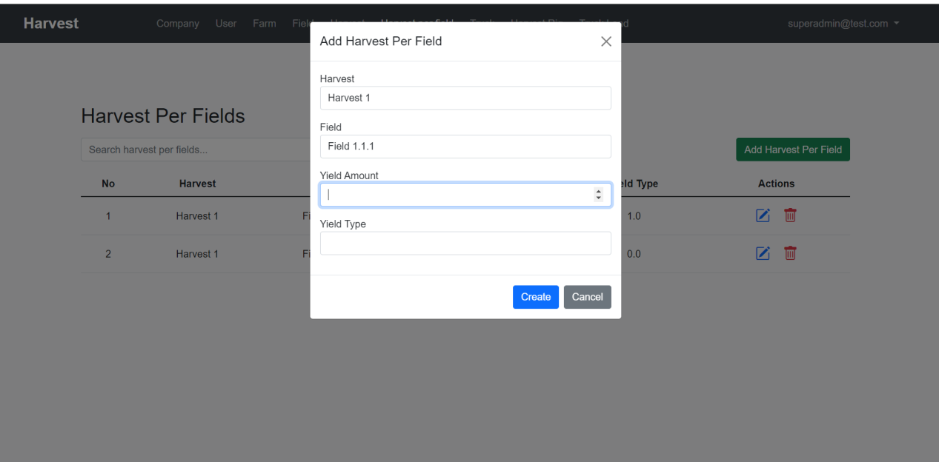

I don’t have any idea on this data like yield amount would have unit and also yield type, too.

Also some data input is not required, here, Harvest per field table can be managed by superadmin, company admin and also office user. So Yield amount and yield type is not required in case of superadmin or company admin since the office user can manage the value on them, I think.

What I want you is to test all the inputs in case of various users (superadmin, company admin) and check the exact input type.

This is key aspect in this project.

So it’s better you provide the fake data(for all table fields) but with correct input type so that I can customize all the database correctly.  
  
2. Project Expand

Please check this flask admin template below https://www.creative-tim.com/live/argon-dashboard-flask

I think we can update this project similar to above demo.  
- What we need?

* Current UI update
  + All visible tables and pages with various color patterns, design format.
* Dashboard pages in superadmin and company admin panel
  + Here, we can use various charts, graphs, cards to display the company’s harvest.
* Profile pages
  + Each user can manage own profile, once the user created, then they are allow name, email, password initially. Once they log in, can manage the profile, and after changing that, once admin allow the change of the user’s profile, they can use updated credential for access.
  + Company admin profiles are managed by superadmin
  + Company users’ profiles are managed by both superadmin and company admin.
* Messaging and alert from admin, users.
  + Once user makes change in their profile, then relevant alert should be displayed in admin page so that they can accept or decline.
  + Once admin accept or decline user’s request, the result should be displayed on user’s page.

I suggested current status and project expand forward and please review this report carefully and if you have any specific opinions let me know.