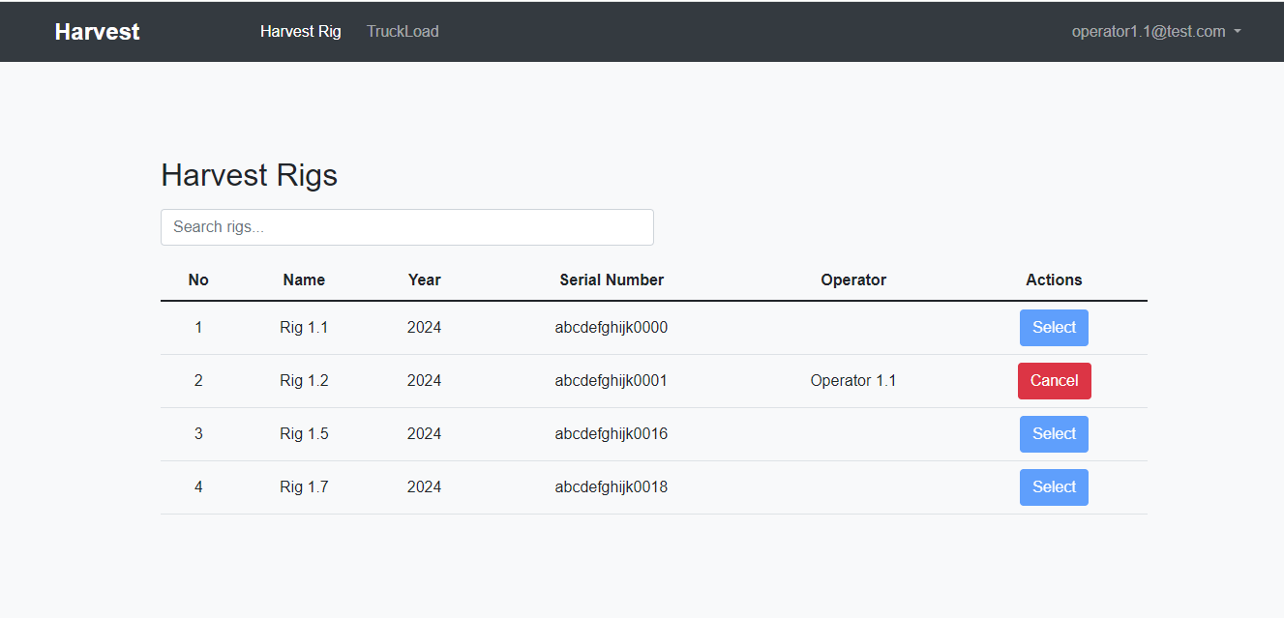

This is operator’s Harvest Rig selection page, Here in example, Operator 1.1 selected Harvest rig 1.2

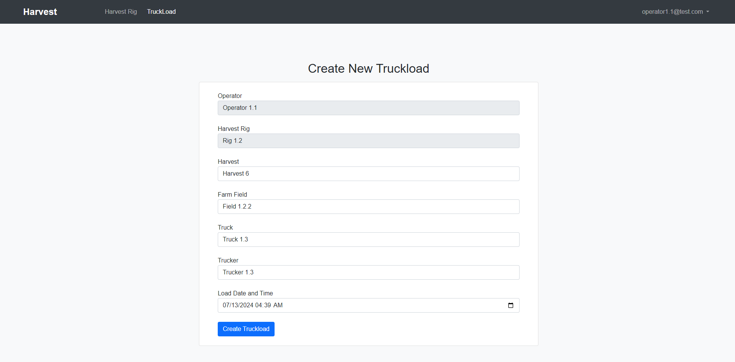

This is Operator’s create Truckload page, here operator 1.1 (selected Harvest rig 1.2) can create new Truckload.

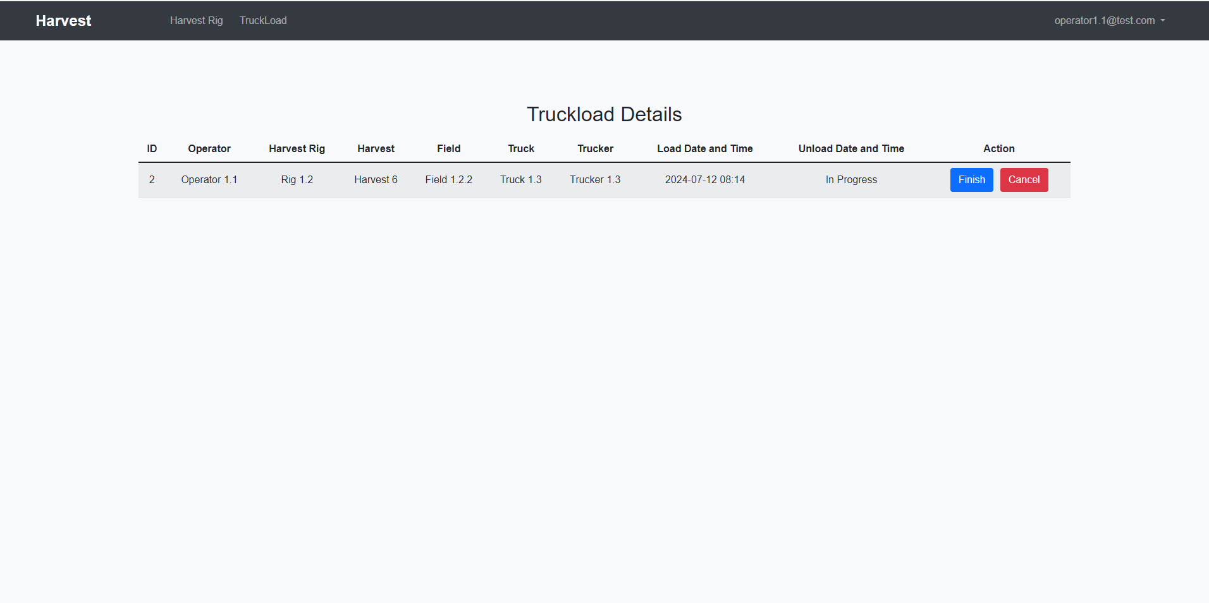

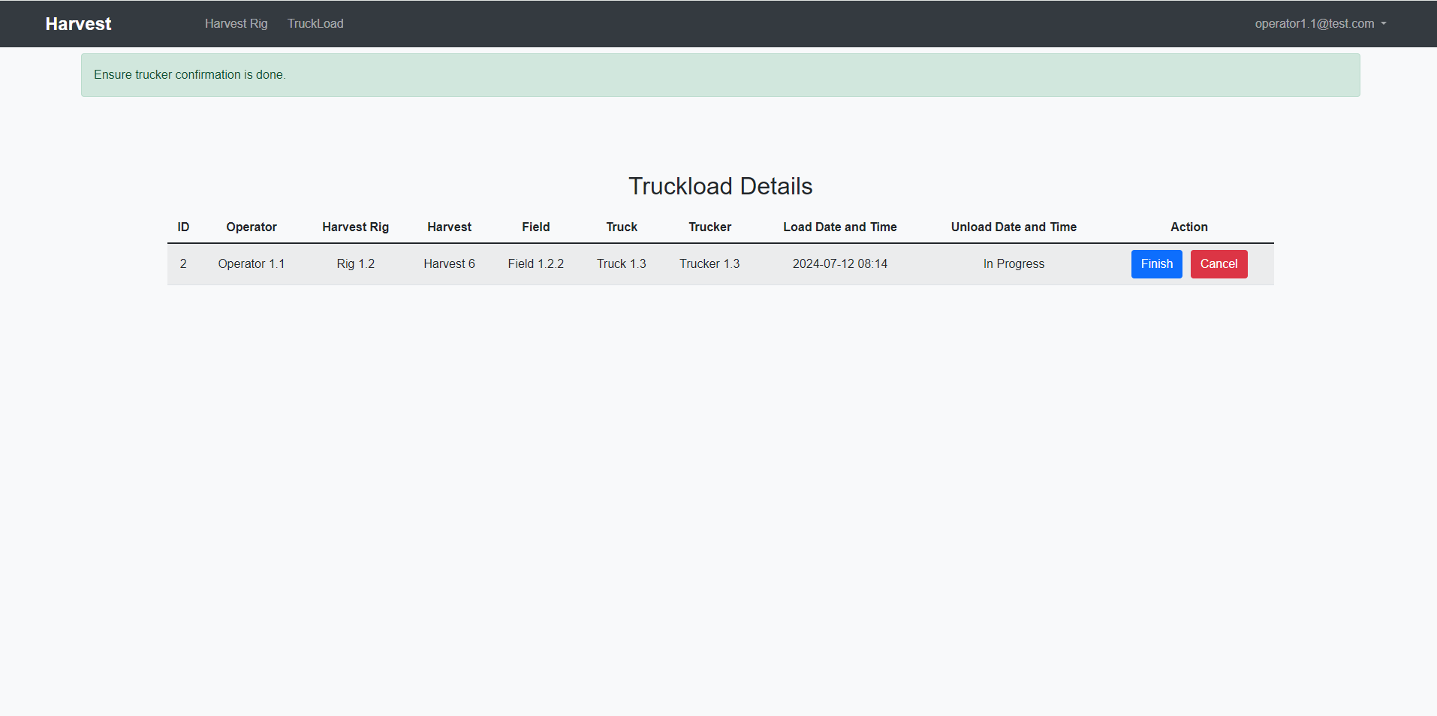

And once Operator create the truckload, until Trucker confirm his Truckload and Office user add the yield amount and yield type, operator can’t finish the truckload created. Here in example, Trucker 1.3 selected for Truckload.

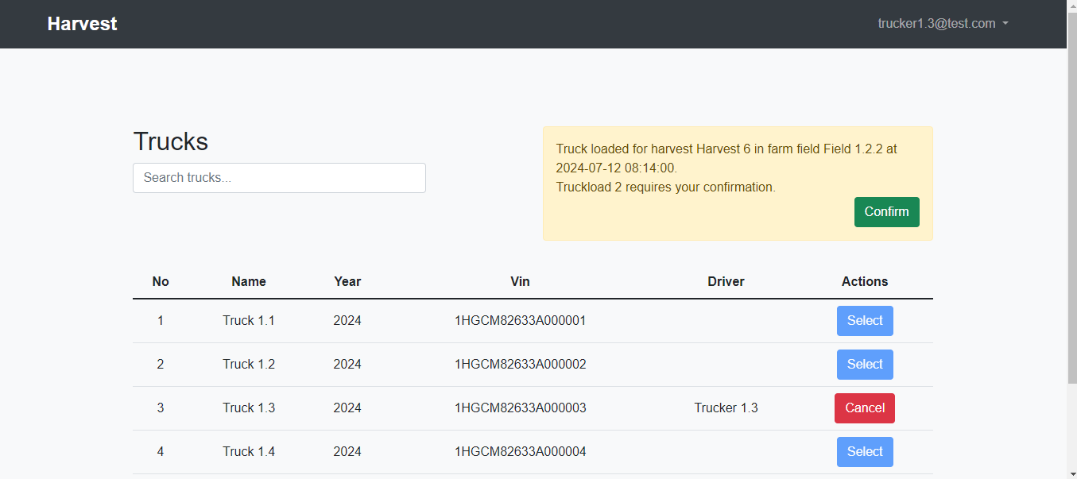

This is Trucker’s page and as operator created truckload with Trucker 1.3, Confirmation alert displays with page refreshing per 30 seconds.

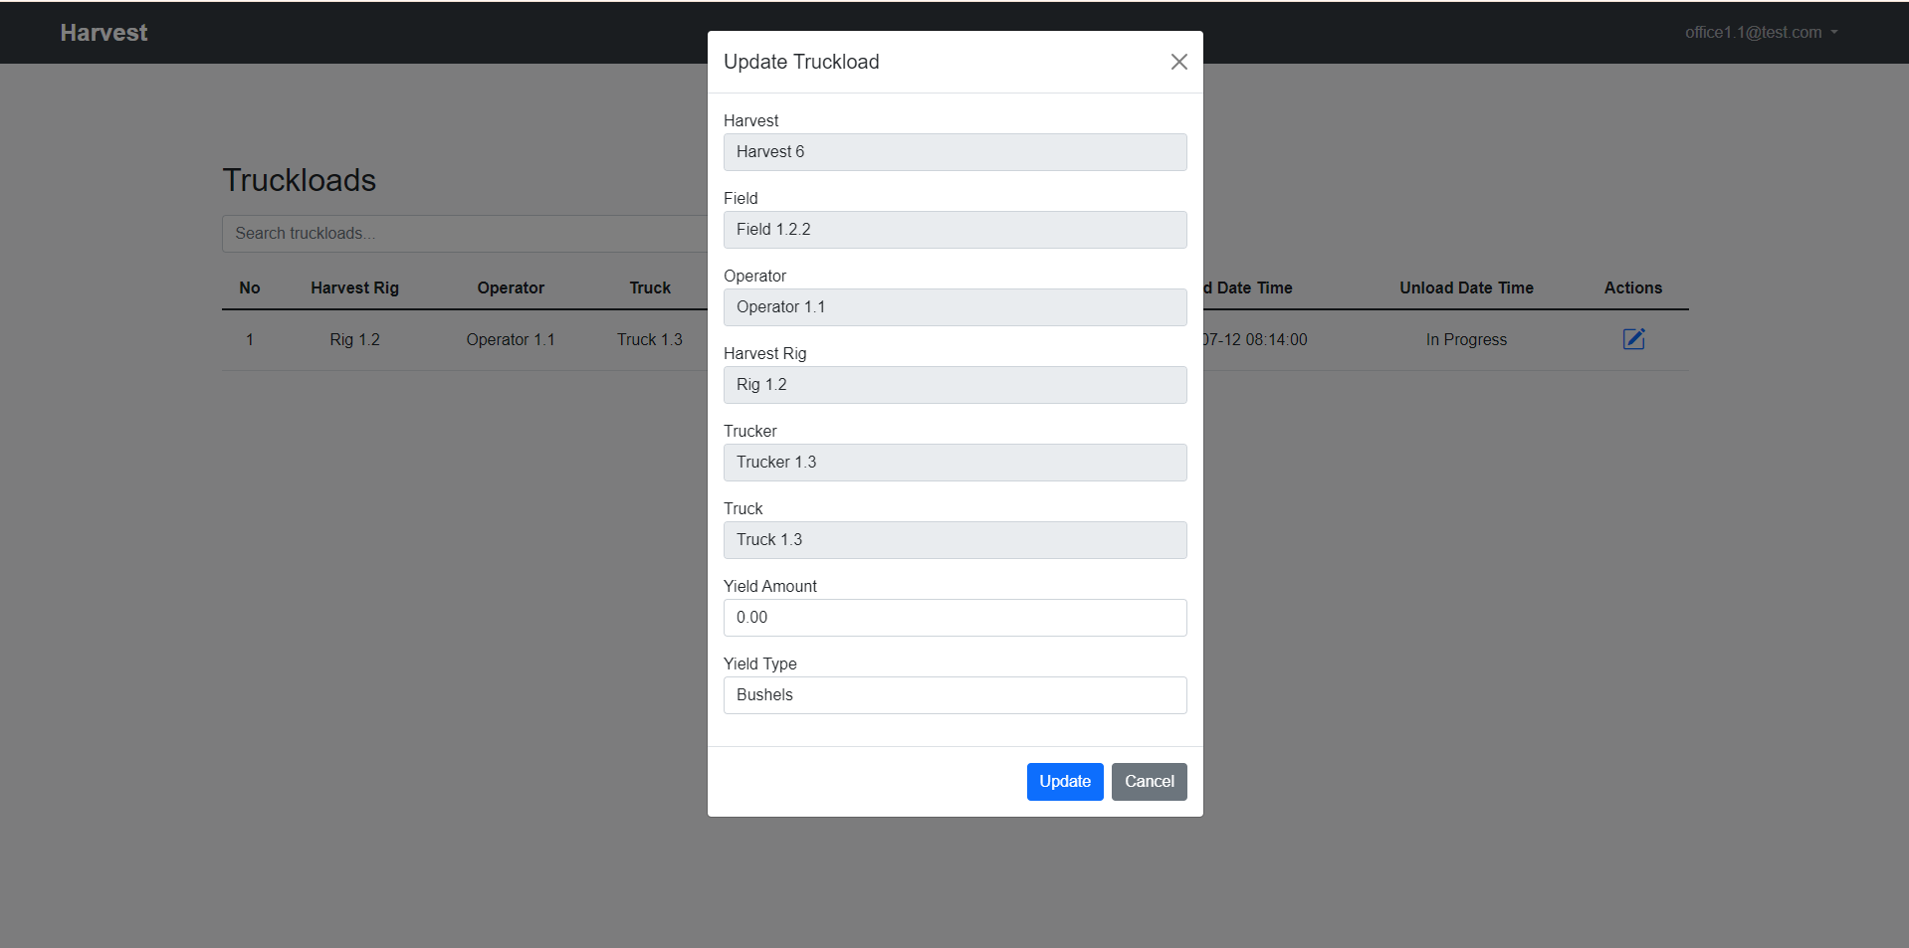

This is Office User page, There is table of Truckload where yield amount and yield type not confirmed.

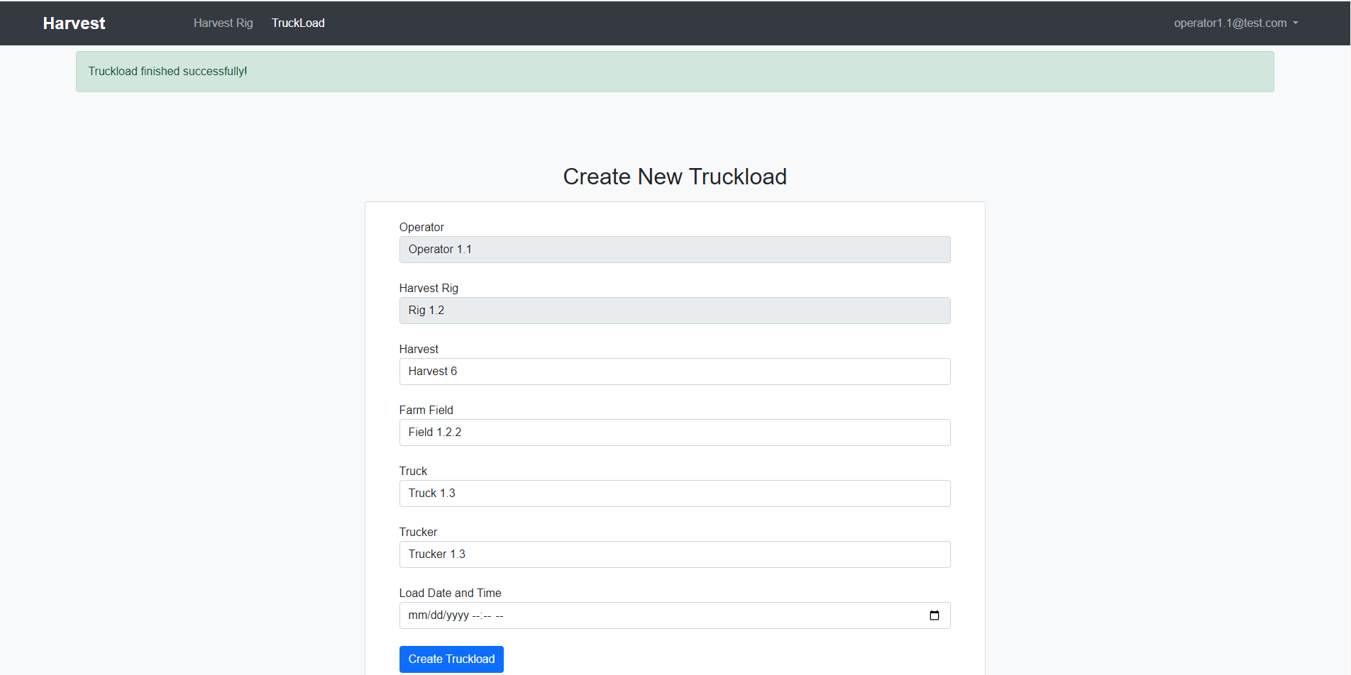

Once Trucker and Office User confirm all Truckload, Operator can finish the Truckload and Create new Truckload.

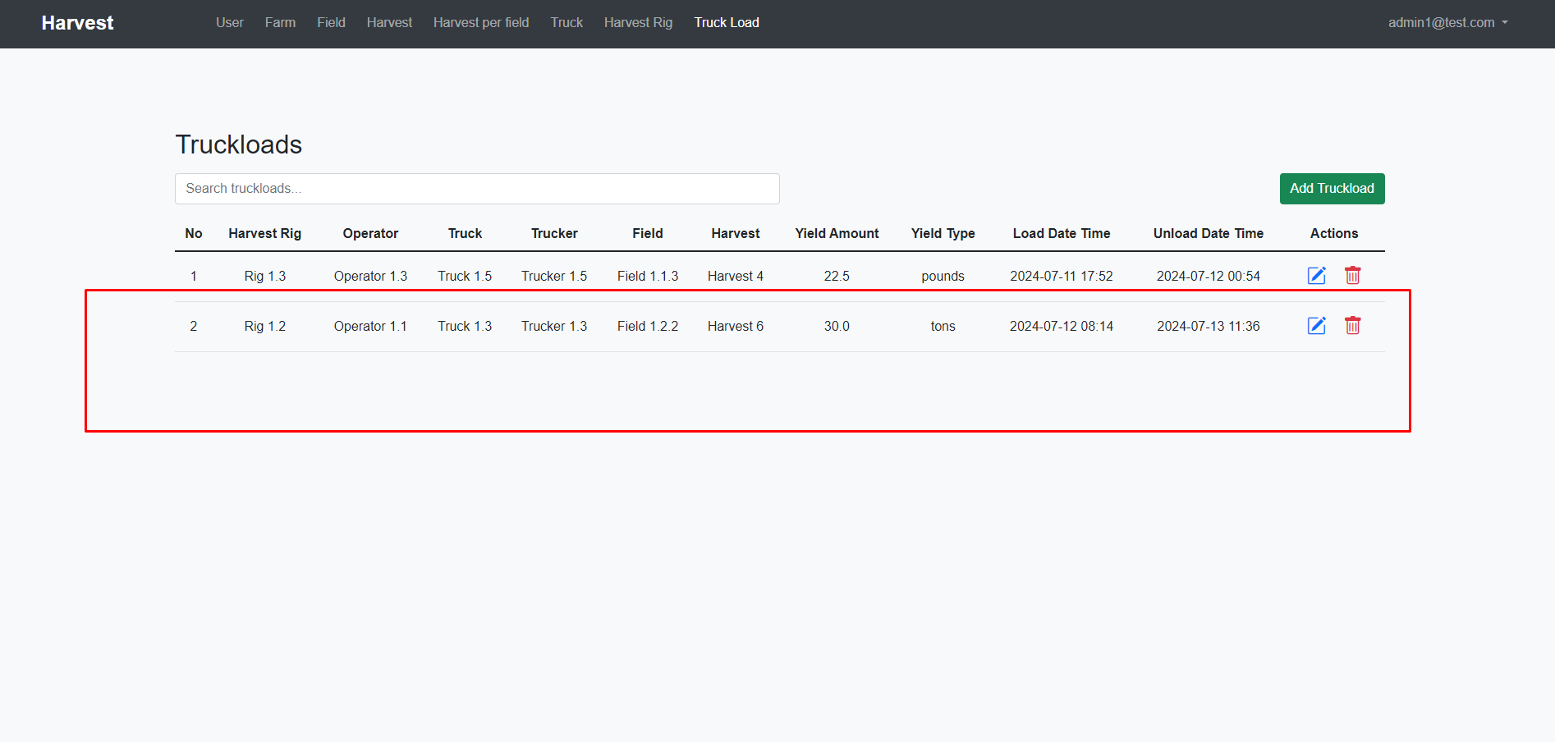

Now Truckload is created.