Aidan Holloway-Bidwell and Jack Lightbody

Computational Models of Cognition, Spring 16

**Pittman’s context character identification network**

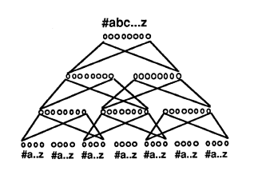

Pittman uses a network that tries to predict the identity of the character based on the probabilities of the identities of surrounding characters. We wish to use the output of the network above to act as additional input to our neural network which will identify a given character.

We plan to use this approach to create an additional input for the given character, hopefully erasing ambiguities.

This means we’ll need two types of neural networks: the context network illustrated above, and a standard pixel values to character identity network similar to the network implemented in homework 6. We will need a dictionary of words to train the context network on, and letters with their pixel values to train the character network on.