Character Recognition Using Various Neural Networks

Aidan Holloway-Bidwell (hollowaya@carleton.edu)
Computer Science, Carleton College
1 North College Street

Northfield, MN 55057

Jack Lightbody (lightbodyj@carleton.edu)
Computer Science, Carleton College
1 North College Street

Northfield, MN 55057

Abstract
Character recognition is an important problem with many varied applications. We created a neural network to learn to recognize handwritten characters. The network uses a combination of context and pixel values to identify characters, and is based off an approach introduced by Pittman (1991). We found ___ Todo: include important results
Keywords: Neural Networks; Context Based Character Recognition; Machine Learning

Background
Recognition of characters from visual stimuli is an important and frequently utilized process in many fields including law enforcement (license plate recognition), translation, and, of course, artificial intelligence and computer vision. Algorithms designed to recognize characters and words from a visual context vary and produce differing results. Some are optimized for handwritten text, others for printed text, and they differ between languages, lexicons, and alphabets. Many algorithms implement a feature recognition system with explicit segmentation of input, although others avoid it, and neural networks have proven especially successful in learning character recognition. While doing initial research for the project, we came upon many different potential methodologies. These include statistical inputs such as the number of endpoints for a given character, using various mathematical tools such as Fourier transformations to find inputs, and using context or stroke shape to analyze the data (Huette & Paquet & Moreau & Lecourtier & Olivier, 1997; Granlund, 1971; Pittman 1991).

Introduction
In class we have gone over several models for human cognition, such as rules and symbol, neural networks, and probabilistic models. We chose to try and extend neural networks for our project. We do so by attempting to use neural networks as a classifier for handwritten English characters. This is a similar task as the digit identification that we attempted in class, but much more difficult due to the large number of possible characters. In addition, we go about the identification in different ways.
We have implemented several different character recognition networks. One is based on the pixel matrices for images of various characters. Another is based on the context of the letter; that is what are the characters that precede and follow it. The third network is a combination of these two approaches, using the output of the pixel matrix network as an input for the context based network. This is based on a methodology suggested by Pittman. His model used image input and context, although our approach does differ from his in several ways (Pittman, 1991).
The reasoning behind using a combined approach is that it might correct inaccuracies of our other models. For example, if the pixel network views two characters as equally likely, the network is still required to choose which of those characters was the true character. By including these results in a context model though, the context provides an additional data point to differentiate the two characters. If the context strongly forecasts the middle character being a certain letter, then even if that letter was slightly less likely according to the pixel network it will still be the predicted character.
This approach is based on human cognition. When viewing a difficult to identify character, humans will often employ context such as the surrounding characters to aid the identification (Rayner & Carlson & Frazier, 1983).

Methodology
The first task that we needed to do was to find an appropriate dataset. We did a quick search and found several possible resources that had a large enough body of samples to enable using neural networks. However, many of these data sets did not include the context of the character, that is the preceding and following characters. Additionally, several had already done some pre-processing on the images to find statistical data, and had included this data instead of the raw pixel values of the produced images. Using one of these datasets would ensure that our results would be better than they would be otherwise, as the publishers of the dataset included them only because they are shown to be important heuristics for character identification. However, we wanted to be able to compare our results to our previous network, so this was an important omission.
After filtering out the datasets that didn’t meet these criteria, we decided on using a dataset that was originally created by Rob Kassel of MIT, and had been cleaned by Ben Taskar at Stanford (2003). This resource does have some issues, but it was the best set that we could find. One big advantage is its’ size, as it is composed of around fifty-thousand characters. The cleaning was a process of rasterizing the image, and selecting only lower case letters. Since the first letter of each word in the original dataset was an uppercase, this means that the dataset is composed of words lacking their first letter. This is one issue with the dataset, as the first letter may be an important character for providing context to ease identification of later characters in the word.
An additional disadvantage is the ordering of the words. Rather than provide words as they might appear in a sentence, the dataset orders the words in a different order. This means that the previous and following words can’t be used as context to identify a word or a specific character, which was included in part of Pittman’s model (1991).

Pixel Value Network
With the dataset chosen, we could then process the data. First we dealt with the pixel values. Each of the images was composed of 128 pixels, and was 16 pixels tall and 8 pixels wide. The data was in binary form, such that a 1 meant that that pixel was black, and a 0 meant that the pixel was white. Converting to this binary representation was part of the cleaning process described above.
To process these values, we decided to average the pixel values between a pixel, and the pixel beneath it. Figure 1 provides a graphic example of how this was done. This resulted in an 8 by 8 grid of pixel values that were either 1, .5, or 0.
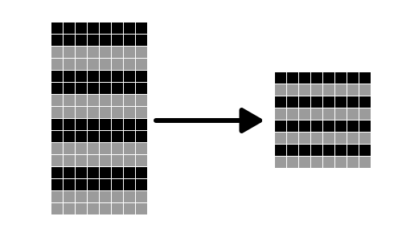
Figure 1: Example of how the pixel values were condensed. Each two-row segment on the left is condensed into one row consisting of the averages of the two rows on the right. Black rows are averaged with black rows, and grey with grey.

These pixel values were then the input for our first neural network. For this neural network, we designed a three layer network. Since there were 64 pixels inputted, there were 64 input nodes. We did not include bias nodes, as we would expect to get an output of entirely zeros given an input of entirely zeros (i.e. a blank character). There were 3 hidden nodes in the hidden layer. There were also 26 output nodes. A simplified representation of the structure of the network is seen in Figure 2.

The output nodes were used to express the probability distribution for the character that the network identified. For example, if the character were believed to be a d, then the highest probability would occur at the fourth output node since d is the fourth letter of the alphabet. Using a probability distribution is valuable for us later on when we create a more complicated network.
The weights of each node were randomly initialized. The function that we used to generate them creates numbers that fit to a Gaussian distribution.

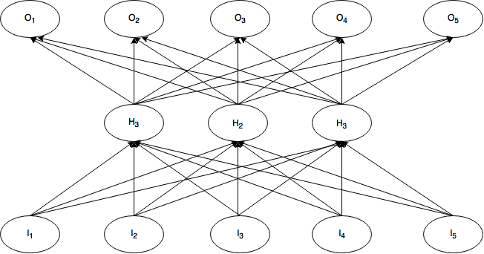
Figure 2: Simplified structure of the pixel neural network. I nodes are the pixel values computed as described, H are the hidden nodes, and O are the outputs. In the full model, there are 26 output nodes and 64 input nodes.

We used the delta rule and the generalized delta rule to compute the changes made to the weights. These rules use gradient descent to converge to weights. The error function for the network was the sum squared error function . This error function was used to compute the back-propagation for the network. We chose to use a tangent function for activation.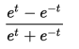. The derivative of this, which we use for back-propagation, is 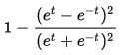. We chose to use tangent rather than a logistic function like we had used previously because it gave us consistently slightly better results. The tangent function is a continuous function, which is important for using gradient descent.
To compute the output values we used a multinomial output function. This is because we primarily care which output node has the highest value, not whether the output node is exactly 1 or 0.
We trained this network with 50 iterations on a subset of the data that consisted of ___ individual characters. We predicted ___ characters. TODO: include exact numbers, charts, data

Context Network
The next implementation that we created was a purely context based network. For this network, the inputs were vector representations for the surrounding characters to the one that we wanted to identify.
The characters that made up this context and that were input into the network were the two previous characters to the character that we wanted to identify and the following two characters. These characters were inputted using their true vector representation. For example, if a character were known to be a d, since d is the fourth letter of the alphabet the vector form would be [0, 0, 0, 1, 0 … 0], with the length of the vector being 26 to represent each character of the alphabet.
In cases where there weren’t two preceding and two following characters, such as at the start or end of a word, vectors consisting entirely of zeros were inputted in place of where the characters would be.
The structure of this network is very similar to the structure of the pixel network outlined in Figure 1. There are 104 input nodes rather than 64 nodes, as each of the 2 preceding and following characters are represented by 26 input nodes. The structure was also the same in terms of the activation function, output function, number of hidden nodes, error function, number of training iterations, and the size of the training and predicting dataset.
The output of this network was of a similar form as the pixel values network, a probability distribution for the middle character being each letter in the alphabet. TODO: results

Combined Network
For our final network, we created a combination of these two previous approaches. Essentially, the probability distribution from trying to identify characters using the pixel network was used as the input to the context network. We also included the output from the pixel network of the character that we were trying to classify, which was not included in the previous context model.
To do this, we first ran the pixel network as done previously. Before we fed this data into our combined network however, we briefly trained the combined model using the true vector representations for the preceding and following two characters, as well as the vector for the character that we wanted to identify. This methodology is based off of one suggested by Pittman, and is essentially a way to allow the network to start to calibrate the weights on something easy, before then moving on to a much harder problem. To do this calibration, we ran a network with the same structure as we have used previously, but with one thousand training inputs and only five iterations.
After this, we were ready to feed in the output from the pixel network into the context network. These outputs were fed in for the two preceding characters, the character that we wanted to identify, and the following 2 characters. Since each character was represented by a length 26 vector, there were a total of 130 input nodes for the network. As before in the context network, if the word was too long or short to have two preceding or following characters, then vectors consisting entirely of zeros represented the missing characters.
The network used the same activation, output, and error functions, had the same number of hidden nodes, training iterations, and size for the training and predicting dataset.

Conclusion

References
Bluche, Theodore, Hermann Ney, Jerome Louradour, and Christopher Kermovant. "Framewise and CTC Training of Neural Networks for Handwriting Recognition." International Conference on Document Analysis and Recognition (2015). IEEE Xplore. Web. 27 Apr. 2016.
Elliot, Steven C. "Context Sensitive Optical Character Recognition Using Neural Networks and Hidden Markov Models." Thesis (1992): n. pag. Rochester Institute of Technology. Web. 30 May 2016.
Granlund, G. H. "Fourier Preprocessing for Hand Print Character Recognition." IEEE Transactions on Computers IEEE Trans. Comput. C-21.2 (1972). Web.
Huette, L., T. Paquet, J. V. Moreau, Y. Lecourtier, and C. Olivier. "A Structural/statistical Feature Based Vector for Handwritten Character Recognition." A Structural/statistical Feature Based Vector for Handwritten Character Recognition. Elsevier Science, 1998. Web. 27 Apr. 2016.
"NumPy V1.10 Manual." NumPy. SciPy, 18 Oct. 2015. Web. 30 May 2016.
Pittman, James A. "Recognizing Handwritten Text." Proceedings of the SIGCHI Conference on Human Factors in Computing Systems Reaching through Technology - CHI '91 (1991).Web.
Rayner, Keith, Marcia Carlson, and Lyn Frazier. "The Interaction of Syntax and Semantics during Sentence Processing: Eye Movements in the Analysis of Semantically Biased Sentences." Journal of Verbal Learning and Verbal Behavior 22.3 (1983). Web.
Taskar, Ben, and Rob Kassel. OCR Dataset. N.d. Raw data. N.p.

See Numpy documentation on randn for more information.

