**3D mapping with Scanse sweep v1.0**

User’s Manual

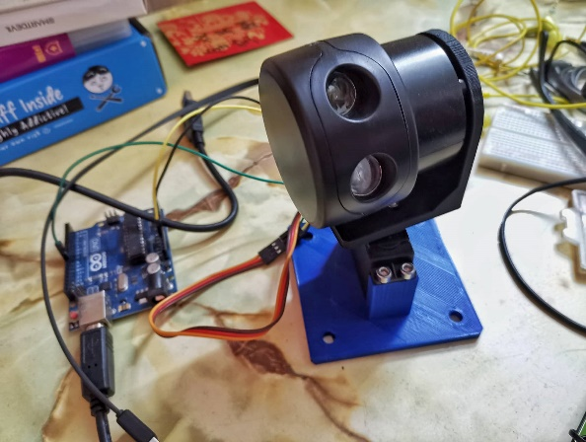

**Quick start guides**

1. Software to install:
   1. python [[here](https://www.python.org/downloads/)]
   2. cmake [[here](https://cmake.org/download/)]
   3. Visual studio community [[here](https://visualstudio.microsoft.com/vs/community/)]
   4. Sweep Visualizer BETA [[here](https://www.dropbox.com/s/hzcn0nl2toajpvq/SweepVisualizerSetup.exe?dl=0)]
   5. Arduino IDE [[here](https://www.arduino.cc/en/Main/Software)]
2. Download the library for the sweep device and place it at the directory of your choice [[here](https://github.com/scanse/sweep-sdk)]
3. Open CMD with admin and cd to the directory of the library to install libsweep using the following commands:

|  |
| --- |
| cd libsweep  cmake .  cmake --build . --config Release  cmake --build . --target install --config Release |

1. Install sweeppy to code using python:

|  |
| --- |
| cd sweeppy  python setup.py install --user |

[Note] You can use CMD to check the COM port of the device assigned to by plugging in one by one and using mode command, or check by using Arduino IDE.

[Note] To check if it is working enter this line in the command prompt, replace COM11 with the COM port that the sweep device is assigned to:

|  |
| --- |
| python -m sweeppy COM11 |

1. After all the above steps, using pip install [library] at the CMD install the following libraries, replace [library] with the following:
   1. transformations
   2. numpy
   3. pyFirmata
2. Upload Arduino with pyfirmata, go to File -> Examples -> Firmata -> StandardFirmata

[Note] You can update Firmata [here](https://github.com/firmata/arduino#updating-firmata-in-the-arduino-ide---older-versions--163-or-10x) (optional)

1. Connect the sweep device to your PC through the serial adapter.
2. Connect the base servo to pin assigned on the Arduino.
3. Change the COM port in the main file according to the COM ports assigned.
4. Run the code and wait for the scan to complete.
5. A CSV file will be generated at the same directory as the main coding of the file.
6. Plot the point cloud using Sweep Visualizer, matlab or any method of your choice. (Sweep Visualizer will be easier)

**Extra details**

* Make sure to tick the add python 3.8 to PATH.

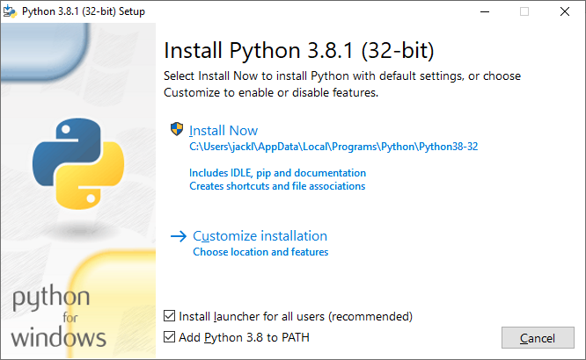

* Right click **This PC**, click properties, **Advanced system settings.**
* Under Advanced tab, click Environment Variables…
* Under System variables, edit the Path variable and add two of these paths at below and press **OK**.



* The predicted life of this sweep device is up to 45 million scan rotation, while operating at 5Hz rotation speed in 1-hour time. The scanning done here is operating at 3Hz with the default LIDAR sampling rate of 500Hz. Make sure to **STOP** the **LIDAR** when it is **not in used** by **unplugging** it from the PC or set the rotation speed to 0Hz using Sweep Visualizer software.
* The polar to cartesian conversion was modified from a project that was done by the other to suit this project, which they also working on 3D mapping using this sweep device.
* **Recommendation**: Change the base servo to a stepper motor to improve the mapping for the first 20° angle. Because the servo tends to be still before the first 20° angle.

**References**

1. Sweep SDK. <https://github.com/scanse/sweep-sdk>
2. Sweep Snow. <https://github.com/ArcticSnow/SweepSnow> (Installation of libsweep reference from this project)
3. 3D scanner. <https://github.com/scanse/sweep-3d-scanner>
4. Euler Angles - Interactive 3D Graphics. <https://www.youtube.com/watch?v=q0jgqeS_ACM> (Info on Euler angles)