目标
了解多点触摸术语
理解响应者链
体系结构
多点触摸的基本应用

1、了解多点触摸术语
触摸事件
指手指放到 iOS 设备屏幕上 从屏幕上拖动或抬起。
iOS中触摸事件，基于多点触摸模型
多点触摸序列 NSSet* touches
一个或多个和屏幕接触的手指，识别为多点触摸序列的一部分
从第一个手指碰到屏幕开始，直到最后一个手指离开屏幕结束
注意：触摸不关心，触摸的时间；只关心触摸的手指数目；触摸次数；触摸的方向；

Touch 是指手指放到屏幕上
触摸数量(touch):等于手指的数量，能够跟踪用户所有的手指，最多11个
点击(tap):手指触摸屏幕、立即离开，则触发轻击
检测到多点触摸，轻击次数置为1-------tapCount
下图表示一次触摸事件：
包含完整触摸事件的多个状态：开始(Began)、移动(Moved)、结束(Ended)、取消(Cancelled)
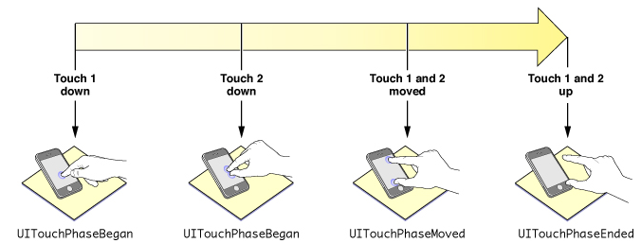

手势
手势：是为简化 触摸操作，推出的一组对象.手势是约定俗成的。
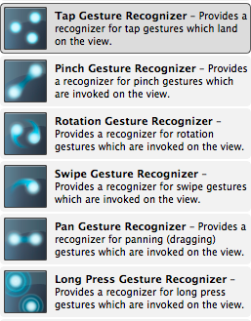
如果使用 手势对象，就不需要在 Began Moved 等方法中写代码。
手势指从用户用一个或多个手指接触屏幕时开始，直到手指离开屏幕为止所发生的所有事件Event。无论多长时间，只要你还有一个或多个手指在屏幕上，这个手势就存在。(除非来电话会中断该手势)

手势通过一系列 事件 内在系统来传递。用户与设备屏幕交互时生成事件。事件包含与发生的一次或多次触摸相关的信息。
每次接触屏幕，都要传递两个参数：
UITouch：多个触摸手指(触摸的顺序、触摸的位置)
UIEvent：一个事件
-(void)touchesEnded:(NSSet *)touches withEvent:(UIEvent *)event
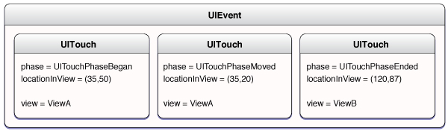

手势识别器
是实现所有手势的对象；
是一个 UIGestureRecognizer 子类的对象；
观察用户操作，并识别用户何时做了预先设置好的几种手势；
可以用于程序中任何视图中；
不需要编写手势处理方法(touchesBegin:withEvent: …)；
可以识别如下手势：
1、拍击 UITapGestureRecognizer (任意次数的拍击) 2、向里或向外捏 UIPinchGestureRecognizer (用于缩放)
3、摇动或者拖拽 UIPanGestureRecognizer
4、擦碰 UISwipeGestureRecognizer (以任意方向)
5、旋转 UIRotationGestureRecognizer (手指朝相反方向移动)
6、长按 UILongPressGestureRecognizer

2、理解响应者链
响应者链
第一响应者是用户正在交互的对象(IB 中叫 First Responder)
以UIResponder为超类的任何类可以成为响应者
如果第一响应者不处理事件，事件会被发送到 “父(上级)响应者”
事件最终会被发到UIApplication，如果它不处理事件，将会被丢弃

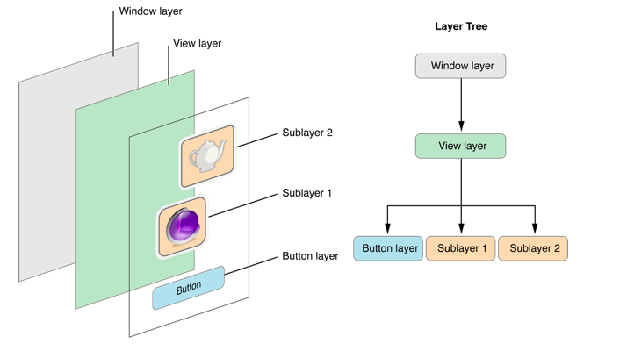
3、体系结构
处理流程
当一个或多个手指触摸屏幕的时候发出发出:
-(void)touchesBegin: (NSSet *)touches withEvent: 消息
当一个或多个手指在屏幕移动的时候发出:
-(void)touchesMoved:withEvent: 消息
当一个或多个手指离开屏幕的时候发出:
-(void)touchesEnded:withEvent: 消息
当触摸序列被电话呼入等事件取消的时候发出:
-(void)touchesCancelled:withEvent: 消息

任何视图组件，都继承了 UIResponder 类，都可以调用触摸事件方法
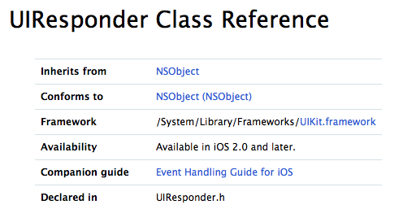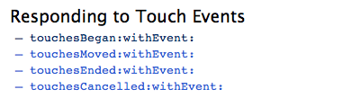
两个参数：
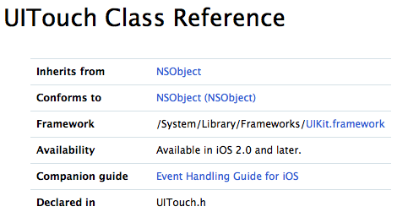
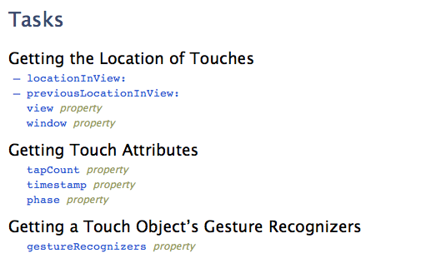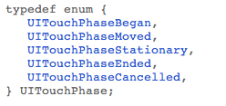
基础代码
UITouch *currentTouch = [touches anyObject]; //得到任意一个触摸对象
Int phaseState = currentTouch.phase ； //当前触摸事件的状态
CGPoint popMoved = [currentTouch locationInView:self.view]; //得到当前触摸事件在当前视图中的位置

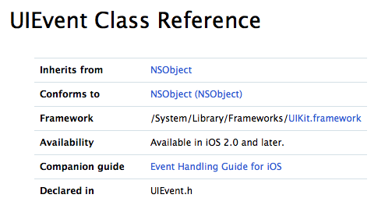
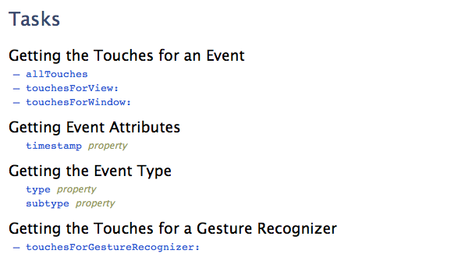

4、多点触摸的基本应用
检测单击或双击
单击事件 + 多触击事件
1.两个触摸事件发生的间隔时间很短
2.也只有当它们和同一个 视图相关联时
在 touchesEnded:withEvent: 触摸结束的时候，
判断击打次数,使用UITouch的tapCount方法
-(void)touchesEnded:(NSSet *)touches withEvent:(UIEvent *)event
{
//得到手指个数
NSInteger ntouchCount = [touches count];
self.lblFingers.text = [NSString stringWithFormat:@"有 %i 根手指",ntouchCount];
//得到点击次数
self.lblTapCounts.text = [NSString stringWithFormat:@"%i 次点击 %f 秒",currentTouch.tapCount,currentTouch.timestamp];
}

//检查手指数目
-(void)checkTouches:(NSSet *)touches
{
UITouch *currentTouch = [touches anyObject];
//根据当前手势的不同阶段，打印不同的信息
switch (currentTouch.phase) {
case UITouchPhaseBegan:
{
//potBegin 开始点击的位置
self.potBegin = [currentTouch locationInView:self.view];
}
break;
case UITouchPhaseMoved:{

}
break;
case UITouchPhaseEnded:{
self.lblEnd.text = @"触摸结束";
[self performSelector:@selector(eraseLabel:) withObject:self.lblEnd afterDelay:0.6f];
}
break;
case UITouchPhaseCancelled:{

}
break;

default:
break;
}

}

检测碰擦手势(Swipe)
*.h 文件中
//触摸的开始坐标
@property(nonatomic)CGPoint potBegin;

//定义用户滑动最少多少像素算一个 手势
#define kMinSwipLength 25
//定义滑动时，偏移最多多少像素的误差
#define kMaxVariance 6

-(void)touchesMoved:(NSSet *)touches withEvent:(UIEvent *)event
{
UITouch *currentTouch = [touches anyObject];
//移动后的点
CGPoint popMoved = [currentTouch locationInView:self.view];

float deltaX = fabsf(self.potBegin.x - popMoved.x);
float deltaY = fabsf(self.potBegin.y - popMoved.y);
//判断滑动方向
if ((deltaX > kMinSwipLength)&&(deltaY < kMaxVariance) ) {
self.lblSwipe.text = @"水平移动";
//调用当前类的方法
[self performSelector:@selector(eraseLabel:) withObject:self.lblSwipe afterDelay:0.6f];
}

if ((deltaY > kMinSwipLength)&&(deltaX < kMaxVariance)) {
self.lblSwipe.text=@"垂直移动";
[self performSelector:@selector(eraseLabel:) withObject:self.lblSwipe afterDelay:0.6f];
}

}

移动一个按钮:
单独新建一个类，继承 UIButton，重写手势方法
-(void)touchesBegan:(NSSet *)touches withEvent:(UIEvent *)event
{
if (!dragEnable) {
return;
}
UITouch *touch = [touches anyObject];
beginPoint = [touch locationInView:self];
}

-(void)touchesMoved:(NSSet *)touches withEvent:(UIEvent *)event
{
if (!dragEnable) {
return;
}
UITouch *touch = [touches anyObject];
CGPoint nowPoint = [touch locationInView:self];
float offsetX = nowPoint.x - beginPoint.x;
float offsetY = nowPoint.y - beginPoint.y;

self.center = CGPointMake(self.center.x+offsetX, self.center.y+offsetY);
}

使用手势识别器
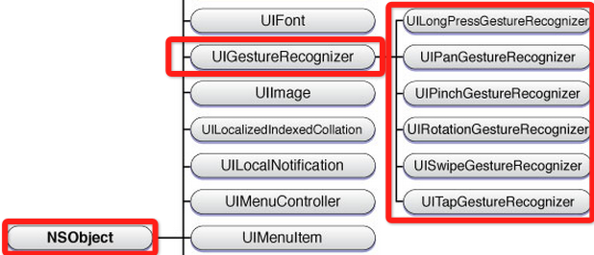
1）创建手势实例。当创建手势时，指定一个回调方法，当手势开始，改变、或结束时，回调方法被调用。
2）添加到需要识别的View中。每个手势只对应一个View，当屏幕触摸在View的边界内时，如果手势和预定的一样，那就会回调方法。
注意：一个手势只能对应一个View，但是一个View可以有多个手势。建议在真机上运行这些手势,模拟器操作不太方便。

使用擦碰识别器(UISwipeGestureRecognizer)
- (void)viewDidLoad
{
[super viewDidLoad];
//直接使用手势判断对象，确定手势并调用方法
UISwipeGestureRecognizer *vertical = [[UISwipeGestureRecognizer alloc]initWithTarget:self action:@selector(reportYSwipe:)];
//设置手势方向
vertical.direction = UISwipeGestureRecognizerDirectionUp|UISwipeGestureRecognizerDirectionDown;
//把手势添加到当前 视图中
[self.view addGestureRecognizer:vertical];

//再添加一个手势
UISwipeGestureRecognizer *horizontal = [[UISwipeGestureRecognizer alloc]initWithTarget:self action:@selector(reportXSwipe:)];
//设置手势方向
horizontal.direction = UISwipeGestureRecognizerDirectionLeft|UISwipeGestureRecognizerDirectionRight;
[self.view addGestureRecognizer:horizontal];

}

#pragma mark - 手势发生后调用的方法
-(void)reportXSwipe:(UIGestureRecognizer *)recognizer
{
self.lbltext.text = @"横向扫过";
[self performSelector:@selector(eraseText) withObject:nil afterDelay:2.0f];
}

-(void)reportYSwipe:(UIGestureRecognizer *)recognizer
{
self.lbltext.text = @"竖向扫过";
[self performSelector:@selector(eraseText) withObject:nil afterDelay:2.0f];
}

//抹除文本标签中的文字
-(void)eraseText
{
self.lbltext.text = @" ";
}

检查多根手指触摸
- (void)viewDidLoad
{
[super viewDidLoad];
//循环5次，生成5个SwipGesturerecognizer，处理5根手指
for (NSUInteger touchCount = 1; touchCount <= 5; touchCount++) {
UISwipeGestureRecognizer *vertical;
vertical = [[UISwipeGestureRecognizer alloc]
initWithTarget:self action:@selector(reportVerticalSwipe:)];

vertical.direction = UISwipeGestureRecognizerDirectionUp
| UISwipeGestureRecognizerDirectionDown;
vertical.numberOfTouchesRequired = touchCount;

[self.view addGestureRecognizer:vertical];

UISwipeGestureRecognizer *horizontal;
horizontal = [[UISwipeGestureRecognizer alloc]
initWithTarget:self action:@selector(reportHorizontalSwipe:)];
horizontal.direction = UISwipeGestureRecognizerDirectionLeft
| UISwipeGestureRecognizerDirectionRight;
horizontal.numberOfTouchesRequired = touchCount;
[self.view addGestureRecognizer:horizontal];
}
}

- (void)eraseText
{
self.label.text = @"";
}

- (NSString *)descriptionForTouchCount:(NSUInteger)touchCount
{
switch (touchCount) {
case 1:
return @"一根手指";
case 2:
return @"两根手指";
case 3:
return @"三根手指";
case 4:
return @"四根手指";
case 5:
return @"五根手指";
default:
return @"";
}
}

- (void)reportHorizontalSwipe:(UIGestureRecognizer *)recognizer
{
self.label.text = [NSString stringWithFormat:@"%@ 根手指水平方向扫过",
[self descriptionForTouchCount:[recognizer numberOfTouches]]];
[self performSelector:@selector(eraseText) withObject:nil afterDelay:2];
}

- (void)reportVerticalSwipe:(UIGestureRecognizer *)recognizer
{
self.label.text = [NSString stringWithFormat:@"%@ 根手指垂直方向扫过",
[self descriptionForTouchCount:[recognizer numberOfTouches]]];
[self performSelector:@selector(eraseText) withObject:nil afterDelay:2];
}

－－－－－－－－－－－－－－－－－－－－－－－－－－－－－

使用点击识别器(UITapGestureRecognizer)

- (void)viewDidLoad
{
[super viewDidLoad];
//创建 点击识别器 对象
UITapGestureRecognizer *singleTap =
[[UITapGestureRecognizer alloc] initWithTarget:self
action:@selector(singleTap)];
singleTap.numberOfTapsRequired = 1; //设置点击次数为 1 次
singleTap.numberOfTouchesRequired = 1; //设置 1 根手指
[self.view addGestureRecognizer:singleTap];

UITapGestureRecognizer *doubleTap =
[[UITapGestureRecognizer alloc] initWithTarget:self
action:@selector(doubleTap)];
doubleTap.numberOfTapsRequired = 2;
doubleTap.numberOfTouchesRequired = 1;
[self.view addGestureRecognizer:doubleTap];
//告诉单击感知器，如果双击 操作未识别时触发自己的操作
[singleTap requireGestureRecognizerToFail:doubleTap];

UITapGestureRecognizer *tripleTap =
[[UITapGestureRecognizer alloc] initWithTarget:self
action:@selector(tripleTap)];
tripleTap.numberOfTapsRequired = 3;
tripleTap.numberOfTouchesRequired = 1;
[self.view addGestureRecognizer:tripleTap];
[doubleTap requireGestureRecognizerToFail:tripleTap];

UITapGestureRecognizer *quadrupleTap =
[[UITapGestureRecognizer alloc] initWithTarget:self
action:@selector(quadrupleTap)];
quadrupleTap.numberOfTapsRequired = 4;
quadrupleTap.numberOfTouchesRequired = 1;
[self.view addGestureRecognizer:quadrupleTap];
[tripleTap requireGestureRecognizerToFail:quadrupleTap];
//点击手势失败链。先检查 4 次点击是否有识别器，如果没有，检查 3 次点击是否有识别器….
}

- (void)singleTap
{
self.singleLabel.text = @"Single Tap Detected";
[self performSelector:@selector(clearLabel:)
withObject:self.singleLabel
afterDelay:1.6f];
}

- (void)doubleTap
{
self.doubleLabel.text = @"Double Tap Detected";
[self performSelector:@selector(clearLabel:)
withObject:self.doubleLabel
afterDelay:1.6f];
}

- (void)tripleTap
{
self.tripleLabel.text = @"Triple Tap Detected";
[self performSelector:@selector(clearLabel:)
withObject:self.tripleLabel
afterDelay:1.6f];
}

- (void)quadrupleTap
{
self.quadrupleLabel.text = @"Quadruple Tap Detected";
[self performSelector:@selector(clearLabel:)
withObject:self.quadrupleLabel
afterDelay:1.6f];
}

- (void)clearLabel:(UILabel *)label
{
label.text = @"";
}

使用缩放识别器(UIPinchGestureRecognizer)
@property(non

-(void)viewDidLoad
{
UIPinchGestureRecognizer *pich = [[UIPinchGestureRecognizer alloc]initWithTarget:self
action:@selector(doPinch:)];
[self.view addGestureRecognizer:pich];
}

-(void)doPinch: (UIPinchGestureRecognizer *)pinch
{
if(pinch.state == UIPinchGestureRecognizerStateBegan)
{
initFontSize = label1.font.pointsize;
}
else
{
label1.font = [label1.font fontWithSize:initFontSize*pinch.scale];
}
}

同时实现“缩放”“旋转”手势识别器
1、头文件实现协议
<UIGestureRecognizerDelegate>
2、

//scale 缩小
//rotation 旋转
@implementation BIDViewController {
CGFloat scale, previousScale;
CGFloat rotation, previousRotation;
}

- (void)viewDidLoad
{
[super viewDidLoad];

previousScale = 1;

UIImage *image = [UIImage imageNamed:@"yosemite-meadows.png"];
self.imageView = [[UIImageView alloc] initWithImage:image];
//能否配合使用
self.imageView.userInteractionEnabled = YES;
self.imageView.center = CGPointMake(160, 160);
[self.view addSubview:self.imageView];

UIPinchGestureRecognizer *pinchGesture =
[[UIPinchGestureRecognizer alloc] initWithTarget:self action:@selector(doPinch:)];
pinchGesture.delegate = self;
[self.imageView addGestureRecognizer:pinchGesture];

UIRotationGestureRecognizer *rotationGesture =
[[UIRotationGestureRecognizer alloc] initWithTarget:self action:@selector(doRotate:)];
rotationGesture.delegate = self;
[self.imageView addGestureRecognizer:rotationGesture];
}

-(BOOL)gestureRecognizer:(UIGestureRecognizer *)gestureRecognizer shouldRecognizeSimultaneouslyWithGestureRecognizer:(UIGestureRecognizer *)otherGestureRecognizer
{
return YES;
}

- (void)transformImageView
{
CGAffineTransform t = CGAffineTransformMakeScale(scale * previousScale,
scale * previousScale);
t = CGAffineTransformRotate(t, rotation + previousRotation);
self.imageView.transform = t;
}

- (void)doPinch:(UIPinchGestureRecognizer *)gesture
{
scale = gesture.scale;
[self transformImageView];
if (gesture.state == UIGestureRecognizerStateEnded) {
previousScale = scale * previousScale;
scale = 1;
}
}

- (void)doRotate:(UIRotationGestureRecognizer *)gesture
{
rotation = gesture.rotation;
[self transformImageView];
if (gesture.state == UIGestureRecognizerStateEnded) {
previousRotation = rotation + previousRotation;
rotation = 0;
}
}

补充：
1、NSObject 类中让方法延迟执行
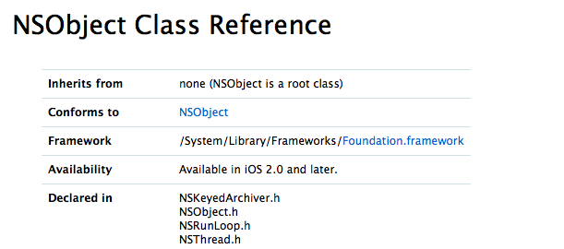
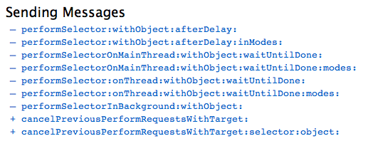

2、擦碰识别器
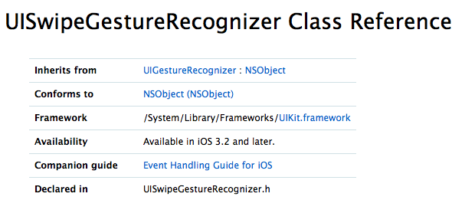
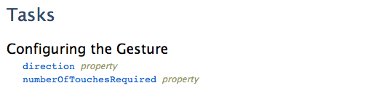
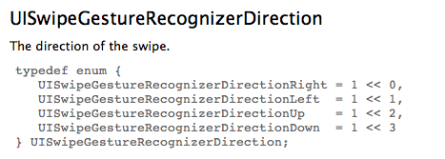

3、点击识别器
