Bezier & B-Spline demo

## Brief

This MS SDI application demonstrates classical 2-Dimensional [Bezier](https://en.wikipedia.org/wiki/B%C3%A9zier_curve) curve and [B-Spline](https://en.wikipedia.org/wiki/B-spline) curve interpolations for the control-points, which are records of user's click in the app's client area. The app also carries out the functionality of saving/loading control-points into/from text formatting file.

The screenshot below shows its GUI with a typical fitting interpolation.

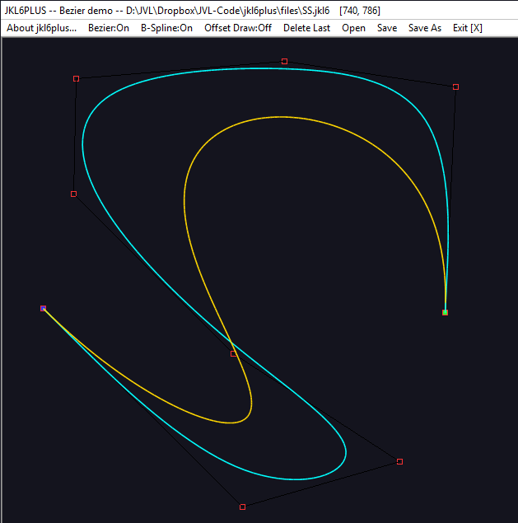

**Control-point**

**Bezier curve**

**B-Spline curve**

## Terms

**Control-Point (CP)**: a single 2-Dimensinal position, used as a control-point of interpolation.  
 1 CP is represented as a 3x3 red square. 

**Control-Point-Group (CPG)**: a sequential record of multiple CPs, that represents a set of CPs used to interpolate 1 fitting curve (Bezier/B-Spline). 1 CPG is represented as multiple CPs linked with black straight line. The first CP is filled green, the last CP is filled blue if finalised. 

**Fitting Curve (FC)**: an interpolated fitting curve that is calculated based on 1 CPG. In this app, it refers Bezier and/or B-Spline.

## Mouse Operations

Left single click: drop a CP with present mouse position in client area, to append to current CPG.

Right single click: finalise current CPG. A finalised FC is drawn with wider offset (if On), current/unfinalised FC is drawn with narrow offset. (Next Left single click will start a new/current CPG)

Left dragging: when cursor turns to , press & hold left button, users can move the hovering CPs with [Ctrl] key holding, users can move the hovering CPGs.

Right double click: to trigger an automated drawing of the entire scene. (Multithreading drawing)

## Menu items

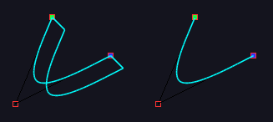

Bezier switch

Offset draw switch

B-Spline switch

Bezier switch: to turn On/Off Bezier fitting curve.  
B-Spline switch: to turn On/Off B-Spline fitting curve.  
Offset draw switch: to turn On/Off offset drawing feature. E.g.

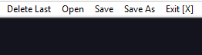

Delete last

Open data from file

Save data into file

Save data into another file

Exit app

Delete last: Delete the last CP from current CPG if not finalised. Or delete the last CPG. A ReDraw will occur with new data.

Open data from file: Users will have a popup ‘Open file dialog’ to choose data file. If there is unsaved change, users will be prompted to save.

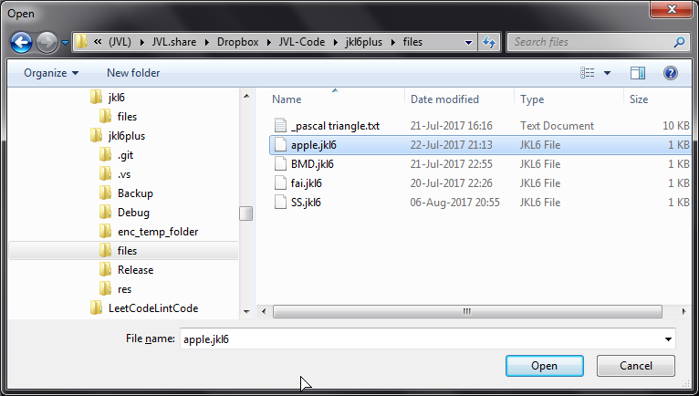

Save data into file: To save current data into the opening data file. If data is created as new, users will be prompted with Save file dialog.

Save data into another file: To allow users to save current data into a different file. User will be prompted with Save file dialog.

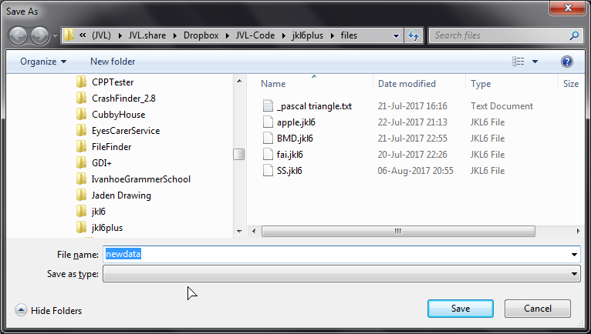

Exit app: Terminate the app. If there is unsaved change, users will be prompted to save.

