Executive Summary Guide
  - PST 315: Methods of Policy Analysis and Presentation
Prof. Jack Reilly
F2026
 About these examples
The examples below use sample data. Skills Win Coaching Organization is a real Syracuse University program, but the project, author, numbers, and responses shown here are invented for teaching purposes and are not actual SWCO results.

Step 1: Open a Word document. Create a header following the guidelines below.
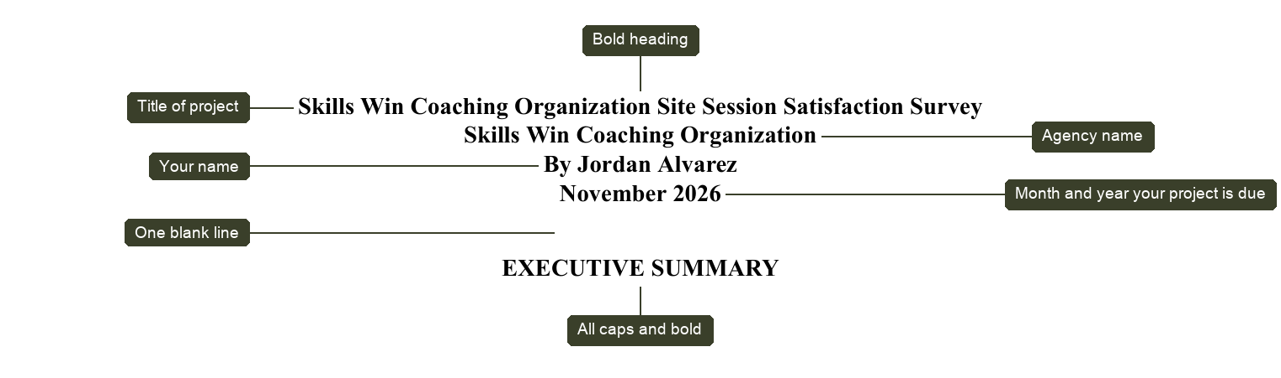
Note: The name of your project should describe in a few words the purpose of your project.
Step 2: Create the introduction by using information from your Organizational Assessment. The first sentences must be: “This study reports __________. The study will be presented to _________.”
The first sentence of the introduction in your executive summary should be identical to the first sentence in the introduction section of your report.
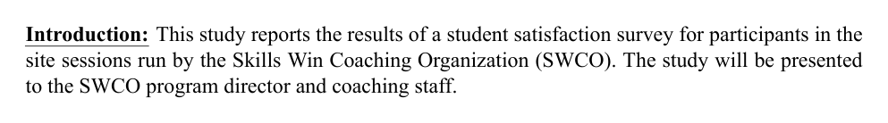
Step 3: Create the methods portion of your executive summary. Methods should overview how data were collected and define the target population, sample, and sampling frame, if applicable. Also in this section, note any MAJOR data collection and accuracy issues.
Questions to answer in Methods:
- How was the data collected?
- What was your target population?
- What was your sample? What was your sampling frame if you had one?
- What were any major data collection or accuracy issues?
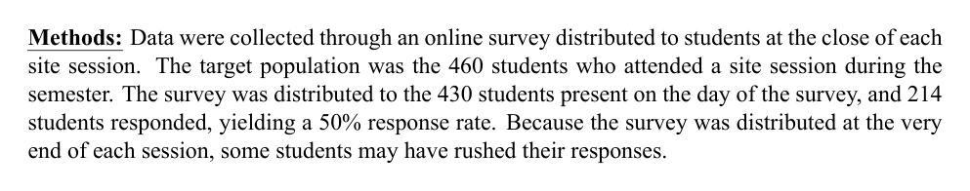
Step 4: Create the findings portion of your executive summary. Each of your findings in this section should EXACTLY match the findings at the top of each of your Findings pages throughout your report – this means word for word. Be sure every research question corresponds with a finding.
Reminders about findings:
- All findings should read “XX% of respondents reported…” OR “XX% of respondents said…”
- N (target population) vs. n (sample) – use the correct case for parentheses after the finding
- “Findings” should be bold and underlined
- Numbers should be left justified and align with the “F” in “Findings”
- Sample size goes after the period in the parentheses
- Single-spaced within paragraphs, double-spaced between paragraphs
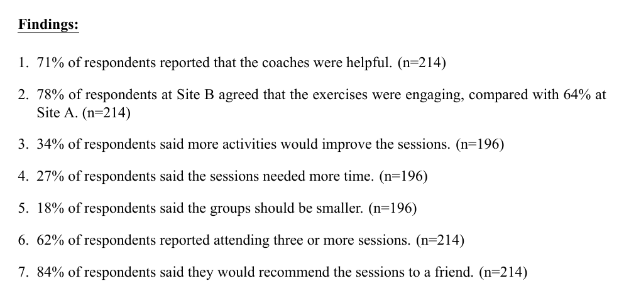

Example executive summary
