Qualitative (Open-Ended) Coding Guide
  - PST 315: Methods of Policy Analysis and Presentation
Prof. Jack Reilly
F2026
 About these examples
The examples below use sample data. Skills Win Coaching Organization is a real Syracuse University program, but the responses and numbers shown here are invented for teaching purposes and are not actual SWCO results.

Note: There are three types of open-ended survey responses: categorical (single category), attitudinal (single category), and check-all-that-apply (multiple categories).
Step 1: List open-ended actual responses.
Copy the responses out of your spreadsheet exactly as they were written – do not fix spelling or grammar.
What could be improved at your site sessions?
Respondent ID | Response
1 | More hands on activities would be good.
2 | add more group activities
3 | More activities like the resume one.
4 | i liked the practice interviews, do more of those
5 | More team exercises.
6 | more activities
7 | Do more of the role playing exercises.
8 | More things to actually practice.
9 | The sessions felt rushed at the end.
10 | more time for each activity
11 | Longer sessions.
12 | We needed more time to finish.
Step 2: Aggregate responses into categories. The number of categories will depend on the variety of responses you have received, but aim to create the fewest number of categories possible while ensuring every response fits into one.
Step 3: Take the number of responses for each category and then divide each raw number by the total number of responses (times 100) to get a percentage.
Category | Responses | Percentage
More activities | 8 | 35%
More time | 6 | 26%
Smaller groups | 4 | 17%
Better materials | 3 | 13%
Nothing | 2 | 9%
Step 4: Graph the percentage data according to the PST 315 graphing guidelines.
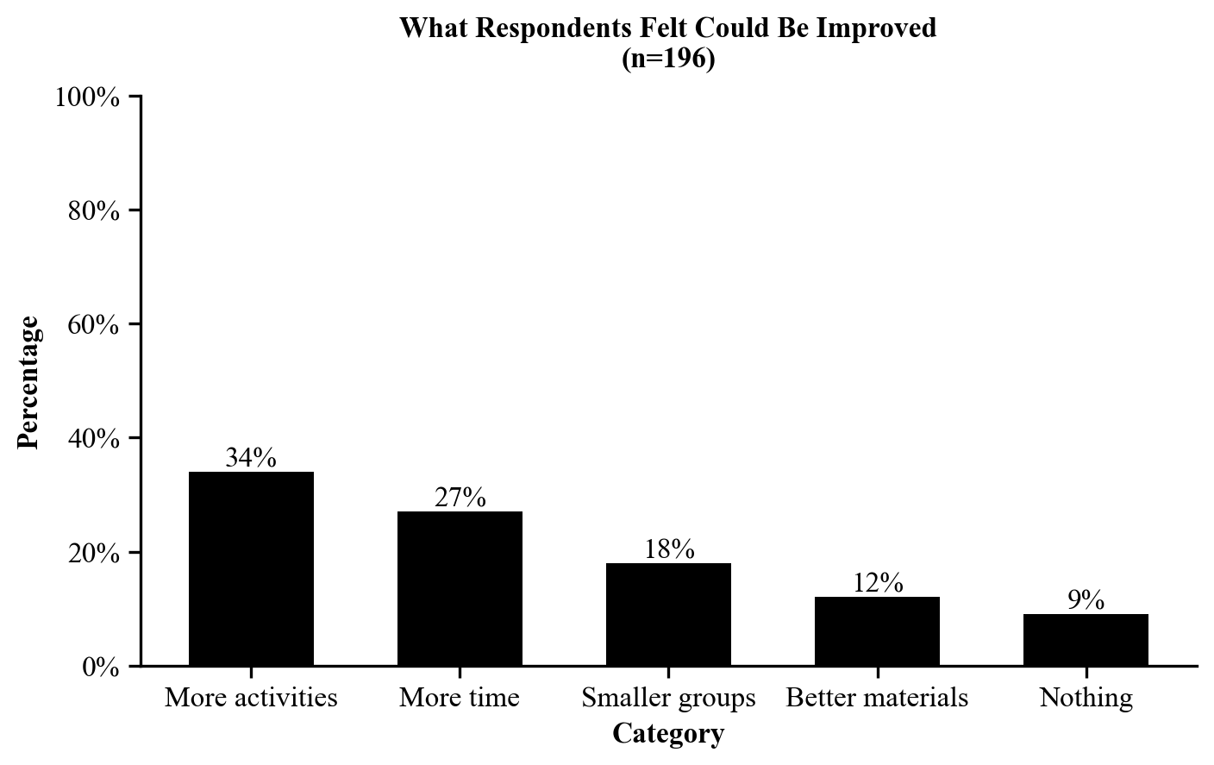
Step 5: Include the category name with actual responses listed below in the appendix. See the Appendices Guide.
More activities (n=8)
- More hands on activities would be good.
- add more group activities
- More activities like the resume one.
- i liked the practice interviews, do more of those
More time (n=6)
- The sessions felt rushed at the end.
- more time for each activity
- Longer sessions.
- We needed more time to finish.
Smaller groups (n=4)
- The groups were too big.
- smaller groups so everyone can talk
- Too many people at my table.
- Smaller groups would help.
Better materials (n=3)
- The handouts were hard to read.
- better worksheets
- The packet had typos in it.
Nothing (n=2)
- Nothing, it was great.
- nothing

