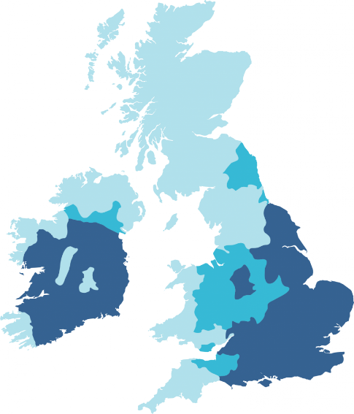



Hard to very hard Medium to hard Soft to moderately soft





