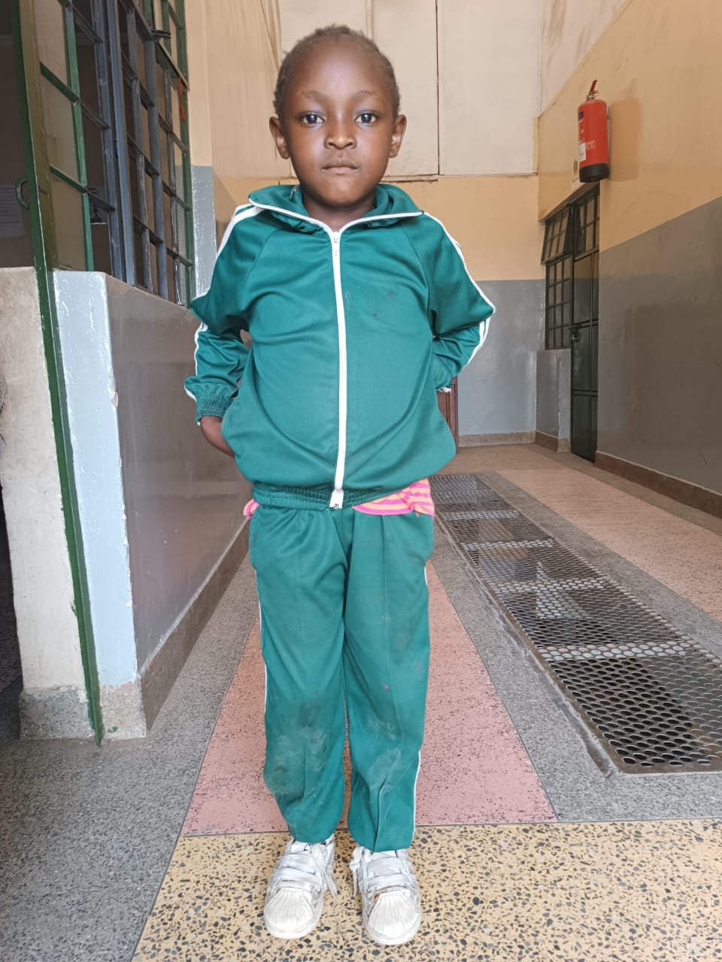

Helping Hands e.V.

***Wirkungsvoll helfen · Nachhaltig verändern***

Helping Hands e.V. in cooperation with Ark School

**Personal Information Form for Sponsorship**

Full Name of Child: Gender:

Female

Stanella Chale

Date of Birth: School Grade: Hobbies:

Dancing

2

2016

Father‘s Name: Mother‘s Name:

Dorine Aswani

Robert Osigwar

Occupation: Occupation:

Cleaner

---------

No. of Brothers: No. of Sisters:

4

----------

Note:

Stanella Chale is a 9 year old in grade two. She is the last born in the family of 4. the four sisters do not share a father though. Stanella and Shaneez share a father who is very drunk and cares less about his family. He threw Stanella, her mother and their sisters out of his house because their mother was not giving birth to a son.

They moved in to stay with their grandmother who died two years later, leaving Stanella and her siblings homeless and unable to find food. Her mother decided to move with her daughters to Nairobi to look for employment. She landed one of the worst jobs in Nairobi of cleaning the local pubs where she too ended up drinking local brews. With her too much drinking the girls became very vulnerable and they came to us begging for a chance to join school. With much empathy and fear for their lives, we took them in school. Their being in school is good, but a challenge to running the school without getting any payments from them. As our economy keeps falling, we are finding it hard to keep them in and meet our financial obligations at the same time. For each school child to get the learning band teaching services, he/she ought to pay ks 6000. Any financial support given to Stanella

Helping Hands e.V.

***Wirkungsvoll helfen · Nachhaltig verändern***

Helping Hands e.V. in cooperation with Ark School

**Personal Information Form for Sponsorship**

Full Name of Child: Gender:

Female

Stanella Chale

Date of Birth: School Grade: Hobbies:

Dancing

3

2016

Father‘s Name: Mother‘s Name:

Dorine Aswani

Robert Osigwar

Occupation: Occupation:

Cleaner

---------

No. of Brothers: No. of Sisters:

4

----------

Note:

Stanella Chale is a 10 year old in grade two. She is the last born in the family of 4. the four sisters do not share a father though. Stanella and Shaneez share a father who is very drunk and cares less about his family. He threw Stanella, her mother and their sisters out of his house because their mother was not giving birth to a son.

They moved in to stay with their grandmother who died two years later, leaving Stanella and her siblings homeless and unable to find food. Her mother decided to move with her daughters to Nairobi to look for employment. She landed one of the worst jobs in Nairobi of cleaning the local pubs where she too ended up drinking local brews. With her too much drinking the girls became very vulnerable and they came to us begging for a chance to join school. With much empathy and fear for their lives, we took them in school. Their being in school is good, but a challenge to running the school without getting any payments from them. As our economy keeps falling, we are finding it hard to keep them in and meet our financial obligations at the same time. For each school child to get the learning band teaching services, he/she ought to pay ks 6000. Any financial support given to Stanella will be highly appreciated.