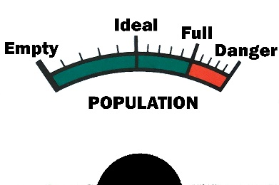 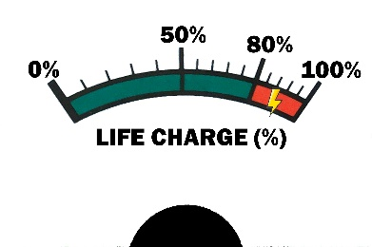

Conway’s Life

* Any live cell with fewer than two live neighbours dies from loneliness.
* Any live cell with two or three live neighbours survives.
* Any live cell with more than three live neighbours dies from overpopulation.
* Any dead cell with exactly three live neighbours becomes a live cell.

