https://github.com/akjasim/cb_laravel_custom_auth

**1) Add username/phone_number column to users migration file.**

Username field add kora migration file e

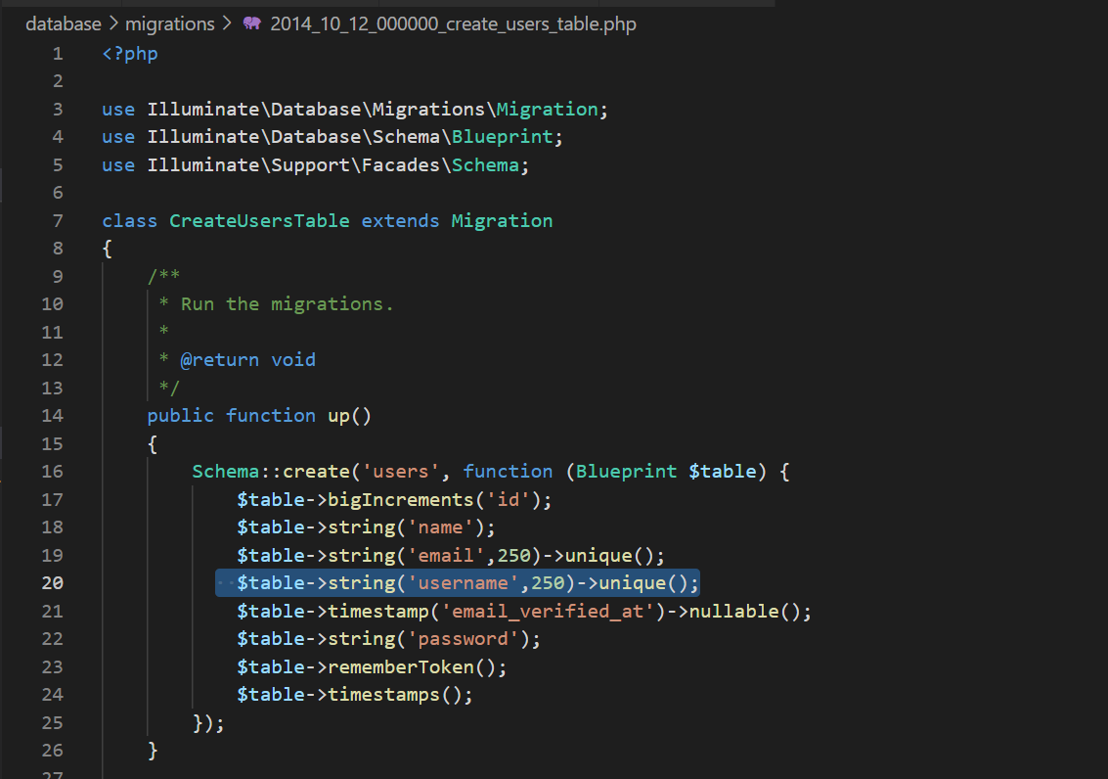

**2) Migrate all files.**

Then php artisan migrate korte hobe

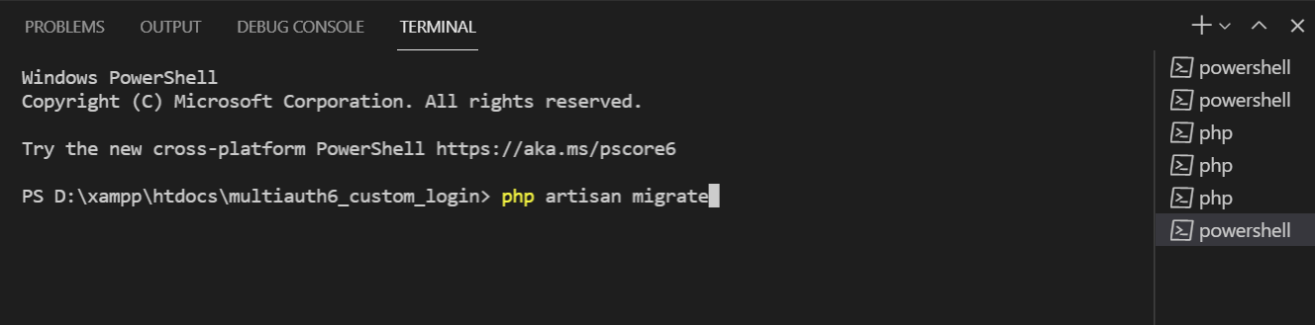

**3) Edit Registration view to add username/phone_number input field.**

Now auth er register.blade file e username field add korte hobe,

Email field er jonno je div ache ta copy kore r ekta div hishebe paste kore tar name username diye dite hobe and validation and message er jaygay username dite hobe

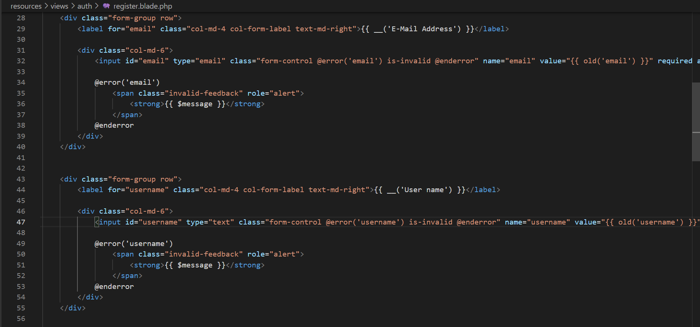

**4) Edit RegisterController**

a) Add username/phone_number to the validate() method.

b) Add username/phone_number to the create() method.

In RegisterCOntroller.php

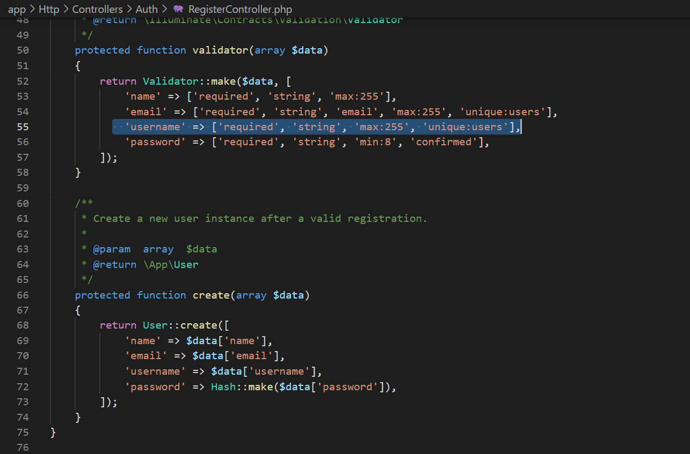

#### 5) Add username/phone_number to $fillable property in User model.

#### 

**6) Override username() method in LoginController to return username/phone_number.**

**New add username() method**

#### 

**7) Edit the Login view to display username/phone_number input instead of Email.**

#### 

#### Create register

#### http://localhost/multiauth6_custom_login/register

#### 

Create Login

