Airlines - SDS2 Project

Giacomo Maretto

03 gennaio 2019

# Airlines Fatalities

## Introduction

In this project we are analyzing data collected from 1976 to 2001 about airline fatal accidents by the International Civil Aviation Organization in Montreal , Canada (www.icao.int).

Our goal is to get a good prediction about future fatalitis through a bayesian approach.

Our data is structured with four columns, year, fatal, miles, rate.

“Passenger miles” are in units of ${10}^{11}$ and the “accident rate” is the number of fatal accidents per ${10}^{11}$ passenger miles.

|  |  |  |  |
| --- | --- | --- | --- |
| year | fatal | miles | rate |
| 1976 | 24 | 3.863 | 6.213 |
| 1977 | 25 | 4.3 | 5.814 |
| 1978 | 31 | 5.027 | 6.167 |
| 1979 | 31 | 5.481 | 5.656 |
| 1980 | 22 | 5.814 | 3.784 |
| 1981 | 21 | 6.033 | 3.481 |
| 1982 | 26 | 5.877 | 4.424 |
| 1983 | 20 | 6.223 | 3.214 |
| 1984 | 16 | 7.433 | 2.152 |
| 1985 | 22 | 7.107 | 3.096 |
| 1986 | 22 | 9.1 | 2.418 |
| 1987 | 25 | 10 | 2.5 |
| 1988 | 29 | 10.6 | 2.736 |
| 1989 | 29 | 10.99 | 2.639 |
| 1990 | 27 | 10.88 | 2.482 |
| 1991 | 29 | 10.63 | 2.727 |
| 1992 | 28 | 11.96 | 2.342 |
| 1993 | 33 | 12.34 | 2.674 |
| 1994 | 27 | 13.01 | 2.075 |
| 1995 | 25 | 14.22 | 1.758 |
| 1996 | 24 | 16.37 | 1.466 |
| 1997 | 26 | 15.48 | 1.679 |
| 1998 | 20 | 18.08 | 1.106 |
| 1999 | 21 | 16.63 | 1.263 |
| 2000 | 18 | 18.88 | 0.954 |
| 2001 | 13 | 19.23 | 0.676 |

### Following three descriptive time series plot respectively about the number of fatal accidents, the miles flown and the accident rate per each year.

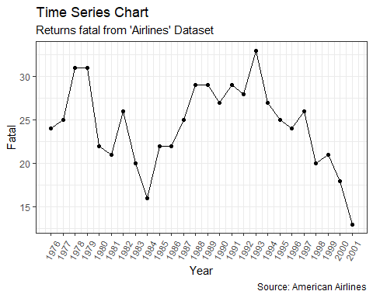

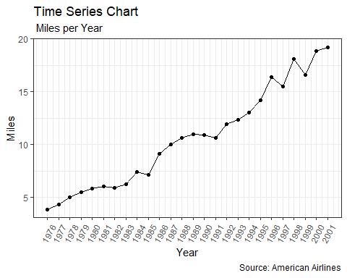

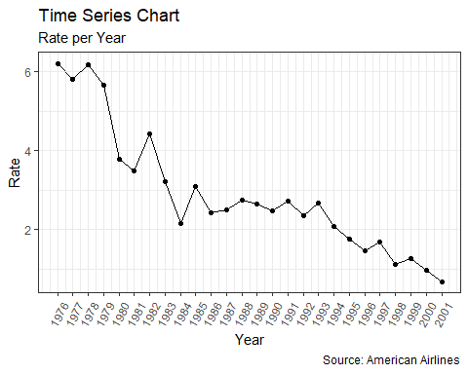 I started with the simplest model i could immagine, that simply all the years look the same. This means that the number of fatal accidents in each year are independend with a Poisson(/theta) distribution. I set a non informative gamma prior distribution for $θ$, that has $(α,β)=(0.01,0.01)$

The model for the data is:

where /theta is the expected number of fatal accidents in an year. If the prior distribution for $θ$ is $(Γ(α,β))$ then the posterior distrubution is $Γ(α+n\overline{y},β+n)$, where in this case $n=26$ and $n\overline{y}=\sum_{i=1}^{26}{y_{i}}=634$

$$y_{i}|θ∼Poisson(θ)$$

## Posterior distribution

The posterior distribution for $θ$ is $θ|y∼Γ(634,26)$ and the conditional distribution of $\overset{̃}{y}$ (the number of fatal accidents in 2002) is $Poisson(θ)$.

So to simulate values of $\overset{̃}{y}$ all we need to do is first generate a realized value form the posterior distribution of $θ$ as the mean. Iterating this process will generate values of $\overset{̃}{y}$ from the posterior predictive distribution. What we are doing here is integrating numerically, using simulation, over the posterior distrobution in $θ$. We can simulate this easily in R.

theta <- rgamma(1000, 634, 26 )  
y.2002 <- rpois(1000,theta)  
#hist( y.2002 )  
plot( table(y.2002), type="h", lwd=5, lend=2, col=gray(0.5), bty="n", ylab="" )

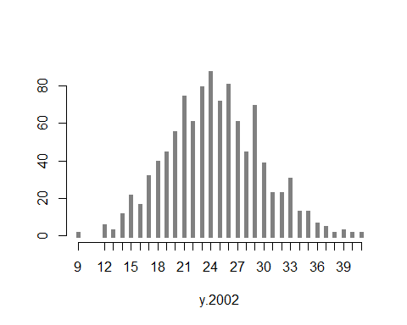 We can specify the model in R using the package rJags.

a1.par <- c("mu","fatal[27]")  
  
a1.ini <- list(list( mu=22 ),  
 list( mu=23 ),  
 list( mu=24 ) )  
  
a1.dat <- list( fatal = c(airline$fatal,NA), I=27 )  
  
# Model compilation and burn-in  
a1.mod <- jags.model( file = "a1.jag",  
 data = a1.dat,  
 inits = a1.ini,  
 n.chains = 3,  
 n.adapt = 1000 )

## Compiling model graph  
## Resolving undeclared variables  
## Allocating nodes  
## Graph information:  
## Observed stochastic nodes: 26  
## Unobserved stochastic nodes: 2  
## Total graph size: 30  
##   
## Initializing model

# Sampling from the posterior  
a1.res <- coda.samples( a1.mod,  
 var = a1.par,  
 n.iter = 10000,  
 thin = 10 )  
summary( a1.res )

##   
## Iterations = 10:10000  
## Thinning interval = 10   
## Number of chains = 3   
## Sample size per chain = 1000   
##   
## 1. Empirical mean and standard deviation for each variable,  
## plus standard error of the mean:  
##   
## Mean SD Naive SE Time-series SE  
## fatal[27] 24.36 4.9184 0.08980 0.08830  
## mu 24.38 0.9778 0.01785 0.01711  
##   
## 2. Quantiles for each variable:  
##   
## 2.5% 25% 50% 75% 97.5%  
## fatal[27] 15.00 21.00 24.00 28.00 34.00  
## mu 22.47 23.71 24.35 25.02 26.35

print( xyplot( a1.res[,1:2] ) )

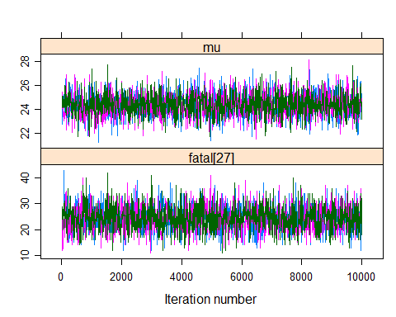

theta <- rgamma(6000, 634, 26 )  
y.2002 <- rpois(6000,theta)  
plot( table(y.2002), type="h", lwd=5, lend=2, col=gray(0.2), bty="n", ylab="", xlim=c(5,50) )  
tpr <- table( as.matrix( a1.res[,"fatal[27]"] ) )  
points( as.numeric(names(tpr))+0.4, tpr, type="h", col="red", lwd=4 )

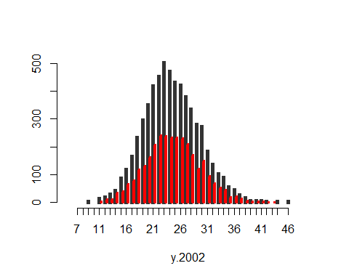

###################

result = ggs(a1.res)  
ggs_density(result)

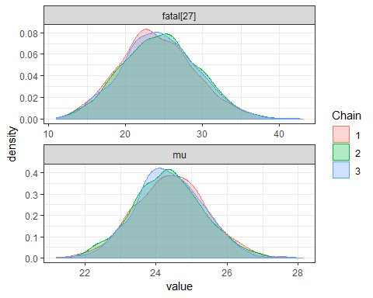

ggs_traceplot(result)

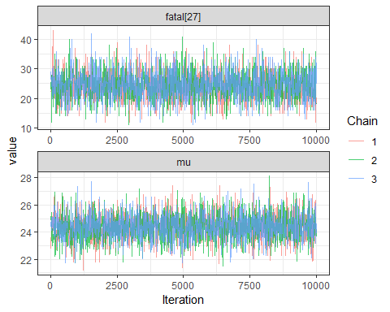

ggs_running(result)

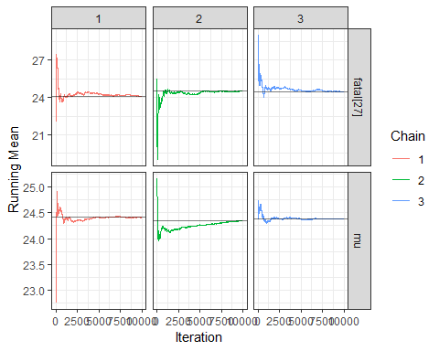

ggs_autocorrelation(result)

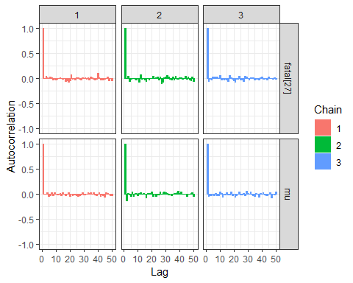

ggs_pairs(result) ########mmmmmeh

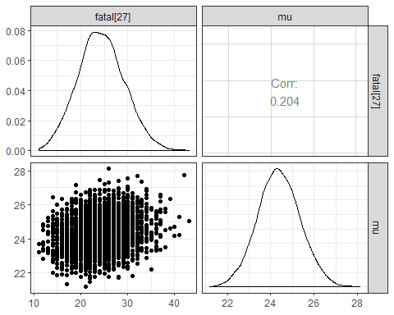 ## MODEL2

a2.ini <- list( list( lambda=10 ),list( lambda=20 ),list( lambda=30 ) )  
a2.dat <- list( fatal=c(airline$fatal,NA),miles=c(airline$miles,20), I=27 )  
a2.par <- c("mu","fatal[27]")  
  
# Model compilation and burn-in  
a2.mod <- jags.model( file = "a2.jag",data = a2.dat,inits = a2.ini,n.chains = 3,n.adapt = 1000 )

## Compiling model graph  
## Resolving undeclared variables  
## Allocating nodes  
## Graph information:  
## Observed stochastic nodes: 26  
## Unobserved stochastic nodes: 2  
## Total graph size: 84  
##   
## Initializing model

# Sampling from the posterior  
a2.res <- coda.samples( a2.mod,var = a2.par,n.iter = 10000,thin = 10 )  
summary( a2.res )

##   
## Iterations = 10:10000  
## Thinning interval = 10   
## Number of chains = 3   
## Sample size per chain = 1000   
##   
## 1. Empirical mean and standard deviation for each variable,  
## plus standard error of the mean:  
##   
## Mean SD Naive SE Time-series SE  
## fatal[27] 46.233 6.9624 0.127115 0.122617  
## mu[1] 8.897 0.3446 0.006292 0.006251  
## mu[2] 9.903 0.3836 0.007004 0.006958  
## mu[3] 11.577 0.4485 0.008188 0.008134  
## mu[4] 12.623 0.4890 0.008927 0.008869  
## mu[5] 13.390 0.5187 0.009470 0.009407  
## mu[6] 13.894 0.5382 0.009826 0.009762  
## mu[7] 13.535 0.5243 0.009572 0.009509  
## mu[8] 14.332 0.5552 0.010136 0.010069  
## mu[9] 17.118 0.6631 0.012107 0.012027  
## mu[10] 16.368 0.6340 0.011576 0.011500  
## mu[11] 20.958 0.8118 0.014822 0.014724  
## mu[12] 23.030 0.8921 0.016288 0.016181  
## mu[13] 24.412 0.9456 0.017265 0.017151  
## mu[14] 25.306 0.9803 0.017897 0.017779  
## mu[15] 25.057 0.9706 0.017721 0.017604  
## mu[16] 24.488 0.9486 0.017319 0.017205  
## mu[17] 27.535 1.0666 0.019474 0.019345  
## mu[18] 28.426 1.1011 0.020104 0.019972  
## mu[19] 29.965 1.1607 0.021192 0.021053  
## mu[20] 32.749 1.2686 0.023161 0.023009  
## mu[21] 37.703 1.4605 0.026665 0.026489  
## mu[22] 35.658 1.3813 0.025218 0.025052  
## mu[23] 41.639 1.6129 0.029448 0.029254  
## mu[24] 38.306 1.4839 0.027091 0.026913  
## mu[25] 43.470 1.6839 0.030743 0.030541  
## mu[26] 44.294 1.7158 0.031326 0.031120  
## mu[27] 46.061 1.7842 0.032575 0.032361  
##   
## 2. Quantiles for each variable:  
##   
## 2.5% 25% 50% 75% 97.5%  
## fatal[27] 33.000 41.000 46.000 51.000 60.000  
## mu[1] 8.209 8.671 8.898 9.128 9.562  
## mu[2] 9.138 9.652 9.905 10.160 10.643  
## mu[3] 10.683 11.284 11.579 11.878 12.443  
## mu[4] 11.648 12.303 12.625 12.951 13.566  
## mu[5] 12.356 13.051 13.392 13.738 14.391  
## mu[6] 12.821 13.542 13.896 14.255 14.933  
## mu[7] 12.490 13.192 13.537 13.886 14.546  
## mu[8] 13.225 13.969 14.334 14.704 15.403  
## mu[9] 15.796 16.685 17.121 17.563 18.398  
## mu[10] 15.103 15.953 16.370 16.793 17.591  
## mu[11] 19.339 20.427 20.961 21.502 22.524  
## mu[12] 21.251 22.447 23.034 23.628 24.752  
## mu[13] 22.527 23.794 24.416 25.046 26.237  
## mu[14] 23.351 24.665 25.310 25.963 27.197  
## mu[15] 23.122 24.422 25.061 25.708 26.930  
## mu[16] 22.597 23.868 24.492 25.124 26.318  
## mu[17] 25.408 26.838 27.540 28.250 29.593  
## mu[18] 26.231 27.706 28.431 29.165 30.551  
## mu[19] 27.650 29.206 29.970 30.743 32.204  
## mu[20] 30.220 31.920 32.754 33.600 35.197  
## mu[21] 34.791 36.748 37.709 38.682 40.521  
## mu[22] 32.904 34.755 35.664 36.584 38.323  
## mu[23] 38.423 40.584 41.646 42.720 44.751  
## mu[24] 35.348 37.336 38.313 39.301 41.169  
## mu[25] 40.112 42.369 43.477 44.599 46.719  
## mu[26] 40.873 43.172 44.301 45.444 47.605  
## mu[27] 42.503 44.894 46.068 47.257 49.503

print( xyplot( a2.res[,1:2] ) )

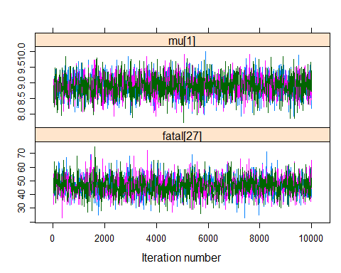

################################   
#A closer inspection of the number of fatal airline crashes can be dome by:  
par(mfrow=c(1,2))  
with(airline, plot( year, fatal, pch=16, type="b", ylim=c(0,32), bty="n" ) )  
with(airline, plot( year, rate, pch=16, type="b", ylim=c(0,7), bty="n" ) )

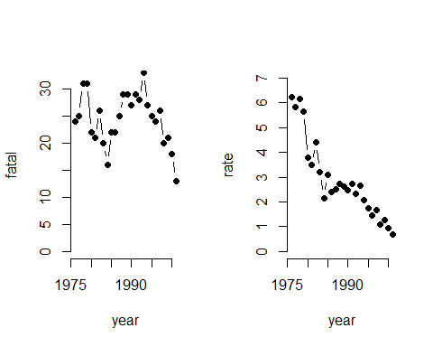

result2 = ggs(a2.res)  
ggs_density(result)



ggs_traceplot(result)



ggs_running(result)



ggs_autocorrelation(result2)

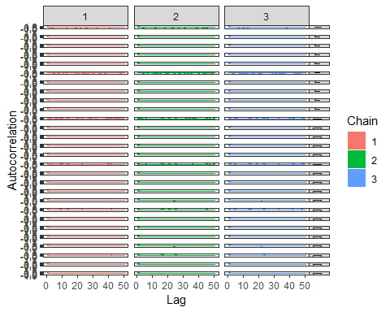 ## MODEL 3

a3.ini <- list( list( alpha=10, beta=-0.5 ),list( alpha=20, beta=-0.6 ),list( alpha=30, beta=-0.4 ) )  
  
a3.dat <- list( fatal=c(airline$fatal,NA),miles=c(airline$miles,20), I=27 )  
  
a3.par <- c("alpha","beta","fatal[27]")  
  
# Model compilation and burn-in  
a3.mod <- jags.model( file = "a3.jag",data = a3.dat,inits = a3.ini,n.chains = 3,n.adapt = 1000 )

## Compiling model graph  
## Resolving undeclared variables  
## Allocating nodes  
## Graph information:  
## Observed stochastic nodes: 26  
## Unobserved stochastic nodes: 3  
## Total graph size: 194  
##   
## Initializing model

# Sampling from the posterior  
a3.res <- coda.samples( a3.mod,var = a3.par,n.iter = 10000,thin = 10 )  
summary( a3.res )

##   
## Iterations = 1010:11000  
## Thinning interval = 10   
## Number of chains = 3   
## Sample size per chain = 1000   
##   
## 1. Empirical mean and standard deviation for each variable,  
## plus standard error of the mean:  
##   
## Mean SD Naive SE Time-series SE  
## alpha 3.4305 0.15686 0.0028638 0.0035699  
## beta -0.1662 0.01325 0.0002419 0.0002932  
## fatal[27] 12.1023 4.17824 0.0762839 0.0751099  
##   
## 2. Quantiles for each variable:  
##   
## 2.5% 25% 50% 75% 97.5%  
## alpha 3.1328 3.3272 3.4241 3.5334 3.7497  
## beta -0.1936 -0.1749 -0.1661 -0.1572 -0.1406  
## fatal[27] 5.0000 9.0000 12.0000 15.0000 21.0000

print( xyplot( a3.res[,1:2] ) )

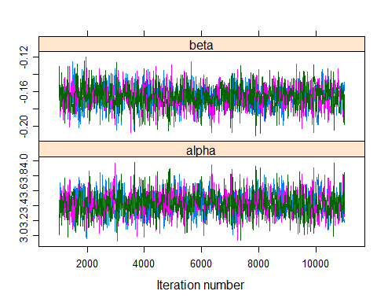

result3 = ggs(a3.res)  
ggs_density(result)



ggs_traceplot(result)



ggs_running(result)



ggs_autocorrelation(result3)

