1. If you have a filename called devops.txt, display the numeric notation of the permissions.
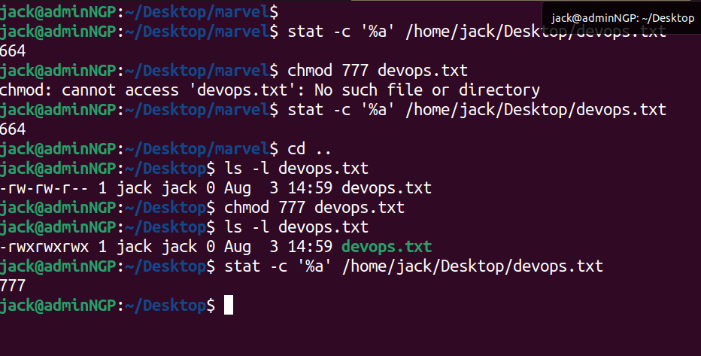

2. Consider we have two users say X and Y who have access to the same directory, both the users can create, read and execute the files in that particular directory, but delete cannot be issued by the other user who created the file (ex: A file created by X cannot be deleted by Y and vice-versa)

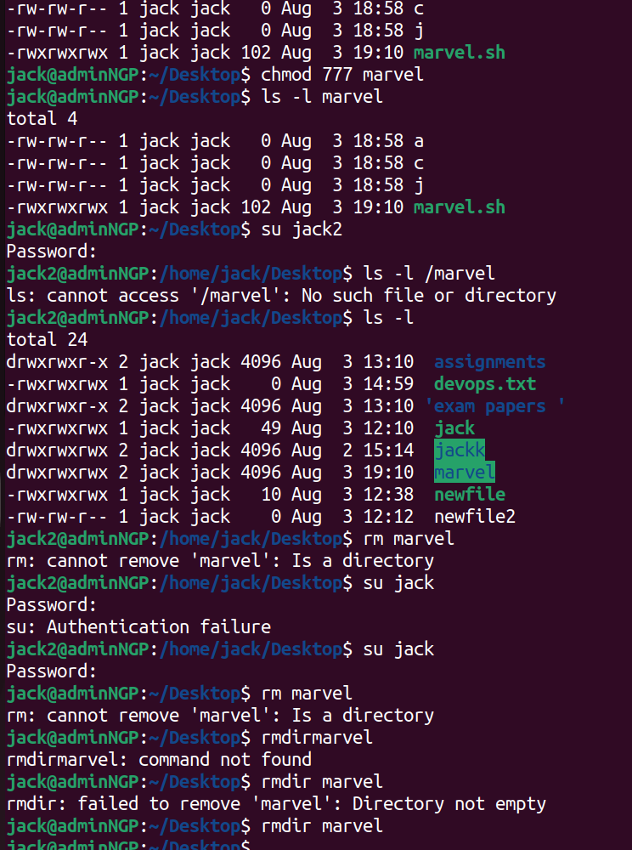

3. In which directories, the system files resides in the linux operating system
Configuration files - /etc
Log files- /var/log
Installation packages - /opt
Binary filesls - binary files
User related files - /usr/bin

4. Create two users, say Alex and Carey, and consider Carey as a group. A directory called marvel has Alex ownership, change the marvel’s group ownership to Carey, but both should have the read, write and execute permissions to the marvel directory.

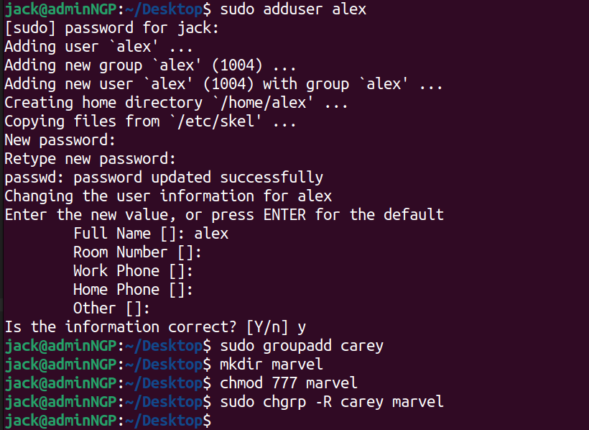
S

5. All the users should be able to access the files in a directory called Avengers, what will be the output?

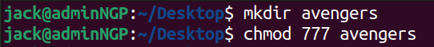
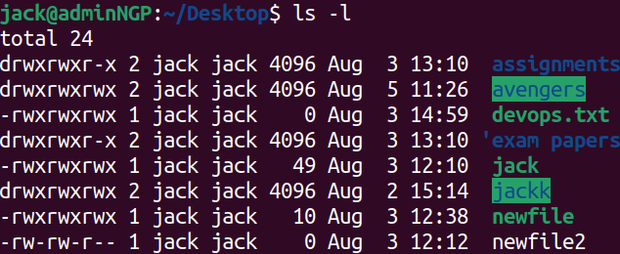

6. A directory has 10 files, in which 4 files have a unique pattern in their names which starts with john. write the file names matched to another new file

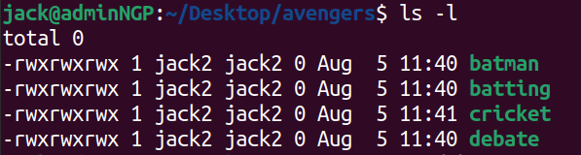
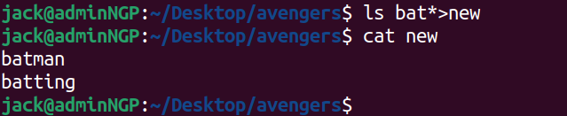

7. List the files in a directory, in which the list condition should be recently modified on the top of human readable format without displaying their group.

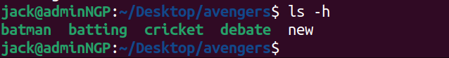
G

8. Consider a file in which the data is continuously written automatically, display the content of the file as soon as it is getting updated.

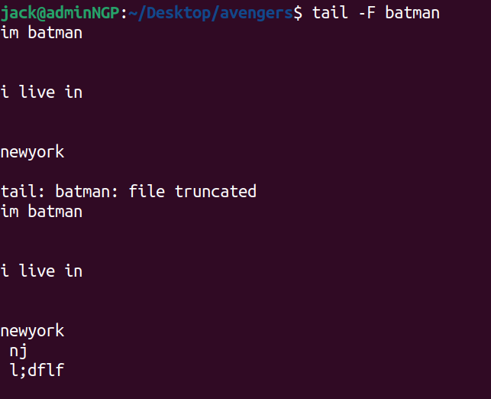
j

9. Consider a directory has n no of files with large sizes, how will you get the total size of the directory?

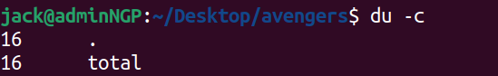
10.
10. Download the file given below in which we have n rows, copy only even rows of records from the given file and write it in the new file and mention how many lines the given file contains?

https://storage.googleapis.com/testing-intern/marvel_assessment/assessment.csv

