1, 2, 3 . creating tables.
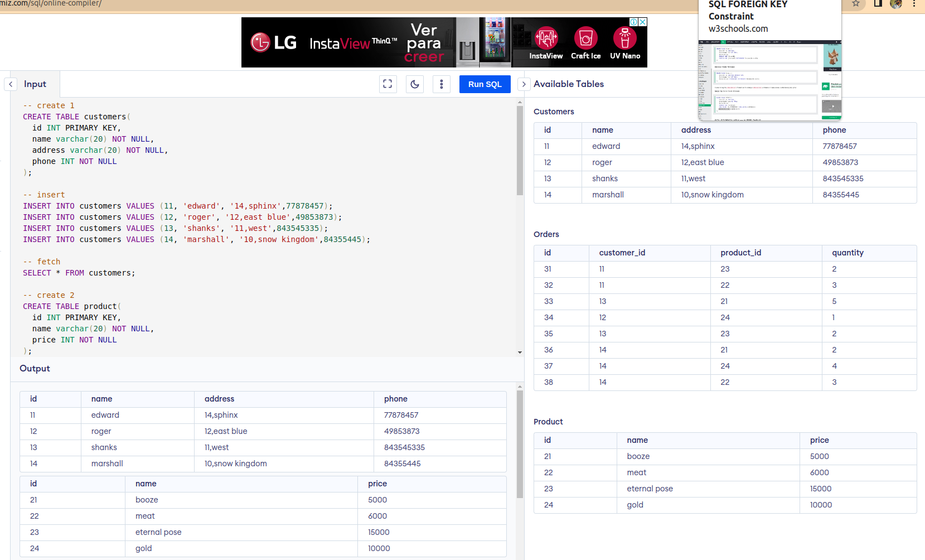
.

4. Get the Customer name, product name, total price based on quantity from the tables mentioned above.
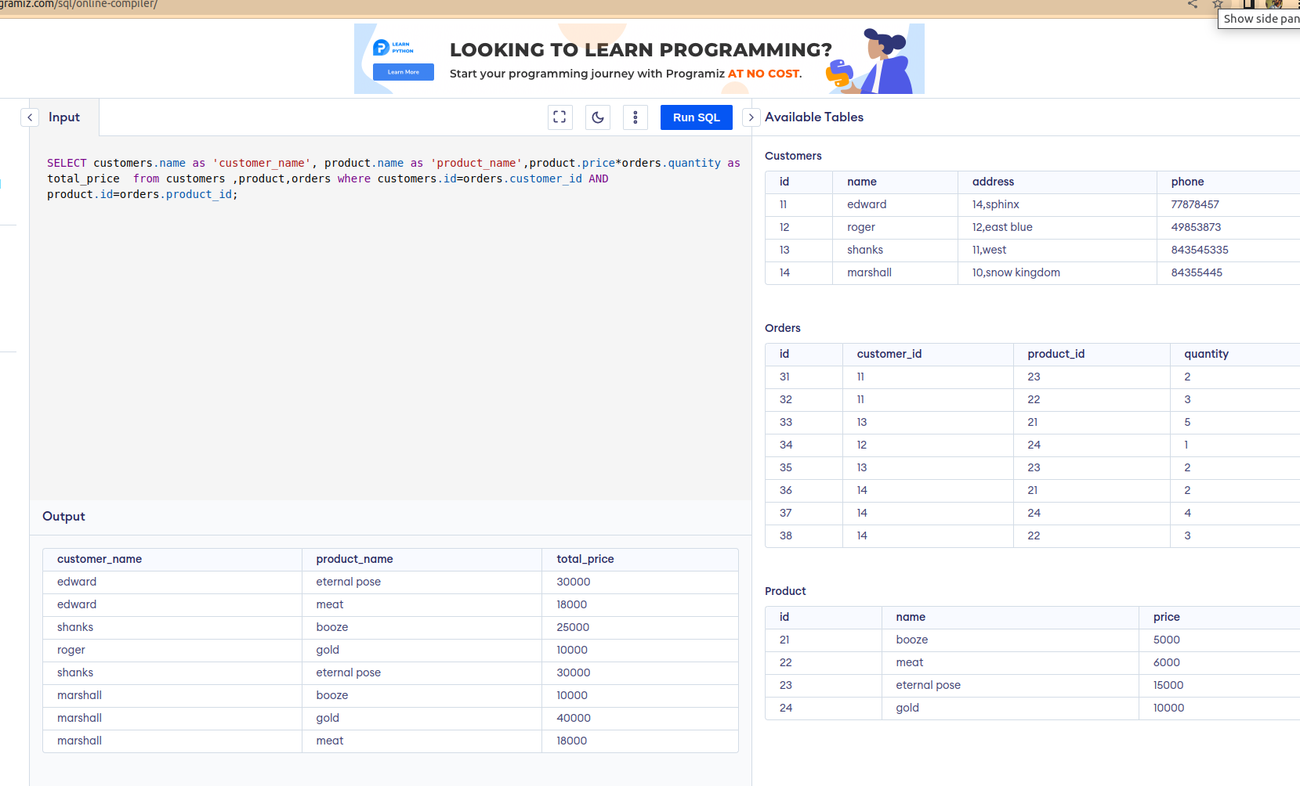
.

5. Get the Customer name and total amount spent by each customer from the tables mentioned above.

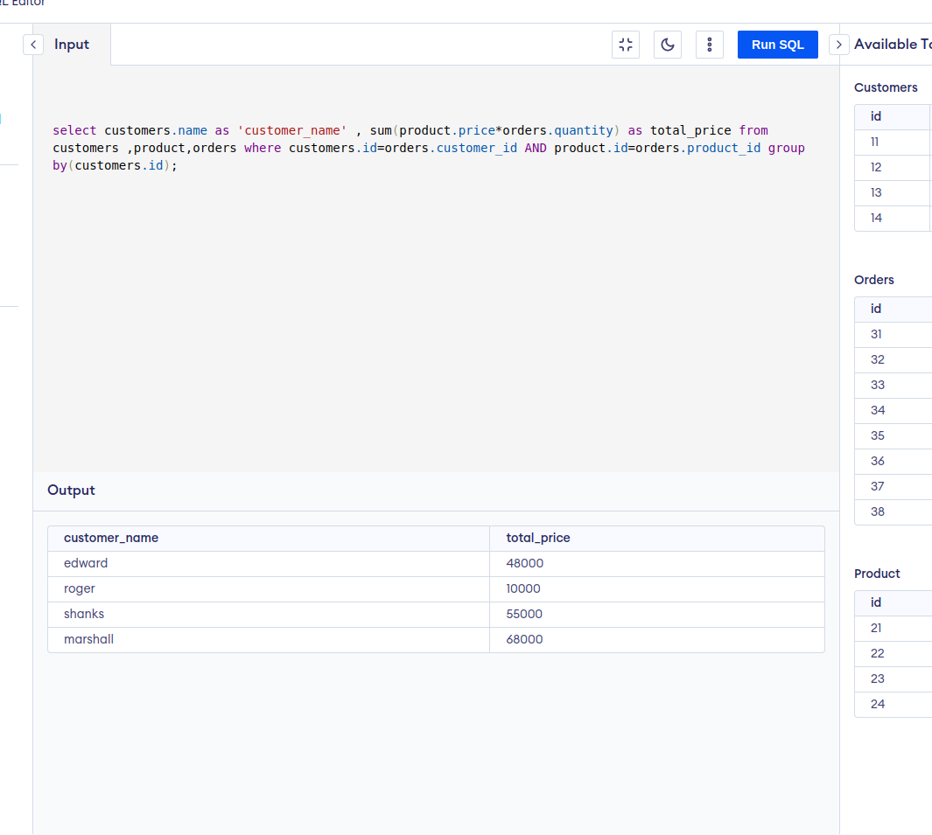
.

6. Update the records by multiplying the price by 2 for which the price is above 7000 in the Product table.

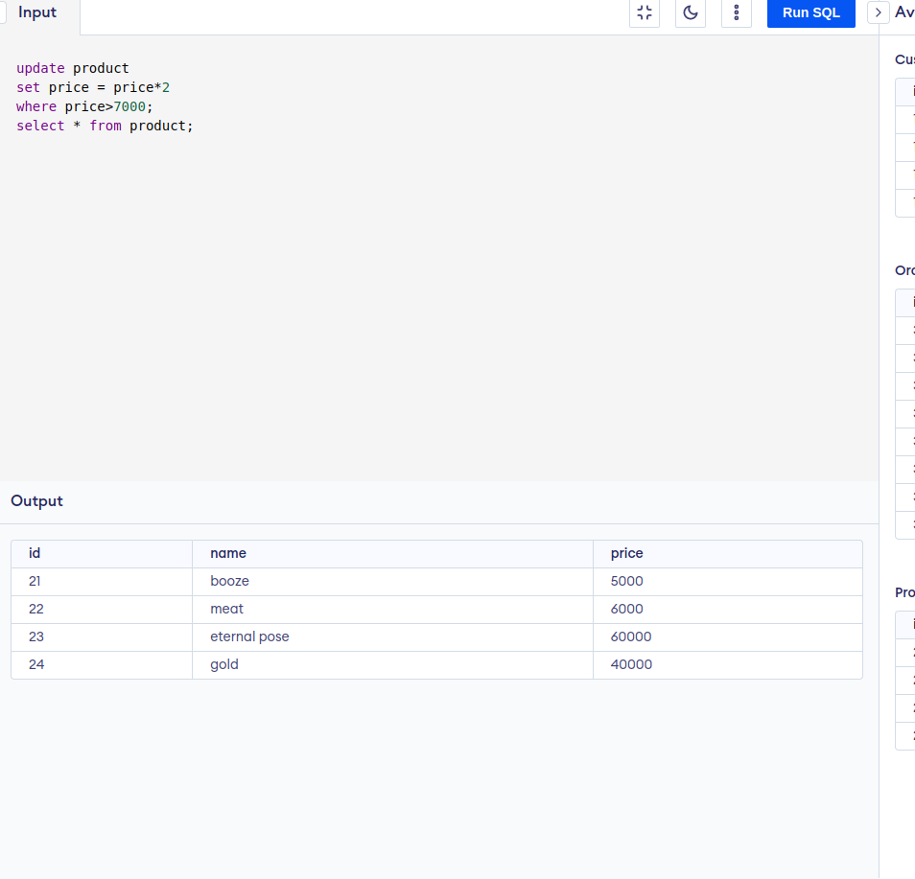
.

7. Delete a record from the customer table whose name has the word ‘hal’.

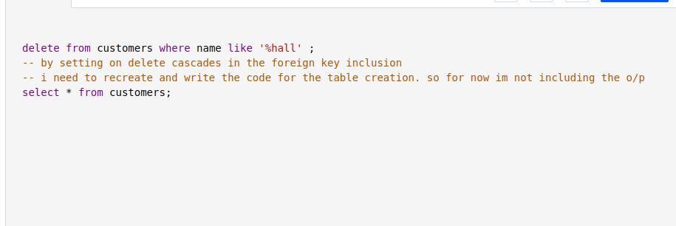
/

8. Create a trigger procedure for every insert in the Customer table, the price column in the Product table gets multiplied by 2.

9.Consider a table with columns Id,Name,CGPA.The table contains lots of duplicate records. Write a query to ignore the duplicate records.
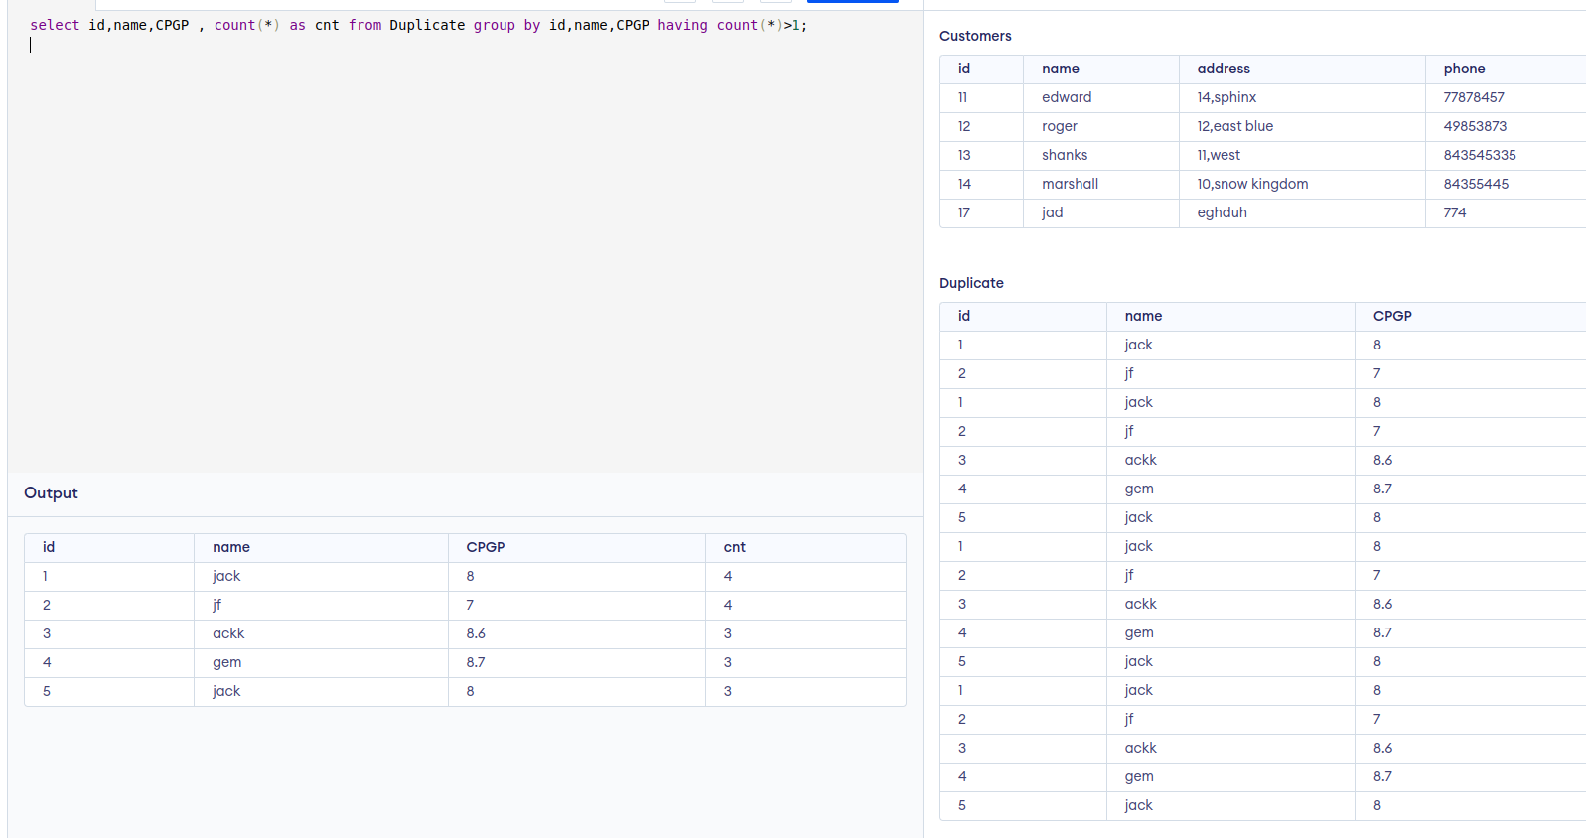
.

10. Write a query to know the difference between the timestamps ‘2022-06-26 14:55:59’ and ‘2022-06-11 12:03:59’ in hours.

