DECLARATION

I Jackson Mihayo declare to the best of my knowledge that the project presented here as fulfillment of Diploma Engineering in Computer, is my own work and has not been copied anywhere or presented elsewhere.,

|  |  |  |
| --- | --- | --- |
| **CANDIDATE NAME** | **SIGNATURE** | **DATE** |
| JACKSON MIHAYO SELEMAN | . | . |
| **SUPERVISOR NAME** | **SIGNATURE** | **DATE** |
| MR. JESSE RAPHAEL . | . | . |

## 

***ABSTRACT***

The primary purpose of this report is to give you a clear report concerning the design and development of the project of Online Project Information Management System, simply the system is straight forward in fact that the user can interact with the system online before, during and after presentation in which admin can upload the project information in a system respectively with the student particulars and admin can add comments, logs, update read and write during presentation. Also student can read and search information of the previous project specifications as well as student can write during presentation.

Different stages have been passed through to ensure that the project is completed successfully, these stages are being described in this book and other fundamental documentations have been given so that the project is well understood and the objectives of the project are met.

In this report you there is an introduction about Online project information Management system, the current procedure which is used for storing project information, there are operating in manual approach. Proposed system and its advantages have also been described so as to bring clear significance of having a new system. Data collection report is included and well defined in this report to enable you understand how data were gathered.

Procedures used in system design have are clearly described to enable full understanding of how the system was designed from the scratch. It explains the tools used to design and implement the whole system.

Finally, appendixes are attached to reveal the evidence on how data were gathered and techniques used to collect these data to make the project successful.

# ACKNOWLEDGEMENTS

There is no way I can forget to express my sincere thanks to my God and Creator who gave me some directives towards the completion of this project. May I also express my sincere thanks to Mr. J. Raphael my supervisor who is always providing me guidance, knowledge and courage to ensure the successful completion of this project. **MAY GOD BLESS YOU!**

I would like to thank the Head of Computer Studies Department Mr. B. Mwalongo, the project coordinator Mr. Justuce and all the lecturers and staff of the Computer Studies Department for making the project program run efficiently, enjoyable and successful and also the whole of the Dar es Salaam Institute of Technology Community.

I would like to express my special gratitude and thanks to my parents Mr. Mihayo and Mrs. Mihayo, my brother, sister-in-law and my young sister who have been my inspiration, courage and support over the years.

My sincere gratitude to OD17 computer students the computer family who are my class mates and also my dear friends for their collaboration and support.

I wish to express my sincere gratitude to my fellow DIT students who have helped towards different stages of accomplishing the project.

**ABBREVIATIONS**

|  |  |
| --- | --- |
| **Abbreviation** | **Meaning** |
| OD17COE | Ordinary Diploma in 2017 in Computer Engineering |
| DIT | Dar es Salaam Institute of Technology |
| MySQL | My Structure Query Language |
| ICT | Information and Communication Technology |
| GSM | Global System for Mobile Communication |
| Admin | Administrative / Administrator |
| COE | Computer Engineering |
| HTML | Hypertext Markup Language |
| PHP | Pre Hypertext Processor |

**TABLE OF CONTENTS**

**DECLARATION……………………………………………………………………………….i**

**ABSTRACT .****ii**

**ACKNOWLEDGMENTS** **iii**

**LIST OF ABBREVIATIONS iv**

**LIST OF TABLES……………………………………………………………………….vii**

**TABLE OF CONTENTS.…………….………………………………………………….viii**

**CHAPTER ONE****……………………………………………………………………………..1**

**1.0 INTRODUCTION** **1**

**1.1 PROBLEM DEFINITION** **1**

**1.2 OBJECTIVES** **1**

**1.2.1 Main Objective** **1**

**1.2.2 Specific Objectives** **1**

**1.3 Scope and Limitation of the project** **2**

**CHAPTER TWO** **3**

**2.0 Literature Review** **3**

**2.1.1 The Existing System** **3**

**2.1.2 Advantages of the Existing System** **4**

**2.1.3 Disadvantages of the Existing System** **4**

**2.2.0 The proposed System** **4**

**2.2.1 How it works** **5**

**2.2.2 Advantages of the proposed system** **....…6**

**CHAPTER THREE…….………………………………………………………………………7**

**3.0 Methodology……………………...………………………………………………………….7**

**3.1 System development tools ………………………………………………………….….…...7**

**3.1.1 Software tools ……………………………………………………………………………...7**

**CHAPTER FOUR……………………………………………………………………………...10**

**4.0 Data collection………………………………………………………..…………………….10**

**4.1 Observation…………………………………………………………………………………10**

**4.2 Interview…………………………………...………………………………………………..10**

**4.3 Document reading and case study visits………………………………………………..…10**

**4.4 Reading materials about similar systems that exist………………………………...........10**

**CHAPTER FIVE…………………………………………………………………………..……14**

**5.1 Conclusion………………………..…………………………………………………….……14**

**5.2 Reference………………………………………..…………………………………...………14**

***LIST OF FIGURES***

Fig. 2.1 The Existing System……………………………………………………………4

Fig. 2.3 Context Diagram for the Proposed System……………………………………...5

**SYMBOLS USED**



Symbol 1.1: Direction of event flow

Symbol 1.2: An entity

Symbol 1.3: A process

## Symbol 1.4: Use case

Symbol 1.5: Actor

**CHAPTER 1**

1. **INTRODUCTION**

The current project information system managed manually in such a way that the managing activities done by writing the project information on the piece of paper or manual paper then typing in Ms. Excel there after compiled in document that trigger to time consuming, costly, duplication of data and risks of losing manual paper.

In order to simply all above, hopeful the proposed system of online project information system will solve these problems

**1.1 PROBLEM STATEMENT**

The problem of the existing system is, to manage project information in the manual approach that is not friendly reliable to the student population simply because its not straight forward.

however, this system encounters the following problems: -

1.Its difficulty to view the previous projects information

2.Its difficult to know the collegian's project title

3.Its difficulty to looking for the scope of the project done

4.Its difficulty to view teacher’s expertise

**1.2 OBJECTIVES**

**1.2.1 MAIN OBJECTIVE.**

**To design the Online project information management system at DIT.**

**1.2.2 SPECIFIC OBJECTIVES.**

The system will have the following specific objectives: -

I. To design subsystem that allow user authentication that is registering, login and reset password.

II. To design subsystem that upload project information

III. To design subsystem that give feedback to the student.

IV. To design tools for printing.

V. To design subsystem that display teacher’s expertise.

VI. To design subsystem for display logs

# 1.3 Scope of the project

The scope of this project is based on designing, testing and implementing the prototype.

**1.4** **Limitations of the project**

The system will not be helpful to student whose not finalist concerning with project of DIT institute, it focus much on finalist concerning with project at DIT and all teachers. system will be based only in centralize project information in one figure.

**1.5 SIGNIFICANCES OF THE PROJECT**

After the completion of this project, I shall come up with the system which

has the following significances:

1. The system will enable user to add, update, and comments during and after presentation
2. The system will help to prevent the risk of lost of some document
3. The system will provide the project information
4. The system will save money from buying plain paper, pen, pencil, eraser etc.
5. The system will enable the student to view the teacher’s expertise even if student want to select the supervisor whose familiar with the idea of the project
6. The system will help to search information of the previous project.

**CHAPTER TWO**

1. **LITERATURE REVIEW**

A literature review is a body of text that aims to review the critical points of current knowledge

including substantive findings as well as theoretical and methodological contributions to a

particular topic. Literature reviews are secondary sources, and as such, do not report any new

or original experimental work. In part the existing system is going to be reviewed to see how it

works, its advantages and disadvantages. Other similar systems are also going to be reviewed

and finally the proposed system.

**2.1.1 How the existing system works:**

The current system beginning by project coordinator collect the information of the project from student during presentation manually on a plain piece of paper then typing in a computer to Ms. Excel later compiled to the document and storing in a computer

**Fig. 2.1Block diagram of existing system**:

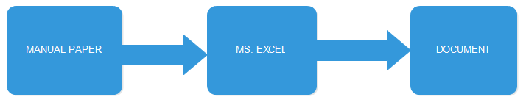

**\**

**2.1.2 Disadvantages of the existing system**

1. Risk of lost some document

2. The existing system is publishing the last paper that involve only book, author, references and abstract.

3. Time consuming and costly.

4. Absent of update or logs during crafting of the system from start to the end

5. It cause duplication of the project idea means collision of one title project among the students.

6. It only handle for few number of students

* 1. **Proposed System:**

The proposed system will be designing to take over the existing system that will enable all important information project activities done online. Examples of such activities are

1. The project coordinator will be able to add, read, write, update and put some comment during presentation.
2. It will allow supervisor and student to read and write logs.
3. The system will allow the students to search the previous project

**Fig. 2.3 Block Diagram for the proposed system:**

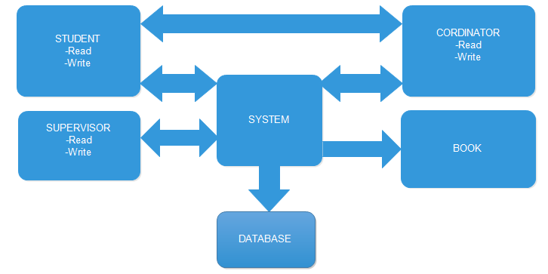

* 1. **How the proposed system will work**

The proposed system will work as follows:

1.The system will provide the previous project information that was done in which scope

2. The system will allow all activities project do online

3.The system will enable the student to view the teacher’s skills even if student want to select the supervisor whose familiar with the idea of the project

4.The system will help to inform the scope of previous project.

1. **4 Advantages of the proposed system**

The proposed system will have the following advantages:

a). The system will enable user to add logs, update, and comments during presentation

b). The system will prevent the risk of lost of some document

c). The system will provide the project information

d). The system will help to prevent collision from one title project to be doing by more than one student

e). The system will save money from buying plain paper, pen, pencil, eraser etc.

f). The system will enable the student to view the teacher’s skills even if student want to select the supervisor whose familiar with the idea of the project

**CHAPTER THREE**

1. **Methodology**

This is a systematic and procedure that will be used towards attaining the main

and specific objectives of this project of Online Project Information management system. Prototyping is a method that is going to be used to develop the Online project information management system.

The Prototyping Model is a systems development method in which an early approximation of final system or product is built, tested, and then reworked as necessary until an acceptable prototype is finally achieved from which the complete system or product can now be developed.

In terms of an information system, prototypes are employed to help system

designers build an information system that intuitive and easy to manipulate for end users.

During the course of development of the information system the following stages will be followed as it is in prototyping:

**TYPES OF METHODOLOGY**

1. Waterfall model
2. Agile software development
3. Protype model
4. Spiral model etc

**3.1 Why prototyping?**

I am prototyping, its because of the following advantages

(i ). prototype is shown to the clients, they get a clear understanding and complete 'feel' of the functionality of the software

(ii ). This method significantly reduces the risk of failure, as potential risks can be identified in early stage and moderation steps can be taken quickly

(iii). The communication between software developer and the client makes very good and conducive environment during a project

(iv). It helps in requirement gathering and requirement analysis when there is lack of requirement documents

(v). It’s adaptable for future use

**3.1.1 Consultation:**

Different professionals have been consulted and will be consulted for more understanding of the system and other software systems.

**Requirements definition/collection**

In this stage data about the system to be developed is collected from students and department coordinators of the project at DIT whose are main concern. After identifying the stake holders of the system i used to write the credentials or requirements and gathering techniques of the system.

These techniques are such as observation, interview, and questionnaire and through reading documents about similar systems. Every technique in this stage of gathering the user and system requirement is

**Prototype design**:

After the requirements have been gathered the blue print of the system is

designed. This helps to give a clear picture of the system in terms of functionality.

For the students and coordinators information a clear picture i.e the layout of the database system for storing project information system is produced, the tables, the primary keys, foreign keys are all put into the overall design of the proposed system to be developed. Also a design of the database interface and integration with user interface.

**Prototype creation:** The prototype of the proposed online project information management system is the first version of the system is produced with the necessary working modules.

**Assessment of the prototype:** The created prototype is tested by the system developer and

then it is taken to the user to see if it functions the way the user or the stake holders expect it

to function. For the case of the coordinator and student information the system is taken to a few test and see whether it fits their requirements.

**Prototype refinement:** From the above stage of assessment the system designers and

developers will again see into the system and adjust and modify the system according to the

suggestions, recommendations and opinions made by the user as this system is made for them.

**System implementation:** After all the prerequisite stages of system development have been

done finally the system comes to its implementation where it will solve the problems of the

user as per the specification and requirements.

**3.1.2 System development tools**

The system use software tools only

**Software tools.**

For the database MySQL will be used for developing the database. A database is a system

intended to organize, store, and retrieve large amounts of data easily. It consists of an

organized collection of data for single or multiple uses. MySQL is an open source relational

database management system (RDBMS) that runs as a server providing multi-user access to a

number of databases. The project aims at providing information to many students at the same

rate. This has been the main reason why MySQL has been used as a tool for developing the

database.

(i) HTML and CSS will be used to build an user interface for registration, login ,submit form and admin interface

(ii) PHP commands will be used for server side language, its because simple for me.

(iii) MySQL will be used as a DBMS for designing database

**CHAPTER FOUR**

1. **Data collection**

This study is based on both a qualitative and quantitative methods in gathering data. Qualitative concerned with view, perceptions, altitude and value system implemented. Quantitative involves collection of data that can be quantified or measured.

During data collection, data were gathered through the following techniques:-

(i) Interview

(ii) Observation

(iii)Questionnaire

Questionnaire refers to the conversation of gathering information

* This is one of the major techniques used to gather information. This interview is conducted through asking some question and obtain answers direct from the person concern

**Observation**

**This is the systematic method of data collection that use the sense of researcher to examine data or information from natural situation**

* By being in two previous panel, it was easy to observe some of the activities done in those projects information management system which helped to understand the interviewee during the interview

**Questionnaire**

**This are set of standardized questions that aims to gathering information or data**

During the process of data collection, questionnaire was only distributed to the DIT organization through so many students and project coordinators the way facing the same problem, this was done with respect to the scope of the project. The attached appendix shows a sample questions asked in questionnaire.

**WHY QUESTIONARE METHOD**

I preferred to use questionnaire method, its because of number of reasons such as

* Its make user to satisfaction with data collections and services
* It shifts in user attitudes and opinions
* Its relevance of collections and services to user needs
* Its relatively easy to collect data in standardized way and easy to analyze
* The format is familiar to most respondent

Sampled Table 1

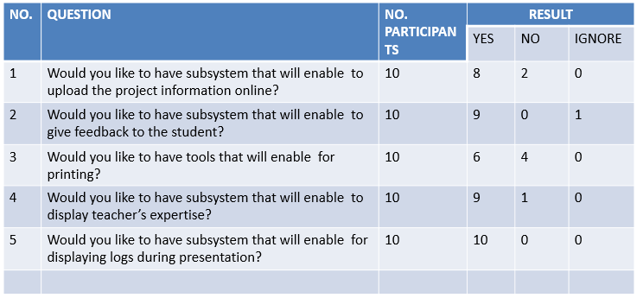

Representation of sampled table answers in pie chart

PIE CHART

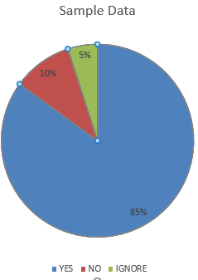

**CHAPTER 5**

**5.1 CONCLUSION**

Therefore the preliminary data by questionnaire method seem participants propose the proposed system about 85% answer YES 10% answer NO and 5% ignore the questions

### **5.2 COST ESTIMATION**

|  |  |  |  |
| --- | --- | --- | --- |
| ITEM | QUANTITY | COST | Total cost |
| Internet |  | 10000 per month | 30000 |
| Stationary | 2 | 20000 | 40000 |
| Transportation fee | 3 | 15000 | 45000 |
| Communication |  | 10000 | 10000 |
| Miscellaneous |  | 30000 | 30000 |
|  |  | **Summation** | **235000** |

Table 2 Cost estimate

**5.3 REFERENCES**

**BOOKS:**

1. Thomas Connolly and Carolyn Begg (2005). Database Systems. A Practical Approach to Design, Implementation, and Management: Person Education Limited, Edinburgh Gate, Harlow, England: Page 281 – 310.
2. Jeffrey L.Whitten, Lonnie D. Bentley, and Victor M. Barlow (1989). Systems Analysis and Design Methods,2nd Ed: Irwin, Homewood, IL/Boston U.S.A: Page 408 – 420.

**WEBSITE**

<http://www.realsoftwaredevelopment.com/2007/08/how-to-finish-a.html>

http://[www.micros.com](http://www.micros.com)

http://[www.ezeefoodie.com](http://www.ezeefoodie.com)