courComputer Science
Strickland, Jack Matthew

Game Analysis
Formula One Tic Tac Toe Game

Coursework
Table of Contents
Coursework 1
Analysis 4
Background to the problem 4
Current problem and research 4
Explanation of the Solution 8
Identify the User 9
Acceptable Limitations 9
Potential Solutions 10
Mechanics of the System 12
Objectives 19
Diagrams – Entity Relationship Diagrams 21
Diagrams – Navigation Diagram 24
Design 27
Technical Overview 27
Entity Relationship Diagram and Entity Attribute Models 30
Navigation 32
32
IPSO 33
Data Dictionary 39
Sample of complex code in my program 44
Folder Structure 64
Types of testing 99
White Box Testing 99
Black Box Testing 123
User Questionnaire feedback and evaluation 132
Final Conclusion 134

Analysis

Background to the problem

Formula 1 is a global brand with over 1.55 billion viewers watching every year. Formula 1 is the pinnacle of motorsport. The series features the most skilled drivers and mechanics while providing the fastest cars in motorsport through innovative technology. The season takes place from late February all the way to the end of November (with many short breaks in between). Each race is known as a grand prix and takes place from Friday to Sunday. The sport is known for its on and off-track drama and this is why the sport has seen such a huge influx in fans in recent years. This is also thanks to Liberty Media's marketing such as the Netflix documentary series ‘Drive to Survive’. This has resulted in the Formula One fanbase increasing so large that Sky reported a 27.8% increase in viewing figures during the 2021 season. The US also saw a 28% increase in viewership, so many young people have now found a passion for the sport, however, must wait weeks for a grand prix to enjoy the sport. The market for Formula 1 is huge yet has so few sources of entertainment aside from the races themselves. Formula 1 only has 2 video games available for the public to play (the F1 game series (a driver simulator where you can drive the licensed Formula 1 tracks) and F1 Manager (a team simulator for users to run their own Formula One teams)). Formula 1 also only has 1 mobile game known as F1 Clash which is a strategy game, however, includes a pay-to-win scheme. This means that though the game is free to play, the user must buy crates to unlock better cars and drivers. This produces a large gap in the market for a strategy quiz game testing Formula 1 fans’ knowledge while playing against a user to take the win. The game will be free to play and skill-based based, unlike F1 Clash.
Tic tac toe is a strategy game known by millions of people worldwide and can be easily learned by all ages. It was also one of the first video games to be created in 1952 and includes strategy, tactics, and observation to win. Tic-Tac-Toe is a simple two-player game played on a 3x3 grid. Players take turns placing their X or O in an empty slot to form a line of three horizontally, vertically or diagonally. The game ends when one player achieves this objective. However, a major flaw of the game is that if both players play optimally then the game will always end in a draw making it a futile game. This means that if the users both know the optimal moves when playing against each other, the game will always end in a draw. The gaming industry has also dramatically advanced since its creation making tic tac toe not as popular as many larger games that are played today. From simple arcade games to the immersive experiences of today, there has been dramatic changes in the industry. With new tech like virtual reality and cloud gaming, gaming has become more accessible and exciting than ever. Genres span from RPGs and FPS games that provide more thrill and excitement for a user meaning many opt to play these types of games. Tic-Tac-Toe has inspired the gaming industry through the concept of one player’s gain being another player’s loss. However, the game is being left behind by the gaming industry.

Current problem and research

With Formula One fans being without a free-to-play F1-based game (without in-app purchases), they have little to test their Formula 1 knowledge with their friends and are unable to have a fun F1-based video game experience without paying the steep price of AAA games. My game will test F1 fans’ knowledge while playing the world-famous strategy game of tic tac toe. For a user to go to a spot, they must choose the correct driver that meets the criteria. On the x-axis and y-axis of the grid, multiple teams and nations will be shown. The user must match the driver with the nations or teams to go in the slot. The first user to get 3 of their noughts or crosses in a horizontal, diagonal, or vertical line will win the game. The problem of tic tac toe always ending in a draw if the users go in the correct slots will be erased as users will only be able to go in the slots they know the answer to.
While websites such as football tic tac toe have already used this idea, they have only included a football mode and have not included other sports such as Formula 1. My project will allow Formula 1 fans to enjoy this experience with the sport they enjoy. My project will also have a login-in system, meaning users can store their stats from previous rounds. My game will include the ability to play either against an AI or another user on the same screen. My project will include a ‘skip go’ button and an ‘end as draw’ button for players who do not know the answers for the rest of the grid. However, it will not include a ‘reveal answers’ button at the end of the game as this is not the key focus of my project and could take a long time to program.

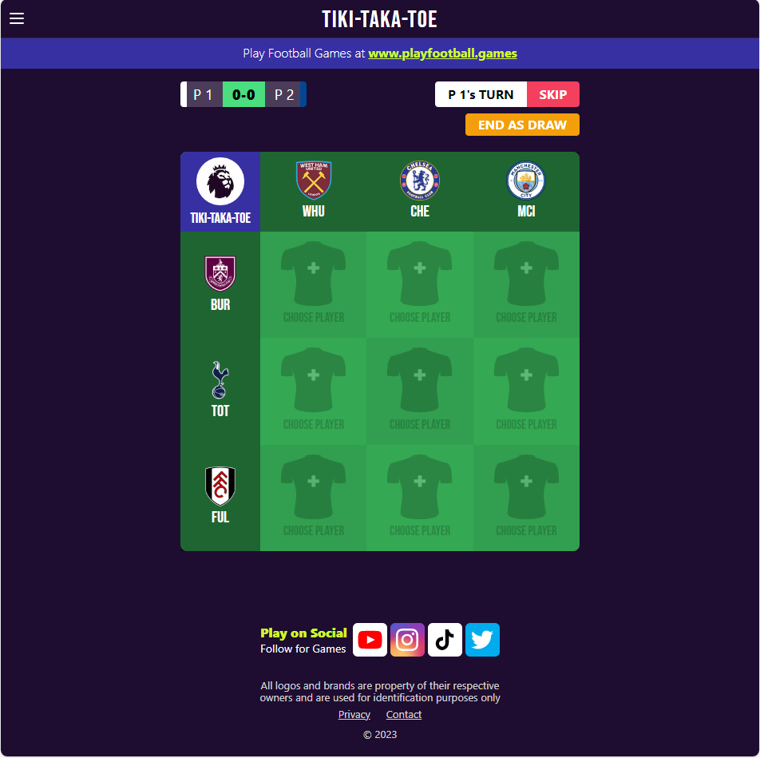

The image below is an Instagram post from skysportsf1 with this concept, however this is only one board, and you have to google to find the answers. My game will have hundreds of random boards to play from and will reveal all possible answers at the end of the game. A similar example to this is the crossover grid game. This game offers many different sports fans a game to test their knowledge like the solution I aim to produce. However, the game is only 1 player as the aim is to fill the grid with the most niche answer possible. If you guess the least known answer, then you gain a much higher score. Once the grid is complete you are ranked against other players that day. As the game is a daily challenge it has very few grids as they are not randomised but made by the creator daily. This means there are only 6 F1 grids as of 12/02/24 due to the creator focussing on the NBA and football grids more than other sports. However, it acts as a good model for what I want my user interface will look like in my game.
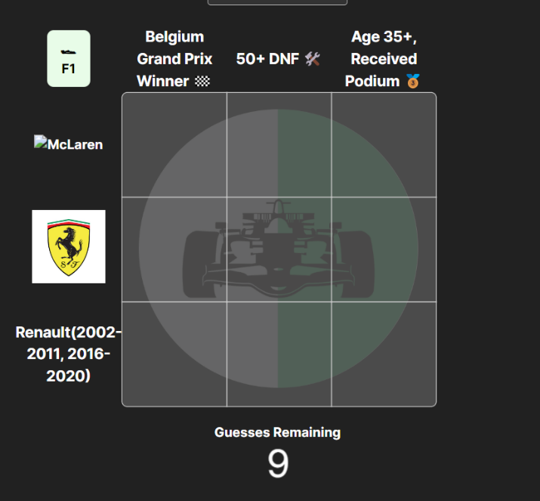
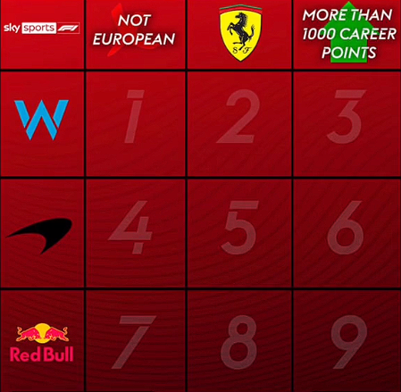

I commenced a questionnaire to over 10 potential users of my game to ask some questions that could help me to find the underlying problem and to see if my solution would provide a suitable fix to the problem of this gap in the sports games market.
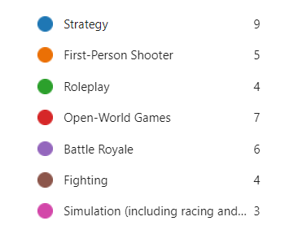
First of all, I asked my potential users what video games they played the most. As seen in the responses the majority of potential users (9 out of 10) said they played strategy games. This highlights the huge demand in the video game space for strategy games. Tic tac toe is one of the most famous strategy games in the world, making my game easy to learn and playable to all age categories. Newer players can enjoy the basics of the game while more advanced players can enjoy the depth of the game through the use of strategy which keeps the game appealing for more experienced players. Its quick gameplay is appealing for players as it can be played in short breaks or simply to pass the time. Unlike games such as F123, users can simply open their phones and play a quick round for fun. The F1 games series requires users to own a high-end expensive gaming console/PC and users to have plenty of time so they can race grand prix while strategy games such as tic tac toe can be played in a short amount of time with basic equipment. This is key to why so many users enjoy playing strategy games such as tic tac toe.

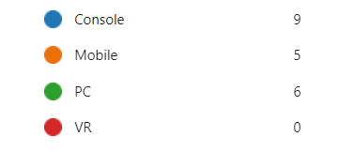
The next question I asked users was what device they played on while playing video games. As seen in the image, the majority of gamers played on consoles while many users also played on mobile phones and PCs. I commenced research into why console gaming was so popular and found multiple key factors. For example, one reason was that video game consoles are purposely made for gaming. This means that they offer a user-friendly interface and an easy setup for new users to adapt to gaming easily. This provides console gaming companies with a huge percentage of gamers due to the easy accessibility provided by their user interfaces. Another factor was that consoles offered exclusive titles such as PlayStation studios’ exclusives and Nintendo's exclusive range of games. For example, Gran Turismo is one of the most iconic gaming franchises to exist. The exclusivity of these games belonging to PlayStation means many users purchase gaming consoles just to play these titles. Nintendo’s Super Mario franchise is also another iconic example of why users choose to buy consoles over other devices that offer games. However, gaming on console is very expensive due to the high cost of games in the current era of gaming with most major titles being excessive of over £50+. Consoles also require online subscriptions such as Xbox Live and PlayStation Network to be able to play online games. This yearly cost causes gamers to pay high prices just to access the games they have purchased for the high price they already paid to buy the game.
Mobile gaming is much more accessible to the casual gamer. The games that are offered are created for much shorter play sessions and are usually free to play so remove the pay barrier that consoles have. My tic tac toe game is a game that takes a very small amount of time to play (1-10 minutes). Due to this factor, I believe my game fits perfectly into the mobile games category and is also a good fit for PC as similar games such as Tika Taka Toe are played on PC which highlights why PC is also a suitable fit for my game. However, a negative of games on mobile and on the web is the addition of microtransactions and adverts. My game will not include either which will appeal to many gamers on the web and mobile as this is considered a very big problem in the gaming community.
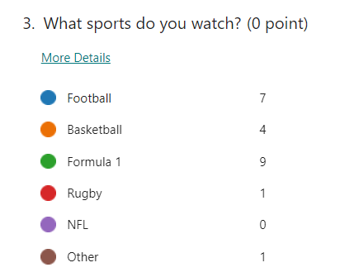
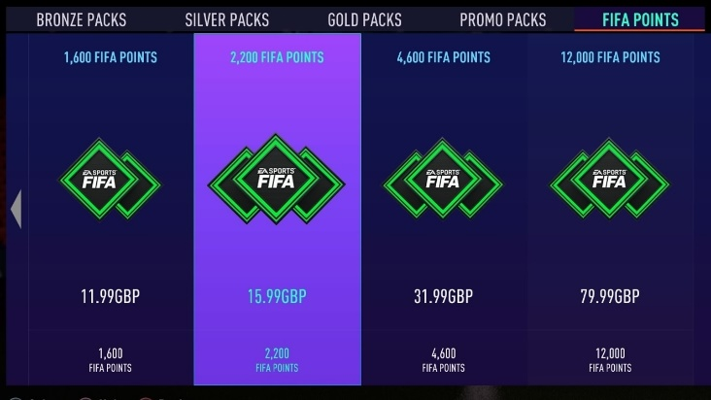
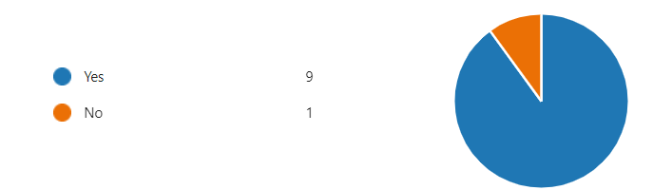
I asked my potential users ‘Do the sports you like have video games that are free to play which do not include microtransactions?’ 7 out of 10 said they did not have games that were free to play based on their favourite sports and if they were free to play they included microtransactions. One user stated, “The company that owns the rights to these sports are EA. They include in-game currency in their online modes which causes a skill gap in the game and makes it impossible for a casual gamer to enjoy their experience.” I researched two key examples of what this user found annoying in the sports game market. FIFA Ultimate Team (now EAFC Ultimate Team) is a football game where users can build their dream teams. However, a key flaw is that users have to spend a huge sum of money to build their teams at a competitive rate. Instead of being able to buy players with real money, an in-game currency known as ‘FIFA Points’ are used to open packs which do not guarantee a good return for the money spent. Instead, gamers are only given a small percentage of getting a good player. This helped EA to profit from over $1.62 billion in revenue in just one year (2022). This highlights the key problem with how big corporations have locked enjoyment for the user as they have to play against much better teams as they do not want to pay money into a game that has already charged them £50 just to download. Another example is F1 clash. This game is a mobile game that is licensed by Formula 1, however still suffers from having loot boxes similar to FIFA’s pack system. The game also includes adverts that users have to watch to earn gold to enter another race. This means that users spend most of the time watching these adverts instead of playing the game. With my game, I will remove this constant annoyance in the sports game industry and make sure the user can spend the majority of their time enjoying the game instead. With over 9 in 10 watching Formula 1, there is a huge demand for my game, and I believe it will become the perfect pass time for people looking for something to do in their break or with friends.
Example of the store within FIFA ULTIMATE TEAM
I also asked my users whether they were more likely to play the game if it was a web application instead of an app on the app store. 9/10 users said they would prefer if the game was a web application. One user stated, ‘If I could play the game from google, then I could play it on any device anywhere as long as I had an internet connection. This would make it much easier to play than if it was an app as I would not have to download it on to each separate device. All I would need to do is open my web browser to play.’ This was very helpful to me as it highlights that the ease of just going on to a website to play a game, is highly favoured over the long download times of apps and their disadvantage of a lack of portability. Therefore, it is clear that my app should be able to access on the web as more users are likely to play my game that way.
In conclusion, my research has given me a strong foundation of what my game should look like and include. For example, I will use a similar design to tika-taka-toe’s design but will implement my unique features within in it (for example score). I will also ensure there are no adverts to ensure maximum user satisfaction when playing my game and also the ability to play my game on the web so users can play my game on any device with a web application.

Explanation of the Solution
My solution will use the information I have gained from my research to create a tic-tac-toe-based strategy game based on the sport of Formula 1. It will include a main menu where users can access their stats, opt to play a new round, and be able to read the instructions on how to play. When users load a new game, they will play against another user on the same screen. The objective is to try to place your X/O in the most optimal place to get 3 in a row, diagonally, vertically, or horizontally. However, to go in the spot they must first select a driver that meets the requirements from the x-axis and y-axis of the grid. The users also can end the game as a draw early if they cannot complete the grid. Users can also skip go if they don’t know any of the answers to the slots. The users will be able to either play on the same screen or against an AI that will attempt to beat them. The users will also be able to play an AI opponent that has 3 difficulty settings: easy, medium, hard. When the user plays the hard AI I will implement a ‘minimax’ function to ensure the AI makes the best move so it is almost impossible to win. Once the user finishes the game they have played they can view their individual stats, which includes the most recent game save and their overall stats. They will also be able to view an overall leaderboard which shows players with the most wins overall. This leaderboard will show the top 10 players in the world.

Identify the User
My users will be Formula One fans. The users of my game will be two individual players who play against each other. The users should be able to first log in to their account or create an account. Once they have logged in, they will be presented with a menu screen. They will then be able to view their stats, play a game against one another, play an AI, or read the instructions on how to play. The users will take turns to take their guess at the grid slot and try to secure their 0/X in the slot they have chosen. The ‘stats’ page will show how many wins the player will have (with other data). It will show the time taken to play the game, the number moves taken in the game and the total amount of games played. Access to the code and the database will not be available to the players as they could change information and cheat their way to having better stats.

Acceptable Limitations
My game will not contain the ability for users to create their own grid. This is because some grids users create may not be possible and this may be difficult to program. For example, if they user selects Mexico on the x-axis of the grid and Formula 1 World Champion on the y-axis as seen below this would make the grid impossible to complete and cause a logic error in the game. Two of grids below are impossible to complete as there is no answer that is true. This means that users cannot complete this game successfully. Therefore, I will also not include some nations/categories as they do not have a sufficient amount of answers for users to use. For a grid to be on my board, the slots must have at least 2 possible answers for users to use. This prevents grids from becoming too difficult for users to complete and most games being ended early due to such a high difficulty. My game will also not include the option to play online against other opponents. The main objective of my solution is for users to have a free-to-play offline game that they can play anywhere. If my game allowed for online games (on two different devices), this would make my objective impossible. I also want to focus on the logic of the game as well instead of spending lots of time working out how to create an online mode for my game. I will also not collect the F1 data myself as I would have to collect nearly 100 years of data. Therefore, I will use a csv database file created by F1 fans containing all the information I need for my game to function. This means that I may have a csv database and a separate sqlite database with my own database.
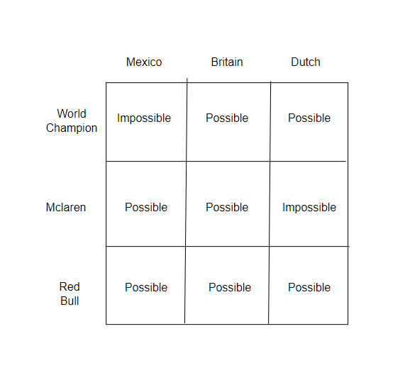

Potential Solutions
Solution 1 – Tkinter and Python
To create my game, I could use python and its built-in function Tkinter. Tkinter is a library on python for creating graphical user interfaces (GUIs). It provides tools and widgets which will allow me to build my application with ease. It is suitable to beginners so I will be able to learn how to use Tkinter in more depth quickly. This will allow me to create my game through python, which I am already strong in, so I will not have to spend lots of time learning a new programming language. I can also use OOP within python to create my user class and driver class. I have been programming in python for over 3 years now so my ability in programming in that language is much stronger than other languages. I will use Visual Studio Code as my IDE as it has good features which can help me when coding. For example, it is easy to download any libraries or languages I need for my project. It also contains good colour coding for different characteristics of my code, such as variables and constants. This will help me to find bugs in my code more easily. Visual Studio Code also contains good indentation so I will save good time with my programming thanks to the structure it provides. The IDE has a user-friendly interface and the addition of a debugger to help me code and test my program. The IDE also has multiple support channels online which are free to access so if I need help, I can find them there.
Advantages of using Tkinter | Disadvantages of Tkinter
- Small knowledge of language already  - Free programming language  - Useable in Visual Studio Code  - Clear formatting of code so easy to read and debug.  - Tkinter is beginner-friendly | - It will take time to learn Tkinter before I can start programming my game.  - Python is not compatible with all operating systems and hardware.

Solution 2 – PyQt and Python
PyQt is another built-in library in python that allows you to create a GUI. PyQt contains many more widgets and features than Tkinter does. It gives you the ability to have more appealing applications and have a more professional look. However, this comes with multiple drawbacks. One drawback is that PyQt requires a license fee to purchase as it is not a free library for use like Tkinter. This license fee is over £500 which is very pricy for the application I plan to build. PyQt also is very challenging and takes over a month to learn before it is understandable for new users. This means that I would have less time to program my actual solution as I would have to spend valuable time learning PyQt. I would also still use Visual Studio Code as it is the best free IDE on the web.

Advantages of using PyQt | Disadvantages of PyQt
- More widgets and features  - Useable in Visual Studio Code  - Looks better visually. | - It will take over a month to learn PyQt before I can start programming my game.  - A license is needed to use PyQt

Solution 3 – Flask and Python
Another way I could create my GUI for my game is by using Flask. This is a web application framework that will help me build my game while being able to maintain my databases and code. Flask is considered the best framework for new beginners who have not used a web framework before. This will make it easier to learn than PyQt and will give me a greater opportunity to learn how to build a web application while being able to handle requests. Flask is easy to understand as its simplicity gives coders a good opportunity to understand what is happening. It is also very flexible so I could use templates which I would need to adapt for my code, which would save a lot of time. Flask is also very fast to debug due to its built-in fast debugger with visual studio code which will make my debugging process much quicker. However, a small disadvantage of Flask is that it is not very scalable, meaning that if the server receives multiple requests at once it will take more time than other frameworks.

Advantages of using Flask | Disadvantages of Flask
- Beginner friendly  - Flexibility  - Easy to debug | - Scalability

Solution 4 – Pygame and Python
Pygame is a set of Python modules that can be used for game development in python programming. It will help me to code my game as it allows for 2D game creation. If is also a free and open-source library and contains lots of features such as graphics, sounds and other game features. It is also accessible to new users and has lots of online resources available to help me learn how to use pygame. I will use pygame to create my actual game. I will connect my pygame into my database backend to allow me to update tables when new users are created or deleted.

Advantages of using Pygame | Disadvantages of Pygame
- Easy to learn and use  - Cross platform  - Reduced time in coding | - Performance limitations when producing games with lots of high-level graphics

I will use pygame for my coding as though I am not fully confident on how to program it yet, it’s easy to learn style will help speed my learning process up quickly.

Mechanics of the System
The login system will be run using a database. The user can create a new login and add a new account to the database or open a current account that already exists within the database. Before a new account is added, a search through the database will take place that checks if an account with the same name already exists.
Another database will also be used to store the stats of the games the users play. Each time a new game is played, the data from that game will be appended to the database so that when the user accesses the stats page, the data is displayed from the database and presented to them
To stop users from overwriting another user’s go by going in the same slot they have just gone in, the ability to enter an answer into the slot that has an X/O in will be unavailable, as I will lock the ability to select that grid slot anymore for users. Therefore a user cannot ‘steal’ a grid by replacing their opponent’s X/O with their X/O.
Winning Combinations
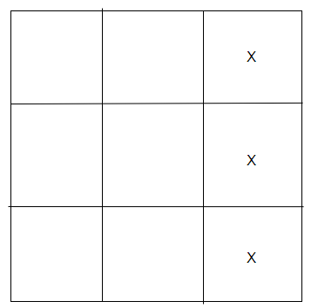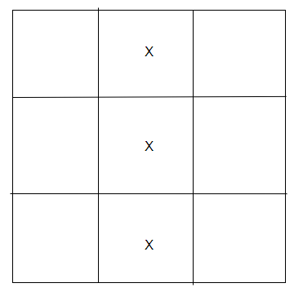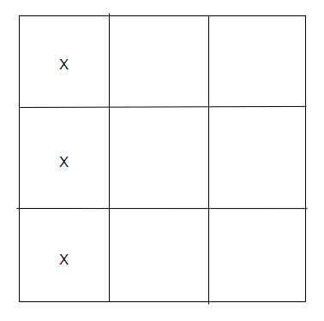

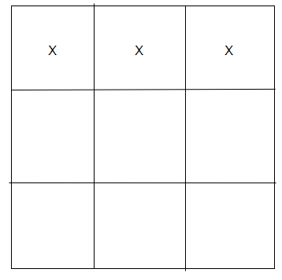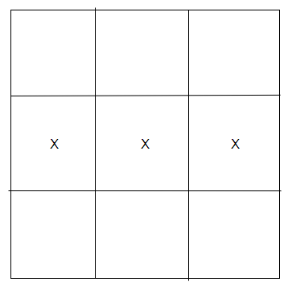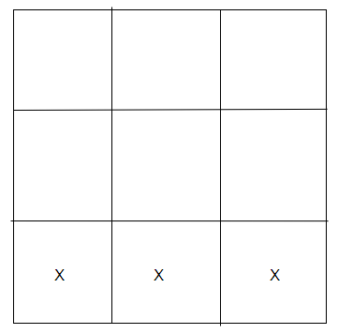
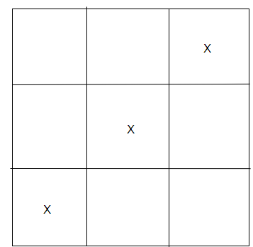
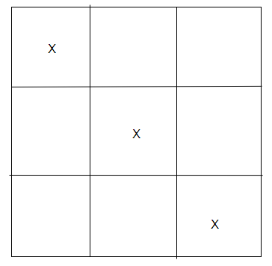

The above eight grid combinations show how a user can win the game. The 3 noughts/crosses must align either horizontally, vertically, or diagonally. This means that there is only a select few ways of winning the game and therefore the introduction of a score prevents these games from always ending in a draw.

I will also use a minimax algorithm to have an AI make smart and optimal moves against its opponent. The minimax algorithm is a decision-making algorithm used in two-player turn-based games like tic-tac-toe.
Steps in Minimax Algorithm:
- Generate the Game Tree:
  - Generate the entire game tree of tic-tac-toe from the current position to the terminal states (win, lose, draw).
- Assign Scores:
  - Assign a score to each terminal state (+1 for a win, -1 for a loss, 0 for a draw).
- Backpropagate Scores:
  - Backpropagate these scores up the tree, ensuring that at each node:
    - The maximizing player (the one trying to win 'X') will choose the move with the maximum score.
    - The minimizing player (the one trying to make the opponent lose 'O') will choose the move with the minimum score.
- Choose the Optimal Move:
  - At the root node, the maximizing player will choose the move that leads to the highest score based on the minimax values.

To illustrate this I have created a simplified game tree for a partially completed tic-tac-toe board where 'X' is the maximizing player and 'O' is the minimizing player.
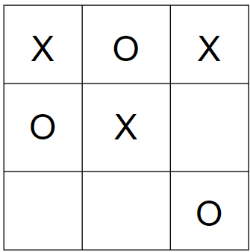
Here, it is 'X's turn. Here are the possible moves for 'X':
- Place 'X' in the bottom left.
- Place 'X' in the bottom middle.
- Place 'X' in the middle right
Now a tree must be drawn to visualise the optimal move.
Game Tree
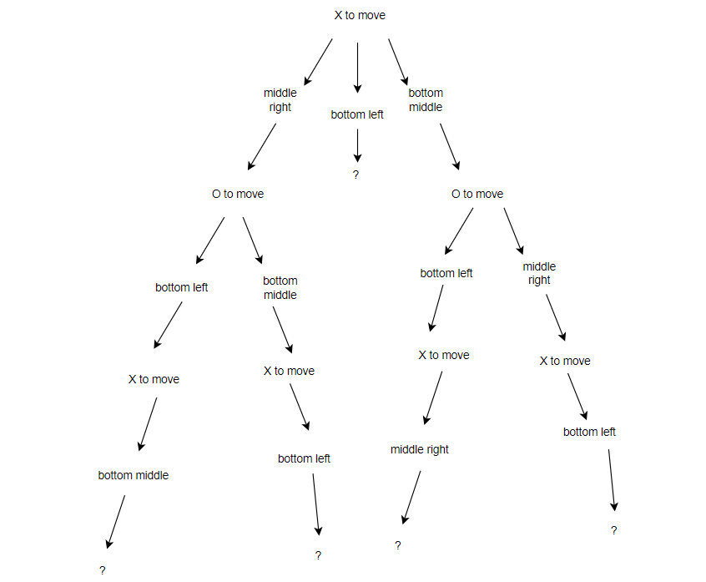

Now the program will run through each tree branch to find the result of the move. (assuming optimal play):
- X moves to middle right, O moves to bottom left then X moves to bottom middle:
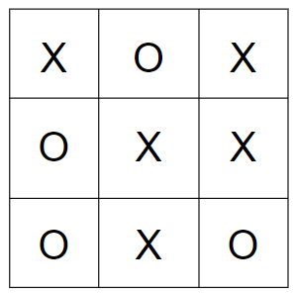
Result: Draw (score = 0)
- X moves to middle right, O moves to bottom middle then X moves to bottom left:
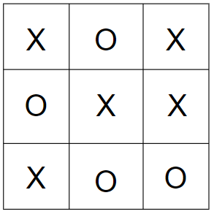
Result: Loss (score = -1)
- X moves to the bottom left
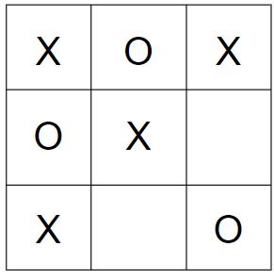
Result = Win (score = -1)
This search continues for the right side of the tree.
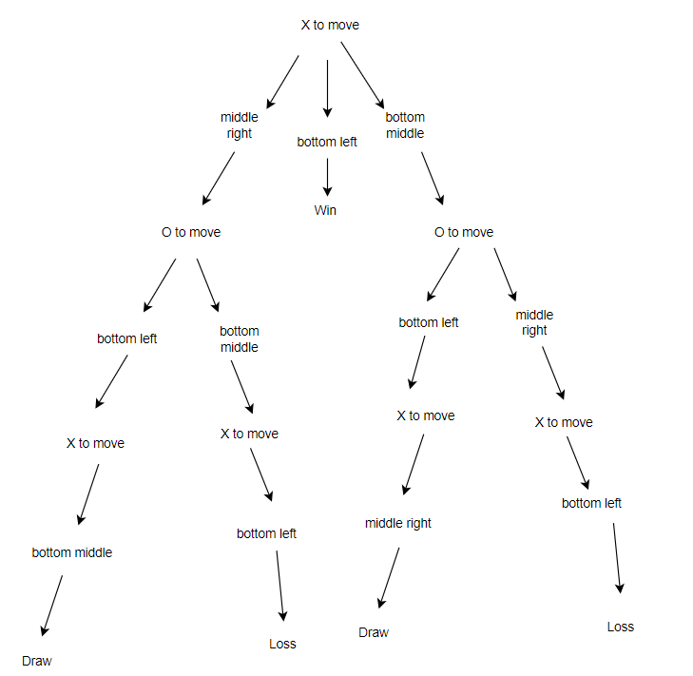
Finally, the game tree with all the possible results is found:
Backpropagating Scores
For 'X' (maximising):
- Attempt 1 leads to a draw (score = 0)
- Attempt 2 leads to a loss (score = -1)
- Attempt 3 leads to a win (score = 1)
As X is maximising it will choose the root with the greatest score so chooses move attempt 3 and places X in the bottom left.
This is how the minimax algorithm determines the optimal move for 'X' in this tic-tac-toe game state.
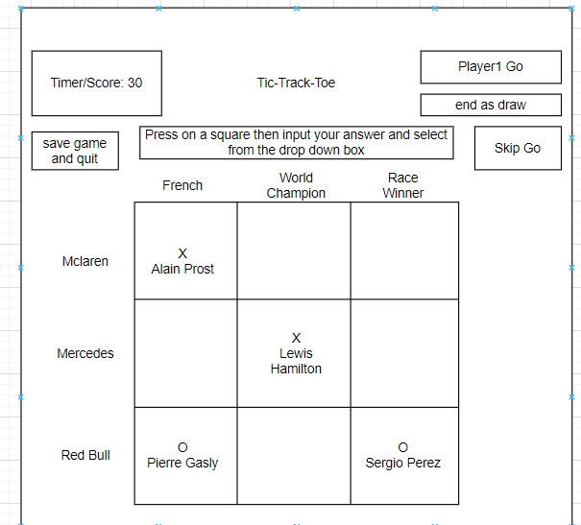
The diagram above shows the user interface I could implement into my program. The top right box shows the players whose go it is, while the box below allows the users to end the game as a draw if they both cannot answer any more boxes. The skip go button allows for the users to skip their go and let the other player go. The grid shows that the players have inputted valid answers and have gone into the grid slots they want to. To answer a question, they have to press on the square they want to go in and then search in the search bar for the intended driver they want to input. Using SQL, the search bar will return the driver they have searched for in a drop box where they can press the driver's name and select them as the answer. If it is correct, the driver will go into the slot alongside an X or O.

Objectives

- Main Functionalities
  - Organised File Structure – Ensure all files are organised in a clear dictionary structure, allowing me to have efficient codebase access and management
  - Database Normalisation – Have all database tables fully normalised with no duplicate data stored and ensure 3rd Normal Form is met
  - GUI usability – Ensure the GUI has a clear format and is easy for users to navigate and search
  - Button Labelling Accuracy – verify all the buttons are descriptives but also concise to display their function
  - Game Class Initialisation – Ensure a new game class is created properly whenever a new game is loaded
- Player Authentication
  - Ensure players are first loaded on the intro screen (pushed into the manager stack) and can navigate to either the login or register page
  - Test that the intro screen loads as the initial state
  - Validate the creation of the Login class and it being pushed into the manager stack
  - Ensure a user can create an account with:
    - Unique Username – handled with exception handling
    - Secure Passwords – protected by hashing algorithm
    - Insertion of user information into database table
  - Confirm that the user can switch between the login and register screen through the button
- Player Login Process
  - Verify that existing users are able to login in with their credentials
  - Incorrect or duplicate login attempts are handled by exception handling and an error message shows
  - Ensure player details are retrieved from the database correctly and the PlayerId is their unique identifier to log them in
- Main Menu Navigation
  - Verify that the main menu screen is loaded after login and pushed in manager stack
  - Navigation to other states:
    - Instructions Page
      - Validate the instructions text is displayed correctly
      - Back button can be pressed to return to the main menu
    - User Stats Page
      - The overall and recent game stats tables are displayed accurately with the correct data
      - When a user has not played a match yet, no game data is shown
      - Back Button can be pressed to return to the main menu
    - Leaderboard
      - Ensure the leaderboard displays the top 8 players sorted by wins
      - Buttons allowing to sort leaderboard by wins, games played, win ratio
      - Back Button can be pressed to return to the main menu
    - PlayAI
      - Allows player to select difficulty of AI they want to face
      - Back Button can be pressed to return to the main menu
    - Play Friend
      - New Game is started
    - Sign Out
      - States are popped from stack back to intro screen
      - Player details are reset to allow user to sign into different account
- Game Modes
  - Play against friend
    - Creation of Play Friend object which is pushed to manager stack
    - A 2D array will be created to represent board positions
    - Confirm the board is generated correctly
    - Dictionaries of teams and nationalities and achievements shuffled randomly to ensure random board layout each game
    - Game Mechanics
      - Timer set to 20 seconds
      - Accurately switches between player turns based on their input or the timer expiring
      - Exception handling for ‘Skip Turn’ and ‘End as Draw’ buttons
      - SQL used to validate driver entries and updating grid
        - Driver entry compared to CSV files storing all F1 data to check for correct answer using SQL search
      - Winner detection logic for when a user has 3 X/Os in a row horizontally, vertically or diagonally
      - Database update with match results
      - Return to main menu button appears to allow users to exit game state
  - Play against AI
    - Pass difficulty selected into game state and load class inheriting form PlayFriend class
    - Confirm the board generation mirrors Play against friend mode
    - AI Behaviour
      - Easy: 40% optimal moves
      - Medium: 70% optimal moves
      - Hard: 100% optimal moves (using minimax algorithm)
        - Minimax Function is run to find optimal move
          - Maximising and minimising player assigned
          - Recursion through all possible moves and outcomes of game made
          - Tree created to find best result for AI
          - Best move returned to AI
          - AI makes move when selected to
          - Check for winner is ran
          - Player’s turn is switched
    - Accurate integration of game mechanics similar to play against friend mode
      - Grid updates, winner detection and database updates at the end of the game, return to menu button (excluding the use of a timer)
- Application Management
  - Users can exit the game by pressing the X button without leaving any background processes running.
  - Confirm the stack-based transition work seamlessly across all my features, including the use of pushing, popping and peeking states
  - Game performance is retained under different conditions (e.g. large leaderboard compared to small leaderboard)
  - Font and button sizes are accurate to allow efficient navigation

Diagrams – Entity Relationship Diagrams

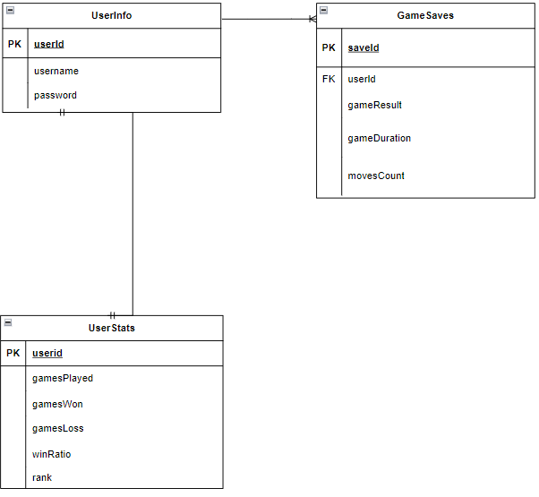

This ERD diagram displays the relationships between all the entities I will create in my program. This diagram will help me to ensure my tables are normalised to the best standard possible and all non-key attributes are dependent on the primary key of their table.

The ERD below represents the attributes that my entities will store. These entities are not all stored in a database, however, are stored while the program is running under variable names. This helps to display what data needs to be stored for the program to run the game without an error.

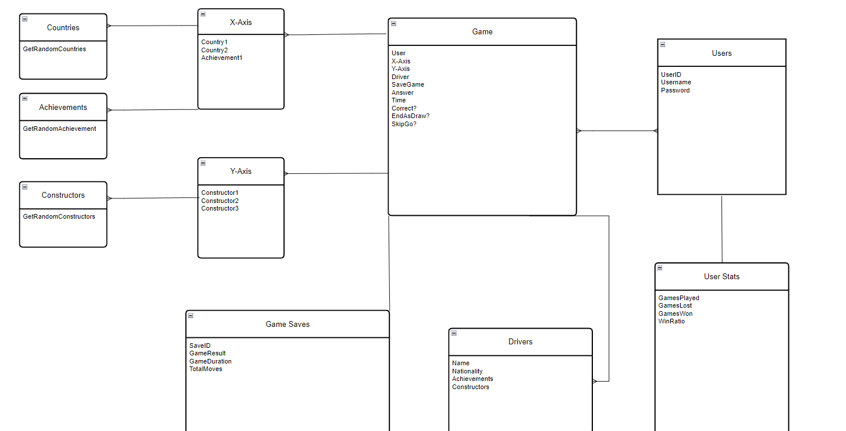
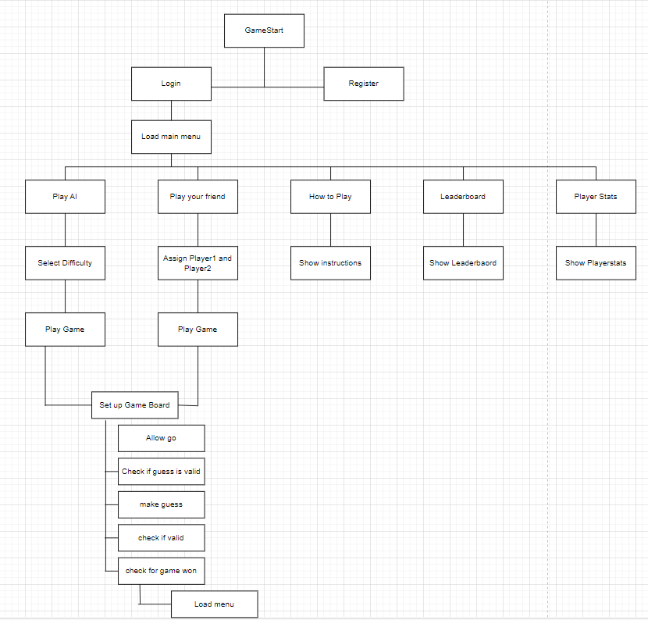

Diagrams – Navigation Diagram

This diagram shows a top-down display of my game. First the game is loaded, then users must login to access the main menu from where they can Play AI or a friend, learn how to play, view the leaderboard or check their own stats. This diagram will help me to break down my solution into more simpler steps. I can focus on each box at a time and then over time build my game. The diagram also shows a clear navigation of how the user can use my game and how they can access each window on my game. I will implement a state machine in my code, to enable users to travel from one screen to another.

Formula One Tic Tac Toe Game
Game Design
courComputer Science
Strickland, Jack Matthew

Design

Technical Overview

App module | Justification
Python | I am strong in my ability in this language so I believe it is suitable to use the language, instead of having to learn a new language which I could easily make mistakes in. Python is very useful when accessing database tables and is available in visual studio code. As I will create my solution in visual studio code this is crucial that the programming language, I will use is accessible in the application. Python is very easy to use as its syntax is very readable to humans which will allow me to write clear and maintainable code throughout my project. When using a complex database in my project, the readability of python will make this less complex. Python also contains many libraries with helpful tools when making my game. For example, pygame will help me to create my game with tools such as Sprite Classes which help programmers use OOP to make code more readable and accessible when adding new features. SQlite3 will also help me to access database tables for my project. When I search for a driver in the database, I will be able to do this through the SQlite3 library. Python has a wide and vast community, meaning I will have access to lots of YouTube tutorials, documentation and forums to support me during my coding process. This will help me to learn key new techniques when coding my game to ensure my code is maintainable and efficient.
SQlite3 | This database browser allows me to easily create, retrieve, update and delete data from my database tables and clearly displays the tables in a readable manner. Therefore, this will give me a stronger understanding of what my tables are doing within my game. SQlite3 is also very lightweight which means it require minimal setup. Therefore, this will reduce the complexity of having to manage a separate database server. SQlite3 has been designed to be fast and efficient when used with python, which will make my gameplay running experience much smoother with less delays in data retrieval. Data is stored in a single database file when you use SQlite3, making it easier for me to manage my database when handling user profiles and leaderboard statistics. SQlite3 also allows for me to input complex queries such as inner join searches and aggregate functions which allow me to fully extract all my information I need to grab from the database tables effectively. It is also open source meaning it is free to use, so I won’t have to spend any money when creating my game database. Another great feature is that SQlite3 has a large community of users, meaning there is plenty of documentation online to help me learn how to use it and optimise my searches to the best of my ability.
Pandasql | Pandasql allows for me to make more efficient searches in my sqlite databases by using special functions that allow me to make searches through the locals command.
Pygame | Pygame is highly portable and will run on almost any operating system I decide to code my project on. It will allow me to code my game strongly as it specialises in 2D games which my game is. Pygame also has an extensive amount of documentation like SQLIte3. For example, below are screenshots of a 4-hour tutorial provided by clear code on the fundamentals of pygame I completed. Following this tutorial, I learnt how use Sprite Classes for a player and obstacle in my game. Within these classes, I learnt how to animate objects to look like they are moving. I learnt how to retrieve player inputs and return a value based on the input. For example, pressing space bar would make the character jump. I learnt how to load images, play sounds and use fonts on pygame as well. Most importantly, the key aspect I learnt from the project was how to use states. This is how to ‘switch screens’ within pygame. For example, when the variable, game _active, was set to True then the actual game code would run. However, when set to False this would draw the menu screen on to the application instead. This was crucial in my learning as I have many different screens, I want the viewer to see in my game For example, when the state machine is equal to ‘menu’ it will clear the previous display on the application and will now show the menu screen. This will now allow users to view multiple different displays on my game. Pygame’s ability to handle user inputs is a key aspect that I will integrate into my game, when players search through the windows or want to input an answer in my main game. Its ability to also be integrated with other libraries such as SQlite3 will help me merge the backend logic of my game onto the frontend for the user to view. Therefore, pygame will be a crucial library in my code.  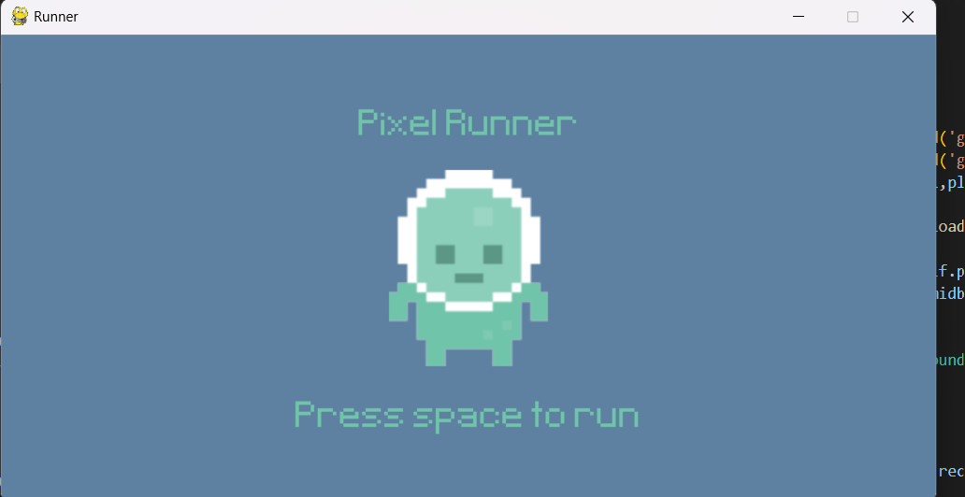  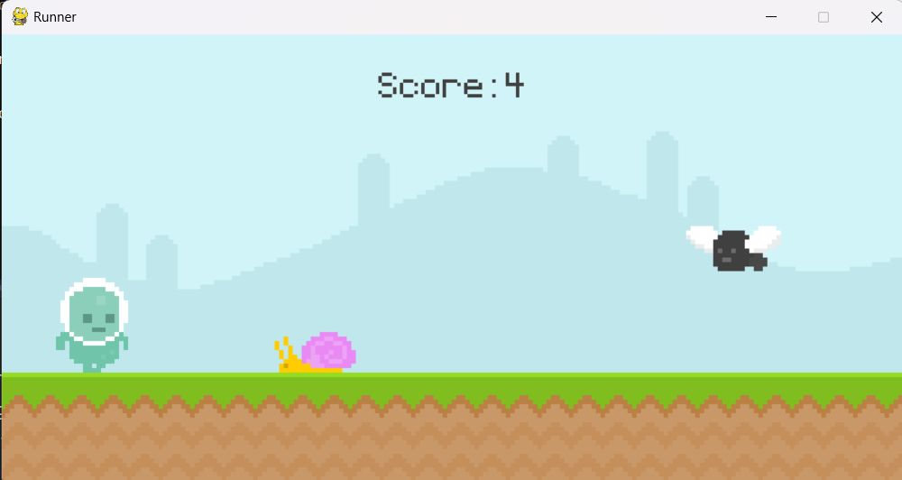

I will also use a Formula 1 database that is available for free use from Ergast.com. It includes all Formula 1 data statistics from the first-ever grand prix to the present day. This was an API that was available to use for coding projects, however it will be depreciated at the end of 2024. Due to this, I will download the databases from a CSV file provided on the website. This will allow me to still use the data they have collected while integrating it into my game. I will use this CSV file to retrieve information about the drivers. As there are hundreds of past Formula 1 drivers, it will save a lot of time as I will be able to focus on more key aspects of my game, rather than filling in a long table full of all the driver stats. The database is free to use for all programmers so I will not face any legal issues of using it. When conditions have been met in my game, I will be able to search the files to check the condition is True and the user has got the answer right.
An example of a search for drivers is presented on this slide. The query has pulled all the drivers that are stored within the database. It includes the driver’s name, number, date of birth and nationality. This means I can search through this table to check for validation to see if a user is correct when one of the conditions is the driver’s nationality.
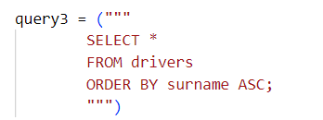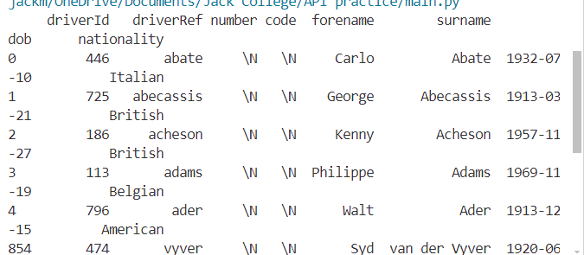

In summary, I will use Python and its pygame module to create my game. They both are simple to learn and contain many libraries and features that will enable me to code and debug in an efficient way. The use of the Ergast database file will also help me allow for many different grids to be used by users and will save hours of time as I no longer have to research all the information about drivers and have to constantly update information after every race to make sure my data is correct and up to date. Instead, I can use inner joins to search through the multiple database tables provided. I can inner join the constructors’ and drivers’ ids from the results table to find what constructor teams drivers have driven for.

Entity Relationship Diagram and Entity Attribute Models

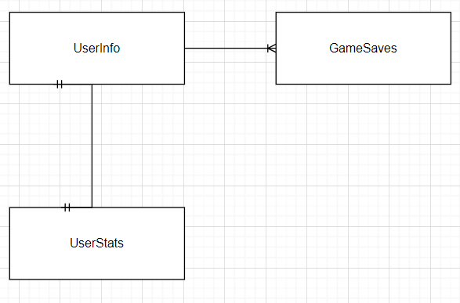
- Each userId in UserInfo maps to exactly one userId in UserStats
  - This implies a strict one-to-one relationship

- Each userId in UserInfo can map to multiple saveId entries in gamesaves
  - This implies that a single user can have multiple game saves. Therefore, producing a one-to-many relationship.

This ERD diagram displays the relationships between all the entities I will create in my program. This diagram will help me to ensure my tables are normalised to the best standard possible and all non-key attributes are dependent on the primary key of their table.



This diagram helps to display the relationships between the entities is a more detailed format by showing the non-key dependencies of the tables. The one-to-many relationship is clearly visible here as GameSaves takes the foreign key userId from UserInfo to create many different saves.

Tables in standard notation

UserInfo(userid , username, password)
GameSaves(saveId , userId , gameResult, gameDuration, movesCount)
UserStats(userid, gamesPlayed, gamesWon, winRatio, rank)

Navigation


This diagram shows a top-down display of my game. First the game is loaded, then users must login to access the main menu from where they can Play AI or a friend, learn how to play, view the leaderboard or check their own stats. This diagram will help me to break down my solution into more simpler steps. I can focus on each box at a time and then over time build my game. The diagram also shows a clear navigation of how the user can use my game and how they can access each window on my game. I will implement a state machine in my code, to enable users to travel from one screen to another.

IPSO

PlayFriend class
Input (I)
- user_id: The ID of the user playing the game
- mouse_pos: The position of the mouse cursor when a mouse event occurs
Process (P)
- handle_events: Processes Pygame events and updates the game state accordingly
- handle_click: Handles mouse clicks on the game board and updates the game state
- check_input: Verifies user input (e.g., text entered in a text box)
- Game logic: Updates the game state based on user input and game rules
Storage (S)
- user_id: Stores the ID of the user playing the game
- board: Stores the current state of the game board
- current_player: Stores the current player's turn (e.g., "X" or "O")
- game_over: Stores whether the game is over or not
- moves_count: Stores the number of moves made by the user
- start_time: Stores the start time of the game
Output (O)
- Game board: Displays the current state of the game board on the screen
- Text boxes: Displays text boxes for user input (e.g., entering a driver's name)
- Buttons: Displays buttons for user interaction (e.g., skipping a turn, ending the game)
- Game results: Displays the outcome of the game (e.g., win, loss, draw)

PlayAI class

Input (I)
- user_id: The ID of the user playing the game
- difficulty: The difficulty level of the AI opponent
- event: Pygame events (e.g., mouse clicks, key presses) handled by the handle_events method
- mouse_pos: The position of the mouse cursor when a mouse event occurs
Process (P)
- handle_events: Processes Pygame events and updates the game state accordingly
- handle_click: Handles mouse clicks on the game board and updates the game state
- check_input: Verifies user input (e.g., text entered in a text box)
- hard_bot_move: Determines the AI's move based on the game state and difficulty level
- minimax: Evaluates possible moves and their outcomes to determine the best move for the AI
- Game logic: Updates the game state based on user input, AI moves, and game rules
Storage (S)
- user_id: Stores the ID of the user playing the game
- difficulty: Stores the difficulty level of the AI opponent
- board: Stores the current state of the game board
- current_player: Stores the current player's turn (e.g., "X" or "O")
- game_over: Stores whether the game is over or not
- moves_count: Stores the number of moves made by the user
- start_time: Stores the start time of the game
- bot_active: Stores whether the AI is active or not
- bot_player: Stores the symbol of the AI player (e.g., "O")
Output (O)
- Game board: Displays the current state of the game board on the screen
- Text boxes: Displays text boxes for user input (e.g., entering a driver's name)
- Buttons: Displays buttons for user interaction (e.g., skipping a turn, ending the game)
- Game results: Displays the outcome of the game (e.g., win, loss, draw)
- AI moves: Displays the moves made by the AI opponent on the game board

Leaderboard Class

Input:
- state_manager: an instance of the StateManager class, passed to the Leaderboard class through its constructor method
- User interactions: mouse clicks on buttons, handled by the handle_events method.
Process:
- Initialisation: the innit method sets up the leaderboard's buttons and font.
- Sorting: the sort_by_wins, sort_by_games_played, and sort_by_win_ratio methods update the leaderboard's sorting method and redraw the leaderboard.
- Event handling: the handle_events method processes user interactions, such as button clicks.
Storage:
- buttons: a list of Button instances, stored as an attribute of the Leaderboard class.
- current_sort_method: the current sorting method, stored as an attribute of the Leaderboard class.
- font: the font used for rendering text, stored as an attribute of the Leaderboard class.
Output:
- The leaderboard's graphical representation, rendered on the screen using Pygame.
- The sorted data, displayed on the leaderboard.

PlayerStats class
Input:
- state_manager: an instance of the StateManager class, passed to the PlayerStats class through its constructor (__init__ method).
- user_id: the ID of the user, passed to the PlayerStats class through its constructor (__init__ method).
- User interactions: mouse clicks on buttons, handled by the handle_events method.
Process:
- Initialisation: the __init__ method sets up the player stats' buttons, font, and user ID.
- Data retrieval: the get_user_stats method retrieves the user's stats from the database.
- Event handling: the handle_events method processes user interactions, such as button clicks.
Storage:
- user_id: the ID of the user, stored as an attribute of the PlayerStats class.
- font: the font used for rendering text, stored as an attribute of the PlayerStats class.
- title_font: the font used for rendering titles, stored as an attribute of the PlayerStats class.
- back_button: a BackButton instance, stored as an attribute of the PlayerStats class.
Output:
- The player stats' graphical representation, rendered on the screen using Pygame.
- The retrieved user stats data, which could be displayed on the screen or used for further processing.

State Manager class
Input:
- User interactions: mouse clicks on buttons, handled by the handle_events method of the current state.
- State changes: new states can be pushed onto the state stack using the push_state method.
Process:
- Initialisation: the __init__ method sets up the state manager, initialising the Pygame display, font, and icon.
- State management: the push_state method adds a new state to the state stack, while the pop_state method removes the current state.
- Event handling: the handle_events method of the current state is called to process user interactions.
- State updates: the update method of the current state is called to update the state's logic.
- Drawing: the draw method of the current state is called to render the state's graphical representation.
Storage:
- state_stack: a list of states, where the current state is the last element in the list.
- user_id: the ID of the user, stored as an attribute of the StateManager class.
- screen: the Pygame display surface, stored as an attribute of the StateManager class.
- font: the font used for rendering text, stored as an attribute of the StateManager class.
Output:
- The graphical representation of the current state, rendered on the screen using Pygame.
- The updated state of the application, which can be used to trigger further actions or changes.

Register Class
Input:
- User interactions: mouse clicks on buttons, handled by the handle_events method.
- User input: username and password, entered through the username_box and password_box text boxes.
- State manager: the Register class receives the state manager as an argument in its constructor.
Process:
- Initialisation: the __init__ method sets up the register state, initializing the text boxes, buttons, and font.
- Event handling: the handle_events method processes user interactions, such as mouse clicks on buttons.
- Registration: when the user clicks the register button, the register_user method is called to handle the registration process.
- Validation: the register_user method checks if the username and password are valid, and if the username is already taken.
Storage:
- username_box: a text box for entering the username.
- password_box: a text box for entering the password.
- back_to_login_button: a button for returning to the login state.
- message: a string for displaying error messages or success messages.
- font: the font used for rendering text.
- register_name: the text for the register label.
- username_text: the text for the username label.
- password_text: the text for the password label.
Output:
- The graphical representation of the register state, rendered on the screen using Pygame.
- The result of the registration process, which can be a success message or an error message.
- The updated state of the application, which can be used to trigger further actions or changes.
Login Class
Input:
- User interactions: mouse clicks on buttons, handled by the handle_events method.
- User input: username and password, entered through the username_box and password_box text boxes.
- State manager: the Login class receives the state manager as an argument in its constructor.
Process:
- Initialisation: the __init__ method sets up the login state, initialising the text boxes, buttons, and font.
- Event handling: the handle_events method processes user interactions, such as mouse clicks on buttons.
- Authentication: when the user clicks the login button or presses the return key, the check_credentials method is called to handle the authentication process.
- Validation: the check_credentials method checks if the username and password are valid.
Storage:
- username_box: a text box for entering the username.
- password_box: a text box for entering the password.
- register_button: a button for switching to the register state.
- message: a string for displaying error messages or success messages.
- font: the font used for rendering text.
- login_name: the text for the login label.
- username_text: the text for the username label.
- password_text: the text for the password label.
Output:
- The graphical representation of the login state, rendered on the screen using Pygame.
- The result of the authentication process, which can be a success message or an error message.
- The updated state of the application, which can be used to trigger further actions or changes, such as switching to the main menu state.

Data Dictionary

These tables are based on the csv files I will select data from in my game.
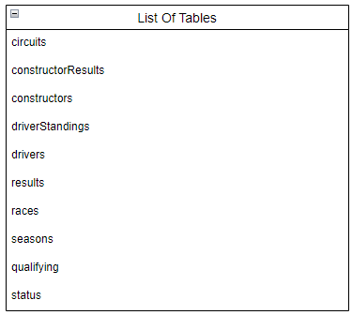

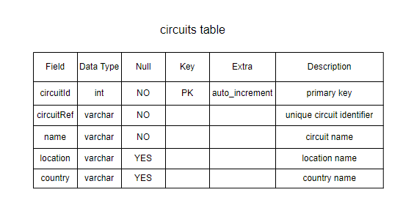
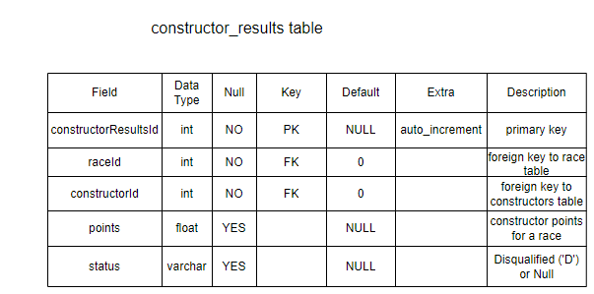
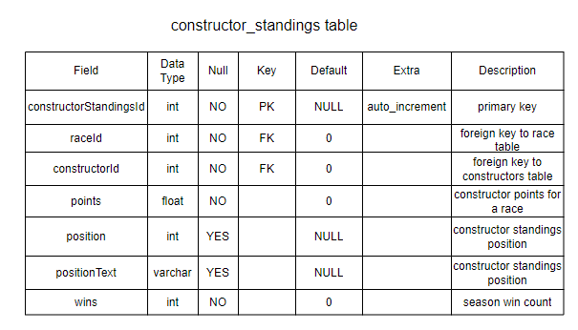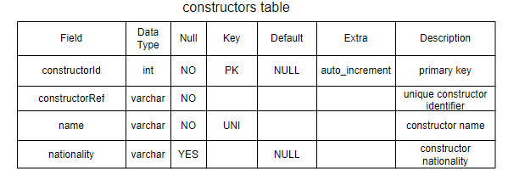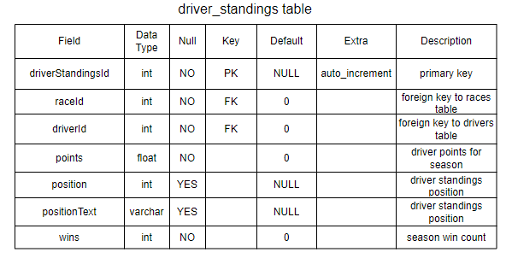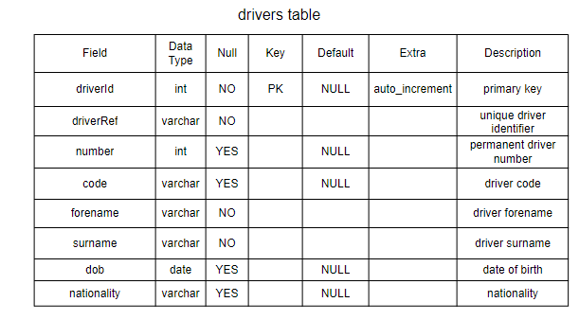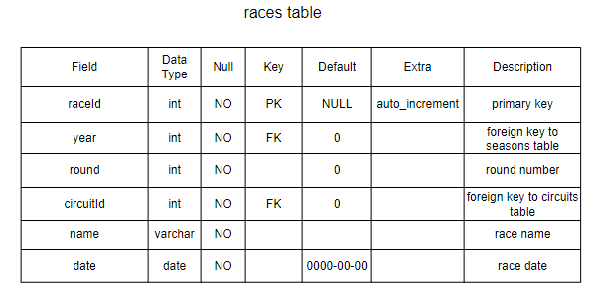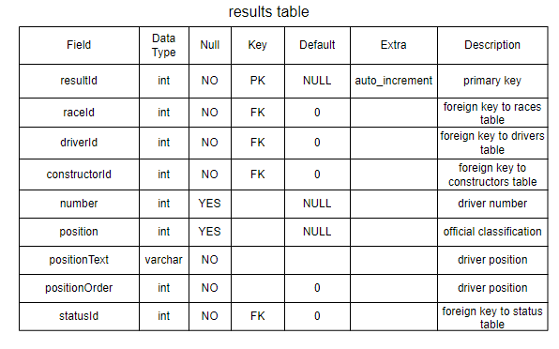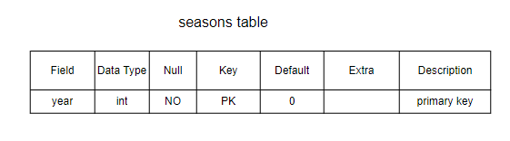

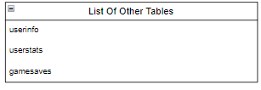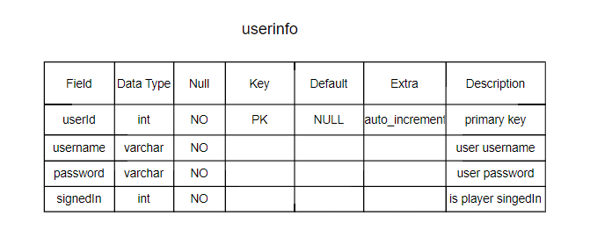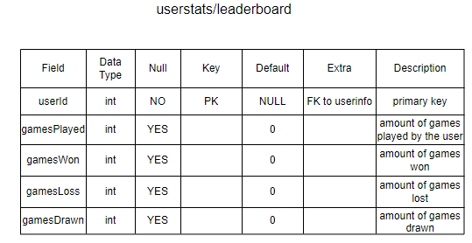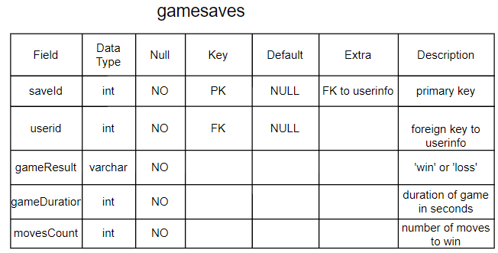

Sample of complex code in my program

Create Database Table​s
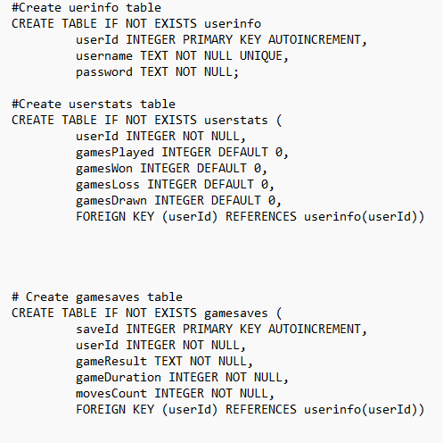

This code shows the creation of three of the databases I will use in my project. The first table stores all the information needed for a user. This contains a unique userid, a username, and password and also whether they are logged in or not. The second table query is used to store all the game stats about the user. It will then be used to create a leaderboard where players can see the top 8 players sorted by wins ascending. The third table is a game saves which will create a unique saveId for a game and link it a user through the userid foreign key. It will also store information about the game just played such as the result, duration and moves taken. I have created these three different databases to ensure that they are normalised as much as possible to avoid redundant fields within them and that all fields are dependent on their primary key.

Using states to control what screen is visible to the user
Below is an inheritance diagram for the menu navigation system I will use using inheritance from the parent class ‘State’ to its subclasses.
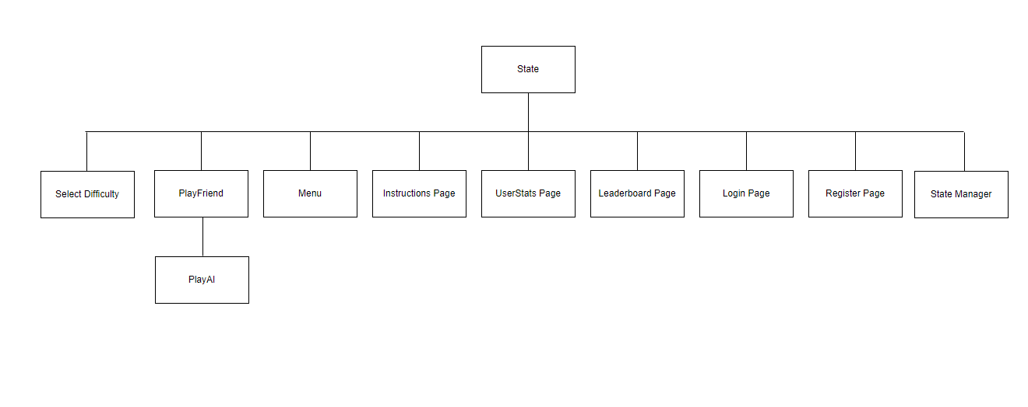

The use of inheritance allows me to connect all the functions and attributes in state and use them in the children classes. Therefore, each class will have their own unique state. Therefore, when the user wants to switch from the menu to the game board page the states will change to match this, and the page will be loaded.
So my players are able to return to the menu screen when they are currently viewing another screen, such as userstats or the instructions page, I will implement a stack data structure to allow my users to return to their previous screen (which will be the main menu screen). A stack data structure is best suited to this situation as it has a Last In First Out (LIFO) structure. This means that the current screen they are viewing will be at the top of the stack. When they want to quit, it can simply be popped and removed from the stack.

Below is an example of how the stack will work. When the user goes to a new page, it will be pushed to the above stack. When the user now wants to exit this page, it will be popped from the stack leaving the stack pointer to point at main menu. This will result in the user moving back to the menu screen. As python does not have a specific stack function, I will use an array to imitate this logic.
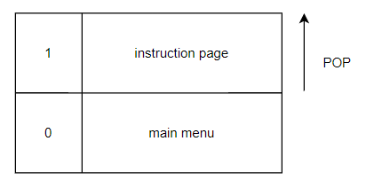

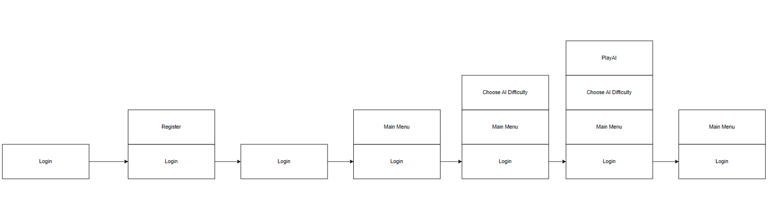
Here is a more in-depth example:
The first state appended to the state stack will be login. If a user is new they must press register to create an account. When this button is pressed, the next state is pushed into stack ‘Register’. This state will now allow for a user to create an account. When they press ‘return to login’ this state is now popped from the stack and they are returned to the login page. Now they can login with their new account details. When they press login, ‘Main Menu’ is now pushed into the stack. From the main menu the user can go to many different states, however it will be impossible for them to return to the ‘Login’ state as ‘Main Menu’ will never be popped from the stack. If the user wants to play the ai, first they will go the ‘Difficulty’ state then the ‘PlayAI’ state. Once the game is finished, the user does not want to be popped back to the difficulty state, so the stack is popped twice to return them back to the ‘Main Menu’ state. This example demonstrates how a user could use the stack within my game.

HCI

Login/Register Page
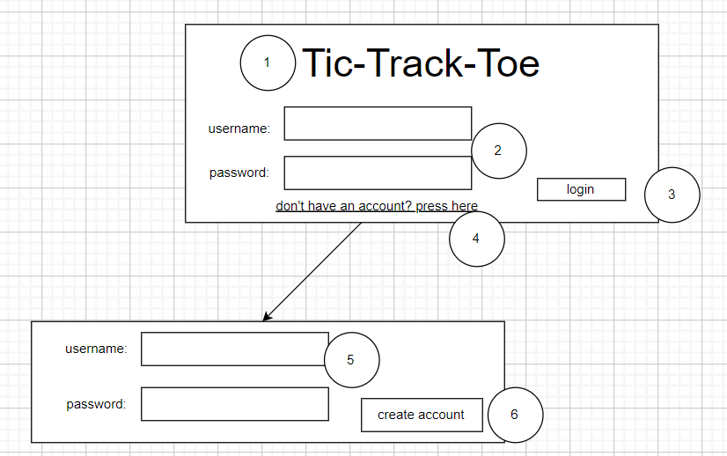

1. When the game is first launched, this label will display the title of the game
2. The user will insert their username and password into the text boxes here. Validation will take place here to ensure that the details entered are valid and within the database.
3. When the user clicks the button, the login function will run, and the user will be redirected to the menu screen.
4. Pressing this text will redirect the user to the create an account page. Here they can add a new account to the user table.
5. The user will insert their new account username and password into the text boxes here. Validation will take place here to ensure that the details entered are valid for the table format.
6. When the user clicks the button, their new user will be appended to the table. They will then be redirected to the login in page where they can sign in from there.

Create an account
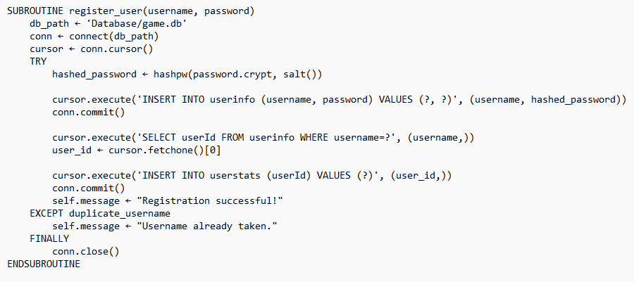
This function will allow for accounts to be created within my database. I will first hash the password so no one could gain access to them if they got access to my database. I will then use the INSERT INTO SQL statement to add the new username and password to userinfo and then insert this new user into the userstats table as well. If the username is already taken, then the request to create the account will be declined.

Main menu page

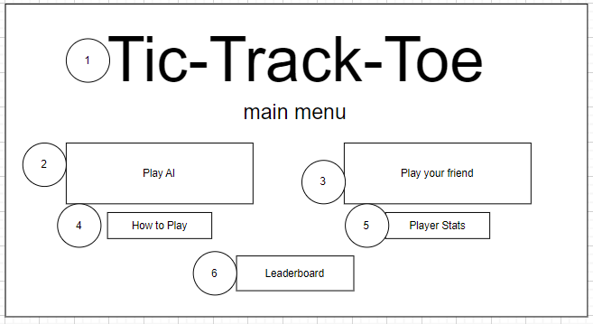
1. This label will display the title of the game on the main menu screen.
2. This is a button that when clicked will redirect the player to the play an AI mode. From there they will then select the AI’s difficulty.
3. When this button is pressed the user will be redirected to the play your friend player assignment screen.
4. When this button is pressed the instructions page will open.
5. When this button is pressed the player stats will be displayed on a new screen
6. When the user presses this button, the leaderboard table will be displayed

Leaderboard page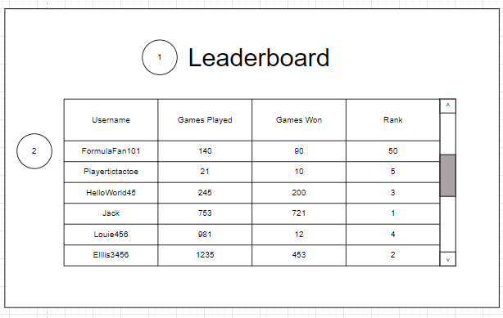
1. This text label displays the text ‘Leaderboard’ on the leaderboard page
2. This is the table being displayed to the user on the window

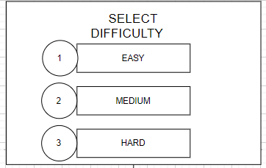
AI difficulty selection page

1. This button assigns the AI to easy mode
2. This button assigns the AI to medium mode
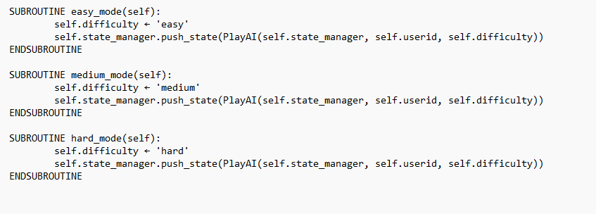
3. This button assigns the AI to hard mode
These subroutines are called when their partner button is pressed. First, they assign the correct difficulty to the constant and then push the PlayAI state into the stack to run the game. The state is pushed with the userid and difficulty so the program knows what difficulty the AI must be when playing the game and which account the stats must be saved to.

Instructions page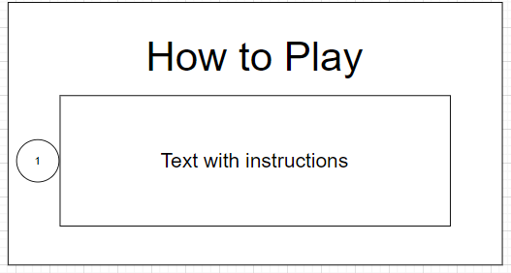
- This text box will contain all the information and instructions needed for the user to play the game.

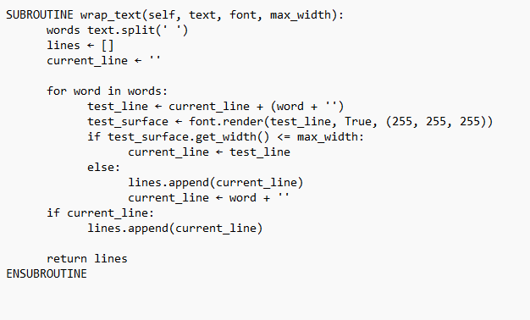
To make sure my instructions line does not exceed the space of the screen, the wrap_text subroutine handles the wrapping of long text into lines that fit within the specific width so my text will fit onto the screen. First, the text is split into words using the .split() method. This will allow the words to be added to the lines one by one. Next, the for loop then iterates through each each and creates a test line through adding the current word to the current line and then applying it to the surface. If the width is within the max width, then the word is added to the current line, else the current line is then appended to the list of lines and a new line is started with the word from current line. After finishing the loop, the last line is added to lines if it's not empty. The subroutine then returns the list of lines which makes sure that the text is broken up properly to fit within the screen's width. This subroutine will allow me to edit the text without the worry of it no longer fitting onto the screen.

Player Stats page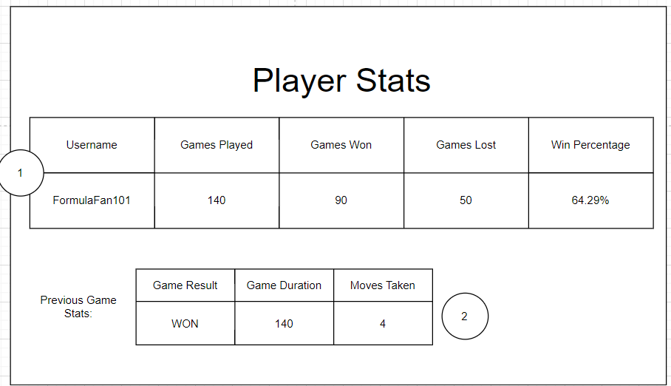
- The user game stats will be taken from the userstats table and displayed to the user so they can see their personal score without having to search through the leaderboard table
- This table will display the user’s result from the previous game they played. Moves taken refers to the total moves made by both players during the game.
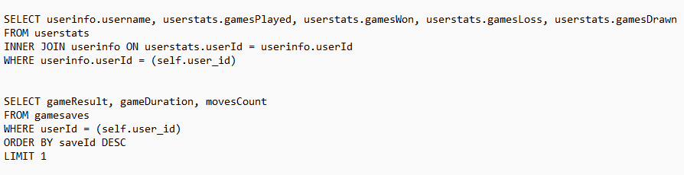
These SQL queries will allow me to form my user stats page for the player. The top SQL statement retrieves all the users all time stats and their username to display, while the other SQL statement retrieves the data from the most recent saveId.

Main game board

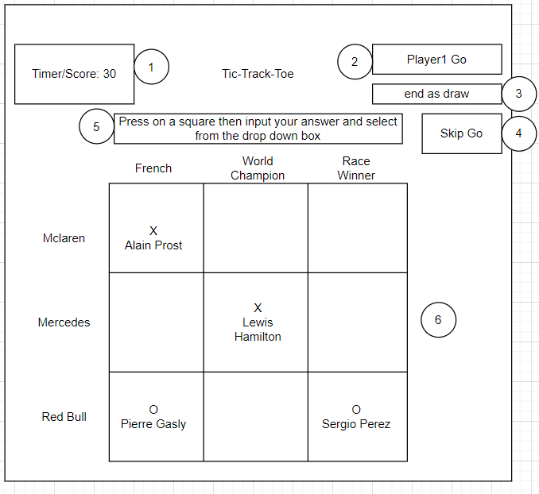
1. This text box will display a timer that counts down from 20 to 0. The user must enter their answer within this time limit. This is to prevent cheating and people searching for the answer on a browser
2. This text box will display which player’s turn it is. This will alternate between player turns
3. This text box will allow players to end the game as a draw if they are both unable to complete the game. It will save the game stats to the player/s rows in the userstats and then return the user to the main menu
4. When the skip go button is pressed, it becomes the other player’s go and the game continues
5. This text box will be where the user can search for a driver in the database. The user must first press on a square in the grid then type in the driver name they have chosen in this rectangle. A drop-down display will then be shown where the user can select their chosen driver.
6. This is the game board. It will be randomised each time the game is played but will never contain impossible answers. The text boxes on the side of each grid will display either a nation, constructor or achievement (e.g. race winner, pole position award). The user can press on each individual tile and make their turn in that slot. If the tile has already been used and has an X/O in, then it will become locked so another user cannot overwrite the tile. If a winning combination is found on the board, then the game will end and the userstats table will be updated with the new information. If the board is full and no winner has been found, then the player with the highest score will win. This will then be updated to the userstats table. The player will then be returned to the main menu screen. If a second user is logged in, then they will be signed out so only the first user to sign in is left logged in.

Handling a user clicking a grid slot on the board

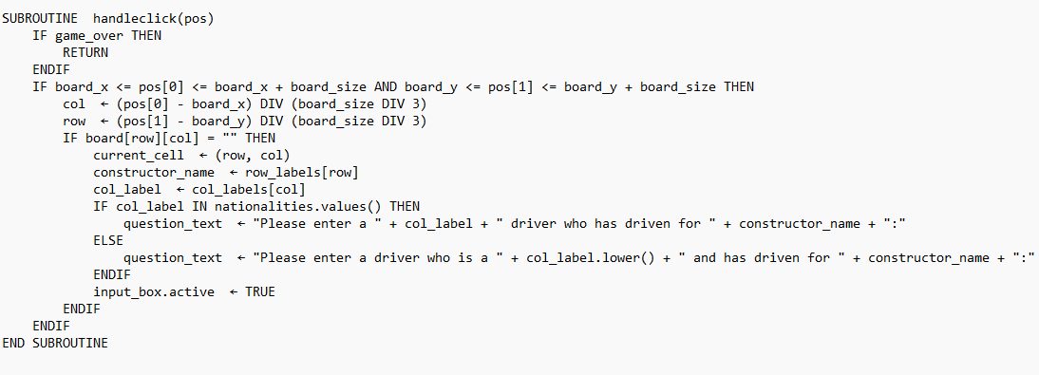
- The code first checks if the game is over, and if so, it immediately returns without doing anything else.
- It then checks if the click position is within the boundaries of the game board. If not, it also returns without doing anything else.
- If the click is within the game board, it calculates the row and column of the clicked cell based on the click position and the size of the game board.
- If the clicked cell is empty (i.e., its value is an empty string), it sets the current cell to the clicked cell and generates a question text based on the row and column labels.
- The question text is generated based on whether the column label is a nationality or not. If it is a nationality, the question asks for a driver of that nationality who has driven for the constructor (team) indicated by the row label. If it's not a nationality, the question asks for a driver who has gained a certain achievement (e.g. ‘World Champion’, ‘Race Winner’) and has driven for the constructor.
- Finally, it activates an input box, to allow the user to input their answer to the question.

How the AI bot discovers the most optimal move to make

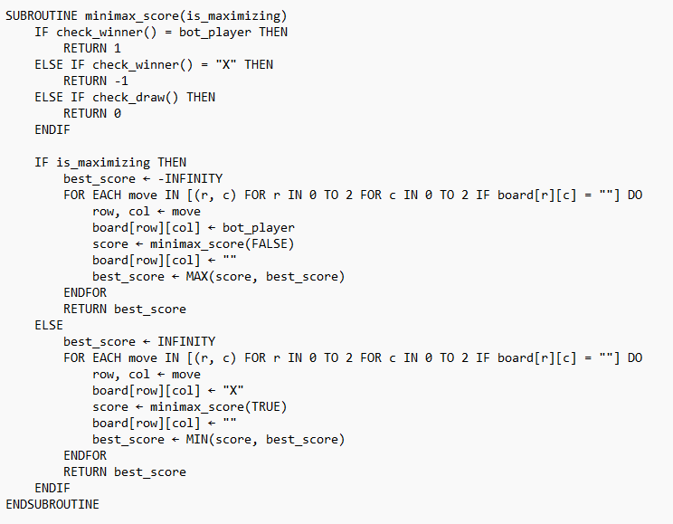

The minimax_score function is designed to check the best move in a game (like my Tic-Tac-Toe) by considering all possible future moves. The function uses recursion to simulate the game and determine the best score that can be achieved for the current player by either maximising the bot's score or minimising the opponent's score.
The function starts by checking conditions:

1. Bot Wins: If the bot player has won, the function returns a score of 1
2. Player Wins: If X has won, the function returns a score of 1.
3. Draw: If the game ends in a draw, the function returns a score of 0.

These conditions help stop further exploration for the best move once a clear outcome is reached.

Recursion

If none of these conditions are met, the function continues by exploring all possible moves using recursion.

Maximizing the Bot's Score

If is_maximizing is set to True, the function is trying to find the best move for the bot player.

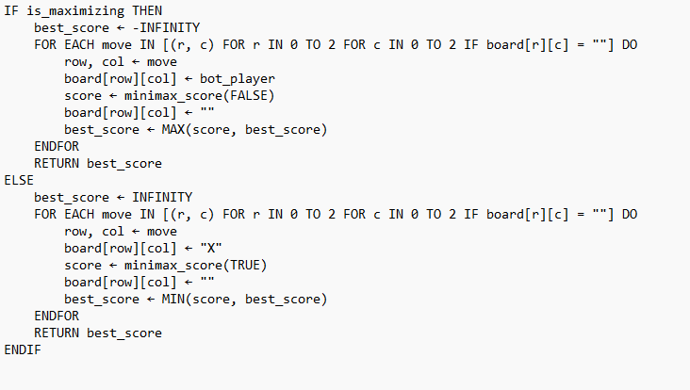
- This loop goes through every cell on the board and selects only the cells that are empty (self.board[r][c] == "").
- For each empty cell:
1. The bot makes a move by placing its symbol in that cell:`self.board[row][col] = self.bot_player.
2. The function then calls itself recursively with is_maximizing set to False, meaning it will now check the opponent's moves with the code ‘score = self.minimax_score(False)`.
3. It updates best_score to the highest score from these recursive calls: ‘best_score = max(score, best_score)`.
4. After checking all these options, it resets the cell to empty to explore other moves: `self.board[row][col] = ""`.

Minimizing the "X" Player's Score

If is_maximizing is set to False, the function tries to find the best move for the X player (the opponent to the bot). This loop works similarly to the maximizing loop:


- Once again, it goes through every empty cell on the board.
- For each cell:
1. The X player makes a move: `self.board[row][col] = "X"`.
2. The function calls itself recursively with is_maximizing set to True to check the bot's next possible move: score = self.minimax_score(True).
3. It updates `best_score` to the lowest score from the recursive calls: `best_score = min(score, best_score)`.
4. After evaluating, it resets the cell to empty for other move possibilities: `self.board[row][col] = ""`.

Return Value

Finally, the function returns the best_score, which reflects the best possible outcome for the current player (either maximising or minimising). The minimax_score function evaluates all potential future moves and countermoves, helping decide the best move in the game. This ensures that each player (bot or opponent) plays optimally, considering the opponent’s possible responses.

Checking for a result
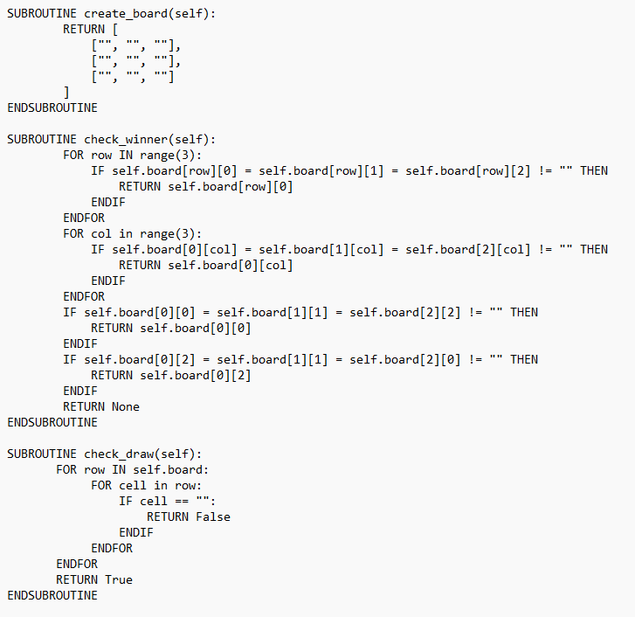
The code below shows a function for checking for a winner or draw in my game. I have also attached an image of how I will create my board by storing the position in an array. When a user goes in a grid slot it will be updated from “” to “X” for example. In the check winner function, a for loop is first used to loop through every row in the board to check for a winning 3 in a row. This is completed again but for the columns. Finally, a check for both diagonal win combinations is checked. If no win is found the nothing is returned. Another function check draw uses a double for loop to check through every row and column in the grid checking for if a grid cell contains “”. If it does, then the board is not full, so the game continues and False is returned. However, if all grid positions are full then it returns True, and the game will end as a draw. Later on, in the code when the game has checked if the user input is correct, a new selection statement will run to check for a winner or if the game is a draw. If a winner is found, then then result text will appear and game over will now be equal to True. IF the player is ‘X’ (the player logged in) then their user stats will be updated will a win and their new game save will be appended to the database. However, if they lost then a loss will be appended to the user stats and the game saves database tables. If check draw returns True then the same will happen but a draw will be appended to the tables instead. If there is no winner, then the current player will be switched, and the result text will show to tell the user if their guess was correct or not.

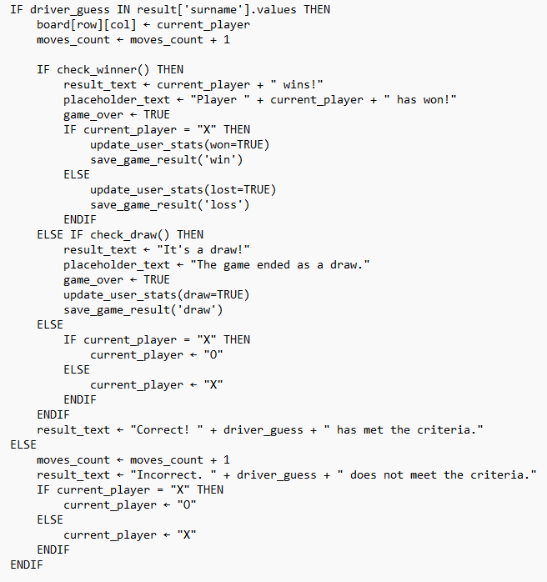

Checking database for the correct answer

This section of code defines a method called check_input that processes the player’s input in the game. It first checks if a cell is currently selected. If a cell is selected, it retrieves the row and column of the cell, the constructor’s name, and the column label. It then formats the player’s input and constructs filters for South American nationalities and Red Bull teams. Based on the column label, it builds a SQL query to fetch the relevant driver data from the database. The query varies depending on whether the column label is a nationality, an achievement, or a specific condition like “South American.” The code then executes the query and checks if the player’s guess matches any driver in the result. If the guess is correct, it updates the game board, increments the move count, and checks for a winner or a draw. If the guess is incorrect, it simply increments the move count and switches the current player. Finally, it resets the input box and updates the game state, including showing a return home button if the game is over. I have used a DISTINCT wildcard so if a driver is listed multiple times, it will only output this to the program once to make my SQL searches more efficient. Below is only a sample of database searches possible, as the actual code will require many more searches.
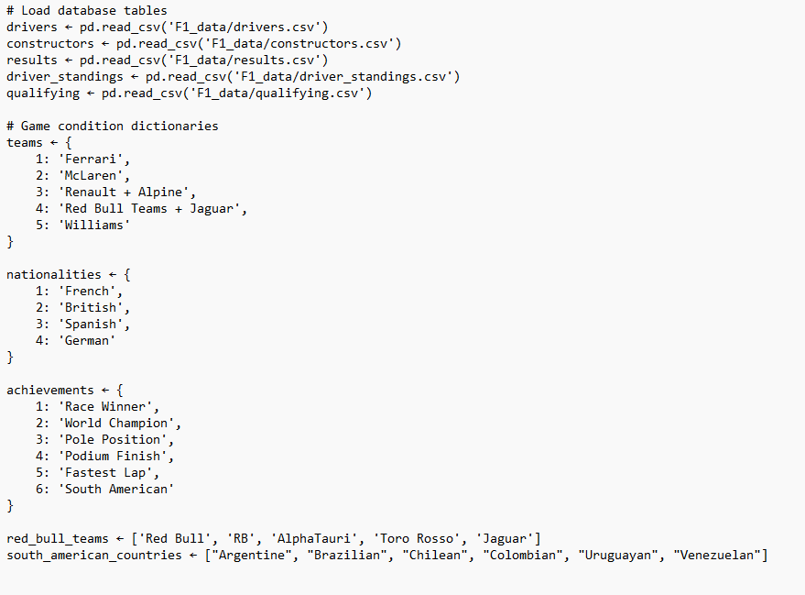
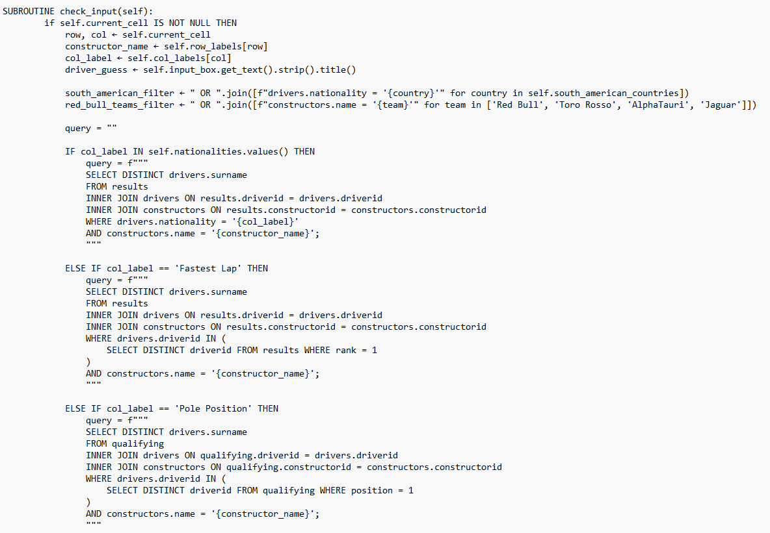

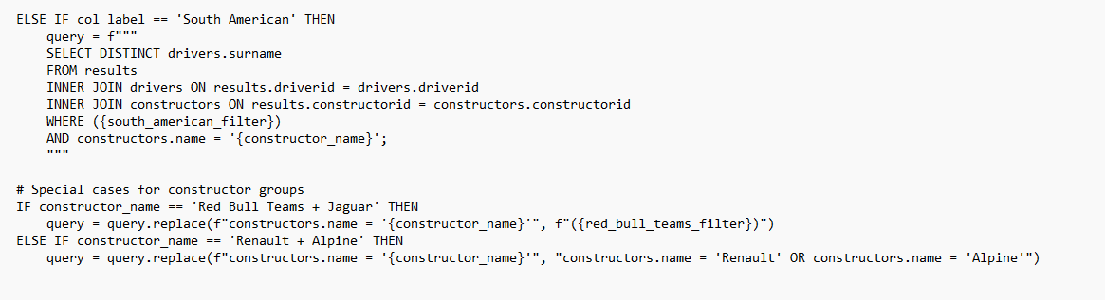
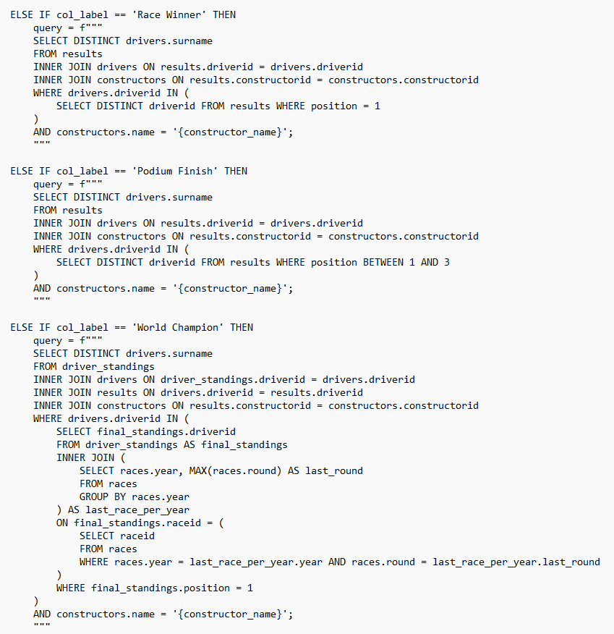

Formula One Tic Tac Toe Game
Game
Implementation
courComputer Science
Strickland, Jack Matthew

Folder Structure
¦ main.py
+---Database
¦ createuserdatabase.py
¦ game.db
¦
+---F1_data
¦ constructors.csv
¦ constructor_results.csv
¦ constructor_standings.csv
¦ drivers.csv
¦ driver_standings.csv
¦ qualifying.csv
¦ races.csv
¦ results.csv
¦ seasons.csv
¦
+---Fonts
¦ Formula1-Bold.otf
¦ Formula1-Regular.otf
¦ Formula1-Wide.otf
¦ info.txt
¦
+---Images
¦ f1icon.png
¦
+---states
¦ ¦ button.py
¦ ¦ instructions.py
¦ ¦ leaderboard.py
¦ ¦ login.py
¦ ¦ main_menu.py
¦ ¦ player_stats.py
¦ ¦ play_ai.py
¦ ¦ play_friend.py
¦ ¦ register.py
¦ ¦ select_difficulty.py
¦ ¦ state.py
¦ ¦ state_manager.py
¦ ¦ textbox.py
¦ ¦ welcome_screen.py
¦ ¦ __init__.py
¦ ¦

main.py

from states.state_manager import StateManager

if __name__ == "__main__":
manager = StateManager()
manager.run()

#RUN FILE TO START NEW GAME SESSION

button.py

import pygame

class Button:
def __init__(self, text, font, colour, x, y, width, height, action=None):
self.text = text
self.font = font
self.colour = colour
self.rect = pygame.Rect(x, y, width, height)
self.surface = pygame.Surface((width, height))
self.create_button_surface()
self.action = action

def create_button_surface(self):
self.surface.fill(self.colour)
text_surf = self.font.render(self.text, True, (255, 255, 255))
text_rect = text_surf.get_rect(center=(self.rect.width // 2, self.rect.height // 2))
self.surface.blit(text_surf, text_rect)

def draw(self, screen):
screen.blit(self.surface, self.rect.topleft)

def is_clicked(self, mouse_pos):
return self.rect.collidepoint(mouse_pos)

def perform_action(self):
if self.action:
self.action()

class BackButton(Button):
def __init__(self, state_manager, x=500, y=525, width=250, height=70):
from states.state_manager import StateManager # Absolute import
super().__init__('Back to Menu', state_manager.main_font, (175, 0, 200), x, y, width, height, action=state_manager.pop_state)
self.state_manager = state_manager

instructions.py

import pygame
from .state import State
from .button import BackButton

class Instructions(State):
def __init__(self, state_manager):
super().__init__(state_manager)

self.back_button = BackButton(state_manager)

def draw(self, screen):
screen.fill((175, 0, 52))
instruction_text = self.wrap_text(
"Here's the rules:\n"
" A 3x3 square grid is lined up with F1 teams, nations and achievements.\n"
" Place your marker, an X or O, in one of the squares if you can name an F1 driver that matches the criteria across the top row and left hand side.\n"
" The driver can be current or former and can be used more than once a game.\n"
" The first to get three in a row, vertically, horizontally or diagonally, is the winner.\n"
" Good luck!", self.state_manager.main_font_instructions, 1000
)
y = 250
for line in instruction_text:
text_surf = self.state_manager.main_font_instructions.render(line, True, (255, 255, 255))
screen.blit(text_surf, (100, y))
y += text_surf.get_height() + 5 # Adds some vertical spacing between lines

self.back_button.draw(screen)

pygame.display.update()

def wrap_text(self, text, font, max_width):
words = text.split(' ')
lines = []
current_line = ''

for word in words:
# Construct a test line to see if adding the new word exceeds the max width
test_line = current_line + (word + ' ')
test_surface = font.render(test_line, True, (255, 255, 255))
if test_surface.get_width() <= max_width:
current_line = test_line
else:
lines.append(current_line)
current_line = word + ' '

if current_line:
lines.append(current_line)

return lines

def handle_events(self, event):
if event.type == pygame.MOUSEBUTTONDOWN and event.button == 1:
if self.back_button.is_clicked(event.pos):
self.back_button.perform_action()
super().handle_events(event)

leaderboard.py

import pygame
import sqlite3
from .state import State
from .button import Button, BackButton

class Leaderboard(State):
def __init__(self, state_manager):
super().__init__(state_manager)

button_width = 200
button_height = 30
start_x = 50
spacing = 250
self.font = pygame.font.Font('Fonts/Formula1-Bold.otf', 13)

self.buttons.append(Button("Sort by Wins", self.font, (175, 0, 200), start_x, 10, button_width, button_height, self.sort_by_wins))
self.buttons.append(Button("Sort by Games Played", self.font, (175, 0, 200), start_x + button_width + spacing, 10, button_width, button_height, self.sort_by_games_played))
self.buttons.append(Button("Sort by Win Ratio", self.font, (175, 0, 200), start_x + 2 * (button_width + spacing), 10, button_width, button_height, self.sort_by_win_ratio))

self.buttons.append(BackButton(state_manager))

self.current_sort_method = self.sort_by_wins

def get_user_stats(self, order_by="gamesWon DESC, gamesPlayed ASC"):
db_path = 'Database/game.db'
conn = sqlite3.connect(db_path)
cursor = conn.cursor()

cursor.execute(f'''
SELECT userinfo.username, userstats.gamesPlayed, userstats.gamesWon, userstats.gamesDrawn, userstats.gamesLoss
FROM userstats
INNER JOIN userinfo ON userstats.userId = userinfo.userId
WHERE userstats.gamesPlayed > 0
ORDER BY {order_by}
LIMIT 8;
''')

rows = cursor.fetchall()
conn.close()

ranked_data = []
rank = 1
for row in rows:
username, games_played, games_won, games_drawn, games_lost = row
ranked_row = (rank, username, games_played, games_won, games_drawn, games_lost)
ranked_data.append(ranked_row)
rank += 1

return ranked_data

def sort_by_wins(self):
self.current_sort_method = self.sort_by_wins
self.draw(self.state_manager.screen)

def sort_by_games_played(self):
self.current_sort_method = self.sort_by_games_played
self.draw(self.state_manager.screen)

def sort_by_win_ratio(self):
self.current_sort_method = self.sort_by_win_ratio
self.draw(self.state_manager.screen)

def draw_table(self, window, data):
font = self.state_manager.main_font_instructions
table_top_left = (50, 50)
cell_width = 200
cell_height = 50
padding = 14

column_headers = ["Rank", "Username", "Games Played", "Games Won", "Games Drawn", "Games Lost"]

x_pos = table_top_left[0]
y_pos = table_top_left[1]

for header in column_headers:
text = font.render(header, True, (255, 255, 255))
window.blit(text, (x_pos + padding, y_pos + padding))
x_pos += cell_width

y_pos += cell_height

for row in data:
x_pos = table_top_left[0]
for cell in row:
text = font.render(str(cell), True, (255, 255, 255))
window.blit(text, (x_pos + padding, y_pos + padding))
x_pos += cell_width
y_pos += cell_height

def handle_events(self, event):
if event.type == pygame.MOUSEBUTTONDOWN:
mouse_pos = pygame.mouse.get_pos()
for button in self.buttons:
if button.is_clicked(mouse_pos):
button.perform_action()

def draw(self, screen):
screen.fill((175, 0, 52))

if self.current_sort_method == self.sort_by_games_played:
user_stats = self.get_user_stats(order_by="gamesPlayed DESC")
elif self.current_sort_method == self.sort_by_win_ratio:
user_stats = self.get_user_stats(order_by="(gamesWon * 1.0 / gamesPlayed) DESC, gamesPlayed ASC")
else:
user_stats = self.get_user_stats(order_by="gamesWon DESC, gamesPlayed DESC")

self.draw_table(screen, user_stats)

for button in self.buttons:
button.draw(screen)

pygame.display.update()

login.py

import bcrypt
import sqlite3
import pygame
from .state import State
from .textbox import TextBox
from .button import Button
from .main_menu import MainMenu
from .register import Register

class Login(State):
def __init__(self, state_manager):
super().__init__(state_manager)
self.font = state_manager.main_font_instructions
self.username_box = TextBox(self.font, 515, 200, 550, 60)
self.password_box = TextBox(self.font, 515, 300, 550, 60, is_password=True)
self.password_box.text_colour = (0,0,0)
self.password_box.base_colour = (255,255,255)
self.password_box.active_colour = (200, 200, 255)
self.message = ''
self.login_name = state_manager.bold_font.render('Login Page - Press enter to sign in', False, (255, 255, 238))
self.login_name_rect = self.login_name.get_rect(center=(600, 100))
self.username_text = state_manager.bold_font_login.render('Username - ', False, (255, 255, 238))
self.username_text_rect = self.username_text.get_rect(midright=(450,225))
self.password_text = state_manager.bold_font_login.render('Password - ', False, (255, 255, 238))
self.password_text_rect = self.password_text.get_rect(midright=(450,325))

self.register_button = Button(
"Press for register page",
self.font,
(0, 0, 255),
515, 425, 550, 60,
self.go_to_register
)

def check_credentials(self, username, password):
db_path = 'Database/game.db'
conn = sqlite3.connect(db_path)
cursor = conn.cursor()
cursor.execute('SELECT password FROM userinfo WHERE username=?', (username,))
result = cursor.fetchone()
conn.close()
if result:
hashed_password = result[0]
return bcrypt.checkpw(password.encode('utf-8'), hashed_password)
return False

def handle_events(self, event):
self.username_box.handle_event(event)
self.password_box.handle_event(event)
self.register_button.is_clicked(pygame.mouse.get_pos())

if event.type == pygame.QUIT:
pygame.quit()
exit()

if event.type == pygame.MOUSEBUTTONDOWN and event.button == 1:
if self.register_button.is_clicked(event.pos):
self.register_button.perform_action()

if event.type == pygame.KEYDOWN and event.key == pygame.K_RETURN:
username = self.username_box.get_text()
password = self.password_box.get_text()

if username and password:
if self.check_credentials(username, password):
self.message = "Login successful!"
self.state_manager.user_id = self.get_user_id(username)
self.state_manager.push_state(MainMenu(self.state_manager))
else:
self.message = "Invalid credentials"

def get_user_id(self, username):
db_path = 'Database/game.db'
conn = sqlite3.connect(db_path)
cursor = conn.cursor()
cursor.execute('SELECT userId FROM userinfo WHERE username=?', (username,))
user_id = cursor.fetchone()[0]
conn.close()
return user_id

def draw(self, screen):
super().draw(screen)
self.username_box.draw(screen)
self.password_box.draw(screen)
self.register_button.draw(screen)
message_surface = self.font.render(self.message, True, (255, 255, 255))
screen.blit(message_surface, (510, 370))
screen.blit(self.login_name, self.login_name_rect)
screen.blit(self.username_text, self.username_text_rect)
screen.blit(self.password_text, self.password_text_rect)
pygame.display.flip()

def update(self):
pass

def go_to_register(self):
self.state_manager.push_state(Register(self.state_manager))

main_menu.py

import pygame
from states.state import State
from states.button import Button
from states.play_ai import PlayAI
from states.play_friend import PlayFriend #change
from states.instructions import Instructions
from states.player_stats import PlayerStats
from states.leaderboard import Leaderboard
from states.select_difficulty import SelectDifficulty

class MainMenu(State):
def __init__(self, state_manager):
super().__init__(state_manager)

# Load car image
self.car_image = pygame.image.load('Images/f1icon.png').convert_alpha()
self.car_image_rect = self.car_image.get_rect(center=(600, 300))

# Create game name
self.game_name = state_manager.bold_font.render('Tic Track Toe', False, (255, 255, 238))
self.game_name_rect = self.game_name.get_rect(center=(600, 100))

# Create menu buttons horizontally
button_width = 215
button_height = 60
spacing = 20 # Space between buttons
start_x = (1200 - (5 * button_width + 4 * spacing)) // 2 # Centering the buttons
#(self, text, font, colour, x, y, width, height, action=None)
self.buttons.append(Button('Play AI', state_manager.main_font, (255, 30, 0), start_x, 450, button_width, button_height,
action=self.play_ai))
self.buttons.append(Button('Play Friend', state_manager.main_font, (255, 30, 0), start_x + button_width + spacing, 450, button_width, button_height,
action=self.play_friend))
self.buttons.append(Button('Instructions', state_manager.main_font, (255, 30, 0), start_x + 2 * (button_width + spacing), 450, button_width, button_height,
action=self.instructions))
self.buttons.append(Button('Player Stats', state_manager.main_font, (255, 30, 0), start_x + 3 * (button_width + spacing), 450, button_width, button_height,
action=self.player_stats))
self.buttons.append(Button('Leaderboard', state_manager.main_font, (255, 30, 0), start_x + 4 * (button_width + spacing), 450, button_width, button_height,
action=self.leaderboard))
self.sign_out_button = Button('Sign Out', state_manager.main_font, (0, 0, 255),490,525,button_width,button_height,
action=self.sign_out)
def play_ai(self):
self.state_manager.push_state(SelectDifficulty(self.state_manager,self.state_manager.user_id))

def play_friend(self):
self.state_manager.push_state(PlayFriend(self.state_manager,self.state_manager.user_id))

def instructions(self):
self.state_manager.push_state(Instructions(self.state_manager))

def player_stats(self):
self.state_manager.push_state(PlayerStats(self.state_manager,self.state_manager.user_id))

def leaderboard(self):
self.state_manager.push_state(Leaderboard(self.state_manager))

def sign_out(self):
self.state_manager.pop_state()
self.state_manager.pop_state()

def handle_events(self, event):
self.sign_out_button.is_clicked(pygame.mouse.get_pos())
if event.type == pygame.MOUSEBUTTONDOWN:
mouse_pos = pygame.mouse.get_pos()
for button in self.buttons:
if button.is_clicked(mouse_pos):
button.perform_action()
elif self.sign_out_button.is_clicked(event.pos):
self.sign_out_button.perform_action()

def draw(self, screen):
super().draw(screen)
screen.blit(self.car_image, self.car_image_rect)
screen.blit(self.game_name, self.game_name_rect)
self.sign_out_button.draw(screen)

player_stats.py

import pygame
import sqlite3
from .button import BackButton
from .state import State

class PlayerStats(State):
def __init__(self, state_manager, user_id):
super().__init__(state_manager)
self.user_id = user_id # Store the logged-in user's ID
self.font = state_manager.main_font_instructions # Use the main instructions font from the state manager
self.title_font = state_manager.bold_font_title

# Add a back button
self.back_button = BackButton(state_manager)

def get_user_stats(self):
db_path = 'Database/game.db'
conn = sqlite3.connect(db_path)
cursor = conn.cursor()

cursor.execute('''
SELECT userinfo.username, userstats.gamesPlayed, userstats.gamesWon, userstats.gamesLoss, userstats.gamesDrawn
FROM userstats
INNER JOIN userinfo ON userstats.userId = userinfo.userId
WHERE userinfo.userId = ?
''', (self.user_id,))

row = cursor.fetchone()
conn.close()

return row

def get_user_game_saves(self):
db_path = 'Database/game.db'
conn = sqlite3.connect(db_path)
cursor = conn.cursor()

cursor.execute('''
SELECT gameResult, gameDuration, movesCount
FROM gamesaves
WHERE userId = ?
ORDER BY saveId DESC
LIMIT 1
''', (self.user_id,))

row = cursor.fetchone()
conn.close()

return [row] if row else []

def draw_table(self, window, data, top_left, column_headers):
font = self.font
cell_width = 230
cell_height = 50
padding = 10
x_start, y_start = top_left

# Draw column headers
column_index = 0
for header in column_headers:
header_text = font.render(header, True, (255, 255, 255))
header_x = x_start + column_index * cell_width + padding
header_y = y_start + padding
window.blit(header_text, (header_x, header_y))
column_index += 1

# Draw rows of data
row_index = 0
for row_data in data:
column_index = 0
for cell_data in row_data:
cell_text = font.render(str(cell_data), True, (255, 255, 255))
cell_x = x_start + column_index * cell_width + padding
cell_y = y_start + (row_index + 1) * cell_height + padding
window.blit(cell_text, (cell_x, cell_y))
column_index += 1
row_index += 1

def draw(self, screen):
screen.fill((175, 0, 52))

# Fetch user stats and draw the table
user_stats = self.get_user_stats()
if user_stats:
title = self.title_font.render("User Stats", True, (255, 255, 255))
screen.blit(title, (50, 20))
self.draw_table(screen, [user_stats], (50, 70), ["Username", "Games Played", "Games Won", "Games Lost", "Games Drawn"])
else:
error_message = self.font.render("No stats available.", True, (255, 255, 255))
screen.blit(error_message, (50, 50))

# Fetch user game saves and draw the table
user_game_saves = self.get_user_game_saves()
if user_game_saves:
title = self.title_font.render("Most Recent Game", True, (255, 255, 255))
screen.blit(title, (50, 180))
self.draw_table(screen, user_game_saves, (50, 240), ["Game Result", "Duration (s)", "Moves Count"])
else:
error_message = self.font.render("No game saves available.", True, (255, 255, 255))
screen.blit(error_message, (50, 210))

# Draw the back button
self.back_button.draw(screen)

pygame.display.update()

def update(self):
pass

def handle_events(self, event):
if event.type == pygame.QUIT:
pygame.quit()
exit()

if event.type == pygame.MOUSEBUTTONDOWN and event.button == 1:
if self.back_button.is_clicked(event.pos):
self.back_button.perform_action()

play_ai.py

import random
import pygame
import pandas as pd
import pandasql as psql
from states.play_friend import PlayFriend

class PlayAI(PlayFriend):
def __init__(self, state_manager, user_id, difficulty):
super().__init__(state_manager, user_id)
self.bot_player = "O"
self.bot_active = False
self.difficulty = difficulty

def handle_events(self, event):
super().handle_events(event)
if not self.game_over and self.current_player == self.bot_player and not self.bot_active:
self.bot_active = True
self.bot_move()
self.bot_active = False

def bot_move(self):
available_moves = [(r, c) for r in range(3) for c in range(3) if self.board[r][c] == ""]
if available_moves:
move = self.choose_move(available_moves)
row, col = move
self.board[row][col] = self.bot_player
self.moves_count += 1
if self.check_winner():
self.result_text = f"{self.bot_player} wins!"
self.placeholder_text = f"Player {self.bot_player} has won!"
self.game_over = True
self.update_user_stats(lost=True)
self.save_game_result('loss')
elif self.check_draw():
self.result_text = "It's a draw!"
self.placeholder_text = "The game ended as a draw."
self.game_over = True
self.update_user_stats(draw=True)
self.save_game_result('draw')
else:
self.current_player = "X"
self.result_text = "Bot has made its move."

if self.game_over:
self.return_home_button.visible = True

def choose_move(self, available_moves):
if self.difficulty == 'easy':
return self.easy_bot_move(available_moves)
elif self.difficulty == 'medium':
return self.medium_bot_move(available_moves)
elif self.difficulty == 'hard':
return self.hard_bot_move(available_moves)

def easy_bot_move(self, available_moves):
if random.random() < 0.4: # 40% chance of making a correct move
return self.find_best_move(available_moves)
else:
return random.choice(available_moves)

def medium_bot_move(self, available_moves):
if random.random() < 0.7: # 70% chance of making a correct move
return self.minimax(available_moves)
else:
return random.choice(available_moves)

def hard_bot_move(self, available_moves):
return self.minimax(available_moves)

def find_best_move(self, available_moves):
# Simplified move for easy bot
for move in available_moves:
row, col = move
self.board[row][col] = self.bot_player
if self.check_winner():
self.board[row][col] = ""
return move
self.board[row][col] = ""
for move in available_moves:
row, col = move
self.board[row][col] = "X"
if self.check_winner():
self.board[row][col] = ""
return move
self.board[row][col] = ""
return random.choice(available_moves)

def minimax(self, available_moves):
best_score = -float('inf')
best_move = None
for move in available_moves:
row, col = move
self.board[row][col] = self.bot_player
score = self.minimax_score(False)
self.board[row][col] = ""
if score > best_score:
best_score = score
best_move = move
return best_move

def minimax_score(self, is_maximising):
if self.check_winner() == self.bot_player:
return 1
elif self.check_winner() == "X":
return -1
elif self.check_draw():
return 0

if is_maximising:
best_score = -float('inf')
for move in [(r, c) for r in range(3) for c in range(3) if self.board[r][c] == ""]:
row, col = move
self.board[row][col] = self.bot_player
score = self.minimax_score(False)
self.board[row][col] = ""
best_score = max(score, best_score)
return best_score
else:
best_score = float('inf')
for move in [(r, c) for r in range(3) for c in range(3) if self.board[r][c] == ""]:
row, col = move
self.board[row][col] = "X"
score = self.minimax_score(True)
self.board[row][col] = ""
best_score = min(score, best_score)
return best_score

def handle_click(self, pos):
if self.game_over or self.current_player != "X":
return

# Calculate the cell that was clicked
col = (pos[0] - self.board_x) // (self.board_size // 3)
row = (pos[1] - self.board_y) // (self.board_size // 3)

# Ensure the click is within the board boundaries
if 0 <= row < 3 and 0 <= col < 3:
if self.board[row][col] == "":
self.current_cell = (row, col)
constructor_name = self.row_labels[row]
col_label = self.col_labels[col]
if col_label in self.nationalities.values():
self.question_text = f'Please enter a {col_label} driver who has driven for {constructor_name}:'
else:
self.question_text = f'Please enter a driver who is a {col_label.lower()} and has driven for {constructor_name}:'
self.input_box.active = True

def check_input(self):
if self.current_cell is not None:
row, col = self.current_cell
constructor_name = self.row_labels[row]
col_label = self.col_labels[col]
driver_guess = self.input_box.get_text().strip().title()
south_american_filter = " OR ".join([f"drivers.nationality = '{country}'" for country in self.south_american_countries])
red_bull_teams_filter = " OR ".join([f"constructors.name = '{team}'" for team in ['Red Bull', 'Toro Rosso', 'AlphaTauri', 'Jaguar']])

query = ""

# Define conditions for various column labels
driver_condition = ""
if col_label in self.nationalities.values():
driver_condition = f"drivers.nationality = '{col_label}'"
elif col_label == 'Fastest Lap':
driver_condition = "drivers.driverid IN (SELECT DISTINCT driverid FROM results WHERE rank = 1)"
elif col_label == 'Pole Position':
driver_condition = "drivers.driverid IN (SELECT DISTINCT driverid FROM qualifying WHERE position = 1)"
elif col_label == 'Race Winner':
driver_condition = "drivers.driverid IN (SELECT DISTINCT driverid FROM results WHERE position = 1)"
elif col_label == 'Podium Finish':
driver_condition = "drivers.driverid IN (SELECT DISTINCT driverid FROM results WHERE position BETWEEN 1 AND 3)"
elif col_label == 'World Champion':
driver_condition = """
drivers.driverid IN (
SELECT final_standings.driverid
FROM driver_standings AS final_standings
INNER JOIN (
SELECT races.year, MAX(races.round) AS last_round
FROM races
GROUP BY races.year
) AS last_race_per_year
ON final_standings.raceid = (
SELECT raceid
FROM races
WHERE races.year = last_race_per_year.year AND races.round = last_race_per_year.last_round
)
WHERE final_standings.position = 1
)
"""
elif col_label == 'South American':
driver_condition = f"({south_american_filter})"

#base query
query = f"""
SELECT DISTINCT drivers.surname
FROM results
INNER JOIN drivers ON results.driverid = drivers.driverid
INNER JOIN constructors ON results.constructorid = constructors.constructorid
WHERE {driver_condition}
AND constructors.name = '{constructor_name}';
"""

# Special cases for constructor groups
if constructor_name == 'Red Bull Teams + Jaguar':
query = query.replace(f"constructors.name = '{constructor_name}'", f"({red_bull_teams_filter})")
elif constructor_name == 'Renault + Alpine':
# Replace with conditions specific to Renault and Alpine
query = query.replace(
f"constructors.name = '{constructor_name}'",
f"""
(constructors.name = 'Renault' AND {driver_condition})
OR
(constructors.name = 'Alpine' AND {driver_condition})
"""
)

# Execute the query with the correct context
local_tables = {
'drivers': self.drivers,
'constructors': self.constructors,
'results': self.results,
'driver_standings': self.driver_standings,
'qualifying': self.qualifying,
'races': self.races
}
result = psql.sqldf(query, local_tables)

if driver_guess in result['surname'].values:
self.board[row][col] = self.current_player
self.moves_count += 1
if self.check_winner():
self.result_text = f"{self.current_player} wins!"
self.placeholder_text = f"Player {self.current_player} has won!"
self.game_over = True
if self.current_player == "X":
self.update_user_stats(won=True)
self.save_game_result('win')
else:
self.update_user_stats(lost=True)
self.save_game_result('loss')
elif self.check_draw():
self.result_text = "It's a draw!"
self.placeholder_text = "The game ended as a draw."
self.game_over = True
self.update_user_stats(draw=True)
self.save_game_result('draw')
else:
self.current_player = self.bot_player
self.result_text = f"Correct! {driver_guess} has met the criteria."
else:
self.result_text = f"Incorrect. {driver_guess} does not meet the criteria."
self.current_player = self.bot_player

self.input_box.text = ''
self.input_box.active = False
self.current_cell = None

# Update the question text based on the new state of the game
if not self.game_over:
self.question_text = f"Click on a square to make a move."
else:
self.return_home_button.visible = True

def draw(self, screen):
super().draw(screen)
self.draw_board(screen)
self.draw_marks(screen)
question_surface = self.font.render(self.question_text, True, self.text_colour)
screen.blit(question_surface, (20, 20))
result_surface = self.font.render(self.result_text, True, self.text_colour)
screen.blit(result_surface, (20, 60))
self.input_box.draw(screen)

label_font = pygame.font.Font('Fonts/Formula1-Regular.otf', 24)
label_surface = label_font.render('Driver Surname:', True, self.text_colour)
screen.blit(label_surface, (20, 110))

self.skip_go_button.draw(screen)

self.draw_current_player(screen)

self.draw_placeholder_text(screen)

if self.game_over:
self.return_home_button.draw(screen)

def return_home(self):
self.state_manager.pop_state()
self.state_manager.pop_state()

def update_timer(self):
pass

def draw_timer(self,screen):
pass

play_friend.py

import random, time, sqlite3, pygame
import pandas as pd
import pandasql as psql
from states.state import State
from states.textbox import TextBox
from states.button import Button

class PlayFriend(State):
def __init__(self, state_manager, user_id):
super().__init__(state_manager)
self.user_id = user_id
self.start_time = time.time()
self.moves_count = 0
self.board = self.create_board()
self.current_player = "X"
self.game_over = False
self.screen_width, self.screen_height = 1200, 600
self.board_size = 300
self.grid_colour = pygame.Color('black')
self.x_colour = pygame.Color('white')
self.o_colour = pygame.Color('red')
self.bg_colour = pygame.Color((175, 0, 52))
self.text_colour = pygame.Color('white')
self.line_width = 10
self.board_x = (self.screen_width - self.board_size) // 2
self.board_y = (self.screen_height - self.board_size) // 2
self.font = pygame.font.Font('Fonts/Formula1-Bold.otf', 13)

# Load database tables
self.drivers = pd.read_csv('F1_data/drivers.csv')
self.constructors = pd.read_csv('F1_data/constructors.csv')
self.results = pd.read_csv('F1_data/results.csv')
self.driver_standings = pd.read_csv('F1_data/driver_standings.csv')
self.qualifying = pd.read_csv('F1_data/qualifying.csv')
self.races = pd.read_csv('F1_data/races.csv')

# Game condition dictionaries
self.teams = {
1: 'Ferrari',
2: 'McLaren',
3: 'Renault + Alpine',
4: 'Red Bull Teams + Jaguar',
5: 'Williams'
}

self.nationalities = {
1: 'French',
2: 'British',
3: 'Spanish',
4: 'German',
}

self.achievements = {
1: 'Race Winner',
2: 'World Champion',
3: 'Pole Position',
4: 'Podium Finish',
5: 'Fastest Lap',
6: 'South American'
}

# Ensure unique selection for teams and criteria (nationalities and achievements)
teams_list = list(self.teams.values())
criteria_list = list(self.nationalities.values()) + list(self.achievements.values())
random.shuffle(teams_list)
random.shuffle(criteria_list)

# Select unique row and column labels
self.row_labels = teams_list[:3]
self.col_labels = criteria_list[:3]

# Set up input for user guesses
self.input_box = TextBox(self.font, 20, 165, 300, 40, colour=(255, 255, 255), text_colour=(0, 0, 0), border_colour=(0, 0, 0), max_characters=30)
self.question_text = 'Click on a square to start the game. The signed in player is X and guest is O'
self.result_text = ''
self.current_cell = None
self.answer_text = ''

# Red Bull and associated teams
self.south_american_countries = ["Argentine", "Brazilian", "Chilean", "Colombian","Uruguayan", "Venezuelan"]

self.skip_go_button = Button('Skip Go', self.font, (0, 128, 0), 1000, 200, 150, 50, self.skip_go)
self.end_as_draw_button = Button('End as Draw', self.font, (128, 0, 0), 1000, 100, 150, 50, self.end_as_draw)

#(hidden initially)
self.return_home_button = Button('Return to Homepage', self.font, (0, 0, 128), 20, 515 , 250, 50, self.return_home)
self.return_home_button.visible = False

self.placeholder_text = "Tic Track Toe"
self.answer_text = ""
self.timer_start = 20
self.time_left = self.timer_start
self.timer_running = True
self.last_tick = pygame.time.get_ticks()

def create_board(self):
return [
["", "", ""],
["", "", ""],
["", "", ""]
]

def draw_board(self, screen):
screen.fill(self.bg_colour)
for line_num in range(1, 3):
horizontal_start_pos = (self.board_x, self.board_y + line_num * self.board_size // 3)
horizontal_end_pos = (self.board_x + self.board_size, self.board_y + line_num * self.board_size // 3)
pygame.draw.line(screen, self.grid_colour, horizontal_start_pos, horizontal_end_pos, self.line_width)
vertical_start_pos = (self.board_x + line_num * self.board_size // 3, self.board_y)
vertical_end_pos = (self.board_x + line_num * self.board_size // 3, self.board_y + self.board_size)
pygame.draw.line(screen, self.grid_colour, vertical_start_pos, vertical_end_pos, self.line_width)
self.draw_labels(screen)

def draw_marks(self, screen):
font = pygame.font.Font(None, 144)
for row in range(3):
for col in range(3):
mark = self.board[row][col]
if mark != "":
x_pos = self.board_x + col * self.board_size // 3 + self.board_size // 6
y_pos = self.board_y + row * self.board_size // 3 + self.board_size // 6
if mark == "X":
colour = self.x_colour
else:
colour = self.o_colour
text = font.render(mark, True, colour)
text_rect = text.get_rect(center=(x_pos, y_pos))
screen.blit(text, text_rect)

def draw_labels(self, screen):
row_label_x_offset = 100 # Offset for row labels
col_label_y_offset = 40 # Offset for column labels

for row in range(len(self.row_labels)):
label = self.row_labels[row]
if label == 'Red Bull Teams + Jaguar':
formatted_label = 'Red Bull Teams\n+ Jaguar'
lines = formatted_label.split('\n')
elif label == 'Renault + Alpine':
formatted_label = 'Renault\n+ Alpine'
lines = formatted_label.split('\n')
else:
lines = [label]

for line_idx in range(len(lines)):
line = lines[line_idx]
if len(line) > 10: # If the label is long, use a smaller font
row_label_font = pygame.font.Font('Fonts/Formula1-Bold.otf', 12)
else:
row_label_font = self.font

row_label = row_label_font.render(line, True, self.text_colour)
label_x = self.board_x - row_label_x_offset # Adjusted position for row labels
label_y = self.board_y + row * self.board_size // 3 + self.board_size // 6 - row_label.get_height() // 2 + line_idx * row_label.get_height()
screen.blit(row_label, (label_x, label_y))

for col in range(len(self.col_labels)):
label = self.col_labels[col]
if len(label) > 10: # If the label is long, use a smaller font
col_label_font = pygame.font.Font('Fonts/Formula1-Bold.otf', 10)
label_y_adjustment = col_label_y_offset
else:
col_label_font = self.font
label_y_adjustment = col_label_y_offset

col_label = col_label_font.render(label, True, self.text_colour)
label_x = self.board_x + col * self.board_size // 3 + self.board_size // 6 - col_label.get_width() // 2
label_y = self.board_y - label_y_adjustment
screen.blit(col_label, (label_x, label_y))

def check_winner(self):
for row in range(3):
if self.board[row][0] == self.board[row][1] == self.board[row][2] != "":
return self.board[row][0]
for col in range(3):
if self.board[0][col] == self.board[1][col] == self.board[2][col] != "":
return self.board[0][col]
if self.board[0][0] == self.board[1][1] == self.board[2][2] != "":
return self.board[0][0]
if self.board[0][2] == self.board[1][1] == self.board[2][0] != "":
return self.board[0][2]
return None

def check_draw(self):
for row in self.board:
for cell in row:
if cell == "":
return False
return True

def reset_board(self):
self.board = self.create_board()
self.current_player = "X"
self.game_over = False
self.question_text = 'Click on a square to start the game. The signed in player is X and guest is O'
self.result_text = ''
self.placeholder_text = "Tic Track Toe"
self.answer_text = ''
self.start_time = time.time() # Reset the start time
self.moves_count = 0

def handle_events(self, event):
super().handle_events(event)
if event.type == pygame.MOUSEBUTTONDOWN:
mouse_pos = pygame.mouse.get_pos()
if self.skip_go_button.is_clicked(mouse_pos):
self.skip_go_button.perform_action()
elif self.end_as_draw_button.is_clicked(mouse_pos):
self.end_as_draw_button.perform_action()
elif self.return_home_button.visible and self.return_home_button.is_clicked(mouse_pos):
self.return_home_button.perform_action()
else:
self.handle_click(mouse_pos)

self.input_box.handle_event(event)
if event.type == pygame.KEYDOWN and event.key == pygame.K_RETURN:
self.check_input()

def handle_click(self, pos):
if self.game_over:
return
if self.board_x <= pos[0] <= self.board_x + self.board_size and self.board_y <= pos[1] <= self.board_y + self.board_size:
col = (pos[0] - self.board_x) // (self.board_size // 3)
row = (pos[1] - self.board_y) // (self.board_size // 3)
if self.board[row][col] == "":
self.current_cell = (row, col)
constructor_name = self.row_labels[row]
col_label = self.col_labels[col]
if col_label in self.nationalities.values():
self.question_text = f'Please enter a {col_label} driver who has driven for {constructor_name}:'
else:
self.question_text = f'Please enter a driver who is a {col_label.lower()} and has driven for {constructor_name}:'
self.input_box.active = True

def check_input(self):
if self.current_cell is not None:
row, col = self.current_cell
constructor_name = self.row_labels[row]
col_label = self.col_labels[col]
driver_guess = self.input_box.get_text().strip().title() #Get the user's input and update it to fix database format

south_american_filter = " OR ".join([f"drivers.nationality = '{country}'" for country in self.south_american_countries])
red_bull_teams_filter = " OR ".join([f"constructors.name = '{team}'" for team in ['Red Bull', 'Toro Rosso', 'AlphaTauri', 'Jaguar']])

query = ""

# Define conditions for various column labels
driver_condition = ""
if col_label in self.nationalities.values():
driver_condition = f"drivers.nationality = '{col_label}'"
elif col_label == 'Fastest Lap':
driver_condition = "drivers.driverid IN (SELECT DISTINCT driverid FROM results WHERE rank = 1)"
elif col_label == 'Pole Position':
driver_condition = "drivers.driverid IN (SELECT DISTINCT driverid FROM qualifying WHERE position = 1)"
elif col_label == 'Race Winner':
driver_condition = "drivers.driverid IN (SELECT DISTINCT driverid FROM results WHERE position = 1)"
elif col_label == 'Podium Finish':
driver_condition = "drivers.driverid IN (SELECT DISTINCT driverid FROM results WHERE position BETWEEN 1 AND 3)"
elif col_label == 'World Champion':
driver_condition = """
drivers.driverid IN (
SELECT final_standings.driverid
FROM driver_standings AS final_standings
INNER JOIN (
SELECT races.year, MAX(races.round) AS last_round
FROM races
GROUP BY races.year
) AS last_race_per_year
ON final_standings.raceid = (
SELECT raceid
FROM races
WHERE races.year = last_race_per_year.year AND races.round = last_race_per_year.last_round
)
WHERE final_standings.position = 1
)
"""
elif col_label == 'South American':
driver_condition = f"({south_american_filter})"

#base query
query = f"""
SELECT DISTINCT drivers.surname
FROM results
INNER JOIN drivers ON results.driverid = drivers.driverid
INNER JOIN constructors ON results.constructorid = constructors.constructorid
WHERE {driver_condition}
AND constructors.name = '{constructor_name}';
"""

# Special cases for constructor groups
if constructor_name == 'Red Bull Teams + Jaguar':
query = query.replace(f"constructors.name = '{constructor_name}'", f"({red_bull_teams_filter})")
elif constructor_name == 'Renault + Alpine':
# Replace with conditions specific to Renault and Alpine
query = query.replace(
f"constructors.name = '{constructor_name}'",
f"""
(constructors.name = 'Renault' AND {driver_condition})
OR
(constructors.name = 'Alpine' AND {driver_condition})
"""
)

# Execute the query with the correct context
local_tables = {
'drivers': self.drivers,
'constructors': self.constructors,
'results': self.results,
'driver_standings': self.driver_standings,
'qualifying': self.qualifying,
'races': self.races
}
result = psql.sqldf(query, local_tables)

if driver_guess in result['surname'].values:
self.board[row][col] = self.current_player
self.moves_count += 1

if self.check_winner():
self.result_text = f"{self.current_player} wins!"
self.placeholder_text = f"Player {self.current_player} has won!"
self.game_over = True
if self.current_player == "X":
self.update_user_stats(won=True)
self.save_game_result('win')
else:
self.update_user_stats(lost=True)
self.save_game_result('loss')
elif self.check_draw():
self.result_text = "It's a draw!"
self.placeholder_text = "The game ended as a draw."
self.game_over = True
self.update_user_stats(draw=True)
self.save_game_result('draw')
else:
self.current_player = "O" if self.current_player == "X" else "X"
self.result_text = f"Correct! {driver_guess} has met the criteria."
else:
self.moves_count += 1
self.result_text = f"Incorrect. {driver_guess} does not meet the criteria."
self.current_player = "O" if self.current_player == "X" else "X"
#answer = result['surname'].values
#self.answer_text = "Possible answers:\n" + "\n".join(str(ans) for ans in answer[:3])

self.input_box.text = ''
self.input_box.active = False
self.current_cell = None

if not self.game_over:
self.question_text = f"Click on a square to make a move."
self.reset_timer()
else:
self.return_home_button.visible = True

def save_game_result(self, result):
game_duration = int(time.time() - self.start_time)
conn = sqlite3.connect('Database/game.db')
cursor = conn.cursor()

cursor.execute("""
INSERT INTO gamesaves (userId, gameResult, gameDuration, movesCount)
VALUES (?, ?, ?, ?)
""", (self.user_id, result, game_duration, self.moves_count))

conn.commit()
conn.close()

def update_user_stats(self, won=False, lost=False, draw=False):
conn = sqlite3.connect('Database/game.db')
cursor = conn.cursor()

cursor.execute("""
SELECT gamesPlayed, gamesWon, gamesLoss, gamesDrawn FROM userstats WHERE userId = ?
""", (self.user_id,))
stats = cursor.fetchone()

if stats:
games_played, games_won, games_lost, games_drawn = stats
games_played += 1
if won:
games_won += 1
if lost:
games_lost += 1
if draw:
games_drawn += 1

cursor.execute("""
UPDATE userstats
SET gamesPlayed = ?, gamesWon = ?, gamesLoss = ?, gamesDrawn = ?
WHERE userId = ?
""", (games_played, games_won, games_lost, games_drawn, self.user_id))
else:
games_played = 1
games_won = 1 if won else 0
games_lost = 1 if lost else 0
games_drawn = 1 if draw else 0

cursor.execute("""
INSERT INTO userstats (userId, gamesPlayed, gamesWon, gamesLoss, gamesDrawn)
VALUES (?, ?, ?, ?, ?)
""", (self.user_id, games_played, games_won, games_lost, games_drawn))

conn.commit()
conn.close()

def skip_go(self):
if not self.game_over:
self.current_player = "O" if self.current_player == "X" else "X"
self.result_text = f"{self.current_player}'s turn has been skipped. Click on a square to make a move."
self.reset_timer()

def end_as_draw(self):
if not self.game_over:
self.game_over = True
self.result_text = "The game has been ended as a draw."
self.placeholder_text = "The game ended as a draw."
self.update_user_stats(draw=True)
self.save_game_result('draw')
self.return_home_button.visible = True
self.timer_running = False

def draw_current_player(self, screen):
current_player_text = f"Player {self.current_player}'s Go"
font = pygame.font.Font('Fonts/Formula1-Bold.otf', 24)
text_surface = font.render(current_player_text, True, self.text_colour)
text_rect = text_surface.get_rect(topright=(self.screen_width - 20, 20))
screen.blit(text_surface, text_rect)

def draw_placeholder_text(self, screen):
font = pygame.font.Font('Fonts/Formula1-Bold.otf', 40)
text_surface = font.render(self.placeholder_text, True, self.text_colour)
text_rect = text_surface.get_rect(center=(self.screen_width // 2, self.screen_height - 60))
screen.blit(text_surface, text_rect)

def update_timer(self):
if self.timer_running and not self.game_over:
current_time = pygame.time.get_ticks()
elapsed_time = (current_time - self.last_tick) / 1000 # Convert milliseconds to seconds

if elapsed_time >= 1: # One second has passed
self.time_left -= 1
self.last_tick = current_time

if self.time_left <= 0:
self.skip_go()
self.reset_timer()

def reset_timer(self):
self.time_left = self.timer_start
self.last_tick = pygame.time.get_ticks()

def draw_timer(self, screen):
if not self.game_over:
font = pygame.font.Font('Fonts/Formula1-Regular.otf', 36)
timer_text = f"Time Left : {self.time_left}s"
text_surface = font.render(timer_text, True, self.text_colour)
text_rect = text_surface.get_rect(bottomleft=(20, self.screen_height - 60))
screen.blit(text_surface, text_rect)

def draw(self, screen):
super().draw(screen)
self.draw_board(screen)
self.draw_marks(screen)
question_surface = self.font.render(self.question_text, True, self.text_colour)
screen.blit(question_surface, (20, 20))
result_surface = self.font.render(self.result_text, True, self.text_colour)
screen.blit(result_surface, (20, 60))
answer_surface = self.font.render(self.answer_text, True, self.text_colour)
screen.blit(answer_surface, (20,250))
label_font = pygame.font.Font('Fonts/Formula1-Regular.otf', 24)
label_surface = label_font.render('Driver Surname:', True, self.text_colour)
screen.blit(label_surface, (20, 110))
#answer_surface = self.font.render(self.answer_text, True, self.text_colour)
#screen.blit(answer_surface, (20,20))

self.input_box.draw(screen)

self.skip_go_button.draw(screen)
self.end_as_draw_button.draw(screen)

self.draw_current_player(screen)

self.draw_placeholder_text(screen)

if self.game_over:
self.return_home_button.draw(screen)

self.draw_timer(screen)

def return_home(self):
self.state_manager.pop_state()

register.py

import pygame, sqlite3 , bcrypt
from .textbox import TextBox
from .state import State
from .button import Button

class Register(State):
def __init__(self, state_manager):
super().__init__(state_manager)
self.font = state_manager.main_font_instructions
self.username_box = TextBox(self.font, 515, 200, 550, 60)
self.password_box = TextBox(self.font, 515, 300, 550, 60, is_password=True)
self.message = ''
self.register_name = state_manager.bold_font.render('Press enter to create account', False, (255, 255, 238))
self.register_name_rect = self.register_name.get_rect(center=(600, 100))
self.username_text = state_manager.bold_font_login.render('New Username - ', False, (255, 255, 238))
self.username_text_rect = self.username_text.get_rect(midright=(450, 225))
self.password_text = state_manager.bold_font_login.render('New Password - ', False, (255, 255, 238))
self.password_text_rect = self.password_text.get_rect(midright=(450, 325))

# Button for returning to the login page
self.back_to_login_button = Button(
"Press for Login page",
self.font,
(0, 0, 255),
515, 400, 550, 60,
self.return_to_login
)

def is_valid_input(self, text):
# Check if text is not empty and contains only alphanumeric characters
return text.isalnum()

def register_user(self, username, password):
db_path = 'Database/game.db'
conn = sqlite3.connect(db_path)
cursor = conn.cursor()
try:
# Hash the password before storing it
hashed_password = bcrypt.hashpw(password.encode('utf-8'), bcrypt.gensalt()) #Add salt to password to encrypt

cursor.execute('INSERT INTO userinfo (username, password) VALUES (?, ?)', (username, hashed_password))
conn.commit()

# Fetch the userId of the new user
cursor.execute('SELECT userId FROM userinfo WHERE username=?', (username,))
user_id = cursor.fetchone()[0]

# Insert into userstats table
cursor.execute('INSERT INTO userstats (userId) VALUES (?)', (user_id,))
conn.commit()
self.message = "Registration successful!"
except sqlite3.IntegrityError:
self.message = "Username already taken."
finally:
conn.close()

def handle_events(self, event):
self.username_box.handle_event(event)
self.password_box.handle_event(event)
self.back_to_login_button.is_clicked(pygame.mouse.get_pos())

if event.type == pygame.QUIT:
pygame.quit()
exit()

if event.type == pygame.MOUSEBUTTONDOWN and event.button == 1:
if self.back_to_login_button.is_clicked(event.pos):
self.back_to_login_button.perform_action()

if event.type == pygame.KEYDOWN and event.key == pygame.K_RETURN:
username = self.username_box.get_text()
password = self.password_box.get_text()
if username and password:
# Validate input
if self.is_valid_input(username) and self.is_valid_input(password):
self.register_user(username, password)
else:
self.message = "Only alphanumeric characters are allowed."

def draw(self, screen):
super().draw(screen)
self.username_box.draw(screen)
self.password_box.draw(screen)
self.back_to_login_button.draw(screen)
message_surface = self.font.render(self.message, True, (255, 255, 255))
screen.blit(message_surface, (515, 500))
screen.blit(self.register_name, self.register_name_rect)
screen.blit(self.username_text, self.username_text_rect)
screen.blit(self.password_text, self.password_text_rect)
pygame.display.flip()

def update(self):
pass

def return_to_login(self):
from .login import Login
self.state_manager.pop_state()
self.state_manager.push_state(Login(self.state_manager))

select_difficulty.py

import pygame
from states.button import Button, BackButton
from states.state import State
from states.play_ai import PlayAI

class SelectDifficulty(State):

def __init__(self, state_manager, userid):
super().__init__(state_manager)
self.difficulty = None
self.userid = userid
self.text = state_manager.bold_font.render('Select Difficulty:', False, (255, 255, 238))
self.text_rect = self.text.get_rect(center=(600, 100))
self.back_button = BackButton(state_manager)

# Create menu buttons horizontally
button_width = 215
button_height = 60
spacing = 20 # Space between buttons
start_x = (1200 - (3 * button_width + 2 * spacing)) // 2 # Centering the buttons

self.buttons.append(Button('Easy', state_manager.main_font, (255, 30, 0), start_x, 300, button_width, button_height,
action=self.easy_mode))
self.buttons.append(Button('Medium', state_manager.main_font, (255, 30, 0), start_x + button_width + spacing, 300, button_width, button_height,
action=self.medium_mode))
self.buttons.append(Button('Hard', state_manager.main_font, (255, 30, 0), start_x + 2 * (button_width + spacing), 300, button_width, button_height,
action=self.hard_mode))

def easy_mode(self):
self.difficulty = 'easy'
self.state_manager.push_state(PlayAI(self.state_manager, self.userid, self.difficulty))

def medium_mode(self):
self.difficulty = 'medium'
self.state_manager.push_state(PlayAI(self.state_manager, self.userid, self.difficulty))

def hard_mode(self):
self.difficulty = 'hard'
self.state_manager.push_state(PlayAI(self.state_manager, self.userid, self.difficulty))

def draw(self, screen):
super().draw(screen)
screen.blit(self.text, self.text_rect)
self.back_button.draw(screen)

pygame.display.update()

def handle_events(self, event):
if event.type == pygame.MOUSEBUTTONDOWN and event.button == 1:
if self.back_button.is_clicked(event.pos):
self.back_button.perform_action()
super().handle_events(event)

state.py

import pygame

class State:
def __init__(self, state_manager):
self.buttons = []
self.state_manager = state_manager

def handle_events(self, event):
if event.type == pygame.MOUSEBUTTONDOWN:
mouse_pos = pygame.mouse.get_pos()
for button in self.buttons:
if button.is_clicked(mouse_pos):
button.perform_action()

def draw(self, screen):
screen.fill((175, 0, 52)) # Default background colour for the state
for button in self.buttons:
button.draw(screen)

state_manager.py

import pygame
from states.main_menu import MainMenu
from states.play_ai import PlayAI
from states.play_friend import PlayFriend
from states.instructions import Instructions
from states.player_stats import PlayerStats
from states.leaderboard import Leaderboard
from states.login import Login
from states.welcome_screen import Welcome_Screen

class StateManager:
def __init__(self):
pygame.init()
self.screen = pygame.display.set_mode((1200, 600))
pygame.display.set_caption('Tic Track Toe')
self.icon = pygame.image.load('Images/f1icon.png').convert_alpha()
pygame.display.set_icon(self.icon)
self.main_font = pygame.font.Font('Fonts/Formula1-Regular.otf', 30)
self.bold_font = pygame.font.Font('Fonts/Formula1-Bold.otf', 60)
self.main_font_instructions = pygame.font.Font('Fonts/Formula1-Bold.otf', 20)
self.bold_font_login = pygame.font.Font('Fonts/Formula1-Bold.otf', 45)
self.bold_font_title = pygame.font.Font('Fonts/Formula1-Bold.otf', 40)

self.user_id = None
self.state_stack = [Welcome_Screen(self)]

def push_state(self, new_state):
self.state_stack.append(new_state)

def pop_state(self):
if len(self.state_stack) > 1:
self.state_stack.pop()

def current_state(self):
return self.state_stack[-1]

def run(self):
clock = pygame.time.Clock()

while True:
for event in pygame.event.get():
if event.type == pygame.QUIT:
pygame.quit()
exit()
self.current_state().handle_events(event)

current_state = self.current_state()

if hasattr(current_state, 'update_timer'):
current_state.update_timer()

self.screen.fill((0, 0, 0))
current_state.draw(self.screen)

pygame.display.update()

clock.tick(60)

textbox.py

import pygame

class TextBox:
def __init__(self, font, x, y, width, height, colour=(255, 255, 255), text_colour=(0, 0, 0), border_colour=(0, 0, 0), max_characters=20, is_password=False):
self.font = font
self.text = ''
self.colour = colour
self.text_colour = text_colour
self.border_colour = border_colour
self.rect = pygame.Rect(x, y, width, height)
self.active = False
self.base_colour = colour
self.active_colour = (200, 200, 255)
self.max_characters = max_characters # Limit the number of characters
self.is_password = is_password # Flag to hide the password
self.cursor_width = 2 # Width of the cursor line
self.cursor_rect = pygame.Rect(self.rect.x + 5, self.rect.y + 5, self.cursor_width, height - 10)

def handle_event(self, event):
if event.type == pygame.MOUSEBUTTONDOWN:
if self.rect.collidepoint(event.pos):
self.active = True
else:
self.active = False

if event.type == pygame.KEYDOWN and self.active:
if event.key == pygame.K_BACKSPACE:
self.text = self.text[:-1]
elif event.key == pygame.K_RETURN:
pass
elif event.key == pygame.K_ESCAPE:
self.active = False
else:
if event.unicode.isprintable():
if len(self.text) < self.max_characters:
self.text += event.unicode

def get_text(self):
return self.text # Return the actual text

def draw(self, screen):
if self.active:
pygame.draw.rect(screen, self.active_colour, self.rect)
else:
pygame.draw.rect(screen, self.base_colour, self.rect)
pygame.draw.rect(screen, self.border_colour, self.rect, 2)

if self.is_password:
text_surface = self.font.render('*' * len(self.text), True, self.text_colour)
else:
text_surface = self.font.render(self.text, True, self.text_colour)
text_rect = text_surface.get_rect(topleft=(self.rect.x + 5, self.rect.y + 5))
screen.blit(text_surface, text_rect)

# Draw the cursor
if self.active:
self.cursor_rect.topleft = (text_rect.right, text_rect.top)
pygame.draw.rect(screen, self.text_colour, self.cursor_rect)

welcome_screen.py

import pygame
from .state import State
from .button import Button

class Welcome_Screen(State):

def __init__(self, state_manager):
super().__init__(state_manager)
self.font = state_manager.main_font_instructions
self.car_image = pygame.image.load('Images/f1icon.png').convert_alpha()
self.car_image_rect = self.car_image.get_rect(center=(600, 300))
self.game_name = state_manager.bold_font.render('Tic Track Toe', False, (255, 255, 238))
self.game_name_rect = self.game_name.get_rect(center=(600, 100))

self.go_to_login = Button(
"Click here to Login Page",
self.font,
(0, 0, 255),
620, 425, 420, 70,
self.go_to_login
)

self.go_to_register = Button(
"Click here to Register Page",
self.font,
(0, 0, 255),
120, 425, 420, 70,
self.go_to_register
)

def go_to_login(self):
from .login import Login
self.state_manager.push_state(Login(self.state_manager))

def go_to_register(self):
from .register import Register
self.state_manager.pop_state()
self.state_manager.push_state(Register(self.state_manager))

def handle_events(self, event):
self.go_to_login.is_clicked(pygame.mouse.get_pos())
self.go_to_register.is_clicked(pygame.mouse.get_pos())

if event.type == pygame.QUIT:
pygame.quit()
exit()

if event.type == pygame.MOUSEBUTTONDOWN and event.button == 1:
if self.go_to_login.is_clicked(event.pos):
self.go_to_login.perform_action()
elif self.go_to_register.is_clicked(event.pos):
self.go_to_register.perform_action()

if event.type == pygame.QUIT:
pygame.quit()
exit()

def draw(self,screen):
super().draw(screen)
self.go_to_login.draw(screen)
self.go_to_register.draw(screen)
screen.blit(self.car_image, self.car_image_rect)
screen.blit(self.game_name, self.game_name_rect)

createuserdatabase.py

import sqlite3

try:
conn = sqlite3.connect('game.db')
cursor = conn.cursor()

# Create userinfo table
cursor.execute('''
CREATE TABLE IF NOT EXISTS userinfo (
userId INTEGER PRIMARY KEY AUTOINCREMENT,
username TEXT NOT NULL UNIQUE,
password TEXT NOT NULL
)
''')

#Create userstats table
cursor.execute('''
CREATE TABLE IF NOT EXISTS userstats (
userId INTEGER NOT NULL,
gamesPlayed INTEGER DEFAULT 0,
gamesWon INTEGER DEFAULT 0,
gamesLoss INTEGER DEFAULT 0,
WinRatio DECIMAL(5, 2) GENERATED ALWAYS AS (CASE WHEN gamesPlayed = 0 THEN 0 ELSE CAST(gamesWon AS FLOAT) / gamesPlayed END) STORED,
rank INTEGER DEFAULT 0,
FOREIGN KEY (userId) REFERENCES userinfo(userId)
)
''')

# Create gamesaves table
cursor.execute('''
CREATE TABLE IF NOT EXISTS gamesaves (
saveId INTEGER PRIMARY KEY AUTOINCREMENT,
userId INTEGER NOT NULL,
gameResult TEXT NOT NULL,
gameDuration INTEGER NOT NULL,
movesCount INTEGER NOT NULL,
FOREIGN KEY (userId) REFERENCES userinfo(userId)
)
''')

# Commit the changes
conn.commit()
print("Tables created successfully.")

except sqlite3.Error as e:
print(f"An error occurred: {e}")

finally:
# Close the connection
if conn:
conn.close()

Formula One Tic Tac Toe Game
Game
Testing
courComputer Science
Strickland, Jack Matthew

Types of testing

When testing my program, I am going to use two types of testing methods: black box testing and white box testing.
Black box testing is where I am not concerned about the actual code; I am more focused on the results I gain from data inputs. This will help me to verify that each function in my code is working as required and all features are available to users. This is advantageous as there is no internal knowledge of how my code works to test it. I will be able to have multiple play testers who try my game and give feedback on the positives and the improvements that could be made. This helps me to find improvements from the user’s experience which is the most important as they will be the one playing the game. However, I must ensure that my testing is not too repetitive, as I could risk wasting unneeded time testing the same function multiple times.
White box testing is where I will focus on the internal code in my game and ensure the structure and design of my code is correct. This will help me to find hidden errors in my code through testing thoroughly. For example, to make sure my password box works, I will enter a correct and incorrect password to ensure inputs are handled and the correct output happens. I am going to create a test table to ensure I can keep track of all my tests. I will also create a testing video to show whether all my objectives run correctly and efficiently. In this video, I will provide a text-based commentary to help explain my code in more depth by showing what tests are taking place during the video.

White Box Testing

Test Number | Description | Data Type | Expected Result | Pass/Fail | Evidence
1 | Register Page Button Works | Normal data | Register page opens when the Register button is pressed. |  | Timestamp: 00:10
2 | Login Page Button Works | Normal data | Login page opens when the Login button is pressed. |  | Timestamp: 01:25
3 | Password entry box works | Normal data | Users can type passwords into the password field. |  | Timestamp: 00:14
4 | Username entry box works | Normal data | Users can type usernames into the username field. |  | Timestamp: 00:14
5 | Enter a username that already exists into register | Erroneous data | System rejects duplicate usernames and displays an error message. |  | Timestamp: 02:31
6 | Create account by pressing enter | Normal data | Pressing Enter after filling username and password creates an account and navigates back to the login screen. |  | Timestamp: 00:30  Timestamp: 00:49
7 | Sign in with existing account by pressing enter | Normal data | Pressing Enter after filling login details signs the user into their account and navigates to the main menu |  | Timestamp: 00:40
8 | Attempt sign in with account that doesn’t exist | Erroneous data | System rejects invalid login attempts and displays an error message. |  | Timestamp: 01:35
9 | Exception handling prevents duplicate usernames | Erroneous data | System rejects duplicate username attempts and shows an error message. |  | Timestamp: 02:31
10 | Password hashing is implemented correctly | Normal data | Passwords stored in the database are hashed and not in plaintext. |  | Timestamp: 00:58
12 | Login pages push states correctly | Normal data | Sign In on Login page navigates correctly to the menu state. |  | Timestamp: 00:40
13 | All menu buttons navigate to the correct screen | Normal data | Each menu button successfully navigates to its corresponding screen. |  | Entire Video
14 | Sign Out Button Works | Normal data | Pressing Sign Out returns the user to the Login page. |  | Timestamp: 01:20
15 | Instructions page displays content correctly | Normal data | Instructions text and format are displayed accurately without errors or missing elements.
16 | User Stats and Leaderboard display correctly for new account | Normal data | User Stats page should have all data set to 0 and there should be no game saves to show. The account should not show on leaderboard yet. |  | Timestamp: 01:15
17 | Stats update after a match | Normal data | Player stats (e.g., total matches, wins, losses) update after a match finishes. |  | Timestamp: 05:54
18 | Game results cannot be altered after match. | Erroneous data | User is unable to overwrite grid slots, and the skip go button becomes locked. |  | Timestamp: 08:43
19 | Leaderboard displays top 8 players sorted by wins and displays rank, username, games played, won, drawn, and lost | Normal data | All required fields display correctly in the leaderboard. |  | Timestamp: 06:05
20 | Press button to sort table by wins | Normal data | Table sorts correctly when the "Sort by Wins" button is pressed. |  | Timestamp: 06:19
21 | Press button to sort table by games played | Normal data | Table sorts correctly when the "Sort by Games Played" button is pressed. |  | Timestamp: 06:10
22 | Press button to sort table by win ratio | Normal data | Table sorts correctly when the "Sort Win Ratio" button is pressed. |  | Timestamp: 06:14
23 | Input box in game session handles random Uppercase letters | Erroneous data | Game converts input into Title format to compare with database correctly. |  | Timestamp: 03:13
24 | Input box does not allow input to be greater than box size | Erroneous data | Answer cannot be bigger than the input box, so the users character length is restricted. |  | Timestamp: 04:09
25 | Timer switches turn when reaching 0 | Normal data | When the timer counts down to 0, control switches to the other player. |  | Timestamp: 04:26
26 | Skip Go button works | Normal data | Skip Go button skips the player’s turn and resets the timer. |  | Timestamp: 03:23
27 | Correct answer places mark in grid slot | Normal data | Correct answers place the player’s marker (X/O) in the grid slot. |  | Timestamp: 03:04
28 | Incorrect answer does not place mark in grid slot | Erroneous data | Incorrect answers do not place a marker, and the player’s turn switches. |  | Timestamp: 03:57
29 | Game is won when 3 markers are in a row horizontally | Normal data | Player wins when 3 markers are placed in a horizontal row. |  | Timestamp: 05:26
30 | Game is won when 3 markers are in a row vertically | Normal data | Player wins when 3 markers are placed in a vertical row. |  | Timestamp: 03:47
31 | Game is won when 3 markers are in a row diagonally | Normal data | Player wins when 3 markers are placed in a diagonal row. |  | Timestamp: 05:02
32 | End as draw button works/ Game is drawn when no winner | Normal data | Game ends in a draw if all grid slots are filled without a winner or button is pressed |  | Timestamp: 05:44
33 | Hard bot always makes the most optimal move and is unbeatable. | Normal data | Hard bot consistently calculates and makes the optimal move every time. | While the bot is unbeatable, on rare occasion it can make an suboptimal move when it could have won in a quicker way. | Timestamp: 09:51
34 | Medium bot makes correct moves 70% of the time | Normal data | Medium bot makes the optimal move 70% of the time and random suboptimal moves the rest of the time. |  | Timestamp: 08:09
35 | Easy bot makes correct moves 40% of the time | Normal data | Easy bot makes the optimal move 40% of the time and random suboptimal moves the rest of the time. |  | Timestamp: 06:30
36 | Quit button exits application | Normal data | Pressing the quit button terminates the application without errors. |  | Timestamp: 13:26
37 | The maximum number of characters is entered to create a username | Boundary Data | Should allow the creation of the account and all leaderboard and stats should be displayed correctly. | Username overlaps in tables as it is too long to display in the correct format. | Timestamp: 12:35
38 | The maximum number of characters is used to create a password | Boundary Data | Should allow the user to have a maximum of 20 characters in their password |  | Timestamp: 12:35
39 | A non-alphanumeric character is used in the username and password | Erroneous Data | Should not allow the user to create the account or password |  | Timestamp: 01:42
 | The following tests check that each possible grid combination has at least 2 answers. |  | Should all return at least 2 possible answers |  | Evidence is from print statements that are returned in my testing game folder. Each print statement is returned after a move to show what answers are possible in that slot.
40 | Ferrari French | Normal Data |  |  | 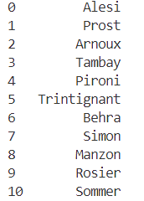
41 | Ferrari British | Normal Data |  |  | 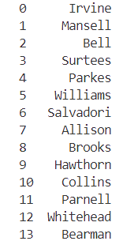
42 | Ferrari Spanish | Normal Data |  |  | 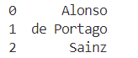
43 | Ferrari German | Normal Data |  |  | 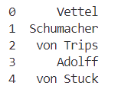
44 | Ferrari Race Winner | Normal Data |  |  | 5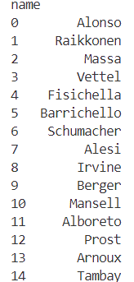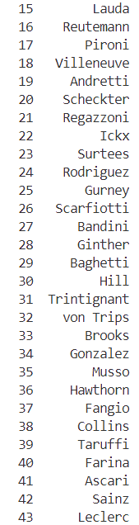
45 | Ferrari World Champion | Normal Data |  |  | 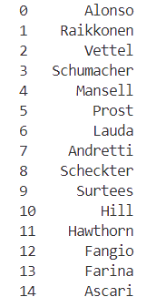
46 | Ferrari Pole Position | Normal Data |  |  | 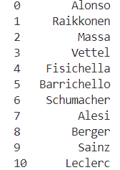
47 | Ferrari Podium Finish | Normal Data |  |  | 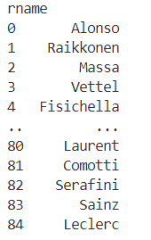
48 | Ferrari Fastest Lap | Normal Data |  |  | 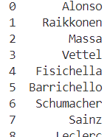
49 | Ferrari South American | Normal Data |  |  | 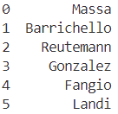
50 | Mclaren French | Normal Data |  |  | 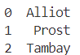
51 | Mclaren British | Normal Data |  |  | 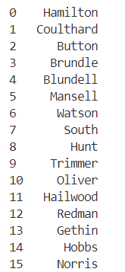
52 | Mclaren Spanish | Normal Data |  |  | 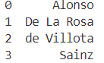
53 | Mclaren German | Normal Data |  | Only 1 answer available
54 | Mclaren Race Winner | Normal Data |  |  | 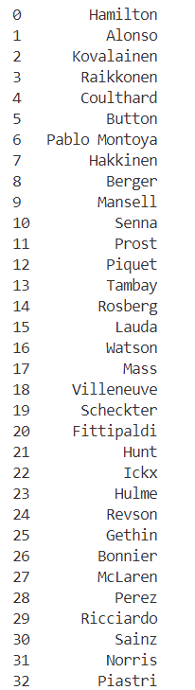
55 | Mclaren World Champion | Normal Data |  |  | 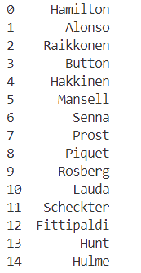
56 | Mclaren Pole Position | Normal Data |  |  | 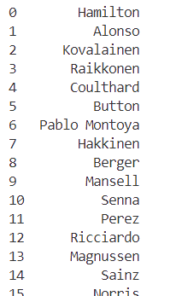
57 | Mclaren Podium Finish | Normal Data |  |  | 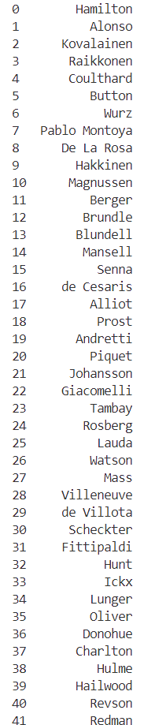
58 | Mclaren Fastest Lap | Normal Data |  |  | 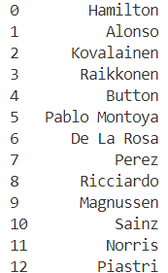
59 | Mclaren South American | Normal Data |  |  | 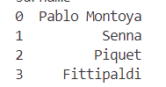
60 | Renault + Alpine French | Normal Data |  |  | 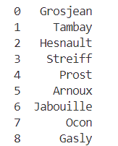
61 | Renault + Alpine British | Normal Data |  |  | 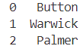
62 | Renault + Alpine Spanish | Normal Data |  |  | 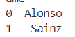
63 | Renault + Alpine German | Normal Data |  |  | 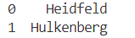
64 | Renault + Alpine Race Winner | Normal Data |  |  | 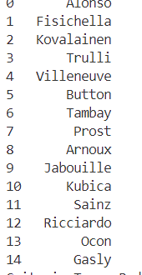
65 | Renault + Alpine World Champion | Normal Data |  |  | 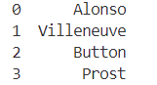
66 | Renault + Alpine Pole Position | Normal Data |  |  | 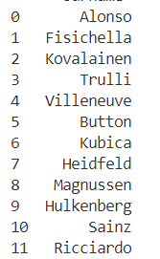
67 | Renault + Alpine Podium Finish | Normal Data |  |  | 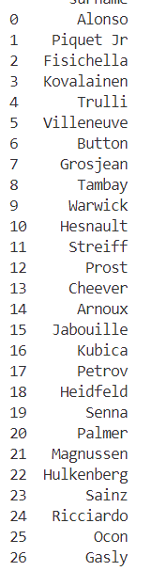
68 | Renault + Alpine Fastest Lap | Normal Data |  |  | 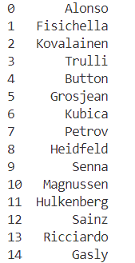
69 | Renault + Alpine South American | Normal Data |  |  | 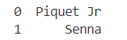
70 | Red Bull Teams + Jaguar French | Normal Data |  |  | 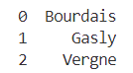
71 | Red Bull Teams + Jaguar British | Normal Data |  |  | 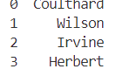
72 | Red Bull Teams + Jaguar Spanish | Normal Data |  |  | 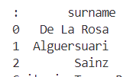
73 | Red Bull Teams + Jaguar German | Normal Data |  | Only 1 answer available
74 | Red Bull Teams + Jaguar Race Winner | Normal Data |  |  | 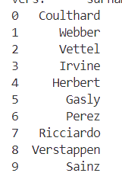
75 | Red Bull Teams + Jaguar World Champion | Normal Data |  |  | 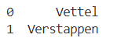
76 | Red Bull Teams + Jaguar Pole Position | Normal Data |  |  | 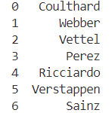
77 | Red Bull Teams + Jaguar Podium Finish | Normal Data |  |  | 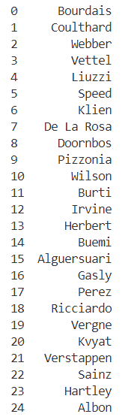
78 | Red Bull Teams + Jaguar Fastest Lap | Normal Data |  |  | 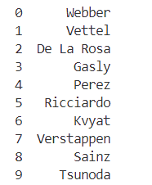
79 | Red Bull Teams + Jaguar South American | Normal Data |  |  | 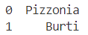
80 | Williams French | Normal Data |  |  | 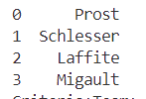
81 | Williams British | Normal Data |  |  | 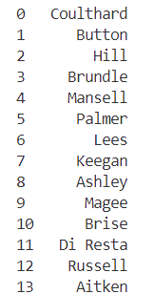
82 | Williams Spanish | Normal Data |  |  | 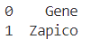
83 | Williams German | Normal Data |  |  | 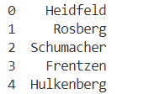
84 | Williams Race Winner | Normal Data |  |  | 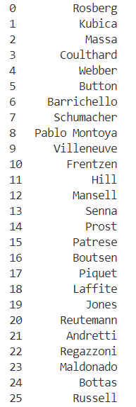
85 | Williams World Champion | Normal Data |  |  | 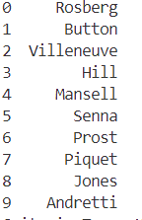
86 | Williams Pole Position | Normal Data |  |  | 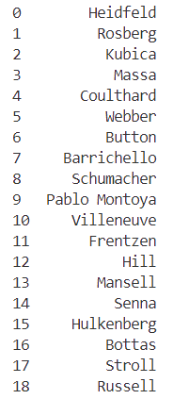
87 | Williams Podium Finish | Normal Data |  |  | 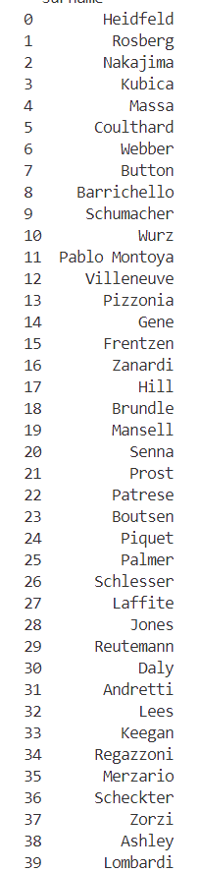
88 | Williams Fastest Lap | Normal Data |  |  | 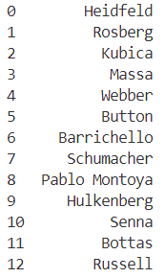
89 | Williams South American | Normal Data |  |  | 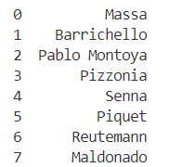

Black Box Testing

I found 3 play testers to play my game for 15 minutes. At the end of their play session, they filled out an online questionnaire I created to gain feedback on their experience. I asked them 5 key questions:
      - What features do you like about the game?
      - What features did you not like in the game?
      - Did you struggle to navigate/use my game? If so, please explain why.
      - What features would you add to my game?
      - What do you think could be improved to increase quality of life (how easy it is to play my game)?
I received in-depth responses from all my testers, and I will use this to evaluate my code. In summary, they thought my game was fun and engaging, however struggled to grasp the login page as they were confused about there being no login button but instead having to press the enter key on their keyboard. They also believed the grid slot should be highlighted when selected, to emphasise the slot they have chosen in my game. This was helpful information for me to understand as it shows me where my game can become difficult to understand if you do not have a clear understanding of the codebase.

Game
Evaluation

Strickland, Jack Matthew

Formula One Tic Tac Toe Game

courComputer Science

Objective | Met? | Comment
1.Main Functionalities

- Organised File Structure – Ensure all files are organised in a clear dictionary structure, allowing me to have efficient codebase access and management |  | All my files are organised correctly in folders such as States, Database, F1 data with each class being split into a separate file. This allows me to update code quickly and efficiently while also allowing me to add new states with ease.
- Database Normalisation – Have all database tables fully normalised with no duplicate data stored and ensure 3rd Normal Form is met |  | My database conformed to 3rd Normal Form allowing for normalisation and no repeating data.
- GUI usability – Ensure the GUI has a clear format and is easy for users to navigate and search |  | My menus are simple to navigate with easy-to-understand buttons. However, players have found the login and register process confusing. In my game, users are also unsure when they have selected a grid slot and how to enter their guess into the gird.
- Button Labelling Accuracy – All the buttons are descriptive but also concise to display their function |  | All my buttons are clear to understand and work as intended.
- Game Class Initialisation – Ensure a new game class is created properly whenever a new game is loaded |  | When my game is first loaded a new state manager is run which adds the new initialised states into the stack, so every game session is unique.
2.Player Authentication
- Ensure players are first loaded on the intro screen (pushed into the manager stack) and can navigate to either the login or register page |  | Each game session loads onto the intro screen and provides 2 buttons: 1 for login, 1 for register.
- Intro screen loads as the initial state |  | The intro screen is always pushed into the stack first.
- Validate the creation of the Login class and it being pushed into the manager stack |  | When the user presses Login Page button, it pushes the login page into the stack and the screen updates to the user to show this.
- Ensure a user can create an account with:  - Unique Username – handled with exception handling  - Secure Passwords – protected by hashing algorithm  - Insertion of user information into database table |  | Users must always have a unique username otherwise an error message shows to the user. Passwords are encrypted using the bycrypt import in python to protect users passwords. When the user presses enter on the register page, their information is inserted into the userinfo table.
- Confirm that the user can switch between the login and register screen through a button |  | Both the login and register page include a button to allow the user to switch between each screen.
3.Player Login Process
- Existing users are able to login in with their credentials |  | User’s details in the database are compared with the entry in the username and password fields and when they match, the userid is taken from the database and passed through to the menu screen with the user.
- Incorrect or duplicate login attempts are handled by exception handling and an error message shows |  | ‘Invalid Credentials’ error message is shown when users input a username or password that is incorrect.
- Ensure player details are retrieved from the database correctly and the PlayerId is their unique identifier to log them in |  | When the user presses the enter key on their keyboard once they have entered their information, their userid is passed through into the main menu state and is passed with them into the game, userstats and leaderboard states to make sure their game stats are correctly updated to the correct account.
4.Main Menu Navigation
- Verify that the main menu screen is loaded after login and pushed in manager stack |  | The main menu state is pushed into the stack to allow the screen to now show once a user has signed in.
- Navigation to other states:
- Instructions Page  - Instructions text is displayed correctly  - Back button can be pressed to return to the main menu |  | My Instructions page displays text on how to play the game and allows the user to return to the main menu state.
- User Stats Page  - The overall and recent game stats tables are displayed accurately with the correct data  - When a user has not played a match yet, no game data is shown  - Back Button can be pressed to return to the main menu |  | My User Stats page has two tables: game stats and overall stats. Both tables contain the most recent and up-to-date data and when a user has not played a match yet the game stats table is not shown but a ‘no game saves’ message is shown instead. A back button also shows to allow users to return to the main menu state.
- Leaderboard  - Leaderboard displays the top 8 players sorted by wins  - Buttons allowing to sort leaderboard by wins, games played, win ratio  - Back Button can be pressed to return to the main menu |  | The Leaderboard page shows the top 8 players sorted by wins when first loaded. The buttons allow for the leaderboard to be sorted by wins, games played and win ratio and the 8 players update correctly, even if they are no shown initially when the table is first loaded. The back button also allows users to return to the main menu state.
- PlayAI  - Allows player to select difficulty of AI they want to face  - Back Button can be pressed to return to the main menu |  | Users are first shown a select difficulty state when they press the ‘Play AI’ button. The difficulty they select is passed into the PlayAI class and initialises the correct AI behaviour. The back button also allows users to back out of selecting a difficulty and back to the main menu state.
- Play Friend  - New Game is started |  | A new game class is initialised when the ‘Play Friend’ button is pressed.
- Sign Out  - States are popped from stack back to intro screen  - Player details are reset to allow user to sign into different account |  | When the user presses the ‘Sign Out’ button, the stack is popped twice to pop the main menu screen but also the login screen. This allows the stack’s front pointer to now point towards the intro screen state. This pop from the stack allows the userid to be removed from the game session and a new user can now login.
5.Game Modes
- Play against friend
- Creation of Play Friend object which is pushed to manager stack |  | PlayFriend class is pushed into stack when button is pressed on main menu screen.
- A 2D array will be created to represent board positions |  | A new 2D array is created at the start of each new match which has 3 “” in each subarray. This allows each position in the grid to be uniquely represented. When a user makes a correct move, it is updated to either ‘X’ or ’O’.
- Board is generated correctly |  | The board is correctly drawn to the screen each time using floor division to centre it to the middle of the screen. The correct size font is also used on certain criteria show it does not overlap with one another when showing the board.
- Dictionaries of teams and nationalities and achievements shuffled randomly to ensure random board layout each game |  | The dictionaries use the .shuffle() function to randomise the criteria the player/s will face each game.
    - Game Mechanics
- Timer set to 20 seconds |  | Timer is set to 20 seconds and begins to count down as soon as the game commences.
- Accurately switches between player turns based on their input or the timer expiring |  | When a player makes a move or the timer expires, it correctly resets and counts down again for the next player.
- Exception handling for ‘Skip Turn’ and ‘End as Draw’ buttons |  | When either ‘skip turn’ or ‘end as draw’ buttons are pressed the game will carry out the correct function to make this happen. The skip turn function switches which player turn it is and also returns a message to the players to let them know this has happened. The end as draw function, prematurely ends the game and updates the main players stats to add a draw to their stats. This button allows users to escape a game they cannot complete as they do not know the answers to go in the grid.
- SQL used to validate driver entries and updating grid  - Driver entry compared to CSV files storing all F1 data to check for correct answer using SQL search |  | Using pandas, I am able compare driver entries through the SELECT SQL statement from the CSV files. I also require INNER JOINS in my SQL statements to correctly compare two criteria that the user must match to go in a grid position.
- Winner detection logic for when a user has 3 X/Os in a row horizontally, vertically or diagonally |  | The check_winner() function uses for loops and if statements to search my 2D array and check for the correct pattern matched with the same X or O. When a winner is found it returns either the X or O that has won.
- Database update with match results |  | At the end of each game, update_user_stats() and save_game_results() functions are run to update each table with the correct match results.
- Return to main menu button appears to allow users to exit game state |  | When the game is finished, the ‘return home’ button appears for users to allow them to return to the main menu state.
  - Play against AI
- Pass difficulty selected into game state and load class inheriting form PlayFriend class |  | I was able to use inheritance to dramatically reduce the amount of code I needed to produce my AI class. I was also able to pass through the correct userid with the difficulty selected.
- Confirm the board generation mirrors Play against friend mode |  | The board is still randomly generated each round, while using the same functionality in PlayFriend.
    - AI Behaviour
- Easy: 40% optimal moves |  | The AI correctly only made he best move 40% of the time on average.
- Medium: 70% optimal moves |  | The AI correctly only made the best move 70% of the time on average.
- Hard: 100% optimal moves (using minimax algorithm) |  | The AI makes the correct move the majority of the time, however on rare occasion can go in the incorrect slot. However, the AI never loses a game and prevent a user from winning every time.
- Maximising and minimising player assigned |  | The minimax correctly assigns whether the player is minimising or maximising to allow the AI to make the most optimal move to either be defences or offensive.
- Recursion through all possible moves and outcomes of game made |  | The minimax algorithm calls upon itself until the best outcome is found.
- Tree created to find best result for AI |  | The AI uses the theory of tree navigation to find the best result it can find in the game presented while minimising the player’s score.
- Best move returned to AI |  | The AI returns the best move for the majority of the time but on rare occasion can make an incorrect move.
- AI makes move when selected to |  | When it is the AI’s move it takes it turn every time.
- Check for winner is ran |  | The check for winner function is ran at the end of each turn to make sure the game is ended when the board is either full or a winner is found.
- Player’s turn is switched |  | At the end of a player’s turn the variable is switched to the other player.
- Accurate integration of game mechanics similar to play against friend mode |  | The PlayAI class inherits from the PlayFriend class allowing me to use the same mechanics from the game mode. I also override the time function as that is only needed in PlayFriend to prevent cheating.
- Grid updates, winner detection and database updates at the end of the game, return to menu button (excluding the use of a timer) |  | Database is updated correctly at the end of rounds and data is correctly represented in user stats and leaderboard page.
6.Application Management
- Users can exit the game by pressing the X button without leaving any background processes running. |  | Use pygame.quit() to allow users to exit application
- Stack-based transition work seamlessly across all my features, including the use of pushing, popping and peeking states |  | Stack is correctly pushed, popped and peeked to display the correct screen to the user
- Game performance is retained under different conditions (e.g. large leaderboard compared to small leaderboard) |  | My game performance is strong when there are different conditions such as different leaderboard sizes and users with lots of games played/very few games played, however when run on different devices, the game can be more laggy with a lower FPS rate.
- Font and button sizes are accurate to allow efficient navigation |  | My buttons are always the correct size with appropriate fonts and names, however, the login process can be confusing to new users as you have to press enter to sign in not the button.

User Questionnaire feedback and evaluation

I commenced a questionnaire to some F1 fans who played my game. I can use their responses to help improve and evaluate my game for improvements I can make in future updates. Each user spent 15 minutes playing my game to allow them to fully gather an idea of the game.

“What features do you like about the game”
Respondent 1: “The option to play against different difficulty AI was good and there was also a large range of possibilities for driving combinations”
Evaluation:
This feedback helps to show that my AI difficulty ratings was a good idea, as it allows for a more challenging experience for users with greater F1 knowledge. It also shows that my game is always kept fresh and new as users are happy with the creation of different board combinations each time they play.
“What features did you not like in the game”
Respondent 1: “There was no option to play against a friend without a time limit and there was no option to change the time limit”
Evaluation:
If I was to update my game, I would add this feature as I do believe the time limit can add some stress and pressure to players that might just want to have a more relaxing game experience. The reason I added the timer was to prevent people having time to search for the answers, however, if they were playing on the same screen this would be unlikely.

“Did you struggle to navigate/ use my game. If so, please explain why.”
Respondent 1: “The log in menu was confusing as there was no button to press once you typed in your details”
Evaluation:
Users have found my login menu confusing as the button under the entry boxes if the button to switch to the register page. Users initially thought this was the button to login and found it confusing. To sign in, users must press the enter key on their keyboard. I should add another button to my login page in the future to simplify the login process and allow users to sign in with the button or by pressing the enter key.

Respondent 2: “the selection of the drivers could be improved to automatically enter the text box so you can type your answer in straight away instead of clicking twice.”
Evaluation:
At the moment, users must press the grid slot and then press the entry field to enter the driver’s name. This could be seen as too many steps to add a driver as when playing under time conditions, it reduces the amount of time they have to think of an answer. Therefore, it would be better if when they pressed on the grid slot, a textbox would then appear for that unique slot and then be removed when they have made their guess. This would simplify the game leading to greater user satisfaction when playing the game as it makes it less clunky.

“What features would you add to the game”
Respondent 1: “I would add a feature where you can make your own tick track toe grid or the option to do a tournament system with friends”
Evaluation:
The tournament system is a good idea as it creates another way to play my game and increases the aspect of competition in my game. I would like to add the ability to create your own grid, however, I chose not to do this in my limitations in my analysis as it would be difficult to ensure that there is always an answer for each grid slot.
Respondent 2: “a new game option when the current game has ended so you don't have to go back to the main menu every time.”
Evaluation:
This would be an easy update to implement as I would just have to create a ‘Play Again’ button when the game ends that initialises a new game class. I will update my code to add this feature.
“What do you think could be improved to increase quality of life (how easy it is to play my game)?”
Respondent 1: “You could add a tutorial to the game explaining how to play the game for those who may be unfamiliar.”
Evaluation:
This is a good idea as my game can be confusing the first time you play it. I have an instructions page, however when players go into the game for the first time they may face the timer. This will not enable the user to familiarise themselves with the game so it makes sense to add a demo/tutorial game users can try first.
Respondent 3: “Be able to increase the size of the screen.”
Evaluation:
I chose to fix the size of the game screen as when users changed the size of the screen, the collide points of the buttons were off-centered, especially when playing the game on the grid. This resulted in a lot of errors in my game and so I was unable to add this feature. In the future when I make a game again, I will use a different method of coding within pygame to ensure that users can change the size of the screen.

Final Conclusion

Overall, I believe my project has been a good success. One reason I believe this is because I was able to meet the majority of my objectives. Though some may not have been fully optimised, I believe I was able to include everything I intended to when I first started my project. I also believe I have been able to reach my target audience, and my game fills the space in the Formula One gaming industry that I was hoping to fill.
Upon reflection, I believe I could have added a tournament mode and a play again button into my game as these would have enhanced my players’ experiences, however I have been able to implement the key foundations of my game and therefore can easily expand upon my game in the future. The use of object-oriented programming allows me to add new features easily without disrupting the original code and therefore, I am going to try to add these features in the future.

