**GGP MOCK**

**APPLICATION**

Version

**Created**: Shavit Cohen Ben-Avraham.

# Revision Table

| **Ver.** | **Date** | **Updated by** | **Updated** | **Comments** |
| --- | --- | --- | --- | --- |
|  |  |  |  |  |
|  |  |  |  |  |
|  |  |  |  |  |
|  |  |  |  |  |

# General info:

888 is releasing an application that will enable 3rd parties game providers to develop games without connecting to 888 environments.

The application will be installed on the user station.

# Necessary!!!!

* IIS installed on your computer
* .Net Framework 4.5 installed

# Step by Step installation.

1. 888 will provide 3rd party with the GGP mock zip for installation through SFTP.

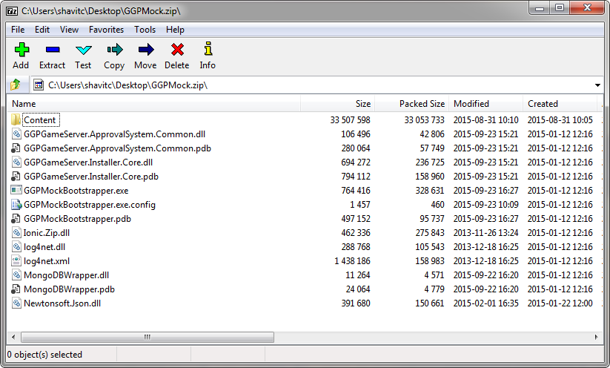

GGP Mock include:

Thin client

GGP server – including all the game server engine that server team has developed.

Ggp simulator

Logger.

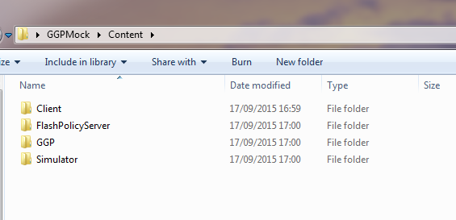

1. Installing:
   1. Run the **GGPMockBootstrapper.exe** as administrator

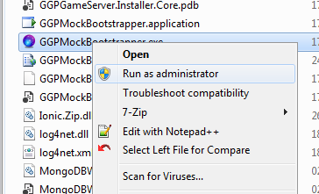

* 1. The following window will appear letting you know that installer is running. Usually the GGP installation takes about 1 minute.   
     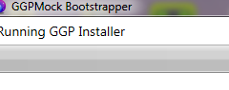
  2. Once app is installed this is how it looks

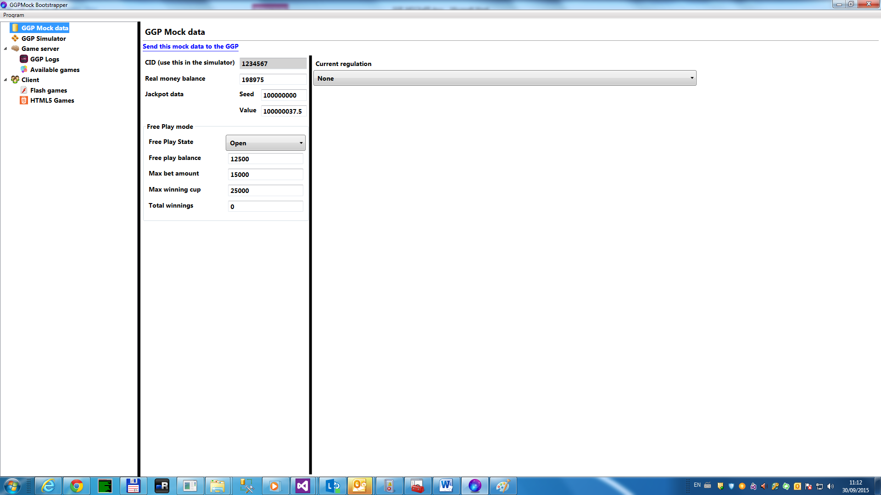

1. Installing the GGP mock will add the following on your desktop:
   1. The mock will create a local folder under **wwwroot** C:\inetpub\wwwroot\ThinClientForMock\
   2. Games folder will be placed under the following link. (Mock has some game folder samples inside)

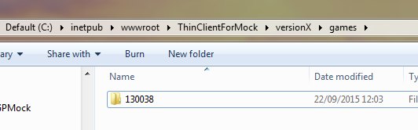

* 1. A new site will be created under IIS default web site

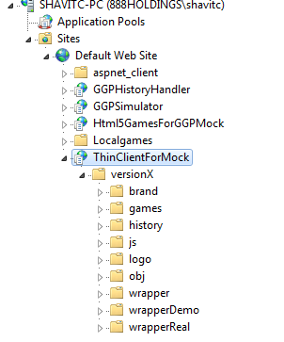

# adding new game:

1. When new game engine is created GGP server developers will add it to GGP version.

The GGP mock will update the server version in the GGP mock.

1. You can easily see the GGP version when clicking on the game server link on the left bar.

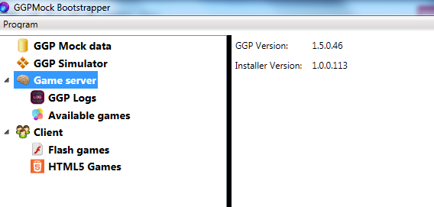

1. When New GGP mock version is released it is not running over the game folders, so you do not have to worry about games been deleted from your local folder.
2. When you want to add more games you need to place them under :

C:\inetpub\wwwroot\ThinClientForMock\versionX\games\

1. After the installation you can search for GGP MOCK on the computer and open it from start menu:

I have added it to the taskbar

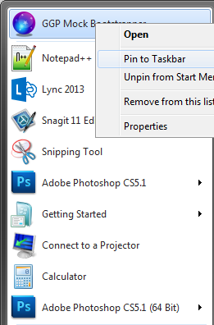

1. In order to add new game to the GGP Mock all you have to do is copy the game folder to the games folder

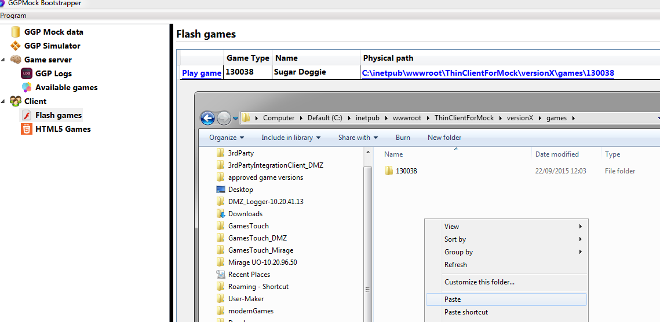

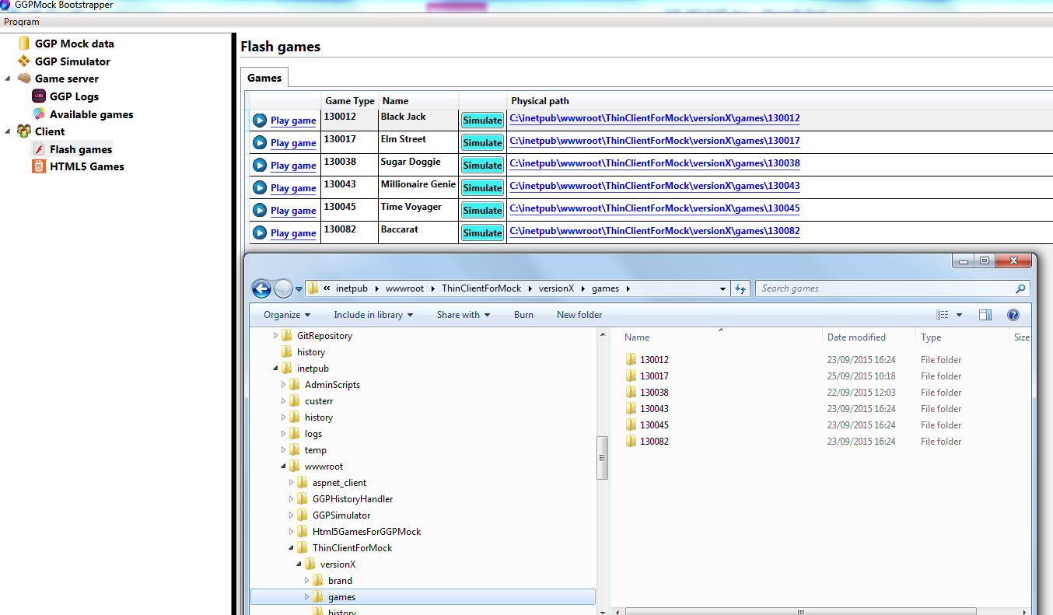

1. In order to add HTML5 game to the GGP Mock you need to copy the following files to: C:\inetpub\wwwroot\Html5GamesForGGPMock\

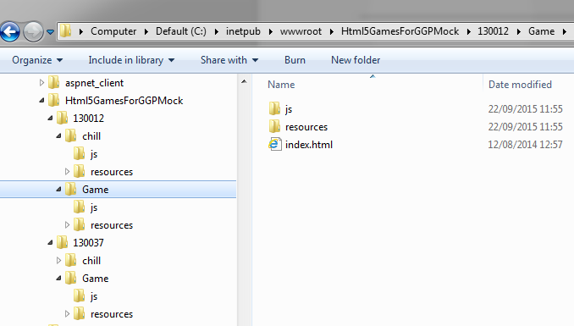

Folder structure for HTML is a bit deferent…

Game id folder 🡪 **chill** folder 🡪 chill files

🡪 **game** folder 🡪 game files

# Application overview:

# GGP mock data:

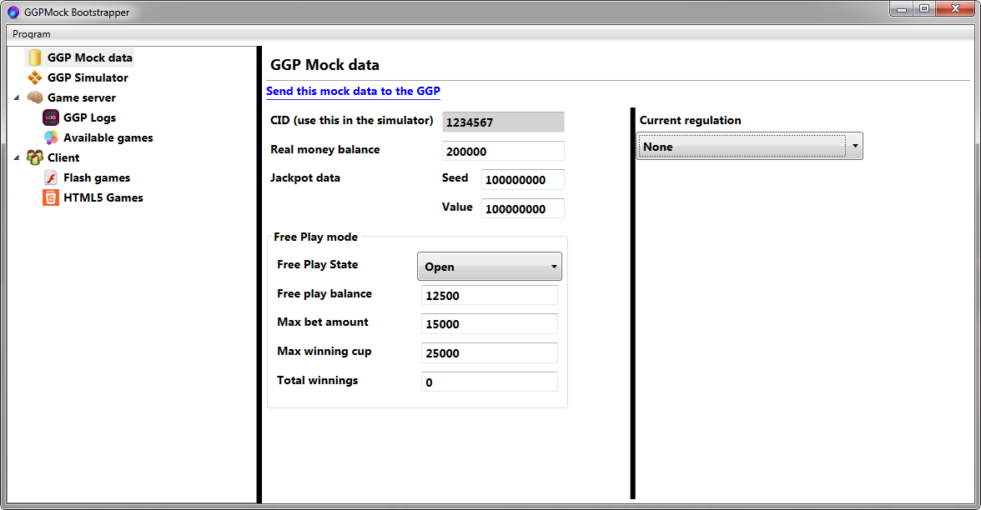

In this link you can set:

1. User bankroll
2. JP value
3. Free play (state, balance, limit, max bet and max winning)

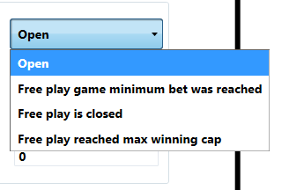

1. Regulation type.

**Imporant: You must click on the link in order to apply the changes on the GGP server.**

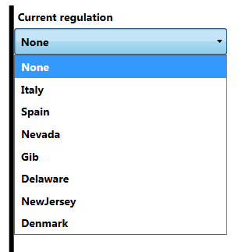

# GGP Simulator

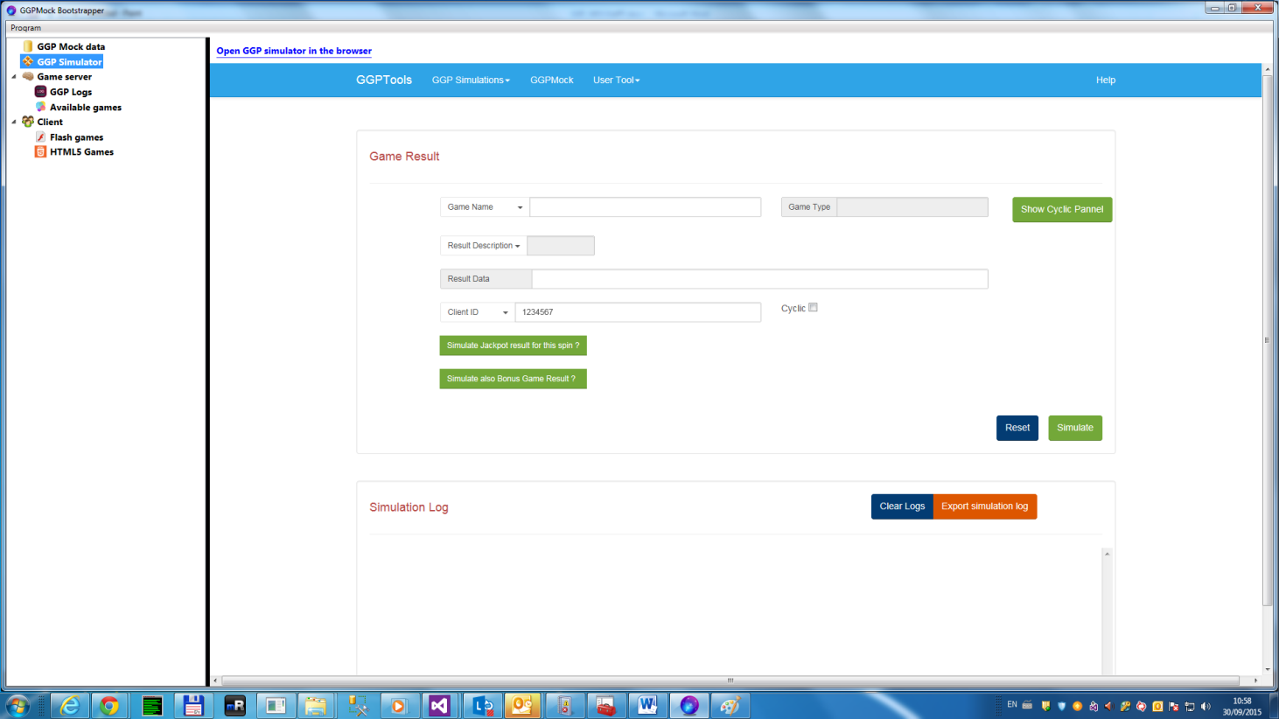

The GGP Simulator is embeded in the GGP Mock user interface but you can always open it in a separate browser by clicking on the  link.

# Game Server

Here you can find the GGP version and installer.

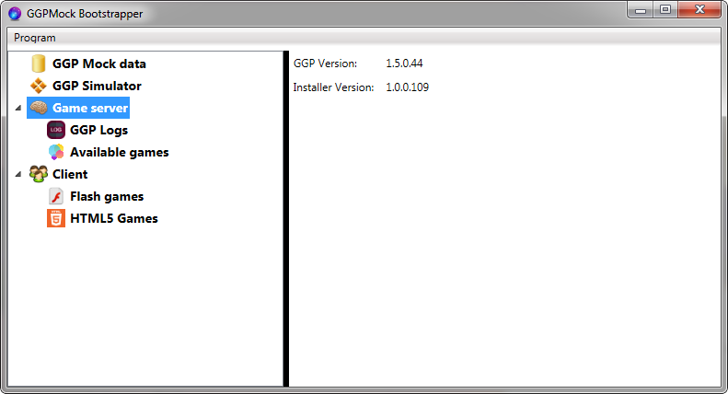

## GGP Logs

Here you’ll be able to see the server logs in case of errors, while developing.

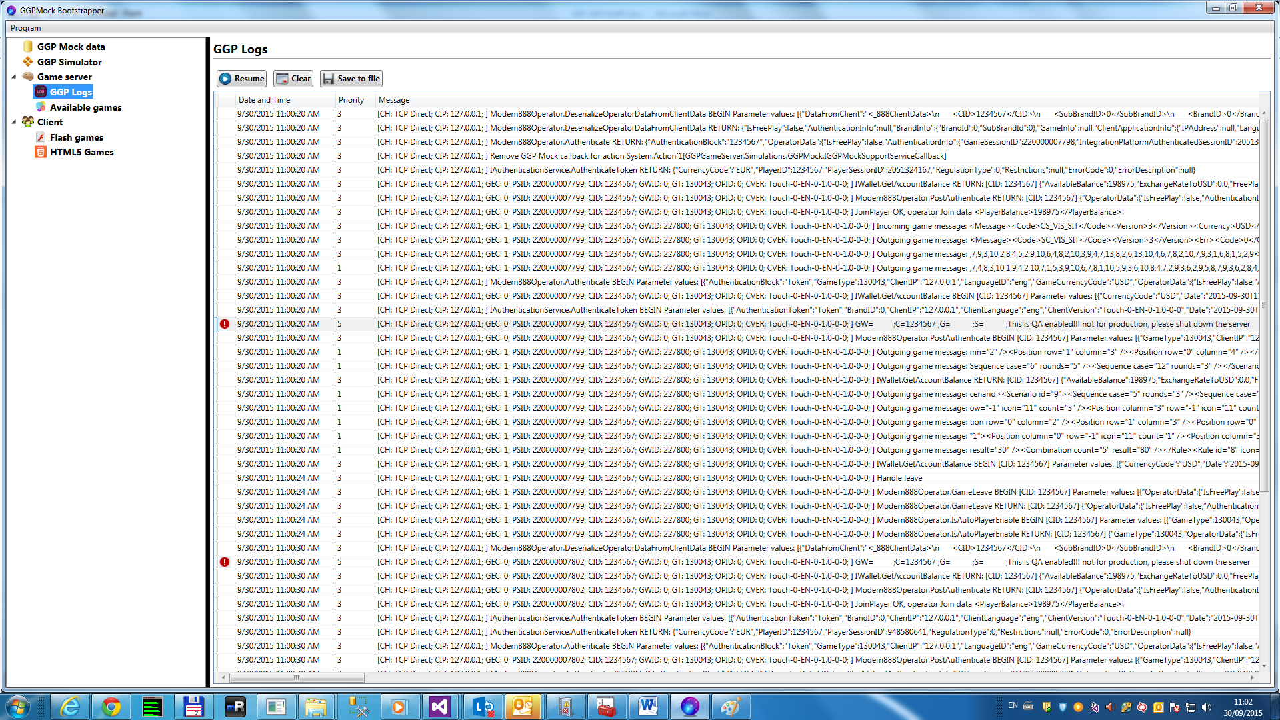

GGP also writes all the logs in text files that can be found in the **C:\GGPMock\GGPLogs** folder. Critical errors are also written in the Windows Event Logs.

## Available games

Here you’ll be able to see the games supported by the current GGP installation.

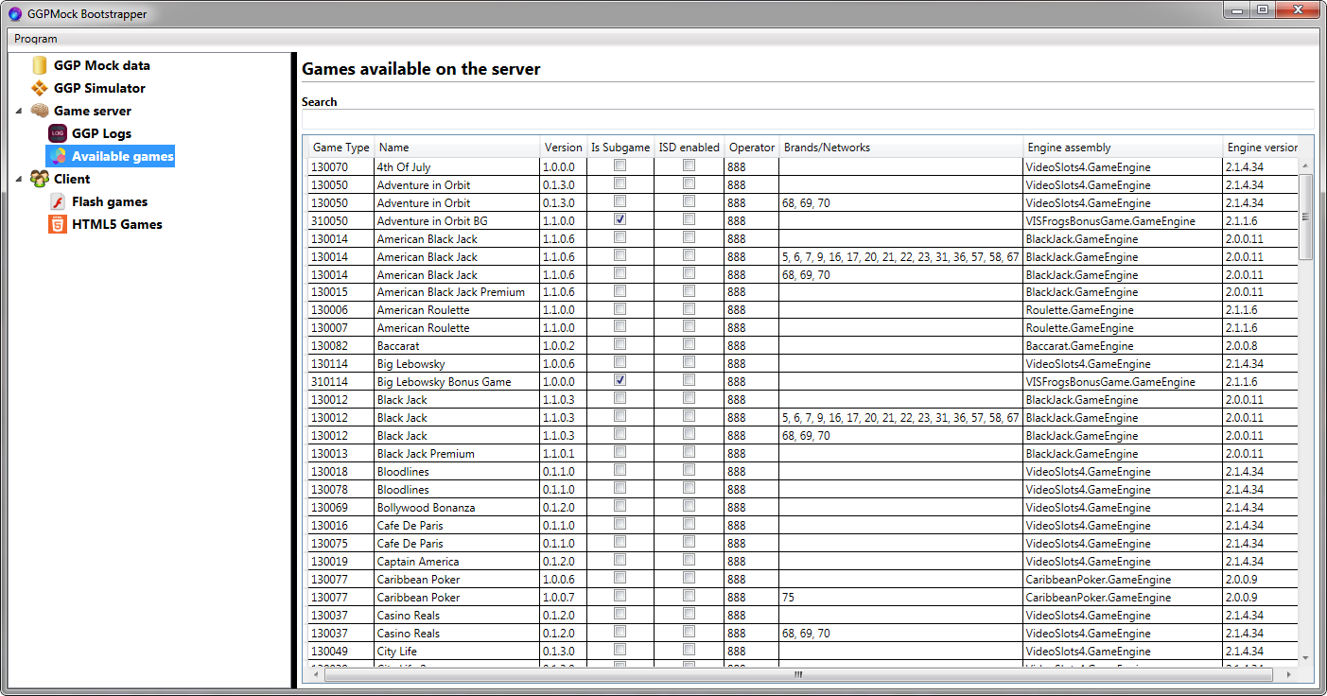

# Clients

## Flash Games

This is the thin client interface where you can access your **FLASH** games from.

In order to add games to this list you need to place the game folder on the following physical path: C:\inetpub\wwwroot\ThinClientForMock\versionX\games. The path may be different according with your IIS default website root directory.

**Important**: **The name of the folder where you place you flash game must have the same name as the GameType**.

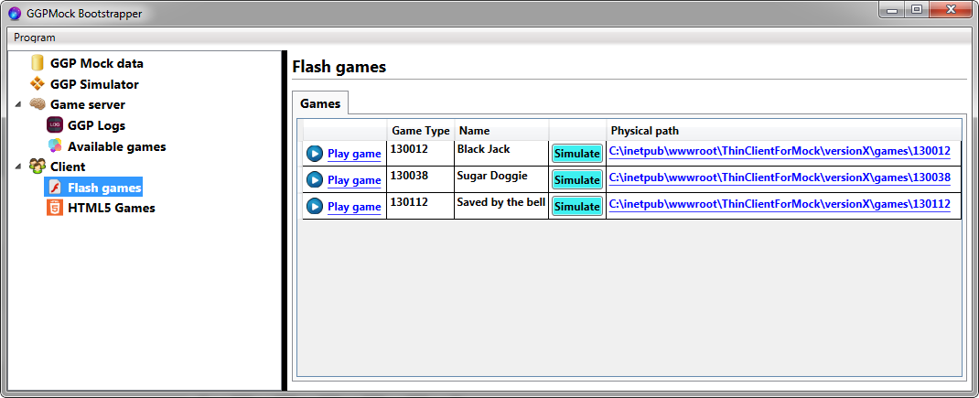

1 – open game

2 – open ggp simulator for game

3 – link to physical game folder

## HTML5 Games

This is the thin client interface where you can access your **HTML5** games from.

In order to add games to this list you need to place the game folder on the following physical path:

C:\inetpub\wwwroot\Html5GamesForGGPMock\

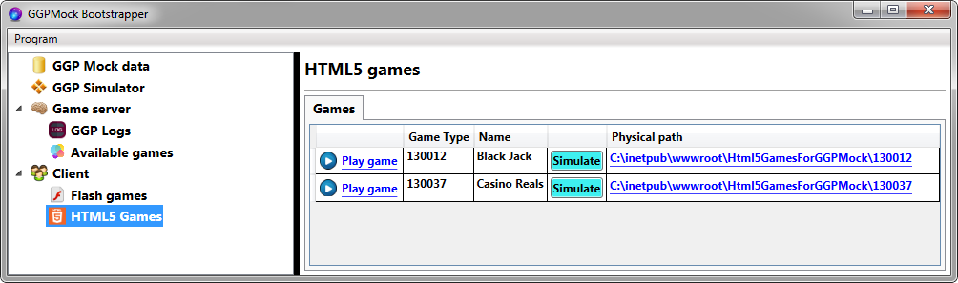

1 – open game

2 – open ggp simulator for game

3 – link to physical game folder

Game simulator link

## C:\Users\shavitc\AppData\Local\Temp\SNAGHTML8965f5.PNG

# Installation:

In order to install the application use one of the following links:

For external developers: <http://192.118.64.79/GGPMockBootstrapper/publish.htm>

For internal developers <http://10.20.40.158/GGPMockBootstrapper/publish.htm>

When application starts it will pop up this notification icon in the system tray area.

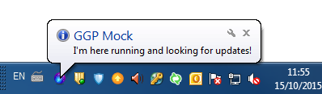

The above notification message also appear when you try close the application from the cid:image002.png@01D10743.5C5124C0 button. The application doesn’t really close when you click this button but it is minimized and shown in the sys tray.

In order to bring back the application main window you need to **right click** on the GGP Mock icon in the sys tray and choose Show menu item from the context menu or to just **double click the icon**.

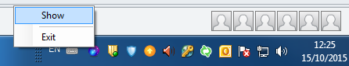

Then the application is checking in the background for new versions. If detects a new version it will download it and when it finish it will pop up another balloon like this:

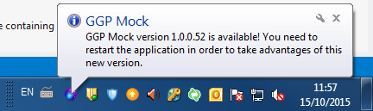

Like the message say you need to close the application and open it again. To close the application you have 2 ways:

1 . Right click on the GGP Mock icon in the sys tray and then click on the Exit menu item:

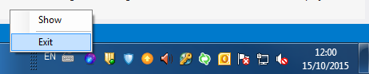

2. Use the Program => Exit  menu item from the application main menu:

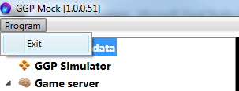

Once you will reopen the application it will pick up the new version that was just downloaded.

If you don’t choose to exit the application when the new version notification appear then the application will pop up another balloon every 2 hours:

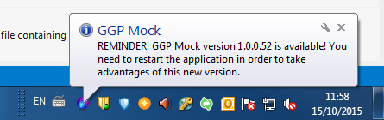

# Windows 8 and above special cases:

When you start the application after each new version update on windows 8 and above OS it will pup-up this screen: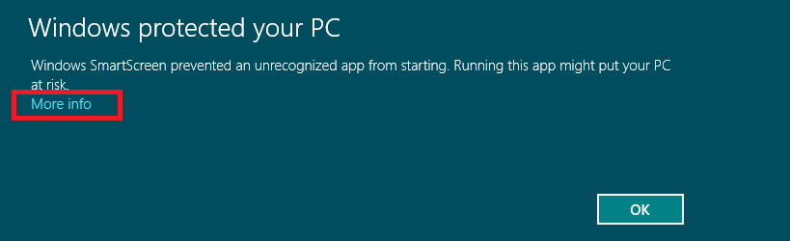

Click on the **More info** link. Then in the next screen that appears click on **Run anyway** button.

