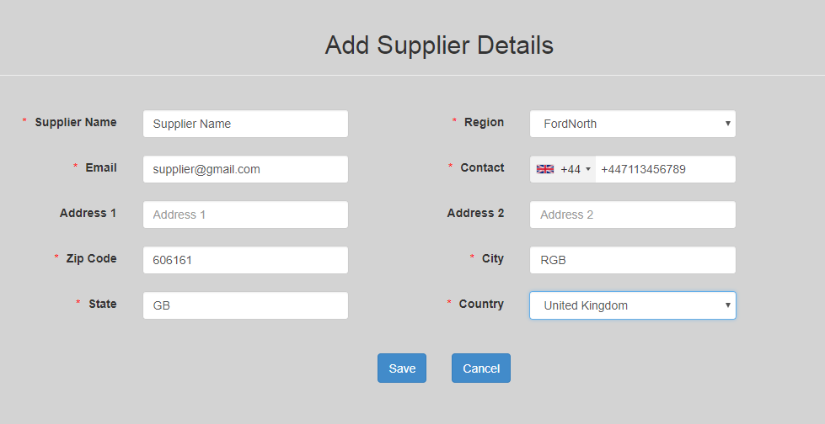

Screen 1 when the record saves:
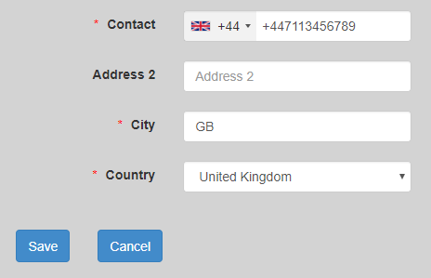

Screen 2 where we see the saved record:

Pop-up on Edit link button click: (default country is set)
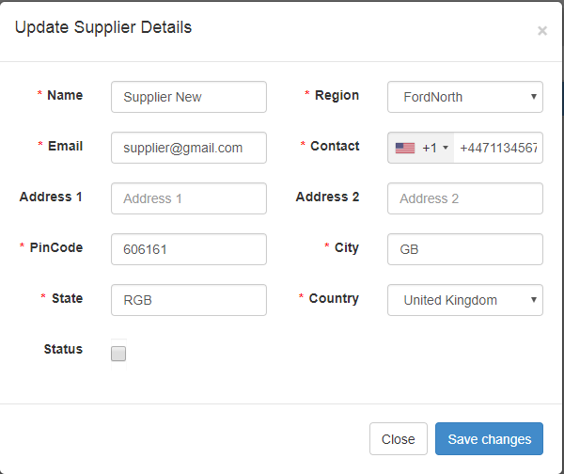
After taking the cursor till the end: (country code changes whereas it should change on load of pop-up itself)
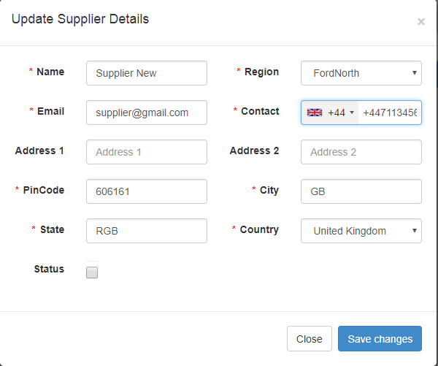

Code: I need to get the number on click of edit link button but if I write the code there it gives me not a function error. I am only able to write the code on load.
