Evaluating Strategies to Improve HIV Care Outcomes in Western Kenya - **Appendix**

***CONTENTS:***

***1*** *- Model Description*

***1.1*** *- Model Design*

***1.2*** *- Calendar Time*

***1.3*** *- C++ / R Interface*

***2*** *- Natural History Model*

***2.1*** *- Structure*

***2.2*** *- Calibration*

***3*** *- Cascade Model*

***3.1*** *- Structure*

***3.2*** *- Calibration*

***4*** *- Cost Derivation*

***5*** *- DALY Weighting*

***6*** *- Intervention Detail*

***7*** *- Intervention Impact on Incidence*

# 1 - Model Description

An individual-based microsimulation was created in C++ to model the care experience of HIV-positive individuals concurrently with HIV-progression and associated mortality in western Kenya. The model is more easily described as two interacting submodels: The Natural History Model and The Cascade Model.

## 1.1 - Model Design

During initialisation, the model creates an instance of a class person. This class possesses three innate characteristics defined during initialisation: gender, age, HIV serostatus and a natural death date. Gender is assigned through sampling from a uniform distribution to obtain a 1:1 ratio of Males:Females{CentralIntelligenceAgency:2013up}. Age is assigned by randomly sampling from a uniform distribution between 0 and 1 years old. However, if an individual enters the model in 1970, then their age is matched to the age distribution in Kenya in 1970[[UNPop](http://esa.un.org/unpd/wpp/Excel-Data/population.htm)]; the rationale behind this will be explained below. All individuals enter the model with an HIV-negative serostatus. Natural death dates are then sampled from sex-stratified survival distributions derived from mortality rates from Kenya, extracted from the United Nations Population Division Database[[UNPop](http://www.un.org/en/development/desa/population/)].

The model simulates the life of an individual until death. During this lifetime many types of events can occur. As mentioned previously, a natural death date is assigned to each individual; this is the last event that will occur in an individual’s lifespan. As the individual moves through time they encounter events that alter their situation (i.e. they are diagnosed with HIV). As an individual’s situation changes, new events may occur (i.e. they initiate ART). This system is highly dynamic; something that an individual-based model lends itself to particularly well, as individuals can act autonomously.

The model is a time-to-event simulation, meaning that there is no specific time-step, but rather the model contains a chronologically ordered queue of events. When an individual is created, the model is aware of the calendar time point at which they enter and can calculate the natural death date by taking into consideration the number of years an individual will live (extracted from the survival distributions described above). This date is then pushed into the queue which reshuffles automatically, ensuring that the next event is the event with the smallest difference in time from the current time of the model. Events can be scheduled at any time and pushed into the queue. Current time in the model begins at the time the individual was created and is updated as the model steps through events.

Thus, the model begins by creating an individual as described above. Then, it runs through a series of functions to schedule various events (e.g. an HIV-test). These events are scheduled if certain criteria are met: the current time must be correct (i.e. an individual will not be scheduled to initiate ART in 1975 if HIV-testing in Kenya was not rolled out until 2004), the individual’s health status must also meet certain criteria (i.e. an individual cannot initiate ART if they are not HIV-positive) and finally the individual’s care status must be correct (i.e. an individual is not allowed to initiate ART if they have never entered care). Events are scheduled by generating a random deviate from an exponential distribution with a mean value derived from the data (explained in calibration section). As events are scheduled, dates are pushed into the queue which organises them chronologically. The model jumps to the next event in time and checks to see which event is scheduled to occur. If the event scheduled is still valid (i.e. some change to the individual doesn’t prevent it from occurring, e.g. an individual was scheduled to receive a CD4 test result but has since dropped out of care, invalidating the CD4 test result event), the model executes that event and updates the current time. The model then checks to see if any further events need to be scheduled if the situation of the individual has changed (i.e. received a CD4 test result confirming eligibility for ART). These events are then pushed into the queue if required. The model repeats this cycle of executing and scheduling events until it encounters a death event, at which point the model terminates that individual. When an individual terminates, the model returns a data frame containing information about that particular individual. This data from each individual is then used to calculate our output metrics.

## 1.2 - Calendar Time

As previously mentioned, the model runs in calendar time. That is to say that each date generated by the model corresponds exactly to a date in time. We begin the model in 1970 by creating an initial cohort of individuals who enter the model on the 1st January 1970. We then simulate these individuals through time until death, as described above. From 1975 onwards, we expose our HIV-negative individuals to an annual age and sex specific hazard of acquiring HIV. This hazard updates each year and is specified by estimates from Kenya extracted from the UNAIDS Spectrum Software, developed by the Futures Institute[[link](http://www.unaids.org/en/dataanalysis/datatools/spectrumepp2013/)]. We allow HIV-tests to be scheduled from 2004 onwards to simulate the rollout of HIV-testing in Kenya. ART also becomes available in 2004 for eligible individuals. Treatment guidelines in 2004 are a CD4 count of <200 or WHO Stage IV{WorldHealthOrganization:2005ws}. This is updated in 2011 to a CD4 count of <350 or WHO Stage III/IV as per Kenyan Guidelines{WorldHealthOrganization:2010wj}.

When all individuals who were part of the initial cohort beginning in 1970 have died, the model then creates a new cohort of individuals that enter the model in 1971. The size of this cohort is determined by the size of the previous cohort adjusted for population growth reported from Kenya between 1970 and 1971 by the World Bank[[World Bank](http://data.worldbank.org/indicator/SP.POP.TOTL/countries/KE?page=6&display=default)]. This cohort is then simulated until all individuals are terminated. This process repeats each year between 1970 and 2030 where the model finishes. After 2013, we hold the population growth rate constant and after 2015 we hold the hazard of HIV acquisition constant as this was the last estimate from Spectrum.

## 1.3 - C++ / R Interface

The model, while written in C++, is controlled through R. We use R to pass a series of arguments to the model, including: the population size, the initial time and any interventions that we wish to implement along with the time at which to implement them. We access our C code through R using a wrapper function .Call() after compiling our model in C using a couple of R specific headers:

R.h

Rdefines.h

Rinternals.h

In our C++ code, the arguments passed from R appear as R objects of the datatype SEXP (S-expression). Our C++ code takes SEXPs as inputs and returns SEXPs as outputs. Therefore, we must create an output matrix using S-expressions and fill in a row per individual that is simulated using an output array that captures the desired information from each individual.

E.g. in C++

// Create an S-expression cohort;

SEXP cohort;

// Allocate a matrix to cohort which contains numeric vectors, nPersons tall and nOutputs wide, and protect it (this prevents it from being deleted by the garbage collector in C);

PROTECT(cohort = allocMatrix(REALSXP, nPersons, nOutputs));

// Create a pointer to cohort;

double *ptr_cohort = REAL(cohort);

// When each individual terminates, in row i for individual i, for each output j, fill in column j of cohort using the variable held in myout[j];

for(int j=0; j<nOutputs; j++)

ptr_cohort[i+j*(nPersons)] = myout[j];

When this has been completed for every individual in the simulation, the completed cohort matrix is return to R. Further details on calling C functions from R can be found in “Advanced R” by Hadley Wickham (2014)[[link](http://adv-r.had.co.nz/C-interface.html)].

# 2 - Natural History Model

## 2.1 - Structure

Now we have covered how the model is designed and how the code is structured, we can explain the events that individuals can encounter. As previously mentioned, individuals enter the model as HIV-negative and are exposed to an annual hazard of acquiring HIV which is age and sex specific. Upon acquiring HIV, the individual is assigned an initial CD4 count category (<200, 200-350, 350-500, >500 cells/μl) by sampling from a uniform distribution such that 58% of individuals are in the >500 CD4 category, 23% in the 350-500 category, 16% in the 200-350 category and 3% in the <200 category{Lodi:2011fg}. Individuals acquiring HIV are assumed to begin with WHO Clinical Stage I infection{WorldHealthOrganization:1990wd}. We capture HIV progression by describing CD4 count decline through our four categories and the acquisition of WHO Stage defining conditions. Progression to the next health state (e.g. from >500 WHO Stage I) is modelled by scheduling a time to progress to the next CD4 category (e.g. 350-500 WHO Stage I) and scheduling a time to progress to the next WHO stage (e.g. >500 WHO Stage II). These hazards compete and the event that happens first is executed and prevails. Additionally, in each health state, individuals are exposed to a CD4 category / WHO Stage specific HIV-related mortality hazard (e.g using the same example, mortality in >500 WHO Stage I). This hazard, as before, competes with the hazards of CD4 decline and WHO Stage progression. This mortality rate schedules an HIV-related death date; this is in addition to the natural death date. If the model encounters the HIV-related death date prior to encountering the natural death date, the individual is said to have died from an HIV-related death. The natural death date sets the upper bound on life span but HIV can reduce life-years-lived considerably.

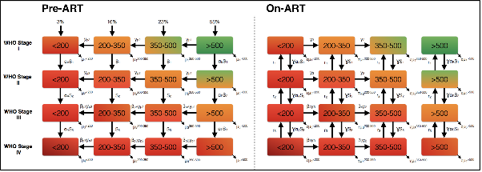

*Figure 1. Model Representation of The Natural History Model*

All individuals acquiring HIV first progress through the pre-ART side of the Natural History Model; shown in figure 1. Once individuals receive a CD4 test result confirming their eligibility for ART in the Cascade Model (explained in detail below), if they adhere to ART, they transition to the on-ART side of the Natural History model. Propensity to adhere to ART is an innate characteristic that is determined for each individual at initialisation. When transitioning to the on-ART side of the Natural History model, individuals stay in the same health status category but switch sides of the model (i.e. when an individual with CD4 <200 and in WHO Stage III on the pre-ART side of the model initiates ART, they move into the <200 WHO Stage III category of the On-ART Model). The pre-ART and on-ART sides of the Natural History Model are shown in figure 1.

Once an individual moves to the on-ART side of the Natural History model, CD4 count decline reverses and patients can recover from their WHO Stage defining conditions. It should be noted that WHO Stage conditions can still develop on this side of the model; thus allowing the model to capture potential failures of treatment among patients adhering to ART. If a patient’s CD4 count falls below 500 cells/μl prior to ART initiation, if this patient subsequently initiates ART, their CD4 count will not recover to more than 500 cells/μl. This assumption was made in response to findings by Lawn *et al.* (2006) illustrating CD4 count reconstitution among patients initiating ART in Cape Town, South Africa{Lawn:2006ht}. As with mortality hazards on the pre-ART side of the Natural History model, mortality hazards are associated with each health status category on the on-ART side of the model. The mortality hazard for a particular health status category on the on-ART side of the model is less than the same health status category on the pre-ART side of the model, thereby giving ART a survival advantage (explained in more detail in the calibration section). Below is a description of each model parameter:

|  |  |
| --- | --- |
| **Parameter** | **Definition** |
| **yp1** | Pre-ART CD4 progression rate from >500 to 350-500 cells/μl (# individuals per year) |
| **yp2** | Pre-ART CD4 progression rate from 350-500 to 200-350 cells/μl (# individuals per year) |
| **yp3** | Pre-ART CD4 progression rate from 200-350 to <200 cells/μl (# individuals per year) |
| **βpA** | Weight applied to Pre-ART CD4 progression rate for patients in WHO Stage III |
| **βpB** | Weight applied to Pre-ART CD4 progression rate for patients in WHO Stage IV |
| **S1** | WHO Stage progression rate from Stage I to II (# individuals per year) |
| **S2** | WHO Stage progression rate from Stage II to III (# individuals per year) |
| **S3** | WHO Stage progression rate from Stage III to IV (# individuals per year) |
| **αA** | Weight applied to WHO Stage progression rate for patients in CD4 category <200 |
| **αB** | Weight applied to WHO Stage progression rate for patients in CD4 category >500 |
| **μ1>500** | Pre-ART Mortality rate for CD4 category >500 and WHO Stage I (# individuals per year) |
| **μ1350-500** | Pre-ART Mortality rate for CD4 category 350-500 and WHO Stage I (# individuals per year) |
| **μ1200-350** | Pre-ART Mortality rate for CD4 category 200-350 and WHO Stage I (# individuals per year) |
| **μ1<200** | Pre-ART Mortality rate for CD4 category <200 and WHO Stage I (# individuals per year) |
| **μ2>500** | Pre-ART Mortality rate for CD4 category >500 and WHO Stage II (# individuals per year) |
| **μ2350-500** | Pre-ART Mortality rate for CD4 category 350-500 and WHO Stage II (# individuals per year) |
| **μ2200-350** | Pre-ART Mortality rate for CD4 category 200-350 and WHO Stage II (# individuals per year) |
| **μ2<200** | Pre-ART Mortality rate for CD4 category <200 and WHO Stage II (# individuals per year) |
| **μ3>500** | Pre-ART Mortality rate for CD4 category >500 and WHO Stage III (# individuals per year) |
| **μ3350-500** | Pre-ART Mortality rate for CD4 category 350-500 and WHO Stage III (# individuals per year) |
| **μ3200-350** | Pre-ART Mortality rate for CD4 category 200-350 and WHO Stage III (# individuals per year) |
| **μ3<200** | Pre-ART Mortality rate for CD4 category <200 and WHO Stage III (# individuals per year) |
| **μ4>500** | Pre-ART Mortality rate for CD4 category >500 and WHO Stage IV (# individuals per year) |
| **μ4350-500** | Pre-ART Mortality rate for CD4 category 350-500 and WHO Stage IV (# individuals per year) |
| **μ4200-350** | Pre-ART Mortality rate for CD4 category 200-350 and WHO Stage IV (# individuals per year) |
| **μ4<200** | Pre-ART Mortality rate for CD4 category <200 and WHO Stage IV (# individuals per year) |
| **𝛕** | Weight applied to Pre-ART mortality rates in on-ART model; giving survival advantage to on-ART model |
| **ɣ** | Weight applied to WHO Stage progression rates in on-ART model |
| **y2** | On-ART CD4 reconstitution rate from 200-350 to 350-500 cells/μl (# individuals per year) |
| **y3** | On-ART CD4 reconstitution rate from <200 to 200-350 cells/μl (# individuals per year) |
| **βA** | Weight applied to On-ART CD4 reconstitution rate for patients in WHO Stage III |
| **βB** | Weight applied to On-ART CD4 reconstitution rate for patients in WHO Stage IV |
| **r1** | On-ART WHO Stage recovery rate from WHO Stage II to I (# individuals per year) |
| **r2** | On-ART WHO Stage recovery rate from WHO Stage III to II (# individuals per year) |
| **r3** | On-ART WHO Stage recovery rate from WHO Stage IV to III (# individuals per year) |

Table 1. Natural History Model Parameters

## 2.2 - Calibration

Calibration of the Natural History model was undertaken by prototyping a deterministic version of the pre-ART and on-ART models in Berkeley Madonna and fitting to data using the least squares method[[link](http://www.berkeleymadonna.com/)]. A review of the literature was conducted to identify relevant studies that would enable us to calibrate every aspect of the Natural History Model. Where possible, data from cohort studies was utilised; although, in some situations data from observational studies was used. Data was sought to parameterise every aspect of the Natural History. Below is a list of data sources identified:

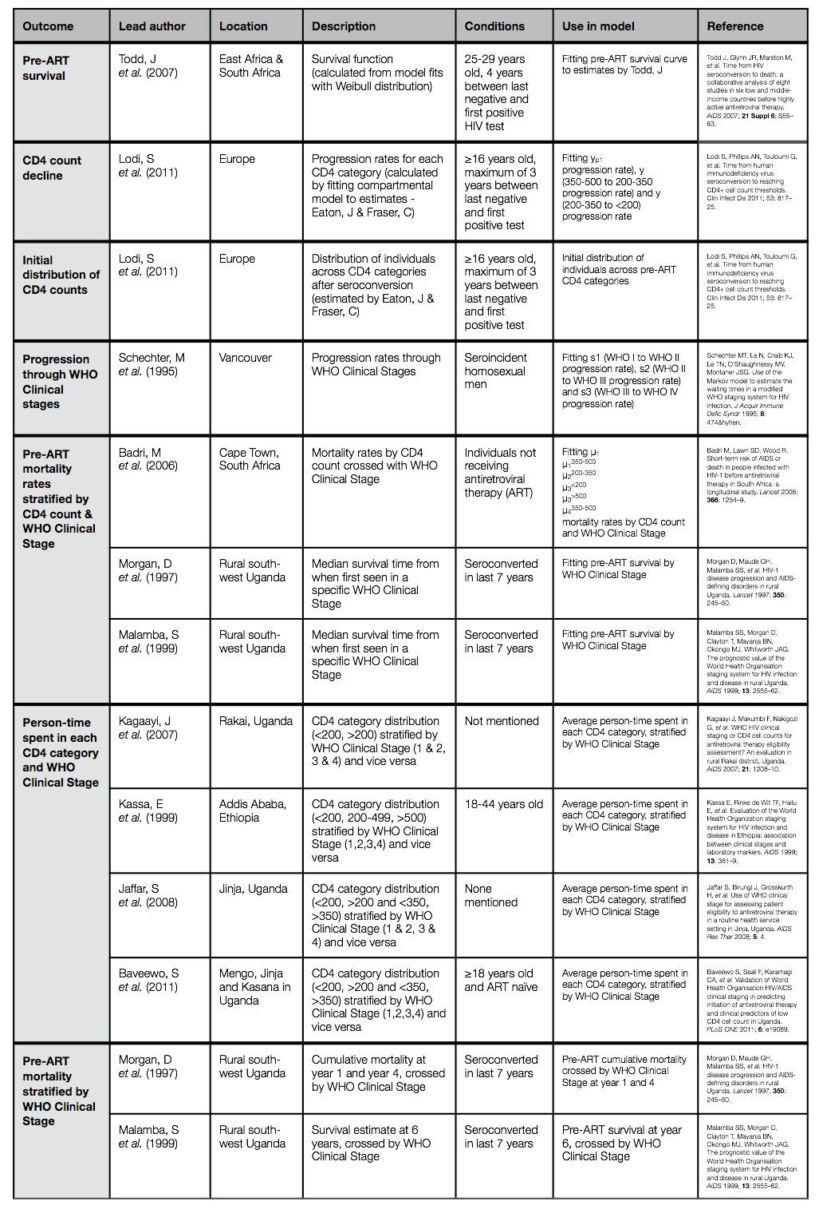

Table 2. Data sources for Natural History pre-ART model fitting

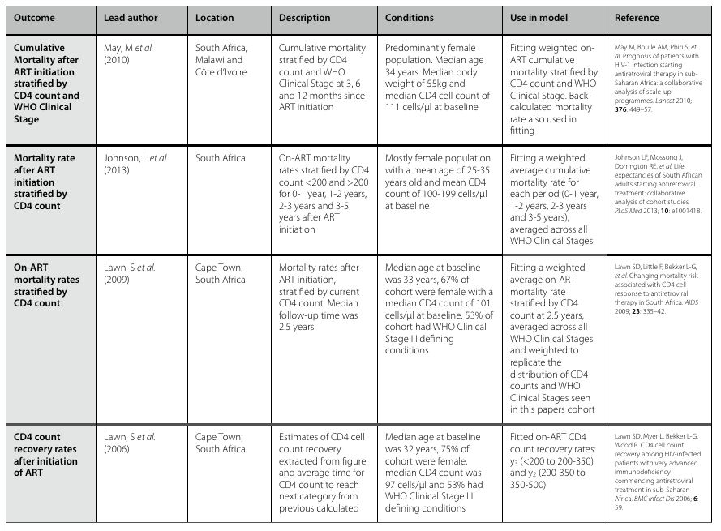

Table 3. Data sources for Natural History on-ART model fitting

Once data was identified for calibrating both the pre-ART and on-ART Natural History models, the data needed to be weighted to ensure that each dataset had equal influence during calibration.

Therefore, if we consider the following:

(1)

Where is the proportion of model error for data point in study , refers to the value of datapoint in study and refers to the value of the model at datapoint in study . It then follows that , the average proportion of model error for study is:

(2)

Where is the total number of data points in study . Therefore, the total error across all studies, can be represented by:

(3)

Now considering (1), we can re-write (3), where is the total number of datasets, as:

(4)

(5)

where (6)

where (7)

In (6) refers to the weight of datapoint in study . In (7), is therefore the weight of the entire dataset in study . Using the definitions of and in (6) and (7), the weight for each data point () was calculated. This was not possible in all cases as some datasets contained several hundred data points, in such cases a weight for the dataset as a whole () was used. [*not sure if I need to include a table of weights for each dataset?*]

Owing to the variety of data identified in tables 2 and 3, and to account for any data sources that may conflict, parameter estimation involved using least squares to find a compromise between conflicting data sources, and to find a model fit that minimised the root-mean-square error (RMSE) between the model and data. Berkeley Madonna’s “Curve Fit” function allows the user to input a range of parameters, supply upper and lower bounds, and then fit the model to data while minimising the RMSE.

In the background, Berkeley Madonna uses a searching algorithm to estimate values of the independent variable ŷ at time t, ŷt, by taking the sum of the mean square error for study i in n studies. Taking the average by dividing by n, taking the square root and multiplying by the minimum value of the parameter to be estimated p. Thus the least square estimate of parameter becomes:

(8)

The value of variable y is a function of time t and the parameter p to be estimated.

|  |  |  |
| --- | --- | --- |
| **Parameter** | **Value** | **Mean (years)** |
| **yp1** | 0.1253 | 7.9816 |
| **yp2** | 0.3715 | 2.6919 |
| **yp3** | 0.3578 | 2.7946 |
| **βpA** | 1.4142 | - |
| **βpB** | 3.3361 | - |
| **S1** | 0.2771 | 3.6084 |
| **S2** | 0.2221 | 4.5018 |
| **S3** | 0.4056 | 2.4655 |
| **αA** | 1.0000 | - |
| **αB** | 0.0323 | - |
| **μ1>500** | 0.0002 | 4100.2024 |
| **μ1350-500** | 0.0069 | 145.1224 |
| **μ1200-350** | 0.0529 | 18.8954 |
| **μ1<200** | 0.0918 | 10.8967 |
| **μ2>500** | 0.0124 | 80.7345 |
| **μ2350-500** | 0.0331 | 30.1923 |
| **μ2200-350** | 0.0608 | 16.4528 |
| **μ2<200** | 0.1800 | 5.5556 |
| **μ3>500** | 0.0435 | 23.0061 |
| **μ3350-500** | 0.0889 | 11.2443 |
| **μ3200-350** | 0.1134 | 8.8193 |
| **μ3<200** | 0.3000 | 3.3333 |
| **μ4>500** | 0.1255 | 7.9669 |
| **μ4350-500** | 0.2547 | 3.9263 |
| **μ4200-350** | 0.3615 | 2.7660 |
| **μ4<200** | 1.2362 | 0.8090 |
| **𝛕** | 0.8943 | - |
| **ɣ** | 0.9369 | - |
| **y2** | 2.2402 | 0.4464 |
| **y3** | 5.7582 | 0.1737 |
| **βA** | 0.6301 | - |
| **βB** | 0.1227 | - |
| **r1** | 2.1197 | 0.4718 |
| **r2** | 3.1014 | 0.3224 |
| **r3** | 26.4328 | 0.0378 |

**Table 4. Fitted parameter values for Natural History Model**

The figures below, show comparisons between the calibrated Natural History model and the data sources shown in tables 2 and 3.

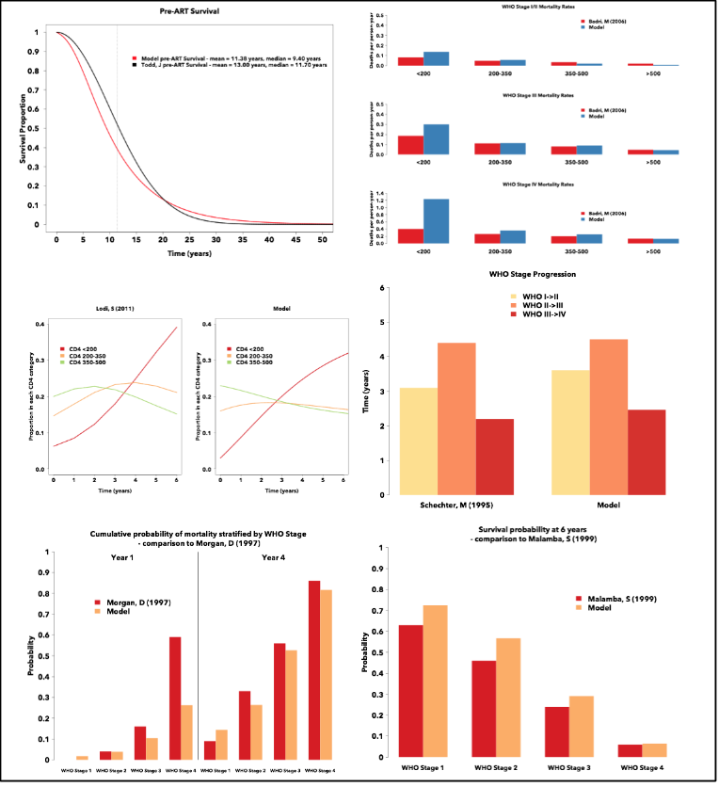

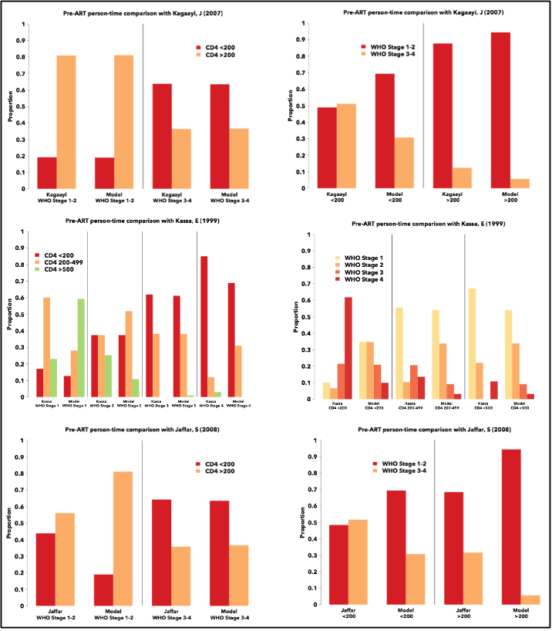

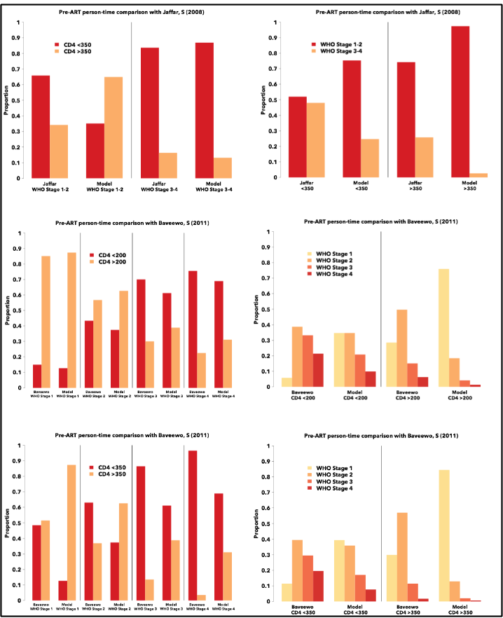

# 

# 3 - Cascade Model

## 3.1 - Structure

The Cascade Model describes the events that make up an ART-programme in sub-Saharan Africa. The model describes the flow of individuals and captures all possible routes through care. The structure of the Cascade Model is show in figure 2. As discussed previously, individuals enter the model as care naïve and HIV-negative. The Natural History Model tracks HIV progression over time and assigns dynamic HIV-related mortality rates. The Natural History model interacts with the Cascade Model by driving care-seeking behaviour and by allowing patients to initiate ART if their health status deems them to be eligible.

As the model begins with care naïve individuals, all persons start in the “never engaged in care” state on the left-hand side of figure 2. With HIV-testing starting in 2004, individuals can start to progress through HIV-care. HIV-testing can occur through one of three routes: HBCT where individuals are sought and tested at home, VCT where individuals voluntarily attend an HIV-clinic or PICT where individuals seek care due to being symptomatic or having had previous healthcare experience. If an individual is found to be HIV-negative, they do not progress any further through care. They may be tested multiple times through their lives and care will only progress if they are found to be HIV-positive.

Once identified as HIV-positive, individuals must be linked to care to be bled for an initial CD4 count. Linkage involves travelling to a nearby clinic, and depending upon the route of entry to care (HBCT/VCT/PICT) a proportion of tested individuals will be lost prior to their initial CD4 test. Individuals lost from care can re-engage at a later date, either by being picked up through HBCT, voluntarily appearing at VCT clinic or upon the onset of HIV-related symptoms seeking care through PICT. However for individuals that successfully link to pre-ART care, these patients see a clinician and blood is drawn for an initial CD4 count. These CD4-tests are typically lab-based and have a turnaround time of around two weeks{Larson:2012dq}. Therefore, patients must return at a later date to receive the results of their CD4 test, in which their eligibility for ART is determined.

Unfortunately, a proportion of individuals are lost between being bled for their initial CD4 test and returning to receive the results. These individuals, like those who were unsuccessful in linking to care, can re-engage at a later date through being tested via HBCT or VCT, or if symptomatic, through PICT. The individuals who were not lost from care after being bled for their initial CD4 test, return to the clinic to receive their CD4 results. However, on the day of the clinic appointment, a small proportion fail to attend and are lost. Of those that attend the initial CD4 test result appointment, these individuals learn of their eligibility for treatment. If a patient is found to be ineligible for treatment at this time, they must be retained in pre-ART care until such a time as they are found to be eligible for treatment. Pre-ART retention involves returning after a period of time, usually 6 months to a year, to receive a secondary CD4 test. During this period a certain proportion of individuals will be lost from care, but can subsequently re-engage as described before. Of patients that return for a secondary CD4 test, these individuals will have blood drawn and will need to return at a later date to receive the results. As before, a certain proportion of patients will not return to receive the results and will be lost from care. This cycle of pre-ART care for HIV-positive patients continues until the results of a CD4 count reveal that a patient is eligible for treatment. When this occurs, a patient will be allowed to initiate ART after a small period of time during which they will receive ART counselling.

Upon initiating ART, the patient will either adhere or not adhere to treatment. The propensity of a patient to adhere to ART is an innate characteristic of each individual. Whether an individual is adhering or not to ART, they are assumed to be in ART care. These individuals are exposed to a hazard of dropping out of ART, where treatment would stop. This hazard changes over time, depending upon the time since ART initiation. If a patient drops out of ART care, treatment stops, and for adherent individuals, their health would begin to deteriorate again. Yet, patients failing to adhere to treatment, do not receive any health benefits from ART; as such their health is declining as if they were not on treatment. Therefore, if a non-adhering patient was to drop out of ART care, their health would continue to deteriorate as before. Once lost from ART care, patients can only re-engage with care and treatment if identified through an outreach programme.

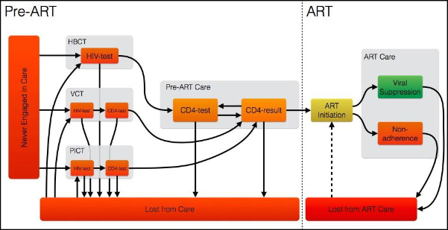

Figure 2. Model Representation of The Cascade of Care

## 3.2 - Calibration

To calibrate the Cascade Model describing the experience of HIV-positive individuals as they move through the various stages of HIV care, we utilised a unique high resolution longitudinal dataset from western Kenya. The Academic Model for Providing Access To Healthcare (AMPATH), based in Eldoret, is made up of Moi University, Moi Teaching and Referral Hospital and a consortium of North American academic health centers led by Indiana University working in partnership with the Government of Kenya.

AMPATH’s ability to look back at the care history of individual patients, through tracing their unique identification number allowed us to ask very specific questions regarding the flow of individuals through care. The list of questions submitted to AMPATH is shown in table 5.

Table 5. Data request submitted to AMPATH for the purposes of calibrating the Cascade Model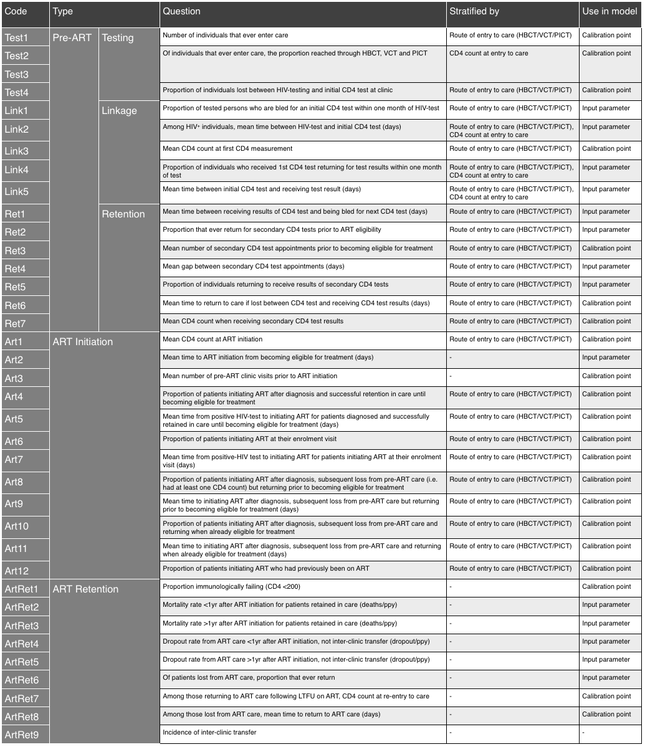

To capture fluctuations in the dynamics of care over time, we asked for data to be split into three discrete time periods:

1. ***Time split 1*** - (01/01/2007 to 31/12/2009) - This time period will inform us about the state of care prior to HBCT, when only VCT and PICT were available, and utilises data from the earliest possible point in time.
2. ***Time split 2*** - (01/01/2010 to 31/12/2010) - This time period covers the initial rollout of HBCT in the community prior to the adoption of new treatment guidelines in 2011.
3. ***Time split 3*** - (01/01/2011 to 03/06/2014) - This time period covers the state of care after the adoption of new treatment guidelines in 2011 (CD4 <350 or WHO Stage III/IV), together with the full perpetual HBCT rollout as part of the FLTR programme.

Two definitions were used to separate a “gap in care” from “lost from care”, for pre-ART care a period of 90 days must elapse after a clinic appointment for an individual to be considered lost from care. While in ART care, an individual was considered to be disengaged with care if they had a gap in care of more than 1 year. These definitions allowed us to separate individuals into those currently engaged or disengaged with care and understand the time delay between events.

Owing to the large volume of data contained within the AMRS and the need to merge multiple datasets in order to answer the specific questions listed in table 5, we were only able to receive data from the Port Victoria catchment area of AMPATH clinics (shown in blue circle in figure 3). This dataset contains information on 3,788 HIV-positive individuals tracked between the 1st January 2007 and the 3rd June 2014. To calibrate the Cascade Model, the data received from AMPATH was split into two groups: input parameters and calibration points. The questions placed into each category are shown in the last column of table 5.

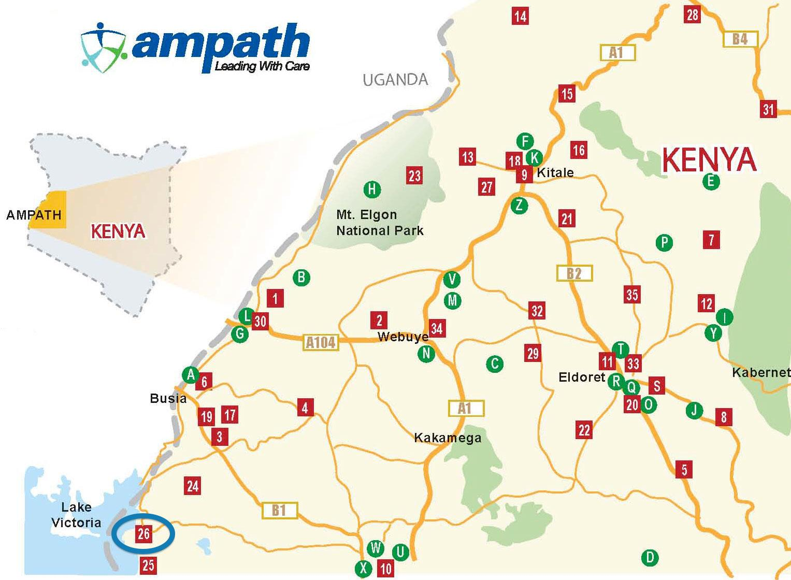

Figure 3. Map of Ministry of Health-AMPATH Clinic Sites in western Kenya. Port Victoria is number 26 (blue circle).

Calibration began by adding the input parameter values to the model. Model outputs were then designed to produce identical metrics to the calibration point data (e.g. CD4 distribution of individuals initiating ART in each time split, as in question *Art1*). With model output metrics matching the calibration point data, fitting was conducted by hand. Calibration was done systematically, starting with data regarding the state of care at the end of 2009. According to AMPATH, 62% of HIV-positive individuals were diagnosed, with ⅔ diagnosed through PICT services and the remaining ⅓ through VCT. By adjusting the baseline rate of seeking care through VCT and the health care seeking rates driving individuals to seek care through PICT, we matched these values exactly as shown below in figure 4.

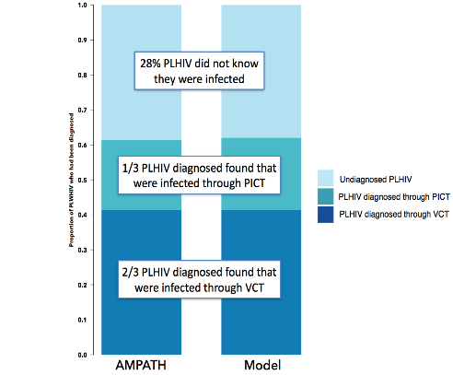

Figure 4. Awareness of HIV status at end of 2009 - Cascade Model calibration result

With knowledge of AMPATH’s HBCT programme rollout in 2010, followed by the addition of the FLTR programme where HBCT becomes perpetual (home-team does not leave an area until everyone is tested, resulting in 100% coverage), we looked at the proportion of individuals entering through each of the three routes into care over the three time splits and compared AMPATH data to model outputs. We modelled HBCT rollout in 2010 but with 100% coverage obtained immediately. As can be seen in figure 5, we over represent the impact of HBCT in 2010 but much more closely match the fit in the third time split (2011 to 2014).

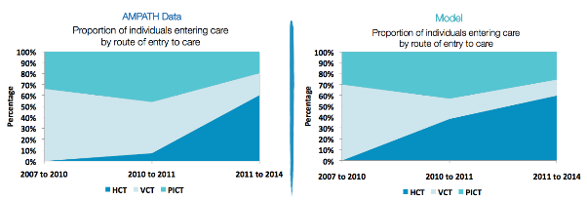

Figure 5. Distribution of individuals among the three routes into care - Cascade Model calibration result

The CD4 distribution of individuals entering care was then compared between the data and the model output. Figure 6, illustrates the results with the proportion of individuals entering care through VCT and PICT with low CD4 counts increasing in the last time split in the data [**WHY!?**], this is not captured by the model [Further investigation pending].

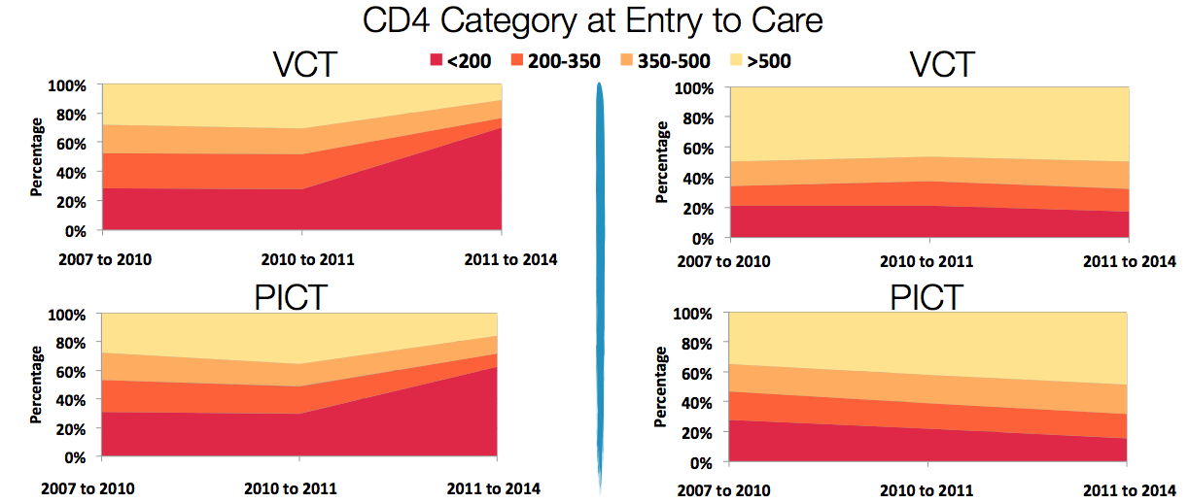

Figure 6. CD4 count distribution at entry to care - Cascade Model calibration result

The CD4 distribution among individuals initiating ART was then considered. This distribution is altered by changes in treatment guidelines, treatment seeking rates and the natural history of HIV. As can be seen in figure 7, the model currently does not match the AMPATH data correctly. Many individuals initiate ART in AMPATH with very high CD4 counts, this is due to a high prevalence of opportunistic infections, something that the model doesn’t capture [**YET, still working on it!**].

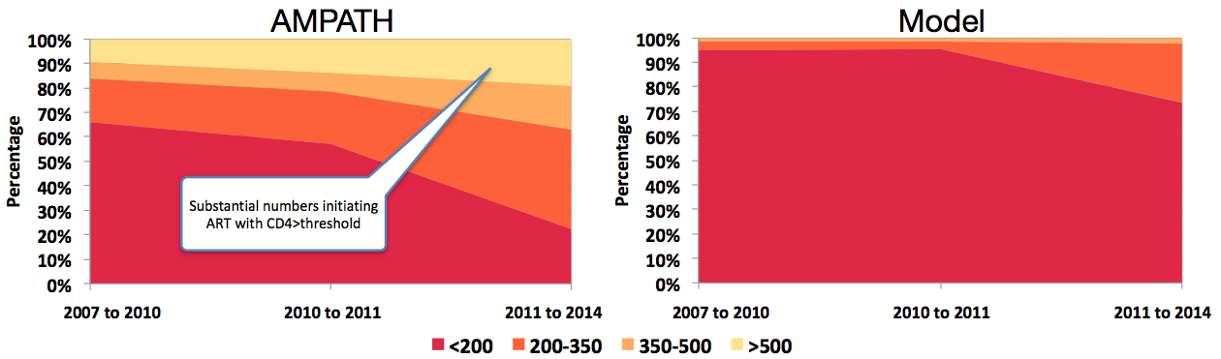

Figure 7. CD4 count distribution at ART initiation - Cascade Model calibration result

Finally, the proportion of HIV-positive individuals initiating ART per year was compared between data and model output. We can see from figure 8, that in the first time split (2007 to 2010), the model fails to capture the 7% or so of individuals initiating ART [**Still working on this calibration, stay tuned!**].

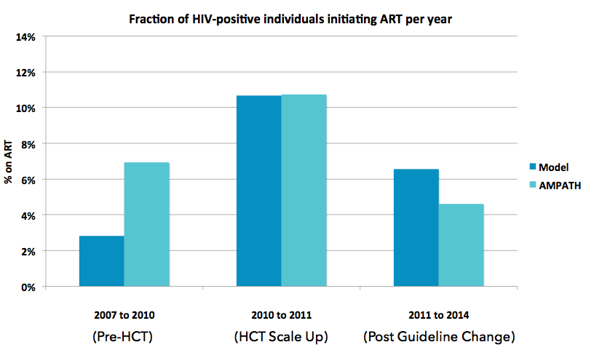

Figure 8. Proportion of HIV-positive individuals initiating ART per year - Cascade Model calibration result

Next, HIV-prevalence was compared to national estimates from the Kenya AIDS Indicator Survey 2007[[KAIS](http://www.nacc.or.ke/nacc%20downloads/official_kais_report_2009.pdf)]. Figure 9, shows the results stratified by gender.

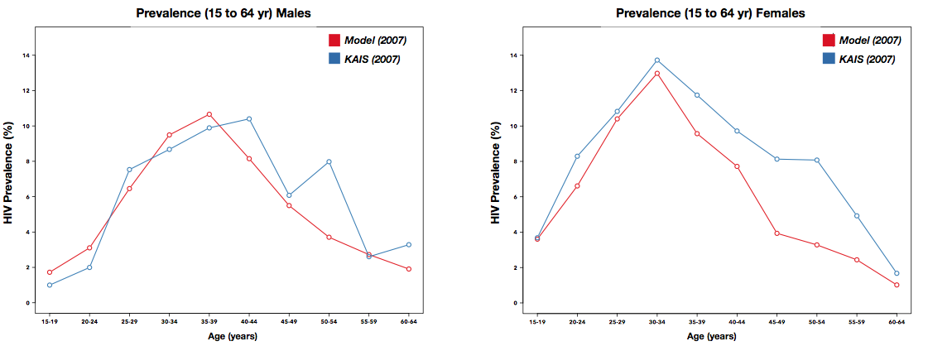Figure 9. Comparison of HIV-prevalence in the model to KAIS 2007 estimates - Cascade Model calibration result

Then, the model was compared to data from the more recent KAIS 2012 study. Model outputs were compared to national HIV-prevalence estimates as well as estimates from Nyanza Province [**Port Victoria is actually in the Western Province!**], shown in figures 10 and 11 respectively.

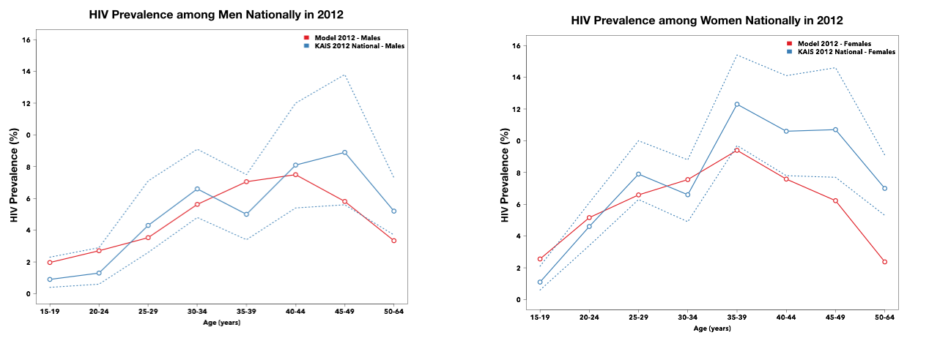Figure 10. Comparison of HIV-prevalence in the model to National KAIS 2012 estimates - Cascade Model calibration result

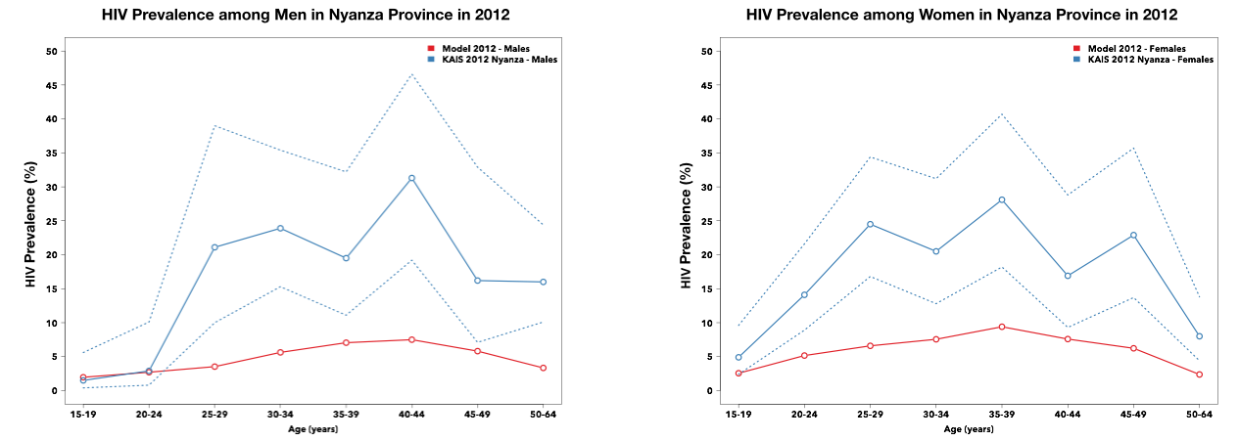Figure 11. Comparison of HIV-prevalence in the model to KAIS 2012 estimates from Nyanza Province - Cascade Model calibration result

Finally, the model was compared HIV-prevalence estimates from UNAIDS and also the proportion of HIV-related deaths among total population over time, shown on the left and right side of figure 12 respectively.

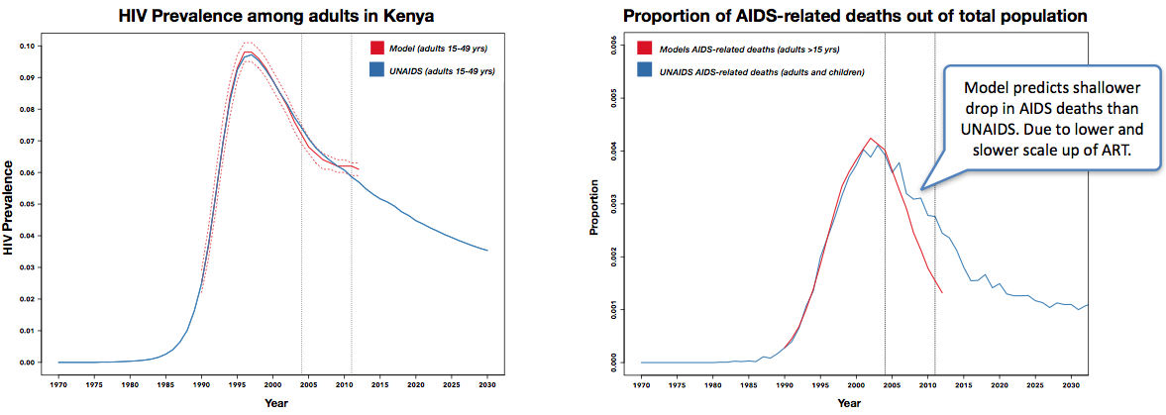Figure 12. Comparison to HIV-prevalence estimates over time from UNAIDS (left), comparison of the proportion of AIDS-related deaths out of the total population to UNAIDS (right) - Cascade Model calibration result

***Note: Cascade model calibration is still ongoing, hence figures 4 to 12 and currently placeholders.***

# 4 - Cost Derivation

Costs in the model were broken down into individual components. This was done to ensure that different events could easily be compared; for example, the cost of a HBCT visit would be composed of the visit cost plus the cost of a rapid HIV-test. The majority of costs, including the cost of ART care, pre-ART clinic visits and CD4 lab-based tests, were derived from a multi-country analysis of 161 treatment facilities across five countries in sub-Saharan Africa[[MATCH](http://thedata.harvard.edu/dvn/dv/chaighf/faces/study/StudyPage.xhtml?studyId=85882&tab=catalog)]. The remaining costs were sourced from the literature. All costs are shown in table 6. A flow diagram of of these costs accumulate to describe the cost of HIV-care is shown in the following sections.

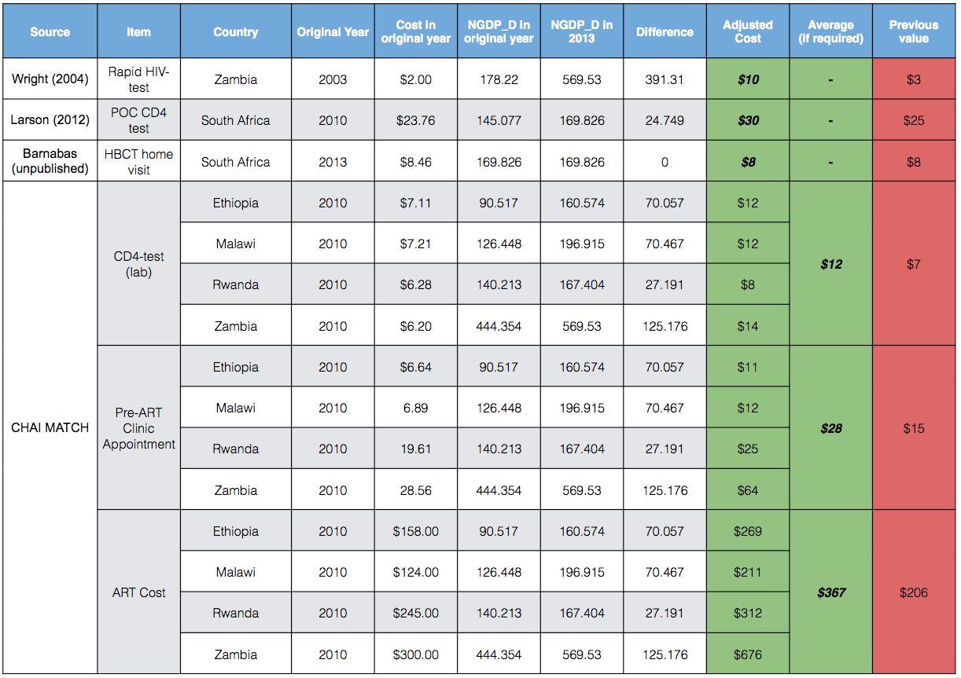

Table 6. Cost of HIV care illustrating the source and GDP deflator (NGDP_D) calculations to adjust for country and inflation. Values shown in bold are used in the model.

# 5 - DALY Weighting

The health benefits afforded by ART are summarised as DALYs averted, which capture the direct effects of ART in prolonging life and from reducing HIV transmission. The disability weights used in this model were sourced from the Global Burden of Disease Study 2010, comparing life-years lived in different health states to full health, values used as shown in table 7{Salomon:2012ib}. It is assumed that untreated HIV-infection with a CD4 count of >350 cells/μl carries the same weight as an HIV-positive individual receiving ART.

|  |  |
| --- | --- |
| **Health State** | **Disability Weight** |
| HIV-positive, CD4 count >350 cells/μl (untreated) | 0.053 |
| HIV-positive, CD4 count 200-350 cells/μl (untreated) | 0.221 |
| HIV-positive, CD4 count <200 cells/μl (untreated) | 0.547 |
| HIV-positive, on ART | 0.053 |

Table 7. Disability weights by health state

# 6 - Intervention Detail

The 12 interventions designed to impact at various points along the cascade are shown in table 8. These interventions can be grouped into: testing interventions, linkage interventions, pre-ART retention interventions, ART interventions and large scale sweeping change interventions. Where possible, each intervention has two scenarios: a “maximum impact” scenario illustrating the best possible impact of the intervention and a “realistic impact” scenario which aims to demonstrate the impact of a more obtainable intervention. The cost of each intervention is shown in the last column of table 8. Where no additional costs are applied for an intervention, costs may be incurred due to the additional life-years spent on ART or HIV/CD4 tests that occur after an intervention is applied. A flow diagram illustrating how costs accumulate in the model, together with the cost of interventions is shown in figure 12. Interventions were implemented in the model from 2010 onwards and their impact on DALYs averted, costs accrued and the care experience of individuals dying from HIV-related deaths quantified.

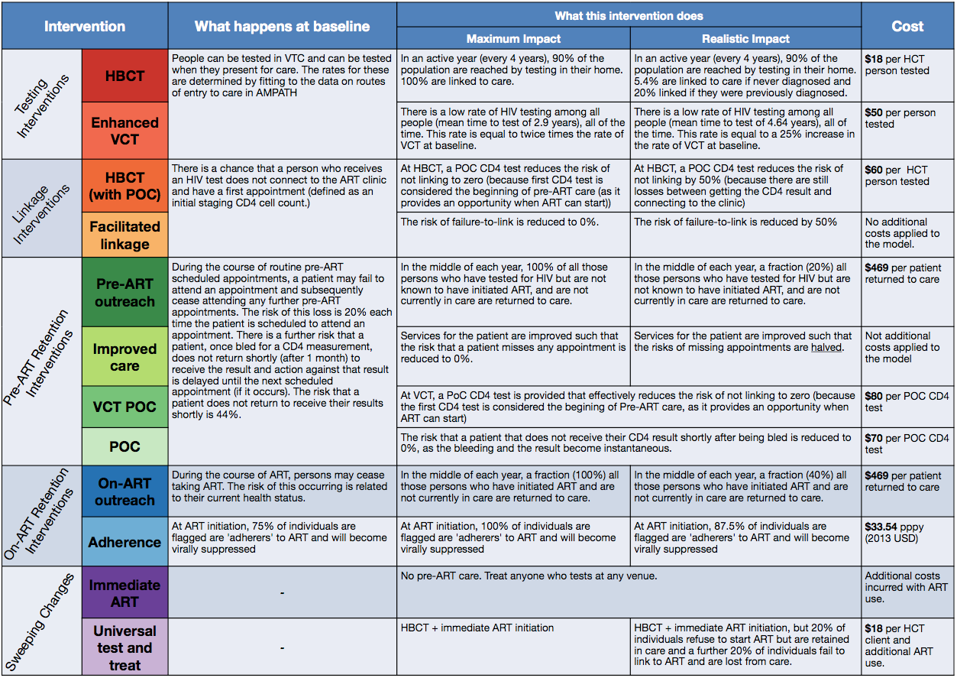

Table 8. Summary of interventions applied from 2010 to 2030. [INCLUDE REFERENCES]

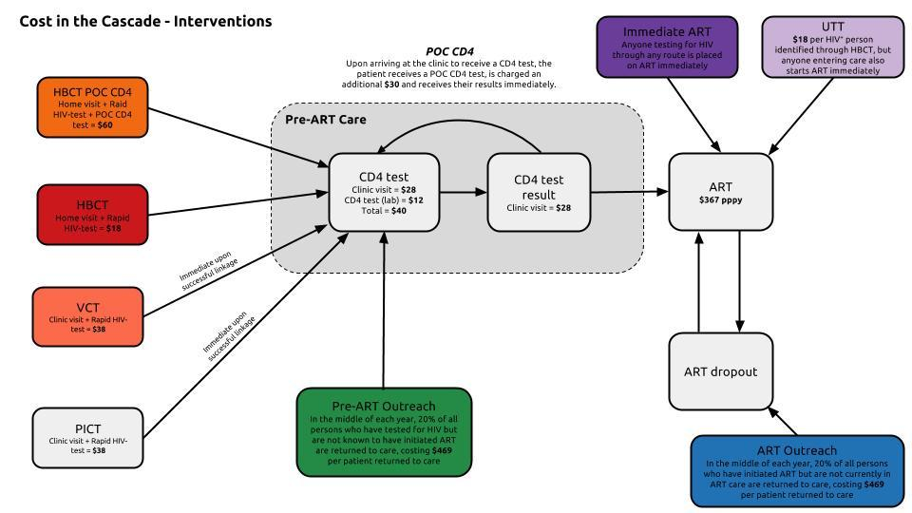

Figure 12. Flow diagram illustrating how baseline costs accumulate and interact with the additional costs applied by interventions in the Cascade Model

7 - Intervention Impact on Incidence

Prior to 2010, HIV incidence is entirely driven by the age and sex specific hazard of acquiring HIV sourced from the Spectrum software by the Futures Institute[[link](http://www.unaids.org/en/dataanalysis/datatools/spectrumepp2013/)]. While the model does not include a full transmission component, we model the impact of our interventions on incident cases by weighting the infectiousness of HIV-positive individuals each year, taking the sum of these individuals and multiplying that by a baseline transmission probability that we define in a reference year, when incidence has stabilised (2002).

To identify our baseline transmission probability in 2002 𝛃(2002) we look at the proportion of incident cases out of the weighted total of n health categories containing HIV-positive individuals of infectiousness i with infectiousness weight w (infectiousness weights are shown in table 9).

(9)

With 𝛃(2002) fixed we rearrange (9) to calculate the number of new infections per year after 2010 as follows:

(10)

|  |  |  |
| --- | --- | --- |
| **Health State Category** | **Infectiousness Weight *(w)*** | **Source** |
| HIV-positive, CD4 count >500 cells/μl (untreated) | 1.35 | Based on 3 months with acute infection and 6.25 years at CD4 >500, and 10-fold infectious with acute infection |
| HIV-positive, CD4 count 350-500 cells/μl (untreated) | 1.00 | Reference |
| HIV-positive, CD4 count 200-350 cells/μl (untreated) | 1.64 | Donnell *et al.* (2010) |
| HIV-positive, CD4 count <200 cells/μl (untreated) | 5.17 | Donnell *et al.* (2010) |
| HIV-positive, on ART | 0.1 | Estimate |

Table 9. Infectiousness weights by health state