**Cascade Tool Simulation Results (04/03/17)**

**Zimbabwe**

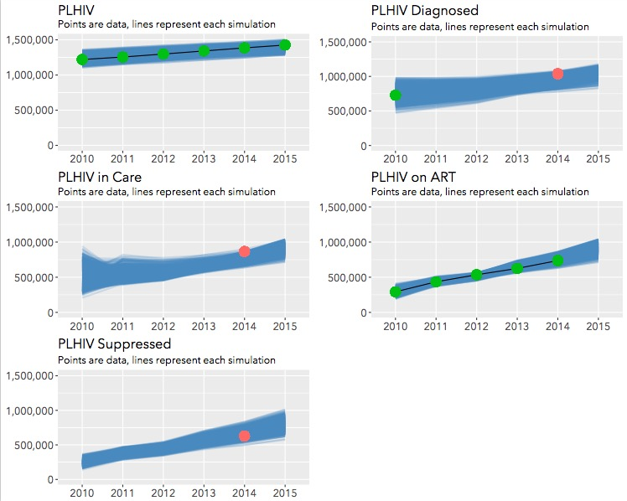

Fig. 1 Calibration results for Zimbabwe to various cascade indicators. Blue streak illustrates 1,000 model fits to colored data points.

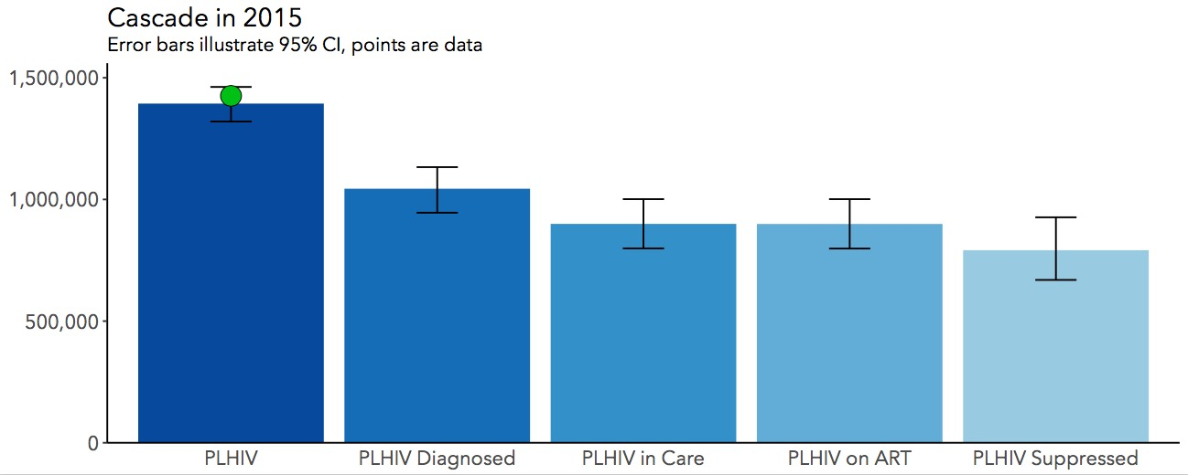

Fig. 2 Modelled estimate of the cascade in 2015 for Zimbabwe.

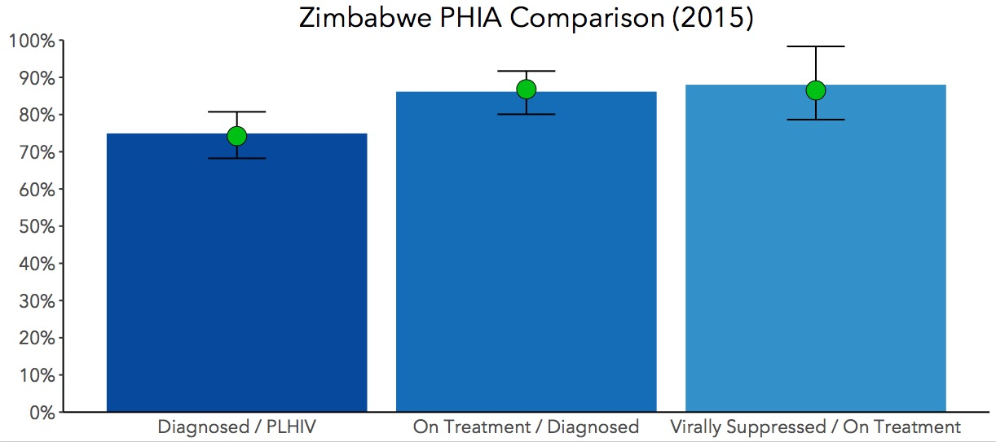

Fig. 3 Model fit to ZIMPHIA data

Data:

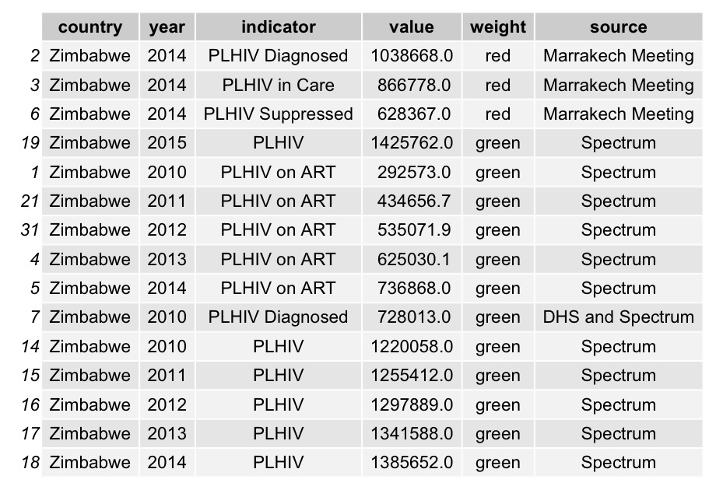

Comment:

*Good data thanks to PHIA, Spectrum estimates and data deposited in Marrakech. This calibration (and the same is true for many other countries) would benefit greatly from enhanced viral suppression data. The model estimates a proportion initiating ART that become virally suppressed and only has one poorly informed data point to make that decision upon. This results in the larger confidence intervals around the third 90.*

**DRC**

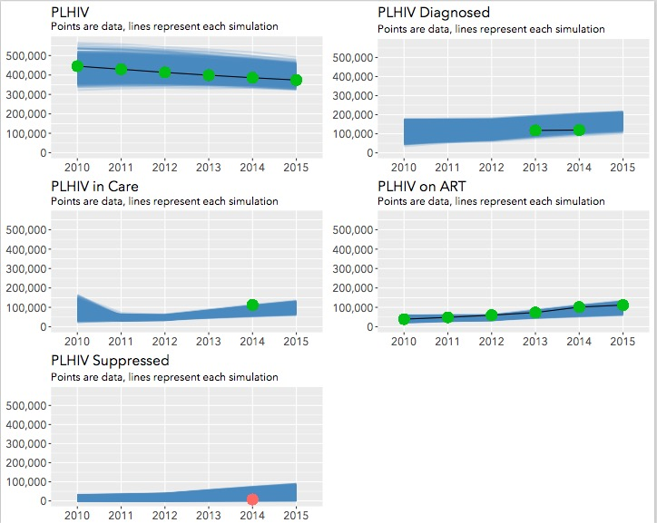

Fig. 4 Calibration results for DRC to various cascade indicators. Blue streak illustrates 1,000 model fits to colored data points

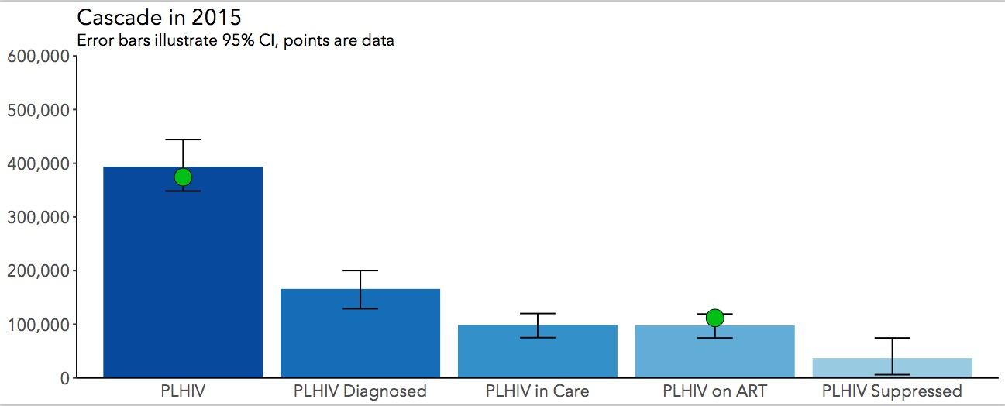  
Fig. 5 Modelled estimate of the cascade in 2015 for DRC

Data:

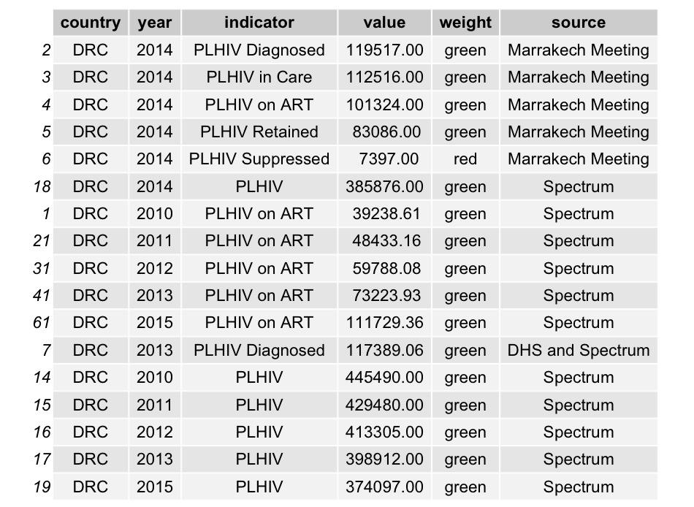

Comment:

*Lack of PHIA data weakens this calibration. However the situation is very different to Zimbabwe in that ART coverage is very low, accompanied by a declining epidemic. This calibration would be strengthened by better estimates of numbers diagnosed from 2010 onwards.*

**Kenya**

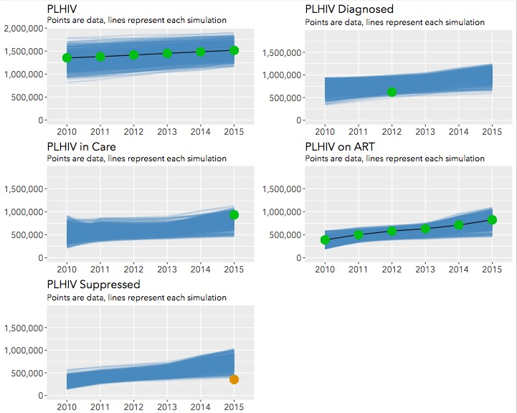

Fig. 6 Calibration results for Kenya to various cascade indicators. Blue streak illustrates 1,000 model fits to colored data points

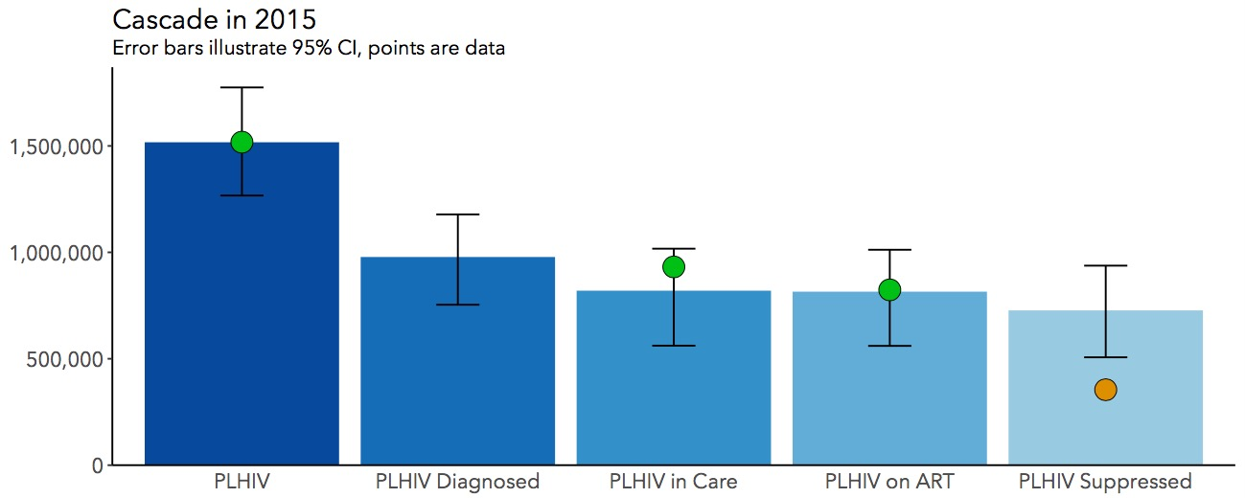

Fig. 7 Modelled estimate of the cascade in 2015 for Kenya

Data:

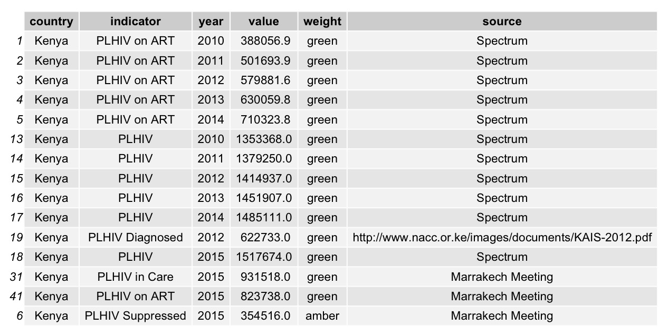

Comments:

*Upcoming PHIA data will greatly enhance this calibration and the estimation of 90-90-90 in Kenya. For the time being, better estimates of those diagnosed and virally suppressed would enhance this calibration, as the model has to rely heavily on Spectrum estimates in most cases to provide the basic structure the modelled cascade.*

**Mozambique**

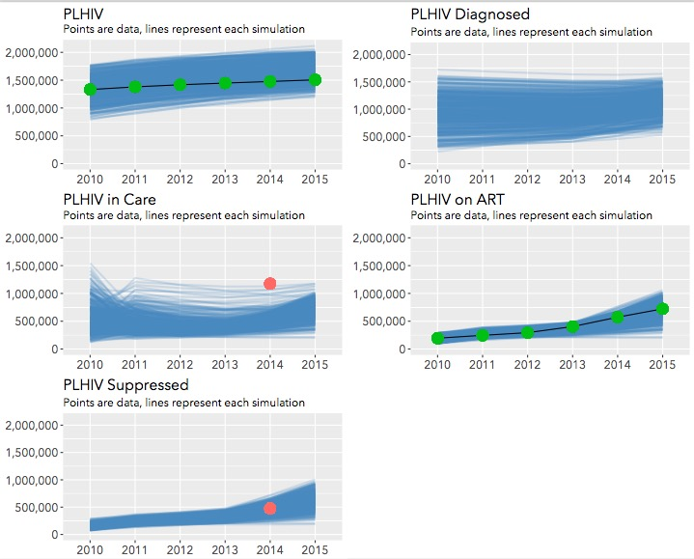

Fig. 8 Calibration results for Mozambique to various cascade indicators. Blue streak illustrates 1,000 model fits to colored data points

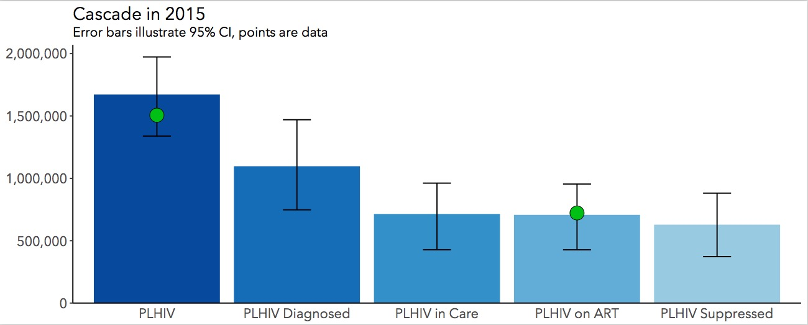

Fig. 9 Modelled estimate of the cascade in 2015 for Mozambique

Data:

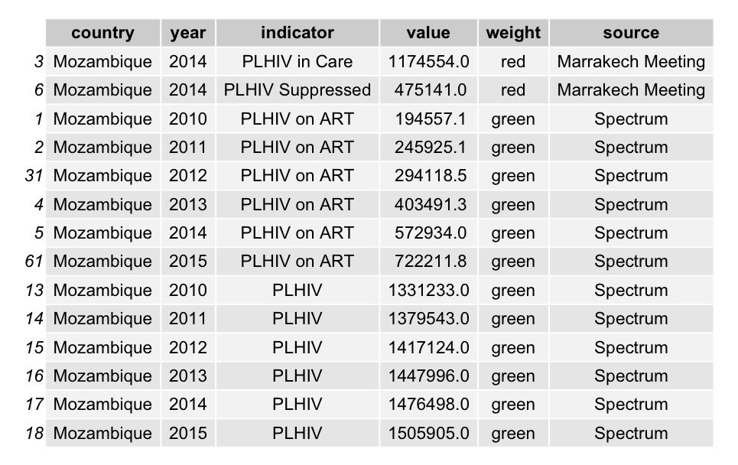

Comments:

*Lack of data on the number of PLHIV diagnosed hinders this calibration significantly, along with a very high estimate of the number in care in 2014 (from Marrakech) which is more than double the number of persons on ART at that time. The model struggles to reconcile this difference and as a result ends up with very large estimates of persons diagnosed and in care.*