
User guide
for
the website of
The Katikati Rotary Club
Contents

- Introduction
- Members Portal
- Update Home Page Content
- Welcome Carousel
- Welcome Information
- Front Page Story
- Add Event to Calendar
- Update Stories
- Club News
- Stories Page
- Adding Stories
- Website Stylesheet

Introduction
This guide is for managing the web content for the Katikati Rotary Club. It contains details on how the members portal allows users to make changes to the web pages.

The home page has the following structure:
- Navigation bar
Member log in / member area, navigation bar links

- Welcome section
A carousel of rotating images and text box

- Front Story section
Display image and text box

- Socials section
Facebook link, membership link, members portal, rotary links, upcoming events, calendar

- Club News section
Club news, link to the stories page

** Important distinction to be made here: club news and stories page are separate libraries. They are intended to show different stories, or some overlapping.

The Members Portal
The Members Portal is designed to allow users to easily edit the content within these sections. The links take you directly to the relevant ClubRunner pages where the content can be edited.
Once on these pages, the inbuilt editors provide a range of options for managing and updating the content.
The following chapters will work through each section of the Members Portal, explaining the available options and providing recommendations for managing the content. Navigation route from ClubRunner will also be included for your reference.
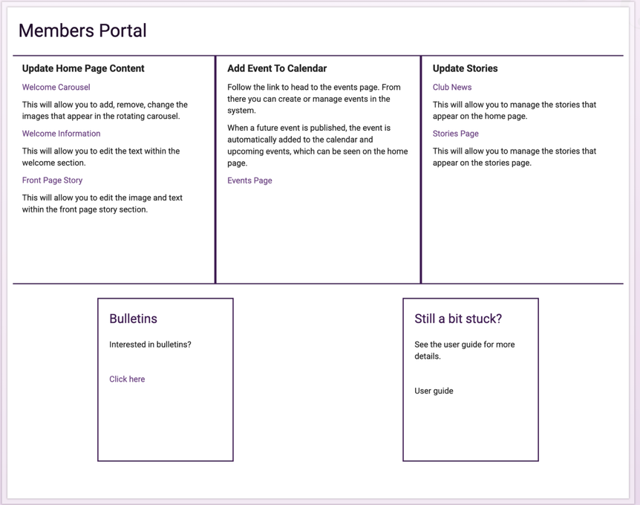

Update Home Page Content – Welcome Carousel
Welcome carousel refers to the display of rotating images at the top of the Home Page. Editing the carousel will allow you to add, remove, and reorder images.
Image Recommendations
Images should be cropped to a consistent aspect ratio before uploading. It’s recommended to use 16:9 for the Welcome Carousel.
For the best results images should be at least 1920 x 1080 pixels. Larger images can be used, provided they are cropped to the correct aspect ratio.
Maintaining the same aspect ratio ensures that images occupy the same amount of space and prevents images from appearing stretched or distorted.
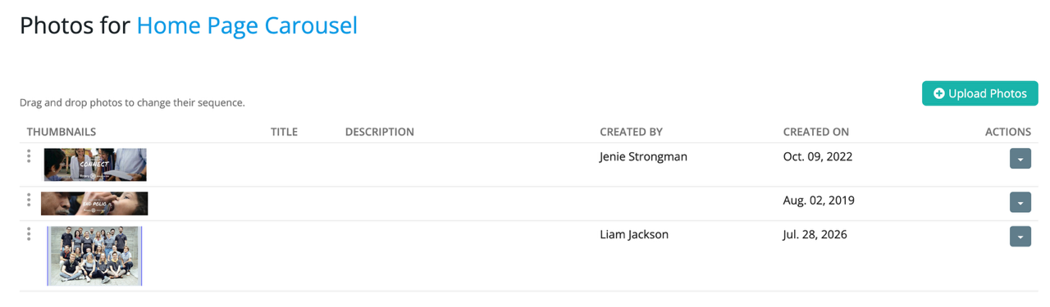
Edit or delete photos
Add images
Drag to change order

ClubRunner Site Admin Website Content: Content Libraries Photo Album Library Home Page Carousel

Update Home Page Content – Welcome Information
Welcome information refers to the text box below the carousel. Introduce the audience to the club here. This box is intended for text only, adding images may affect the layout. Font size, font style and other options are available using the inbuilt formatting options.
For best results use the options to format the title as a heading and format the text as paragraph.
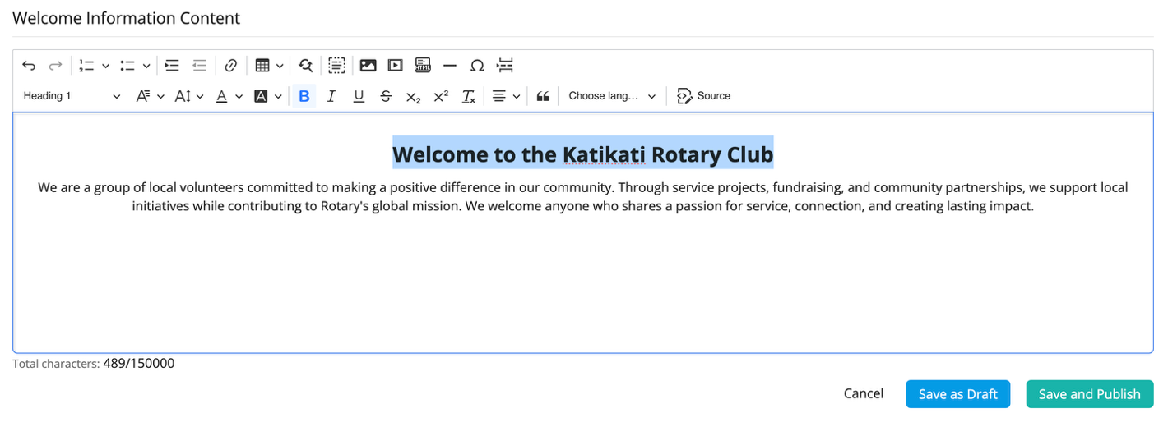
Heading selected for title
Inbuilt formatting options

ClubRunner Site Admin Website Content: Content Libraries Global Custom Widgets Welcome Information

Update Home Page Content – Front Page Story
The Front Page Story is the section that follows the Welcome Text. It is intended to showcase a relevant story, event or other content that you would like visitors to see.
When editing this section, add the image first, followed by the text.
Image Recommendations
The editor accepts both portrait and landscape images.
Use the inbuilt options to add a photo. Once the image has been added, click on it to display the image formatting options. Use these options to ensure the image is centred.
For best results, select 600px as the image size where appropriate, and crop any whitespace from the image before uploading. You may choose a larger size using the custom option but to retain image quality it’s recommended to stay around 600px.
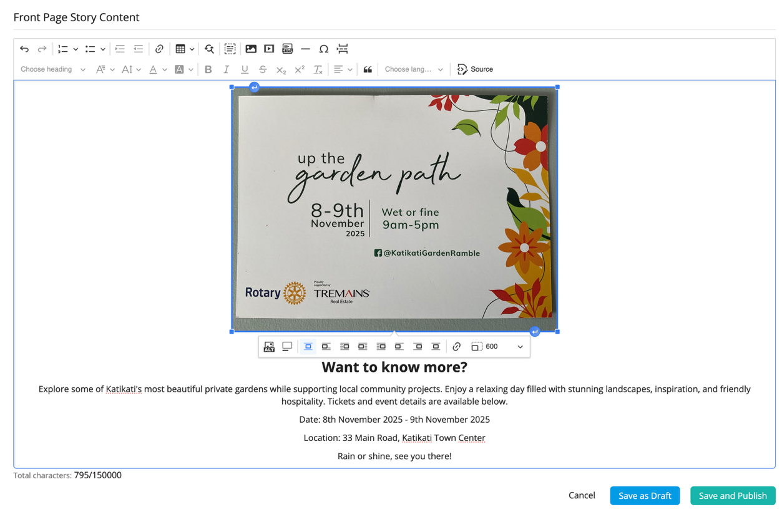
Avoid using images that are low quality, blurry or pixelated, particularly where the image contains text. Using a clear, tightly cropped image will help ensure the content remains easy to read when displayed on the website.
Image size
Center image
Add image

ClubRunner Home Admin Website Content: Content Libraries Global Custom Widgets Front Page Story
Add event to calendar
Add event to calendar takes you to a list that allows you to easily manage upcoming and past events. Don’t forget to publish events, any unpublished work will not be displayed on the front page.
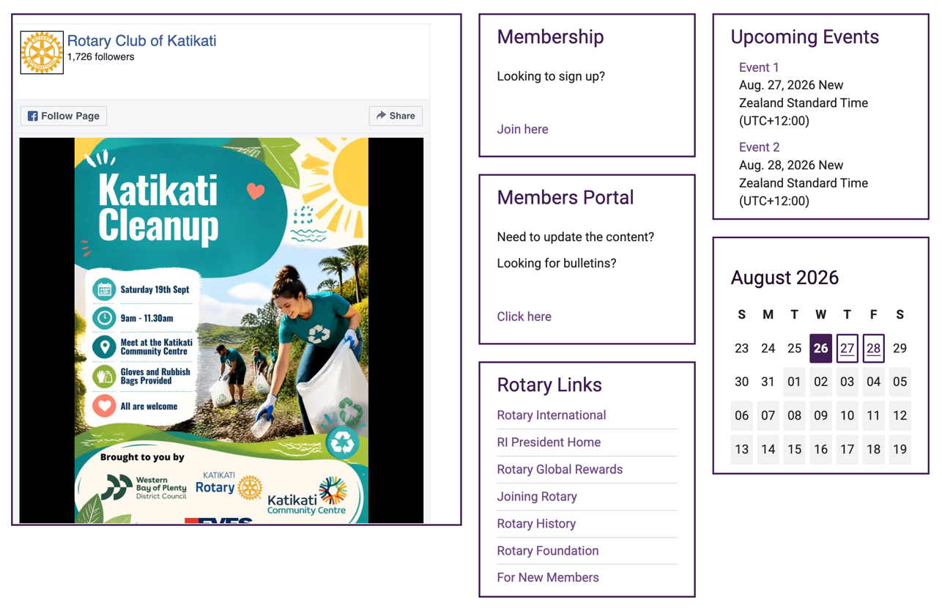
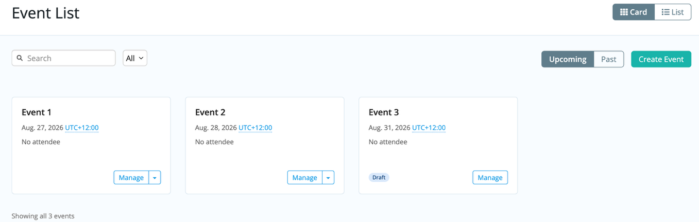
This feature utilises ClubRunners Cloud Events system. You’ll notice during the event set up there are a lot of options. For more information on what you can do, see https://www.clubrunnersupport.com/kb/articles/what-is-cloud-events.
Published events displayed here
Draft event not displayed

ClubRunner Home Admin Events tab: Events Home Cloud Events: View Events

Update Stories – Club News
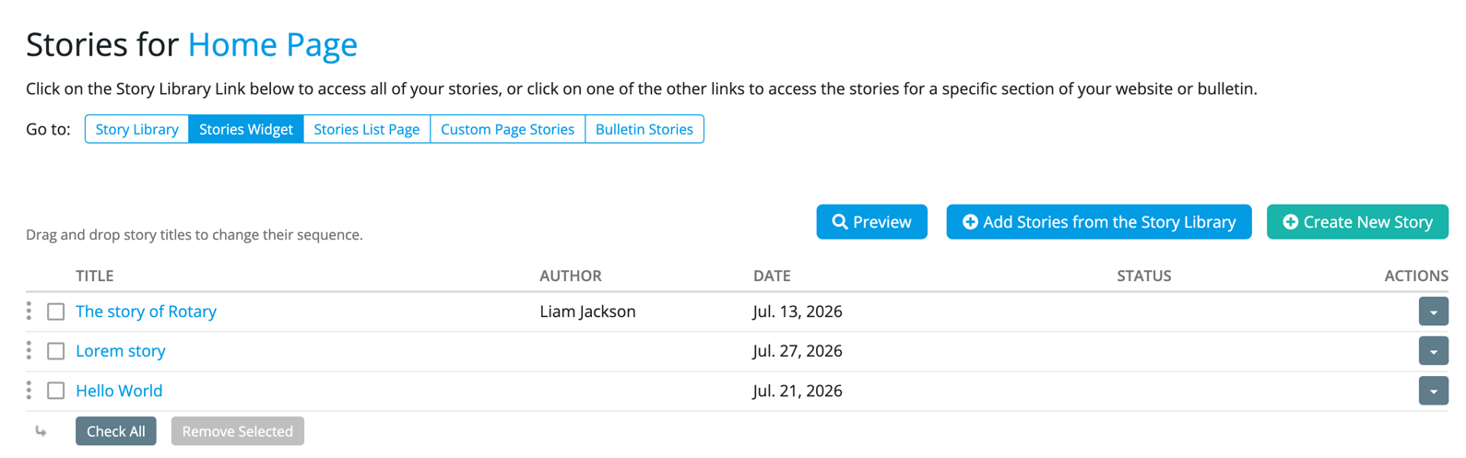
Club News is the section near the bottom of the home page designed to display some stories on the home page. The story library is the overall library containing all stories added to ClubRunner. Club News is the list of stories that will appear on the home page. In this panel you can either add new stories or import existing ones from the library.
Drag to rearrange
Edit or delete

ClubRunner Home Admin Website Content: Home Page Content Homepage Stories

Update Stories – Stories Page
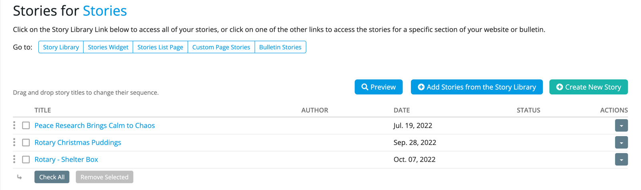
Stories Page is found in the navigation bar at the top of the page or by selecting the See more stories link in Club News. It is its own webpage dedicated to displaying stories not seen on the home page. It works the same as Club News in the sense that it is its own library. Meaning you can display different stories from the home page, or the same if you’d like.

ClubRunner Home Admin Website Content: Content Libraries Custom Page Stories Stories
Adding Stories
Story Brief and Story Content are part of ClubRunners inbuilt editor for creating stories.
The story brief is displayed on the home page, while the story content is displayed when user selects Read more…
It’s recommended to keep the story brief as an introduction with some details and use the story content for the body of the text.
Image Recommendations
The editor accepts both portrait and landscape images.
Use the inbuilt options to add a photo. Once the image has been added, click on it to display the image formatting options. Use these options to size and position the image.
For best results:
- Use 250px for images in the story brief
- Use 300-450px for images in the story content
- Position (wrap) images to sit around the text
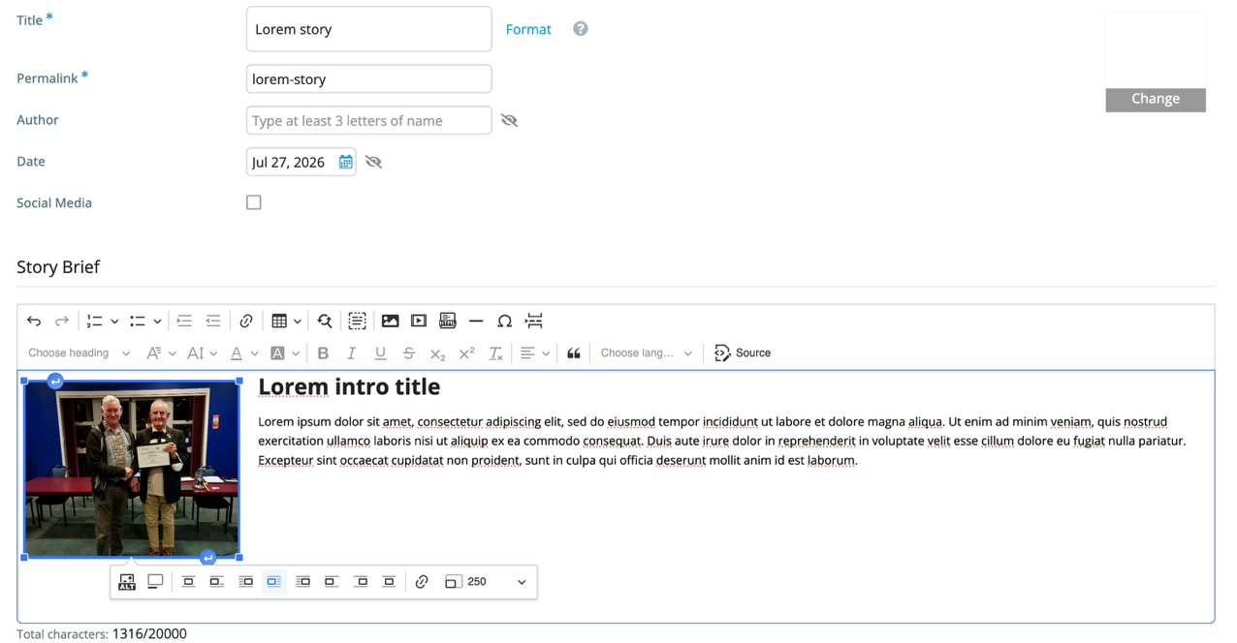
Positioning or wrapping images around the text helps maintain consistent spacing on the home page and allows the surrounding content to make better use of the space. Sizing is more flexible in the story content as we have a full web page of space to occupy. Multiple images can be added too and positioned around the text to give an article style layout.
Editor:
Image size
Add image
Left aligned wrapped around text
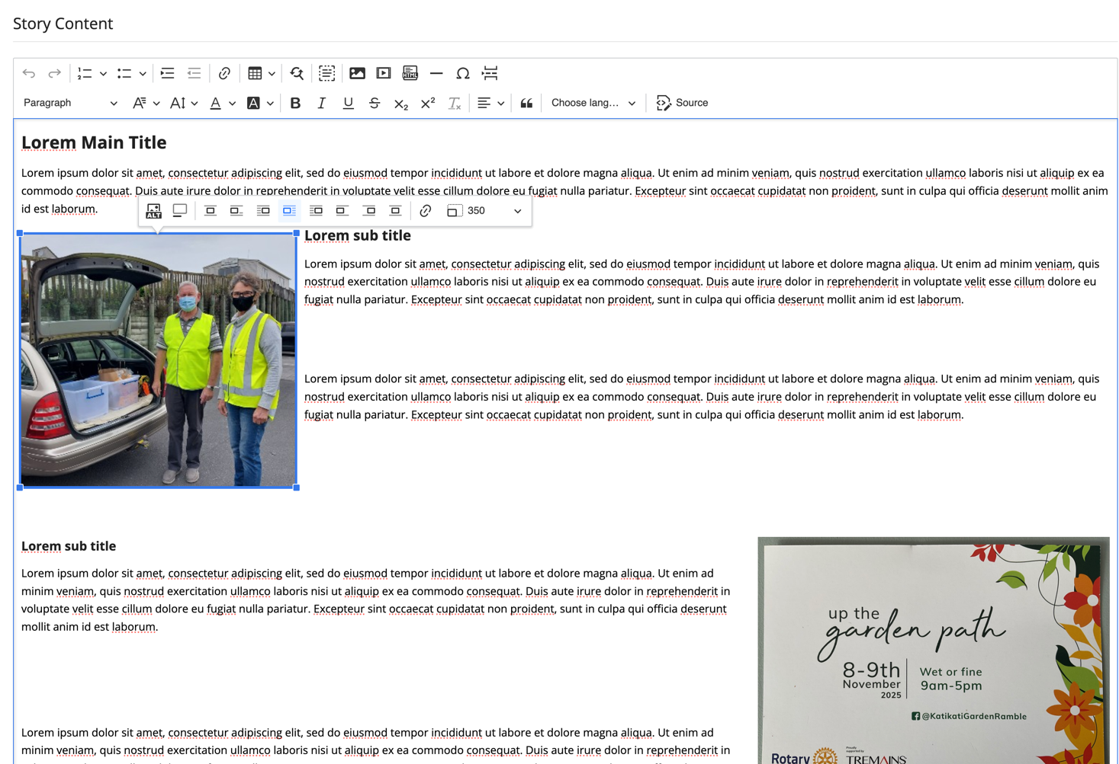
Larger images can be used in story content
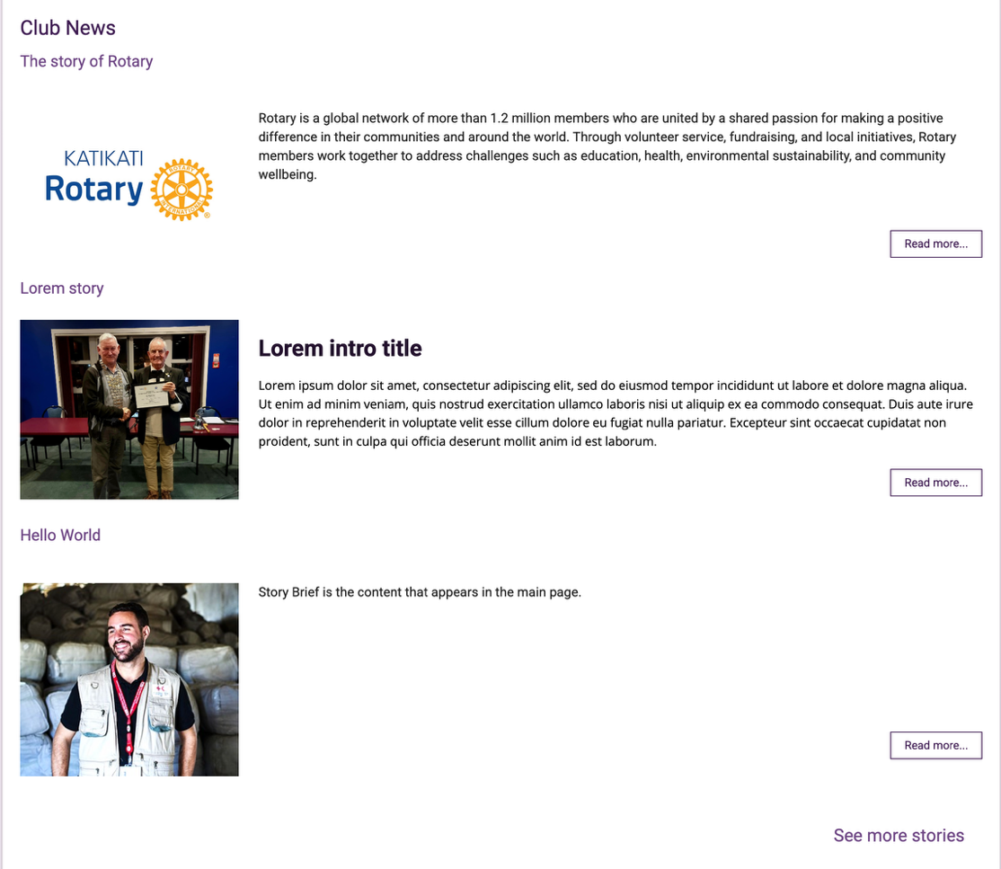
Main page view:
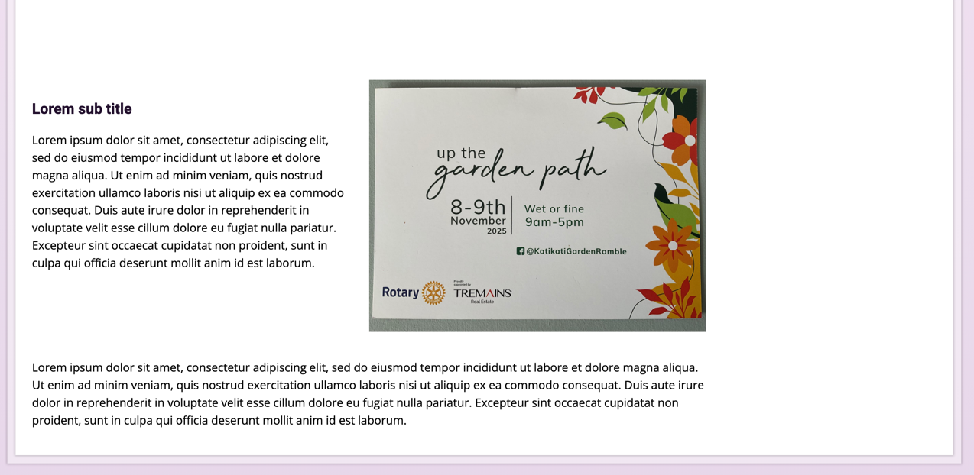
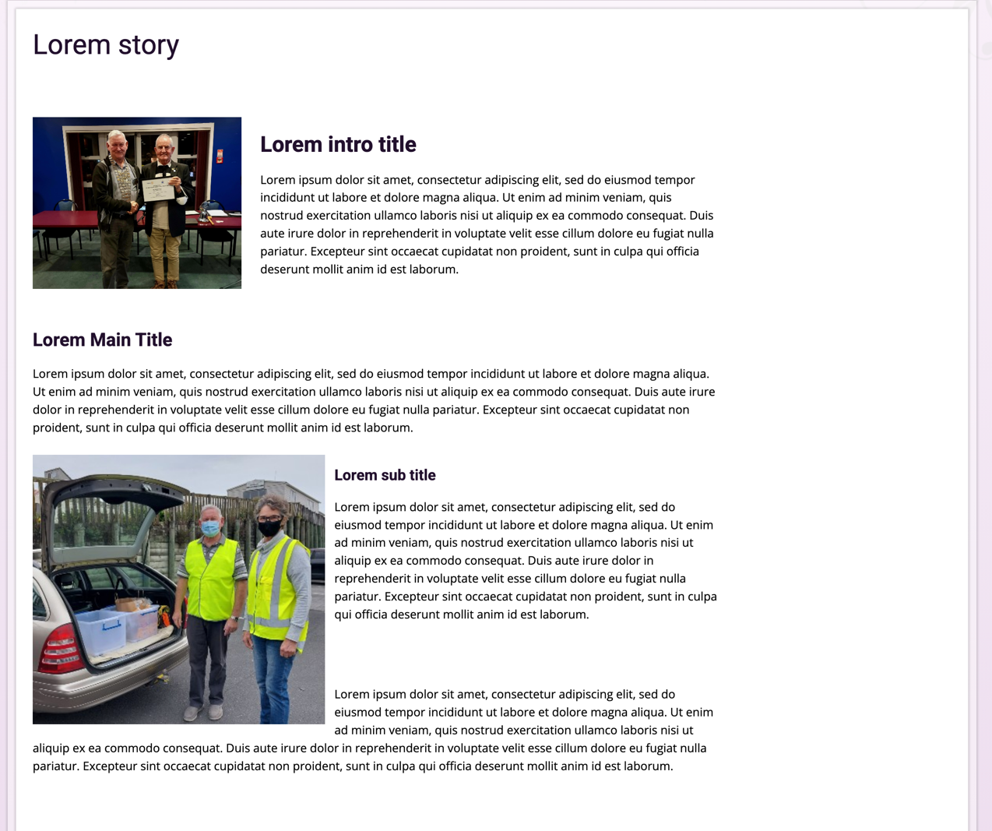
Full story displayed:

Website Stylesheet
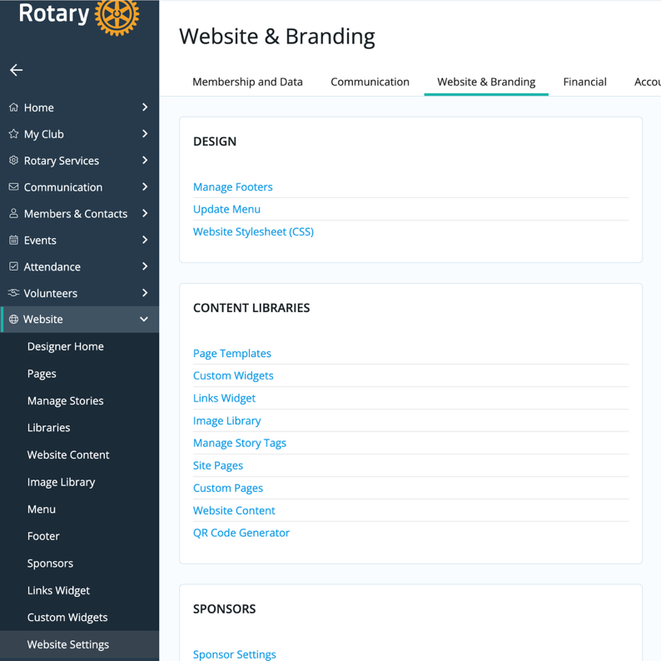
Website Stylesheet is for the website manager as it requires permission and some knowledge of HTML/CSS. The stylesheet is written in CSS and used to control HTML elements on the web page. Using the panel on the left open Website and click Website Settings. On Website and Branding, find Design and select Website Stylesheet (CSS).

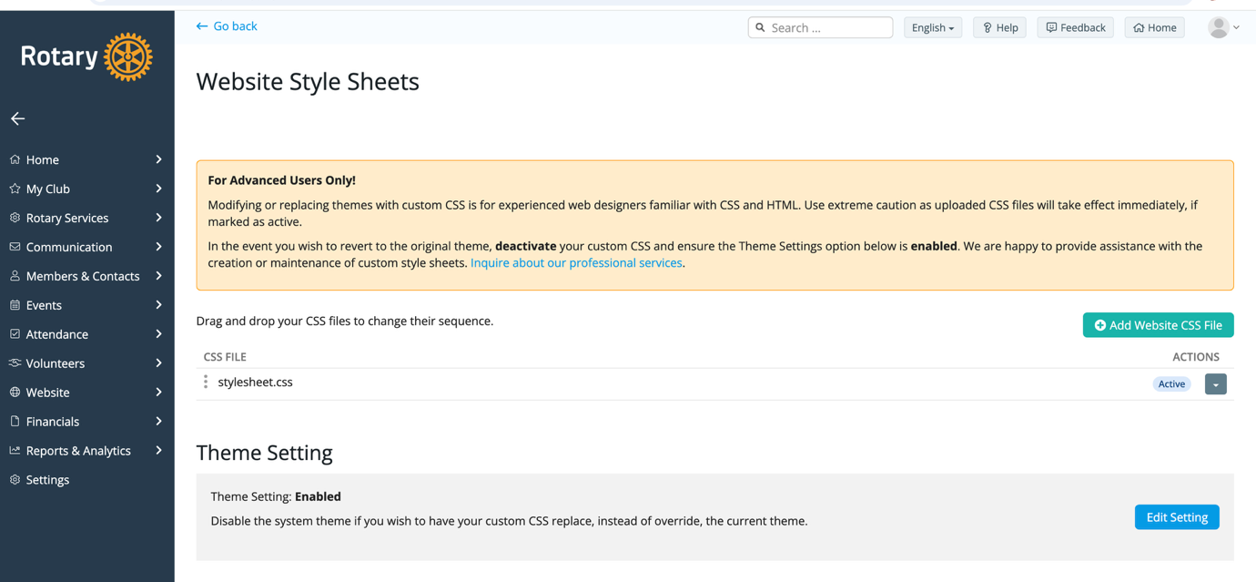
To edit stylesheet.css, use the actions tab on the right to view the file. Here I’d recommend copying the contents and pasting into a code editor such as visual studio code. Then, make changes in code editor, and reupload the new stylesheet.css to overwrite.
Website Structure
In ClubRunner’s webpage editor, the pages are divided into bands, which contain the individual widgets that make up the page.

Band 1
- Welcome Carousel
- Welcome Text
Band 2
- Front Page Story Image
- Front Page Story Text
Band 3
- Facebook Link
- Membership Link
- Members Portal Link
- Upcoming Events
- Calendar
Band 4
- Club News
- See More Stories Link
- Club Information

Stylesheet and Image Settings
The custom stylesheet is primarily used to provide consistent control over widget spacing, positioning and text alignment across the website.
Image sizing and aspect ratios are controlled within ClubRunner’s inbuilt editors, rather than through the stylesheet. This allows ClubRunners responsive design to manage images appropriately across different screen sizes and devices.
Feel free to adjust the stylesheet as you’d like. An original copy can be found at https://github.com/jackotech67/ClubRunner-project.
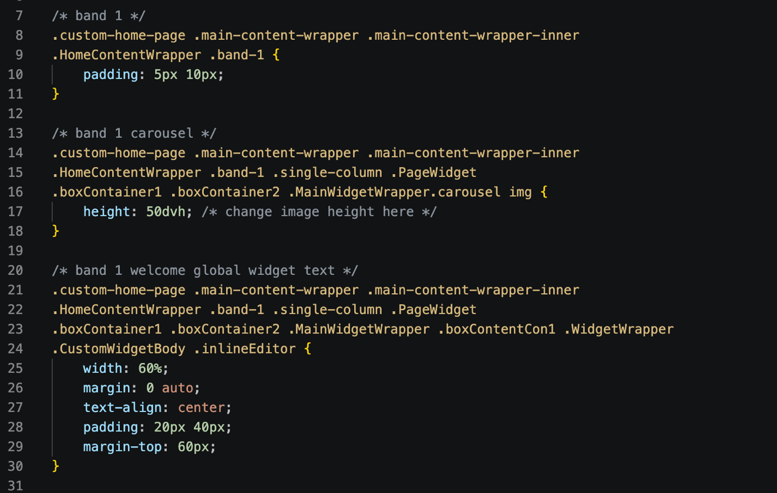
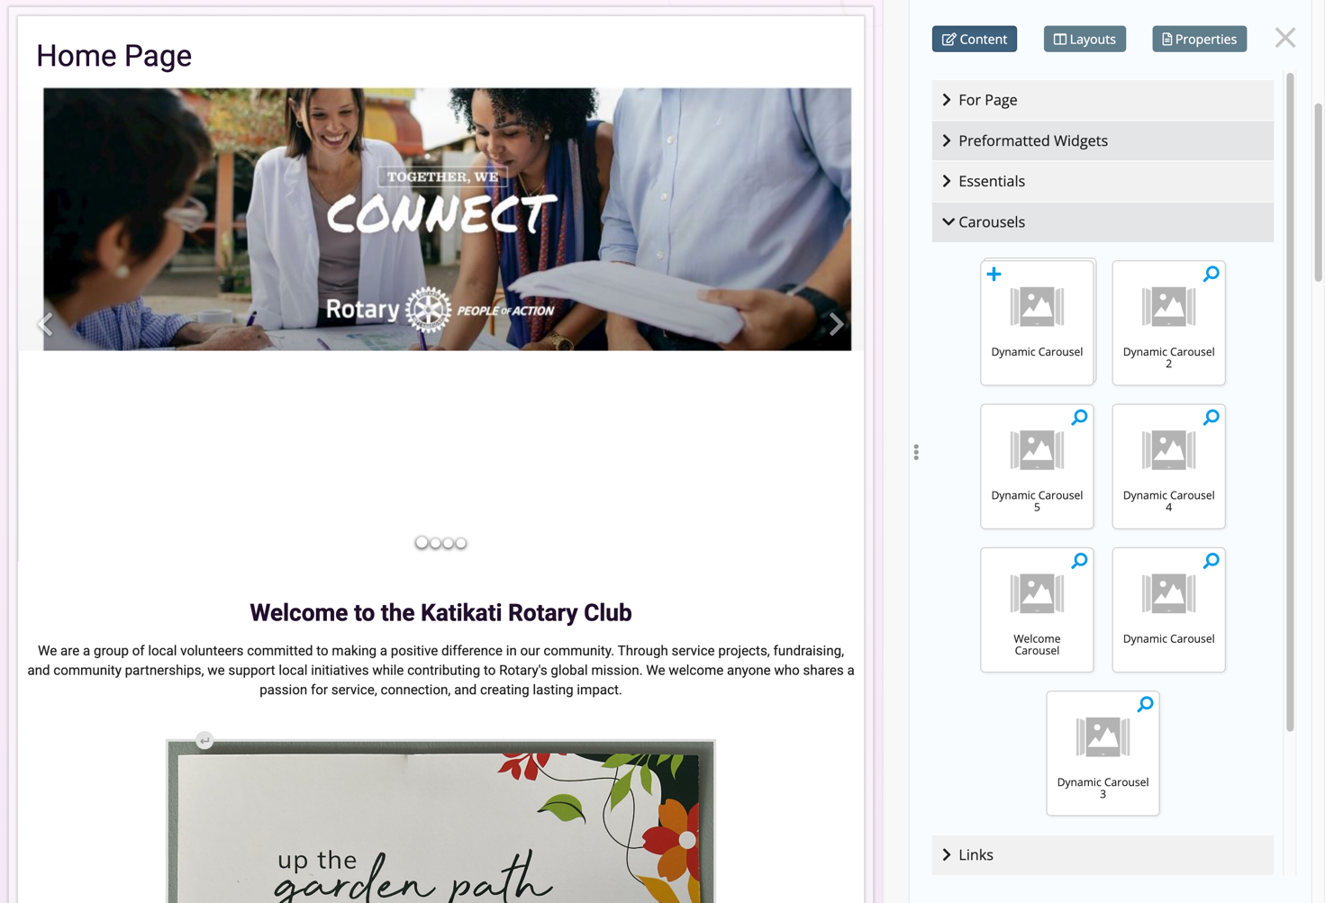
Changes carousel height
Band 1 text
*/
Band 1 carousel
Carousel widget

Pixel dimensions are the same as image dimensions. Right click get info on the image file to find the details.

