User Guide

- Introduction
This guide is for managing the web content for the Katikati Rotary Club. It’s intention is to help members understand the structure of the site so they can confidently make changes in the right section.
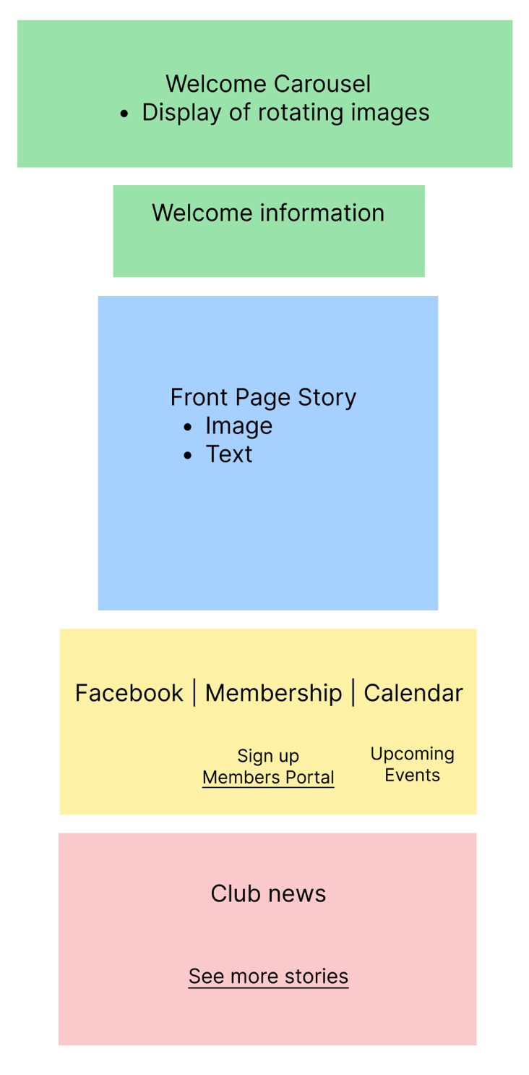
We’ll start by breaking the home page into sections, from there we should start to recognise how each section of the members portal interacts with the site.
Club News section
Socials section
Front Story section
Welcome section
- Update Home Page Content – Welcome Section
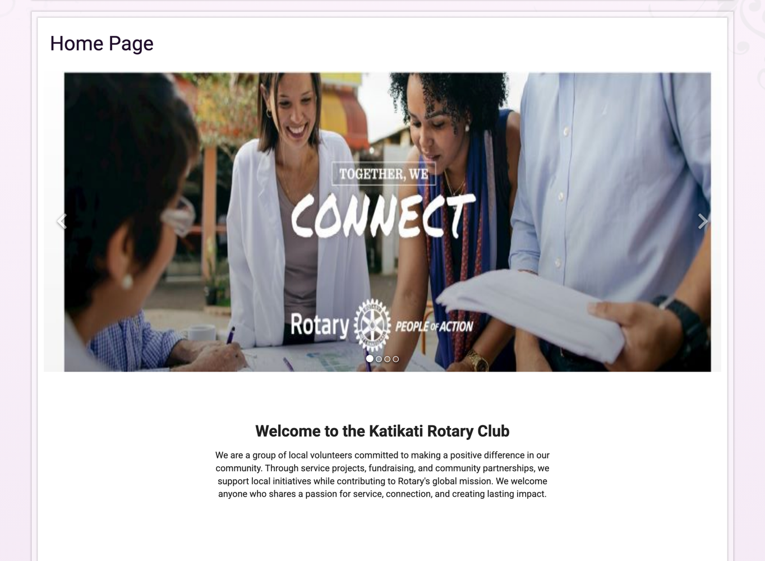

Welcome carousel refers to the display of rotating images at the top of the page. Editing the carousel will allow you to add, remove, and change the order the images appear in.
Recommended image sizes should go here. Mention keeping image sizes consistent.

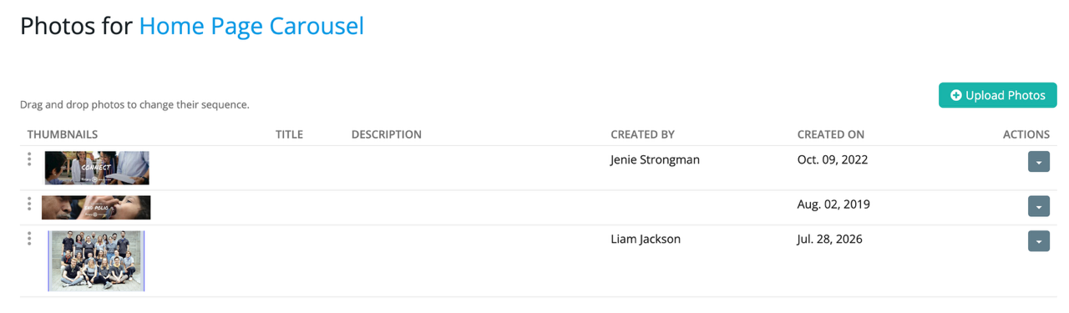
Add images
Drag to change order
Edit or delete photos
Welcome information refers to the text box below the carousel. Introduce the audience to the club here. This box is intended for text only, adding images here may affect the layout.
Do a format check. What happens if we change format options in clubrunner. Potentially need to override in css file
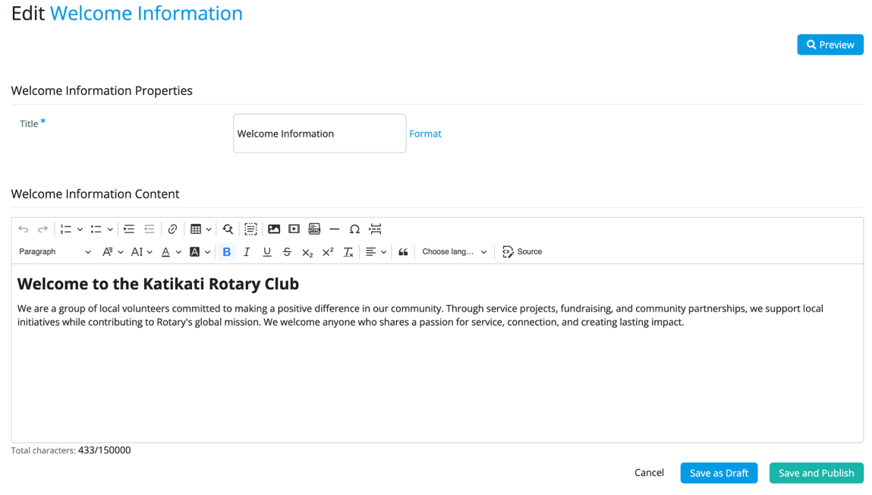

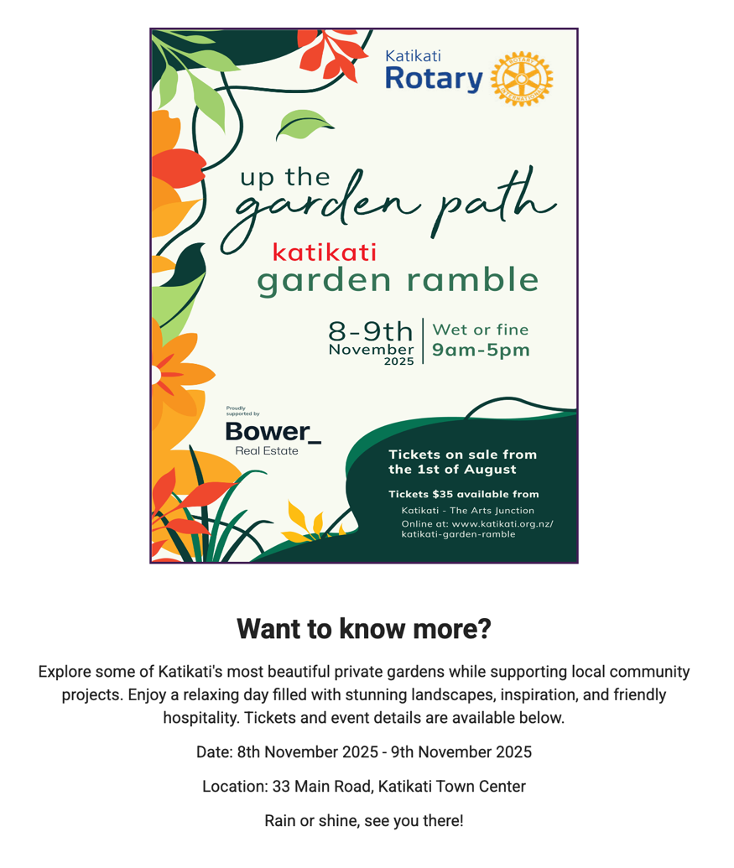
- Update Home Page Content – Front Page Story

Front page story refers to the section that follows and is intended to showcase a relevant story or event that you’d like everyone to see. In the editor, add the image first and the text below:
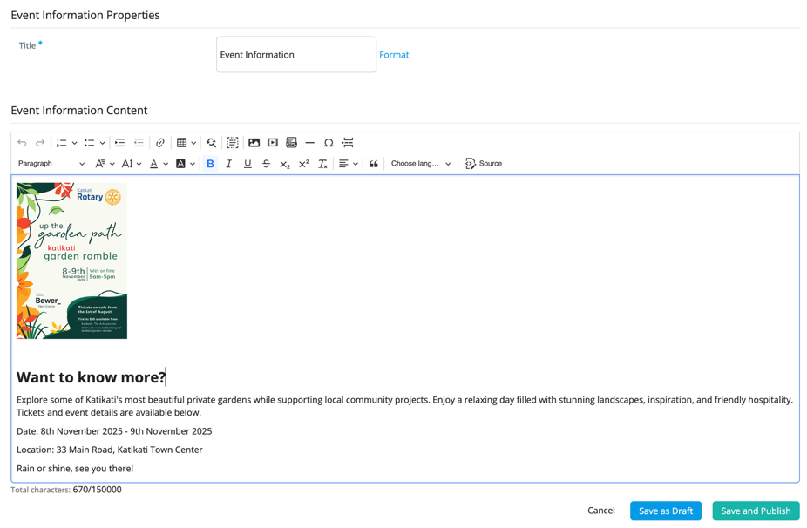
Recommended image sizes go here. Could implement a max width and height in css
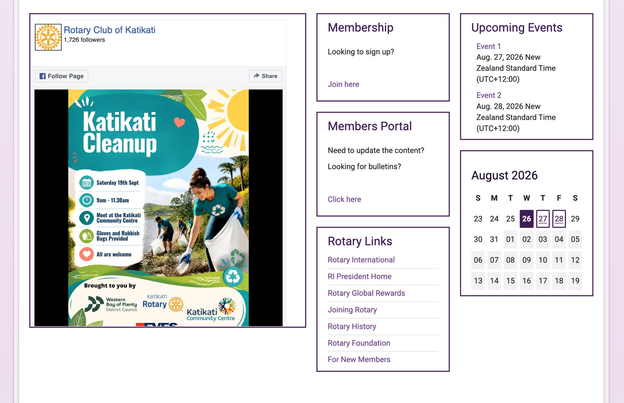
- Add Event to Calendar – Events Page
Published events displayed here

Add event to calendar takes you to a list that allows you to easily manage upcoming and past events. Don’t forget to publish events, any unpublished work will not be displayed on the front page.
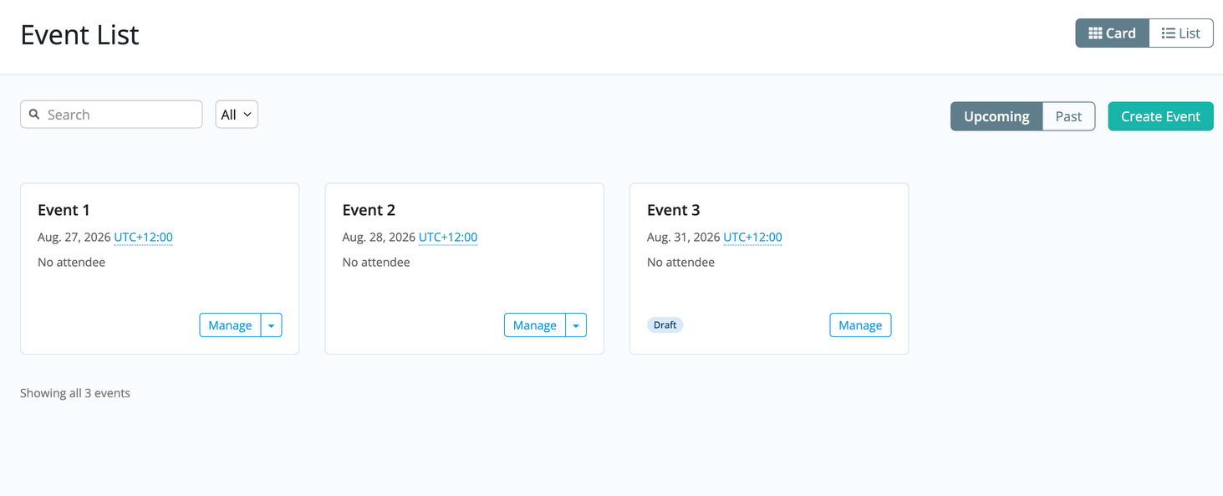
This feature utilises ClubRunners Could Events system. You’ll notice during the event set up there are a lot of options. For more information on what you can do, see https://www.clubrunnersupport.com/kb/articles/what-is-cloud-events.
Draft event not displayed

- Update Stories – Club News
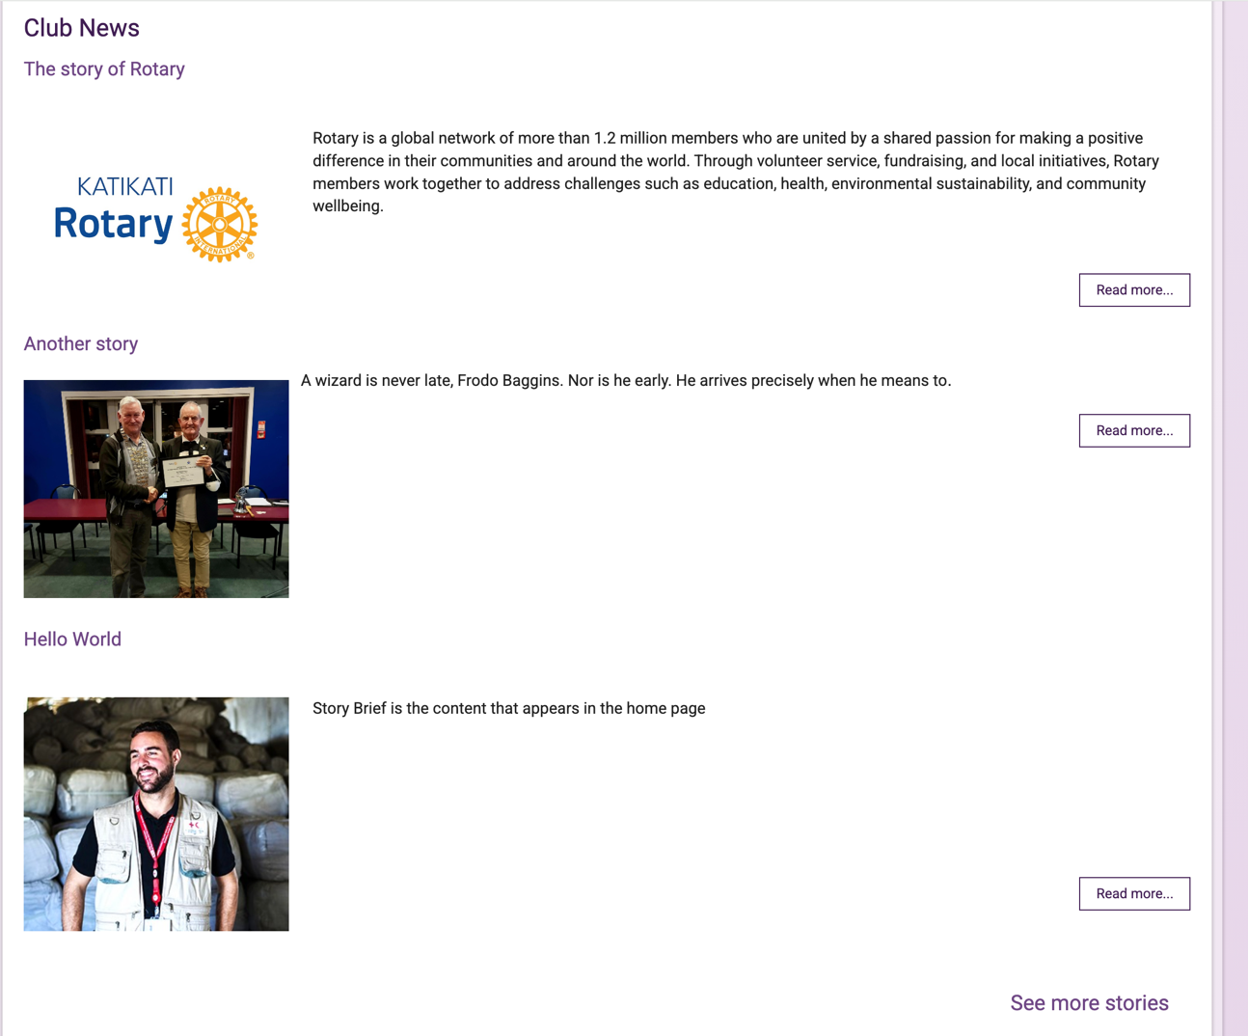
There is a distinction to be made between club news and stories page. Club news are the stories that appear on the home page, while the stories page is a another web page dedicated to displaying more stories.
Opens the full story
Link to stories page
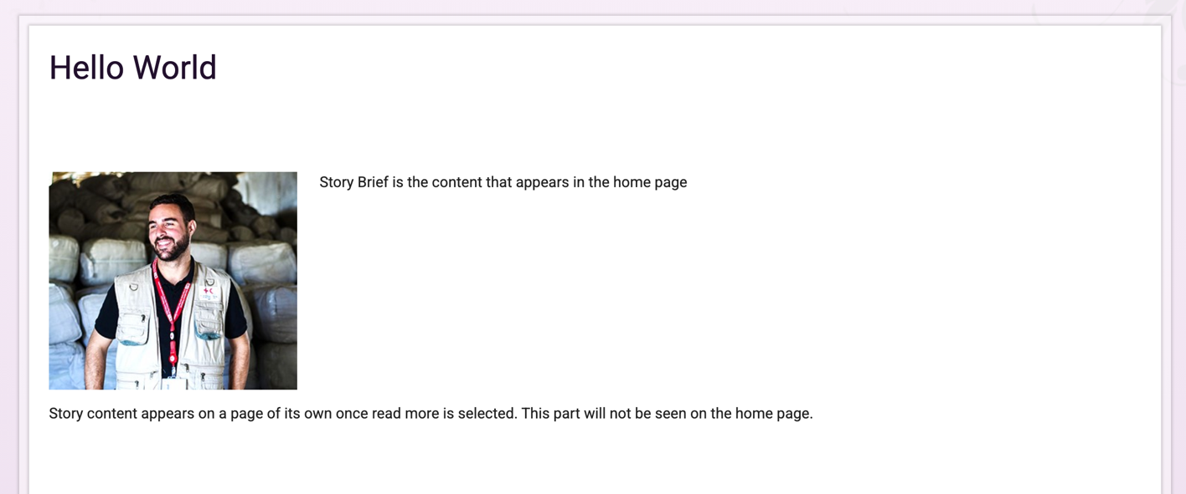
Story Content
Story brief

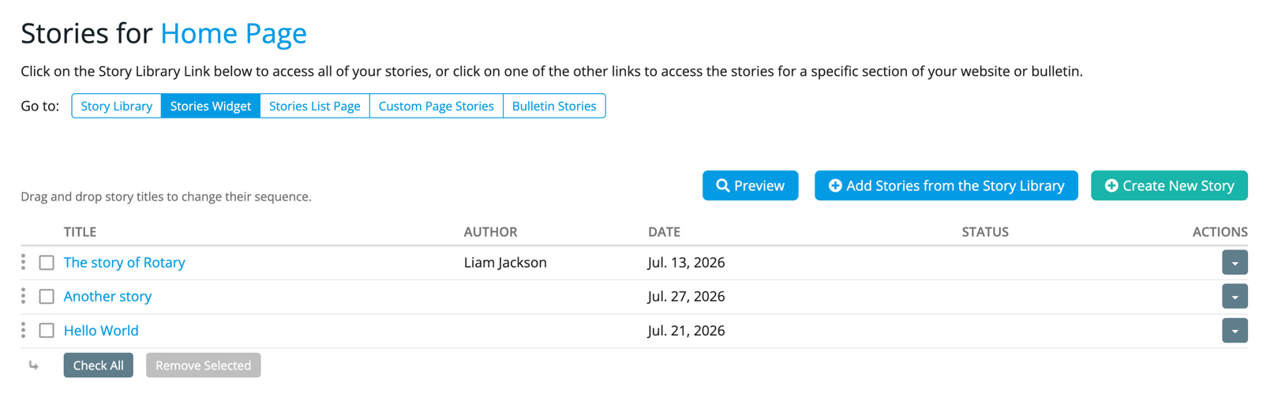
Drag to change order
Add new story or import one from the library
Edit or delete stories

- Update Stories – Stories Page

- Images
- Recommended image sizes
- Uploading/Replacing images
- Keeping images consistent
- This could be mentioned in each section
- Important things to avoid
- Maybe format check
- Maybe image placement / crop

