ME 2331/L Project 2: Design, Build, Test
Engineering Report: Can-Flipping Robot
Concept A: claw + wrist flip + turntable
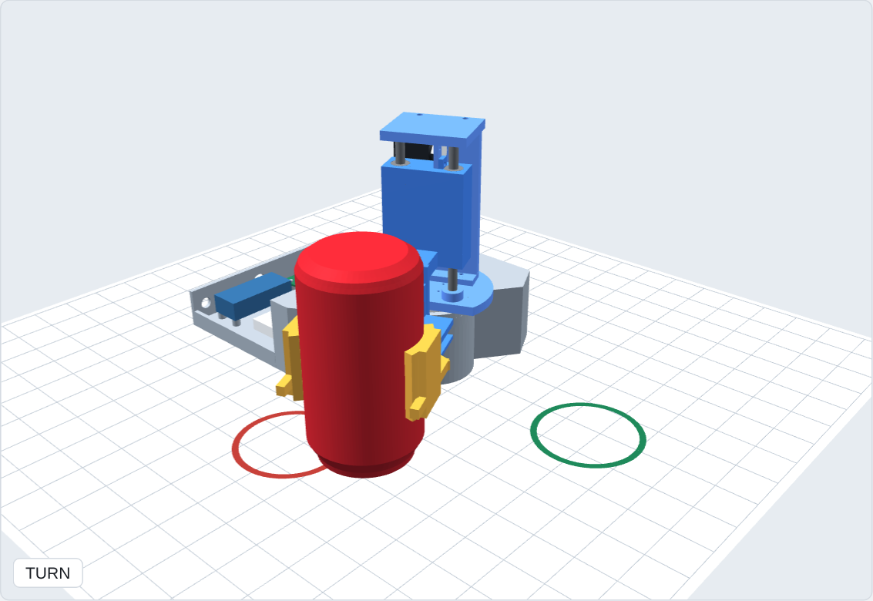
Team: [names]
Status: detail design complete and verified by analysis and simulation. Build and test results to be added after the demo.

1. Summary
An Arduino Uno robot picks up an empty standard 12 oz Coke can standing upright 5 in from the robot, turns it upside down, and sets it down free-standing 90° around the robot at the same 5 in radius, with one button press and no other human input.
The selected design (Concept A) is a small crane on a turntable. Four hobby servos move one at a time: grip → lift 0.6 in → wrist flips 180° → turntable turns 90° → lower → release, in 7.4 s.
Before ordering hardware, the design was verified as far as possible on the laptop:
- Detail CAD of every printed and purchased part, with PETG print tolerances and screws from the team's Harbor Freight #67675 kit.
- A collision check that runs the real firmware sequence through the CAD in 289 poses: no part touches another or the table, the can lands inverted at (127.0, 0.0) mm with 0.0° tilt, and the robot stays 37 mm inside its tip-over footprint.
- Mechanical analysis: lift clearance, grip force, servo torques (5× and 30× margins), lift jam check.
- Electrical analysis: servo signals replayed from the firmware, a current budget, and an ngspice/LTspice circuit run comparing two power designs. The Uno holds 5.00 V even with a servo stalled.
- The firmware compiles for the Uno (19.6 % flash) and runs the full sequence on an emulated ATmega328P.

2. Requirements
From the assignment: the robot must complete the test objective (TO1–TO3), use an Arduino Uno or similar, be operated by the microcontroller, fit a classroom tabletop, and need no direct human intervention. The test objective: start with the can upright and free-standing at the initial location (TO1); turn it upside down and move it about 90° around the robot at about 5 in (TO2); end with it free-standing and inverted at the target (TO3). Every requirement is traced to a design feature and its evidence in the RVTM (section 9).
Can (as modelled) | Value
Type | Standard 12 oz Coke can, empty
Diameter × height | 66.2 × 122.2 mm (2.61 × 4.81 in)
Mass | 15 g
Start / target | (0, 127) mm and (127, 0) mm from the turntable axis

3. Concept selection
Four concepts were developed and animated (docs/01_concepts_and_decision_matrix.md):
- Concept A: claw + wrist flip + turntable (selected).
- Concept B: cradle flip in place, then drag the can 90° on its rim.
- Concept C: multi-joint pincer arm with inverse kinematics.
- Concept D: one 180° roll about a 45° axis (mirror flip). The robot never visibly turns.
Two matrices were used: the team's weighted 1–5 matrix and a binary yes/no matrix in which every score carries the number behind it (docs/decision_matrix_and_bom.xlsx).
Matrix | A | B | C | D
Weighted team matrix (1–5) | 3.85 | 3.30 | 2.75 | 3.00
Binary matrix (of 10 criteria) | 8 | 6 | 5 | 6
Rank | 1 | 2 | 4 | 3

A wins because the 90° turn is literal and obvious, it uses only hobby servos with no encoder or closed-loop tuning, and every move can be tested on its own. Its cost is four actuators in series and the need for a lift: gripped at mid-height, the can's corner is 2.74 in from the grip point, 0.33 in more than the 2.41 in to the table, so it would dig into the table mid-flip without lifting 0.6 in first.

4. Design description
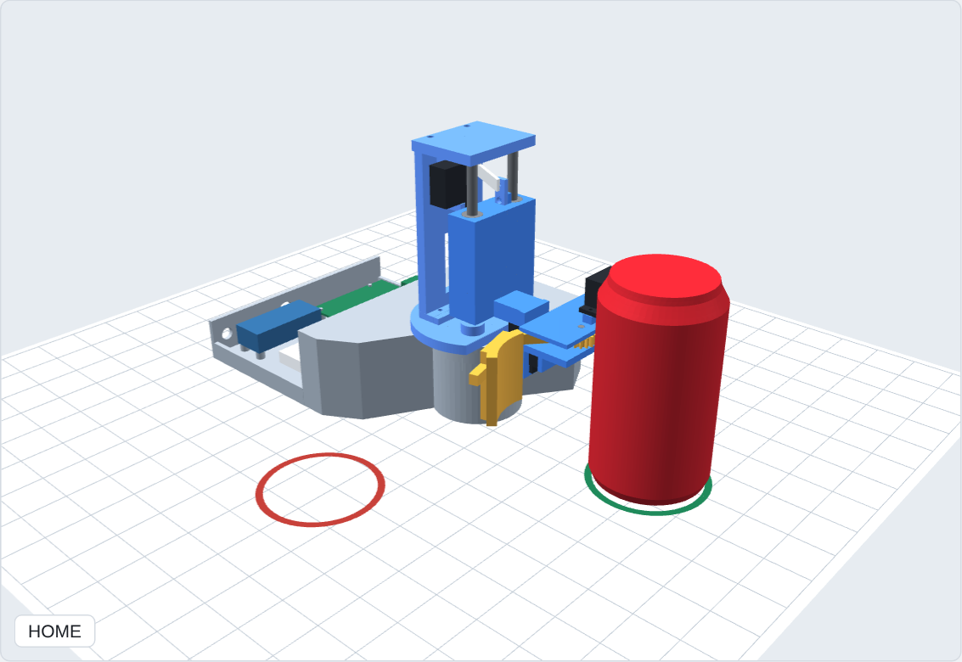
Figure 1. Detail CAD at HOME: arm at the start can (red ring); target is the green ring.
Subsystem | Design | Why
Base (CA-101) | Printed box with a bearing tower; the 175° sector the arm and can sweep is cut away | Holds the turntable; footprint keeps the CG ≥ 37 mm inside in every pose
Turntable | MG996R + 6807-2RS bearing (35 × 47 × 7 mm) carrying a D-shaped turret plate (CA-201) | The bearing takes the weight and tipping load, so the servo only turns it
Lift | Carriage + arm (CA-301) on 4 LM6UU bearings on two 6 mm rods; MG90S crank + link (CA-302) | 15.3 mm (0.6 in) stroke; jam ratio 0.018 (a printed slide would be 0.55)
Wrist | MG90S rolls the gripper 180° about the radial line through the can's centre | Flipping about the can's own centre means lowering 0.6 in sets it exactly on the table
Gripper | Gripper frame (CA-401) + two geared fingers (CA-402/403) with curved pads; SG90 | One servo closes both arms equally and centres the can; release opens only 25°
Electronics | Uno, 12 V adapter, XL4015 buck at 5.8 V, START button, status LED on a printed tray (CA-102) | Section 6

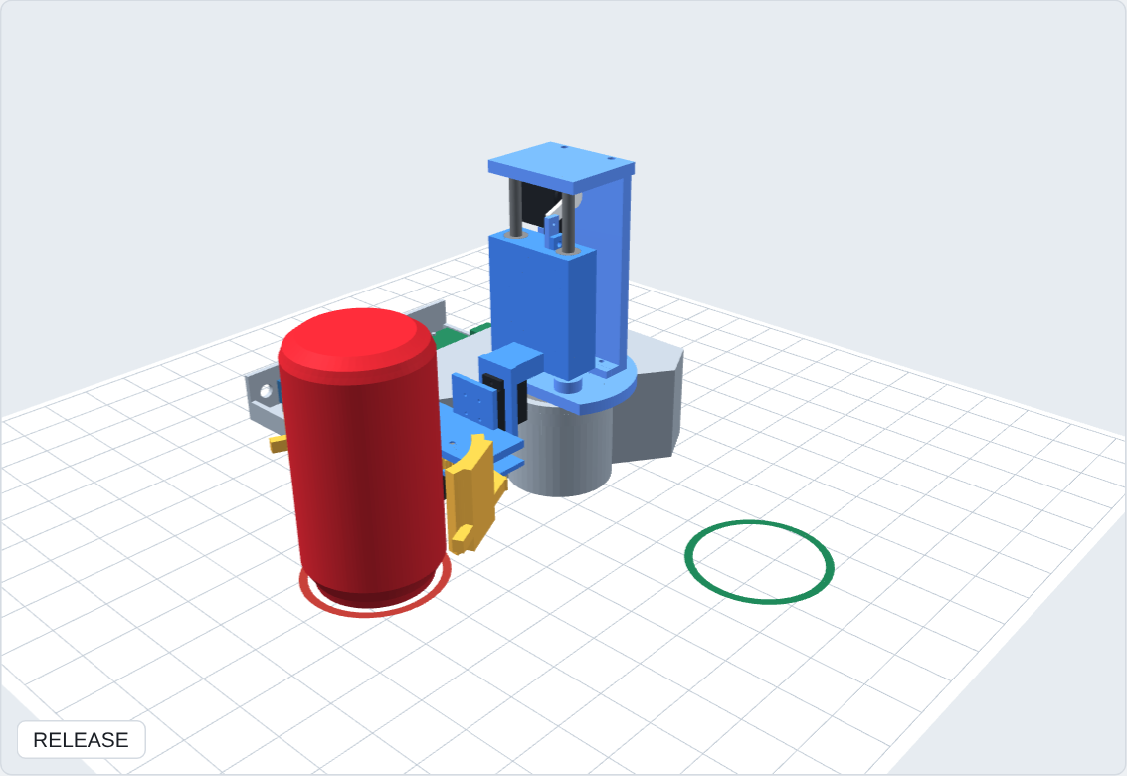
Figure 2. At the target after release: can inverted and free-standing, 90° around the robot.

4.1 Detail design changes found by the motion check
Running the real part shapes through the firmware sequence found problems the block-level PDR model missed. Each fix below closed a collision or margin the check reported:
- The original lazy-susan stack was as tall as the grip axis, so the wrist servo hit it: replaced by a 6807 bearing in a 28 mm tower and a D-shaped turret plate.
- The square base corner was in the can's path: the base is cut away in the swept sector.
- At the target the gripper is upside down, so opening fully swung an arm into the base: release opens only 25°, which still swings the pads 13 mm clear of the can.
- Un-flipping with the arms open would sweep them through the table: homing closes the arms first, and runs only after the can is lifted off.

4.2 Print tolerances and fasteners
Fit | Printed size (mm) | Used for
#6-32 clearance / pilot | 3.9 / 2.9 | Most joints; screws thread into the plastic (no nuts in the kit)
#8-32 pilot | 3.5 | MG996R flange
Servo-bag screw pilot | 1.7 | Servo tabs and horns
6 mm rod press | 6.00 | Guide rods
LM6UU press | 12.15 | Linear bearings
6807 housing / hub | 47.10 / 34.95 | Turntable bearing
Moving clearance | ≥ 0.5 | Fingers between the gripper plates

A tolerance coupon (CA-900) with all six hole sizes is printed first; if a fit is off, the TOL table in backend/cad/model.py is changed and every part regenerates. Screws: 8 × #6-32 × ½″ and 4 × #8-32 × ½″ from the HF #67675 kit.

5. Mechanical analysis
Check | Calculation / method | Result
Lift clearance | Can corner from the grip point √(1.30² + 2.41²) = 2.74 in vs 2.41 in to the table | Without lift −0.33 in (hits); 0.6 in lift → +0.27 in
Grip force | Minimum squeeze per arm = SF·m·a / (2μ) = 3 × 0.015 × 10.52 / (2 × 0.6) | 0.39 N; set 0.5–1 N (dent ~8 N; SG90 max 1.8 N at the 44 mm lever)
Lift servo | 149 g moving incl. can, CG 39 mm in front of the rods | 0.33 kg·cm vs MG90S 1.8 → 5×
Wrist servo | 58 g rotating, CG 10.3 mm off the roll axis | 0.06 kg·cm vs 1.8 → 30×
Turntable | J = 7.7 kg·cm², weight on the bearing | 0.032 kg·cm vs MG996R 9.4
Lift jam | Drawer effect 2μe/L with bushings 43 mm apart | 0.018 with LM6UU (printed slide 0.55)
Collisions | Solid booleans, 289 poses, run + homing | None; tightest moving gaps 0.5 mm (designed)
Tip-over | CG vs convex hull of base + tray; dynamic ZMP with all inertial forces | ≥ 37 mm static, ≥ 36.7 mm dynamic, inside in every pose
Landing | Can pose after LOWER | (127.0, 0.0) mm, inverted, 0.0° tilt, z = 0.00
Error budget | Turntable error → landing offset 5 in × sin(e) | 1° → 0.09 in, 2° → 0.17 in

Mass: 564 g robot (294 g printed PETG, 270 g purchased) + 15 g can. The full engineering check (backend/mech/mech_checks.py → cad/check/mech_report.txt) runs 43 checks on servo torque and speed (inverse dynamics from CAD masses and inertias), the lift slider-crank, the gears (contact ratio, undercut, Lewis bending), can friction through every acceleration, dynamic stability, strength, stiffness and power: all 43 pass.

6. Electrical design
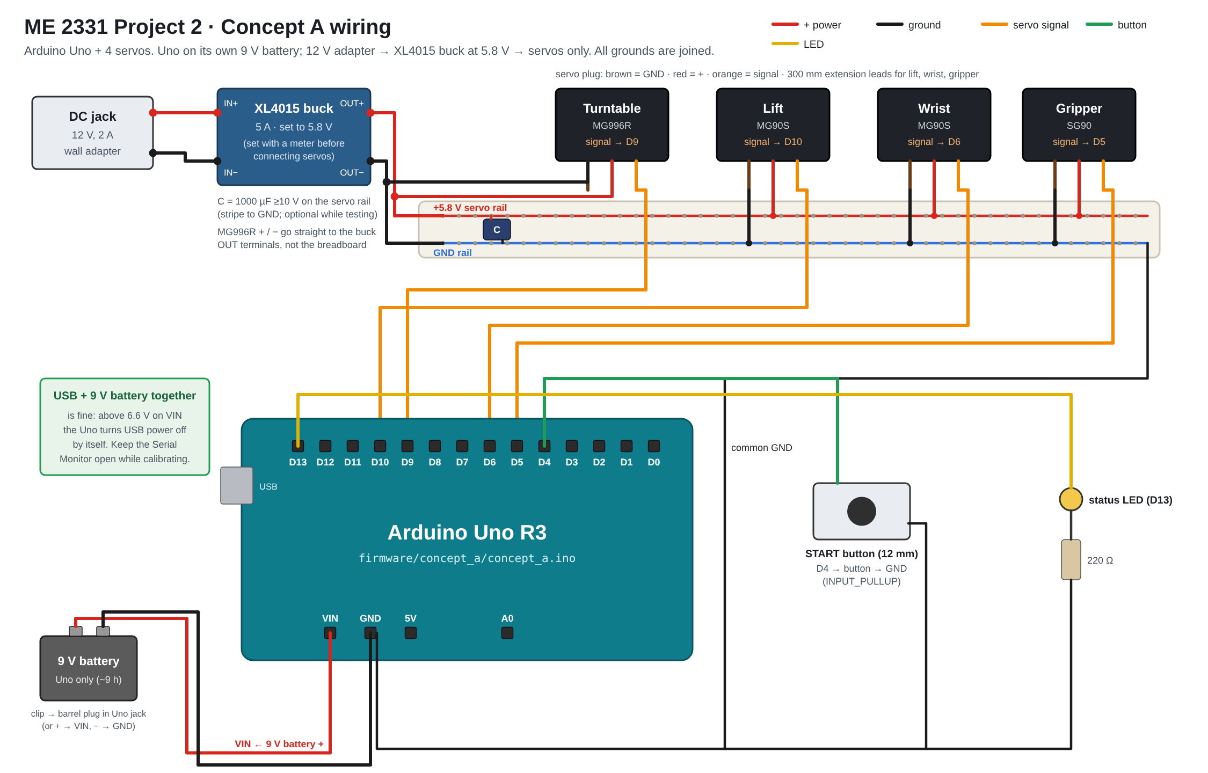
Figure 3. Wiring diagram (breadboard style, as drawn in Fritzing).
Uno pin | Connects to | Notes
D9 | Turntable servo MG996R signal | Power on the buck terminals
D10 | Lift servo MG90S | 300 mm extension
D6 | Wrist servo MG90S | Pulse range widened to 500–2500 µs to reach 180°
D5 | Gripper servo SG90 | 300 mm extension
D4 | START button to GND | INPUT_PULLUP, debounced
D13 | Status LED + 220 Ω | 13.6 mA
VIN / GND | 12 V adapter | Uno makes its own 5 V

6.1 Power: why a buck converter
Two power designs were simulated in ngspice with the real servo currents: (A) one 5 V 4 A adapter feeding the servos and the Uno's 5V pin, and (B, selected) a 12 V 2 A adapter feeding the Uno's VIN plus an XL4015 buck at 5.8 V for the servos. Both pass the normal run; only B passes the fault cases.
Check (limit) | A normal | A stall | B normal | B stall
Uno 5 V (≥ 4.5 V) | 4.86 | 4.43 ✘ | 5.00 | 5.00
Servo supply (≥ 4.8 V) | 4.82 | 4.25 ✘ | 5.72 | 5.50
Adapter current | 0.66 / 4 A | 3.16 / 4 A | 0.38 / 2 A | 1.79 / 2 A
USB while powered | not allowed |  | allowed

The buck also lets USB stay plugged in for calibration (the Uno switches USB power off above 6.6 V on VIN). A 9 V battery was rejected: it supplies about 0.5–1 A, and one servo stall needs 2.5 A. Power decision matrix: 12 V + buck 7/9, 5 V direct 6/9, LiPo 5/9, 9 V battery and AA pack 4/9.
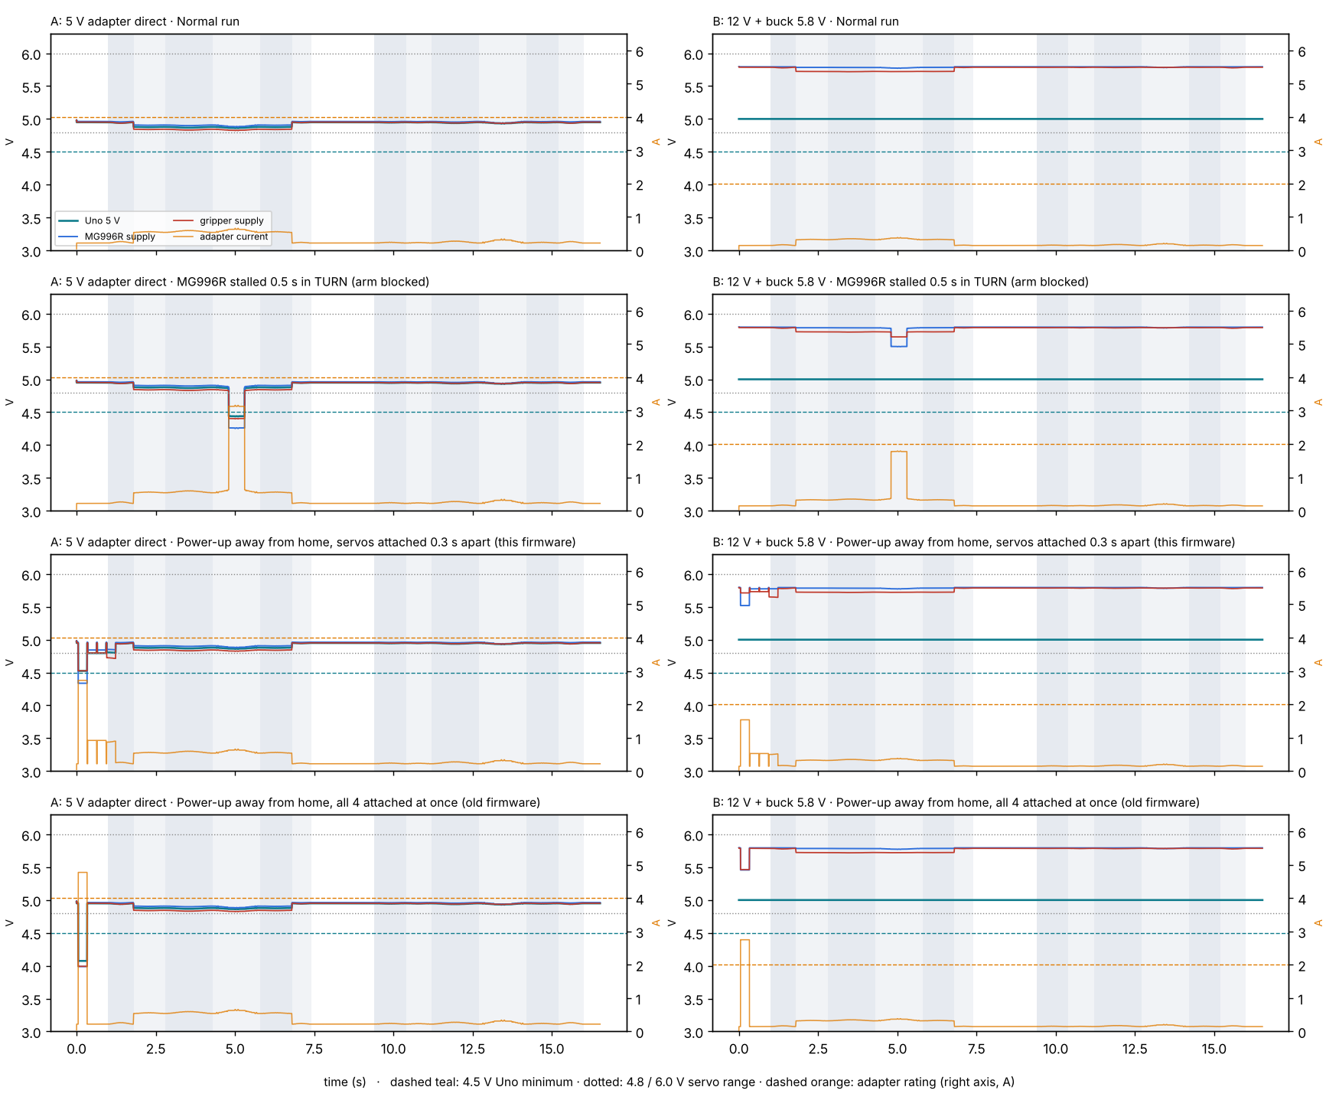
Figure 4. ngspice: both power designs in the normal run, a stall, and power-up away from home.

6.2 Current budget
Step | Peak current
GRIP | 0.26 A
LIFT | 0.56 A
FLIP | 0.60 A
TURN | 0.65 A (largest)
LOWER | 0.56 A
RELEASE | 0.24 A
Homing steps | ≤ 0.34 A

The largest steady load is the gripper holding the can: 0.8 N per arm × 44 mm × 2 arms = 0.72 kg·cm, 45 % of the SG90's stall torque, about 0.29 A for 5 s. Two rules came out of the analysis: the MG996R's power goes straight to the buck terminals (its 2.5 A stall would exceed a breadboard contact's ~1 A), and the firmware attaches the servos 0.3 s apart so a power-up away from home never pulls all four stall currents at once (4.7 A).

7. Code discussion
The firmware is one Arduino sketch (firmware/concept_a/concept_a.ino) using only the built-in Servo library, so it runs unchanged in the Arduino IDE, Tinkercad and Wokwi.
- Sequence as data. The run is a table of steps; each row holds the target angle of all four servos and a move time. The loop blends from the current pose to the next row, so changing the sequence never touches the logic.
- Eased moves. Every move follows a minimum-jerk curve s³(10 − 15s + 6s²): speed and acceleration are zero at both ends, so the light can isn't shaken loose. The loop updates every 10 ms; the Servo library sends a new pulse every 20 ms.
- State machine. IDLE → (button) → RUNNING → DONE → (can removed, button) → RETURNING → IDLE. Homing only runs after the can is lifted off, because the open arms straddle it.
- Calibration. All angles are named constants at the top (TURN_START, LIFT_UP, GRIP_CLOSED, …); calibration never touches the logic. PRINT_ANGLES streams the angles to the Serial Plotter.
- Power-up. The home pose is written before attach(), and the servos are attached 0.3 s apart.
- Status LED. Off = idle, blinking = moving, on = done.
Step | D9 turntable | D10 lift | D6 wrist | D5 gripper | Time
HOME | 135° / 1936 µs | 30° / 853 | 0° / 500 | 20° / 750 | —
GRIP | 135° | 30° | 0° | 95° / 1523 | 0.8 s
LIFT | 135° | 75° / 1317 | 0° | 95° | 1.0 s
FLIP | 135° | 75° | 180° / 2500 | 95° | 1.5 s
TURN | 45° / 1008 | 75° | 180° | 95° | 1.5 s
LOWER | 45° | 30° / 853 | 180° | 95° | 1.0 s
RELEASE | 45° | 30° | 180° | 70° / 1265 | 0.6 s
Table: servo angle / pulse width at the end of each step (pulse = map(angle, 0, 180, min, max) µs).
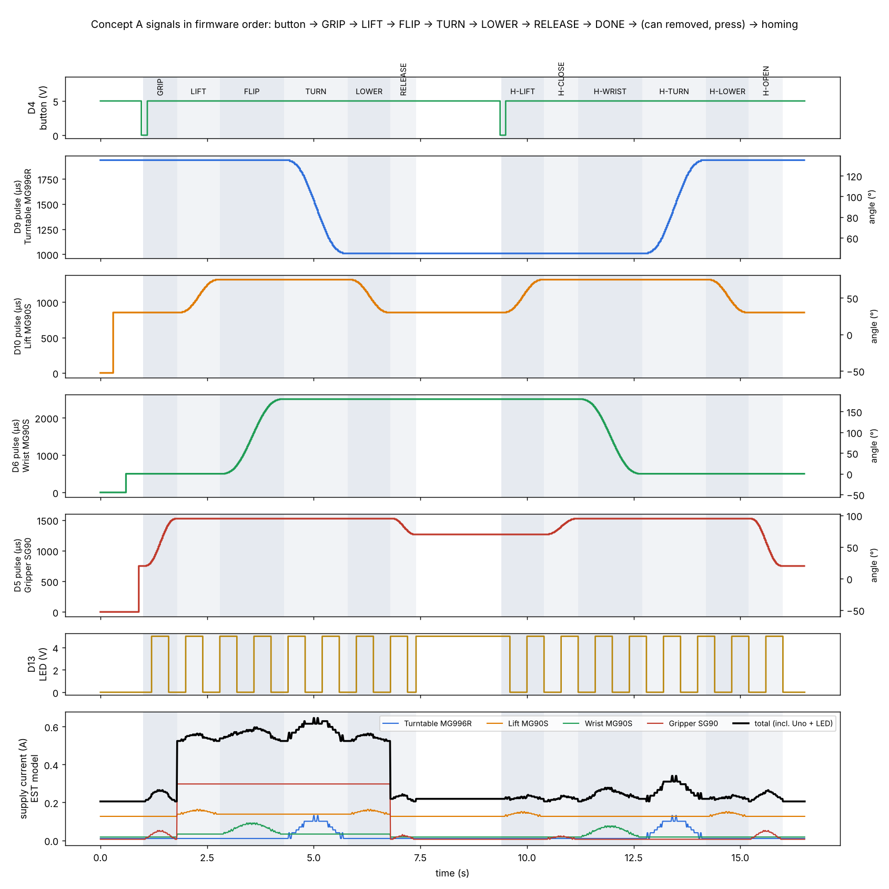
Figure 5. Button, servo pulse widths, LED and supply current in firmware order, replayed from the code.
Verification: the sketch compiles to 6.4 KB (19.6 % flash, 24.5 % RAM) and runs the full GRIP → RELEASE → DONE sequence on an emulated ATmega328P (backend/tools/emulate_concept_a.sh); the Wokwi and Tinkercad circuits run the same sketch.

8. Bill of materials
Designed parts (3D printed in PETG unless noted). Drawings for every part are in the appendix (docs/drawings/all_drawings.pdf).
Part no. | Part | Material | Qty | Mass (g)
CA-101 | Base | PETG | 1 | 101.9
CA-102 | Electronics tray | PETG | 1 | 56.9
CA-201 | Turret plate | PETG | 1 | 24.4
CA-202 | Spine | PETG | 1 | 21.5
CA-203 | Top cap | PETG | 1 | 10.5
CA-301 | Carriage + arm | PETG | 1 | 45.8
CA-302 | Lift link | PETG | 1 | 0.2
CA-401 | Gripper frame | PETG | 1 | 11.7
CA-402 | Finger, right | PETG | 1 | 9.7
CA-403 | Finger, left | PETG | 1 | 9.7
CA-404 | Can bumper | Silicone sheet | 1 | 0.1
CA-900 | Tolerance coupon | PETG | 1 | 8.2

Purchased parts. Every item in docs/05_bom.md also states why it is needed and which alternative was rejected (for example, a physical START button instead of an IR remote: one wire, nothing to pair, no stray triggers).
Part no. | Item | Qty | Unit $ (EST) | Used for
CA-P01 | Arduino Uno R3 | 1 | have | Controller
CA-P02 | Servo MG996R | 1 | 9 | Turntable (D9)
CA-P03 | Servo MG90S | 2 | 4 | Lift (D10) + wrist (D6)
CA-P04 | Servo SG90 | 1 | have | Gripper (D5)
CA-P05 | Ball bearing 6807-2RS | 1 | 5 | Turntable
CA-P06 | Linear bearing LM6UU | 4 | 1 | Lift carriage
CA-P07 | Steel rod 6 mm (h6), 300 mm long | 1 | 5 | Lift guide rods
CA-P08 | Wall adapter 12 V, 2 A | 1 | 8 | Uno VIN + buck input
CA-P09 | Buck converter XL4015 | 1 | 5 | Servo rail
CA-P10 | DC panel jack | 1 | 1 | Power input
CA-P11 | Electrolytic capacitor | 1 | have | Servo rail
CA-P12 | Push button | 1 | have | START (D4)
CA-P13 | LED + 220 Ω resistor | 1 | have | Status (D13)
CA-P14 | Mini breadboard | 1 | have | Servo rail
CA-P15 | Jumper wires | 20 | have | Signals, ground
CA-P16 | Servo extension lead | 4 | 1 | Lift, wrist: 300; gripper: 500; 1 × 300 cut for the MG996R
CA-P17 | Zip ties + adhesive tie mounts | 8 | 0.5 | Tie points: arm beam, carriage side, back of spine, base floor, tray
CA-P18 | Machine screw #6-32 × ½″ | 8 | have | Tray 2, spine 2, top cap 2, link 1, gear axle 1
CA-P19 | Machine screw #8-32 × ½″ | 4 | have | MG996R flange
CA-P20 | Servo-bag screws | 14 | have | Servo tabs, horns, crank
CA-P21 | Silicone rubber sheet | 1 | 6 | Finger pads + can bumper
CA-P22 | Steel washers + rubber feet | 1 | 3 | Base
CA-P23 | PETG filament | 1 | have | Printed parts

Spend beyond what the team already has: ≈ $62 (typical online prices).

9. Requirements verification traceability matrix
Method: A = analysis, I = inspection, D = demonstration, T = test. Status as of the detail design, before hardware.

9.1 Assignment requirements
ID | Requirement | Design feature | Method | Evidence | Status
R1 | Complete the test objective (TO1–TO3) | Turntable + lift + wrist flip + gripper, one move at a time | D, T | Part B demo; backend/tools/emulate_concept_a.sh | Emulated ✔, hardware pending
R2 | Arduino Uno or similar | Arduino Uno R3 | I | BOM CA-P01; 6.4 KB (19.6 %) flash, 24.5 % RAM | ✔ (build)
R3 | Operated by the microcontroller | The Uno runs the whole sequence from concept_a.ino. No laptop needed | I, D | Firmware | Design ✔
R4 | Sized for a classroom tabletop | 167 × 331 mm footprint incl. the electronics tray and the can (6.6 × 13 in), 168 mm (6.6 in) tall, 571 g | I | Drawing CA-000; cad/step/concept_a_assembly.step | Detail CAD ✔
R5 | No direct human intervention | One START press; the rest is automatic | D | Firmware; backend/tools/emulate_concept_a.sh | Emulated ✔

9.2 Test objective
ID | Requirement | Design feature | Method | Evidence | Status
TO1 | Start: can upright, free-standing, at the initial location | Can placed against the bumper; gripper closes at START | D | Firmware GRIP step, cad/check/check_report.txt | Design ✔
TO2a | Turn the can upside down | Wrist rolls 180° about the radial line through the can's centre | A, T | backend/sim/concept_a.py § 1 | Analysis ✔
TO2b | Move ~90° about the robot at ~5 in | Turntable 90°, can held at r = 127 mm (5.0 in) | A, T | CAD check: can lands at (127.0, 0.0) mm; error budget 2° → 0.17 in | CAD ✔
TO3 | Ends free-standing, inverted, at the target | Lowered back the same 0.6 in, so it's set down, not dropped | A, T | CAD check: inverted, 0.0° tilt, bottom at z = 0.00 mm; 02_design_analysis.md § 1, § 6 | CAD ✔, bench pending

9.3 Derived design requirements
ID | Requirement | Rationale | Method | Evidence | Status
DR1 | Lift ≥ 0.6 in before the flip | The can corner dips 0.33 in below the table mid-flip | A | Clearance +0.27 in at 0.6 in lift | ✔
DR2 | Wrist reaches 180° ± 3° | Tilt at release; tip-over at 24° | T | Servo range test | Pending
DR3 | Turntable 90° ± 2° | Landing within 0.17 in | T | Calibrate TURN_TARGET | Pending
DR4 | Grip ≥ 0.39 N per arm, below the dent force | Slip vs dent | A, T | backend/sim/concept_a.py § 3; crush test | Analysis ✔, test pending
DR5 | Lift carriage slides without jamming (2μe/L < 1) | Drawer effect | A, T | CAD masses: LM6UU 0.018; printed slide 0.55 (rejected) | Analysis ✔
DR6 | Servo supply stays in the 4.8–6.0 V rating, Uno ≥ 4.5 V, in a normal run and a servo stall | Stall 2.5 A; the Uno must not misbehave | A (SPICE), T | EE/README.md: servos ≥ 5.50 V, Uno 5.00 V (12 V + buck 5.8 V) | Simulated ✔, bench pending
DR7 | Moves eased (zero speed and accel at both ends) | Don't shake the 15 g can loose | A, T | concept_a_sequence.png; emulator log | ✔
DR8 | Home only after the can is removed | The open arms straddle the can | D | Firmware DONE → button → HOMING | Design ✔
DR9 | No part collides with another or the table in any pose of the run and homing | 4 joints moving near each other and the can | A | backend/cad/check.py: 289 poses, solid booleans → no collisions | CAD ✔
DR10 | Robot doesn't tip over | Arm + can reach 5 in out | A | CG stays ≥ 39 mm inside the footprint in every pose | CAD ✔
DR11 | Printed fits work in PETG (screws, rods, bearings) | No nuts; press fits | T | Tolerance coupon CA-900 | Pending (print first)
DR12 | Power-up away from home stays within the adapter rating | All 4 servos jumping = 4.7 A | A (SPICE), D | Servos attached 0.3 s apart → 1.54 A of 2 A | Simulated ✔
DR13 | Gripper holds without stalling the SG90 | Squeeze 0.5–1 N per arm; SG90 max 1.8 N per arm at the 44 mm lever | A, T | EE/README.md § 2: 0.72 kg·cm = 45 % of stall | Analysis ✔, bench pending

10. Test plan and results
Results are filled in after the build. Pass criteria come from the derived requirements.
Test | Procedure | Pass criterion | Result
Tolerance coupon (DR11) | Print CA-900; fit screws, rod, LM6UU | Screws thread, rod and LM6UU press in by hand
Buck setting (DR6) | Meter on OUT before servos | 5.8 ± 0.1 V
Wrist range (DR2) | Command 0° and 180° | 180° ± 3°
Turntable (DR3) | Calibrate TURN_TARGET | 90° ± 2°; can within 0.17 in
Grip (DR4, DR13) | Close on a scrap can; shake | Holds; no dent; SG90 not hot
Rail under load (DR6) | Meter on the rail during a run | ≥ 5.5 V servos, Uno 5 V
Full run (R1, TO1–TO3) | 10 runs from the start mark | Can inverted, free-standing at the target in ≥ 9 of 10

11. Conclusion
Concept A meets every requirement that can be checked before hardware: the motion runs collision-free through the full firmware sequence, the can lands inverted and level at the target, every servo has at least a 5× torque margin, and the power design keeps the Uno at 5.00 V even with a servo stalled. The remaining risks are the ones only hardware can settle: whether the wrist servo reaches a full 180°, the grip squeeze, and the printed fits. Each has a planned test and a mitigation (wider wrist pulse range, the GRIP_CLOSED constant, and the tolerance coupon).

Appendix A. Drawings
13 sheets, one per designed part plus the assembly, generated from the CAD (backend/cad/drawings.py): third-angle views, overall dimensions, a hole table with fits and positions, and a title block. Full set: docs/drawings/all_drawings.pdf.
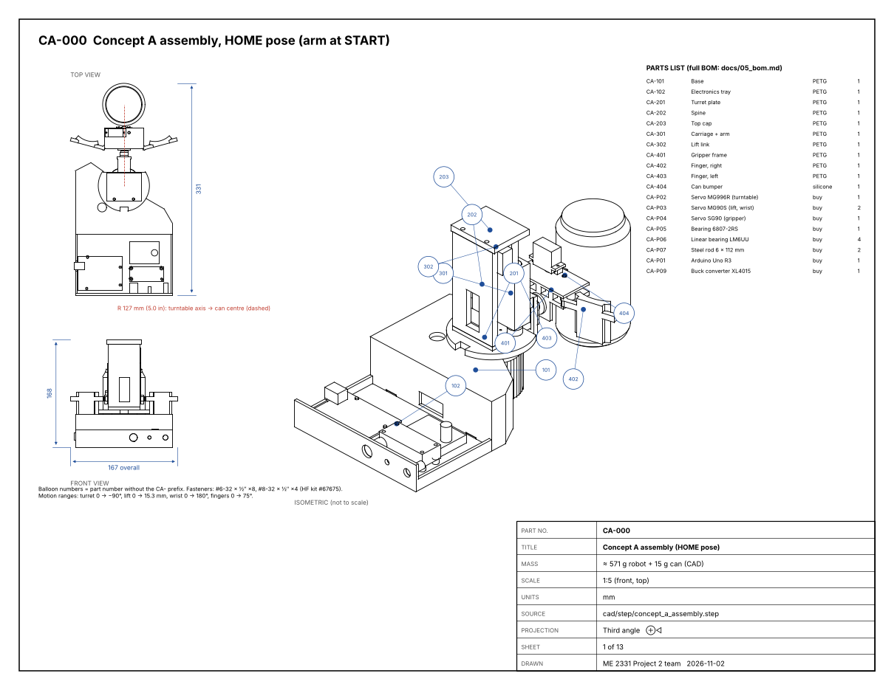
Sheet 1: assembly CA-000.

Appendix B. Files
What | Where
Detail CAD, STEP and STL | cad/ (model.py, out/)
Collision / mass / load check | backend/cad/check.py → cad/check/check_report.txt
Drawings | docs/drawings/
Firmware | firmware/concept_a/concept_a.ino
Electronics calculations and LTspice | EE/
BOM and decision matrices | docs/05_bom.md, docs/decision_matrix_and_bom.xlsx
Wiring | docs/04_wiring.md, docs/wiring/

