JACKPOTS WORLD TOURS & TRAVELS

Complete Technical Project Documentation Report
Volume 1 – Master Report (Chapters 1–8, 10, 12–20)
How the platform works, from the browser to the database and back
Project | JackPots World Tours & Travels – owner-operated travel company (B2B merchant portal + B2C customer website)
Document version | 1.0 (first complete code-derived edition)
Preparation date | 2026-11-07
Source analysed | GitHub repository jackpotsworldtourstravels/JackPotsworldtoursandtravels, branch main, commit ca9a64d6 (merged 2026-11-05). Analysed from a clean git archive of origin/main, not from the working tree.
Volumes | Vol 1 = this master report. Vol 2 = Chapter 9 (API catalogue, 405 entries). Vol 3 = Chapter 11 (database dictionary, 72 active tables).
Status of evidence | Static code analysis plus test runs performed during this review (see Chapter 15). No production system, live database, payment gateway or supplier was contacted.

Table of Contents
Document Control 5
Revision history 5
Review and approval 5
How the three volumes fit together 5
Evidence labels used throughout 5
Feature status labels (Chapter 17) 5
Scope, method and limits 6
1. Executive Summary 7
1.1 What the project is 7
1.2 Business purpose and the problem it solves 7
1.3 Target users 7
1.4 Major features (verified counts) 7
1.5 Business model (B2B and B2C) 8
1.6 Current development status 8
1.7 Technology overview 8
2. Complete System Architecture 10
2.1 Overall architecture 10
2.2 Frontend architecture 10
2.3 Backend architecture 11
2.4 Database architecture 11
2.5 API communication 11
2.6 Authentication and authorization (summary) 11
2.7 External services and integrations 11
2.8 Background processing 11
2.9 Deployment architecture 11
2.10 How one user action travels to the database and back 12
3. Portal Architecture and User Roles 13
3.1 Customer website 14
3.2 Merchant Portal (classic) 14
3.3 Admin portal 14
3.4 Manager portal 15
3.5 Super Admin portal 15
3.6 Operations workspace 15
4. B2C Customer Website 16
4.1 Shared widgets included by most pages 16
4.2 Page inventory 16
4.3 Page-by-page trace 17
Contact Us – contact-us.html 17
Cruises – cruises.html 18
My Account – customer/dashboard.html 18
Forgot Password – customer/forgot-password.html 18
Create Account – customer/register.html 19
Reset Password – customer/reset-password.html 19
Hotels – destination-hotels.html 19
Destination – destination.html 20
Destinations – destinations.html 20
Flights – flights.html 20
Gaming Tour Enquiry – gaming-packages.html 21
Hotels – hotels.html 21
JackPots World Tours & Travels – index.html 22
Places to visit – location.html 22
My Bookings – my-bookings.html 23
Tour package – package.html 23
Tour Packages – packages.html 24
Register – register.html 24
Ticket Verification – ticket-verify.html 24
4.4 Static and policy pages 25
4.5 Feature-by-feature (B2C) 25
5. B2B Merchant Portal 27
5.1 Login, session and access control 27
5.2 Navigation 27
5.3 Features, screens, scripts and APIs 27
5.4 Script inventory 30
5.5 Permissions 31
5.6 Workflow: request → approval → booking → payment → completion 32
5.7 Premium / Partner workspace (frontend/merchant/index.html) 33
6. Admin Portal 35
6.1 Access 35
6.2 Sections, scripts and APIs 35
6.3 Required feature coverage check 37
6.4 Permissions held by role admin 37
6.5 Admin script inventory 38
7. Manager and Operations Workspaces 41
7.1 Manager portal 41
7.2 Manager versus Admin versus Merchant 41
7.3 Operations workspace 41
7.4 Assignment and escalation 44
8. Super Admin Portal 45
9. Complete API Documentation (summary) 47
10. Backend Architecture and Business Logic 49
10.1 Structure of backend/app 49
10.2 Request lifecycle inside the backend 49
10.3 Key mechanisms explained 50
10.4 Validation, errors, logging, background tasks 50
10.5 Schemas and response shape 50
11. Complete Database Documentation (summary) 51
12. Complete Business Workflows 53
12.1 Date change (workflow 11) 59
12.2 Passenger modification (workflow 12) 59
12.3 Support tickets (workflow 14) 59
12.4 Additional workflows found 59
13. Integrations and External Services 61
14. Security Architecture 62
14.1 Controls and where they live 62
14.2 Weaknesses and concerns 62
15. Testing and Quality Assurance 64
15.1 Inventory 64
15.2 Results actually obtained in this review 64
15.3 Results reported in repository documents (not re-executed) 64
15.4 Gaps and inconsistencies 64
16. Deployment and Environment Setup 66
16.1 Local development (from README and config) 66
16.2 Environment variables (names only) 66
16.3 Production architecture 66
17. Current Project Status and Gap Analysis 68
17.1 Gaps by category 68
18. Future Architecture Recommendations 69
Immediate (next 1–2 months) 69
Medium term (3–6 months) 69
Long term 69
19. Glossary and Learning Guide 70
20. Source Code Reference Index 71
20.1 Full backend module inventory 71
20.2 Frontend script inventory 78
Appendix A. Inspected and Pending Verification 84
A.1 Inspected (read or machine-scanned) 84
A.2 Pending Verification 84
A.3 Reproducing this report’s numbers 84

(If the page numbers above are blank, right-click the table in Word and choose Update Field.)

Document Control

Revision history
Version | Date | Author | Change
1.0 | 2026-11-07 | Claude Code (automated analysis session) for the project owner | First complete edition built from main @ ca9a64d6

Review and approval
Role | Name | Date | Signature
Project owner
Technical reviewer

How the three volumes fit together
Table 1. Report volumes
Volume | File | Contents
1 | JackPots_Vol1_Master_Report.docx | Executive summary, architecture, portals, customer site, merchant/admin/manager/super-admin portals, backend, workflows, integrations, security, QA, deployment, gap analysis, roadmap, glossary and source index.
2 | JackPots_Vol2_API_Catalogue.docx | Chapter 9 – every route entry grouped by portal and router module, with auth, roles, parameters, schemas, errors, tables and frontend callers.
3 | JackPots_Vol3_Database_Dictionary.docx | Chapter 11 – table-by-table data dictionary, ERDs, migration history, enumerations and data flows.

Chapters 9 and 11 are summarised in this volume (Sections 9 and 11) and cross-referenced to the full text. Chapter numbers are the same in every volume.

Evidence labels used throughout
Table 2. Evidence labels
Label | Meaning
Verified from code | Read in a source file on main, or produced by running code/tests in this review. The file path (and function or line) is given.
Reported in repository documents | Stated by a document in the repository (for example qa/*.md) but not re-executed here.
Not verified | Could not be confirmed from the available source. Written exactly as “Not verified from the available source code.” where required.
Design intent | A comment or document says this is planned or intended; the code does not (yet) prove it.

Feature status labels (Chapter 17)
Status | Meaning
Implemented in code | Code path exists end to end (UI → API → service → table) and was read.
Partially implemented | Some layers exist; a layer or a case is missing.
Configuration-dependent | Works only when an environment variable/credential/provider is set; behaviour then depends on that outside system.
Planned/deferred | Explicitly deferred or described as future work in code or docs.
Unverified | Code exists but behaviour could not be confirmed.
Not found | No implementation found in the repository.

Scope, method and limits
- Method: (1) exported a clean snapshot of origin/main; (2) scanned all 60 router files with a Python AST parser to list routes, dependencies, parameters and handler functions; (3) imported the real FastAPI application to obtain its OpenAPI schema (404 operations) and the role-permission matrix; (4) parsed all SQLAlchemy models (111 table classes) and all 94 Alembic revisions; (5) matched string literals in 178 frontend scripts to routes to find callers; (6) read the main services, auth, payment, chat, OCR, storage and deployment modules; (7) ran the automated test suites (Chapter 15).
- The working tree on the owner’s machine has 85 uncommitted modified files and an uncommitted mobile-app/ folder (an Expo mobile client). They are not part of main and are excluded here; the mobile app is therefore reported as outside the verified scope.
- No credentials, tokens or secrets are reproduced. Where the code contains a seeded default administrator password, only the fact is reported (Chapter 14).
- Because the repository contains very large modules (for example ticket_service.py 1,827 lines, travel_ai_assistant.py 2,420 lines), services were characterised from their module documentation, function inventory and call sites; every line was not individually audited. Gaps are listed in the “Pending Verification” appendix.

1. Executive Summary

1.1 What the project is
JackPots World Tours & Travels is a travel-booking platform for a real, owner-operated company. In plain terms it is one web application that serves two kinds of customer: (1) businesses (gaming companies, corporates, travel agencies and partners) that sign in to a Merchant Portal to request flight tickets, hotels, visas and holiday packages from the company’s staff; and (2) members of the public who use a customer website to search and book flights, hotels and tour packages and pay online.
Technically it is a FastAPI (Python) backend with a PostgreSQL database and a hand-written HTML/CSS/JavaScript frontend that the same backend serves. There are five separate sign-in portals (customer, merchant, admin, manager, super admin) plus an Operations workspace that re-uses a staff or merchant session.

1.2 Business purpose and the problem it solves
- B2B desk (Verified from code: enquiry_service, ticket_service, manager_service, wallet_service). A merchant sends an enquiry for a sector or a hotel; the company’s Admin desk quotes it; the merchant raises a booking request; a Manager approves it (Classic Tours track) or the booking goes through approval, payment and ticketing (standard track); documents, invoice and ticket are produced; the merchant’s prepaid wallet is debited. This replaces phone/WhatsApp/spreadsheet handling with a tracked, permissioned workflow.
- **B2C site (Verified from code: customer_* routers/services).** Customers search flights (demo or Duffel supplier), hotels and packages, see server-computed prices, book, and pay through a provider-verified payment flow; they get an e-ticket with a verification QR, a wishlist, notifications, live chat and voice calls with support, and an AI travel assistant.
- Company back office. Admin, Manager and Super Admin portals manage merchants, bookings, payments, wallets, catalogue content, cancellations/refunds, reviews, reports and audit logs.

1.3 Target users
Table 3. Target users
User | Portal | Typical tasks
Public traveller / customer | Customer website | Search, book, pay, manage bookings, chat/call support
Merchant admin | Merchant Portal | Raise enquiries and bookings, approve staff requests, top up wallet, manage team, reports
Merchant staff (manager, supervisor, operator, finance, data operator) | Merchant Portal | Role-limited subsets of the same screens
Platform Admin | Admin portal | Quote enquiries, approve/issue, verify payments, run B2C desks and catalogue, support
Platform Manager | Manager portal | Sign off submitted Classic Tours booking requests
Super Admin | Super Admin portal | Create/suspend Admins, view permission matrix, audit logs, system info

1.4 Major features (verified counts)
Table 4. Key facts
Measure | Value | Evidence
API route entries / OpenAPI operations | 405 / 404 (+2 WebSocket) | AST scan of routers + app.openapi()
Router modules / include_router calls | 60 / 63 | backend/app/routers, main.py
Service modules | 135 | backend/app/services
Active database tables (ORM = migrations) | 72 | models_v2.py (26) + models_customer.py (46); migration replay
Alembic migrations (head 0093) | 94 | backend/alembic/versions
Permission codes / roles / merchant sub-roles | 53 / 6 / 5 | backend/app/auth/rbac.py
Frontend HTML pages / scripts / stylesheets | 45 / 178 / 46 | frontend/
Backend pytest result (run in this review) | 1,124 passed, 0 failed (22.5 s, SQLite, Python 3.13) | backend/tests
Frontend node tests (run in this review) | 14 + 155 passed | frontend/tests, tests/js
Payment providers coded | HDFC SmartGateway, Razorpay, TrustBrick, mock | services/payments/

1.5 Business model (B2B and B2C)
B2B (merchant) side: merchants are classified by CompanyType (gaming_company, corporate_company, travel_agency, business_partner, direct_customer) and are activated directly by an Admin; there is no approval queue any more (merchant.approve was retired by migration 0078). A merchant’s usable products are controlled by merchant_service_access (flights, hotels, visa, holidays); by default only flights are enabled in the UI (classic-shell.js). Settlement is mainly the merchant’s prepaid wallet: it tops up by bank/UPI/QR transfer and an Admin verifies the proof; ticketing debits the wallet (negative balances are allowed by design).
B2C side: direct customers pay online per booking through a payment provider; only the server decides that money arrived (Chapter 13/14). Customers hold no permissions; their tokens are scoped so they cannot reach any staff endpoint.

1.6 Current development status
- All five portals and the customer site have code paths for the flows described in Chapters 4–8. The backend test suite passes in full in this review.
- The system is configuration-dependent: payments, OTP email, OCR, AI assistants, Duffel flights, Redis-backed chat and S3 storage all need environment settings. Their live behaviour was not verified.
- docs/HDFC_UAT_EVIDENCE.md lists the bank-issued merchant id, UAT API key and webhook credentials as “still outstanding” and describes the evidence still to be produced. No record of a completed real or UAT payment is in the repository. Live payment behaviour: Not verified from the available source code.
- Notable gaps found: README API table is stale; legacy ORM package still present; no staff account lockout; no global Content-Security-Policy; several API routes have no frontend caller. Full list in Chapter 17.

1.7 Technology overview
Table 5. Technology stack
Layer | Technology (verified) | Where
Frontend | Static HTML, CSS, vanilla JavaScript (no build step); axios in staff portals; GSAP for animation | frontend/
Backend | Python 3.12 (Docker) / FastAPI, Uvicorn/Gunicorn, Pydantic v2, slowapi rate limiting | backend/, Dockerfile
Database | PostgreSQL via SQLAlchemy 2.0 + Alembic; SQLite for tests | backend/app/models*, alembic/
Auth | bcrypt passwords, HS256 JWT access/refresh, e-mailed OTP second factor, RBAC permission codes | backend/app/auth/
Real-time | WebSocket chat/call signalling with Redis fan-out; WebRTC media | chat_gateway.py, chat_broker.py, call_signaling.py
Files | Local volume or S3, magic-byte validation, authenticated downloads only | storage.py, document_service.py
Deployment | Docker + docker-compose (app, redis, caddy); Render blueprint; GitHub Actions CI | deploy/, render.yaml, .github/workflows

2. Complete System Architecture

2.1 Overall architecture
Think of the system as a restaurant. The frontend is the dining room (pages the user sees). The API is the waiter: it takes an order in a fixed format. The services are the kitchen where the real rules are applied. The database is the pantry. Outside suppliers (payment gateways, email, flight and hotel suppliers) are delivery companies the kitchen calls when needed.
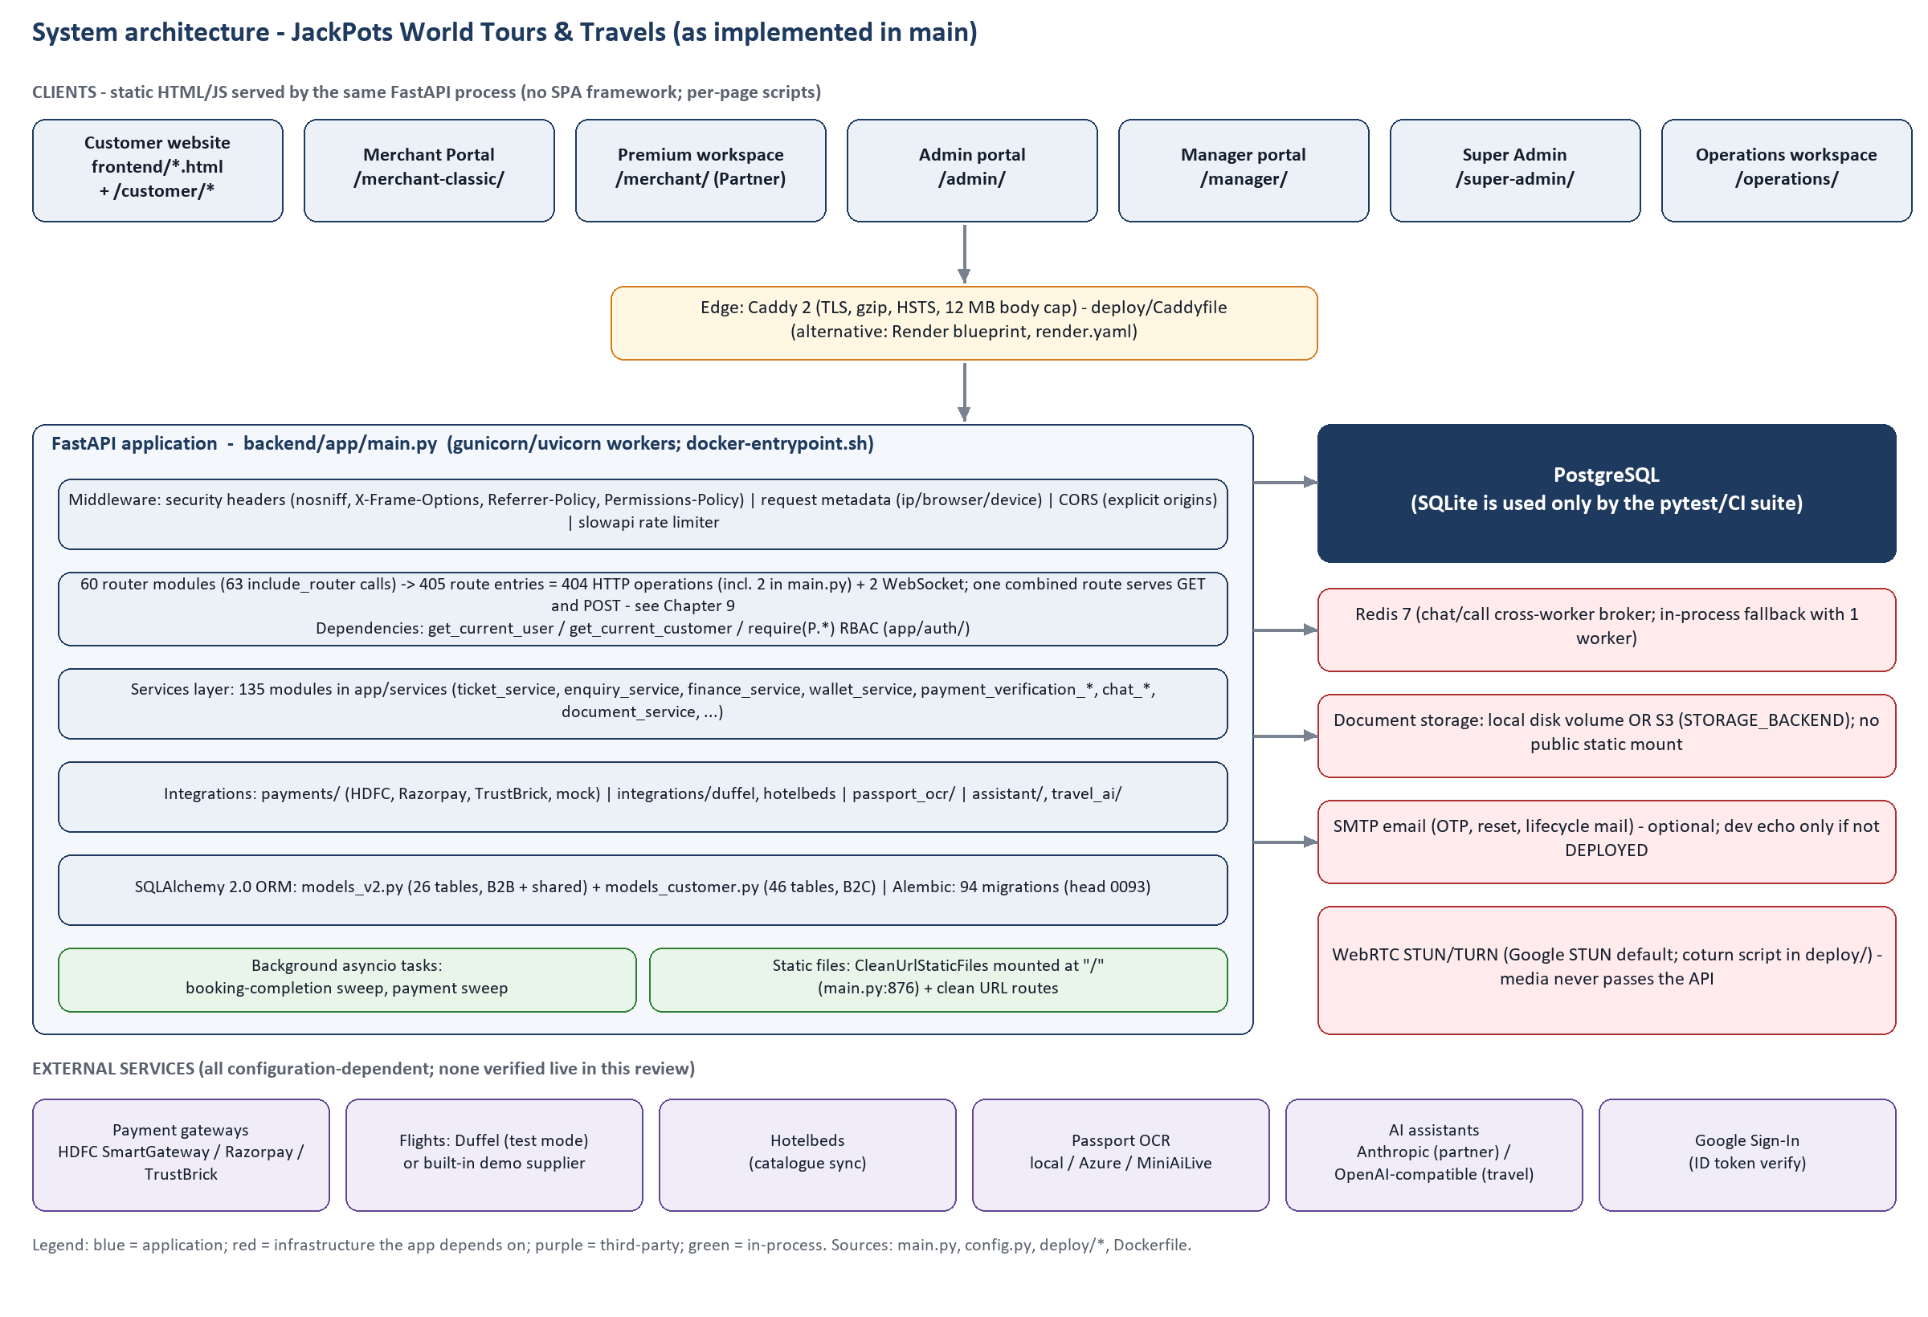
Figure 1. System architecture (generated from main.py, config.py, deploy files)

2.2 Frontend architecture
- Multi-page, no framework. Each HTML page loads its own scripts. Shared widgets (header, footer, notification bell, live chat, call widget, assistant) are plain scripts included by many pages (frontend/assets/js/).
- API base rule. Scripts call the API at http://127.0.0.1:8000 on localhost and same-origin elsewhere (for example OPS_API_BASE in operations/js/ops-core.js).
- Session storage. Staff and merchant tokens are kept in localStorage under three deliberately separate namespaces (auth.js), so a login in one portal cannot overwrite another. The customer site uses its own keys (jpc_access, jpc_refresh). Tokens in localStorage are readable by any script on the page (see Chapter 14).
- Clean URLs. CleanUrlStaticFiles mounted at / (main.py:876) plus routes for /destination/{slug}, /hotels/{destination}/{location}, /package/{id} and /ticket/verify/{token}.
- Retired/redirect pages. cruises.html, login.html, customer/index.html and portal-login.html are redirects; the customer sign-in is a dialog on the home page (index.html + assets/js/app.js).

2.3 Backend architecture
backend/app/main.py builds the FastAPI app, registers three HTTP middleware layers (security headers, request metadata, CORS), the slowapi rate-limit handler, 63 include_router calls, startup/shutdown hooks and the static frontend mount. Details are in Chapter 10.

2.4 Database architecture
One PostgreSQL database holds two deliberately separate table families: the B2B/shared family (26 tables in models_v2.py, born in the 2026-07 “nine-table redesign”, migration 0023) and the B2C customer family (46 tables in models_customer.py). They share no rows. See Chapter 11 (Volume 3).

2.5 API communication
All communication is JSON over HTTPS REST (/api/...), plus two WebSockets (/api/customer/chat/ws, /api/admin/chat/ws), file uploads as multipart forms, file downloads as streamed responses (never as static URLs), and provider callbacks (/api/webhooks/payments/{provider}, /api/payments/{provider}/return).

2.6 Authentication and authorization (summary)
- Staff/merchant: password → OTP → JWT (access 30 min, refresh 7 days by default). PORTAL_ROLES forces the role to match the portal being opened.
- Customer: signup/login/passwordless/Google/guest, always ending in an OTP or verified-identity step; JWT carries scope=customer.
- Authorization: Depends(require(P.X)) on each endpoint; a user’s effective permissions are role defaults ∪ merchant-role defaults ∪ explicit users.permissions.

2.7 External services and integrations
See Chapter 13 for the full table. In summary: payment gateways, SMTP, Redis, S3, Duffel, Hotelbeds, three OCR providers, two AI providers, Google Sign-In and STUN/TURN.

2.8 Background processing
Table 6. Background jobs (plain asyncio tasks, no scheduler library)
Task | What it does | Schedule / switch | Evidence
Booking completion sweep | Moves Ticket Issued bookings to Completed once the journey has finished | every 15 min (BOOKING_COMPLETION_INTERVAL_MINUTES); BOOKING_COMPLETION_ENABLED | main.py _completion_loop; booking_completion_service
Deferred payment sweep | Re-verifies deferred payment events and stale pending payments with the provider | every 5 min; only if a payment provider is configured | main.py _payment_sweep_loop; payment_verification_service
Default admin self-heal | Creates the seeded Super Admin if missing (concurrency-safe) | every startup | main.py; user_service.ensure_default_admin

These loops run inside each worker process; sweep_once_locked uses an advisory lock so multiple workers do not repeat the work.

2.9 Deployment architecture
Production path in the repository: Docker Compose runs app (gunicorn, port 8000, upload volume), redis (7-alpine, no persistence, LRU 256 MB) and caddy (TLS, gzip, security headers, 12 MB request cap). A Render blueprint (render.yaml) is an alternative single-service deployment. See Chapter 16.

2.10 How one user action travels to the database and back
Example: a staff member presses Sign in. The page script (jp-login.js) sends POST /api/auth/login. Caddy forwards it; middleware records the IP and browser; the rate limiter allows 10 attempts a minute per IP; Pydantic checks the body; the router calls auth_service.authenticate, checks the portal/role match and the merchant’s status, and otp_service.issue stores only a hash of the code and emails it. The response contains a short-lived challenge token, never a session.
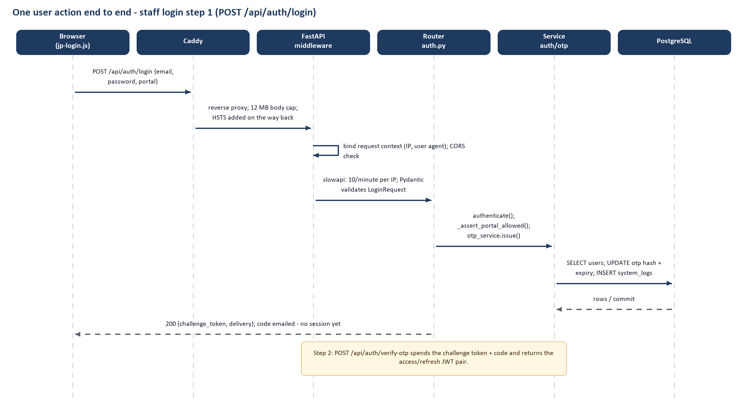
Figure 2. One request from browser to database and back (staff login step 1)

3. Portal Architecture and User Roles
Portals are distinguished by who may sign in, which URL they use and which token type protects their APIs. Five are separate sign-in systems; two more screens are workspaces that sit on top of an existing session.
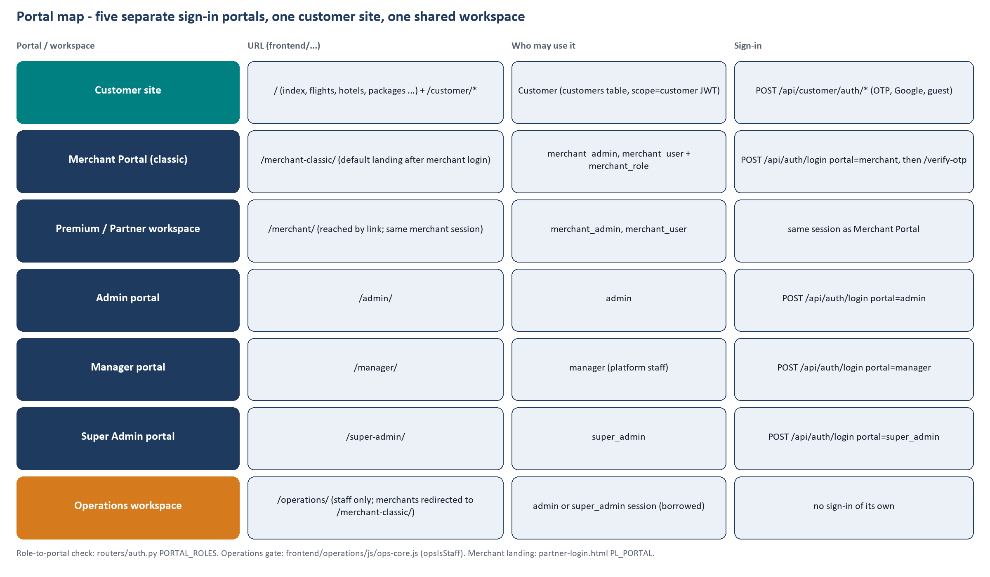
Figure 3. Portals and workspaces in the repository
Table 7. Separate portals versus workspaces
Item | Separate portal? | Evidence
Customer website (/ and /customer/*) | Yes – own users table family, own JWT scope | customer_auth router; auth/customer_deps.py
Merchant Portal (/merchant-classic/) | Yes – PORTAL_ROLES['merchant'] | routers/auth.py; partner-login.html PL_PORTAL
Admin portal (/admin/) | Yes – PORTAL_ROLES['admin'] | routers/auth.py
Manager portal (/manager/) | Yes – PORTAL_ROLES['manager'] | routers/auth.py (own portal by design, CR-2)
Super Admin portal (/super-admin/) | Yes – PORTAL_ROLES['super_admin'] | routers/auth.py
Premium / Partner workspace (/merchant/) | No – second interface onto the merchant session | operations ops-core.js link text “Premium Travel Workspace”; same endpoints
Operations workspace (/operations/) | No – permission-driven workspace, staff sessions only | ops-core.js (OPS_PORTALS, opsIsStaff redirect of merchants)

Table 8. Roles and default permission counts (rbac.ROLE_PERMISSIONS)
Role (UserRole enum) | Default permission codes | Examples
super_admin | 15 | admin.create, admin.delete, admin.edit, admin.reset_password, admin.suspend, admin.view, audit.view, chat.view, merchant.view, notification.view, …
admin | 34 | audit.view, catalog.manage, chat.manage, chat.view, customer.view, document.verify, merchant.create, merchant.delete, merchant.edit, merchant.suspend, …
manager | 4 | booking.manager_approve, booking.manager_return, notification.view, profile.manage
merchant_admin | 18 | booking.merchant_approve, booking.merchant_return, chat.create, chat.view, document.upload, merchant_user.create, merchant_user.manage, notification.view, payment.pay, payment.view, …
merchant_user | 6 | chat.view, notification.view, payment.view, profile.manage, report.view, ticket.view
customer | 0

Table 9. Merchant sub-roles (MerchantRole)
Merchant sub-role | Action codes added on top of the merchant read floor
manager | booking.merchant_approve, booking.merchant_return, chat.create, document.upload, merchant_user.create, merchant_user.manage, payment.pay, report.export, servicerequest.approve, servicerequest.create, ticket.enquiry, ticket.request
supervisor | chat.create, document.upload, report.export, servicerequest.create, ticket.enquiry, ticket.request
operator | chat.create, document.upload, servicerequest.create, ticket.enquiry, ticket.request
finance | chat.create, payment.pay, report.export
data_operator | chat.create, document.upload, servicerequest.create, ticket.enquiry, ticket.request

3.1 Customer website
Purpose / entry | frontend/index.html + frontend/customer/*
Intended users | Public travellers (B2C customers), guests
Login / access method | OTP by email/mobile, password + OTP, Google, or guest (POST /api/customer/auth/*); sign-in dialog on the home page
Sidebar / navigation | Header: Flights, Hotels, Packages, Destinations, Visa, My Bookings, account menu (jw-header.js, profile-menu.js). Account Center tabs in account-center.js.
Dashboard | customer/dashboard.html (My Account: profile, sessions, password)
Permissions | Customers hold no permission codes; all /api/customer endpoints use get_current_customer and scope every query by customer_id.

3.2 Merchant Portal (classic)
Purpose / entry | frontend/merchant-classic/index.html
Intended users | merchant_admin and merchant_user (+ merchant sub-role)
Login / access method | partner-login.html → POST /api/auth/login (portal=merchant) → /verify-otp
Sidebar / navigation | Profile & Settings | Support Center | Dashboard | Booking Enquiry | Booking Request | Visa | Holidays | Approvals | Service Requests | Wallet | Payment Management | Booking History | Reports | Notifications
Dashboard | Dashboard (classic-dashboard.js)
Permissions | Merchant read floor + sub-role actions; Visa/Holidays/Approvals menu items appear only when service access / permission allows.

3.3 Admin portal
Purpose / entry | frontend/admin/index.html
Intended users | Platform admins (role admin; 34 default permission codes)
Login / access method | /admin/ sign-in card → POST /api/auth/login (portal=admin) → /verify-otp
Sidebar / navigation | Dashboard | Merchant Management | Active Users | Booking Enquiries | Approval Queue | Booking Operations | Service Request Management | Provider Management | Manual Enquiry | Manual Booking | Payment Management | Wallet & Top-ups | Reports | Analytics | Audit Logs | System Logs | Support Management | Communication | Customers | Bookings | Cancellations & Refunds | Reviews & Ratings | Live Support | Communication | Customer Payments | Payment Reconciliation | User Activity | Flights | Hotels | Tour Packages | Gaming Enquiries | Customer Requests | Converted Bookings | Closed Requests | Destinations | Reports | Analytics | Profile
Dashboard | Dashboard (section reports)
Permissions | 34 permission codes incl. ticket.approve/issue, payment.verify/manage, merchant.*, customer.view, catalog.manage

3.4 Manager portal
Purpose / entry | frontend/manager/index.html
Intended users | role manager (platform staff)
Login / access method | /manager/ → POST /api/auth/login (portal=manager)
Sidebar / navigation | Booking Requests | Notifications | Profile & Security
Dashboard | Approval queue with counts
Permissions | booking.manager_approve, booking.manager_return, notification.view, profile.manage

3.5 Super Admin portal
Purpose / entry | frontend/super-admin/index.html
Intended users | role super_admin
Login / access method | /super-admin/ → POST /api/auth/login (portal=super_admin)
Sidebar / navigation | Dashboard | Admin Management | Profile & Security
Dashboard | System overview KPIs (GET /api/super-admin/dashboard)
Permissions | 15 codes: admin.* lifecycle, audit.view, system.activity.view, merchant.view, report.*, chat.view, refund.view – explicitly no ticket creation

3.6 Operations workspace
Purpose / entry | frontend/operations/index.html
Intended users | Staff sessions (admin / super_admin). Merchants are redirected to /merchant-classic/
Login / access method | None of its own: reads an existing portal session (localStorage key ops_active_portal)
Sidebar / navigation | Permission-driven: Dashboard, Flights, Hotels, Cruises, Packages, Bookings, Requests, Approvals, Payments, Wallet, Customers, Merchants, Users, Reports, Support, System Logs, Settings; grouped into Ticketing/Finance/Support/Administration desks
Dashboard | ops-dashboard.js
Permissions | Each module appears only if opsCan(...) of the listed codes is true (same codes the API checks)

Pages, buttons and API calls per portal are documented in Chapters 4–8; endpoint details in Volume 2.

4. B2C Customer Website
This chapter inventories every customer-facing page. For each interactive page, scripts that the page includes were resolved to files and every string literal in them was matched against the real route table, so the API list is verified from source. “Event handling” is the number of addEventListener/inline handlers found in the page’s own scripts.

4.1 Shared widgets included by most pages
Table 10. Shared scripts that call the API
Script | Purpose (from its header comment) | API routes referenced
auth.js | auth.js — single source of truth for JWT/session management across every portal. Three DELIBERATELY SEPARATE l | GET /auth/me  POST /auth/change-password  POST /auth/forgot-password  POST /auth/login  +8 more
api.js | api.js — reusable API layer. Every method here wraps axios + API_BASE + the right auth headers for exactly one | GET /admin/merchants  GET /auth/me  GET /notifications  POST /admin/merchants  +2 more
notification-bell.js | notification bell.js — the header bell: unread badge + dropdown. The notifications themselves are the server's | GET /customer/notifications
account-center.js | account center.js the customer Account Center, mountable on any B2C page. WHY THIS IS ITS OWN FILE This used t | DELETE /customer/notifications/read  DELETE /customer/reviews/{review_id}  DELETE /customer/travellers/{traveller_id}  DELETE /customer/wishlist/{wishlist_id}  +24 more
jw-interest.js | jw interest.js — a small, private memory of what a traveller has been looking at, so the landing page can pick | POST /customer/activity
jw-foryou.js | jw foryou.js — the landing page's "Recommended for you" shelf. TWO SOURCES, ONE SHELF, IN THIS ORDER OF TRUST: | GET /customer/recommendations
app.js | SAME ORIGIN UNLESS THE PAGE CAME OFF A FILE SERVER. localhost:8000 and 127.0.0.1:8000 are one machine and | DELETE /customer/reviews/{review_id}  DELETE /customer/wishlist/{wishlist_id}  GET /customer/auth/google/config  GET /customer/auth/me  +15 more

4.2 Page inventory
Table 11. Customer-facing pages (counts are verified literal matches in page-specific scripts)
Page | HTML file | Page-specific scripts | API routes found
About Us | about.html | — | 0
Activities | activities.html | booking-pay.js | 0
Cancellation & Refund Policy | cancellation-refund-policy.html | — | 0
Contact Us | contact-us.html | contact-enquiry.js | 1
Cookie Policy | cookie-policy.html | — | 0
Cruises | cruises.html | airports.js, travel-data.js, booking-api.js, booking-data.js, booking-store.js | 50
Customer Support | customer-support.html | — | 0
My Account | customer/dashboard.html | customer-core.js, customer-dashboard.js | 6
Forgot Password | customer/forgot-password.html | customer-core.js, customer-password.js | 3
Sign In | customer/index.html | — | 0
Create Account | customer/register.html | customer-core.js, customer-register.js | 4
Reset Password | customer/reset-password.html | customer-core.js, customer-password.js | 3
Hotels | destination-hotels.html | hotel-images.js, hotel-image-map.js, destination-hotels.js | 0
Destination | destination.html | destination-images.js, location-images.js, destination.js | 2
Destinations | destinations.html | destination-images.js, location-images.js, destinations-page.js | 1
Disclaimer | disclaimer.html | — | 0
FAQs | faqs.html | — | 0
Flights | flights.html | airports.js, search-widgets.js, destinations.js, rooms-selector.js, pax-selector.js | 51
Gaming Tour Enquiry | gaming-packages.html | airports.js, search-widgets.js, search-persist.js, gaming-enquiry.js | 1
Hotels | hotels.html | airports.js, search-widgets.js, destinations.js, rooms-selector.js, pax-selector.js | 51
Image Credits | image-credits.html | destination-images.js, location-images.js, hotel-images.js, image-credits.js | 0
JackPots World Tours & Travels | index.html | travel-locations.js, airports.js, search-widgets.js, destinations.js, rooms-selector.js | 2
Places to visit | location.html | location-images.js, hotel-images.js, hotel-image-map.js, destination-images.js, location.js | 0
My Bookings | my-bookings.html | jw-products.js, booking-api.js, booking-store.js, booking-ticket.js, my-bookings.js | 46
Tour package | package.html | destination-images.js, location-images.js, hotel-images.js, hotel-image-map.js, airports.js | 50
Tour Packages | packages.html | destination-images.js, location-images.js, jw-products.js, search-persist.js, package-listing.js | 6
Payment Security | payment-security.html | — | 0
Privacy Policy | privacy-policy.html | — | 0
Register | register.html | — | 0
Website Terms & Conditions | terms-and-conditions.html | — | 0
Ticket Verification | ticket-verify.html | — | 0
Visa Services | visa.html | booking-pay.js | 0

4.3 Page-by-page trace
Pages with at least one page-specific API route are traced below. Request/response schemas are in Volume 2; “Backend” lists router modules; “Database” is the indicative table scan (Chapter 9.1).

Contact Us – contact-us.html
Page name | Contact Us
HTML file | frontend/contact-us.html
JavaScript file(s) | assets/js/contact-enquiry.js
UI components | 1 form(s), 0 table(s), 1 <button> element(s)
Buttons (labels in HTML) | Send Enquiry
Event handling | 6 listener/inline-handler registrations in page-specific scripts
API (method + endpoint) | POST /customer/tour-package-enquiries
Request | See Volume 2 for each route’s parameters / body schema
Backend | tour_package_enquiries.py
Database (indicative) | —
Response | JSON as per the response schemas in Volume 2; rendered by the page scripts
Result (what the user sees) | Contact / tour-package enquiry form (POST /api/customer/tour-package-enquiries).

Cruises – cruises.html
Page name | Cruises
HTML file | frontend/cruises.html
JavaScript file(s) | assets/js/airports.js, assets/js/travel-data.js, assets/js/booking-api.js, assets/js/booking-data.js, assets/js/booking-store.js, assets/js/booking-flow.js, assets/js/booking-products.js, assets/js/booking-ticket.js, assets/js/booking-flows.js, assets/js/travel-explore.js, assets/js/booking-pay.js
UI components | 0 form(s), 0 table(s), 0 <button> element(s)
Buttons (labels in HTML) | No static <button> labels (controls are created by scripts)
Event handling | 74 listener/inline-handler registrations in page-specific scripts
API (method + endpoint) | DELETE /customer/travellers/{traveller_id}  GET /customer/addons  GET /customer/auth/me  GET /customer/bookings  GET /customer/bookings/{booking_ref}  GET /customer/bookings/{booking_ref}/ticket  GET /customer/coupons  GET /customer/flights/search  GET /customer/flights/seatmap  GET /customer/hotel-bookings  … +40 more (see Volume 2)
Request | See Volume 2 for each route’s parameters / body schema
Backend | auth.py, customer_auth.py, customer_bookings.py, customer_hotel_bookings.py, customer_package_bookings.py, customer_travellers.py, eticket.py
Database (indicative) | customer_audit_logs, customer_package_booking_payments, customer_package_bookings, customers, users
Response | JSON as per the response schemas in Volume 2; rendered by the page scripts
Result (what the user sees) | Retired: redirects home (page comment “Cruises is not offered”).

My Account – customer/dashboard.html
Page name | My Account
HTML file | frontend/customer/dashboard.html
JavaScript file(s) | customer/js/customer-core.js, customer/js/customer-dashboard.js
UI components | 2 form(s), 0 table(s), 6 <button> element(s)
Buttons (labels in HTML) | Sign Out | Save Changes | Update Password
Event handling | 6 listener/inline-handler registrations in page-specific scripts
API (method + endpoint) | GET /customer/auth/me  GET /customer/profile  GET /customer/profile/sessions  PATCH /customer/profile  POST /customer/auth/change-password  POST /customer/auth/logout
Request | See Volume 2 for each route’s parameters / body schema
Backend | customer_auth.py, customer_profile.py
Database (indicative) | customer_audit_logs, customer_profiles, customer_sessions, customers
Response | JSON as per the response schemas in Volume 2; rendered by the page scripts
Result (what the user sees) | My Account: profile edit, active sessions, change password, logout.

Forgot Password – customer/forgot-password.html
Page name | Forgot Password
HTML file | frontend/customer/forgot-password.html
JavaScript file(s) | customer/js/customer-core.js, customer/js/customer-password.js
UI components | 0 form(s), 0 table(s), 0 <button> element(s)
Buttons (labels in HTML) | No static <button> labels (controls are created by scripts)
Event handling | 5 listener/inline-handler registrations in page-specific scripts
API (method + endpoint) | GET /customer/auth/me  POST /customer/auth/forgot-password  POST /customer/auth/reset-password
Request | See Volume 2 for each route’s parameters / body schema
Backend | customer_auth.py
Database (indicative) | customer_audit_logs, customer_password_resets, customer_sessions, customers
Response | JSON as per the response schemas in Volume 2; rendered by the page scripts
Result (what the user sees) | Starts a password reset (always the same generic message).

Create Account – customer/register.html
Page name | Create Account
HTML file | frontend/customer/register.html
JavaScript file(s) | customer/js/customer-core.js, customer/js/customer-register.js
UI components | 0 form(s), 0 table(s), 0 <button> element(s)
Buttons (labels in HTML) | No static <button> labels (controls are created by scripts)
Event handling | 8 listener/inline-handler registrations in page-specific scripts
API (method + endpoint) | GET /customer/auth/me  POST /customer/auth/resend-otp  POST /customer/auth/signup  POST /customer/auth/verify-otp
Request | See Volume 2 for each route’s parameters / body schema
Backend | customer_auth.py
Database (indicative) | customer_audit_logs, customer_auth, customer_otps, customer_profiles, customer_sessions, customers
Response | JSON as per the response schemas in Volume 2; rendered by the page scripts
Result (what the user sees) | Account creation then OTP verification.

Reset Password – customer/reset-password.html
Page name | Reset Password
HTML file | frontend/customer/reset-password.html
JavaScript file(s) | customer/js/customer-core.js, customer/js/customer-password.js
UI components | 0 form(s), 0 table(s), 0 <button> element(s)
Buttons (labels in HTML) | No static <button> labels (controls are created by scripts)
Event handling | 5 listener/inline-handler registrations in page-specific scripts
API (method + endpoint) | GET /customer/auth/me  POST /customer/auth/forgot-password  POST /customer/auth/reset-password
Request | See Volume 2 for each route’s parameters / body schema
Backend | customer_auth.py
Database (indicative) | customer_audit_logs, customer_password_resets, customer_sessions, customers
Response | JSON as per the response schemas in Volume 2; rendered by the page scripts
Result (what the user sees) | Completes a password reset with the e-mailed token.

Hotels – destination-hotels.html
Page name | Hotels
HTML file | frontend/destination-hotels.html
JavaScript file(s) | assets/js/hotel-images.js, assets/js/hotel-image-map.js, assets/js/destination-hotels.js
UI components | 0 form(s), 0 table(s), 1 <button> element(s)
Buttons (labels in HTML) | No static <button> labels (controls are created by scripts)
Event handling | 6 listener/inline-handler registrations in page-specific scripts
API (method + endpoint) | None found by static scan
Request | No request sent by page-specific scripts
Backend | —
Database (indicative) | —
Response | —
Result (what the user sees) | Hotels inside a destination/location/attraction.

Destination – destination.html
Page name | Destination
HTML file | frontend/destination.html
JavaScript file(s) | assets/js/destination-images.js, assets/js/location-images.js, assets/js/destination.js
UI components | 0 form(s), 0 table(s), 0 <button> element(s)
Buttons (labels in HTML) | No static <button> labels (controls are created by scripts)
Event handling | 2 listener/inline-handler registrations in page-specific scripts
API (method + endpoint) | GET /customer/destinations  GET /customer/packages
Request | See Volume 2 for each route’s parameters / body schema
Backend | customer_destinations.py, customer_package_bookings.py
Database (indicative) | —
Response | JSON as per the response schemas in Volume 2; rendered by the page scripts
Result (what the user sees) | One destination with its locations and attractions.

Destinations – destinations.html
Page name | Destinations
HTML file | frontend/destinations.html
JavaScript file(s) | assets/js/destination-images.js, assets/js/location-images.js, assets/js/destinations-page.js
UI components | 0 form(s), 0 table(s), 0 <button> element(s)
Buttons (labels in HTML) | No static <button> labels (controls are created by scripts)
Event handling | 1 listener/inline-handler registrations in page-specific scripts
API (method + endpoint) | GET /customer/destinations
Request | See Volume 2 for each route’s parameters / body schema
Backend | customer_destinations.py
Database (indicative) | —
Response | JSON as per the response schemas in Volume 2; rendered by the page scripts
Result (what the user sees) | Destination catalogue (customer_destinations).

Flights – flights.html
Page name | Flights
HTML file | frontend/flights.html
JavaScript file(s) | assets/js/airports.js, assets/js/search-widgets.js, assets/js/destinations.js, assets/js/rooms-selector.js, assets/js/pax-selector.js, assets/js/search-persist.js, assets/js/booking-card.js, assets/js/jw-products.js, assets/js/airline-logos.js, assets/js/travel-data.js, assets/js/booking-api.js, assets/js/booking-data.js, assets/js/booking-store.js, assets/js/booking-flow.js, assets/js/booking-products.js, assets/js/booking-ticket.js, assets/js/booking-flows.js, assets/js/group-enquiry.js, assets/js/filter-engine.js, assets/js/flight-filters.js, assets/js/search-strip.js, assets/js/round-trip.js, assets/js/travel-explore.js, assets/js/flights-sticky-search.js, assets/js/booking-pay.js
UI components | 0 form(s), 0 table(s), 2 <button> element(s)
Buttons (labels in HTML) | Filters
Event handling | 151 listener/inline-handler registrations in page-specific scripts
API (method + endpoint) | DELETE /customer/travellers/{traveller_id}  GET /customer/addons  GET /customer/auth/me  GET /customer/bookings  GET /customer/bookings/{booking_ref}  GET /customer/bookings/{booking_ref}/ticket  GET /customer/coupons  GET /customer/flights/search  GET /customer/flights/seatmap  GET /customer/hotel-bookings  … +41 more (see Volume 2)
Request | See Volume 2 for each route’s parameters / body schema
Backend | auth.py, customer_auth.py, customer_bookings.py, customer_hotel_bookings.py, customer_package_bookings.py, customer_travellers.py, eticket.py, public.py
Database (indicative) | customer_audit_logs, customer_package_booking_payments, customer_package_bookings, customers, users
Response | JSON as per the response schemas in Volume 2; rendered by the page scripts
Result (what the user sees) | Flight search form (airports, dates, passengers, round-trip/multi-city) and result list with filters; booking flow continues via booking-flow scripts → passengers → add-ons → payment screen.

Gaming Tour Enquiry – gaming-packages.html
Page name | Gaming Tour Enquiry
HTML file | frontend/gaming-packages.html
JavaScript file(s) | assets/js/airports.js, assets/js/search-widgets.js, assets/js/search-persist.js, assets/js/gaming-enquiry.js
UI components | 1 form(s), 0 table(s), 1 <button> element(s)
Buttons (labels in HTML) | Submit Enquiry
Event handling | 16 listener/inline-handler registrations in page-specific scripts
API (method + endpoint) | POST /customer/gaming-tour-enquiries
Request | See Volume 2 for each route’s parameters / body schema
Backend | gaming_tour_enquiries.py
Database (indicative) | —
Response | JSON as per the response schemas in Volume 2; rendered by the page scripts
Result (what the user sees) | Gaming Tour Enquiry form (POST /api/customer/gaming-tour-enquiries); admin desk handles it.

Hotels – hotels.html
Page name | Hotels
HTML file | frontend/hotels.html
JavaScript file(s) | assets/js/airports.js, assets/js/search-widgets.js, assets/js/destinations.js, assets/js/rooms-selector.js, assets/js/pax-selector.js, assets/js/search-persist.js, assets/js/booking-card.js, assets/js/jw-products.js, assets/js/hotel-images.js, assets/js/hotel-image-map.js, assets/js/travel-data.js, assets/js/booking-api.js, assets/js/booking-data.js, assets/js/booking-store.js, assets/js/booking-flow.js, assets/js/booking-products.js, assets/js/booking-ticket.js, assets/js/booking-flows.js, assets/js/hotel-search.js, assets/js/filter-engine.js, assets/js/hotel-filters.js, assets/js/hotel-details.js, assets/js/hotel-rooms.js, assets/js/hotel-guests.js, assets/js/hotel-review.js, assets/js/hotel-payment.js, assets/js/hotel-confirm.js, assets/js/hotel-results.js, assets/js/group-enquiry.js, assets/js/travel-explore.js, assets/js/booking-pay.js
UI components | 0 form(s), 0 table(s), 1 <button> element(s)
Buttons (labels in HTML) | Filters
Event handling | 181 listener/inline-handler registrations in page-specific scripts
API (method + endpoint) | DELETE /customer/travellers/{traveller_id}  GET /customer/addons  GET /customer/auth/me  GET /customer/bookings  GET /customer/bookings/{booking_ref}  GET /customer/bookings/{booking_ref}/ticket  GET /customer/coupons  GET /customer/flights/search  GET /customer/flights/seatmap  GET /customer/hotel-bookings  … +41 more (see Volume 2)
Request | See Volume 2 for each route’s parameters / body schema
Backend | auth.py, customer_auth.py, customer_bookings.py, customer_hotel_bookings.py, customer_package_bookings.py, customer_travellers.py, eticket.py, public.py
Database (indicative) | customer_audit_logs, customer_package_booking_payments, customer_package_bookings, customers, users
Response | JSON as per the response schemas in Volume 2; rendered by the page scripts
Result (what the user sees) | Hotel search (destination, dates, rooms/guests) and results with filters; leads to hotel details, rooms, review and payment pages (hotel-*.js).

JackPots World Tours & Travels – index.html
Page name | JackPots World Tours & Travels
HTML file | frontend/index.html
JavaScript file(s) | assets/js/travel-locations.js, assets/js/airports.js, assets/js/search-widgets.js, assets/js/destinations.js, assets/js/rooms-selector.js, assets/js/pax-selector.js, assets/js/search-persist.js, assets/js/booking-card.js, assets/js/country-codes.js, assets/js/assistant-results.js, assets/js/group-enquiry.js, assets/js/home-cinema.js, assets/js/destination-images.js, assets/js/home-destinations.js, assets/js/booking-pay.js
UI components | 10 form(s), 1 table(s), 32 <button> element(s)
Buttons (labels in HTML) | Subscribe | Send Message | Continue | Create account | Change | Create Account | Verify OTP | Resend OTP in 30s
Event handling | 68 listener/inline-handler registrations in page-specific scripts
API (method + endpoint) | GET /customer/destinations  POST /hotel-group-enquiry
Request | See Volume 2 for each route’s parameters / body schema
Backend | customer_destinations.py, public.py
Database (indicative) | —
Response | JSON as per the response schemas in Volume 2; rendered by the page scripts
Result (what the user sees) | Landing page: hero search for flights/hotels/packages, destination and offer sections, contact/tour-package enquiry form, newsletter, customer sign-in dialog (mobile or email + OTP), travel assistant widget.

Places to visit – location.html
Page name | Places to visit
HTML file | frontend/location.html
JavaScript file(s) | assets/js/location-images.js, assets/js/hotel-images.js, assets/js/hotel-image-map.js, assets/js/destination-images.js, assets/js/location.js
UI components | 0 form(s), 0 table(s), 2 <button> element(s)
Buttons (labels in HTML) | Read more
Event handling | 6 listener/inline-handler registrations in page-specific scripts
API (method + endpoint) | None found by static scan
Request | No request sent by page-specific scripts
Backend | —
Database (indicative) | —
Response | —
Result (what the user sees) | Places to visit within a destination.

My Bookings – my-bookings.html
Page name | My Bookings
HTML file | frontend/my-bookings.html
JavaScript file(s) | assets/js/jw-products.js, assets/js/booking-api.js, assets/js/booking-store.js, assets/js/booking-ticket.js, assets/js/my-bookings.js, assets/js/booking-pay.js
UI components | 0 form(s), 0 table(s), 0 <button> element(s)
Buttons (labels in HTML) | No static <button> labels (controls are created by scripts)
Event handling | 16 listener/inline-handler registrations in page-specific scripts
API (method + endpoint) | DELETE /customer/travellers/{traveller_id}  GET /customer/addons  GET /customer/auth/me  GET /customer/bookings  GET /customer/bookings/{booking_ref}  GET /customer/bookings/{booking_ref}/ticket  GET /customer/coupons  GET /customer/flights/seatmap  GET /customer/hotel-bookings  GET /customer/hotel-bookings/{booking_ref}  … +36 more (see Volume 2)
Request | See Volume 2 for each route’s parameters / body schema
Backend | auth.py, customer_auth.py, customer_bookings.py, customer_hotel_bookings.py, customer_package_bookings.py, customer_travellers.py, eticket.py
Database (indicative) | customer_audit_logs, customer_package_booking_payments, customer_package_bookings, customers, users
Response | JSON as per the response schemas in Volume 2; rendered by the page scripts
Result (what the user sees) | List and detail of the customer’s flight, hotel and package bookings, payment status, e-ticket, cancellation request.

Tour package – package.html
Page name | Tour package
HTML file | frontend/package.html
JavaScript file(s) | assets/js/destination-images.js, assets/js/location-images.js, assets/js/hotel-images.js, assets/js/hotel-image-map.js, assets/js/airports.js, assets/js/search-widgets.js, assets/js/pax-selector.js, assets/js/travel-data.js, assets/js/booking-api.js, assets/js/booking-data.js, assets/js/booking-store.js, assets/js/booking-flow.js, assets/js/booking-card.js, assets/js/booking-products.js, assets/js/booking-ticket.js, assets/js/booking-flows.js, assets/js/booking-pay.js, assets/js/package.js
UI components | 0 form(s), 0 table(s), 2 <button> element(s)
Buttons (labels in HTML) | Book now | Read more
Event handling | 109 listener/inline-handler registrations in page-specific scripts
API (method + endpoint) | DELETE /customer/travellers/{traveller_id}  GET /customer/addons  GET /customer/auth/me  GET /customer/bookings  GET /customer/bookings/{booking_ref}  GET /customer/bookings/{booking_ref}/ticket  GET /customer/coupons  GET /customer/flights/search  GET /customer/flights/seatmap  GET /customer/hotel-bookings  … +40 more (see Volume 2)
Request | See Volume 2 for each route’s parameters / body schema
Backend | auth.py, customer_auth.py, customer_bookings.py, customer_hotel_bookings.py, customer_package_bookings.py, customer_travellers.py, eticket.py
Database (indicative) | customer_audit_logs, customer_package_booking_payments, customer_package_bookings, customers, users
Response | JSON as per the response schemas in Volume 2; rendered by the page scripts
Result (what the user sees) | Package detail: itinerary, departures, add-ons, quote and booking.

Tour Packages – packages.html
Page name | Tour Packages
HTML file | frontend/packages.html
JavaScript file(s) | assets/js/destination-images.js, assets/js/location-images.js, assets/js/jw-products.js, assets/js/search-persist.js, assets/js/package-listing.js
UI components | 0 form(s), 0 table(s), 1 <button> element(s)
Buttons (labels in HTML) | Filters&#9662;
Event handling | 16 listener/inline-handler registrations in page-specific scripts
API (method + endpoint) | GET /customer/coupons  GET /customer/destinations  GET /customer/packages  GET /customer/packages/facets  GET /customer/packages/trip-types  GET /customer/packages/{package_id}
Request | See Volume 2 for each route’s parameters / body schema
Backend | customer_bookings.py, customer_destinations.py, customer_package_bookings.py
Database (indicative) | —
Response | JSON as per the response schemas in Volume 2; rendered by the page scripts
Result (what the user sees) | Tour package catalogue with facets/trip types; opens package.html detail.

Register – register.html
Page name | Register
HTML file | frontend/register.html
JavaScript file(s) | shared scripts only
UI components | 1 form(s), 0 table(s), 1 <button> element(s)
Buttons (labels in HTML) | Register
Event handling | 0 listener/inline-handler registrations in page-specific scripts
API (method + endpoint) | None found by static scan
Request | No request sent by page-specific scripts
Backend | —
Database (indicative) | —
Response | —
Result (what the user sees) | Registration page that redirects to index.html (sign-up is handled by the home-page dialog).

Ticket Verification – ticket-verify.html
Page name | Ticket Verification
HTML file | frontend/ticket-verify.html
JavaScript file(s) | shared scripts only
UI components | 0 form(s), 0 table(s), 0 <button> element(s)
Buttons (labels in HTML) | No static <button> labels (controls are created by scripts)
Event handling | 0 listener/inline-handler registrations in page-specific scripts
API (method + endpoint) | None found by static scan
Request | No request sent by page-specific scripts
Backend | —
Database (indicative) | —
Response | —
Result (what the user sees) | Public ticket verification by QR token (GET /api/tickets/verify/{token}).

4.4 Static and policy pages
The following pages contain content only (no API calls found): about.html, activities.html, cancellation-refund-policy.html, cookie-policy.html, customer-support.html, disclaimer.html, faqs.html, image-credits.html, payment-security.html, privacy-policy.html, terms-and-conditions.html, visa.html, 404.html. Note: customer-support.html is an information page; the /api/customer/support-tickets routes have no frontend caller (Chapter 17).

4.5 Feature-by-feature (B2C)
Table 12. B2C features traced from route to table
Feature | APIs | Services | Tables | Status
Registration, login, OTP | POST /api/customer/auth/signup, /login, /request-otp, /verify-otp, /resend-otp, /google, /guest, /refresh, /logout | customer_auth_service, customer_otp_service, customer_google_auth_service, customer_guest_service | customers, customer_auth, customer_profiles, customer_otps, customer_sessions, customer_identities | Implemented in code (OTP email needs SMTP; Google needs client id)
Profile | GET/PATCH /api/customer/profile; GET /profile/sessions | customer_account_service | customer_profiles, customer_sessions | Implemented in code
Traveller management + passport scan | /api/customer/travellers*, /travellers/passport/extract | customer_traveller_service, customer_passport_ocr_service | customer_travellers | Implemented in code; OCR is provider-dependent
Flights search/booking | /api/customer/flights/search, /bookings/quote, /bookings, /pay, /checkout, /reconcile, /cancel | customer_booking_service, customer_pricing_service, flight_supplier_service | customer_bookings*, customer_booking_payments | Implemented in code (supplier demo by default; Duffel test mode optional)
Hotels search/booking | /api/customer/hotels*, /hotel-bookings* | customer_hotel_* services | customer_hotels, rooms, customer_hotel_bookings* | Implemented in code (catalogue is own tables; Hotelbeds sync tool exists)
Tour packages | /api/customer/packages*, /package-bookings* | customer_package_* services | customer_packages*, customer_package_bookings* | Implemented in code
Destinations / attractions | /api/customer/destinations*, /attractions* | customer_destination_service | customer_destinations, customer_locations, customer_attractions | Implemented in code
Search and filters | Client-side filter engines (filter-engine.js, flight-filters.js, hotel-filters.js) over API results; server facets for packages | — | — | Implemented in code
Booking history & e-ticket | GET /api/customer/bookings, /bookings/{ref}/ticket, public /api/tickets/verify/{token} | eticket_service | customer_bookings | Implemented in code
Wishlist | /api/customer/wishlist (GET/POST/PATCH/DELETE) | customer_account_service | customer_wishlist | Implemented in code
Coupons | GET /api/customer/coupons; POST /coupons/validate | customer_pricing_service | customer_coupons | Implemented in code (coupon issuance UI for admins not found)
Notifications | /api/customer/notifications* | customer_account_service | customer_notifications | Implemented in code
Reviews | /api/customer/reviews*; admin moderation /api/admin/reviews* | customer_review_admin_service | customer_reviews | Implemented in code
Customer support tickets | /api/customer/support-tickets* | customer_account_service | customer_support_tickets, customer_support_messages | Partially implemented – API exists, no frontend caller found
Live chat and voice calling | /api/customer/chat/* + WebSocket; WebRTC | customer_chat_service, chat_gateway, call_* | customer_conversations, customer_chat_messages, customer_calls | Configuration-dependent (Redis needed for >1 worker; TURN for NAT traversal)
Travel assistant | /api/customer/assistant/* | travel_ai_assistant, customer_assistant_service | customer_assistant_sessions/messages | Configuration-dependent (rules fallback works without an AI key)
Cancellation request | POST /api/customer/cancellation-requests | customer_cancellation_admin_service | customer_cancellation_requests | Implemented in code (decision by admin desk)
Enquiries (contact, gaming, hotel group) | /api/contact, /api/customer/tour-package-enquiries, /gaming-tour-enquiries, /api/hotel-group-enquiry, /api/newsletter | tour_package_enquiry_service, gaming_tour_enquiry_service, email_service | tour_package_enquiries, gaming_tour_enquiries | Implemented in code

5. B2B Merchant Portal
The Merchant Portal is where a travel company (a merchant) asks JackPots staff for tickets, hotels and holidays and pays for them from a prepaid wallet. The default interface is frontend/merchant-classic/index.html (reached from partner-login.html). A second interface, frontend/merchant/index.html (“Partner Portal” / “Premium Travel Workspace”), uses the same APIs and the same merchant session.

5.1 Login, session and access control
- The merchant opens partner-login.html; jp-login.js posts email + password + portal=merchant to POST /api/auth/login.
- The server checks the password, that the role is merchant_admin or merchant_user, and that the company’s status is active (_assert_merchant_tradeable); a suspended/inactive/deleted company is refused with the reason.
- A one-time code is issued (hash stored, valid 5 minutes) and e-mailed; the browser receives only a challenge token.
- POST /api/auth/verify-otp returns access + refresh tokens and the profile, including permissions and service_access (a map of flights/hotels/visa/holidays).
- The portal calls /api/auth/me and /api/profile on load so menu items follow the live permissions/service access, not a cached copy (classic-shell.js).

5.2 Navigation
Classic portal sidebar: Profile & Settings, Support Center, Dashboard, Booking Enquiry, Booking Request, Visa, Holidays, Approvals, Service Requests, Wallet, Payment Management, Booking History, Reports, Notifications. Visa, Holidays and Approvals are hidden until the merchant’s service access or permission allows them (classic-shell.js lines ~690–700; default service access is flights only).

5.3 Features, screens, scripts and APIs
Table 13. Merchant Portal features (classic interface)
Feature | UI location | Script(s) | API routes referenced (verified literals) | Status
Dashboard | Dashboard | classic-dashboard.js | None found by static scan | Implemented in code
Profile & team settings | Profile & Settings | classic-account.js, classic-shell.js | POST /auth/login | Implemented in code
Merchant team management | Profile & Settings / Operations Users | classic-account.js, ops-directory.js | None found by static scan | Implemented in code – create/edit/status/reset-password under /api/merchant/team
Flight booking enquiry | Booking Enquiry | classic-enquiry.js, booking-enquiry-core.js | None found by static scan | Implemented in code
Hotel booking enquiry | Booking Enquiry (Hotel) | classic-enquiry-hotel.js | None found by static scan | Implemented in code
Booking request / booking | Booking Request | classic-booking.js, classic-booking-hotel.js, classic-booking-detail.js | None found by static scan | Implemented in code
Passenger info + passport scan (OCR) | Booking Request | classic-passport-ocr.js, classic-booking.js | None found by static scan | Configuration-dependent – OCR provider setting
Visa service | Visa | classic-visa.js | None found by static scan | Partially implemented – visible only when visa service access is enabled; backing endpoints Not verified
Holidays (tour package) service | Holidays | classic-holidays.js | None found by static scan | Partially implemented – service code holidays; dedicated package-booking endpoints Not verified
Merchant-internal approvals (CR-3) | Approvals | classic-approvals.js | None found by static scan | Implemented in code
Service requests (cancel, date change, baggage ...) | Service Requests | classic-service.js, classic-requests.js | None found by static scan | Implemented in code
Booking history | Booking History | classic-history.js | None found by static scan | Implemented in code
Wallet, top-ups, ledger | Wallet | classic-wallet.js | None found by static scan | Implemented in code
Payments / payment requests | Payment Management | classic-payments.js | None found by static scan | Implemented in code
Reports and export | Reports | classic-reports.js | None found by static scan | Implemented in code
Notifications | Notifications | partner-notifications.js, classic-shell.js | GET /notifications  GET /notifications/unread-count  PATCH /notifications/{notification_id}/read  POST /auth/login  POST /notifications/read-all | Implemented in code
Support tickets / live chat | Support Center | classic-support.js, partner-live-chat.js | None found by static scan | Implemented in code
Assistant (voice/text helper) | Assistant | classic-assistant.js | None found by static scan | Configuration-dependent – rules provider default; Anthropic optional

Many portal screens do not call the API directly: they call functions of a shared client script, so the per-feature table above shows only literals inside the screen’s own script. The shared client merchant-api.js references the 90 routes below (verified literal matches). Which screen uses which function was not traced individually (Not verified).
Table 14. Routes referenced by the shared merchant client (frontend/shared/merchant-api.js)
Method | Route | Router module
DELETE | /documents/{document_id} | documents.py
DELETE | /group-bookings/imports/{import_id} | group_bookings.py
DELETE | /requests/{request_id} | tickets.py
GET | /analytics/bookings | analytics.py
GET | /analytics/change-requests | analytics.py
GET | /assistant/config | assistant.py
GET | /bookings/passport/availability | passport_ocr.py
GET | /bookings/passport/extract/{extraction_id} | passport_ocr.py
GET | /bookings/passport/extract/{extraction_id}/scan | passport_ocr.py
GET | /bookings/{booking_id}/change-requests | change_requests.py
GET | /change-requests | change_requests.py
GET | /change-requests/counts | change_requests.py
GET | /change-requests/{request_id} | change_requests.py
GET | /documents/{document_id}/download | documents.py
GET | /enquiries | enquiries.py
GET | /enquiries/{enquiry_id} | enquiries.py
GET | /group-bookings/imports/{import_id} | group_bookings.py
GET | /group-bookings/imports/{import_id}/errors | group_bookings.py
GET | /group-bookings/imports/{import_id}/file | group_bookings.py
GET | /group-bookings/limits | group_bookings.py
GET | /group-bookings/template | group_bookings.py
GET | /hotel/enquiries | hotel_enquiries.py
GET | /hotel/enquiries/{enquiry_id} | hotel_enquiries.py
GET | /manager/service-requests | manager_approvals.py
GET | /manager/service-requests/counts | manager_approvals.py
GET | /merchant/approvals | merchant_approvals.py
GET | /merchant/approvals/counts | merchant_approvals.py
GET | /merchant/approvals/{request_id} | merchant_approvals.py
GET | /merchant/dashboard | dashboard.py
GET | /merchant/finance/position | finance.py
GET | /merchant/finance/statement | finance.py
GET | /merchant/payment-requests | wallet.py
GET | /merchant/payment-requests/counts | wallet.py
GET | /merchant/wallet | wallet.py
GET | /merchant/wallet/payment-accounts | wallet.py
GET | /merchant/wallet/payment-accounts/{account_id}/qr | wallet.py
GET | /merchant/wallet/topups | wallet.py
GET | /merchant/wallet/topups/{topup_id}/proof | wallet.py
GET | /merchant/wallet/transactions | wallet.py
GET | /notifications | notifications_v2.py
GET | /notifications/unread-count | notifications_v2.py
GET | /passengers/lookup | tickets.py
GET | /profile | profile.py
GET | /reports/export | reports.py
GET | /reports/summary | reports.py
GET | /requests | tickets.py
GET | /requests/{request_id} | tickets.py
GET | /requests/{request_id}/confirmation | tickets.py
GET | /requests/{request_id}/documents | documents.py
GET | /requests/{request_id}/invoice | tickets.py
GET | /requests/{request_id}/tickets | tickets.py
GET | /support/threads | support_tickets.py
GET | /support/threads/{thread_id} | support_tickets.py
GET | /support/threads/{thread_id}/documents | support_tickets.py
GET | /support/unread-count | support_tickets.py
PATCH | /notifications/{notification_id}/read | notifications_v2.py
POST | /assistant/interpret | assistant.py
POST | /auth/change-password | auth.py
POST | /bookings/direct | enquiries.py
POST | /bookings/passport/extract | passport_ocr.py
POST | /bookings/passport/extract/{extraction_id}/edits | passport_ocr.py
POST | /bookings/{booking_id}/cancellation | change_requests.py
POST | /bookings/{booking_id}/reschedule | change_requests.py
POST | /enquiries | enquiries.py
POST | /enquiries/{enquiry_id}/booking-request | enquiries.py
POST | /group-bookings/imports | group_bookings.py
POST | /hotel/bookings/direct | hotel_enquiries.py
POST | /hotel/enquiries | hotel_enquiries.py
POST | /hotel/enquiries/{enquiry_id}/booking-request | hotel_enquiries.py
POST | /manager/service-requests/{request_id}/approve | manager_approvals.py
POST | /manager/service-requests/{request_id}/reject | manager_approvals.py
POST | /merchant/approvals/{request_id}/approve | merchant_approvals.py
POST | /merchant/approvals/{request_id}/return | merchant_approvals.py
POST | /merchant/approvals/{request_id}/start-review | merchant_approvals.py
POST | /merchant/payment-requests/{topup_id}/settle | wallet.py
POST | /merchant/wallet/topups | wallet.py
POST | /notifications/read-all | notifications_v2.py
POST | /requests | tickets.py
POST | /requests/{request_id}/cancel | tickets.py
POST | /requests/{request_id}/documents | documents.py
POST | /requests/{request_id}/pay | tickets.py
POST | /requests/{request_id}/submit | tickets.py
POST | /service-requests | tickets.py
POST | /support/threads | support_tickets.py
POST | /support/threads/{thread_id}/documents | support_tickets.py
POST | /support/threads/{thread_id}/messages | support_tickets.py
POST | /support/threads/{thread_id}/reopen | support_tickets.py
PUT | /profile | profile.py
PUT | /requests/{request_id} | tickets.py
PUT | /requests/{request_id}/passengers | tickets.py

5.4 Script inventory
Table 15. Merchant Portal scripts (classic + shared)
Script | Purpose (header comment) | Lines | Listeners | API routes referenced
classic-account.js | Merchant Portal — Profile & Settings. A profile card, the user's own details, security, and an honest account of what is… | 360 | 5 | No literal API route found
classic-approvals.js | Classic — Approvals: the merchant signs off the booking requests its own staff raised (CR 3). CR 2 put this sign off wit… | 344 | 10 | No literal API route found
classic-assistant.js | Classic — Partner Assistant. A launcher in the corner and a conversation panel. The merchant types a question; the assis… | 892 | 9 | No literal API route found
classic-booking-detail.js | Classic — Booking Request Details (Phase 3). A dedicated page, not another modal. A booking request carries an itinerary… | 820 | 8 | No literal API route found
classic-booking-hotel.js | Classic — Hotel Booking Request. Hotel's equivalent of classic booking.js. Reached two ways, same as Flight's screen: Ra… | 670 | 9 | No literal API route found
classic-booking.js | Classic — Booking Request. This file used to hold two screens: Inventory Search and Raise Request. The search half is GO… | 2199 | 24 | No literal API route found
classic-dashboard.js | Merchant Portal — Dashboard. Two bands, in the order a merchant actually reads them: 1. BOOKING OVERVIEW — five figures … | 651 | 3 | No literal API route found
classic-enquiry-hotel.js | Classic — Hotel Enquiry. The Hotel branch of the New Booking Enquiry form. Loaded alongside classic enquiry.js and shari… | 524 | 20 | No literal API route found
classic-enquiry.js | Classic — Booking Enquiry. This screen replaces Inventory Search outright. The old flow searched a catalog and booked a … | 2868 | 61 | No literal API route found
classic-history.js | Merchant Portal — Booking History. Everything that has stopped moving: ticketed, completed, cancelled, and the ones we c… | 728 | 11 | No literal API route found
classic-holidays.js | Classic — Holidays. Service access only, same posture as classic visa.js when Visa first shipped: a placeholder page, no… | 24 | 0 | No literal API route found
classic-icons.js | Classic — the icon set. Inline SVG, stroked with currentColor, on a 24x24 grid at 2px weight. One shape per concept, d… | 95 | 0 | No literal API route found
classic-passport-ocr.js | Passport scanning on the booking form. Upload a passport, get the passenger fields filled in with a confidence score on … | 664 | 4 | No literal API route found
classic-payments.js | Classic — Payment Management (migration 0041). The merchant's side of the payments desk: requests our team has raised, t… | 406 | 7 | No literal API route found
classic-reports.js | Merchant Portal — Reports (a BI dashboard) and the Notification Center. Two screens live in this file because they are t… | 556 | 12 | No literal API route found
classic-requests.js | Merchant Portal — My Requests: ACTIVE WORK ONLY. This screen used to be every request the merchant had ever raised, at e… | 1034 | 26 | No literal API route found
classic-service.js | Classic — Service Requests: post booking changes against an existing booking. SIX TYPES, TWO BACKENDS, ONE SCREEN. Cance… | 1032 | 24 | No literal API route found
classic-shell.js | Merchant Portal — shell: auth, routing, chrome, and the primitives every screen module renders with. Shares the session … | 1115 | 33 | POST /auth/login
classic-support.js | Merchant Portal — Support Center. A FULL PAGE MESSAGING WORKSPACE, not a ticket form. Three columns: the merchant's conv… | 2263 | 51 | No literal API route found
classic-visa.js | Classic — Visa Services. Service access only in this phase (spec item 10): a placeholder page, no backend route, no fake… | 24 | 0 | No literal API route found
classic-wallet.js | Classic — Wallet (CR 4c). The merchant's running account: what it holds, what it owes, everything that ever moved the ba… | 879 | 10 | No literal API route found
booking-enquiry-core.js | booking enquiry core.js — what a valid Booking Enquiry IS, in one place. Two portals collect a flight enquiry: the Merch… | 233 | 0 | No literal API route found
countries.js | countries.js — country names and their demonyms, for the two passenger fields that used to be free text. WHY THIS IS A U… | 393 | 0 | No literal API route found
formatters.js | formatters.js — small display formatting helpers used by every portal. Previously copy pasted (byte for byte identical, … | 180 | 0 | No literal API route found
merchant-api.js | merchant api.js — the merchant portal's backend contract, in one place. Every call the Merchant/Partner experience can m… | 1065 | 0 | DELETE /documents/{document_id}  DELETE /group-bookings/imports/{import_id}  DELETE /requests/{request_id}  GET /analytics/bookings  GET /analytics/change-requests  … +85 more (see Volume 2)
ops-api.js | ops api.js — the Operations Portal's backend contract, in one place. VERSION 2 (frontend/operations/) talks to the backe… | 700 | 0 | DELETE /admin/merchants/{merchant_id}  DELETE /requests/{request_id}  DELETE /super-admin/admins/{user_id}  GET /admin/approval-queue  GET /admin/communication-settings/{merchant_id}  … +80 more (see Volume 2)

5.5 Permissions
A merchant account always holds a read floor (view tickets, payments, reports, notifications, profile). A merchant sub-role only adds action codes. This matches the design note in rbac.py: the portal is one interface for the company and a sub-role “changes which buttons work, never which screens exist.”
Table 16. Merchant capabilities by sub-role (from MERCHANT_ROLE_PERMISSIONS; merchant_admin from ROLE_PERMISSIONS)
Capability | merchant_admin | manager | supervisor | operator | finance | data_operator
Raise enquiries / booking requests (ticket.enquiry, ticket.request) | yes | yes | yes | yes | no | yes
Pay / top up wallet (payment.pay) | yes | yes | no | no | yes | no
Merchant-internal approval (booking.merchant_approve/return) | yes | yes | no | no | no | no
Approve service requests (servicerequest.approve) | yes | yes | no | no | no | no
Manage team (merchant_user.create/manage) | yes | yes | no | no | no | no
Upload documents (document.upload) | yes | yes | yes | yes | no | yes
Export reports (report.export) | yes | yes | yes | no | yes | no

Merchant data isolation: every merchant route resolves the merchant from the token (user.merchant_id), not from the URL; the wallet router states that the two routes that take an id re-check ownership and return 404 (not 403) so other companies’ existence is not revealed (wallet.py docstring). Documents use scoped_query so scope is enforced in the SQL (document_service docstring).

5.6 Workflow: request → approval → booking → payment → completion
- Enquiry (POST /api/enquiries, ticket.enquiry): creates a service_requests row of type ticket_enquiry; Admin reviews and responds with a quotation (/api/admin/enquiries/{id}/review|respond). Hotels have their own tables and routes (/api/hotel/enquiries).
- Booking request (POST /api/enquiries/{id}/booking-request, or POST /api/bookings/direct): passengers added (PUT /api/requests/{id}/passengers), documents uploaded, then submit.
- Merchant approval (optional, CR-3): a merchant manager signs off staff-raised requests (/api/merchant/approvals/*).
- Platform approval: Classic Tours track → Manager (/api/manager/bookings/*); standard track → Admin approve/reprice/reject (/api/admin/requests/{id}/approve|reprice|reject).
- Payment/settlement: standard track uses POST /api/requests/{id}/pay + Admin verify; Classic Tours is settled from the wallet at ticketing and has no payment step.
- Ticketing and completion: Admin issue-ticket stores ticket/invoice documents and debits the wallet; status becomes Ticket Issued and the 15-minute sweep later sets Completed.
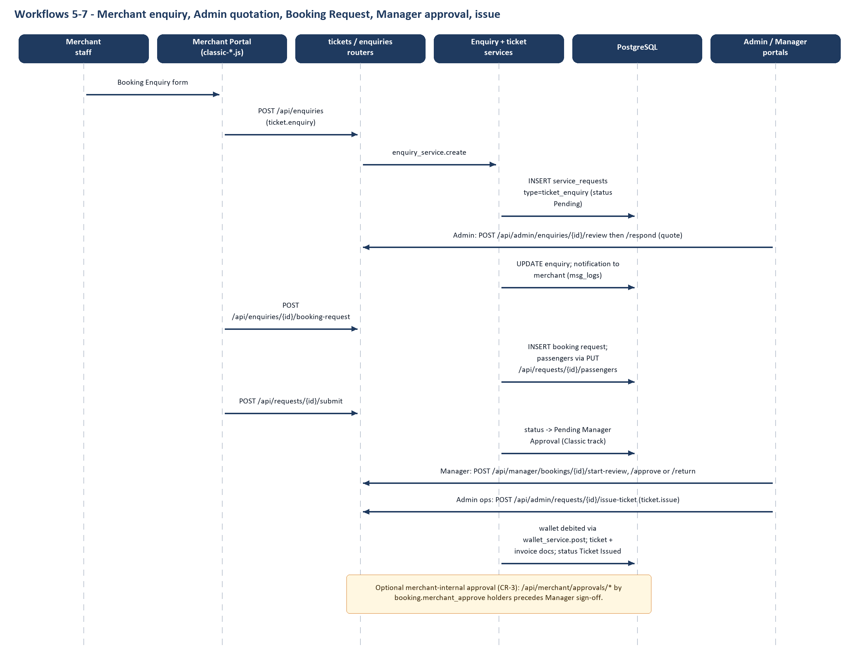
Figure 4. Merchant enquiry to ticket issue (verified route names)
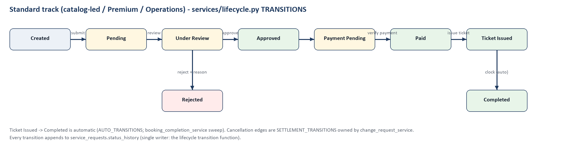
Figure 5. Standard lifecycle (lifecycle.py TRANSITIONS)
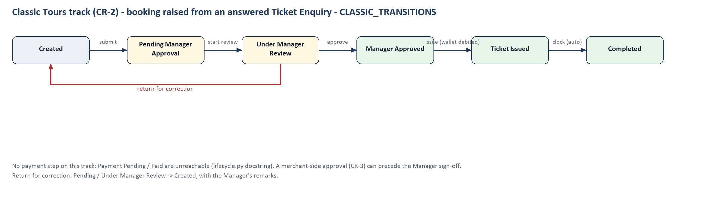
Figure 6. Classic Tours lifecycle (lifecycle.py CLASSIC_TRANSITIONS)

5.7 Premium / Partner workspace (frontend/merchant/index.html)
A second merchant interface with sections Dashboard, My Requests, Payments, Service Requests, Reports, Live Chat Support and Profile (plus Ticket Enquiry and Request Ticket). It is implemented by partner-*.js and mh-*.js scripts that call the same /api routes (for example /api/requests, /api/enquiries). Which interface is the “official” one is a product decision; the code makes merchant-classic the default landing page.
Table 17. Partner / Premium workspace scripts
Script | Purpose (header comment) | Lines | Listeners | API routes referenced
partner-shared.js | Partner Portal — shared helpers. Deliberately separate localStorage namespace (partner_jwt_ , not jwt_ ) — index.html, a… | 223 | 11 | No literal API route found
mh-visuals.js | Merchant Portal — visual primitives for the booking surfaces. Why this file generates imagery instead of loading it: fro… | 321 | 3 | No literal API route found
mh-filters.js | Merchant Home — result filters and sorting. Filtering is CLIENT SIDE and deliberately so. GET /api/catalog/search accept… | 443 | 3 | No literal API route found
mh-autocomplete.js | Smart travel search — a ranked, keyboard driven autocomplete for every location field in the merchant portal. Two source… | 368 | 7 | GET /catalog/search
mh-datepicker.js | Travel style calendar replacing the browser native date control. The original <input type "date"> element is KEPT IN THE… | 214 | 6 | No literal API route found
partner-auth.js | Merchant Portal — Login > Password > OTP > Dashboard (docs/API_CONTRACT.md §1). Uses the shared /api/auth/login|verify o… | 94 | 4 | No literal API route found
partner-dashboard.js | Merchant Portal — Dashboard KPIs. GET /api/merchant/dashboard (API_CONTRACT.md §6.1). Every card is a real <button> that… | 130 | 2 | GET /merchant/dashboard
partner-home.js | Merchant Home — the MakeMyTrip style booking surface that a merchant lands on after sign in. Backend: nothing new. This … | 1169 | 31 | GET /catalog/search  GET /catalog/{item_id}/quote  GET /merchant/dashboard  GET /requests  POST /requests
partner-payments.js | Merchant Portal — Payments. New screen in this pass, no new backend. There is deliberately no merchant payments list end… | 100 | 3 | GET /requests  POST /requests
partner-ticket-enquiry.js | Merchant Portal — Ticket Enquiry. GET /api/catalog/search (API_CONTRACT.md — existing, live). Inventory is real catalog … | 119 | 3 | GET /catalog/search  GET /catalog/{item_id}/quote
partner-request-ticket.js | Merchant Portal — Request Ticket. Books exactly one catalog item (real fare + inventory), priced server side — there is … | 636 | 14 | GET /requests  POST /requests  POST /requests/{request_id}/submit
partner-request-history.js | Merchant Portal — Request History. GET /api/requests + GET /api/requests/{id} (API_CONTRACT.md — existing, live). The de… | 193 | 8 | DELETE /requests/{request_id}  GET /requests  GET /requests/{request_id}  POST /requests  POST /requests/{request_id}/cancel  … +3 more (see Volume 2)
partner-service-request.js | Merchant Portal — Service Request (4 tabs). POST /api/service requests (API_CONTRACT.md — existing, live). One shared en… | 190 | 7 | GET /requests  POST /requests  POST /service-requests
partner-reports.js | Merchant Portal — Reports. The on screen table reuses GET /api/requests directly (a plain filtered list isn't a new capa… | 73 | 4 | GET /reports/export  GET /requests  POST /requests
partner-notifications.js | Notification centre — polls GET /api/notifications (API_CONTRACT.md §6.4; no WebSocket backend exists yet, so this is th… | 193 | 6 | GET /notifications  GET /notifications/unread-count  PATCH /notifications/{notification_id}/read  POST /notifications/read-all
partner-live-chat.js | Live Chat Support — frontend component architecture, ready for a future backend (WebSocket/SSE). No chat backend exists … | 102 | 3 | No literal API route found
partner-profile.js | Merchant Portal — Profile: view/update account info + change password. GET/PUT /api/profile (API_CONTRACT.md §6.6), chan… | 102 | 2 | GET /merchant/dashboard  GET /profile  POST /auth/change-password  PUT /profile

6. Admin Portal
frontend/admin/index.html is a single large page (119 KB) with 38 sidebar sections, 68 buttons and 5 forms, driven by the admin*.js scripts (axios-based). It is organised in two groups: the B2B desk (merchants, enquiries, bookings, payments, wallet, providers, reports, audit) and the B2C desk (customers, bookings, cancellations, reviews, live support, payments, reconciliation, activity, catalogue, gaming enquiries, reports, analytics).

6.1 Access
Sign-in card on /admin/ → POST /api/auth/login with portal=admin → OTP. Role admin holds 34 permission codes (table below); the Super Admin portal cannot open this portal because PORTAL_ROLES binds each role to one portal.

6.2 Sections, scripts and APIs
Table 18. Admin sections (script mapping inferred from file names and header comments; the API column is verified)
Feature (sidebar label) | data-section | Script(s) | API routes referenced (verified literals)
Dashboard | reports | admin.js | DELETE /admin/merchants/{merchant_id}  DELETE /admin/merchants/{merchant_id}/users/{user_id}  GET /admin/approval-queue  GET /admin/dashboard  GET /admin/merchants  GET /admin/merchants/{merchant_id}  GET /admin/merchants/{merchant_id}/finance  … +39 more (see Volume 2)
Merchant Management | users | admin.js | DELETE /admin/merchants/{merchant_id}  DELETE /admin/merchants/{merchant_id}/users/{user_id}  GET /admin/approval-queue  GET /admin/dashboard  GET /admin/merchants  GET /admin/merchants/{merchant_id}  GET /admin/merchants/{merchant_id}/finance  … +39 more (see Volume 2)
Active Users | active-users | admin.js | DELETE /admin/merchants/{merchant_id}  DELETE /admin/merchants/{merchant_id}/users/{user_id}  GET /admin/approval-queue  GET /admin/dashboard  GET /admin/merchants  GET /admin/merchants/{merchant_id}  GET /admin/merchants/{merchant_id}/finance  … +39 more (see Volume 2)
Booking Enquiries (flight + hotel) | ticket-enquiries | admin-enquiries.js, admin-enquiry-host.js | GET /enquiries  GET /enquiries/{enquiry_id}  GET /hotel/enquiries  GET /hotel/enquiries/{enquiry_id}  POST /admin/enquiries/{enquiry_id}/respond  POST /admin/enquiries/{enquiry_id}/review  POST /admin/hotel-enquiries/{enquiry_id}/respond  … +3 more (see Volume 2)
Approval Queue | partner-requests | admin.js, admin-bookings.js | DELETE /admin/merchants/{merchant_id}  DELETE /admin/merchants/{merchant_id}/users/{user_id}  DELETE /requests/{request_id}  GET /admin/approval-queue  GET /admin/dashboard  GET /admin/merchants  GET /admin/merchants/{merchant_id}  … +45 more (see Volume 2)
Booking Operations | booking-ops | admin-booking-ops.js | DELETE /documents/{document_id}  DELETE /requests/{request_id}  GET /admin/bookings/queue  GET /admin/bookings/queue/counts  GET /admin/bookings/{request_id}/notes  GET /admin/providers/options  GET /admin/providers/{provider_id}  … +9 more (see Volume 2)
Service Request Management (change requests) | service-requests-mgmt | admin-change-requests.js | GET /change-requests/{request_id}
Provider Management | providers | admin-providers.js | GET /admin/providers  GET /admin/providers/export  GET /admin/providers/{provider_id}  PATCH /admin/provider-users/{provider_user_id}  PATCH /admin/providers/{provider_id}  POST /admin/providers  POST /admin/providers/{provider_id}/users
Manual Enquiry / Manual Booking | manual-enquiry, manual-request | admin-manual-booking.js, admin-enquiry-host.js | DELETE /requests/{request_id}  GET /admin/merchants  GET /enquiries  GET /requests/{request_id}  GET /requests/{request_id}/invoice  POST /admin/merchants  POST /enquiries  … +1 more (see Volume 2)
Payment Management (+ payment requests) | payments | admin-payment-requests.js, admin.js | DELETE /admin/merchants/{merchant_id}  DELETE /admin/merchants/{merchant_id}/users/{user_id}  GET /admin/approval-queue  GET /admin/dashboard  GET /admin/merchants  GET /admin/merchants/{merchant_id}  GET /admin/merchants/{merchant_id}/finance  … +45 more (see Volume 2)
Wallet & Top-ups | wallet-desk | admin-wallet-desk.js | GET /admin/merchants/{merchant_id}/wallet/transactions  GET /admin/wallet/reconciliation  GET /admin/wallet/topups  GET /admin/wallet/topups/counts  GET /admin/wallet/topups/{topup_id}  GET /admin/wallet/topups/{topup_id}/proof
Reports / Analytics (B2B) | reports-export, analytics | admin-analytics.js, admin.js | DELETE /admin/merchants/{merchant_id}  DELETE /admin/merchants/{merchant_id}/users/{user_id}  GET /admin/approval-queue  GET /admin/dashboard  GET /admin/merchants  GET /admin/merchants/{merchant_id}  GET /admin/merchants/{merchant_id}/finance  … +42 more (see Volume 2)
Audit Logs / System Logs | audit, system-logs | admin-logs.js | GET /super-admin/activity  GET /super-admin/activity/filters  GET /super-admin/audit-logs  GET /super-admin/audit-logs/tables
Support Management / Communication | support, notifications | admin-message-delivery.js, admin.js | DELETE /admin/merchants/{merchant_id}  DELETE /admin/merchants/{merchant_id}/users/{user_id}  GET /admin/approval-queue  GET /admin/dashboard  GET /admin/merchants  GET /admin/merchants/{merchant_id}  GET /admin/merchants/{merchant_id}/finance  … +41 more (see Volume 2)
Customers (B2C) | b2c-customers | admin-b2c-customers.js | GET /admin/customers  GET /admin/customers/{customer_id}
Bookings (B2C) | b2c-bookings | admin-b2c-bookings.js | GET /admin/customer-bookings  GET /admin/customer-bookings/{booking_id}  PATCH /admin/customer-bookings/{booking_id}/status
Cancellations & Refunds | b2c-refunds | admin-b2c-refunds.js | GET /admin/cancellations  GET /admin/cancellations/{cancellation_id}  PATCH /admin/cancellations/{cancellation_id}
Reviews & Ratings | b2c-reviews | admin-b2c-reviews.js | None found by static scan
Live Support (chat + calls) | live-support | admin-live-support.js, webrtc-call.js | GET /status
Communication (B2C) | b2c-communication | admin-b2c-communication.js | GET /notifications
Customer Payments + Reconciliation | customer-payments, b2c-reconciliation | admin-customer-payments.js, admin-b2c-reconciliation.js | GET /admin/customer-payments  GET /admin/customer-payments/counts  GET /admin/customer-payments/{product}/{payment_id}  GET /admin/payment-reconciliation  POST /admin/payment-reconciliation/{product}/{payment_id}/verify
User Activity | b2c-activity | admin-b2c-activity.js | None found by static scan
Catalogue: Flights | b2c-cat-flights | admin-b2c-flights.js | None found by static scan
Catalogue: Hotels | b2c-cat-hotels | admin-b2c-hotels.js | None found by static scan
Catalogue: Tour Packages | b2c-cat-packages | admin-b2c-packages.js | None found by static scan
Catalogue: Destinations | b2c-cat-destinations | admin-b2c-destinations.js | None found by static scan
Gaming tour enquiries (4 queues) | gaming-new/requests/converted/closed | admin-gaming-enquiries.js | GET /admin/gaming-tour-enquiries  GET /admin/gaming-tour-enquiries/{enquiry_id}  PATCH /admin/gaming-tour-enquiries/{enquiry_id}
Reports and Analytics (B2C) | b2c-reports, b2c-analytics | admin-b2c-reports.js, admin-b2c-analytics.js | GET /admin/b2c-analytics/overview  GET /admin/b2c-reports/export  GET /admin/b2c-reports/preview  GET /admin/b2c-reports/types

6.3 Required feature coverage check
Table 19. Admin coverage against the requested list
Requested item | Found? | Evidence
Merchant management / service access control | Yes | /api/admin/merchants*, PATCH .../service-access (merchants.py)
User management | Yes | Active Users, merchant users under /api/admin/merchants/{id}/users; Admin accounts are managed by Super Admin
Booking management, enquiries, approvals | Yes | ticket-enquiries, partner-requests, booking-ops sections
Hotel enquiries | Yes | /api/admin/hotel-enquiries/{id}/review|respond
Tour package enquiries | Partial | Public submit exists; an admin listing endpoint for tour_package_enquiries was Not found (only POST /api/customer/tour-package-enquiries)
Gaming tour enquiries | Yes | /api/admin/gaming-tour-enquiries*
Group bookings | Yes | /api/group-bookings/* (merchant upload) + /api/admin/requests/{id}/group-import
Payment and wallet management | Yes | /api/admin/payments*, /api/admin/wallet/*, /api/admin/payment-accounts*
Support tickets / notifications / reports | Yes | /api/support/threads*, /api/admin/notifications/broadcast, /api/reports*
Document management | Yes | /api/documents/*, /api/admin/documents/{id}/verify
Audit logs | Yes | Admin: system logs; Super Admin: /api/super-admin/audit-logs
System settings | Not found as an editable screen | Only read-only /api/super-admin/system-info exists; per-merchant communication settings are editable (/api/admin/communication-settings/{id})

6.4 Permissions held by role admin
Table 20. 34 default admin permission codes
Permission code
audit.view | catalog.manage | chat.manage
chat.view | customer.view | document.verify
merchant.create | merchant.delete | merchant.edit
merchant.suspend | merchant.view | merchant_user.delete
merchant_user.manage | notification.send | notification.view
payment.manage | payment.verify | payment.view
profile.manage | provider.manage | provider.view
refund.execute | refund.reconcile | refund.view
report.export | report.view | servicerequest.manage
support.manage | system.activity.view | ticket.approve
ticket.issue | ticket.manual | ticket.reject
ticket.view

6.5 Admin script inventory
Table 21. Admin scripts
Script | Purpose (header comment) | Lines | Listeners | API routes referenced
admin-analytics.js | Admin Portal — Analytics (M6). Four panels over three endpoints, and not one number computed here: GET /api/analytics/op… | 357 | 0 | GET /analytics/bookings  GET /analytics/change-requests  GET /analytics/operations
admin-auth.js | Admin Portal — Login > Password > OTP > Dashboard (docs/API_CONTRACT.md §1). Uses the shared /api/auth/login|verify otp|… | 91 | 4 | No literal API route found
admin-b2c-activity.js | Admin — B2C User Activity (Phase 7 of the B2C Admin Portal build out) READ ONLY view of what B2C customers have done: th… | 137 | 3 | No literal API route found
admin-b2c-analytics.js | Admin — B2C Analytics (Phase 8 of the B2C Admin Portal build out) THE BROWSER ONLY DRAWS. Every figure arrives from GET … | 211 | 1 | GET /admin/b2c-analytics/overview
admin-b2c-bookings.js | Admin — B2C Bookings (Phase 2 of the B2C Admin Portal build out) This is the module that answers "when a customer books … | 263 | 8 | GET /admin/customer-bookings  GET /admin/customer-bookings/{booking_id}  PATCH /admin/customer-bookings/{booking_id}/status
admin-b2c-catalogue-common.js | Admin — B2C Catalogue Management, shared pieces (Phase 5 of the B2C Admin Portal build out) What the four catalogue scre… | 204 | 2 | No literal API route found
admin-b2c-communication.js | Admin — B2C Communication (Phase 7 of the B2C Admin Portal build out) A READ ONLY RECORD of what customers have been sen… | 187 | 5 | GET /notifications
admin-b2c-customers.js | Admin — B2C Customers (Phase 1 of the B2C Admin Portal build out) Direct customers — everyone who books through the webs… | 211 | 5 | GET /admin/customers  GET /admin/customers/{customer_id}
admin-b2c-destinations.js | Admin — B2C Catalogue: Destinations (Phase 5 of the B2C Admin Portal build out) Edits the SAME destination and location … | 229 | 7 | No literal API route found
admin-b2c-flights.js | Admin — B2C Catalogue: Flights (Phase 5 of the B2C Admin Portal build out) THIS SCREEN HAS NO FORMS ON PURPOSE. Flights … | 59 | 0 | No literal API route found
admin-b2c-hotels.js | Admin — B2C Catalogue: Hotels (Phase 5 of the B2C Admin Portal build out) Edits the SAME hotel and room rows the custome… | 310 | 9 | No literal API route found
admin-b2c-packages.js | Admin — B2C Catalogue: Tour Packages (Phase 5 of the B2C Admin Portal build out) Creates and edits the SAME package, iti… | 324 | 10 | No literal API route found
admin-b2c-reconciliation.js | Admin — B2C Payment Reconciliation (Phase 4 of the B2C Admin Portal build out) Verifies that the money a gateway says mo… | 150 | 3 | GET /admin/payment-reconciliation  POST /admin/payment-reconciliation/{product}/{payment_id}/verify
admin-b2c-refunds.js | Admin — B2C Cancellations & Refunds (Phase 3 of the B2C Admin Portal build out) Completes the lifecycle the plan drew: C… | 259 | 9 | GET /admin/cancellations  GET /admin/cancellations/{cancellation_id}  PATCH /admin/cancellations/{cancellation_id}
admin-b2c-reports.js | Admin — B2C Reports (Phase 8 of the B2C Admin Portal build out) Pick a report, narrow it, see what a download will conta… | 118 | 3 | GET /admin/b2c-reports/export  GET /admin/b2c-reports/preview  GET /admin/b2c-reports/types
admin-b2c-reviews.js | Admin — B2C Reviews & Ratings (Phase 6 of the B2C Admin Portal build out) Moderates the reviews customers write from the… | 203 | 6 | No literal API route found
admin-booking-ops.js | Admin — Booking Operations (CR 2, over the M1/M2 backend) The desk that works a booking after it is approved: who the me… | 1041 | 18 | DELETE /documents/{document_id}  DELETE /requests/{request_id}  GET /admin/bookings/queue  GET /admin/bookings/queue/counts  GET /admin/bookings/{request_id}/notes  … +11 more (see Volume 2)
admin-bookings.js | Admin — Booking review from the Approval Queue The Approval Queue could always approve or reject a booking; what it coul… | 643 | 14 | DELETE /requests/{request_id}  GET /admin/requests/{request_id}/passport-ocr  GET /bookings/passport/extract/{extraction_id}/scan  GET /documents/{document_id}/download  GET /requests/{request_id}  … +2 more (see Volume 2)
admin-change-requests.js | Admin — the cancellation & reschedule settle dialog (M3) Where a merchant's request to cancel or move a confirmed bookin… | 396 | 7 | GET /change-requests/{request_id}
admin-customer-payments.js | Admin — Customer Payments (B2C) What a member of the public paid for their own trip, through the gateway. THIS IS NOT TH… | 293 | 5 | GET /admin/customer-payments  GET /admin/customer-payments/counts  GET /admin/customer-payments/{product}/{payment_id}
admin-dialog-standard.js | ADMIN DIALOG STANDARD — the header close control 2026 08 04 Companion to jp ds.css §15. That section standardises the fr… | 130 | 2 | No literal API route found
admin-enquiries.js | Admin — Booking Enquiries (Phase 2) The Admin half of the merchant's Enquire Ticket flow. A merchant describes a sector;… | 554 | 10 | GET /enquiries  GET /enquiries/{enquiry_id}  GET /hotel/enquiries  GET /hotel/enquiries/{enquiry_id}  POST /admin/enquiries/{enquiry_id}/respond  … +5 more (see Volume 2)
admin-enquiry-host.js | Admin Portal — the host the Merchant Portal's booking enquiry form runs in. THE FORM ITSELF IS NOT IN THIS FILE, AND THA… | 384 | 8 | No literal API route found
admin-gaming-enquiries.js | Admin — Gaming Tour Enquiries A public submission's queue, not a merchant's. See app.models_v2.GamingTourEnquiry for why… | 314 | 10 | GET /admin/gaming-tour-enquiries  GET /admin/gaming-tour-enquiries/{enquiry_id}  PATCH /admin/gaming-tour-enquiries/{enquiry_id}
admin-live-support.js | admin live support.js — the agent console (CR 9, slice 4) Three panes: the queue, the thread, and who the customer is. A… | 1241 | 28 | GET /status
admin-logs.js | Admin Portal — Audit Logs and System Logs. AUDIT LOGS MOVED HERE FROM THE SUPER ADMIN PORTAL, AND NOTHING SERVER SIDE HA… | 268 | 5 | GET /super-admin/activity  GET /super-admin/activity/filters  GET /super-admin/audit-logs  GET /super-admin/audit-logs/tables
admin-manual-booking.js | Admin Portal — Manual Booking. Manual Enquiry mounts THE MERCHANT PORTAL'S OWN booking enquiry form: merchant classic/js… | 2009 | 22 | DELETE /requests/{request_id}  GET /admin/merchants  GET /enquiries  GET /requests/{request_id}  GET /requests/{request_id}/invoice  … +3 more (see Volume 2)
admin-message-delivery.js | Admin — Delivery Failures (M5) The screen that satisfies M5's last requirement: "a bounced or failed send is visible to … | 93 | 4 | GET /admin/messages/counts  GET /admin/messages/failed
admin-payment-requests.js | Admin — Payment Management (migration 0041) The desk asks a merchant's manager to pay, the manager pays and uploads the … | 647 | 15 | GET /admin/merchants  GET /admin/merchants/{merchant_id}/managers  GET /admin/wallet/topups  GET /admin/wallet/topups/counts  GET /admin/wallet/topups/{topup_id}  … +4 more (see Volume 2)
admin-providers.js | Admin — Provider Management (0039) The external suppliers the operations desk buys tickets from, and the named people at… | 626 | 24 | GET /admin/providers  GET /admin/providers/export  GET /admin/providers/{provider_id}  PATCH /admin/provider-users/{provider_user_id}  PATCH /admin/providers/{provider_id}  … +2 more (see Volume 2)
admin-wallet-desk.js | Admin — Wallet & Top ups (CR 4d) The staff side of the merchant wallet: the queue that decides whether money arrived, an… | 485 | 16 | GET /admin/merchants/{merchant_id}/wallet/transactions  GET /admin/wallet/reconciliation  GET /admin/wallet/topups  GET /admin/wallet/topups/counts  GET /admin/wallet/topups/{topup_id}  … +1 more (see Volume 2)
admin.js | SAME ORIGIN UNLESS THE PAGE CAME OFF A FILE SERVER. localhost:8000 and 127.0.0.1:8000 are one machine and TWO ORIGIN… | 2632 | 78 | DELETE /admin/merchants/{merchant_id}  DELETE /admin/merchants/{merchant_id}/users/{user_id}  GET /admin/approval-queue  GET /admin/dashboard  GET /admin/merchants  … +41 more (see Volume 2)
api.js | api.js — reusable API layer. Every method here wraps axios + API_BASE + the right auth headers for exactly one real back… | 71 | 0 | GET /admin/merchants  GET /auth/me  GET /notifications  POST /admin/merchants  POST /auth/login  … +1 more (see Volume 2)
webrtc-call.js | webrtc call.js — one voice call, from either side (CR 10) Loaded by BOTH the customer widget and the agent console. A ca… | 1088 | 1 | No literal API route found

7. Manager and Operations Workspaces

7.1 Manager portal
The Manager role (migration 0033, CR-2) exists so that the person who answered an enquiry cannot also approve the resulting booking. Its portal (frontend/manager/index.html, script manager-portal.js, 32 listeners) has three sections: Booking Requests (queue with counts), Notifications and Profile & Security. A read-only review modal offers two decisions: approve or return for correction.
Table 22. Manager portal APIs (manager.py, manager_approvals.py)
Action | API | Permission
List / counts / detail | GET /api/manager/bookings, /bookings/counts, /bookings/{id} | booking.manager_approve
Start review | POST /api/manager/bookings/{id}/start-review | booking.manager_approve
Approve | POST /api/manager/bookings/{id}/approve | booking.manager_approve
Return for correction (remarks) | POST /api/manager/bookings/{id}/return | booking.manager_return
Service-request approvals (merchant-side managers) | /api/manager/service-requests* | servicerequest.approve (merchant roles, not the platform Manager)

7.2 Manager versus Admin versus Merchant
Table 23. Role comparison (rbac.py ROLE_PERMISSIONS)
Aspect | Manager | Admin | Merchant
Sign-in portal | manager | admin | merchant
Default permission codes | 4 | 34 | 6–18 (+ sub-role)
Can answer enquiries / quote | No | Yes (ticket.approve/reject) | No (raises them)
Can sign off a Classic booking | Yes | No – deliberately | Merchant-internal approval only (CR-3)
Can issue tickets / verify payments | No | Yes | No
Sees other merchants’ data | Queue of platform bookings | Yes | Never (scoped by merchant_id)

7.3 Operations workspace
frontend/operations/index.html is not a login portal. ops-core.js reads the session of whichever portal is signed in, calls /api/auth/me, and builds its sidebar by asking opsCan(code) for each module, so one UI can serve different staff accounts. A merchant session is redirected to /merchant-classic/ (the “merchant lock” comment: “Nothing here was deleted — remove this block to let merchants back in”). Modules are grouped into desks: Ticketing, Finance, Support and Administration.
Table 24. Operations modules (ops-core.js navigation definition)
Module | Visible when holder has any of | Desk(s)
Flights / Hotels / Cruises / Packages | ticket.enquiry, ticket.view | ticketing
Bookings | ticket.view | ticketing, finance, support
Requests | ticket.view | ticketing, support
Approvals | ticket.approve, ticket.reject, servicerequest.manage | ticketing, admin
Payments | payment.view, payment.pay, payment.verify | finance
Wallet | ticket.view, merchant.view | finance
Customers | ticket.view | ticketing, support
Merchants | merchant.view | admin, finance, support
Users | merchant_user.manage/create, admin.view | admin
Reports | report.view, report.export | ticketing, finance, admin
Support | chat.view | support
System Logs | system.activity.view, audit.view | admin
Settings | (always) | all

Note: the workspace shows a “Cruises” module although the customer site retired cruises (cruises.html redirects home); the Operations Cruises screen was not individually traced (Not verified).
Many portal screens do not call the API directly: they call functions of a shared client script, so the per-feature table above shows only literals inside the screen’s own script. The shared client ops-api.js references the 85 routes below (verified literal matches). Which screen uses which function was not traced individually (Not verified).
Table 25. Routes referenced by the shared operations client (frontend/shared/ops-api.js)
Method | Route | Router module
DELETE | /admin/merchants/{merchant_id} | merchants.py
DELETE | /requests/{request_id} | tickets.py
DELETE | /super-admin/admins/{user_id} | super_admin.py
GET | /admin/approval-queue | admin_ops.py
GET | /admin/communication-settings/{merchant_id} | admin_ops.py
GET | /admin/dashboard | dashboard.py
GET | /admin/merchants | merchants.py
GET | /admin/merchants/{merchant_id} | merchants.py
GET | /admin/merchants/{merchant_id}/users | merchants.py
GET | /admin/payments | admin_ops.py
GET | /admin/payments/pending | tickets.py
GET | /admin/users | admin_ops.py
GET | /auth/me | auth.py
GET | /catalog/search | tickets.py
GET | /catalog/{item_id}/quote | tickets.py
GET | /documents/{document_id}/download | documents.py
GET | /merchant/dashboard | dashboard.py
GET | /merchant/finance/position | finance.py
GET | /merchant/team | merchant_team.py
GET | /merchant/team/{user_id} | merchant_team.py
GET | /notifications | notifications_v2.py
GET | /notifications/unread-count | notifications_v2.py
GET | /profile | profile.py
GET | /reports/export | reports.py
GET | /requests | tickets.py
GET | /requests/{request_id} | tickets.py
GET | /requests/{request_id}/invoice | tickets.py
GET | /super-admin/activity | super_admin.py
GET | /super-admin/activity/filters | super_admin.py
GET | /super-admin/admins | super_admin.py
GET | /super-admin/admins/{user_id} | super_admin.py
GET | /super-admin/admins/{user_id}/permissions | super_admin.py
GET | /super-admin/audit-logs | super_admin.py
GET | /super-admin/audit-logs/tables | super_admin.py
GET | /super-admin/dashboard | super_admin.py
GET | /super-admin/permissions/matrix | super_admin.py
GET | /super-admin/reports/summary | super_admin.py
GET | /super-admin/system-info | super_admin.py
GET | /support/threads | support_tickets.py
GET | /support/threads/{thread_id} | support_tickets.py
GET | /support/threads/{thread_id}/documents | support_tickets.py
GET | /support/threads/{thread_id}/notes | support_tickets.py
GET | /support/unread-count | support_tickets.py
PATCH | /admin/merchants/{merchant_id}/status | merchants.py
PATCH | /merchant/team/{user_id}/status | merchant_team.py
PATCH | /notifications/{notification_id}/read | notifications_v2.py
PATCH | /super-admin/admins/{user_id}/status | super_admin.py
PATCH | /support/threads/{thread_id}/triage | support_tickets.py
POST | /admin/merchants | merchants.py
POST | /admin/merchants/{merchant_id}/users | merchants.py
POST | /admin/merchants/{merchant_id}/users/{user_id}/reset-password | merchants.py
POST | /admin/notifications/broadcast | admin_ops.py
POST | /admin/payments/{payment_id}/refund | admin_ops.py
POST | /admin/payments/{payment_id}/verify | tickets.py
POST | /admin/requests/{request_id}/approve | tickets.py
POST | /admin/requests/{request_id}/issue-ticket | tickets.py
POST | /admin/requests/{request_id}/reject | tickets.py
POST | /admin/requests/{request_id}/reprice | tickets.py
POST | /admin/service-requests/{request_id}/resolve | tickets.py
POST | /auth/change-password | auth.py
POST | /merchant/team | merchant_team.py
POST | /merchant/team/{user_id}/reset-password | merchant_team.py
POST | /notifications/read-all | notifications_v2.py
POST | /profile/heartbeat | profile.py
POST | /requests | tickets.py
POST | /requests/{request_id}/cancel | tickets.py
POST | /requests/{request_id}/pay | tickets.py
POST | /requests/{request_id}/submit | tickets.py
POST | /service-requests | tickets.py
POST | /super-admin/admins | super_admin.py
POST | /super-admin/admins/{user_id}/reset-password | super_admin.py
POST | /support/threads | support_tickets.py
POST | /support/threads/{thread_id}/claim | support_tickets.py
POST | /support/threads/{thread_id}/documents | support_tickets.py
POST | /support/threads/{thread_id}/messages | support_tickets.py
POST | /support/threads/{thread_id}/notes | support_tickets.py
POST | /support/threads/{thread_id}/resolve | support_tickets.py
PUT | /admin/communication-settings/{merchant_id} | admin_ops.py
PUT | /admin/merchants/{merchant_id} | merchants.py
PUT | /merchant/team/{user_id} | merchant_team.py
PUT | /profile | profile.py
PUT | /requests/{request_id} | tickets.py
PUT | /requests/{request_id}/passengers | tickets.py
PUT | /super-admin/admins/{user_id} | super_admin.py
PUT | /super-admin/admins/{user_id}/permissions | super_admin.py

Table 26. Operations workspace scripts
Script | Purpose (header comment) | Lines | Listeners | API routes referenced
ops-core.js | Operations Portal — shell. Session, permissions, navigation, routing, keyboard shortcuts, global search, and the primiti… | 1273 | 27 | GET /auth/me
ops-api.js | ops api.js — the Operations Portal's backend contract, in one place. VERSION 2 (frontend/operations/) talks to the backe… | 700 | 0 | DELETE /admin/merchants/{merchant_id}  DELETE /requests/{request_id}  DELETE /super-admin/admins/{user_id}  GET /admin/approval-queue  GET /admin/communication-settings/{merchant_id}  … +80 more (see Volume 2)
ops-dashboard.js | Operations Portal — Dashboard. There are three dashboard endpoints, one per portal, each behind its own permission: GET … | 595 | 6 | No literal API route found
ops-inventory.js | Operations Portal — Flights, Hotels, Cruises, Packages. Four sidebar entries, one module: the only difference between th… | 290 | 1 | No literal API route found
ops-requests.js | Operations Portal — Bookings, Requests, Approvals, and the Request Ticket form. Everything in this file works on ONE tab… | 1569 | 37 | No literal API route found
ops-finance.js | Operations Portal — Payments and Wallet. Three different questions, three different endpoints, three tabs — because they… | 731 | 7 | No literal API route found
ops-directory.js | Operations Portal — Customers, Merchants, Users. CUSTOMERS IS DERIVED, AND SAYS SO There is no customer or passenger end… | 1012 | 25 | No literal API route found
ops-insight.js | Operations Portal — Reports and System Logs. REPORTS There is no aggregation endpoint for bookings. `GET /api/reports/ex… | 495 | 3 | No literal API route found
ops-support.js | Operations Portal — Support. Chat threads are service_requests rows with request_type live_chat, and chat_service.py wal… | 622 | 13 | No literal API route found
ops-profile.js | Operations Portal — Profile (merchant workspace). The brief's Profile screen: Company Information, GST, PAN, Documents, … | 294 | 1 | No literal API route found
ops-settings.js | Operations Portal — Settings. Four groups, each present only when the account can reach it: Profile GET/PUT /api/profile… | 399 | 7 | No literal API route found
ops-grid.js | Operations Portal — the data grid. ONE component behind every table in the workspace, so "search, filters, sorting, pagi… | 955 | 29 | No literal API route found

7.4 Assignment and escalation
- Assignment: implemented. POST /api/admin/bookings/{id}/assign (ticket.approve) sets service_requests.assigned_admin; GET /api/admin/bookings/operators lists assignees; PUT /api/admin/bookings/{id}/references stores supplier/ticket references; internal notes via /api/admin/bookings/{id}/notes (booking_ops.py).
- Escalation: no dedicated escalation workflow was found. The closest constructs are the priority enum (low/normal/high/urgent) and the Manager return-for-correction loop. Status: Not found.

8. Super Admin Portal
frontend/super-admin/index.html has three sections (Dashboard, Admin Management, Profile & Security) driven by super-admin-*.js. The Super Admin manages Admins only; it deliberately cannot raise tickets, create merchants or touch bookings.
Table 27. Super Admin capabilities
Capability | API | Permission | Evidence status
System dashboard KPIs | GET /api/super-admin/dashboard | system.activity.view | Implemented in code
Admin lifecycle: list/create/edit/suspend/reset password/delete | /api/super-admin/admins* | admin.view/create/edit/suspend/reset_password/delete | Implemented in code
Role/permission visibility | GET /api/super-admin/permissions/matrix | system.activity.view | Read-only by design (rbac docstring: role assignments are fixed)
Grant/revoke extra permission codes to an Admin | GET/PUT /api/super-admin/admins/{id}/permissions | admin.view / admin.edit | Implemented in code
System information (read-only) | GET /api/super-admin/system-info | system.activity.view | Implemented in code (no write path)
Audit logs | GET /api/super-admin/audit-logs, /audit-logs/tables | audit.view | Implemented in code (trigger-populated audit_logs)
System activity / monitoring | GET /api/super-admin/activity, /activity/filters | system.activity.view | Implemented in code
Global reports summary | GET /api/super-admin/reports/summary | role super_admin or admin | Implemented in code
Merchant and user administration | GET merchants only (merchant.view) | merchant.view | Partial by design – Admin owns merchant lifecycle
Configuration editing | — | — | Not found (system info is read-only)

Table 28. Super Admin scripts
Script | Purpose (header comment) | Lines | Listeners | API routes referenced
super-admin-auth.js | Super Admin Portal — Login > Password > OTP > Dashboard (docs/API_CONTRACT.md §1). Uses the shared /api/auth/login|verif… | 91 | 4 | No literal API route found
super-admin-dashboard.js | Super Admin Portal — Dashboard KPIs and system overview. GET /api/super admin/dashboard (API_CONTRACT.md §6.1). Delibera… | 50 | 0 | GET /super-admin/dashboard
super-admin-admin-management.js | Super Admin Portal — Admin Management. Create / Edit / Suspend / Activate / Reset Password / Delete, against /api/super … | 324 | 13 | DELETE /super-admin/admins/{user_id}  GET /super-admin/admins  GET /super-admin/admins/{user_id}  PATCH /super-admin/admins/{user_id}/status  POST /super-admin/admins  … +2 more (see Volume 2)
super-admin-reports.js | Super Admin Portal — Global Reports & Analytics. GET /api/super admin/reports/summary — the cross merchant rollup, which… | 88 | 3 | GET /reports/export  GET /super-admin/reports/summary
super-admin-profile.js | Super Admin Portal — Profile & Security. GET|PUT /api/profile — the shared profile endpoint every portal uses POST /api/… | 142 | 6 | GET /profile  GET /super-admin/activity  POST /auth/change-password  PUT /profile
super-admin-shared.js | Super Admin Portal — shared helpers. Separate localStorage namespace (super_admin_jwt_ ) so a Super Admin session can ne… | 163 | 8 | No literal API route found

Note: auth/security.py also contains create_super_admin_access_token for a username-based sentinel subject (-1); no caller of it was found on main (Not verified whether it is dead code).

9. Complete API Documentation (summary)
The complete catalogue is Volume 2. Verified totals:
Table 29. Route entries by method (405 total: 403 in routers + 2 in main.py)
HTTP method | Entries
DELETE | 13
GET+POST (1 route) | 1
GET | 206
PATCH | 24
POST | 145
PUT | 14
WEBSOCKET | 2
Total | 405

Table 30. Entries by path prefix
Path prefix | Entries
/api/admin | 146
/api/customer | 115
/api/merchant | 25
/api/super-admin | 17
/api/requests | 14
/api/support | 13
/api/manager | 10
/api/auth | 9
/api/bookings | 9
/api/group-bookings | 7
/api/hotel | 5
/api/enquiries | 4
/api/notifications | 4
/api/analytics | 3
/api/change-requests | 3
/api/profile | 3
/api/assistant | 2
/api/documents | 2
/api/reports | 2
/api/catalog | 2
/api/tickets | 1
/api/payments | 1
/api/webhooks | 1
/api/contact | 1
/api/hotel-group-enquiry | 1
/api/newsletter | 1
/api/passengers | 1
/api/service-requests | 1
/api/health | 1
/api/status | 1

Public (no Depends-based authentication): 59 entries; permission-gated entries and rate limits are listed per endpoint in Volume 2. The README’s API Reference table (/api/flights, /api/hotels, /api/cruises, /api/packages, /api/wishlist, /api/reviews, /api/support-tickets, /api/users, /api/partner-auth, /api/partner/*) does not match the current routes – none of those prefixes exist (verified against the route table); it describes the retired pre-0023 application.

10. Backend Architecture and Business Logic

10.1 Structure of backend/app
Table 31. Backend layout
Folder / file | Role | Size
main.py | Creates the app, middleware, routers, startup tasks, static mount | 879 lines
config.py | Settings (pydantic-settings) – every environment variable | ~690 lines
routers/ | HTTP layer: parse request, check permission, call a service, shape the response | 60 modules
services/ | Business rules and database work; integrations in services/payments, passport_ocr, assistant, travel_ai | 135 modules
schemas/ | Pydantic request/response models | 67 modules
models_v2.py, models_customer.py | Active SQLAlchemy tables (B2B/shared and B2C) | 26 + 46 tables
models/, services/{admin,booking_management,payment_management,pricing,catalog_items,inventory}_service.py | Legacy (pre-0023) ORM and services; no router imports them | see Chapter 17
auth/ | JWT helpers, RBAC, dependencies, rate limiter, customer dependencies | 6 files
integrations/ | Duffel and Hotelbeds HTTP clients and mappers | 2 packages
database/session.py | Engine, SessionLocal, get_db dependency | 19 lines

10.2 Request lifecycle inside the backend
- Middleware stack: request_metadata (binds IP/browser/device so every log_activity call records them), security_headers, CORS, slowapi.
- FastAPI matches a route and resolves dependencies: get_db (one SQLAlchemy session per request, closed in finally), then authentication (get_current_user / get_current_customer), then require(P.X) permission checks.
- The router validates input through a Pydantic schema (invalid input → HTTP 422) and calls a service function.
- The service does the work inside the session; money- or state-changing services commit once and write an audit/activity row.
- The router returns a Pydantic response model (or a stream for files); errors are HTTPExceptions with a plain-language detail string.

10.3 Key mechanisms explained
Table 32. Important functions
Mechanism | In simple words | Technical detail (file)
get_current_user | Checks the visitor’s access card (JWT) and that the account is still allowed in. | auth/deps.py:30 – decodes the token, requires type=access and no scope claim (so customer tokens are refused), loads the user, requires status ACTIVE, rejects tokens issued before force_logout_at.
require(*codes) | A gate on a door that lists which keys open it. | auth/rbac.py:417 – returns a FastAPI dependency; passes if the user holds ANY listed code (or ALL with require_all=True); effective codes = role defaults ∪ merchant-role defaults ∪ users.permissions.
Lifecycle transition function | The only person allowed to change a booking’s status, and they write it in the diary. | services/lifecycle.py – TRANSITIONS, CLASSIC_TRANSITIONS, AUTO_TRANSITIONS, SETTLEMENT_TRANSITIONS; each edge names its permission; every change appends to service_requests.status_history.
wallet_service.post | The one cash register: nothing moves the wallet except through it. | services/wallet_service.py – SELECT … FOR UPDATE on the merchant row, then ledger row + balance update together; negative balances allowed (migration 0036).
payment_verification_* | Only the verifier may say “paid”, and only after asking the bank. | services/payment_verification_service.py (+ _flight_, _hotel_) – locks the payment, asks the provider, compares order id, payment id, currency and amount (integer paise) with the booking, then captures and confirms in one transaction; transport errors are retryable, never “failed”.
otp_service | A 5-minute code, stored only as a hash. | services/otp_service.py – SHA-256 hash, TTL 5 min, 5 requests/hour, constant-time compare, attempt cap.
document_service | Passport scans are handed out only through the front desk. | services/document_service.py – magic-byte sniff, size cap, uuid storage key, no static mount, scope enforced in the query.

10.4 Validation, errors, logging, background tasks
- Validation: Pydantic schemas (e.g. new_password min 8, max 72 – the bcrypt limit; OTP code 4–10 chars). Business validation lives in services and raises HTTPException.
- Exception handling: one custom handler is registered (RateLimitExceeded, main.py:117); everything else uses FastAPI defaults. Expected errors are HTTPException(detail=…); unexpected errors return a generic 500.
- Logging: Python logging at INFO to stdout (main.py), with docker json-file rotation (10 MB × 3). Business activity is written to the system_logs table through activity_service.log_activity (with IP, browser, device), and database triggers write audit_logs. B2C writes customer_audit_logs and customer_activity.
- Background tasks: two asyncio loops (Chapter 2.8). No Celery/APScheduler.
- Rate limiting: slowapi decorators on 39 routes (5–120 per minute per IP). The limiter uses the default in-memory store, so counters are per worker process.

10.5 Schemas and response shape
Responses are Pydantic models returned as JSON; list endpoints typically return {items, total, page, page_size, total_pages} (e.g. Page_AccountResponse_ in the OpenAPI schema). Money is Decimal in the database and serialised per the schema; payment verification compares integer paise. No global response envelope is used.

11. Complete Database Documentation (summary)
The full data dictionary, ERDs and migration list are Volume 3. This summary gives the facts a reader needs first.
Table 33. Database facts
Fact | Value | Evidence
Active ORM tables | 72 (26 B2B/shared + 46 B2C) | models_v2.py, models_customer.py
Tables from replaying migration upgrade() code | 72 – identical set | static replay of 94 revisions
Legacy ORM-only tables | 36 (39 classes minus three that reuse live table names) | backend/app/models/*
Live/production database | Not verified from the available source code | no database access
Nine-table redesign | Migration 0023 dropped all legacy tables and created merchants, users, service_requests, payments, passenger_data, communication_settings, msg_logs, system_logs, audit_logs | alembic 0023; db/schema_v2/02_nine_table_schema.sql

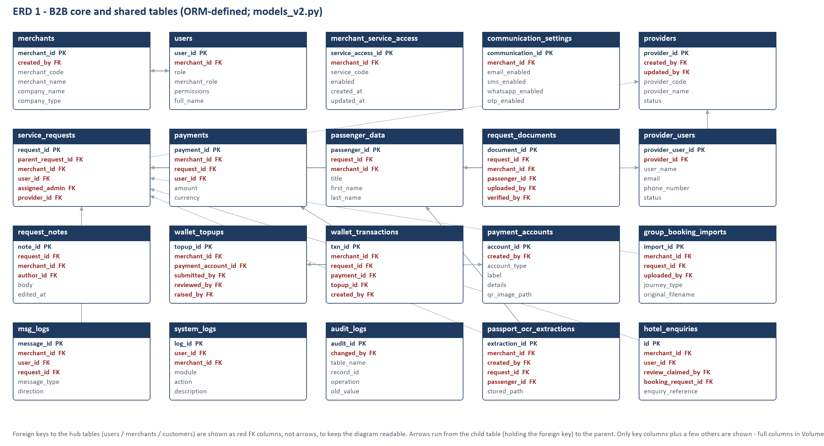
Figure 7. B2B core ERD (see Volume 3 for all tables)
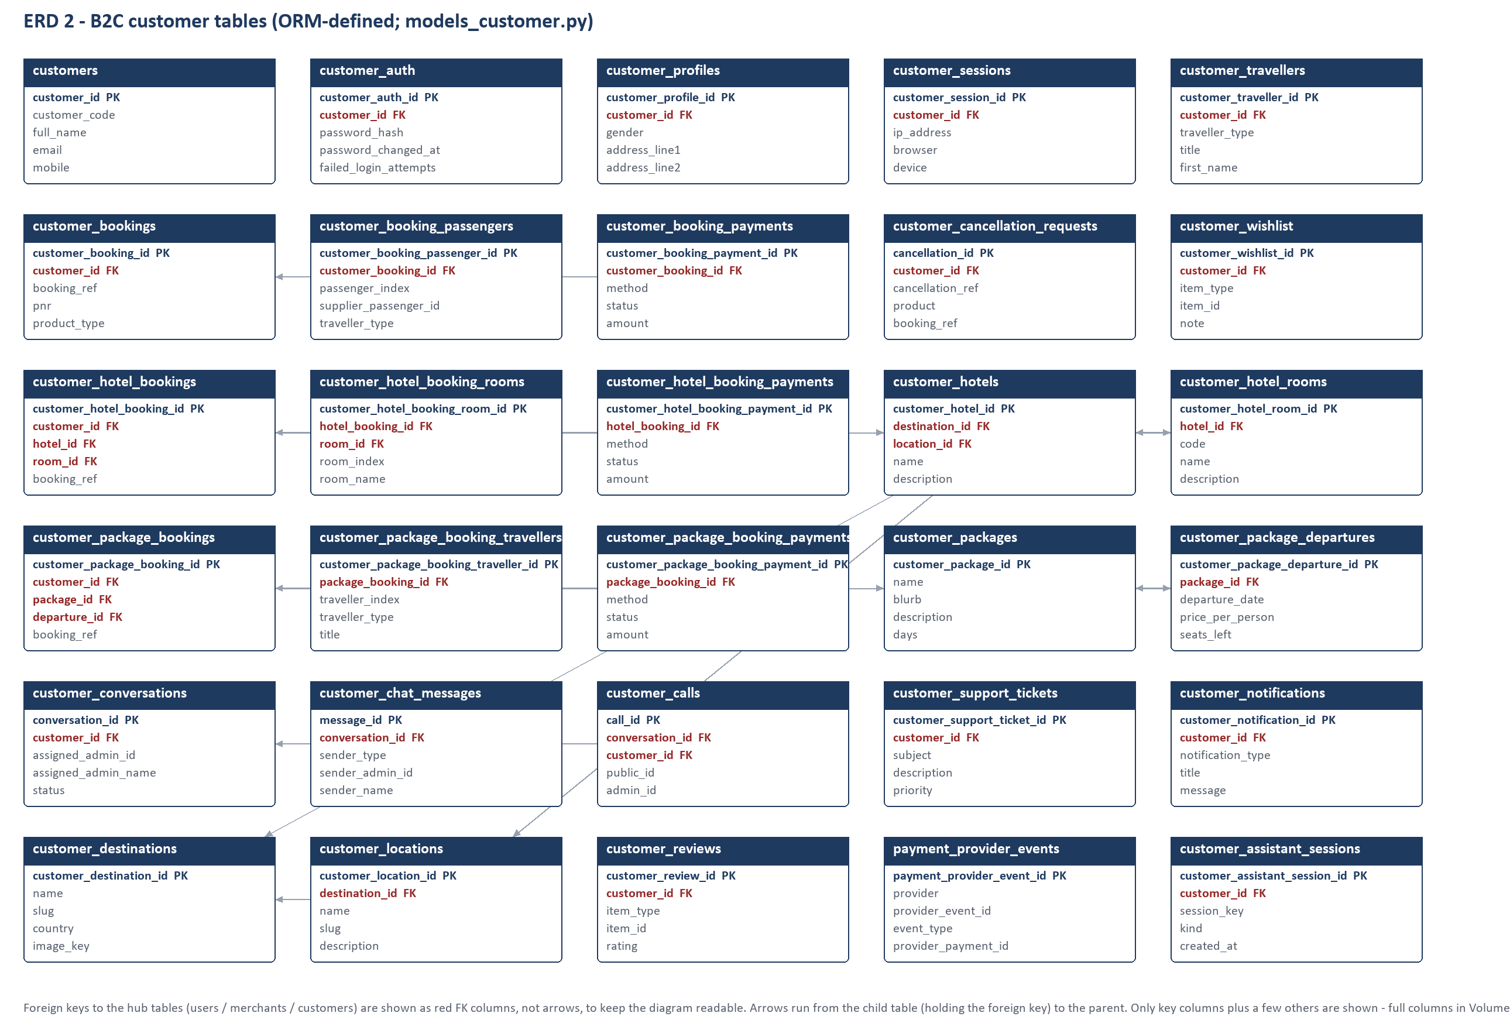
Figure 8. B2C ERD (see Volume 3)
Documentation mismatches in the database area
database/ (14 SQL files) and docs/DATABASE_STRUCTURE.md describe a *proposed* fully domain-separated v2 schema that “has not been applied”; they do not describe the running schema.
main.py still says “Schema v2 port in progress”, version="2.0.0-alpha" and lists “Pending” modules that are now live; /api/status reports from those static lists. README table counts and API reference are from the legacy application.

12. Complete Business Workflows
Each workflow is written in the required chain: User → Frontend → API → Router → Service → Database → External service → Response → Frontend. Route names were verified against the route table; table names come from the service code or the models.
Table 34. Workflow index
# | Workflow | Chain (abbreviated) | Status
1 | Customer registration & login | Customer → index.html dialog / customer/register.html → POST /api/customer/auth/signup|request-otp → customer_auth router → customer_auth_service + customer_otp_service → customers, customer_auth, customer_otps, customer_sessions → SMTP → challenge token → /verify-otp → JWT scope=customer | Implemented in code
2 | Customer flight search & booking | booking-*.js → GET /api/customer/flights/search → flight_supplier_service (demo|Duffel) ; POST /bookings/quote, /bookings → customer_pricing_service, customer_booking_service → customer_bookings* → /checkout /reconcile → payment provider | Implemented in code / Configuration-dependent
3 | Customer hotel search & booking | hotel-*.js → /api/customer/hotels* → customer_hotel_* services → customer_hotel_bookings* | Implemented in code
4 | Tour package booking | package*.js → /api/customer/packages*, /package-bookings* → customer_package_* services | Implemented in code
5 | Merchant receives enquiry | Merchant POST /api/enquiries → enquiry_service → service_requests; Admin desk sees it in Booking Enquiries; merchant notified via msg_logs | Implemented in code
6 | Admin reviews booking request | Admin portal → /api/admin/requests/{id}/approve|reprice|reject (standard) or /api/manager/bookings/* (Classic) | Implemented in code
7 | Merchant approval (CR-3) | classic-approvals.js → /api/merchant/approvals/{id}/start-review|approve|return → merchant_approvals router → manager_approval service | Implemented in code
8 | Payment processing (B2C) | provider → /api/webhooks/payments/{provider} → payment_event_service → payment_provider_events; verifier → customer_*_payments; sweeps | Configuration-dependent
8b | Payment processing (B2B) | Merchant POST /api/requests/{id}/pay → ticket_service.record_payment → payments (pending); Admin POST /api/admin/payments/{id}/verify (payment.verify) | Implemented in code
9 | Wallet top-up and transaction | classic-wallet.js → POST /api/merchant/wallet/topups → topup_service → wallet_topups; Admin verify → wallet_service.post → wallet_transactions + merchants.wallet_balance | Implemented in code
10 | Booking cancellation | B2C: POST /api/customer/cancellation-requests → admin PATCH /api/admin/cancellations/{id}; B2B: POST /api/bookings/{id}/cancellation → change_request_service | Implemented in code
11 | Date change | see 12.1 | Implemented in code
12 | Passenger modification | see 12.2 | Partially implemented
13 | Document upload / download | POST /api/requests/{id}/documents ; GET /api/documents/{id}/download → document_service → storage → request_documents | Implemented in code
14 | Customer support ticket | see 12.3 | Partially implemented
15 | Live chat | live-chat.js → WebSocket /api/customer/chat/ws → chat_gateway/chat_service → Redis broker → admin-live-support.js | Configuration-dependent
16 | Voice calling | webrtc-call.js → call frames over the same WebSocket → call_signaling/customer_call_service → customer_calls; media P2P/TURN | Configuration-dependent
17 | Notifications | services → notification_service/delivery_service → msg_logs (+SMTP) ; bell polls /api/notifications | Implemented in code
18 | Additional | Group booking, passport OCR, hotel/gaming/tour enquiries, e-ticket verification, travel assistant (12.4) | Implemented in code

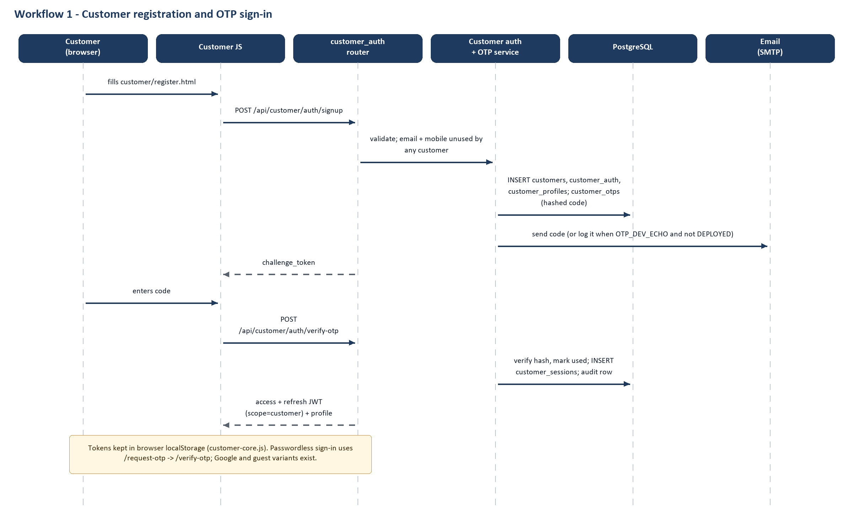
Figure 9. Workflow 1 – customer registration and OTP
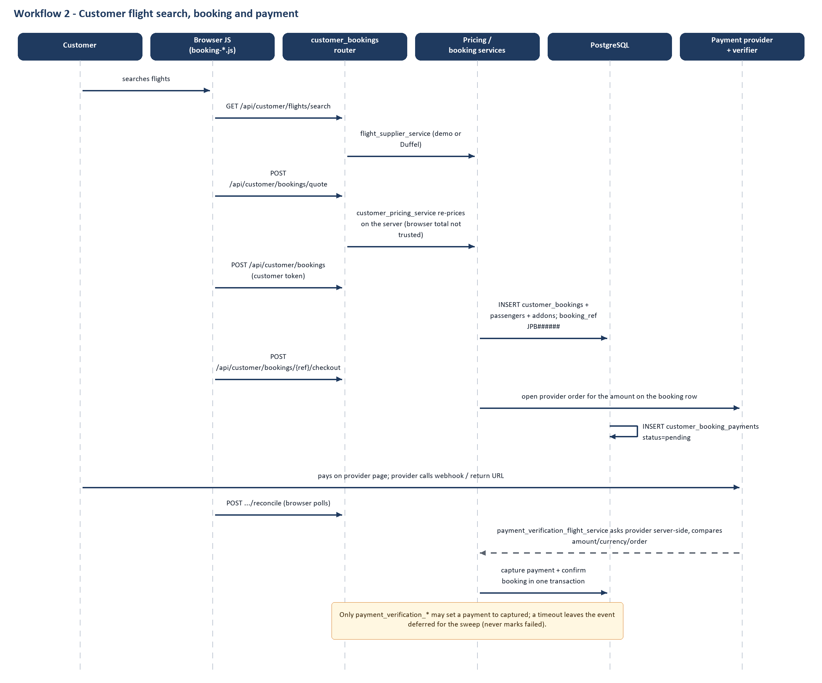
Figure 10. Workflow 2 – customer flight booking and payment
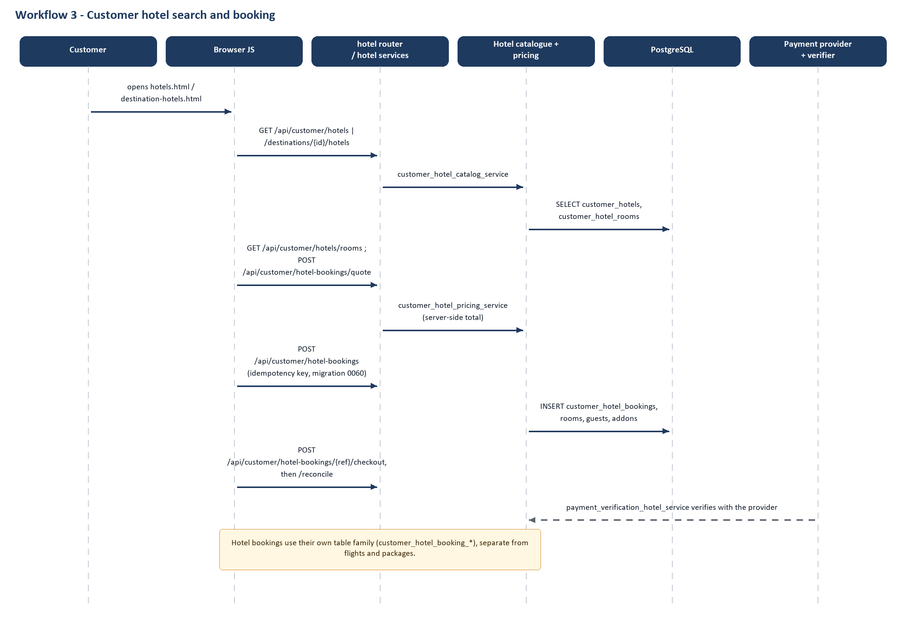
Figure 11. Workflow 3 – hotel booking
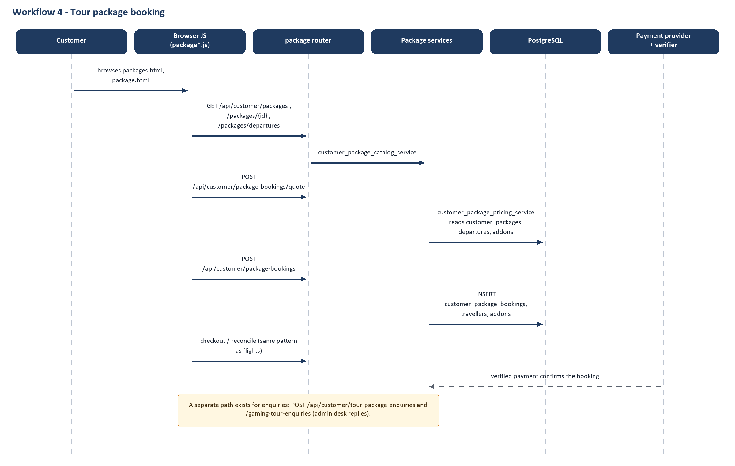
Figure 12. Workflow 4 – package booking
Figure 13. Workflows 5–7 – enquiry to ticket
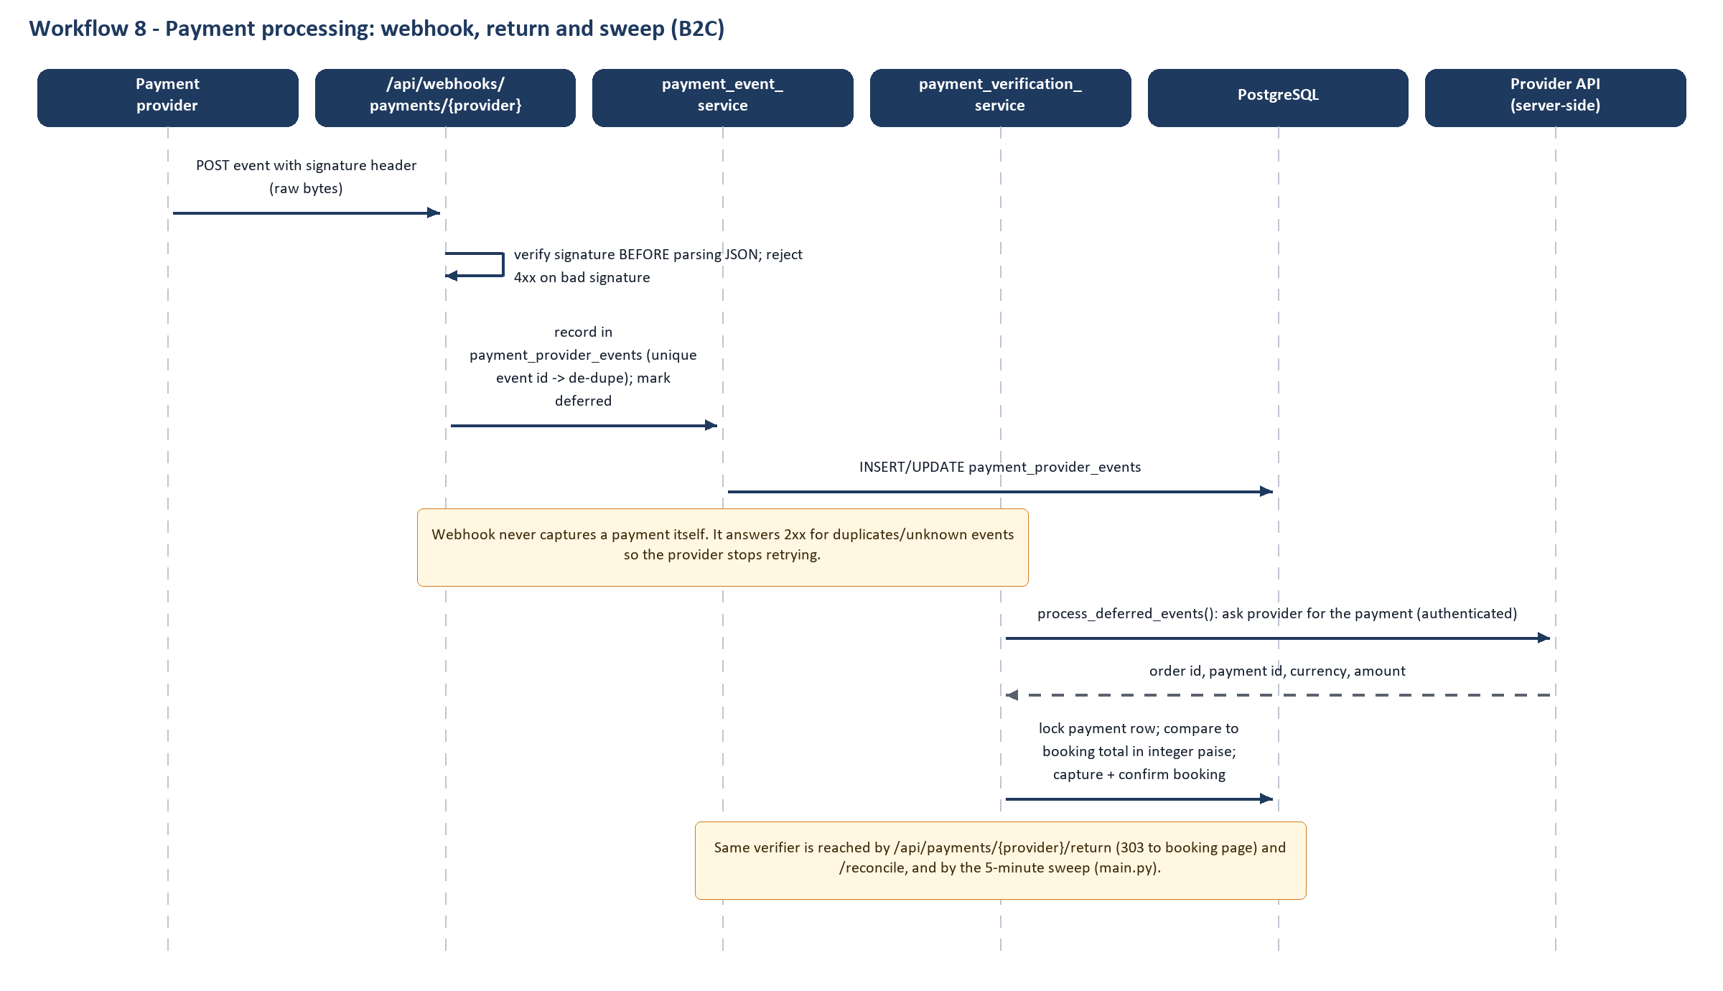
Figure 14. Workflow 8 – payment events
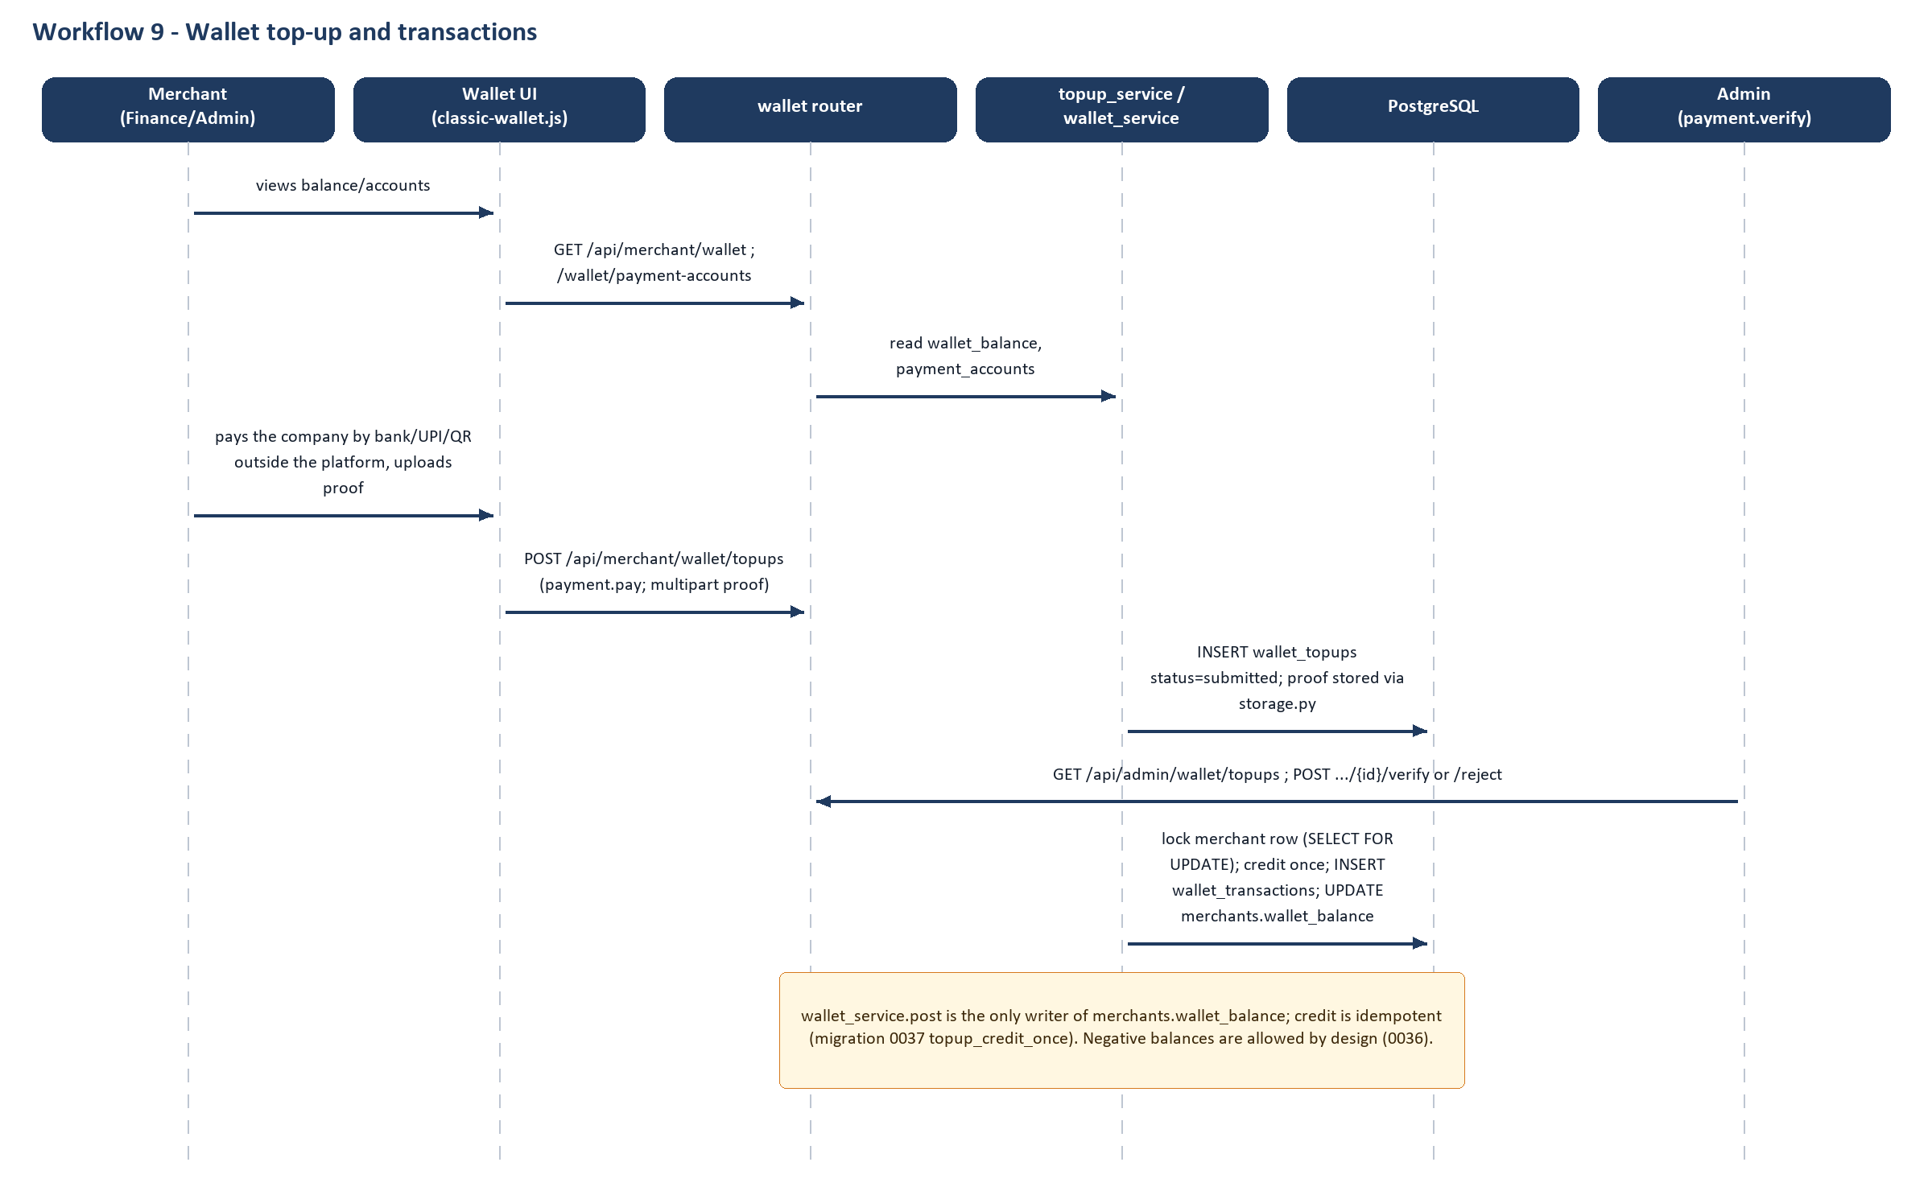
Figure 15. Workflow 9 – wallet
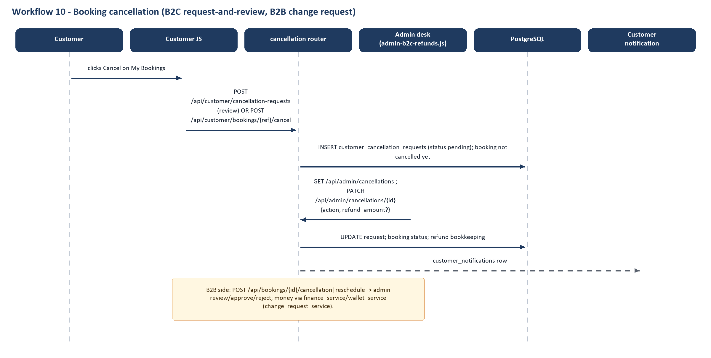
Figure 16. Workflow 10 – cancellation
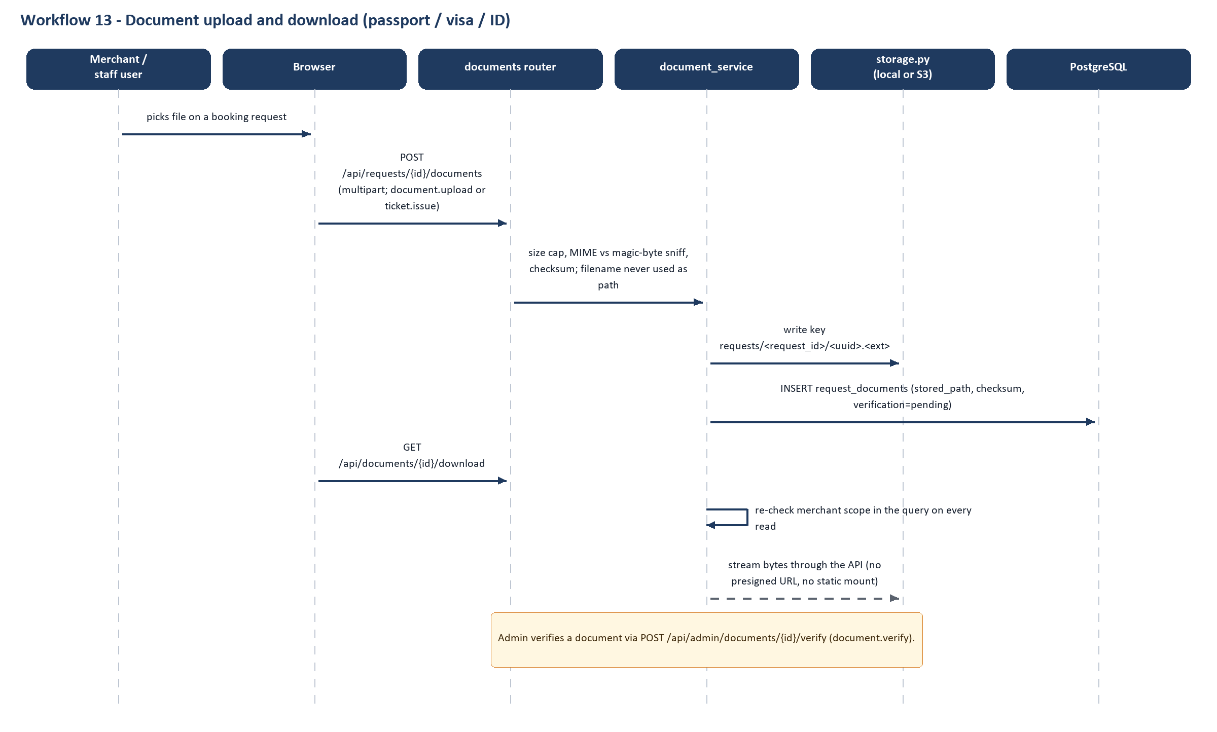
Figure 17. Workflow 13 – documents
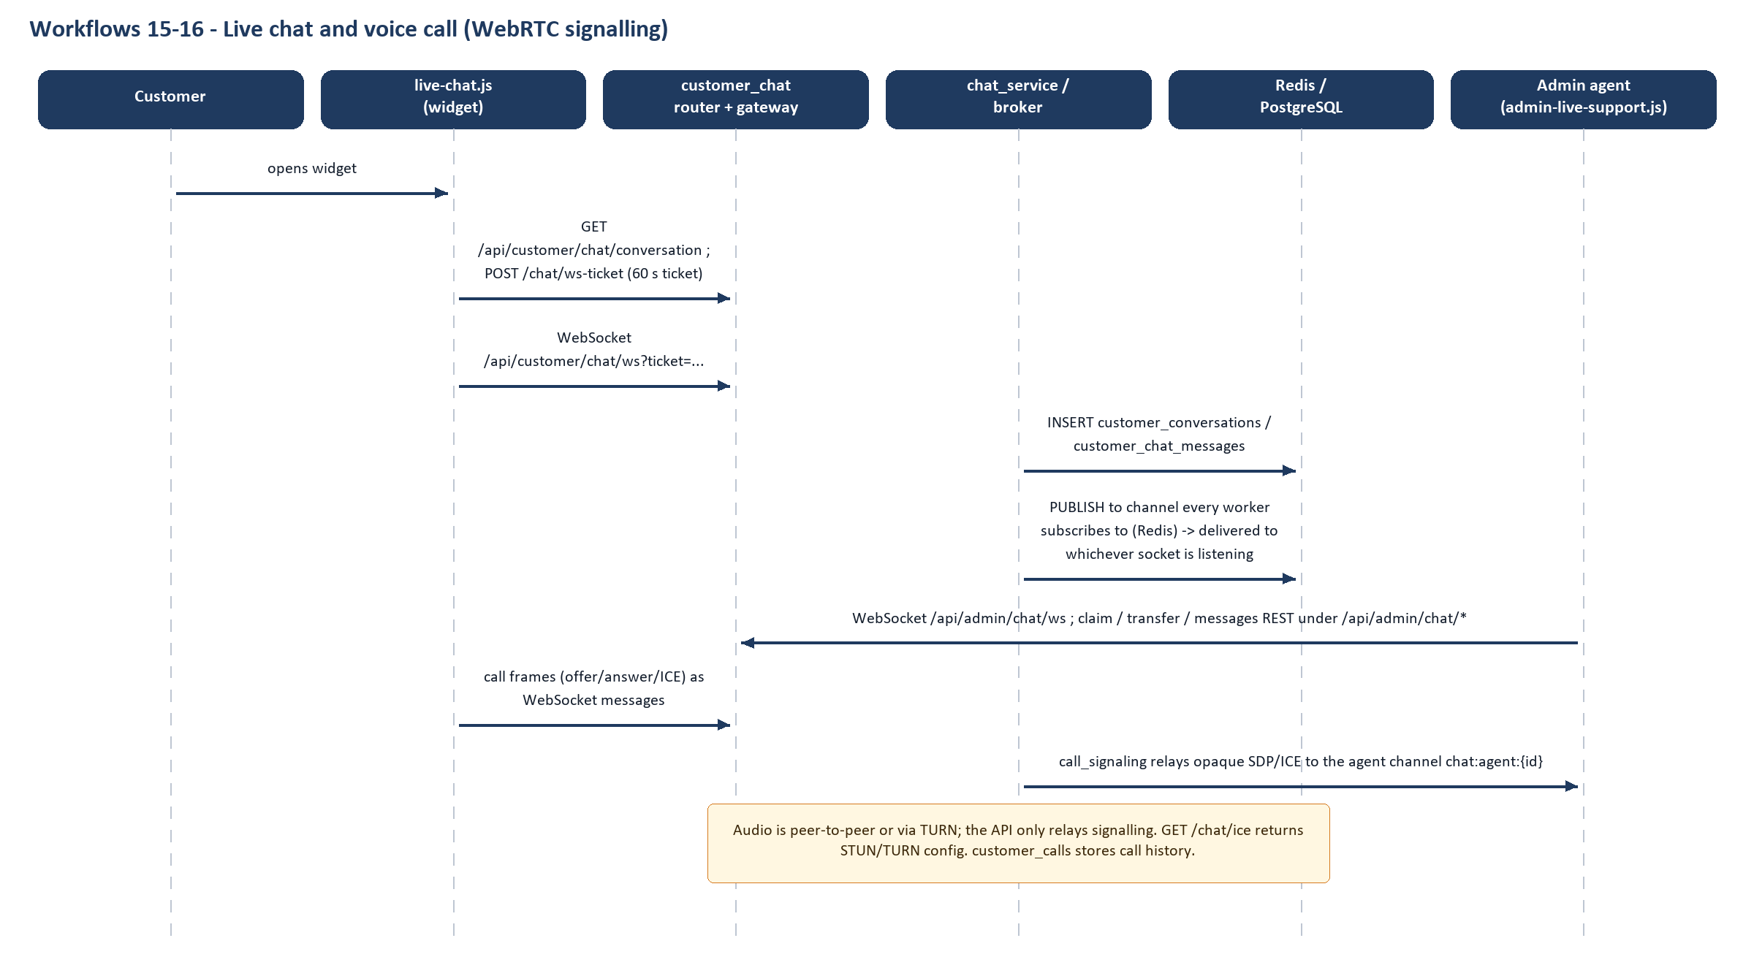
Figure 18. Workflows 15–16 – chat and call
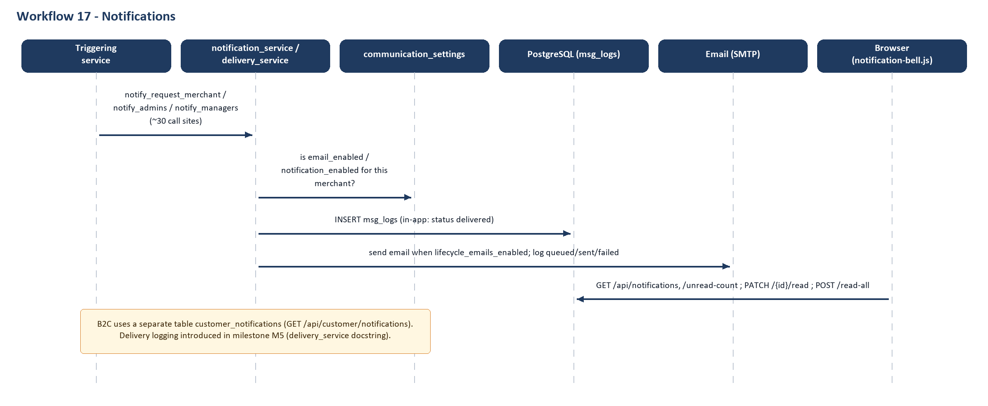
Figure 19. Workflow 17 – notifications

12.1 Date change (workflow 11)
- Merchant opens a booking and chooses reschedule → POST /api/bookings/{booking_id}/reschedule (servicerequest.create).
- change_request_service quotes the amounts, creates a child service_requests row (request_type=date_change, parent_request_id = the booking) and notifies staff.
- Admin reviews: POST /api/admin/change-requests/{id}/review, then /approve or /reject (servicerequest.manage).
- On approval the change is applied to the booking and money moves through finance_service/wallet_service (wallet type reschedule_fee, migration 0038).
- The merchant sees the outcome in GET /api/change-requests and via a notification.

12.2 Passenger modification (workflow 12)
Before submission, passengers can be replaced with PUT /api/requests/{id}/passengers. After ticketing, a merchant raises POST /api/service-requests with request_type=passenger_modification (also cancellation, date_change, refund, extra_baggage, meal, seat – SERVICE_REQUEST_TYPES in ticket_service.py); cancellation and reschedule are refused here and must use the change-request routes. Admin resolves it with POST /api/admin/service-requests/{id}/resolve (servicerequest.manage). Whether resolving automatically rewrites the passenger_data rows: Not verified from the available source code.

12.3 Support tickets (workflow 14)
- B2B: POST /api/support/threads (chat.create) opens a thread; staff claim/triage/resolve (chat.manage); messages, notes and documents attach to the thread (support_tickets.py, chat_service.py). Stored in service_requests with request_type=support_ticket.
- B2C: POST /api/customer/support-tickets and message routes exist (customer_account.py → customer_support_tickets, customer_support_messages) but no frontend script calls them; the customer-visible support channel in the UI is live chat/call. Status: Partially implemented.

12.4 Additional workflows found
- Group booking: merchant downloads a spreadsheet template, uploads the passenger manifest (/api/group-bookings/*, group_booking_service, up to 1000 passengers by default), errors are returned as a downloadable report; Admin can download the original file.
- Passport OCR: POST /api/bookings/passport/extract stores the scan privately, runs the configured provider, records per-field confidence and every manual edit (passport_ocr_extractions, passport_ocr_field_edits).
- Hotel enquiry/booking (B2B): separate hotel enquiry tables, multi-room support and a quotation before booking (/api/hotel/enquiries).
- Gaming tour enquiry: public form → admin queues (new, requests, converted, closed).
- E-ticket verification: each B2C ticket carries a signed token and QR; GET /api/tickets/verify/{token} is public.
- Travel assistant: POST /api/customer/assistant/message understands a sentence, picks a tool from a controlled set and returns which screen answers it; the backend, not the model, decides and the model never sees money (travel_ai/tools.py, assistant/base.py).

13. Integrations and External Services
Configuration names are listed; their values are never reproduced. “Operationally verified” is No for every item: this review did not contact any external service.
Table 35. Integration matrix
Integration | Configuration (names only) | Data exchanged | Failure handling | Verified live?
HDFC SmartGateway (hosted payment page) | PAYMENT_PROVIDER=hdfc, HDFC_SG_BASE_URL, _MERCHANT_ID, _API_KEY, _CLIENT_ID, _RETURN_URL, _WEBHOOK_USERNAME/PASSWORD, _RESPONSE_KEY, PAYMENT_ENVIRONMENT | Order creation (amount in the booking row), order-status query, webhook | Timeouts are retryable, never “failed”; sandbox_guard refuses UAT/test gateways for the public; hdfc_readiness checklist | No – UAT evidence still outstanding (docs/HDFC_UAT_EVIDENCE.md)
Razorpay (INR, UPI) | RAZORPAY_KEY_ID/_SECRET/_WEBHOOK_SECRET; test-key guard | Orders, payment fetch, signed webhooks | Signature checked on raw bytes before parsing; duplicate events de-duplicated by event id | No
TrustBrick | TRUSTBRICK_* incl. callback secret; pilot booking refs | Partner API collecting via their merchant account | Pilot-gated per booking ref | No
Mock payment provider | PAYMENT_PROVIDER=mock | Takes no money | Demo/CI only | Code-verified; tests pass
SMTP e-mail / OTP | SMTP_HOST/PORT/USERNAME/PASSWORD/USE_TLS/FROM; OTP_DEV_ECHO; DEPLOYED | OTP codes, reset links, lifecycle mail | On a deployed host without SMTP, sign-in cannot complete (startup logs an error); dev echo refused when DEPLOYED | No
Redis | REDIS_URL (compose sets redis://redis:6379/0) | Chat/call pub-sub, WebSocket tickets | InProcessBroker fallback is correct only with one worker and logs a warning | No
WebSockets | CHAT_TICKET_TTL_SECONDS=60, CHAT_RATE_BURST/WINDOW | Chat and call frames | Close code 4401 for bad ticket; rate limiter per socket | Code-verified; QA report notes one concurrency finding (Finding B)
WebRTC STUN/TURN | STUN_URLS (default Google STUN), TURN_URLS/_USERNAME/_PASSWORD or TURN_STATIC_AUTH_SECRET, VOICE_CALLS_ENABLED; deploy/setup-coturn.sh | ICE config only; audio never passes the API | Without TURN, calls may fail across strict NATs (Not verified) | No
File storage (local / S3) | STORAGE_BACKEND, UPLOAD_ROOT, S3_BUCKET/_REGION/_PREFIX/_ENDPOINT_URL/_SSE, MAX_UPLOAD_MB | Passport/visa/ticket files, chat attachments, QR images | Keys validated on every operation; downloads proxied, never public | Tests exist (verify_storage*, not run here)
Passport OCR | OCR_PROVIDER=none|local|azure|miniailive, OCR_AZURE_*, MINIAILIVE_*, timeouts | Image in, per-field value + confidence out | Returns “unavailable” when none; field-level confidence; inline wait 8 s then async | No
Flight supplier: demo / Duffel | FLIGHT_SUPPLIER=demo|duffel, DUFFEL_ACCESS_TOKEN | Offers, seat maps | Test mode by construction; typed errors (offer expired, price changed) | Duffel adapter unit-tested (test_duffel_adapter.py); live: No
TekTravels / TBO flight API | — | — | — | Not found – only a spec PDF and an xlsx reference in docs/; no integration code
Hotelbeds (HBX) | HOTELBEDS_API_KEY/_SECRET, base URLs (test hosts by default) | Static hotel content synced into own tables via scripts/sync_hotelbeds_catalogue.py | Typed configuration vs transport errors | No
AI – Anthropic (partner assistant) | ASSISTANT_PROVIDER=none|anthropic, ASSISTANT_API_KEY, ASSISTANT_MODEL | Intent classification only; no money values | Deterministic rules provider is always the fallback; 12 s timeout | No
AI – OpenAI-compatible (travel assistant) | TRAVEL_AI_PROVIDER, _API_KEY, _BASE_URL, _MODEL | Sentence → tool choice | 6 s timeout; rules fallback; tamper-evident session state (conversation_state.py) | No
Google Sign-In | GOOGLE_CLIENT_ID/_SECRET, allowed issuers | ID token verified server-side | Disabled if not configured; request e-mail never trusted | No
Mobile app (Expo) | — | — | — | Not in main (uncommitted local folder); out of scope

14. Security Architecture

14.1 Controls and where they live
Table 36. Security controls
Area | Implementation (verified) | Evidence
Password handling | bcrypt via passlib (bcrypt==4.0.1 pinned); new/changed password 8–72 characters; no complexity rules found | auth/security.py; schemas/auth.py
JWT / sessions | HS256, access 30 min, refresh 7 days, reset token 60 min (config); type claim; customer/partner tokens carry scope; force_logout_at revokes older tokens; logout revokes | auth/security.py, deps.py, auth_service.is_token_revoked
OTP second factor | 6-digit numeric code, SHA-256 hashed, 5-min expiry, 5 requests/hour, capped attempts, constant-time comparison, challenge token (scope otp_challenge, 10-minute TTL) so it is not a session | otp_service.py; routers/auth.py
Role-based permissions | require(P.X) on endpoints; PORTAL_ROLES binds role to portal; Manager and merchant approval codes kept separate from Admin codes | auth/rbac.py; routers/auth.py
Merchant data isolation | merchant id taken from the token; queries filtered by merchant_id; cross-tenant ids return 404 | wallet.py, document_service.scoped_query
Customer data isolation | customer_id from get_current_customer; customer tokens rejected on staff routes and vice versa; refresh endpoint rejects scoped tokens (fixed id-collision bug documented in auth_service) | auth/customer_deps.py; auth_service.refresh_access_token
Document access | No static mount for uploads; authenticated streaming only; MIME sniffing; uuid keys; S3 not public | document_service.py; storage.py; main.py comment
Payment verification | Only verifier may capture; amount/currency/ids compared with booking; integer paise | payment_verification_service.py
Webhook security | Signature over raw bytes verified before parsing; duplicate-safe; replay by sweep re-verifies with provider | routers/payment_webhooks.py; payment_event_service.py
Input validation | Pydantic schemas; upload type/size checks; filename never used as path | schemas/*; document_service
Transport/headers | HSTS, nosniff, X-Frame-Options DENY, Referrer-Policy, Permissions-Policy (microphone=self) at both app and Caddy | main.py _SECURITY_HEADERS; deploy/Caddyfile
Rate limiting | slowapi on 39 routes (login 10/min, OTP resend 5/min, …) | routers/*; auth/rate_limit.py
Logging and auditing | system_logs (activity, sessions, failed logins with IP/UA), audit_logs (DB triggers), customer_audit_logs | activity_service; audit_service
Sensitive information | DB URL logged with password hidden; OTP echo only when not DEPLOYED; AI assistants never receive money values | main.py; config.py; assistant/base.py
CSRF | Bearer tokens in the Authorization header, not cookies, so classic CSRF does not apply | auth/deps.py (HTTPBearer)

14.2 Weaknesses and concerns
Confirmed = visible directly in the code. Concern = plausible risk that depends on deployment or on testing not done here. Recommendation = improvement, not a defect.
Table 37. Security findings (static review; no penetration testing performed)
ID | Class | Finding | Evidence | Suggested action
S1 | Confirmed | A default Super Admin e-mail and password literal are committed to source (user_service.py constants, migrations 0003 and 0023) and are used if ADMIN_SEED_PASSWORD is unset. The code logs a warning when the default is in use. The README states “No password is ever hardcoded in source control”, which is not true. Whether production overrides it: Not verified. | services/user_service.py:21–22, 249; alembic 0003, 0023; README “Default Admin Login” | Confirm the production value was changed; remove the literal and make the seed fail closed; fix README.
S2 | Confirmed | No account lockout for staff/merchant users: auth_service.record_failed_login is never called (grep), so users.failed_login_attempts is never incremented. Only the per-IP limiter (10/min) slows guessing, and the OTP step is a second barrier. | auth_service.py:132; routers/auth.py login | Call it from the login path and lock/slow after N failures.
S3 | Confirmed | No global Content-Security-Policy (only chat attachments set one) while access and refresh tokens are stored in localStorage; any XSS would expose them. | main.py headers; deploy/Caddyfile; auth.js | Add a CSP, review innerHTML use, consider httpOnly cookies.
S4 | Concern | Rate-limit counters are per worker (in-memory slowapi store); with 2 workers the effective limit doubles. The client IP depends on proxy headers (FORWARDED_ALLOW_IPS="*"), which is safe behind Caddy with the app port not published but unsafe if the port is exposed. | auth/rate_limit.py; deploy/docker-compose.yml | Use a Redis storage URI for the limiter; restrict trusted proxies.
S5 | Concern | Refresh tokens work without a second factor for 7 days and are not rotated or individually revocable (only per-user force_logout_at). | auth_service.refresh_access_token | Add rotation/jti store.
S6 | Concern | Several state-changing B2C endpoints are guarded by the code named customer.view (e.g. PATCH /api/admin/cancellations/{id}); the comment says this is deliberate (one code per desk), but the name hides write power. | rbac.py:158; admin_cancellations.py | Rename or split into view/manage.
S7 | Concern | Webhook module docstring says it is “the only unauthenticated write surface”; public sign-up, OTP, contact, newsletter and enquiry POSTs are also unauthenticated writes. | payment_webhooks.py header; public.py | Correct the comment; ensure those endpoints are rate-limited (several are).
S8 | Concern | Default CORS origins are localhost addresses when CORS_ORIGINS is unset; startup refuses *. | config.py:15; main.py | Set explicit origins per environment.
S9 | Concern | QA investigation reports a possible race when two chat tabs open a conversation simultaneously (verify_live_chat). Reported in qa/FINDING_B_live_chat.md; not re-run here. | qa/FINDING_B_live_chat.md | Re-run and fix if reproducible.
S10 | Recommendation | Add password complexity/breach checks and an optional TOTP/authenticator option; add dependency scanning (pip-audit, npm audit) to CI. | — | —

15. Testing and Quality Assurance

15.1 Inventory
Table 38. Test inventory
Suite | Location | Count (verified by scan) | Type
Backend pytest | backend/tests (34 test files + conftest, fixtures, fakes) | 646 test functions (1,124 test cases after parametrisation) | Unit + API/integration against SQLite with fakes for providers
Frontend node tests | frontend/tests (14 files) | 14 tests | JS unit (node:test)
Frontend module tests | tests/js (*.test.mjs, browser/ subfolder) | 155 tests | JS unit
Live end-to-end scripts | tests/verify_*.py (51 scripts) + run_all.py | 51 scripts | Black-box E2E against a running server and database
Playwright UI E2E / smoke / authz | qa/playwright (e2e/{smoke,authz,journeys,cross_portal}, a11y and visual placeholders) | 31 test functions + 22 in qa/tests | Browser tests (Chromium)
Load tests | loadtest/locustfile.py + seed_accounts.py | 1 Locust profile | Load (to be run on staging only)
QA documents | qa/*.md (coverage matrix, missing coverage, workflow inventory, stage reports) | 20 documents | Planning/evidence
CI | .github/workflows/ci.yml (backend SQLite, frontend node, Postgres migration up/down) and ui-e2e.yml (Playwright on disposable Postgres) | 2 workflows | Automation

15.2 Results actually obtained in this review
Table 39. Executed results (this review)
Command | Result | Environment
python -m pytest tests -q (backend) | 1,124 passed, 0 failed, 23 warnings in 22.5 s | Clean snapshot of main; Python 3.13; SQLite (DATABASE_URL=sqlite, dummy JWT secret) as CI does
node --test frontend/tests/*.test.js | 14 passed, 0 failed | Node 22
node --test tests/js/*.test.mjs | 155 passed, 0 failed | Node 22
Not run | tests/verify_*.py live scripts, Playwright, Postgres migration job, load test | Need a running server/database/browser; no results claimed

15.3 Results reported in repository documents (not re-executed)
- qa/STAGE4_CLOSURE_REVIEW.md reports Playwright 43 collected: 38 e2e (37 passed, 1 skipped) + 5 scaffold passed; backend 1,124 passed; frontend 169 passed. The backend and frontend numbers match what this review obtained.
- qa/STAGE3_COMPLETE_FINAL_REPORT.md reports 42 of 48 live verify scripts passing in an isolated run, with failures attributed to environment (Windows console encoding, per-IP rate limit exhaustion, a safety self-skip for payments) and one candidate defect (live-chat concurrent open, Finding B). Not re-executed.

15.4 Gaps and inconsistencies
- qa/MISSING_COVERAGE.md (Stage 2, 2026-11-04) lists 48 endpoints with no mapped test – mainly admin catalogue CRUD (21), hotel enquiries (7), admin customer bookings (4), reviews (4), gaming enquiries (4), user activity (3). Some may have been covered since; not re-measured.
- 213 endpoints are covered only by live E2E scripts, not by fast pytest (tickets, admin_chat, support_tickets, merchants, wallet, booking_ops, change_requests, group_bookings, providers ...).
- No measured code-coverage percentage exists in the repository (no coverage tool configured). Coverage statements here are mappings, not measurements.
- qa/inventory.json counts 400 endpoints; this review counts 405 entries (including 2 WebSocket and 2 in main.py); the counting rules differ and were not reconciled.
- a11y and visual-regression suites are empty placeholders (README only).
- Backend tests run on SQLite while production uses PostgreSQL; PostgreSQL-specific behaviour (JSONB, row locks, advisory locks, triggers) is exercised only by the CI migration job and the live scripts.

16. Deployment and Environment Setup

16.1 Local development (from README and config)
- Prerequisites: Python 3.12 (Docker image) – 3.13 also ran the tests; PostgreSQL; Node 22 only for JS tests; Docker for deployment.
- Create a virtual environment and pip install -r backend/requirements.txt (FastAPI, SQLAlchemy 2, Alembic, psycopg2-binary, pydantic-settings, python-jose, passlib+bcrypt 4.0.1, slowapi, openpyxl, reportlab, xlrd, boto3, httpx).
- Copy backend/.env.example to backend/.env; set at minimum DATABASE_URL and JWT_SECRET_KEY (both are required fields with no default in Settings).
- Create the database and run alembic upgrade head (94 revisions; 0023 is destructive to any pre-redesign data and recreates nothing on downgrade).
- Start the API: uvicorn app.main:app from backend/; it also serves the frontend, so one process is enough. (The README still describes a separate frontend server on port 5500; the CORS default allows it.)
- Local OTP: leave SMTP unset and not DEPLOYED – codes are returned/logged (dev_otp) only in that mode.

16.2 Environment variables (names only)
Table 40. Environment variable groups (Settings in backend/app/config.py)
Group | Variables
Core | DATABASE_URL, JWT_SECRET_KEY, JWT_ALGORITHM, ACCESS_TOKEN_EXPIRE_MINUTES, REFRESH_TOKEN_EXPIRE_DAYS, CORS_ORIGINS, DEBUG, FRONTEND_BASE_URL, DEPLOYED, OTP_DEV_ECHO, APP_COMMIT, WEB_CONCURRENCY
Email | SMTP_HOST, SMTP_PORT, SMTP_USERNAME, SMTP_PASSWORD, SMTP_USE_TLS, SMTP_FROM_EMAIL, SMTP_FROM_NAME, LIFECYCLE_EMAILS_ENABLED
Storage/OCR | STORAGE_BACKEND, UPLOAD_ROOT, MAX_UPLOAD_MB, S3_*, OCR_PROVIDER, OCR_*, MINIAILIVE_*
Payments | PAYMENT_PROVIDER, PAYMENT_ENVIRONMENT, PAYMENT_MODE, ALLOW_SANDBOX_PAYMENTS, RAZORPAY_*, HDFC_SG_*, TRUSTBRICK_*, PAYMENT_SWEEP_*
Jobs | BOOKING_COMPLETION_ENABLED, _INTERVAL_MINUTES, _BUFFER_HOURS, _BATCH_SIZE, BOOKING_LOCAL_UTC_OFFSET_MINUTES
Realtime | REDIS_URL, CHAT_*, VOICE_CALLS_ENABLED, STUN_URLS, TURN_*
Suppliers/AI/Auth | FLIGHT_SUPPLIER, DUFFEL_*, HOTELBEDS_*, ASSISTANT_*, TRAVEL_AI_*, GOOGLE_*
Company/invoice | COMPANY_LEGAL_NAME, _GSTIN, _PAN, _CIN, INVOICE_TERMS … (printed on invoices)
Seeding | ADMIN_SEED_EMAIL, ADMIN_SEED_PASSWORD

16.3 Production architecture
- docker-compose (deploy/docker-compose.yml): app (built from the root Dockerfile, env from backend/.env, DEPLOYED=true, OTP_DEV_ECHO=false, uploads volume, health check on /api/health), redis (no persistence, 256 MB LRU), caddy (ports 80/443, SITE_DOMAIN). docker-entrypoint.sh runs alembic upgrade head automatically on every container start and then launches gunicorn (WEB_CONCURRENCY workers, default 2, 120 s timeout); redeploy.sh rebuilds and health-checks, aborting with the previous containers still up if a step fails.
- Reverse proxy: Caddyfile – reverse_proxy app:8000, 12 MB body limit, gzip, HSTS and header hardening, www → apex redirect.
- Alternative: render.yaml Docker web service with an external Postgres; deploy/nginx.conf is mentioned in code comments but not present in main (Not found).
- Logging and monitoring: container logs (json-file rotation), health endpoint /api/health; no metrics, tracing or alerting stack found.
- Backup and recovery: not defined in the repository. Migration 0023 itself instructs taking a pg_dump before upgrading. Uploads live in a Docker volume (or S3) and need their own backup. Restore procedures: Not found.
- Live system: no statement about the running production server is made (Not verified). The project memory notes a deployment procedure through AWS SSM; it is not part of the repository evidence.

17. Current Project Status and Gap Analysis
Table 41. Feature status matrix
Module | Feature | Status | Evidence | Gap | Recommended next action
Auth | Staff login + OTP + portals | Implemented in code | routers/auth.py; tests | No lockout (S2) | Add lockout/slow-down
Auth | Customer OTP / Google / guest | Configuration-dependent | customer_auth* | Needs SMTP / Google id | Verify on staging
B2B | Enquiry → booking → ticket | Implemented in code | enquiry_service, ticket_service, tests verify_cr2/cr5 | Live E2E not re-run | Run verify suite in CI nightly
B2B | Manager approval + merchant approval | Implemented in code | manager*, merchant_approvals | — | —
B2B | Wallet and top-ups | Implemented in code | wallet_service, topup_service | Fast pytest coverage thin (only live scripts) | Add pytest for wallet.py
B2B | Visa and Holidays services | Partially implemented | classic-visa.js, classic-holidays.js, service codes | Dedicated backend flows Not verified | Confirm scope with owner
B2B | Passenger modification apply-back | Unverified | SERVICE_REQUEST_TYPES | Auto-update of passenger_data Not verified | Trace resolve_service_request
B2C | Flights | Configuration-dependent | flight_supplier_service | Real supplier only via Duffel test mode; TBO not integrated | Decide supplier; implement or retire spec
B2C | Hotels / packages | Implemented in code | customer_hotel_*, customer_package_* | Catalogue is own tables; Hotelbeds only as content sync | —
B2C | Payments (HDFC/Razorpay/TrustBrick) | Configuration-dependent | services/payments; tests | No evidence of a real UAT/production payment | Complete HDFC UAT evidence
B2C | Customer support tickets UI | Partially implemented | customer_account.py routes | No frontend caller | Build UI or remove API
B2C | Coupons administration | Not found | no admin coupon route | Coupons readable/validated but no admin CRUD found | Add admin desk or document seeding
B2C | Admin tour-package enquiry desk | Not found | tour_package_enquiries.py has 1 route | Submissions stored; no admin list/reply route | Add admin queue
Realtime | Chat and calls | Configuration-dependent | chat_*, call_* | Needs Redis + TURN; Finding B | Load/NAT test
Admin | Catalogue management | Implemented in code | admin_catalogue_* | Zero mapped tests (MISSING_COVERAGE) | Write tests
Admin | System settings editing | Not found | system_info read-only | No settings screen | Decide need
Admin | Escalation workflow | Not found | — | Only priority + assignment | Define SLA/escalation
Data | Legacy ORM + 5 legacy services | Partially implemented | app/models, *_service.py | Dead code imported by alembic env | Remove after confirming
Docs | README/API docs | Partially implemented | README vs route table | Stale API list, wrong claims | Rewrite README from this report
Ops | Backup/restore, monitoring | Not found | deploy/ | No documented procedure | Write runbook
Mobile | Expo app | Unverified | uncommitted mobile-app/ | Not in main | Commit or exclude

17.1 Gaps by category
- Documentation mismatches: README API table and feature text (legacy); main.py description/version/pending lists; database/ redesign folder; webhook docstring; QA endpoint count; docs/ files that predate the nine-table redesign (not individually verified).
- API gaps: 55 routes had no static frontend caller after literal matching plus base-path matching (307 matched by literal, 43 by base path) (Volume 2 lists each as “No static reference found”); some are called through variables, so these are candidates, not proven dead routes.
- Database inconsistencies: 36 legacy ORM tables with no migration; enum MerchantStatus.pending_approval retained after the approval step was retired; /api/status static lists.
- Technical debt: two huge services (ticket_service 1.8k lines, travel_ai_assistant 2.4k lines); both merchant UIs (classic and Partner) maintained in parallel; hard-coded Windows-console-unsafe prints in tests (reported).
- Testing gaps: Chapter 15.4.

18. Future Architecture Recommendations
These are recommendations, not existing features.

Immediate (next 1–2 months)
- Rotate/confirm the Super Admin password in production; remove the literal default (S1); fix README claims.
- Add staff login lockout and move rate limiting to Redis (S2, S4).
- Add a Content-Security-Policy and audit inline scripts (S3).
- Finish HDFC UAT evidence and one real end-to-end payment on staging; keep the sandbox guard.
- Run the 51 live verify scripts and Playwright in the scheduled CI against disposable Postgres; fix Finding B.
- Remove or quarantine legacy app/models and five legacy services; update alembic/env.py.

Medium term (3–6 months)
- Single booking lifecycle document and a shared state-machine for B2B and B2C; consider unifying cancellations/refunds reporting.
- Decide the future of the second merchant UI (Partner/Premium) to avoid duplicated features.
- Add admin screens for coupons and tour-package enquiries; add the customer support-ticket UI or retire the API.
- Move heavy exports and OCR to a job queue (Celery/RQ) once more than two background jobs exist (the code itself says so).
- Add structured logging, metrics (Prometheus/OpenTelemetry), error tracking and uptime alerts; define backup/restore with periodic restore drills.
- Database: confirm indexes under load (loadtest), add partitioning/archival for system_logs, msg_logs, customer_activity.
- Pagination and response conventions: standardise {items,total,...} and error bodies; publish the OpenAPI document as a versioned contract.

Long term
- Real flight supplier integration (TBO/TekTravels or Duffel production) behind the existing flight_supplier_service seam.
- Customer mobile app (Expo) shipped from the repository with CI; account-deletion backend endpoint.
- Read replicas / caching for catalogue reads; CDN for static assets.
- Single sign-on and TOTP for staff; fine-grained per-desk permissions (for example separating customer.view from customer.manage).

19. Glossary and Learning Guide
Table 42. Glossary
Term | Simple explanation
Frontend | The part the user sees in the browser: HTML (structure), CSS (looks), JavaScript (behaviour). Here: the frontend/ folder.
Backend | The server program that applies rules and talks to the database. Here: FastAPI in backend/app.
API | A menu of requests a program can make to another program. Here, URLs under /api/.
Endpoint | One item on that menu: a URL plus a method, e.g. POST /api/auth/login.
Router | A file that groups related endpoints and hands each request to a service.
Service | A Python module holding the business rules, e.g. how a wallet is debited.
ORM | Object-Relational Mapper (SQLAlchemy): lets Python classes stand for database tables.
Model | A Python class describing a table.
Schema (Pydantic) | A class describing the shape of data going in/out of the API and checking it.
Database | Organised storage of records; here PostgreSQL.
Primary key | A column that uniquely identifies each row.
Foreign key | A column pointing at another table’s primary key, linking the rows.
Migration | A versioned script (Alembic) that changes the database structure step by step.
JWT | JSON Web Token: a signed text token proving who you are for a limited time.
RBAC | Role-Based Access Control: what you may do depends on your role/permissions.
WebSocket | A long-lived two-way connection, used for chat so the server can push messages.
Redis | A very fast in-memory store; here used to pass chat messages between server workers.
WebRTC | Browser technology for direct audio/video between two people; the server only helps them find each other (signalling).
Webhook | A call made by an outside service (e.g. a payment provider) to tell us something happened.
Background task | Work the server does on a timer, with no user waiting.
Middleware | Code that runs on every request before/after the endpoint (headers, logging).
S3 | Amazon’s file storage service; an optional place to keep uploaded documents.
OCR | Optical Character Recognition: reading text from an image, e.g. a passport.
OTP | One-Time Password: a short code e-mailed to prove you control the account.
Merchant | A business customer of JackPots (travel agency, corporate, gaming company) using the Merchant Portal.
Enquiry vs Booking Request | An enquiry asks for a quote; a booking request asks the company to act on an agreed quote.
Classic Tours track | The booking path that needs Manager approval and is settled from the wallet, with no online payment step.
PNR | Passenger Name Record: the airline’s booking code. B2C PNRs are not invented – shown as null until a supplier issues one.
Wallet / Top-up | A merchant’s prepaid balance with JackPots; a top-up is the merchant reporting that it paid money in, to be verified.
Sweep | A periodic job that re-checks work, e.g. payments or completed trips.
Desk | A group of staff screens for one job (ticketing, finance, support).

Brand spelling: both “JackPots World Tours & Travels” and “JackpotsWorld Tours & Travels” appear in the repository (page titles, policies). This report uses the former in headings; the owner prefers “JackpotsWorld Tours & Travels” for new material.

20. Source Code Reference Index
Table 43. Important source files (full inventory below)
File | Portal | Purpose / main symbols | Chapters
backend/app/routers/auth.py | Staff portals | login, verify-otp, refresh, logout. user_response, login, verify_otp, resend_otp | Ch5, 14
backend/app/routers/customer_auth.py | Customer | signup, OTP, Google, guest. customer_response, signup, login, request_otp | Ch4
backend/app/routers/customer_bookings.py | Customer | flight booking and checkout. search_flights, get_seat_map, get_addons, get_reference | Ch4, 12
backend/app/routers/enquiries.py | Merchant/Admin | enquiry and booking request. create_enquiry, list_enquiries, get_enquiry, enquiry_to_booking_request | Ch5, 12
backend/app/routers/payment_webhooks.py | Provider | webhook intake. receive_payment_webhook | Ch13
backend/app/routers/tickets.py | Merchant/Admin | requests, approve, pay, issue-ticket, service-requests. search_catalog, quote_item, list_requests, get_request | Ch5, 12
backend/app/routers/wallet.py | Merchant | wallet, top-ups. my_wallet, my_transactions, payment_accounts, account_qr | Ch5, 12
backend/app/services/document_service.py | B2B | document upload/download rules. StoredUpload, staff_upload_stages, discard_file, get_document, list_documents | Ch14
backend/app/services/lifecycle.py | B2B | state machine. Transition, is_classic_track, labels_for, label_of, allowed_transitions | Ch5, 10
backend/app/services/payment_verification_service.py | B2C | only place payments are captured. Verification, verify_and_capture, confirm_booking, process_deferred_events, reconcile_stale_pending | Ch13, 14
backend/app/services/ticket_service.py | B2B | booking lifecycle service (1,827 lines). scoped_query, get_request, list_requests, passenger_columns | Ch12
backend/app/services/wallet_service.py | B2B | single wallet writer. q, lock, balance, ledger_balance | Ch10
backend/app/auth/customer_deps.py | Customer | get_current_customer. get_current_customer, get_current_customer_optional | Ch14
backend/app/auth/deps.py | Staff | get_current_user. get_current_user, get_current_admin, get_current_user_optional, require_permission | Ch10, 14
backend/app/auth/rbac.py | All staff | P codes; role matrices; require(). P, role_permission_matrix, effective_permissions, has_permission, require | Ch3, 14
backend/app/auth/security.py | All | Password hashing, JWT helpers. hash_password, verify_password, create_access_token, create_refresh_token | Ch14
backend/app/config.py | All | Settings. Settings | Ch13, 16
backend/app/main.py | All portals | App wiring; middleware; startup sweeps; static mount. CleanUrlStaticFiles, security_headers, request_metadata, ensure_default_admin_exists, warn_if_otp_echo_is_on | Ch2, 10
backend/app/models_customer.py | B2C | 46 tables. Base, CustomerStatus, CustomerOtpPurpose | Ch11
backend/app/models_v2.py | B2B/shared | 26 tables. Base, UserRole, UserStatus | Ch11

20.1 Full backend module inventory
Table 44. Backend modules (routers, services, auth, integrations)
File | Lines | Purpose (first docstring line)
routers/admin_b2c_reports.py | 128 | Admin B2C reports & analytics — `/api/admin/b2c-reports/* and /api/admin/b2c-analytics/*`. Phase 8 of the B2C Admin Portal b
routers/admin_cancellations.py | 127 | Admin view of B2C cancellations & refunds — `/api/admin/cancellations/*`. Phase 3 of the B2C Admin Portal build-out: completes t
routers/admin_catalogue.py | 52 | Catalogue-level admin endpoints — `/api/admin/catalogue/*`. Phase 5 of the B2C Admin Portal build-out: the flight-supplier statu
routers/admin_catalogue_destinations.py | 132 | Admin destinations — `/api/admin/catalogue/destinations/*. Phase 5 of the B2C Admin Portal build-out. See `catalogue_destinati
routers/admin_catalogue_hotels.py | 112 | Admin hotel catalogue — `/api/admin/catalogue/hotels/*. Phase 5 of the B2C Admin Portal build-out. See `catalogue_hotel_admin_
routers/admin_catalogue_packages.py | 141 | Admin tour-package catalogue — `/api/admin/catalogue/packages/*. Phase 5 of the B2C Admin Portal build-out. See `catalogue_pac
routers/admin_chat.py | 567 | Live Support, agent side — `/api/admin/chat/*` (CR-9, slice 4). The customer side is scoped by the caller's own id; this side i
routers/admin_communication.py | 95 | Admin B2C communication record — `/api/admin/communication/*. Phase 7 of the B2C Admin Portal build-out. READ-ONLY: see `custo
routers/admin_customer_bookings.py | 150 | Admin view of B2C bookings — `/api/admin/customer-bookings/*`. Phase 2 of the B2C Admin Portal build-out: this is the module tha
routers/admin_ops.py | 246 | Admin Portal operations — Approval Queue, Payment Management, Active Users, Communication (API_CONTRACT.md §4.1-§4.4, Phase 3).
routers/admin_reconciliation.py | 102 | Admin B2C payment reconciliation — `/api/admin/payment-reconciliation/*. Phase 4 of the B2C Admin Portal build-out. See `custo
routers/admin_reviews.py | 105 | Admin B2C reviews & ratings — `/api/admin/reviews/*. Phase 6 of the B2C Admin Portal build-out. See `customer_review_admin_ser
routers/admin_user_activity.py | 86 | Admin B2C user activity — `/api/admin/user-activity/*. Phase 7 of the B2C Admin Portal build-out. READ-ONLY, over `customer_au
routers/analytics.py | 111 | Analytics — M6 (API_CONTRACT.md §6.9). Scope is inferred from the caller, exactly as `reports.py and `ticket_service.list_req
routers/assistant.py | 149 | Partner Assistant — the merchant's helper in the Classic portal. TWO ROUTES, AND NEITHER RETURNS BUSINESS DATA GET /api/ass
routers/auth.py | 407 | Unified login for all three portals. Implements the spec's flow, identical for Super Admin, Admin and Merchant:: Login -> Pa
routers/booking_ops.py | 285 | Booking Operations — the post-approval desk (Phase 4). Deliberately separate from `admin_ops.approval_queue`: that queue ends t
routers/change_requests.py | 346 | Cancellation & Reschedule (M3) — a confirmed booking moving backwards. TWO PREFIXES, ONE RESOURCE Merchant-facing paths sit under
routers/customer_account.py | 335 | Customer Account Center — `/api/customer/{payments,wishlist,notifications, reviews,support-tickets}`. Fixes four tabs in index.
routers/customer_admin.py | 84 | Admin view of B2C customers — `/api/admin/customers/*`. Phase 1 of the B2C Admin Portal build-out (see the plan's own doc for th
routers/customer_assistant.py | 142 | Travel Assistant — `/api/customer/assistant/*`. POST /message say something, get an answer and a screen to open
routers/customer_auth.py | 651 | Customer Portal (V1) authentication — `/api/customer/auth/*`. The login is the same two-call flow the three B2B portals use::
routers/customer_bookings.py | 618 | Customer flight bookings — `/api/customer/bookings/*` and the catalogue. The booking flow's server side, in the order the custo
routers/customer_cancellations.py | 52 | Customer-facing cancellation/refund requests — `/api/customer/ cancellation-requests`. Phase 3 of the B2C Admin Portal build-out
routers/customer_chat.py | 407 | Live chat, customer side — `/api/customer/chat/* (CR-9, migration 0064). Every route resolves the caller through `Depends(get
routers/customer_destinations.py | 220 | Destination discovery — `/api/customer/destinations/*`. GET /api/customer/destinations the homepage's De
routers/customer_hotel_bookings.py | 512 | Customer hotel bookings — `/api/customer/hotels/* and /hotel-bookings/*`. The hotel flow's server side, in the order the cu
routers/customer_package_bookings.py | 814 | Customer tour-package bookings — `/api/customer/packages/* and /package-bookings/*`. The package flow's server side, in the
routers/customer_payment_admin.py | 160 | Admin view of B2C customer payments — `/api/admin/customer-payments/*. PERMISSIONS — NO NEW CODES Reads are gated on `payment
routers/customer_profile.py | 138 | Customer Portal (V1) profile — `/api/customer/profile/*`. Every route here is implicitly scoped to the caller: no path carries
routers/customer_recommendations.py | 166 | Customer recommendations — `/api/customer/recommendations and the activity that feeds it, /api/customer/activity`. Both rou
routers/customer_travellers.py | 186 | The customer's saved traveller list — `/api/customer/travellers/*. Scoped to the caller the same way customer_profile` is:
routers/dashboard.py | 50 | Dashboard KPIs — one endpoint per portal (API_CONTRACT.md §6.1).
routers/documents.py | 179 | Supporting documents on a booking request. Permissions reuse the two codes that have existed since 0023 and were reserved for exa
routers/enquiries.py | 279 | Ticket Enquiry — the merchant's entry point, and the Admin's answer. Merchant and Admin endpoints live in one router for the same
routers/eticket.py | 83 | Customer flight e-ticket endpoints. `GET /api/customer/bookings/{ref}/ticket` - the owner's full ticket data plus its verificat
routers/finance.py | 203 | Finance — merchant position, statement, and wallet management (M4). Every figure served here comes from `finance_service`. No e
routers/gaming_tour_enquiries.py | 142 | Gaming Tour Enquiries — the public submission and the Admin queue. Both halves live in one router for the reason enquiries.py g
routers/group_bookings.py | 409 | Group booking — the passenger manifest endpoints. Merchant and Admin routes live together for the reason :mod:`app.routers.enquir
routers/hotel_enquiries.py | 227 | Hotel Enquiry — the merchant's entry point, and the Admin's answer. Separate router, separate tables (migration 0047) — see ``ser
routers/manager.py | 182 | Manager portal — approval of submitted Booking Requests (CR-2). Every endpoint declares `booking.manager_approve or `booking.
routers/manager_approvals.py | 126 | The merchant's own approval queue — sign-off before a request reaches us. Every service request a merchant raises (cancellation,
routers/merchant_approvals.py | 202 | Merchant approval desk — the merchant signs off its own Booking Requests (CR-3). CR-2 put this sign-off with a *platform* Manager
routers/merchant_team.py | 171 | Merchant portal — a merchant managing its own staff. The spec's Merchant User Creation flow:: Merchant -> Create User -> Use
routers/merchants.py | 404 | Admin portal — merchant (partner company) management. Covers the spec's Merchant Management box: create, approve, edit, suspend,
routers/messages.py | 107 | Message delivery, seen by the people who can do something about it (M5). PERMISSION — notification.send, NOT `notification.view
routers/notifications_v2.py | 81 | Notification Center — API_CONTRACT.md §6.4. Named distinctly from the legacy, unmounted `routers/notifications.py`. The service
routers/passport_ocr.py | 343 | Passport OCR endpoints. POST /api/bookings/passport/extract upload a passport, get fields GET /api/bookings/pas
routers/payment_admin.py | 550 | The staff wallet desk: payment accounts, verification queue, reconciliation (CR-4d). PERMISSIONS — NO NEW CODES CR-4 §5.6 decided
routers/payment_returns.py | 184 | Where a hosted payment page sends the customer back — `/api/payments/*/return`. WHAT THIS ROUTE IS, AND WHAT IT IS NOT A drop-i
routers/payment_webhooks.py | 159 | Where a payment provider tells us what happened — `/api/webhooks/payments/*`. THE ONLY UNAUTHENTICATED WRITE SURFACE IN THIS AP
routers/profile.py | 87 | Shared Profile screen — every portal edits its own account the same way. Separate from `/api/auth/me` (read-only identity + per
routers/providers.py | 237 | Provider Management — Admin endpoints (0039). Every route is gated on `provider.view (reads) or provider.manage` (writes),
routers/public.py | 83 | Endpoints behind the landing page's own forms — reachable with no session, because nobody is signed in when they use them. Kept o
routers/reports.py | 369 | Reports export — API_CONTRACT.md §6.2. Shared by every portal: scope is inferred from the caller the same way ``ticket_service.li
routers/super_admin.py | 429 | Super Admin portal — administrator management. Per the spec, the Super Admin's entire remit is Admins plus oversight: create, edi
routers/support_tickets.py | 385 | Support Management / Live Chat endpoints. The file name predates this redesign; see app/services/chat_service.py for why "Support
routers/tickets.py | 718 | Ticket enquiry, requests, approvals, payments and issuance. One router covering the spec's central transaction, because merchant
routers/tour_package_enquiries.py | 52 | Tour Package Enquiries — the Contact Us page's "Enquire About Dates" form. Public, reachable with no session — the same pattern a
routers/wallet.py | 484 | The merchant's own wallet: balance, ledger, and adding money (CR-4c). PERMISSIONS — NO NEW CODES Same convention as ``routers/fin
services/account_service.py | 685 | Account lifecycle: Super Admin manages Admins, Merchant manages its staff. Two hierarchies, one implementation, because the rules
services/activity_service.py | 459 | Activity logging on the v2 `system_logs table. Replaces the legacy activity_logs` table. Two legacy columns have no dedicat
services/admin_merchant_service.py | 305
services/admin_partner_service.py | 87
services/admin_service.py | 384
services/airport_reference.py | 206 | The airport reference the Travel Assistant resolves cities and codes against. lookup("Goa") -> found [GOI Goa]
services/analytics_service.py | 585 | Analytics — M6 (API_CONTRACT.md §6.9). Every figure this module returns is produced by a SQL aggregate. Nothing is counted in Pyt
services/approval_service.py | 136 | Unified Approval Queue — API_CONTRACT.md §4.2 (sign-off 2026-07-29). Merges two different kinds of "awaiting a decision" rows — p
services/audit_service.py | 52 | Audit Logs — read-only queries over the trigger-populated `audit_logs table. Rows arrive from fn_write_audit_log` (see migr
services/auth_service.py | 228 | Authentication against the v2 `users` table. Column renames from the legacy schema: =========================== =============
services/booking_completion_service.py | 245 | Completing a booking once its journey has actually finished. WHY THIS EXISTS Issuing a ticket used to end the booking: ``issue_ti
services/booking_management_service.py | 386
services/booking_ops_service.py | 489 | Booking operations — the desk that works a booking after it is approved. WHERE THIS SITS `ticket_service` owns the *lifecycle*
services/call_handlers.py | 617 | The call frame handlers, written once for both sides (CR-10). WHY ONE MODULE RATHER THAN TWO SETS OF METHODS A call is symmetric.
services/call_signaling.py | 275 | WebRTC signalling: who gets told what, and when (CR-10). A RELAY, NOT A PARTICIPANT This module forwards opaque strings between t
services/catalog_items.py | 50
services/catalog_service.py | 178 | Catalog / inventory — what Ticket Enquiry searches. Inventory lives in `service_requests with request_type='catalog_item'`
services/catalogue_common.py | 61 | Small helpers the four Phase 5 catalogue services share, so none of them restates them: list cleaning, and the one audit line ever
services/catalogue_destination_admin_service.py | 232 | Managing destinations and their locations for the admin desk — Phase 5 of the B2C Admin Portal build-out. NO NEW TABLE. This edit
services/catalogue_flight_admin_service.py | 66 | What the admin desk sees about flights — Phase 5 of the B2C Admin Portal build-out. THERE IS NO FLIGHT INVENTORY TO MANAGE, AND T
services/catalogue_hotel_admin_service.py | 298 | Managing the hotel catalogue for the admin desk — Phase 5 of the B2C Admin Portal build-out. NO NEW TABLE, NO SECOND CATALOGUE. T
services/catalogue_images.py | 98 | The shipped image libraries an admin may point a catalogue row at. Phase 5 of the B2C Admin Portal build-out. IMAGES ARE KEYS, N
services/catalogue_package_admin_service.py | 291 | Managing the tour-package catalogue for the admin desk — Phase 5 of the B2C Admin Portal build-out. NO NEW TABLE. This edits ``cu
services/change_request_service.py | 967 | Cancellation and reschedule — what happens when a booking moves backwards. WHERE THIS SITS `ticket_service` walks a booking for
services/chat_assignment.py | 168 | Who a new chat goes to, and when it goes to them (CR-9). THE BRIEF ASKS FOR TWO THINGS * "Automatically assign to available Adm
services/chat_attachments.py | 253 | Files on a chat message (CR-9, slice 5). WHAT THIS MODULE IS FOR `document_service.store_upload` already owns the security-crit
services/chat_broker.py | 366 | Cross-worker fan-out and short-lived tickets for live chat (CR-9, slice 3). THE PROBLEM THIS EXISTS TO SOLVE, STATED ONCE `WEB_CO
services/chat_context_service.py | 243 | What the agent needs to know before they say hello (CR-11). THE PROBLEM THIS SOLVES An agent opens a chat and the first four exch
services/chat_gateway.py | 703 | The WebSocket side of live chat (CR-9, slice 3). TRANSPORT ONLY. Every rule about what a message is, who may see it and what a st
services/chat_service.py | 826 | Support Management / Live Chat. Kept in a module named for the file the earlier phase plan pointed at (`support_tickets.py`), b
services/communication_service.py | 58 | Per-merchant channel preferences + Admin broadcast — API_CONTRACT.md §4.4. Broadcasts fan out one `msg_logs` row per recipient,
services/conversation_state.py | 64 | The conversation's held search, made tamper-evident, session-bound and short-lived. The assistant keeps no server-side memory bet
services/customer_account_service.py | 347 | Service functions behind the Account Center tabs (migration 0054). Every query here is scoped by customer_id from the authentic
services/customer_activity_admin_service.py | 171 | Reading what B2C customers have done on the site — Phase 7 of the B2C Admin Portal build-out (User Activity). READ-ONLY, OVER TWO
services/customer_admin_service.py | 215 | Reading B2C customers for the admin desk — Phase 1 of the B2C Admin Portal build-out. READ-ONLY, LIKE THE PAYMENTS DESK NEXT TO I
services/customer_analytics_admin_service.py | 231 | B2C analytics for the admin desk — Phase 8 of the B2C Admin Portal build-out (Analytics). THE B2B ANALYTICS RULE APPLIES HERE: ev
services/customer_assistant_service.py | 227 | The Travel Assistant's conversation — the session, the turns, and who owns them. get_session(...) the conversation this
services/customer_audit_service.py | 116 | The customer's own audit trail. Writes to `customer_audit_logs only. The merchant side has two log tables — system_logs` (a
services/customer_auth_service.py | 349 | Authentication for the Customer Portal (V1). Mirrors the shape of `auth_service` — same password hashing, same JWT helpers, sam
services/customer_booking_admin_service.py | 293 | Reading and updating B2C bookings for the admin desk — Phase 2 of the B2C Admin Portal build-out. This is the module that answers
services/customer_booking_service.py | 674 | Creating, listing and cancelling a customer's flight bookings. THE BOOKING REFERENCE IS REAL. THE PNR IS NOT INVENTED. ``booking
services/customer_call_service.py | 525 | Voice call state, inside a conversation (CR-10). WHAT THIS MODULE OWNS The lifecycle of a call: who may start one, who may answer
services/customer_cancellation_admin_service.py | 222 | B2C cancellation/refund requests — Phase 3 of the B2C Admin Portal build-out. Completes the lifecycle the plan drew: Customer -> B
services/customer_catalog_service.py | 243 | What a flight costs to add things to: seat maps, baggage, meals, services. WHY THIS EXISTS AT ALL. Until now the browser built it
services/customer_chat_service.py | 632 | Live chat between a customer and support (CR-9, migration 0064). Every query is scoped by customer_id from the authenticated ca
services/customer_communication_admin_service.py | 175 | Reading what B2C customers have been sent and have said — Phase 7 of the B2C Admin Portal build-out (Communication). READ-ONLY, A
services/customer_destination_service.py | 601 | Destinations and the locations inside them. MASTER DATA, READ FROM ITS OWN TABLES. An earlier version of this module derived a de
services/customer_google_auth_service.py | 238 | Turn a VERIFIED Google identity into a customer — sign in, link, or create. This never verifies a token itself; it is handed alre
services/customer_guest_service.py | 244 | Continue as guest — an anonymous customer, and the way out of it. start_guest(db) a new anonymous customer +
services/customer_hotel_booking_service.py | 672 | Creating, listing and cancelling a customer's hotel bookings. Same two disciplines as `customer_booking_service.py`, applied to
services/customer_hotel_catalog_service.py | 106 | The hotel catalogue: properties, their rooms, and what can be added to a stay. THIS IS A STAND-IN, AND SAYS SO — same seam ``cust
services/customer_hotel_pricing_service.py | 148 | What a hotel stay costs. The only place that answers that question. Same discipline as `customer_pricing_service.py`: the brows
services/customer_otp_service.py | 237 | One-time codes for the Customer Portal. Same delivery contract as the B2B `otp_service`: * SMTP configured — the code is
services/customer_package_booking_service.py | 719 | Creating, listing and cancelling a customer's tour-package bookings. Same two disciplines as the flight and hotel booking service
services/customer_package_catalog_service.py | 304 | The tour-package catalogue: trips, their departures, and what can be added. Same stand-in seam as ``customer_hotel_catalog_servic
services/customer_package_pricing_service.py | 117 | What a tour package costs. The only place that answers that question. Same discipline as the flight and hotel pricing services: t
services/customer_passport_ocr_service.py | 158 | Passport scanning for the B2C traveller step. WHERE THIS SITS, AND WHY IT IS NOT `passport_ocr_service` That module owns the me
services/customer_payment_admin_service.py | 285 | Reading B2C customer payments for the admin desk. THE B2B `payments TABLE IS NOT IMPORTED HERE, AND MUST NOT BE. payments`
services/customer_payment_window.py | 73 | How long a booking stays payable, in one place. WHY THIS IS NOT THREE COPIES Flights, hotels and packages each have their own boo
services/customer_pricing_service.py | 358 | What a flight booking costs. The only place that answers that question. THE POINT OF THIS MODULE IS THAT THE BROWSER NO LONGER PR
services/customer_reconciliation_service.py | 115 | B2C payment reconciliation — Phase 4 of the B2C Admin Portal build-out. Completes the plan's own diagram: Customer -> Booking -> P
services/customer_report_service.py | 269 | B2C report rows and exports for the admin desk — Phase 8 of the B2C Admin Portal build-out (Reports). REUSES, DOES NOT RE-IMPLEME
services/customer_review_admin_service.py | 241 | Moderating B2C reviews for the admin desk — Phase 6 of the B2C Admin Portal build-out. REUSES `customer_reviews`, the table cus
services/customer_session_service.py | 95 | Customer sign-in sessions. Writes to `customer_sessions and nowhere else. The merchant side keeps its sessions in `system_log
services/customer_traveller_service.py | 175 | The saved traveller list — what makes passport auto-fetch real. A customer books for the same handful of people over and over: th
services/dashboard_service.py | 351 | Dashboard KPIs — one aggregate query per portal (API_CONTRACT.md §6.1). Merchant only for now (Phase 2). Admin and Super Admin da
services/delivery_service.py | 286 | Getting a message to a person, and telling the truth about whether it arrived (M5). WHY THIS EXISTS Before M5 the platform had tw
services/document_service.py | 545 | Supporting documents on a booking request — passports, visas, IDs. THE THREAT MODEL, BECAUSE IT SHAPES EVERYTHING BELOW These fil
services/email_service.py | 328
services/enquiry_service.py | 1168 | Ticket Enquiry — ask the desk about a sector, then book what it quotes. Merchant: Enquire Ticket -> (Pending) Admin: R
services/eticket_service.py | 114 | Customer flight e-ticket: a signed token per booking, and the QR that carries it. (Not to be confused with `ticket_service /
services/export_service.py | 89 | CSV/Excel/PDF export — API_CONTRACT.md §6.2. One row-builder per report type feeds one format registry, so adding a new export fo
services/finance_service.py | 797 | Finance — the one place money is computed (M4). WHY THIS FILE EXISTS Before M4 every surface did its own arithmetic. The invoice
services/flight_slots.py | 373 | A flight request as STATE — what is known, what was just asked, and what to ask next. THE BUG THIS REPLACES. "Flights to Goa" ->
services/flight_supplier_service.py | 178 | The one switch between the demo flight provider and a real supplier. Frontend -> our API -> THIS -> (demo | Duffel adapter) -
services/gaming_tour_enquiry_service.py | 160 | gaming_tour_enquiry_service.py — the Gaming Tour Enquiry desk. ONE TABLE, ONE DESK, NO MERCHANT SCOPING. Every other queue this a
services/google_identity_service.py | 134 | Verify a Google ID token — the ONLY thing that decides a Google identity is real. Nothing above this module trusts anything the b
services/group_booking_service.py | 1299 | Group booking — the passenger list arrives as a spreadsheet. A party of eighty is not typed into a form. The merchant downloads a
services/hotel_booking_service.py | 380 | Hotel Booking — a quoted hotel enquiry becomes a service_requests row. Merchant: Raise Booking (on an Approved hotel enquiry)
services/hotel_enquiry_service.py | 334 | Hotel Enquiry — ask the desk about a stay, then wait for a quotation. Merchant: New Booking Enquiry -> Hotel Enquiry -> (Pend
services/hotelbeds_sync_service.py | 308 | Pull the Hotelbeds static catalogue into our own tables. WHAT THIS IS AND IS NOT. It copies CONTENT — what a property is, where i
services/inventory_service.py | 74
services/invoice_layout.py | 740 | The JackPots World invoice — an A4 tax-invoice layout, built from real rows. WHY THIS IS A SEPARATE MODULE `invoice_service` ow
services/invoice_service.py | 413 | Invoice and booking-confirmation PDFs. WHY THE INVOICE IS GENERATED AND THE TICKET IS UPLOADED They come from different places an
services/lifecycle.py | 602 | Request status lifecycle — the state machine every transition goes through. There are two tracks, and which one a request is
services/manager_approval.py | 437 | Manager sign-off — the merchant's own approval step in front of ours. WHAT CHANGED, AND WHY A service request used to go straight
services/manager_service.py | 627 | Manager approval — the sign-off between a submitted Booking Request and the operations desk (CR-2). WHERE THIS SITS ``enquiry_ser
services/merchant_service.py | 416 | Merchant lifecycle, owned by Admin. Implements the spec's flow:: Admin -> Create Merchant -> Merchant Details -> M
services/notification_service.py | 284 | Notifications on the v2 `msg_logs table. Replaces the legacy notifications and partner_notifications` tables. A notific
services/notification_templates.py | 116 | The email layout every lifecycle message is rendered into (M5). WHY ONE LAYOUT AND NOT ONE TEMPLATE PER EVENT The roadmap asks fo
services/otp_service.py | 197 | One-time-password login step, shared by all three portals. The spec puts OTP between password and dashboard for Super Admin, Admi
services/partner_auth_service.py | 187
services/partner_booking_service.py | 159
services/partner_notifications_service.py | 40
services/partner_reports_service.py | 38
services/partner_service_request_service.py | 81
services/passport_ocr_service.py | 684 | Passport OCR: storing the scan, running the provider, recording what changed. WHERE THIS SITS `app.services.passport_ocr` owns
services/passport_rules.py | 124 | The passport validity rule, in one place, for every flow that judges one. WHY THIS MODULE EXISTS Three unrelated code paths ask t
services/payment_admin_service.py | 982 | The staff side of the wallet: payment accounts, and verifying what merchants send (CR-4d). WHY THIS IS A NEW MODULE AND NOT MORE
services/payment_event_service.py | 405 | Receiving what a payment provider tells us, exactly once. WHAT THIS FILE IS RESPONSIBLE FOR, AND WHAT IT DELIBERATELY IS NOT It
services/payment_management_service.py | 211
services/payment_verification_flight_service.py | 571 | The authoritative payment path for FLIGHT bookings. WHY THIS IS A SEPARATE MODULE AND NOT A PARAMETER ``payment_verification_serv
services/payment_verification_hotel_service.py | 569 | The authoritative payment path for HOTEL bookings. WHY THIS IS A SEPARATE MODULE AND NOT A PARAMETER ``payment_verification_servi
services/payment_verification_service.py | 953 | Deciding that money actually arrived — the only place that may. NOTHING ELSE IN THIS CODEBASE MAY SET A PAYMENT TO `captured`.
services/place_matcher.py | 400 | Typo-tolerant matching of spoken place names to the catalogue's own records. resolve(text, candidates, parent_slugs=...) ->
services/pricing_service.py | 188
services/provider_service.py | 810 | Provider Management — the suppliers the desk buys tickets from (0039). WHAT THIS OWNS The `providers and provider_users` ta
services/recommendation_service.py | 279 | recommendation_service.py — turn a customer's activity into suggestions. WHAT IT IS. A small, transparent scorer, not a machine-l
services/service_access_service.py | 138 | Which travel products a merchant may use — Flights / Hotels / Visa / Holidays. Orthogonal to `app/auth/rbac.py`: RBAC governs w
services/session_service.py | 300 | Session tracking on the v2 `system_logs table. Replaces the legacy user_sessions table. A session is a system_logs` row
services/storage.py | 239 | Where document bytes physically live. `document_service` owns *who may touch a file and whether the bytes are acceptable*; this
services/system_info_service.py | 36 | System Configuration / Global Settings — assembles the read-only snapshot. See app/schemas/system_info.py for why this has no wri
services/ticket_service.py | 1827 | Ticket request lifecycle — the spec's core transaction. Merchant: Ticket Enquiry -> Passenger Details -> Select Flight
services/topup_service.py | 738 | Wallet top-ups and the accounts merchants send money to (CR-4c). WHY THIS IS A NEW FILE AND NOT MORE OF `wallet_service `wall
services/tour_package_enquiry_service.py | 66 | tour_package_enquiry_service.py — stores a Tour Package enquiry raised from the Contact Us page. See `app.models_v2.TourPackageEnq
services/travel_ai_assistant.py | 2420 | The Travel Assistant's understanding — what was asked, and which screen answers it. FIVE FUNCTIONS, IN THE ORDER THEY RUN: e
services/travel_dates.py | 146 | Reading a day out of a sentence — only the days that can be read with certainty. parse_day("tomorrow") -> today +
services/user_service.py | 255 | User management against the v2 `users table. Roles are an enum column rather than a joined roles` row, and the extended pro
services/wallet_service.py | 420 | The merchant wallet — one ledger, one lock, one place the balance moves (CR-4a). WHY THIS FILE EXISTS Before CR-4 the wallet was
services/assistant/anthropic_provider.py | 234 | Claude-backed intent classification (`ASSISTANT_PROVIDER=anthropic`). WHAT THE MODEL IS GIVEN, AND WHAT IT IS NOT It receives:
services/assistant/base.py | 404 | Partner Assistant — the intent vocabulary, and why the model never sees money. WHAT THIS LAYER IS The assistant answers a merchan
services/assistant/rules.py | 293 | Deterministic intent matching — the default, and always the fallback. This provider needs no API key, no network call and no vend
services/passport_ocr/azure_provider.py | 325 | Azure AI Document Intelligence — the `prebuilt-idDocument model. WHY THE REST API AND NOT azure-ai-documentintelligence` Th
services/passport_ocr/base.py | 461 | The contract every passport OCR provider implements. WHY THIS FILE EXISTS AT ALL The booking flow must not know which OCR vendor
services/passport_ocr/local_provider.py | 1116 | Read the passport that was actually uploaded, on this server, with no vendor. WHAT THIS REPLACED, AND WHY IT MATTERS The provider
services/payments/base.py | 423 | The contract every payment provider implements. WHY THIS FILE EXISTS AT ALL The booking flow must not know which payment provider
services/payments/hdfc_provider.py | 1118 | HDFC SmartGateway — API integration, Basic Auth, hosted payment page. EVERY ENDPOINT, FIELD AND HEADER BELOW IS FROM HDFC'S OWN D
services/payments/hdfc_readiness.py | 220 | Is this deployment ready to take REAL money through HDFC SmartGateway? A read-only checklist over configuration. It opens no conn
services/payments/mock_provider.py | 336 | A payment provider that takes no money and says so. WHAT THIS IS FOR Running the whole payment path — order creation, checkout, w
services/payments/razorpay_provider.py | 805 | Razorpay Payment Gateway — INR, UPI Intent and UPI QR. WHY THERE IS NO `import razorpay` HERE The four calls this platform make
services/payments/sandbox_guard.py | 410 | A sandbox gateway must never quietly collect from the public. WHY THIS EXISTS HDFC SmartGateway pointed at a UAT host takes no mo
services/payments/trustbrick_provider.py | 694 | TrustBrick Partner API — collecting through TrustBrick's Razorpay merchant account. WHY THIS ADAPTER EXISTS TrustBrick holds the
services/travel_ai/base.py | 115 | What a Travel Assistant provider is, and the only thing one may return. ONE JOB: READ THE SENTENCE. A provider says what was aske
services/travel_ai/openai_provider.py | 330 | OpenAI-compatible classification, and the locally hosted twin of it. TWO CLASSES, ONE WIRE FORMAT. `/v1/chat/completions` with
services/travel_ai/tools.py | 211 | The controlled set of tools a model may choose between — and the one place they are defined. A MODEL ROUTES; THE BACKEND DECIDES.
auth/customer_deps.py | 90 | Request-scoped auth dependency for the Customer Portal (V1). The token scopes stay mutually exclusive, and each dependency is str
auth/deps.py | 92 | Request-scoped auth dependencies for the v2 schema. Roles are now an enum on `users rather than a joined roles` row, and me
auth/rate_limit.py | 7
auth/rbac.py | 474 | Role-based access control for the three-role B2B platform. Single source of truth for "who may do what". Every protected endpoint
auth/security.py | 178
integrations/duffel/client.py | 229 | The HTTP client for the Duffel Flights API — TEST MODE by construction. THE ONLY PLACE IN THE PROJECT THAT HOLDS THE DUFFEL TOKEN
integrations/duffel/exceptions.py | 104 | What can go wrong talking to Duffel, as types the caller can act on. Same three-way split the Hotelbeds integration draws, for th
integrations/duffel/mapper.py | 344 | Translate Duffel's vocabulary into ours, and never invent a value. Two directions: * OUT: a :class:DuffelOffer -> the intern
integrations/duffel/schemas.py | 295 | The Duffel wire shapes we send and the ones we parse back. Two halves: * REQUEST BUILDERS turn our own inputs into the JSON bo
integrations/hotelbeds/client.py | 252 | The signed HTTP client for the Hotelbeds (HBX Group) APIs. THE ONLY PLACE IN THE PROJECT THAT TOUCHES THESE CREDENTIALS. Nothing
integrations/hotelbeds/content.py | 319 | The Content API adapter: fetch static hotel catalogue, hand back JackPots shapes. Endpoints used (all verified in OpenAPI-Hotel-C
integrations/hotelbeds/exceptions.py | 67 | What can go wrong talking to Hotelbeds, as types the caller can act on. The distinction that matters here is CONFIGURATION vs TRA
integrations/hotelbeds/schemas.py | 91 | JackPots-shaped views of Hotelbeds content. THE TRANSLATION BOUNDARY. Above this file nothing knows what `categoryCode, `zone
schemas/auth.py | 109 | Auth request/response schemas for the three-portal B2B login.
schemas/partner_auth.py | 72

20.2 Frontend script inventory
Table 45. Frontend scripts (178 files)
Script | Lines | Routes found | Purpose (header comment)
assets/js/account-center.js | 1668 | 28 | account center.js the customer Account Center, mountable on any B2C page. WHY THIS IS ITS OWN FILE This used t
assets/js/admin-analytics.js | 357 | 3 | Admin Portal — Analytics (M6). Four panels over three endpoints, and not one number computed here: GET /api/an
assets/js/admin-auth.js | 91 | 0 | Admin Portal — Login > Password > OTP > Dashboard (docs/API_CONTRACT.md §1). Uses the shared /api/auth/login|v
assets/js/admin-b2c-activity.js | 137 | 0 | Admin — B2C User Activity (Phase 7 of the B2C Admin Portal build out) READ ONLY view of what B2C customers hav
assets/js/admin-b2c-analytics.js | 211 | 1 | Admin — B2C Analytics (Phase 8 of the B2C Admin Portal build out) THE BROWSER ONLY DRAWS. Every figure arrives
assets/js/admin-b2c-bookings.js | 263 | 3 | Admin — B2C Bookings (Phase 2 of the B2C Admin Portal build out) This is the module that answers "when a custo
assets/js/admin-b2c-catalogue-common.js | 204 | 0 | Admin — B2C Catalogue Management, shared pieces (Phase 5 of the B2C Admin Portal build out) What the four cata
assets/js/admin-b2c-communication.js | 187 | 1 | Admin — B2C Communication (Phase 7 of the B2C Admin Portal build out) A READ ONLY RECORD of what customers hav
assets/js/admin-b2c-customers.js | 211 | 2 | Admin — B2C Customers (Phase 1 of the B2C Admin Portal build out) Direct customers — everyone who books throug
assets/js/admin-b2c-destinations.js | 229 | 0 | Admin — B2C Catalogue: Destinations (Phase 5 of the B2C Admin Portal build out) Edits the SAME destination and
assets/js/admin-b2c-flights.js | 59 | 0 | Admin — B2C Catalogue: Flights (Phase 5 of the B2C Admin Portal build out) THIS SCREEN HAS NO FORMS ON PURPOSE
assets/js/admin-b2c-hotels.js | 310 | 0 | Admin — B2C Catalogue: Hotels (Phase 5 of the B2C Admin Portal build out) Edits the SAME hotel and room rows t
assets/js/admin-b2c-packages.js | 324 | 0 | Admin — B2C Catalogue: Tour Packages (Phase 5 of the B2C Admin Portal build out) Creates and edits the SAME pa
assets/js/admin-b2c-reconciliation.js | 150 | 2 | Admin — B2C Payment Reconciliation (Phase 4 of the B2C Admin Portal build out) Verifies that the money a gatew
assets/js/admin-b2c-refunds.js | 259 | 3 | Admin — B2C Cancellations & Refunds (Phase 3 of the B2C Admin Portal build out) Completes the lifecycle the pl
assets/js/admin-b2c-reports.js | 118 | 3 | Admin — B2C Reports (Phase 8 of the B2C Admin Portal build out) Pick a report, narrow it, see what a download
assets/js/admin-b2c-reviews.js | 203 | 0 | Admin — B2C Reviews & Ratings (Phase 6 of the B2C Admin Portal build out) Moderates the reviews customers writ
assets/js/admin-booking-ops.js | 1041 | 16 | Admin — Booking Operations (CR 2, over the M1/M2 backend) The desk that works a booking after it is approved:
assets/js/admin-bookings.js | 643 | 7 | Admin — Booking review from the Approval Queue The Approval Queue could always approve or reject a booking; wh
assets/js/admin-change-requests.js | 396 | 1 | Admin — the cancellation & reschedule settle dialog (M3) Where a merchant's request to cancel or move a confir
assets/js/admin-customer-payments.js | 293 | 3 | Admin — Customer Payments (B2C) What a member of the public paid for their own trip, through the gateway. THIS
assets/js/admin-dialog-standard.js | 130 | 0 | ADMIN DIALOG STANDARD — the header close control 2026 08 04 Companion to jp ds.css §15. That section standardi
assets/js/admin-enquiries.js | 554 | 10 | Admin — Booking Enquiries (Phase 2) The Admin half of the merchant's Enquire Ticket flow. A merchant describes
assets/js/admin-enquiry-host.js | 384 | 0 | Admin Portal — the host the Merchant Portal's booking enquiry form runs in. THE FORM ITSELF IS NOT IN THIS FIL
assets/js/admin-gaming-enquiries.js | 314 | 3 | Admin — Gaming Tour Enquiries A public submission's queue, not a merchant's. See app.models_v2.GamingTourEnqui
assets/js/admin-live-support.js | 1241 | 1 | admin live support.js — the agent console (CR 9, slice 4) Three panes: the queue, the thread, and who the cust
assets/js/admin-logs.js | 268 | 4 | Admin Portal — Audit Logs and System Logs. AUDIT LOGS MOVED HERE FROM THE SUPER ADMIN PORTAL, AND NOTHING SERV
assets/js/admin-manual-booking.js | 2009 | 8 | Admin Portal — Manual Booking. Manual Enquiry mounts THE MERCHANT PORTAL'S OWN booking enquiry form: merchant
assets/js/admin-message-delivery.js | 93 | 2 | Admin — Delivery Failures (M5) The screen that satisfies M5's last requirement: "a bounced or failed send is v
assets/js/admin-payment-requests.js | 647 | 9 | Admin — Payment Management (migration 0041) The desk asks a merchant's manager to pay, the manager pays and up
assets/js/admin-providers.js | 626 | 7 | Admin — Provider Management (0039) The external suppliers the operations desk buys tickets from, and the named
assets/js/admin-wallet-desk.js | 485 | 6 | Admin — Wallet & Top ups (CR 4d) The staff side of the merchant wallet: the queue that decides whether money a
assets/js/admin.js | 2632 | 46 | SAME ORIGIN UNLESS THE PAGE CAME OFF A FILE SERVER. localhost:8000 and 127.0.0.1:8000 are one machine and
assets/js/airline-logos.js | 173 | 0 | GENERATED by scripts/fetch_airline_logos.mjs — do not hand edit. Re run that script to add or refresh airlines
assets/js/airports.js | 240 | 0 | airports.js — the airport reference, and how a typed query finds one. WHY THIS IS ITS OWN FILE The table used
assets/js/api.js | 71 | 6 | api.js — reusable API layer. Every method here wraps axios + API_BASE + the right auth headers for exactly one
assets/js/app.js | 1956 | 19 | SAME ORIGIN UNLESS THE PAGE CAME OFF A FILE SERVER. localhost:8000 and 127.0.0.1:8000 are one machine and
assets/js/assistant-results.js | 467 | 0 | assistant results.js — what the Travel Assistant shows after it understands The server says WHAT was asked (a
assets/js/auth.js | 690 | 12 | auth.js — single source of truth for JWT/session management across every portal. Three DELIBERATELY SEPARATE l
assets/js/booking-api.js | 520 | 45 | booking api.js — the booking flow's line to the server. THE ONE PLACE THE BOOKING FLOW TALKS TO THE BACKEND. b
assets/js/booking-card.js | 2547 | 0 | booking card.js — the hero search card, rendered once and used everywhere. WHY THIS IS A MODULE AND NOT MARKUP
assets/js/booking-data.js | 341 | 6 | booking data.js — everything a BOOKING needs that a listing does not. travel data.js answers "what is on sale"
assets/js/booking-flow.js | 1163 | 0 | booking flow.js — the multi step booking engine. ONE ENGINE, FIVE PRODUCTS. Flights, hotels, cruises, packages
assets/js/booking-flows.js | 971 | 0 | booking flows.js — the five products, assembled from shared steps. Each export returns a definition BookingFlo
assets/js/booking-pay.js | 323 | 0 | ONE PAYMENT OPENER FOR EVERY SCREEN THAT LISTS A BOOKING. Four screens can start a payment, and they divide cl
assets/js/booking-products.js | 3478 | 0 | booking products.js — what each product's booking actually contains. BookingFlow owns navigation, validation,
assets/js/booking-store.js | 428 | 3 | booking store.js — where a completed demo booking lives. THIS IS THE OTHER SEAM. travel data.js and booking da
assets/js/booking-ticket.js | 401 | 1 | booking ticket.js — the ticket document, and what the confirmation buttons do. Download / Print / Email all re
assets/js/contact-enquiry.js | 272 | 1 | contact enquiry.js — the Contact Us page's "Enquire About This Tour Package" form. WHERE THE PACKAGE CONTEXT C
assets/js/country-codes.js | 343 | 0 | country codes.js one dialling code table for the whole front end. WHY THIS FILE EXISTS. Three places asked a t
assets/js/destination-hotels.js | 355 | 0 | The hotels page — /hotels/{destination}/{location}, the last step of Destination > famous locations > hotels.
assets/js/destination-images.js | 115 | 0 | GENERATED by scripts/fetch_destination_images.py — do not edit by hand. Run `python scripts/fetch_destination_
assets/js/destination.js | 369 | 2 | The destination page — /destination/{slug}. STEP TWO OF THREE: Destination > its famous places > hotels near o
assets/js/destinations-page.js | 241 | 1 | destinations page.js — the Destinations discovery page. TWO PUBLIC ENDPOINTS, AND NOTHING NAMED IN THIS FILE:
assets/js/destinations.js | 183 | 0 | destinations.js — where a hotel search can go, and how typing finds it. The hotel counterpart to airports.js,
assets/js/filter-engine.js | 769 | 0 | filter engine.js — one results page filter panel, for any product. WHAT THIS IS. Everything a filter sidebar d
assets/js/flight-filters.js | 367 | 0 | flight filters.js — what a flight can be filtered and sorted BY. The panel itself — rendering, counts, collaps
assets/js/flights-sticky-search.js | 103 | 0 | flights sticky search.js — pins the Edit Search card while the results scroll. Loaded by flights.html only. Th
assets/js/gaming-enquiry.js | 233 | 1 | gaming enquiry.js — the Gaming Tour Enquiry form. ONE REQUEST DECIDES THE WHOLE PAGE: POST /api/customer/gamin
assets/js/group-enquiry.js | 154 | 1 | group enquiry.js — sending a Group Deals hotel enquiry. THE ONE PLACE THE GROUP FLOW TALKS TO THE BACKEND, spl
assets/js/hero-shell.js | 819 | 0 | hero shell.js — the landing page's header and footer, on a service page. The Flights page is not a different s
assets/js/home-cinema.js | 623 | 0 | home cinema.js — the homepage's motion: one engine, GSAP + ScrollTrigger. WHAT IT DRIVES, in the order the pag
assets/js/home-destinations.js | 326 | 1 | destinations.js — the homepage Destinations shelf NOTHING IN THIS FILE NAMES A PLACE. Grep it for any city or
assets/js/hotel-confirm.js | 579 | 0 | hotel confirm.js — the Confirmation screen. Step 8, and the only screen a traveller may come back to days late
assets/js/hotel-details.js | 566 | 0 | hotel details.js — the Hotel Details screen. Step 3 of the hotel journey, between Results and Room Selection.
assets/js/hotel-filters.js | 258 | 0 | hotel filters.js — what a property can be filtered and sorted BY. The panel itself is filter engine.js. This f
assets/js/hotel-guests.js | 724 | 0 | hotel guests.js — the Guest Details screen. Step 5. Collects who is staying, grouped BY ROOM, plus any special
assets/js/hotel-image-map.js | 423 | 0 | hotel image map.js — THE hotel photograph resolver. window.HotelPhoto. Every surface that shows a picture fo
assets/js/hotel-images.js | 141 | 0 | GENERATED by scripts/fetch_hotel_images.py — do not edit by hand. Run python scripts/fetch_hotel_images.py t
assets/js/hotel-payment.js | 740 | 0 | hotel payment.js — the Payment screen. Step 7. What this screen can honestly do is narrower than what a paymen
assets/js/hotel-results.js | 1697 | 0 | hotel results.js — the Hotel Results screen. The professional three column results layout: filters on the left
assets/js/hotel-review.js | 673 | 0 | hotel review.js — the Review screen. Step 6, and the last screen before money is discussed. Its job is to let
assets/js/hotel-rooms.js | 594 | 0 | hotel rooms.js — the Room Selection screen. Step 4 of the hotel journey. Reads the property's real room types
assets/js/hotel-search.js | 452 | 0 | hotel search.js — the Hotels search panel. Built from SearchWidgets, like every other search panel in the prod
assets/js/image-credits.js | 78 | 0 | image credits.js — the Image Credits page (image credits.html). Draws one table per image set straight from th
assets/js/jp-icons.js | 725 | 0 | jp icons.js — the animated travel icon family THE ONLY PLACE ICON MARKUP IS WRITTEN. Callers ask for a name: J
assets/js/jp-login.js | 353 | 0 | JACKPOTS — INTERNAL PORTAL AUTHENTICATION, one shell for every screen. Fifteen screens render from this file:
assets/js/jw-foryou.js | 167 | 1 | jw foryou.js — the landing page's "Recommended for you" shelf. TWO SOURCES, ONE SHELF, IN THIS ORDER OF TRUST:
assets/js/jw-header.js | 224 | 0 | jw header.js — THE site header. One definition, every page. There used to be three: index.html's static nav, h
assets/js/jw-interest.js | 104 | 1 | jw interest.js — a small, private memory of what a traveller has been looking at, so the landing page can pick
assets/js/jw-loader.js | 211 | 0 | jw loader.js — the JackPots World branded travel loader. One component. THE SITE ALREADY HAS A LOADING LANGUAG
assets/js/jw-motion.js | 247 | 0 | jw motion.js — two hooks, so photographs arrive the way the rest of the site already moves. THIS IS NOT A SECO
assets/js/jw-products.js | 388 | 0 | jw products.js — motion for the product results pages, nothing else. The renderers (travel explore.js, hotel r
assets/js/jw-select.js | 344 | 0 | jw select.js — the Flights page's one dropdown list. Replaces the browser's own popup on the page's native <se
assets/js/jw-system.js | 364 | 0 | jw system.js — the design system's behaviour. window.DS. The companion of jw system.css. It owns what CSS ca
assets/js/live-chat.js | 1747 | 0 | live chat.js — the customer chat widget (CR 9, slice 2) ONE COMPONENT, TWO PLACES. A floating launcher on ever
assets/js/location-images.js | 639 | 0 | GENERATED by scripts/fetch_attraction_images.py do not edit by hand. Photographs of the famous places, vendore
assets/js/location.js | 646 | 0 | location.js — one famous place: its photograph, its price, its story. THE THIRD STEP of Destination > famous p
assets/js/manager-portal.js | 806 | 10 | Manager Portal (CR 2) — approval of submitted Booking Requests. Three sections — the approval queue, notificat
assets/js/mh-autocomplete.js | 368 | 1 | Smart travel search — a ranked, keyboard driven autocomplete for every location field in the merchant portal.
assets/js/mh-datepicker.js | 214 | 0 | Travel style calendar replacing the browser native date control. The original <input type "date"> element is K
assets/js/mh-filters.js | 443 | 0 | Merchant Home — result filters and sorting. Filtering is CLIENT SIDE and deliberately so. GET /api/catalog/sea
assets/js/mh-visuals.js | 321 | 0 | Merchant Portal — visual primitives for the booking surfaces. Why this file generates imagery instead of loadi
assets/js/my-bookings.js | 454 | 0 | my bookings.js — the list of everything booked. Reads BookingStore, which is the same seam the booking flow wr
assets/js/notification-bell.js | 277 | 1 | notification bell.js — the header bell: unread badge + dropdown. The notifications themselves are the server's
assets/js/package-listing.js | 867 | 6 | package listing.js — the Tour Packages shelf: three categories, a filter rail, and the trips that match. STEPS
assets/js/package-search.js | 342 | 0 | package search.js — the Tour Packages search panel. Third panel on the same SearchWidgets: a destination autoc
assets/js/package.js | 642 | 2 | package.js — one tour package: what it is, day by day, and what it costs. THE FOURTH STEP of Tour Packages > a
assets/js/partner-auth.js | 94 | 0 | Merchant Portal — Login > Password > OTP > Dashboard (docs/API_CONTRACT.md §1). Uses the shared /api/auth/logi
assets/js/partner-dashboard.js | 130 | 1 | Merchant Portal — Dashboard KPIs. GET /api/merchant/dashboard (API_CONTRACT.md §6.1). Every card is a real <bu
assets/js/partner-home.js | 1169 | 5 | Merchant Home — the MakeMyTrip style booking surface that a merchant lands on after sign in. Backend: nothing
assets/js/partner-live-chat.js | 102 | 0 | Live Chat Support — frontend component architecture, ready for a future backend (WebSocket/SSE). No chat backe
assets/js/partner-notifications.js | 193 | 4 | Notification centre — polls GET /api/notifications (API_CONTRACT.md §6.4; no WebSocket backend exists yet, so
assets/js/partner-payments.js | 100 | 2 | Merchant Portal — Payments. New screen in this pass, no new backend. There is deliberately no merchant payment
assets/js/partner-profile.js | 102 | 4 | Merchant Portal — Profile: view/update account info + change password. GET/PUT /api/profile (API_CONTRACT.md §
assets/js/partner-reports.js | 73 | 3 | Merchant Portal — Reports. The on screen table reuses GET /api/requests directly (a plain filtered list isn't
assets/js/partner-request-history.js | 193 | 8 | Merchant Portal — Request History. GET /api/requests + GET /api/requests/{id} (API_CONTRACT.md — existing, liv
assets/js/partner-request-ticket.js | 636 | 3 | Merchant Portal — Request Ticket. Books exactly one catalog item (real fare + inventory), priced server side —
assets/js/partner-service-request.js | 190 | 3 | Merchant Portal — Service Request (4 tabs). POST /api/service requests (API_CONTRACT.md — existing, live). One
assets/js/partner-shared.js | 223 | 0 | Partner Portal — shared helpers. Deliberately separate localStorage namespace (partner_jwt_ , not jwt_ ) — ind
assets/js/partner-ticket-enquiry.js | 119 | 2 | Merchant Portal — Ticket Enquiry. GET /api/catalog/search (API_CONTRACT.md — existing, live). Inventory is rea
assets/js/pax-selector.js | 422 | 0 | pax selector.js — the passenger picker, and the rules behind it. ONE implementation, used by every trip type.
assets/js/payment-screen.js | 812 | 0 | JackPots World — branded payment screen (Phase 4) WHAT THIS FILE DOES, AND THE ONE THING IT REFUSES TO DO It r
assets/js/profile-menu.js | 340 | 0 | profile menu.js — the signed in profile chip and its dropdown. One copy. WHY THIS EXISTS. There were three: in
assets/js/rooms-selector.js | 458 | 0 | rooms selector.js — the Rooms & Guests picker, and the rules behind it. The hotel counterpart to pax selector.
assets/js/round-trip.js | 225 | 0 | round trip.js — the round trip rules that have nothing to do with the DOM. Pairing an onward and a return flig
assets/js/search-persist.js | 119 | 0 | search persist.js — per product search persistence. ONE small store, shared by every page that carries a searc
assets/js/search-strip.js | 748 | 0 | search strip.js — the results pages' search strip. A SEPARATE COMPONENT FROM booking card.js, ON PURPOSE. The
assets/js/search-widgets.js | 348 | 0 | search widgets.js — the controls both search panels are built from. Flights needed an airport picker, a calend
assets/js/service-shell.js | 248 | 0 | service shell.js — one header, one footer, shared by every service page. The markup is built here rather than
assets/js/site-footer.js | 345 | 0 | site footer.js — the company footer, rendered from one definition THE PROBLEM THIS SOLVES. The footer used to
assets/js/super-admin-admin-management.js | 324 | 7 | Super Admin Portal — Admin Management. Create / Edit / Suspend / Activate / Reset Password / Delete, against /
assets/js/super-admin-auth.js | 91 | 0 | Super Admin Portal — Login > Password > OTP > Dashboard (docs/API_CONTRACT.md §1). Uses the shared /api/auth/l
assets/js/super-admin-dashboard.js | 50 | 1 | Super Admin Portal — Dashboard KPIs and system overview. GET /api/super admin/dashboard (API_CONTRACT.md §6.1)
assets/js/super-admin-profile.js | 142 | 4 | Super Admin Portal — Profile & Security. GET|PUT /api/profile — the shared profile endpoint every portal uses
assets/js/super-admin-reports.js | 88 | 2 | Super Admin Portal — Global Reports & Analytics. GET /api/super admin/reports/summary — the cross merchant rol
assets/js/super-admin-shared.js | 163 | 0 | Super Admin Portal — shared helpers. Separate localStorage namespace (super_admin_jwt_ ) so a Super Admin sess
assets/js/travel-assistant.js | 1499 | 0 | travel assistant.js — the floating menu's Travel Assistant and Voice Assistant TWO DOORS, ONE BRAIN. The typed
assets/js/travel-data.js | 565 | 3 | travel data.js — THE ONLY FILE THAT KNOWS WHERE TRAVEL DATA COMES FROM. The Explore sections (flights, hotels,
assets/js/travel-explore.js | 3759 | 0 | travel explore.js — renders the Explore band under the V1 hero. Reads ONLY the normalised shapes from travel d
assets/js/travel-locations.js | 208 | 0 | Travel location reference data + ranked matching for the smart search fields. This is deliberately a STATIC FR
assets/js/webrtc-call.js | 1088 | 0 | webrtc call.js — one voice call, from either side (CR 10) Loaded by BOTH the customer widget and the agent con
assets/js/wishlist.js | 174 | 0 | wishlist.js — "save this for later", for any product. Generic over item_type because the endpoint is: the Ac
components/confirm-dialog.js | 41 | 0 | confirm dialog.js — reusable, promise based confirmation dialog. Built on the exact .modal overlay/.modal card
components/focus-trap.js | 131 | 0 | focus trap.js — keyboard containment for modal dialogs. WHY THIS EXISTS Every portal here opens modals by togg
components/spinner.js | 33 | 0 | spinner.js — small reusable loading spinner helper. New (no existing page had a shared spinner before this the
components/toast.js | 29 | 0 | toast.js — lightweight confirmation/error banner. Extracted from assets/js/app.js (used there since the beginn
customer/js/customer-core.js | 391 | 1 | JACKPOTS — CUSTOMER PORTAL (V1), shared runtime API base, token storage, the fetch wrapper, the auth guard, ic
customer/js/customer-dashboard.js | 217 | 5 | CUSTOMER PORTAL — account home Identity card, profile form, change password, and the customer's own live sessi
customer/js/customer-password.js | 176 | 2 | CUSTOMER PORTAL — forgot password / reset password One file, two screens, chosen by data cx screen on the sh
customer/js/customer-register.js | 207 | 3 | CUSTOMER PORTAL — create an account Signup finishes at the SAME verification step as a login, so a new custome
merchant-classic/js/classic-account.js | 360 | 0 | Merchant Portal — Profile & Settings. A profile card, the user's own details, security, and an honest account
merchant-classic/js/classic-approvals.js | 344 | 0 | Classic — Approvals: the merchant signs off the booking requests its own staff raised (CR 3). CR 2 put this si
merchant-classic/js/classic-assistant.js | 892 | 0 | Classic — Partner Assistant. A launcher in the corner and a conversation panel. The merchant types a question;
merchant-classic/js/classic-booking-detail.js | 820 | 0 | Classic — Booking Request Details (Phase 3). A dedicated page, not another modal. A booking request carries an
merchant-classic/js/classic-booking-hotel.js | 670 | 0 | Classic — Hotel Booking Request. Hotel's equivalent of classic booking.js. Reached two ways, same as Flight's
merchant-classic/js/classic-booking.js | 2199 | 0 | Classic — Booking Request. This file used to hold two screens: Inventory Search and Raise Request. The search
merchant-classic/js/classic-dashboard.js | 651 | 0 | Merchant Portal — Dashboard. Two bands, in the order a merchant actually reads them: 1. BOOKING OVERVIEW — fiv
merchant-classic/js/classic-enquiry-hotel.js | 524 | 0 | Classic — Hotel Enquiry. The Hotel branch of the New Booking Enquiry form. Loaded alongside classic enquiry.js
merchant-classic/js/classic-enquiry.js | 2868 | 0 | Classic — Booking Enquiry. This screen replaces Inventory Search outright. The old flow searched a catalog and
merchant-classic/js/classic-history.js | 728 | 0 | Merchant Portal — Booking History. Everything that has stopped moving: ticketed, completed, cancelled, and the
merchant-classic/js/classic-holidays.js | 24 | 0 | Classic — Holidays. Service access only, same posture as classic visa.js when Visa first shipped: a placeholde
merchant-classic/js/classic-icons.js | 95 | 0 | Classic — the icon set. Inline SVG, stroked with currentColor, on a 24x24 grid at 2px weight. One shape per
merchant-classic/js/classic-passport-ocr.js | 664 | 0 | Passport scanning on the booking form. Upload a passport, get the passenger fields filled in with a confidence
merchant-classic/js/classic-payments.js | 406 | 0 | Classic — Payment Management (migration 0041). The merchant's side of the payments desk: requests our team has
merchant-classic/js/classic-reports.js | 556 | 0 | Merchant Portal — Reports (a BI dashboard) and the Notification Center. Two screens live in this file because
merchant-classic/js/classic-requests.js | 1034 | 0 | Merchant Portal — My Requests: ACTIVE WORK ONLY. This screen used to be every request the merchant had ever ra
merchant-classic/js/classic-service.js | 1032 | 0 | Classic — Service Requests: post booking changes against an existing booking. SIX TYPES, TWO BACKENDS, ONE SCR
merchant-classic/js/classic-shell.js | 1115 | 1 | Merchant Portal — shell: auth, routing, chrome, and the primitives every screen module renders with. Shares th
merchant-classic/js/classic-support.js | 2263 | 0 | Merchant Portal — Support Center. A FULL PAGE MESSAGING WORKSPACE, not a ticket form. Three columns: the merch
merchant-classic/js/classic-visa.js | 24 | 0 | Classic — Visa Services. Service access only in this phase (spec item 10): a placeholder page, no backend rout
merchant-classic/js/classic-wallet.js | 879 | 0 | Classic — Wallet (CR 4c). The merchant's running account: what it holds, what it owes, everything that ever mo
operations/js/ops-core.js | 1273 | 1 | Operations Portal — shell. Session, permissions, navigation, routing, keyboard shortcuts, global search, and t
operations/js/ops-dashboard.js | 595 | 0 | Operations Portal — Dashboard. There are three dashboard endpoints, one per portal, each behind its own permis
operations/js/ops-directory.js | 1012 | 0 | Operations Portal — Customers, Merchants, Users. CUSTOMERS IS DERIVED, AND SAYS SO There is no customer or pas
operations/js/ops-finance.js | 731 | 0 | Operations Portal — Payments and Wallet. Three different questions, three different endpoints, three tabs — be
operations/js/ops-grid.js | 955 | 0 | Operations Portal — the data grid. ONE component behind every table in the workspace, so "search, filters, sor
operations/js/ops-insight.js | 495 | 0 | Operations Portal — Reports and System Logs. REPORTS There is no aggregation endpoint for bookings. `GET /api/
operations/js/ops-inventory.js | 290 | 0 | Operations Portal — Flights, Hotels, Cruises, Packages. Four sidebar entries, one module: the only difference
operations/js/ops-profile.js | 294 | 0 | Operations Portal — Profile (merchant workspace). The brief's Profile screen: Company Information, GST, PAN, D
operations/js/ops-requests.js | 1569 | 0 | Operations Portal — Bookings, Requests, Approvals, and the Request Ticket form. Everything in this file works
operations/js/ops-settings.js | 399 | 0 | Operations Portal — Settings. Four groups, each present only when the account can reach it: Profile GET/PUT /a
operations/js/ops-support.js | 622 | 0 | Operations Portal — Support. Chat threads are service_requests rows with request_type live_chat, and chat_serv
shared/booking-enquiry-core.js | 233 | 0 | booking enquiry core.js — what a valid Booking Enquiry IS, in one place. Two portals collect a flight enquiry:
shared/countries.js | 393 | 0 | countries.js — country names and their demonyms, for the two passenger fields that used to be free text. WHY T
shared/formatters.js | 180 | 0 | formatters.js — small display formatting helpers used by every portal. Previously copy pasted (byte for byte i
shared/merchant-api.js | 1065 | 90 | merchant api.js — the merchant portal's backend contract, in one place. Every call the Merchant/Partner experi
shared/ops-api.js | 700 | 85 | ops api.js — the Operations Portal's backend contract, in one place. VERSION 2 (frontend/operations/) talks to

Appendix A. Inspected and Pending Verification

A.1 Inspected (read or machine-scanned)
- All 60 router files (AST), main.py, config.py, auth/*, database/session.py, models_v2.py, models_customer.py, models/*.py (AST); alembic versions (94) and db/schema_v2 SQL.
- Service docstrings and function inventory for all 135 service modules; full reading of lifecycle (header), otp_service (key parts), auth_service (login/refresh), user_service.ensure_default_admin, payment_verification_service (header), wallet_service (header), document_service/storage (header), chat_broker/call_signaling (header), delivery_service (header).
- All 45 HTML pages (titles, scripts, buttons, forms); all 178 frontend scripts (header comments, listeners, literal API matches); portal navigation of 6 portal pages.
- Dockerfile, deploy/*, render.yaml, CI workflows, tests inventory, qa/*.md (headline files), README, selected docs.
- Executed: backend pytest, frontend node tests (Chapter 15).

A.2 Pending Verification
- Full line-by-line audit of ticket_service.py, enquiry_service.py, finance_service.py, group_booking_service.py, change_request_service.py, travel_ai_assistant.py and every frontend script’s button handlers (characterised from headers, function lists and call sites).
- Column-level agreement between ORM, migrations and 02_nine_table_schema.sql; database triggers/functions (fn_write_audit_log); partial indexes.
- Live database, production deployment, real payments, supplier calls, SMTP, Redis, TURN, OCR providers.
- The uncommitted working-tree changes (85 files) and the mobile-app/ folder.
- Exact behaviour of Visa/Holidays merchant services and passenger-modification apply-back.
- Operations workspace module-by-module behaviour (only navigation/permissions verified).
- Whether the routes with no static frontend caller are used by other clients.

A.3 Reproducing this report’s numbers
The scripts used (AST route scan, model scan, migration replay, call matcher, diagram generators, document builders) were run from a scratch folder against a git archive of origin/main. They are not part of the repository. To refresh the report after code changes, the same steps must be re-run.

